Diversity-Oriented Synthesis and chemoinformatic analysis of the molecular diversity of sp³-rich morpholine peptidomimetics

Elena Lenci,* Riccardo Innocenti, Gloria Menchi, Andrea Trabocchi∗
Department of Chemistry “Ugo Schiff”, University of Florence, Via della Lastruccia 13, 50019, Sesto Fiorentino, Florence, Italy

SUPPLEMENTARY MATERIAL

Experimental procedures and characterization data for 25, 28-31, 35-38, 42 S2-S6
¹H and ¹³C NMR spectra for compounds 29, 35-38, 42 S7-S12
NOESY1D spectra of compounds 37 and 42 S13-S14
PCA data for morpholine library compounds S15-S16
PMI data for morpholine library compounds S17-S20
Medicinally-relevant molecular properties (MW, ClogP, HBD, HBA,
rotatable bonds count, Fsp³ and FC*) for morpholine library compounds S21-S25
Fsp³ and FC* data for a reference set of BB drugs S26
References S27

General
¹H NMR and ¹³C NMR spectra were recorded on a Varian Mercury 400 (¹H: 400 MHz, ¹³C: 100 MHz), or a Varian Gemini 200 (¹H: 200 MHz, ¹³C: 50 MHz). The chemical shifts (δ) and coupling constants (J) are expressed in parts per million (ppm) and hertz (Hz), respectively. Flash column chromatography (FCC) purifications were performed manually using glass columns with Merck silica gel (0.040–0.063 mm), or using the Biotage Isolera system and SNAP silica cartridges. TLC analyses were performed on Merck silica gel 60 F254 plates. Melting points were recorded on a Büchi B-540 instrument and are uncorrected. Elemental analyses were performed on a Perkin Elmer 240 C, H, N analyzer. ESI mass spectra were recorded on a Thermo LCQ-Fleet. Microwave heated reactions were performed using a Biotage Initiator instrument. Optical rotation measurements were performed on a JASCO DIP-370 polarimeter and are given in 10⁻¹ deg cm² g⁻¹. All commercially available reagents and solvents were used as received, unless otherwise specified.

trans-Methyl 4-benzyl-3-(4-methoxyphenyl)-5-oxomorpholine-2-carboxylate (25)
A mixture of 1,4-dioxane-2,6-dione (340 mg, 2.93 mmol) and N-(4-methoxybenzylidene)-1-phenylmethanamine (660 mg, 2.93 mmol) in toluene (13 mL) was heated at 80 °C and stirred for 4 hours at this temperature, as reported in literature. Then, the crude mixture was dissolved in MeOH (29.3 mL), SOCl₂ (1.1 mL, 5.86 mmol) was added dropwise and the mixture was left refluxing for 2 h. After solvent evaporation, the crude mixture was purified by flash chromatography (EtOAc/Petr. et. = 1:1) to give compound 25 (696 mg, 1.96 mmol) in 67% overall yield. Spectroscopical data are in agreement with values reported in the literature.

(S)-Methyl 4-benzyl-5-oxomorpholine-3-carboxylate (28)
To a solution of bromoacetyl bromide (200 μL, 2.29 mmol) and Et₃N (478 μL, 3.44 mmol) in dry CH₂Cl₂ (23 mL), a solution of N-benzylserine (446 mg, 2.29 mmol) in dry CH₂Cl₂ (23 mL) was added slowly at −15 °C. The resulting mixture was left stirring at the same temperature for 1 h, then the solvent was evaporated under reduced pressure. After dissolving the crude mixture (450 mg, 1.37 mmol) in anhydrous THF (27 mL), sodium hydride (60% in oil, 110 mg, 2.74 mmol) was added slowly at 0 °C, and the mixture was left stirring for 1 h at room temperature. NaH was quenched with MeOH (10 mL) and filtered through Celite. The filtrate was concentrated under vacuum, to yield a yellow oil that was purified by flash chromatography (EtOAc/Petr. et. = 1:1) affording pure compound 28 (367 mg, 1.47 mmol) in 64% overall yield. Spectroscopical data are in agreement with values reported in the literature.

(2R,3S)-Methyl 4-benzyl-2-methyl-5-oxomorpholine-3-carboxylate (29)
To a solution of bromoacetyl bromide (260 μL, 3.00 mmol) and Et₃N (630 μL, 4.50 mmol) in dry CH₂Cl₂ (30 mL), a solution of N-benzylthreonine (630 mg, 3.00 mmol) in dry CH₂Cl₂ (30 mL) was added slowly at −15 °C. The resulting mixture was left stirring at the same temperature for 1 h, then the solvent was evaporated under reduced pressure. After dissolving the crude mixture (541 mg, 1.57 mmol) in anhydrous THF (30 mL), sodium hydride (60% in oil, 125 mg, 3.15 mmol) was added slowly at 0 °C, and the mixture was left stirring for 1 h at room temperature. NaH was quenched with MeOH (10 mL) and filtered through Celite. The filtrate was concentrated under vacuum, to yield a yellow oil that was purified by flash chromatography (EtOAc/Petr. et. = 1:2) affording pure compound 29 (386 mg, 1.47 mmol) in 55% overall yield. [α]_{D}²¹ = + 46.7 (CHCl₃, c = 1.2). ¹H NMR (400 MHz, CDCl₃) δ 7.33 – 7.22 (m, 5H, CH_{ar} x 5), 5.47 (d, J = 14.8 Hz, 1H, CH_{2a}-Ph), 4.27 (m, 2H, CH₂-6), 4.20 (q, J = 4.6 Hz, 1H, CH-2), 3.79 (d, J = 14.8 Hz, 1H, CH_{2b}-Ph), 3.72 (s, 3H, OCH₃), 3.71 (s, 1H, CH-3), 1.23 (d, J = 6.5 Hz, 3H, CH₃).¹³C NMR (100 MHz, CDCl₃) δ 169.9 (CO₂), 166.8 (CO), 135.3 (C_{ar}), 128.8 (2C, CH_{ar} x 2), 128.7 (2C, CH_{ar} x 2), 127.9 (CH_{ar}), 70.6 (CH-2), 64.6 (CH-3), 62.7 (CH₂-6), 52.7 (OCH₃), 48.3 (CH₂-Ph), 16.6 (CH₃). MS (ESI) m/z (%): 286.32 [(M + Na)⁺, 100]. Anal. Calcd. for C₁₄H₁₇NO₄: C, 63.87; H, 6.51; N, 5.32. Found: C, 63.98; H, 6.64; N, 5.17.
(S)-4-Benzyl-5-oxomorpholine-3-carbonyl chloride (30)
Morpholine-3-one 28 (367 mg, 1.47 mmol) was dissolved in THF (9 mL), then 1 M aqueous solution of LiOH (3 mL, 3 mmol) was added slowly at 0 °C. After stirring for 16 h at room temperature, the mixture was diluted with EtOAc and acidified to pH 1 with a 1 M solution of HCl. Then, the aqueous phase was extracted three times with EtOAc, dried with Na₂SO₄ and concentrated under vacuum. The resulting pure acid (258 mg, 1.10 mmol) was then dissolved in SOCl₂ (810 µL, 11.00 mmol) and left refluxing for 2 h under a nitrogen atmosphere. After removing the volatiles under reduced pressure, acyl chloride 30 (290 mg, 1.15 mmol, 78% overall yield) was obtained and immediately used in the Staudinger reaction.

(2R,3S)-4-Benzyl-2-methyl-5-oxomorpholine-3-carbonyl chloride (31)
Morpholine-3-one 29 (305 mg, 1.15 mmol) was dissolved in THF (7 mL), then 1 M aqueous solution of LiOH in water (2.3 mL, 2.3 mmol) was added slowly at 0 °C. After stirring for 16 h at room temperature, the mixture was diluted with EtOAc and acidified to pH 1 with a 1 M solution of HCl. Then, the aqueous phase was extracted three times with EtOAc, dried with Na₂SO₄ and concentrated under vacuum. The resulting pure acid (300 mg, 1.15 mmol) was then dissolved in SOCl₂ (838 µL, 11.50 mmol) and left refluxing for 2 h under a nitrogen atmosphere. After removing the volatiles under reduced pressure, acyl chloride 31 (258 mg, 0.96 mmol, 84% overall yield) was obtained and immediately used in the Staudinger reaction.

General procedure for the synthesis of imines.
A solution of the corresponding amine (1 eq.) and aldehyde (1 eq.) in dichloromethane (2 mL / mmol) was kept over MgSO₄ (1.5 eq.) at room temperature for 16 hours. After completion of the reaction, the insoluble material was filtered off and the filtrate was concentrated under reduced pressure, giving the corresponding pure imine that was immediately used in the Staudinger reaction.

General procedure for the synthesis of spiro compounds.
A solution of the proper imine (1.1 eq.) and dry TEA (1.5 eq.) in dry toluene (5 mL / mmol) was heated to reflux under a nitrogen atmosphere; then a mixture of morpholine-3-one acyl chloride (1 eq.) in dry toluene (2.5 mL / mmol) was added. The mixture was stirred at 110 °C under a nitrogen atmosphere for 16 hours. Then, the organic phase was washed with a saturated NaHCO₃ aqueous solution and brine. The organic phase was dried with Na₂SO₄, filtered and concentrated under reduced pressure to give a dark oil that was purified by flash chromatography.

(±)-(3S,4S)-2,5-Dibenzyl-3-phenyl-8-oxa-2,5-diazaspiro[3.5]nonane-1,6-dione (35)
Compound 35 was obtained following the general Staudinger procedure starting from serine-derived morpholine-3-one acyl chloride 30 (66 mg, 0.26 mmol) and N-benzylidene-1-phenylmethanamine (51 mg, 0.26 mmol). The crude product was purified by flash chromatography (EtOAc/Petr. et. = 1:2) affording compound 35 (56 mg, 52%) as a racemic mixture of the (3,4)-cis-stereoisomer. ¹H NMR (400 MHz, CDCl₃) δ 7.48 – 7.30 (m, 7H, CH_{ar} x 7), 7.30 – 7.13 (m, 8H, CH_{ar} x 8), 5.11 (d, J = 14.6 Hz, 1H, N(5)-CH_{2a}-Ph), 4.76 (s, 1H, CH-3), 4.20 (m, 3H, N(5)-CH_{2b}-Ph + CH₂-7), 4.09 (d, J = 11.8 Hz, 1H, CH_{2a}-9), 3.94 (dd, J = 13.4, 8.9 Hz, 2H, CH_{2b}-9 + N(2)-CH_{2a}-Ph), 3.69 (d, J = 15.1 Hz, 1H, N(2)-CH_{2b}-Ph).¹³C NMR (100 MHz, CDCl₃) δ 166.4 (CO), 164.4 (CO), 136.5 (C_{ar}), 134.5 (C_{ar}), 134.2 (C_{ar}), 129.2 (4C, CH_{ar} x 4), 128.7 (2C, CH_{ar} x 2), 128.5 (2C, CH_{ar} x 2), 128.1 (2C, CH_{ar} x 2), 127.7 (2C, CH_{ar} x 2), 127.1 (CH_{ar}), 126.2 (2C, CH_{ar} x 2), 78.2 (C-4), 69.4 (CH₂-9), 68.2 (CH₂-7), 66.3 (CH-3), 50.6 (N(2)-CH₂-Ph), 46.2 (N(5)-CH₂-Ph). MS (ESI) m/z (%): 435.29 [(M + Na)⁺, 100]. Anal. Calcd. for C₂₆H₂₄N₂O₃: C, 75.71; H, 5.86; N, 6.79. Found: C, 75.99; H, 5.98; N, 6.65.

(±)-(3SR,4S)-5-Benzyl-3-(4-methoxyphenyl)-2-(p-tolyl)-8-oxa-2,5-diazaspiro[3.5]nonane-1,6-dione (36)
Compound 36 was obtained following the general Staudinger procedure starting from serine-derived morpholine-3-one acyl chloride 30 (223 mg, 0.87 mmol) and N-(4-methoxybenzylidene)-4-methylaniline (196 mg, 0.87 mmol). The crude product was purified by flash chromatography (EtOAc/Petr. et. = 1:3) affording compound 36 (116 mg, 35%) as a 3:1 mixture of diastereoisomer in favour of the cis-isomer. ¹H NMR (400 MHz, CDCl₃) major diastereoisomer δ 7.34 – 6.79 (m, 26H, CH_{ar} x 26, Major and minor), 5.66 (d, J = 15.6 Hz, 1H, N(5)-CH_{2a}-Ph, Major), 5.41 (s, 1H, CH-3, minor), 4.74 (s, 1H, CH-3, Major), 4.40 – 4.16 (m, 6H, CH₂-7, Major and minor, + CH₂-9, minor), 4.13 – 4.03 (m, 1H, N(5)-CH_{2b}-Ph, Major), 3.94 (d, J = 15.2 Hz, 1H, N(5)-CH_{2a}-Ph, minor), 3.87 – 3.74 (m, 3H, N(5)-CH_{2b}-Ph, minor, + CH₂-9, major), 3.82 (s, 3H, OCH₃, minor), 3.75 (s, 3H, OCH₃, Major), 2.33 (s, 3H, CH₃, minor), 2.30 (s, 3H, CH₃, Major). ¹³C NMR (100 MHz, CDCl₃) δ 167.4 (CO, Major), 166.6 (CO, minor), 162.3 (CO, Major), 161.1 (CO, minor), 159.8 (C_{ar}-OMe, Major), 159.7 (C_{ar}-OMe, minor), 137.5 (C_{ar}, Major), 136.6 (C_{ar}, minor), 134.9 (C_{ar}, minor), 134.8 (C_{ar}, minor), 134.7 (C_{ar}, Major), 133.5 (C_{ar,} Major), 129.8 (2C, CH_{ar} x 2, Minor), 129.7 (2C, CH_{ar} x 2, minor), 128.9 (2C, CH_{ar} x 2, Major), 128.6 (2C, CH_{ar} x 2, Major), 128.1 (CH_{ar,} Major), 128.0 (2C, CH_{ar} x 2, Major), 127.9 (CH_{ar}, minor), 127.8 (2C, 2 x CH_{ar}, minor), 127.6 (2C, CH_{ar} x 2, Major), 127.2 (C_{ar}, minor), 127.1 (C_{ar}, Major) 124.9 (CH_{ar}, minor), 123.9 (CH_{ar}, minor), 118.0 (2C, CH_{ar} x 2, Major), 117.5 (2C, CH_{ar} x 2, minor), 114.6 (2C, CH_{ar} x 2, minor), 114.3 (2C, CH_{ar} x 2, Major), 75.8 (2C, C-4, Major and minor), 70.2 (CH₂-9, minor), 68.3 (CH₂-7, minor), 68.2 (CH₂-9, Major), 66.6 (CH-3, minor), 65.3 (CH₂-7, Major), 63.9 (CH-3, Major), 55.3 (OCH₃, minor), 55.2 (OCH₃, Major), 50.8 (N(5)-CH₂-Ph, minor), 46.6 (N(5)-CH₂-Ph, Major), 21.0 (2C, CH₃, Major and minor). MS (ESI) m/z (%): 465.41 [(M + Na)⁺, 100]. Anal. Calcd. for C₂₇H₂₆N₂O₄: C, 73.28; H, 5.92; N, 6.33. Found: C, 73.75; H, 6.05; N, 6.17.

(3S,4S,9R)-2,5-Dibenzyl-9-methyl-3-phenyl-8-oxa-2,5-diazaspiro[3.5]nonane-1,6-dione (37)
Compound 37 was obtained following the general Staudinger procedure starting from threonine-derived morhpoline-3-one acyl chloride 31 (130 mg, 0.48 mmol) and N-benzylidene-1-phenylmethanamine (93 mg, 0.48 mmol). The crude product was purified by flash chromatography (EtOAc/Petr. et. = 1:2) affording compound 37 (10 mg, 15%) as a single stereoisomer together with small impurities of the amide by-product. [α]_{D}²⁰ = + 59.3 (CHCl₃, c = 0.8). ¹H NMR (400 MHz, CDCl₃) δ 7.51 – 7.11 (m, 15H, CH_{ar} x 5), 5.03 (d, J = 14.3 Hz, 1H, N(5)-CH_{2a}-Ph), 4.84 (s, 1H, CH-3), 4.26 – 4.08 (m, 4H, N(5)-CH_{2b}-Ph + CH₂-7 + CH-9), 4.02 – 3.94 (d, J = 15.1 Hz, 1H, N(2)-CH_{2a}-Ph), 3.78 (d, J = 15.1 Hz, 1H, N(2)-CH_{2b}-Ph), 1.00 (d, J = 6.5 Hz, 3H, CH₃).¹³C NMR (50 MHz, CDCl₃) δ 166.7 (CO), 164.5 (CO), 136.9 (C_{ar}), 134.5 (C_{ar}), 134.4 (C_{ar}), 129.5 (2C, CH_{ar} x 2), 129.2 (2C, CH_{ar} x 2), 129.0 (2C, CH_{ar} x 2), 128.6 (CH_{ar}), 128.5 (CH_{ar}), 128.1 (2C, CH_{ar} x 2), 127.8 (2C, CH_{ar} x 2), 127.1 (CH_{ar}), 126.5 (2C, CH_{ar} x 2), 81.2 (C-4), 74.2 (CH-9), 68.4 (CH₂-7), 61.7 (CH-3), 51.2 (N(2)-CH₂-Ph), 46.4 (N(5)-CH₂-Ph), 15.5 (CH₃). MS (ESI) m/z (%): 449.49 [(M + Na)⁺, 100]. Anal. Calcd. for C₂₇H₂₆N₂O₃: C, 76.03; H, 6.14; N, 6.57. Found: C, 76.34; H, 6.26; N, 6.24.

(3S,4S,9R)-2,5-Dibenzyl-3-(4-methoxyphenyl)-9-methyl-8-oxa-2,5-diazaspiro[3.5]nonane-1,6-dione (38)
Compound 38 was obtained following the general Staudinger procedure starting from threonine-derived morhpoline-3-one acyl chloride 31 (80 mg, 0.30 mmol) and N-(4-methoxybenzylidene)-1-phenylmethanamine (68 mg, 0.30 mmol). The crude product was purified by flash chromatography (EtOAc/Petr. et. = 1:3) affording compound 38 (26 mg, 19%) as a single stereoisomer together with small impurities of the amide by-product. [α]_{D}²³ = + 18.9 (CHCl₃, c = 0.7). ¹H NMR (400 MHz, CDCl₃) δ 7.46 – 7.10 (m, 12H, CH_{ar} x 12), 6.99 – 6.86 (m, 2H, CH_{ar} x 2), 5.00 (d, J = 14.2 Hz, 1H, N(5)-CH_{2a}-Ph), 4.77 (s, 1H, CH-3), 4.21 – 4.13 (m, 4H, N(5)-CH_{2b}-Ph + CH₂-7 + CH-9), 4.11 – 4.03 (m, 1H, N(2)-CH_{2a}-Ph), 3.82 (s, 3H, OCH₃), 3.82 – 3.76 (m, 1H, N(2)-CH_{2b}-Ph), 1.00 (d, J = 6.5 Hz, 3H, CH₃). ¹³C NMR (50 MHz, CDCl₃) δ 166.7 (CO), 163.1 (CO), 159.8 (C_{ar}-OMe), 137.0 (C_{ar}), 134.3 (C_{ar}), 129.5 (2C, CH_{ar} x 2), 129.0 (2C, CH_{ar} x 2), 128.5 (CH_{ar}), 128.1 (2C, CH_{ar} x 2), 127.8 (2C, CH_{ar} x 2), 127.7 (2C, CH_{ar} x 2), 127.1 (CH_{ar}), 121.9 (C_{ar}), 114.7 (2C, CH_{ar} x 2), 79.8 (C-4), 74.0 (CH-9), 68.3 (CH₂-7), 61.3 (CH-3), 55.3 (OCH₃), 51.3 (N(5)-CH₂-Ph), 46.2 (N(2)-CH₂-Ph), 15.5 (CH₃). MS (ESI) m/z (%): 479.33 [(M + Na)⁺, 100]. Anal. Calcd. for C₂₈H₂₈N₂O₄: C, 73.66; H, 6.18; N, 6.14. Found: C, 73.89; H, 6.45; N, 5.98.

(±)-(2S,3S)-methyl 4-benzyl-3-(4-methoxyphenyl)-2-methyl-5-oxomorpholine-2-carboxylate (42)
A solution of 25 (645 mg, 1.96 mmol) in anhydrous THF (13 mL) was cooled to -78 °C, then a 1 M NaHMDS solution in THF (2.94 mL, 2.94 mmol) was added dropwise. The resulting solution was left stirring at -78 °C under a nitrogen atmosphere for 1 h, then methyl iodide (134 µL, 2.16 mmol) was slowly added. The reaction mixture was allowed to return to room temperature and left stirring for 16 hours at such temperature. Successively, the reaction mixture was quenched with a 1:1 mixture of EtOAc (50 mL) and 1 M HCl (50 mL), the aqueous phase was discarded and the organic phase was washed with 1 M HCl (3x 30 mL), brine (30 mL) and dried over sodium sulfate. After solvent evaporation, the crude product was purified by flash chromatography (EtOAc/Hexane = 1:1) to give pure compound 42 in 72% yield. ¹H NMR (400 MHz, CDCl₃) δ 7.39 – 7.28 (m, 3H, CH_{ar} x 3), 7.23 (dd, J = 8.6, 7.1 Hz, 2H, CH_{ar} x 2), 7.13 (d, J = 8.7 Hz, 2H, CH_{ar} x 2), 6.86 (d, J = 8.6 Hz, 2H, CH_{ar} x 2), 5.54 (d, J = 14.5 Hz, 1H, CH_{2a}-Ph), 4.65 (d, J = 17.5 Hz, 1H, CH_{2b}-6), 4.44 (d, J = 17.5 Hz, 1H, CH_{2a}-6), 4.13 (s, 1H, CH-2), 3.79 (s, 3H, O-CH₃), 3.38 (s, 3H, CO₂CH₃), 3.26 (d, J = 14.5 Hz, 1H, CH_{2b}-Ph), 1.53 (s, 3H, CH₃).¹³C NMR (100 MHz, CDCl₃) δ 170.5 (CO₂), 165.5 (C-5), 159.9 (C_{ar}), 135.8 (C_{ar}), 129.7 (2C, CH_{ar} x 2), 128.9 (2C, CH_{ar} x 2), 128.8 (2C, CH_{ar} x 2), 128.0 (CH_{ar}), 127.2 (C_{ar}), 113.9 (2C, CH_{ar} x 2), 78.3 (C-2), 63.1 (CH₂-6), 62.8 (CH-3), 55.3 (OCH₃), 52.3 (CO₂CH₃), 46.8 (CH₂-Ph), 19.5 (CCH₃). MS (ESI) m/z (%): 392.44 [(M + Na)⁺, 100]. Anal. Calcd. for C₂₁H₂₃NO₅: C, 68.28; H, 6.28; N, 3.79. Found: C, 68.55; H, 6.41; N, 3.51.

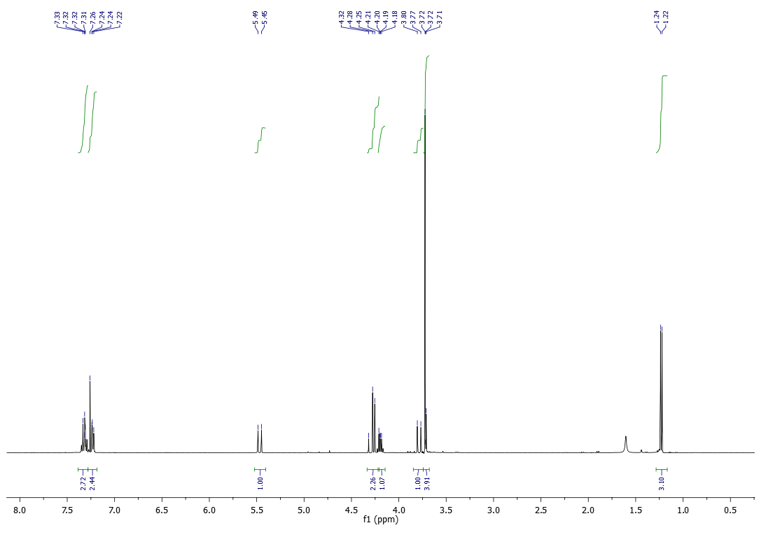
Figure S1. ¹H NMR spectrum of compound 29 (400 MHz, CDCl₃).
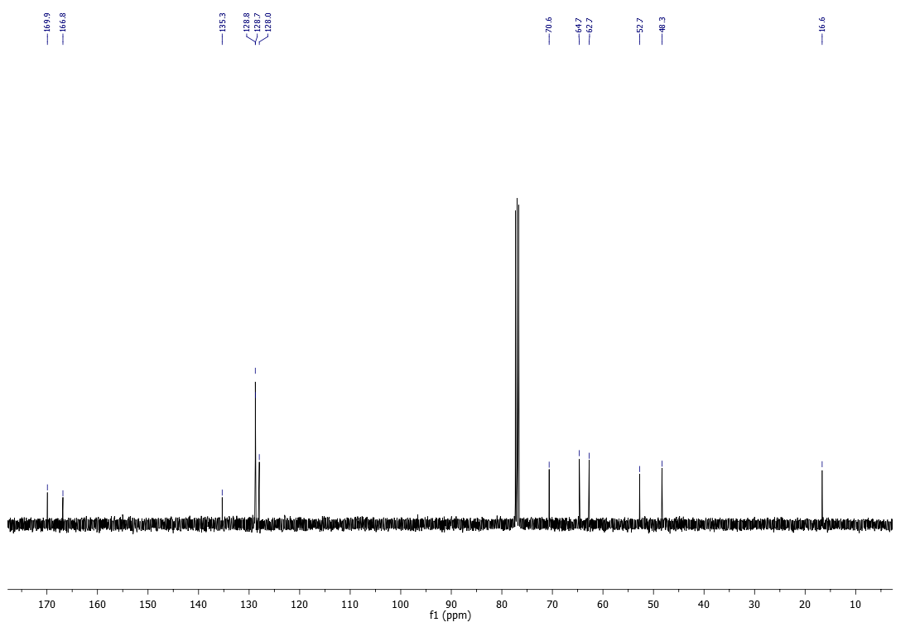
Figure S2. ¹³C NMR spectrum of compound 29 (100 MHz, CDCl₃).
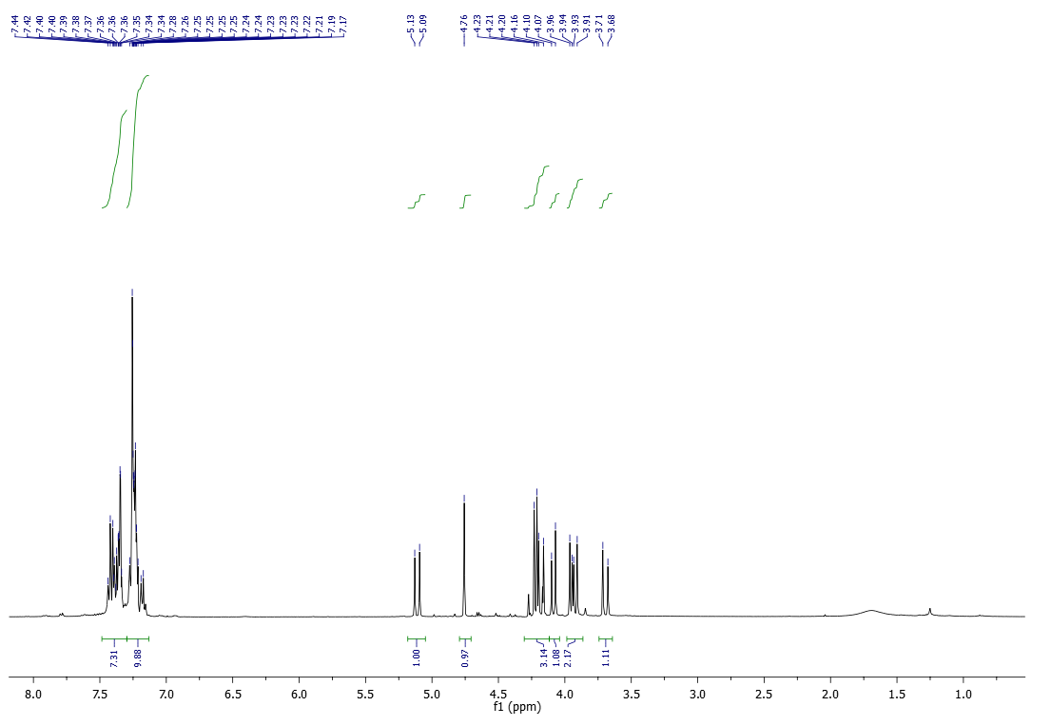Figure S3. ¹H NMR spectrum of compound 35 (50 MHz, CDCl₃).
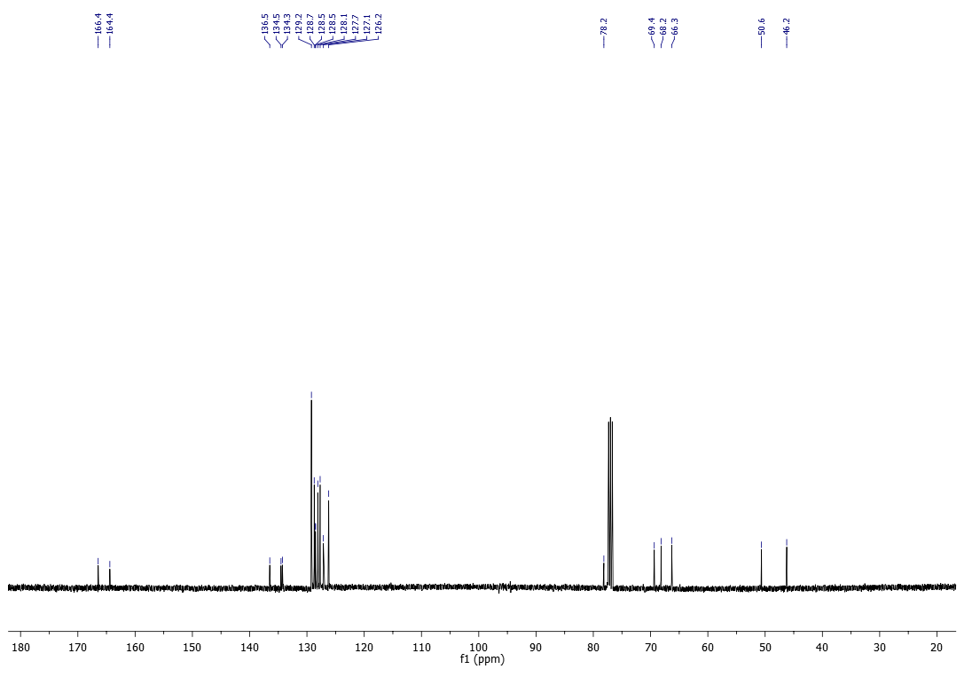
Figure S4. ¹³C NMR spectrum of compound 35 (100 MHz, CDCl₃).
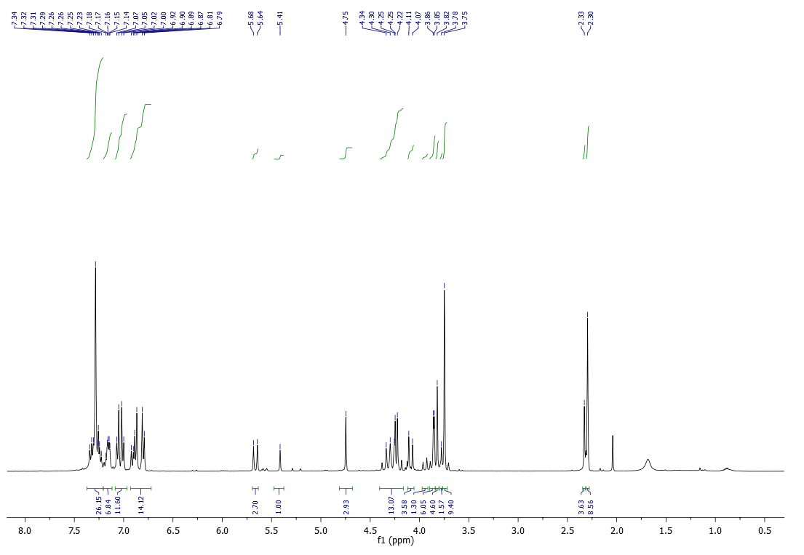
Figure S5. ¹H NMR spectrum of compound 36 (400 MHz, CDCl₃).
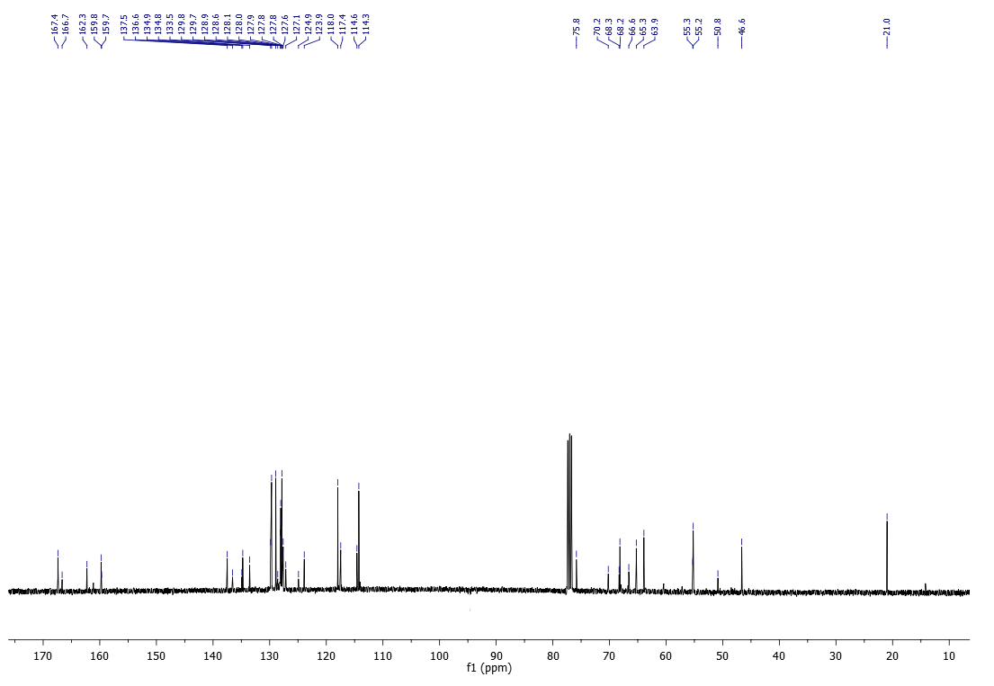
Figure S6. ¹³C NMR spectrum of compound 36 (100 MHz, CDCl₃).
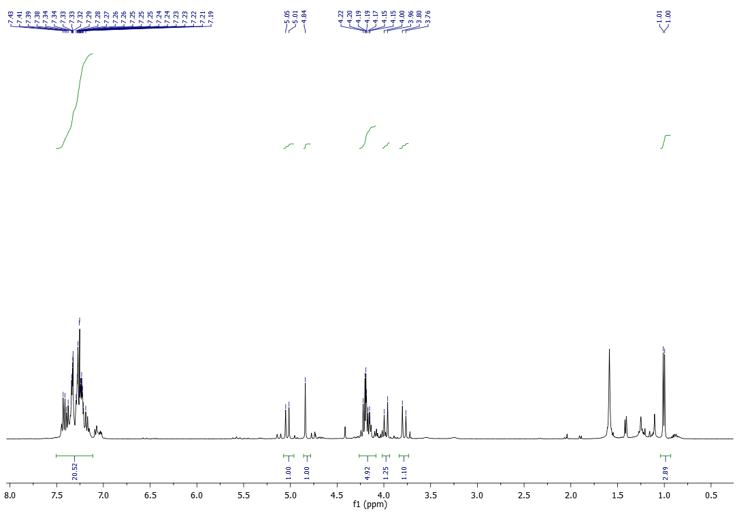
Figure S7. ¹H NMR spectrum of compound 37 (400 MHz, CDCl₃).
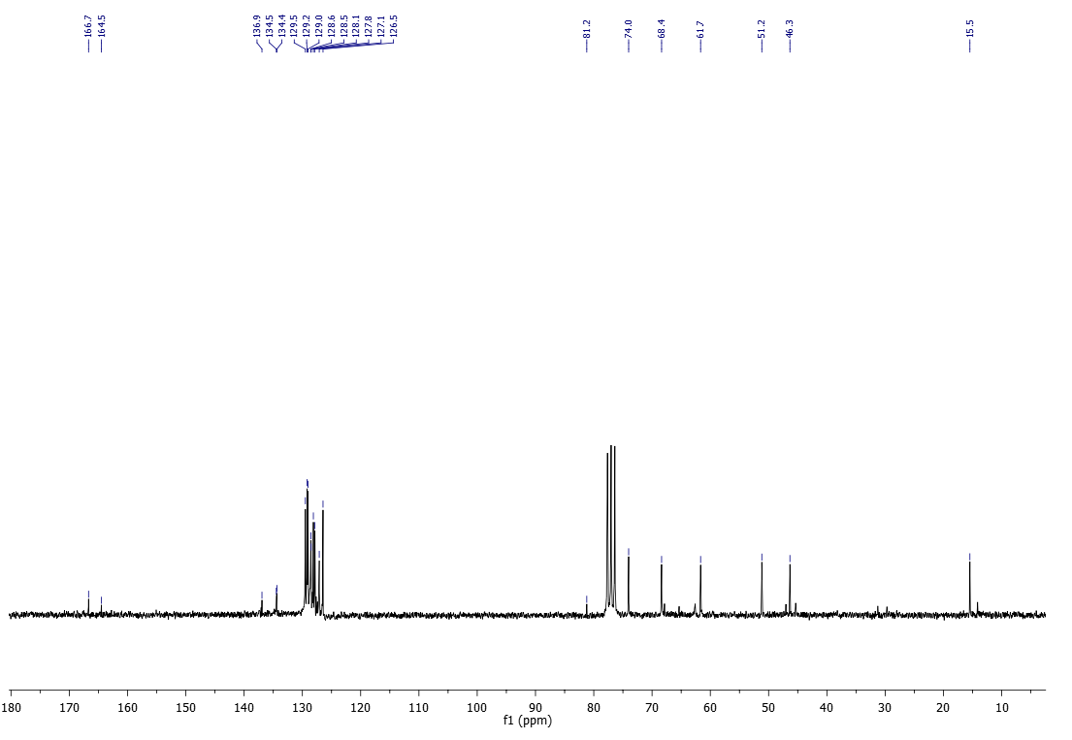Figure S8. ¹³C NMR spectrum of compound 37 (50 MHz, CDCl₃).
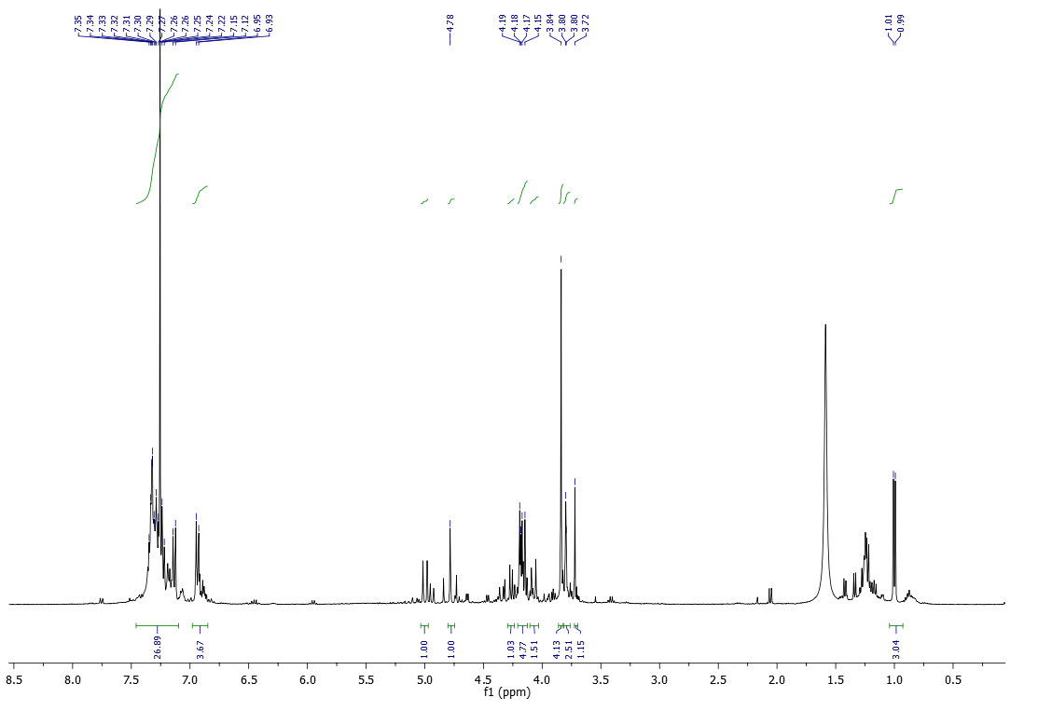Figure S9. ¹H NMR spectrum of compound 38 (400 MHz, CDCl₃).
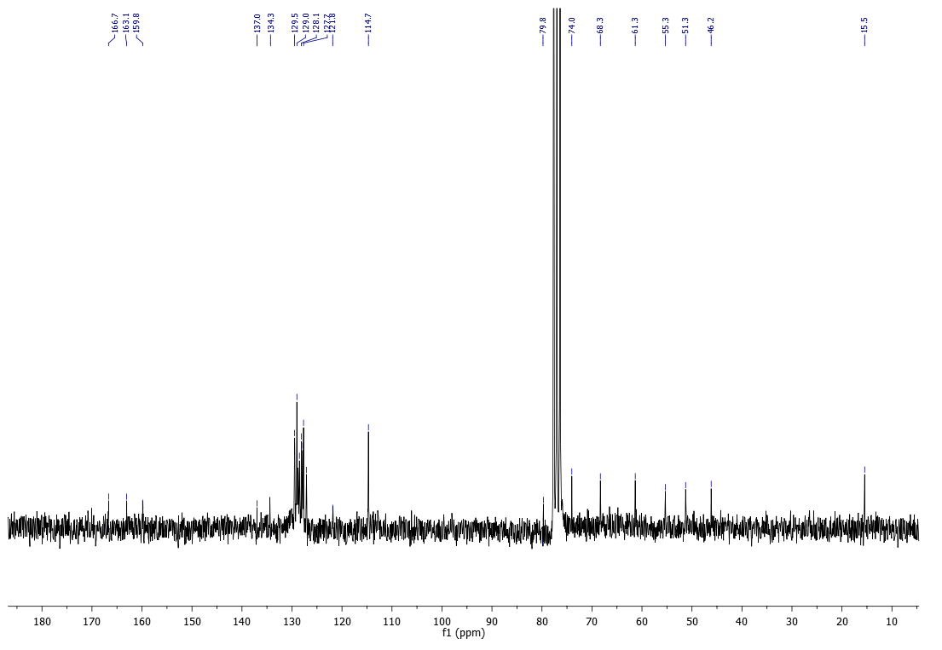Figure S10. ¹³C NMR spectrum of compound 38 (50 MHz, CDCl₃).
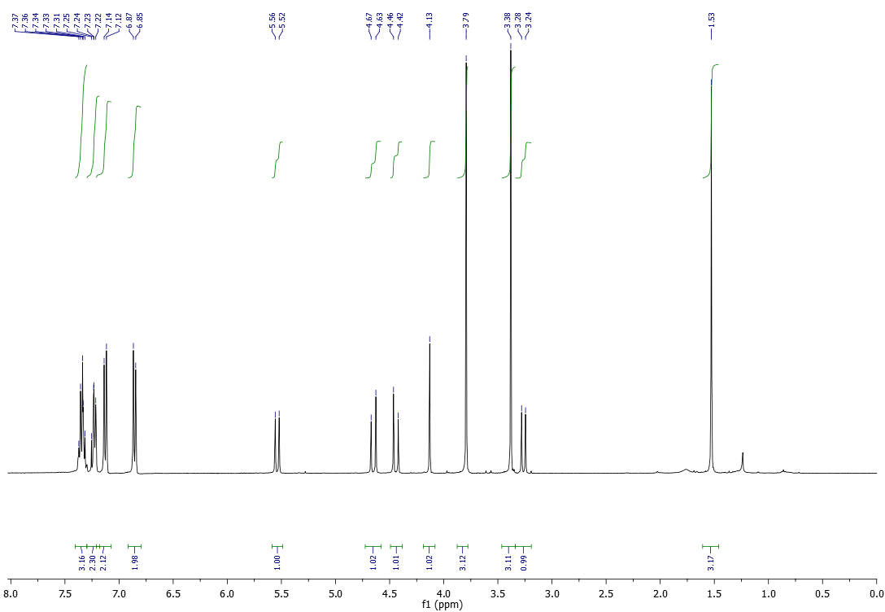
Figure S11. ¹H NMR spectrum of compound 42 (400 MHz, CDCl₃).
Figure S12. ¹³C NMR spectrum of compound 42 (100 MHz, CDCl₃).
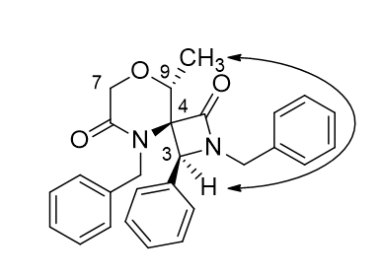

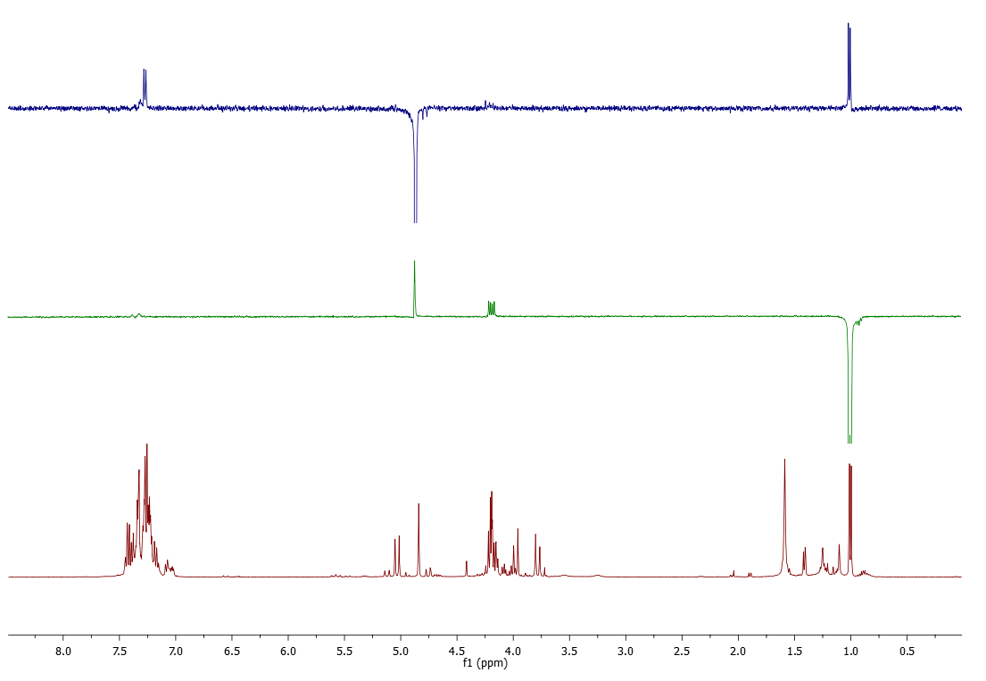
CH₃
H₃
Figure S13. 1D NOESY experiments of compound 37 (400 MHz, CDCl₃).

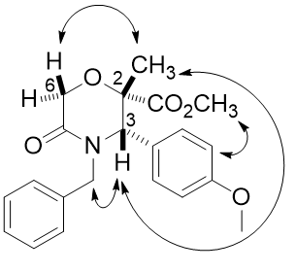

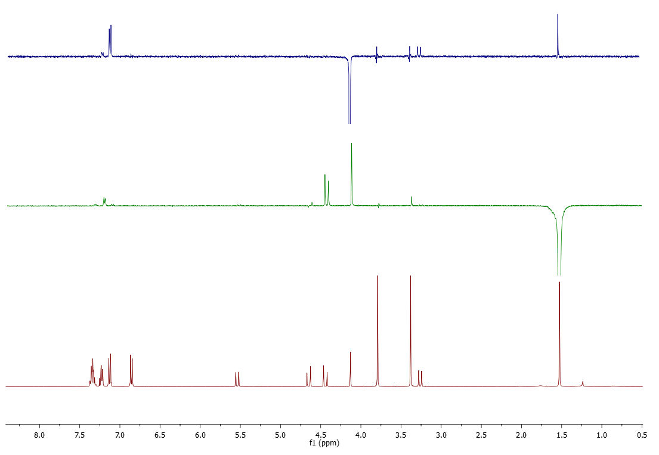
CH₃
H_{6b}
H₃
Figure S14. 1D NOESY experiments of compound 42 (400 MHz, CDCl₃).

Table S1. PCA results table for the first three dimensions of morpholine library compounds
MOL ID | PC1 | PC2 | PC3 | MOL ID | PC1 | PC2 | PC3
1 | -1,541148 | 0,703663 | -0,086007 | 46 | -2,374855 | -1,158703 | -1,38737
2 | -1,673943 | 0,857898 | -0,081706 | 47 | -1,295638 | -1,903838 | -1,271803
3 | -1,326882 | 0,564861 | 0,126071 | 48 | -2,332816 | -1,309781 | -1,423388
4 | -1,748761 | 0,833539 | -0,405759 | 49 | -0,802913 | 0,212342 | -0,650012
5 | -1,457219 | 0,603488 | -0,491373 | 50 | -1,209120 | 0,371396 | -0,719512
6 | -3,154545 | -0,883323 | -1,362029 | 51 | 0,169068 | 1,678186 | 0,254832
7 | -1,899064 | 0,874189 | -0,538544 | 52 | -1,552757 | 0,601323 | -0,60749
8 | -2,765563 | -1,084712 | -0,908441 | 53 | -2,572603 | -1,353736 | -0,880827
9 | -3,121891 | -0,772765 | -1,123044 | 54 | 0,677108 | -2,334505 | 1,827699
10 | -3,303290 | -0,694739 | -1,294183 | 55 | 2,169964 | -0,987372 | 2,56001
11 | 0,924511 | 1,713175 | 1,081888 | 56 | -2,943493 | -0,841522 | -1,234982
12 | -2,323816 | 1,220862 | -0,98588 | 57 | -1,408018 | 0,646606 | -0,385304
13 | -1,440920 | 0,908810 | -0,719746 | 58 | -0,195732 | 2,126650 | 0,32033
14 | -2,021046 | 1,059258 | -0,192982 | 59 | -2,803049 | -1,052102 | -1,233467
15 | 1,264809 | 1,468511 | 1,211567 | 60 | -1,837833 | 2,400944 | 1,34062
16 | -2,273179 | 1,100533 | -0,430059 | 61 | -1,425658 | 2,202230 | 1,35683
17 | -2,132978 | 1,082211 | -0,433316 | 62 | -2,906202 | 0,930619 | 0,010582
18 | 1,295545 | 1,430172 | 1,248242 | 63 | -1,658685 | 2,294502 | 1,507356
19 | 1,085089 | 1,553441 | 1,045155 | 64 | -0,011746 | -0,231415 | 1,975313
20 | -3,373783 | -0,752670 | -1,628265 | 65 | 0,352996 | 1,471038 | 2,697839
21 | -2,765563 | -1,084712 | -0,908441 | 66 | -0,011746 | -0,231415 | 1,975313
22 | -3,121891 | -0,772765 | -1,123044 | 67 | -1,175564 | 0,227275 | 0,218453
23 | -3,303290 | -0,694739 | -1,294183 | 68 | -1,175564 | 0,227275 | 0,218453
24 | -2,980291 | -0,984645 | -1 | 69 | -2 | 0,754003 | 0,407609
25 | -1,629750 | 0,716595 | -0,726448 | 70 | 0,754635 | 1,454661 | -0,292545
26 | -3,154545 | -0,883323 | -1,362029 | 71 | -2,075691 | -1,795427 | -2,52569
27 | 0,303186 | -2,129134 | 1,723852 | 72 | -2,075691 | -1,795427 | -2,52569
28 | -3,982886 | -0,906091 | -1,648385 | 73 | 1,371461 | 1,030234 | -0,600329
29 | -1,738391 | 0,773283 | -0,229001 | 74 | 1,371461 | 1,030234 | -0,600329
30 | 1,280398 | 1,657812 | 1,118252 | 75 | 1,127785 | 1,311264 | -0,241421
31 | -2,101513 | 0,954635 | -0,511396 | 76 | 0,529496 | 1,618797 | 0,113817
32 | -1,627498 | 0,572040 | 0,221623 | 77 | -0,413946 | -0,057156 | -1,270597
33 | -1,430255 | 0,587557 | -0,028643 | 78 | -0,287804 | 0,065299 | -1,325948
34 | -0,836996 | 0,204097 | -0,604393 | 79 | 0,529496 | 1,618797 | 0,113817
35 | -0,974778 | 0,384463 | -0,670643 | 80 | -0,064027 | 1,930090 | 0,457406
36 | 0,131412 | 1,648945 | -0,025491 | 81 | -3,750377 | -1,287016 | -1,208018
37 | -0,856358 | 0,199218 | -0,33756 | 82 | -3,750377 | -1,287016 | -1,208018
38 | -0,874496 | 0,231036 | -0,650953 | 83 | 0,026717 | 1,851641 | 1,113443
39 | -2,996516 | -1,110731 | -1,420084 | 84 | 0,026717 | 1,851641 | 1,113443
40 | -2,396483 | -1,393159 | -0,718584 | 85 | 0,000943 | 1,916311 | 0,54782
41 | -2,396483 | -1,393159 | -0,718584 | 86 | 0,000943 | 1,916311 | 0,54782
42 | -2,782279 | -1,201664 | -1,164716 | 87 | -0,410413 | 2,087265 | 0,530338
43 | -2,179744 | -1,488253 | -1,5159 | 88 | -0,378954 | 2,042821 | 1,030643
44 | -2,297971 | -1,363165 | -1,379629 | 89 | -0,543452 | 2,227892 | 0,679915
45 | -2,100961 | -1,570792 | -1,119375 | 90 | -0,558560 | 2,135844 | 0,863627
MOL ID | PC1 | PC2 | PC3 | MOL ID | PC1 | PC2 | PC3
91 | -0,369325 | 2,108996 | 0,91532 | 138 | -0,455297 | 0,010440 | -0,21298
92 | -0,582456 | 2,177927 | 0,298028 | 139 | -0,455297 | 0,010440 | -0,21298
93 | -3,313834 | -1,483947 | -1,800951 | 140 | -0,238871 | -1,948030 | 0,376387
94 | -2,265485 | 0,697538 | -0,192886 | 141 | 0,808030 | -0,269056 | 0,903508
95 | -1,513659 | 0,487401 | 0,108589 | 142 | -0,238871 | -1,948030 | 0,376387
96 | -1,903117 | 0,756591 | -0,085481 | 143 | 0,80803 | -0,269056 | 0,903508
97 | -0,388999 | 0,270821 | 0,62538 | 144 | -1,344446 | -1,744622 | -0,381875
98 | -0,782259 | 0,425310 | 0,056891 | 145 | -0,381033 | 0,321677 | 0,155799
99 | -0,782259 | 0,425310 | 0,056891 | 146 | -1,011561 | -1,627569 | 0,108149
100 | -1,262152 | 0,470356 | -0,489816 | 147 | -1,011561 | -1,627569 | 0,108149
101 | -1,004004 | 0,581114 | -0,729906 | 148 | -0,258091 | -2,054034 | -0,331763
102 | -0,434141 | 0,266388 | 0,421007 | 149 | -0,381033 | 0,321677 | 0,155799
103 | -0,434141 | 0,266388 | 0,421007 | 150 | -1,044101 | -1,588803 | 0,047684
104 | 6,254258 | -0,096509 | 1,622724 | 151 | -1,044101 | -1,588803 | 0,047684
105 | 0,510325 | -2,207885 | -0,748006 | 152 | -1,044112 | -1,591268 | 0,03649
106 | 2,598080 | -2,641528 | -0,62069 | 153 | -1,044112 | -1,591268 | 0,03649
107 | 5,138126 | -3,131111 | 0,084342 | 154 | -1,249281 | -1,480034 | -0,233797
108 | 2,018787 | 2,852832 | 1,717214 | 155 | -1,067063 | -1,574469 | -0,527156
109 | 2,018787 | 2,852832 | 1,717214 | 156 | -1,067063 | -1,574469 | -0,527156
110 | 0,950453 | 3,232186 | 1,520721 | 157 | -1,067063 | -1,574469 | -0,527156
111 | 0,950453 | 3,232186 | 1,520721 | 158 | -0,174142 | 1,683570 | 0,419277
112 | 0,923085 | 3,290001 | 1,565615 | 159 | -1,249281 | -1,480034 | -0,233797
113 | 0,923085 | 3,290001 | 1,565615 | 160 | -0,174142 | 0,168357 | 0,419277
114 | 1,152677 | 3,210109 | 1,38018 | 161 | -1,250215 | 0,532335 | 0,1438
115 | 1,152677 | 3,210109 | 1,38018 | 162 | -1,344446 | -1,744622 | -0,381875
116 | 1,548761 | 3,299216 | 1,020903 | 163 | -0,455297 | 0,010440 | -0,21298
117 | 1,548761 | 3,299216 | 1,020903 | 164 | -0,763072 | 0,373413 | -1,0441
118 | 1,732055 | 3,211549 | 1,20781 | 165 | -1,889387 | 0,771838 | 0,024009
119 | 1,732055 | 3,211549 | 1,20781 | 166 | 0,022086 | 1,967984 | 0,831041
120 | 1,336367 | 3,119610 | 1,567822 | 167 | -2,129748 | 0,958687 | -0,049214
121 | 1,336367 | 3,119610 | 1,567822 | 168 | -0,541880 | 2,142237 | 1,128283
122 | 1,535093 | 3,306388 | 1,657321 | 169 | 1,318122 | 1,501511 | 1,506345
123 | 1,535093 | 3,306388 | 1,657321 | 170 | 1,318122 | 1,501511 | 1,506345
124 | 0,342290 | 1,696030 | 1,325281 | 171 | -0,541880 | 2,142237 | 1,128283
125 | 0,144714 | 1,933901 | 0,165979 | 172 | -1,328651 | 0,654633 | 0,073511
126 | -0,029222 | 2,018058 | 0,457172 | 173 | 0,263151 | 1,818488 | 1,256332
127 | 1,123306 | 1,222406 | 0,96056 | 174 | -0,268250 | 0,299988 | 0,4057
128 | 0,310238 | -0,324459 | 0,597176 | 175 | 0,263151 | 1,818488 | 1,256332
129 | 0,749764 | 1,502643 | 0,750277 | 176 | -2,251386 | 0,782214 | -0,141662
130 | 0,533689 | 1,527139 | 0,31202 | 177 | -2,420987 | 0,869918 | -0,370114
131 | 1,162224 | 1,263843 | 0,848412 | 178 | -0,640925 | 2,025866 | 0,674857
132 | 1,123306 | 1,222406 | 0,96056 | 179 | 0,786008 | 3,231783 | 1,584825
133 | -0,411259 | 0,197816 | -0,570115 | 180 | 1,193538 | 3,032230 | 1,656075
134 | -0,411259 | 0,197816 | -0,570115 | 181 | -0,462198 | 1,925783 | 0,812086
135 | -1,250215 | 0,532335 | 0,1438 | 182 | 0,986161 | 3,182679 | 1,533474
136 | -0,455297 | 0,010440 | -0,21298 | 183 | 0,606074 | 3,327628 | 1,416935
137 | -0,455297 | 0,010440 | -0,21298
Table S2: PMI results table for morpholine library compounds
MOLID | I1 | I2 | I3 | I2/I3 | I1/I3
1 | 3687,9539 | 3218,9777 | 840,0751 | 0,8728 | 0,2278
2 | 3768,9034 | 3137,2321 | 759,5119 | 0,8324 | 0,2015
3 | 4332,0202 | 3754,7247 | 975,3587 | 0,8667 | 0,2252
4 | 3037,1785 | 2646,7818 | 771,1435 | 0,8715 | 0,2539
5 | 4785,2122 | 4399,8300 | 692,7546 | 0,9195 | 0,1448
6 | 1351,4185 | 1049,0133 | 489,6340 | 0,7762 | 0,3623
7 | 2912,2702 | 2642,0997 | 624,9829 | 0,9072 | 0,2146
8 | 2078,5661 | 1839,6145 | 519,2793 | 0,8850 | 0,2498
9 | 1568,1641 | 1114,5588 | 529,4317 | 0,7107 | 0,3376
10 | 1399,7814 | 990,5079 | 446,0086 | 0,7076 | 0,3186
11 | 4930,5006 | 4447,7576 | 3013,7260 | 0,9021 | 0,6112
12 | 1792,7004 | 1478,2408 | 572,6464 | 0,8246 | 0,3194
13 | 1928,9406 | 1870,6355 | 1106,3415 | 0,9698 | 0,5735
14 | 2563,0310 | 2007,0581 | 1535,8460 | 0,7831 | 0,5992
15 | 11387,0352 | 10357,4469 | 2241,9841 | 0,9096 | 0,1969
16 | 1945,6743 | 1652,8016 | 682,5330 | 0,8495 | 0,3508
17 | 2971,0160 | 2801,3274 | 639,4227 | 0,9429 | 0,2152
18 | 12617,9096 | 11337,7914 | 2313,6352 | 0,8985 | 0,1834
19 | 9814,4499 | 8717,1648 | 2292,2736 | 0,8882 | 0,2336
20 | 1108,9919 | 793,0910 | 450,8365 | 0,7151 | 0,4065
21 | 1857,1868 | 1659,6375 | 609,4986 | 0,8936 | 0,3282
22 | 1566,4503 | 1084,0932 | 548,0793 | 0,6921 | 0,3499
23 | 1382,4894 | 989,1165 | 437,8535 | 0,7155 | 0,3167
24 | 1439,5274 | 1223,6698 | 577,4025 | 0,8500 | 0,4011
25 | 4415,3218 | 3990,5536 | 619,8411 | 0,9038 | 0,1404
26 | 1337,7401 | 1013,7253 | 532,4362 | 0,7578 | 0,3980
27 | 7185,6404 | 4232,7957 | 3946,7794 | 0,5891 | 0,5493
28 | 970,3609 | 834,5247 | 220,8237 | 0,8600 | 0,2276
29 | 3593,0062 | 2923,6212 | 1212,5852 | 0,8137 | 0,3375
30 | 10308,3892 | 9619,6573 | 2449,0946 | 0,9332 | 0,2376
31 | 2477,9849 | 1709,7083 | 1106,9982 | 0,6900 | 0,4467
32 | 5046,4814 | 4483,9397 | 1006,4940 | 0,8885 | 0,1994
33 | 3609,9028 | 2961,2303 | 1029,4193 | 0,8203 | 0,2852
34 | 3420,5445 | 2438,6616 | 1619,4069 | 0,7129 | 0,4734
35 | 3206,1511 | 2450,7139 | 1428,3789 | 0,7644 | 0,4455
36 | 4509,8483 | 3625,2336 | 2434,6164 | 0,8038 | 0,5398
37 | 3203,8903 | 2777,1507 | 1400,1418 | 0,8668 | 0,4370
38 | 2924,7317 | 2634,5005 | 1282,6898 | 0,9008 | 0,4386
39 | 1789,6739 | 1434,9019 | 510,5240 | 0,8018 | 0,2853
40 | 2718,1474 | 2404,7854 | 676,2068 | 0,8847 | 0,2488
41 | 2817,2021 | 2366,8868 | 789,2632 | 0,8402 | 0,2802
42 | 1848,5327 | 1585,6237 | 668,2134 | 0,8578 | 0,3615
43 | 2293,1786 | 1942,9398 | 800,2006 | 0,8473 | 0,3489
44 | 2242,7709 | 2010,6636 | 684,3002 | 0,8965 | 0,3051
45 | 2791,5471 | 2546,7618 | 716,2016 | 0,9123 | 0,2566
46 | 2212,2783 | 1968,3745 | 674,3745 | 0,8897 | 0,3048
47 | 3972,2083 | 3589,5218 | 970,4625 | 0,9037 | 0,2443
48 | 2181,9725 | 1850,7071 | 686,0280 | 0,8482 | 0,3144
49 | 5091,5742 | 4714,4974 | 1110,0860 | 0,9259 | 0,2180
50 | 3765,4731 | 3551,4898 | 885,8059 | 0,9432 | 0,2352
51 | 8000,4924 | 7590,2075 | 1325,7714 | 0,9487 | 0,1657
52 | 2960,4957 | 2665,5457 | 934,7268 | 0,9004 | 0,3157
53 | 2174,6743 | 1854,4260 | 872,0669 | 0,8527 | 0,4010
54 | 6507,7621 | 5146,9969 | 3963,5053 | 0,7909 | 0,6090
55 | 10993,8826 | 8348,8741 | 4886,7377 | 0,7594 | 0,4445
56 | 1478,2433 | 1307,2820 | 479,2031 | 0,8843 | 0,3242
57 | 4265,0349 | 3836,3821 | 929,6140 | 0,8995 | 0,2180
58 | 5495,0271 | 4629,2342 | 1539,1636 | 0,8424 | 0,2801
59 | 1683,4949 | 1364,9529 | 570,7771 | 0,8108 | 0,3390
60 | 2690,4892 | 2329,8784 | 815,4313 | 0,8660 | 0,3031
61 | 4601,7059 | 3400,4579 | 1522,1197 | 0,7390 | 0,3308
62 | 3072,8346 | 3063,1321 | 218,3817 | 0,9968 | 0,0711
63 | 2924,4376 | 2360,9128 | 963,9547 | 0,8073 | 0,3296
64 | 6162,1351 | 5185,0159 | 2664,6254 | 0,8414 | 0,4324
65 | 7928,2980 | 7610,3305 | 1636,7961 | 0,9599 | 0,2064
66 | 6188,4322 | 4258,6989 | 3257,0359 | 0,6882 | 0,5263
67 | 3867,1280 | 3023,7546 | 1667,2125 | 0,7819 | 0,4311
68 | 4036,7206 | 3416,7329 | 1823,6275 | 0,8464 | 0,4518
69 | 3687,1667 | 2932,5217 | 1286,7346 | 0,7953 | 0,3490
70 | 4137,7904 | 3515,0956 | 2259,5857 | 0,8495 | 0,5461
71 | 1671,3558 | 1485,4349 | 1017,5281 | 0,8888 | 0,6088
72 | 2422,0072 | 1866,9608 | 794,2956 | 0,7708 | 0,3279
73 | 4502,5252 | 4005,8908 | 2662,0039 | 0,8897 | 0,5912
74 | 5197,2627 | 4631,5704 | 2598,8087 | 0,8912 | 0,5000
75 | 6991,0727 | 5532,5168 | 2532,6802 | 0,7914 | 0,3623
76 | 5091,1025 | 4555,6336 | 2143,6168 | 0,8948 | 0,4211
77 | 5285,4117 | 3810,7007 | 1757,1931 | 0,7210 | 0,3325
78 | 3925,6514 | 3065,0933 | 1635,1018 | 0,7808 | 0,4165
79 | 6264,9089 | 5126,6102 | 1961,8739 | 0,8183 | 0,3132
80 | 6460,0803 | 5455,9793 | 1675,7432 | 0,8446 | 0,2594
81 | 1067,5211 | 1012,9499 | 351,4320 | 0,9489 | 0,3292
82 | 1028,9004 | 1012,6541 | 313,1851 | 0,9842 | 0,3044
83 | 7222,7188 | 6068,6339 | 1697,1183 | 0,8402 | 0,2350
84 | 4745,6724 | 4471,8125 | 1807,5103 | 0,9423 | 0,3809
85 | 6758,5333 | 5863,5692 | 1408,9803 | 0,8676 | 0,2085
86 | 4578,5605 | 4449,1970 | 1683,2001 | 0,9717 | 0,3676
87 | 4972,0421 | 4365,0369 | 1279,4115 | 0,8779 | 0,2573
88 | 5442,5604 | 4657,3352 | 1447,9879 | 0,8557 | 0,2660
89 | 5059,2744 | 4537,3960 | 1429,6759 | 0,8968 | 0,2826
90 | 4190,0523 | 3708,3133 | 1611,2092 | 0,8850 | 0,3845
91 | 5409,2155 | 4824,7041 | 1598,6966 | 0,8919 | 0,2956
92 | 4751,2609 | 4074,4073 | 1480,9383 | 0,8575 | 0,3117
93 | 1440,2412 | 1112,6892 | 502,8275 | 0,7726 | 0,3491
94 | 2135,6068 | 1877,1021 | 716,2570 | 0,8790 | 0,3354
95 | 4393,6496 | 3706,4406 | 1291,7096 | 0,8436 | 0,2940
96 | 3094,4388 | 2737,3291 | 850,4263 | 0,8846 | 0,2748
97 | 5515,5785 | 3833,6505 | 2724,8266 | 0,6951 | 0,4940
98 | 4941,6168 | 3508,3597 | 2077,7478 | 0,7100 | 0,4205
99 | 4938,6338 | 4261,2644 | 1529,3661 | 0,8628 | 0,3097
100 | 4195,2739 | 3547,9174 | 1052,2037 | 0,8457 | 0,2508
101 | 4461,2442 | 3687,8662 | 1212,0217 | 0,8266 | 0,2717
102 | 5646,7350 | 3593,8222 | 2785,0444 | 0,6364 | 0,4932
103 | 5742,5056 | 5013,8752 | 1794,8574 | 0,8731 | 0,3126
104 | 14522,7211 | 12360,2188 | 2162,5023 | 0,8511 | 0,1489
105 | 5299,7049 | 3779,1283 | 2723,1479 | 0,7131 | 0,5138
106 | 9041,4106 | 8075,3650 | 3472,6839 | 0,8932 | 0,3841
107 | 11498,8993 | 10514,5351 | 984,3641 | 0,9144 | 0,0856
108 | 9482,3007 | 8722,8828 | 3122,1947 | 0,9199 | 0,3293
109 | 8151,1141 | 6855,8264 | 3017,8240 | 0,8411 | 0,3702
110 | 6288,5409 | 5759,6948 | 2104,5759 | 0,9159 | 0,3347
111 | 6381,3838 | 5175,6150 | 2040,3076 | 0,8110 | 0,3197
112 | 7116,1894 | 6865,5079 | 1968,4787 | 0,9648 | 0,2766
113 | 7398,3392 | 6393,9047 | 1642,0370 | 0,8642 | 0,2219
114 | 7987,5348 | 7861,3103 | 2093,6151 | 0,9842 | 0,2621
115 | 8432,5209 | 7376,0477 | 1710,5392 | 0,8747 | 0,2029
116 | 9014,2528 | 8748,4063 | 1970,2298 | 0,9705 | 0,2186
117 | 9324,4084 | 8331,6857 | 1700,1070 | 0,8935 | 0,1823
118 | 8530,6975 | 6882,6521 | 3283,3934 | 0,8068 | 0,3849
119 | 8028,3494 | 6287,5794 | 2763,9835 | 0,7832 | 0,3443
120 | 8241,1956 | 7022,2993 | 2969,7083 | 0,8521 | 0,3603
121 | 8070,2858 | 6339,0600 | 2384,8154 | 0,7855 | 0,2955
122 | 9738,6786 | 7188,1294 | 4272,8461 | 0,7381 | 0,4388
123 | 9200,3617 | 6388,6241 | 3485,2776 | 0,6944 | 0,3788
124 | 7327,7926 | 6709,5081 | 1368,5268 | 0,9156 | 0,1868
125 | 8873,9049 | 8575,0266 | 1162,2635 | 0,9663 | 0,1310
126 | 8929,5167 | 8580,5231 | 1147,2683 | 0,9609 | 0,1285
127 | 7254,3983 | 6900,7839 | 2274,5040 | 0,9513 | 0,3135
128 | 6199,5131 | 5473,6320 | 2360,2734 | 0,8829 | 0,3807
129 | 7652,9356 | 7197,0299 | 1633,2706 | 0,9404 | 0,2134
130 | 5714,7102 | 4810,8995 | 1739,5038 | 0,8418 | 0,3044
131 | 10269,5866 | 9412,7450 | 1798,0921 | 0,9166 | 0,1751
132 | 7831,7072 | 7050,3852 | 2006,4317 | 0,9002 | 0,2562
133 | 4565,0698 | 4075,4215 | 1410,2967 | 0,8927 | 0,3089
134 | 4975,6295 | 4191,0785 | 1508,7389 | 0,8423 | 0,3032
135 | 4483,3003 | 4362,5168 | 889,2299 | 0,9731 | 0,1983
136 | 5267,3094 | 4778,1296 | 1416,2668 | 0,9071 | 0,2689
137 | 5336,2426 | 4776,4364 | 1358,2268 | 0,8951 | 0,2545
138 | 5545,6957 | 5023,3447 | 1310,9756 | 0,9058 | 0,2364
139 | 8519,8409 | 7704,7309 | 1801,5949 | 0,9043 | 0,2115
140 | 6423,1582 | 5714,5392 | 1827,9495 | 0,8897 | 0,2846
141 | 10099,2427 | 8209,6450 | 2923,8759 | 0,8129 | 0,2895
142 | 5577,9001 | 4915,8876 | 1818,9732 | 0,8813 | 0,3261
143 | 8547,8077 | 5258,6226 | 4146,4515 | 0,6152 | 0,4851
144 | 4561,4955 | 4364,8489 | 954,9873 | 0,9569 | 0,2094
145 | 5572,7402 | 4932,4221 | 1434,5556 | 0,8851 | 0,2574
146 | 5367,1957 | 4973,8475 | 1072,5315 | 0,9267 | 0,1998
147 | 5391,2564 | 5104,3134 | 1025,7867 | 0,9468 | 0,1903
148 | 6297,1797 | 5863,4764 | 1525,9177 | 0,9311 | 0,2423
149 | 5769,0064 | 5216,1607 | 1319,9981 | 0,9042 | 0,2288
150 | 4780,4756 | 4370,9121 | 1328,7988 | 0,9143 | 0,2780
151 | 5047,3456 | 4714,1446 | 1149,4093 | 0,9340 | 0,2277
152 | 5317,6086 | 4856,5360 | 1189,3844 | 0,9133 | 0,2237
153 | 5162,4546 | 4806,1538 | 1082,7912 | 0,9310 | 0,2097
154 | 4359,1360 | 3939,0743 | 1168,1797 | 0,9036 | 0,2680
155 | 5075,3739 | 4902,9792 | 991,7015 | 0,9660 | 0,1954
156 | 5258,5522 | 5116,8611 | 866,4469 | 0,9731 | 0,1648
157 | 5064,7003 | 4805,4970 | 982,3071 | 0,9488 | 0,1940
158 | 7149,2798 | 6746,5042 | 1157,9004 | 0,9437 | 0,1620
159 | 4649,4136 | 4360,3355 | 1098,0235 | 0,9378 | 0,2362
160 | 7285,3471 | 7036,5128 | 1046,2068 | 0,9658 | 0,1436
161 | 4986,9630 | 4780,6636 | 670,4954 | 0,9586 | 0,1344
162 | 4200,0938 | 3909,1568 | 1025,6207 | 0,9307 | 0,2442
163 | 5631,0578 | 5157,9538 | 1184,4235 | 0,9160 | 0,2103
164 | 5365,4990 | 5196,9444 | 848,3370 | 0,9686 | 0,1581
165 | 3275,6064 | 3034,7913 | 786,5054 | 0,9265 | 0,2401
166 | 5648,2013 | 4916,4861 | 1405,1008 | 0,8705 | 0,2488
167 | 3097,4056 | 2777,2800 | 673,7952 | 0,8966 | 0,2175
168 | 5001,4262 | 4327,4397 | 1350,5616 | 0,8652 | 0,2700
169 | 12691,7876 | 11715,4103 | 1997,0804 | 0,9231 | 0,1574
170 | 12020,1199 | 10807,3728 | 2126,0653 | 0,8991 | 0,1769
171 | 5001,9475 | 4325,7798 | 1352,7833 | 0,8648 | 0,2705
172 | 5031,6650 | 4915,3449 | 821,6668 | 0,9769 | 0,1633
173 | 7614,5944 | 6965,1785 | 1529,8801 | 0,9147 | 0,2009
174 | 9563,7693 | 9391,7908 | 914,9864 | 0,9820 | 0,0957
175 | 7369,3955 | 6792,9723 | 1550,2257 | 0,9218 | 0,2104
176 | 1985,0424 | 1487,9800 | 875,2570 | 0,7496 | 0,4409
177 | 1776,9980 | 1316,5519 | 807,0495 | 0,7409 | 0,4542
178 | 3874,1123 | 3572,6012 | 1833,5168 | 0,9222 | 0,4733
179 | 4873,1862 | 4556,7979 | 2253,1369 | 0,9351 | 0,4624
180 | 5789,1978 | 4871,9413 | 3101,7440 | 0,8416 | 0,5358
181 | 3888,3042 | 3716,1665 | 1835,5895 | 0,9557 | 0,4721
182 | 6881,4683 | 4535,6947 | 3099,5348 | 0,6591 | 0,4504
183 | 4846,0621 | 4376,6991 | 2081,2667 | 0,9031 | 0,4295

Table S3: Medicinally-relevant molecular properties (MW, ClogP, HBD, HBA, rotatable bonds count, Fsp³ and FC*) for morpholine library compounds

MOLID | MW | logP | HBD | HBA | Fsp³ | FC* | Rot. Bonds
1 | 300.35 | 2.23 | 1 | 5 | 0,41 | 0,18 | 2
2 | 298.34 | 1.57 | 0 | 5 | 0,41 | 0,18 | 1
3 | 314.38 | 2.58 | 1 | 5 | 0,44 | 0,17 | 3
4 | 286.33 | 1.45 | 1 | 5 | 0,38 | 0,13 | 1
5 | 302.33 | 0.61 | 1 | 6 | 0,38 | 0,19 | 4
6 | 210.23 | 0.16 | 1 | 5 | 0,60 | 0,20 | 1
7 | 272.3 | 1.22 | 1 | 5 | 0,33 | 0,20 | 2
8 | 238.28 | 0.95 | 1 | 5 | 0,67 | 0,25 | 2
9 | 222.24 | -0.07 | 0 | 5 | 0,64 | 0,27 | 0
10 | 208.21 | -0.5 | 0 | 5 | 0,60 | 0,20 | 0
11 | 462.49 | 3.13 | 0 | 8 | 0,35 | 0,12 | 6
12 | 244.25 | 0.72 | 1 | 5 | 0,23 | 0,15 | 0
13 | 306.27 | 1.48 | 0 | 8 | 0,29 | 0,14 | 4
14 | 387.17 | 2.31 | 0 | 5 | 0,29 | 0,14 | 3
15 | 478.54 | 4.23 | 1 | 8 | 0,37 | 0,15 | 8
16 | 259.26 | 1.37 | 0 | 5 | 0,29 | 0,14 | 2
17 | 275.26 | 1.3 | 0 | 6 | 0,29 | 0,14 | 3
18 | 478.54 | 4.15 | 1 | 8 | 0,37 | 0,11 | 9
19 | 464.51 | 3.79 | 1 | 8 | 0,35 | 0,12 | 8
20 | 196.2 | -0.62 | 1 | 5 | 0,56 | 0,11 | 0
21 | 238.28 | 0.95 | 1 | 5 | 0,67 | 0,25 | 2
22 | 222.24 | -0.07 | 0 | 5 | 0,64 | 0,27 | 0
23 | 208.21 | -0.5 | 0 | 5 | 0,60 | 0,20 | 0
24 | 224.26 | 0.59 | 1 | 5 | 0,64 | 0,27 | 1
25 | 288.3 | 0.17 | 1 | 6 | 0,33 | 0,13 | 4
26 | 210.23 | 0.16 | 1 | 5 | 0,60 | 0,20 | 1
27 | 448.6 | 5.7 | 0 | 7 | 0,80 | 0,12 | 15
28 | 173.17 | -0.77 | 1 | 5 | 0,86 | 0,43 | 1
29 | 307.3 | 1.06 | 0 | 7 | 0,47 | 0,20 | 4
30 | 492.52 | 2.73 | 0 | 9 | 0,44 | 0,19 | 5
31 | 277.27 | 0.82 | 0 | 6 | 0,43 | 0,21 | 2
32 | 319.35 | 1.31 | 0 | 6 | 0,59 | 0,35 | 4
33 | 316.35 | 0.98 | 0 | 6 | 0,53 | 0,18 | 3
34 | 334.37 | 0.43 | 2 | 7 | 0,41 | 0,18 | 6
35 | 332.35 | -0.1 | 2 | 7 | 0,41 | 0,18 | 5
36 | 384.43 | 1.28 | 2 | 7 | 0,33 | 0,14 | 6
37 | 348.39 | 0.46 | 1 | 7 | 0,56 | 0,17 | 4
38 | 334.37 | 0.34 | 2 | 7 | 0,53 | 0,18 | 5
39 | 228.25 | -0.86 | 1 | 6 | 0,80 | 0,20 | 1
40 | 270.32 | 0.71 | 1 | 6 | 0,85 | 0,31 | 3
41 | 270.32 | 0.71 | 1 | 6 | 0,85 | 0,31 | 3
42 | 242.27 | -0.08 | 1 | 6 | 0,82 | 0,27 | 2
43 | 272.3 | -0.7 | 2 | 7 | 0,83 | 0,33 | 3
44 | 270.28 | -1.33 | 1 | 7 | 0,83 | 0,25 | 3
45 | 286.32 | -0.55 | 1 | 7 | 0,85 | 0,23 | 4
46 | 268.27 | -1.77 | 1 | 7 | 0,67 | 0,25 | 3
47 | 330.38 | -0.81 | 2 | 8 | 0,87 | 0,27 | 6
48 | 270.28 | -1.36 | 1 | 7 | 0,83 | 0,33 | 2
49 | 350.37 | -0.42 | 1 | 8 | 0,53 | 0,18 | 5
50 | 320.34 | -0.39 | 1 | 7 | 0,50 | 0,19 | 4
51 | 396.44 | 1.24 | 1 | 7 | 0,36 | 0,14 | 5
52 | 306.31 | -0.13 | 1 | 7 | 0,47 | 0,20 | 4
53 | 256.3 | 0.27 | 1 | 6 | 0,83 | 0,25 | 3
54 | 480.64 | 5.46 | 0 | 8 | 0,88 | 0,15 | 16
55 | 560.72 | 6.4 | 0 | 9 | 0,71 | 0,10 | 19
56 | 238.24 | -0.9 | 0 | 6 | 0,82 | 0,36 | 0
57 | 318.32 | 0.04 | 0 | 7 | 0,50 | 0,19 | 3
58 | 381.38 | 2.35 | 1 | 7 | 0,33 | 0,19 | 4
59 | 240.26 | -0.24 | 1 | 6 | 0,82 | 0,36 | 1
60 | 279.38 | 3.56 | 0 | 2 | 0,26 | 0,05 | 4
61 | 309.4 | 3.57 | 0 | 3 | 0,30 | 0,10 | 5
62 | 219.28 | 1.61 | 1 | 3 | 0,38 | 0,15 | 3
63 | 293.4 | 3.96 | 0 | 2 | 0,30 | 0,10 | 4
64 | 433.58 | 4.66 | 0 | 6 | 0,64 | 0,12 | 10
65 | 435.6 | 6.29 | 0 | 4 | 0,46 | 0,11 | 8
66 | 433.58 | 4.66 | 0 | 6 | 0,64 | 0,16 | 10
67 | 335.39 | 1.78 | 1 | 6 | 0,50 | 0,22 | 7
68 | 335.39 | 2.33 | 1 | 6 | 0,50 | 0,17 | 7
69 | 303.35 | 2.24 | 0 | 5 | 0,47 | 0,29 | 3
70 | 427.45 | 0.87 | 3 | 8 | 0,43 | 0,26 | 6
71 | 277.27 | -2.21 | 3 | 8 | 0,91 | 0,45 | 3
72 | 277.27 | -2.21 | 3 | 8 | 0,91 | 0,45 | 3
73 | 459.49 | 0.41 | 4 | 9 | 0,46 | 0,25 | 8
74 | 459.49 | 0.41 | 4 | 9 | 0,46 | 0,25 | 8
75 | 457.47 | 1.44 | 3 | 9 | 0,46 | 0,29 | 6
76 | 427.45 | 2.05 | 2 | 8 | 0,43 | 0,26 | 5
77 | 369.37 | -0.18 | 3 | 9 | 0,59 | 0,35 | 6
78 | 389.42 | -0.37 | 3 | 9 | 0,63 | 0,38 | 4
79 | 427.45 | 2.05 | 2 | 8 | 0,43 | 0,26 | 5
80 | 397.42 | 2.12 | 1 | 7 | 0,41 | 0,23 | 4
81 | 189.21 | -0.17 | 1 | 5 | 0,88 | 0,38 | 3
82 | 189.21 | -0.17 | 1 | 5 | 0,88 | 0,38 | 3
83 | 411.45 | 3.27 | 0 | 7 | 0,39 | 0,17 | 6
84 | 411.45 | 3.27 | 0 | 7 | 0,39 | 0,17 | 6
85 | 397.42 | 2.95 | 1 | 7 | 0,36 | 0,18 | 5
86 | 397.42 | 2.95 | 1 | 7 | 0,36 | 0,18 | 5
87 | 367.4 | 2.93 | 1 | 6 | 0,33 | 0,14 | 4
88 | 381.42 | 3.26 | 0 | 6 | 0,36 | 0,14 | 5
89 | 365.38 | 3.08 | 0 | 6 | 0,24 | 0,10 | 5
90 | 367.4 | 2.82 | 0 | 6 | 0,33 | 0,10 | 5
91 | 379.41 | 3.51 | 0 | 6 | 0,27 | 0,14 | 5
92 | 353.37 | 2.5 | 1 | 6 | 0,30 | 0,10 | 4
93 | 205.21 | -1.22 | 2 | 6 | 0,88 | 0,38 | 4
94 | 265.3 | 1.11 | 1 | 5 | 0,50 | 0,21 | 4
95 | 323.34 | 1.65 | 0 | 7 | 0,50 | 0,19 | 6
96 | 291.3 | 1.89 | 0 | 6 | 0,33 | 0,13 | 5
97 | 405.44 | 2.39 | 0 | 8 | 0,57 | 0,24 | 8
98 | 363.36 | 1.33 | 0 | 8 | 0,50 | 0,22 | 8
99 | 363.36 | 1.33 | 0 | 8 | 0,50 | 0,22 | 8
100 | 321.33 | 0.68 | 1 | 7 | 0,50 | 0,25 | 6
101 | 335.31 | 0.64 | 1 | 8 | 0,44 | 0,25 | 6
102 | 391.42 | 1.95 | 0 | 8 | 0,55 | 0,20 | 8
103 | 391.42 | 1.95 | 0 | 8 | 0,55 | 0,20 | 8
104 | 747.88 | 5.35 | 4 | 14 | 0,50 | 0,15 | 17
105 | 428.52 | 0.94 | 4 | 10 | 0,80 | 0,20 | 11
106 | 527.65 | 1.32 | 5 | 12 | 0,80 | 0,20 | 13
107 | 696.83 | 2.97 | 5 | 16 | 0,73 | 0,18 | 18
108 | 512.55 | 3.3 | 0 | 8 | 0,30 | 0,17 | 8
109 | 512.55 | 3.3 | 0 | 8 | 0,30 | 0,17 | 8
110 | 440.49 | 2.88 | 0 | 6 | 0,26 | 0,15 | 5
111 | 440.49 | 2.88 | 0 | 6 | 0,26 | 0,15 | 5
112 | 440.49 | 3.31 | 0 | 6 | 0,26 | 0,15 | 4
113 | 440.49 | 3.31 | 0 | 6 | 0,26 | 0,15 | 4
114 | 456.49 | 2.92 | 0 | 7 | 0,26 | 0,15 | 5
115 | 456.49 | 2.92 | 0 | 7 | 0,26 | 0,15 | 5
116 | 471.46 | 2.77 | 0 | 9 | 0,23 | 0,15 | 5
117 | 471.46 | 2.77 | 0 | 9 | 0,23 | 0,15 | 5
118 | 485.49 | 3.14 | 0 | 9 | 0,26 | 0,15 | 5
119 | 485.49 | 3.14 | 0 | 9 | 0,26 | 0,15 | 5
120 | 470.52 | 3.28 | 0 | 7 | 0,29 | 0,14 | 5
121 | 470.52 | 3.28 | 0 | 7 | 0,29 | 0,14 | 5
122 | 519.39 | 4.0 | 0 | 6 | 0,26 | 0,15 | 4
123 | 519.39 | 4.0 | 0 | 6 | 0,26 | 0,15 | 4
124 | 420.5 | 3.13 | 0 | 6 | 0,44 | 0,16 | 5
125 | 396.39 | 1.39 | 1 | 8 | 0,33 | 0,14 | 5
126 | 397.38 | 1.96 | 0 | 8 | 0,33 | 0,14 | 6
127 | 452.54 | 3.17 | 2 | 7 | 0,46 | 0,19 | 9
128 | 418.53 | 2.9 | 2 | 7 | 0,65 | 0,22 | 9
129 | 436.5 | 2.15 | 1 | 7 | 0,44 | 0,20 | 6
130 | 410.46 | 1.85 | 2 | 7 | 0,39 | 0,22 | 7
131 | 465.54 | 1.41 | 1 | 8 | 0,46 | 0,15 | 7
132 | 452.54 | 3.17 | 2 | 7 | 0,46 | 0,19 | 9
133 | 362.38 | 1.04 | 2 | 8 | 0,50 | 0,22 | 6
134 | 362.38 | 1.04 | 2 | 8 | 0,50 | 0,22 | 6
135 | 330.38 | 1.11 | 0 | 6 | 0,56 | 0,17 | 3
136 | 362.42 | 1.15 | 2 | 7 | 0,58 | 0,21 | 7
137 | 362.42 | 1.15 | 2 | 7 | 0,58 | 0,21 | 7
138 | 362.42 | 1.15 | 2 | 7 | 0,58 | 0,21 | 7
139 | 452.54 | 2.83 | 1 | 7 | 0,46 | 0,15 | 9
140 | 409.52 | 1.93 | 1 | 8 | 0,86 | 0,19 | 8
141 | 457.56 | 2.64 | 1 | 8 | 0,64 | 0,16 | 8
142 | 409.52 | 1.93 | 1 | 8 | 0,86 | 0,19 | 8
143 | 457.56 | 2.64 | 1 | 8 | 0,64 | 0,16 | 8
144 | 340.41 | 0.68 | 1 | 7 | 0,88 | 0,24 | 5
145 | 388.41 | 1.23 | 0 | 8 | 0,55 | 0,20 | 5
146 | 368.42 | 1.36 | 0 | 8 | 0,83 | 0,22 | 7
147 | 368.42 | 1.36 | 0 | 8 | 0,83 | 0,22 | 7
148 | 400.47 | 1.3 | 2 | 9 | 0,84 | 0,26 | 10
149 | 388.41 | 1.23 | 0 | 8 | 0,55 | 0,20 | 5
150 | 368.42 | 1.26 | 0 | 8 | 0,83 | 0,28 | 6
151 | 368.42 | 1.26 | 0 | 8 | 0,83 | 0,28 | 6
152 | 368.42 | 1.26 | 0 | 8 | 0,83 | 0,22 | 6
153 | 368.42 | 1.26 | 0 | 8 | 0,83 | 0,22 | 6
154 | 354.4 | 0.9 | 0 | 8 | 0,82 | 0,24 | 5
155 | 354.4 | 0.93 | 1 | 8 | 0,82 | 0,24 | 5
156 | 354.4 | 0.93 | 1 | 8 | 0,82 | 0,24 | 5
157 | 354.4 | 0.93 | 1 | 8 | 0,82 | 0,24 | 5
158 | 402.44 | 1.52 | 0 | 8 | 0,57 | 0,19 | 6
159 | 354.4 | 0.9 | 0 | 8 | 0,82 | 0,24 | 5
160 | 402.44 | 1.52 | 0 | 8 | 0,57 | 0,19 | 6
161 | 330.38 | 1.11 | 0 | 6 | 0,56 | 0,17 | 3
162 | 340.41 | 0.68 | 1 | 7 | 0,88 | 0,24 | 5
163 | 362.42 | 1.15 | 2 | 7 | 0,58 | 0,21 | 7
164 | 334.32 | -0.42 | 2 | 8 | 0,44 | 0,19 | 6
165 | 286.33 | 0.73 | 1 | 5 | 0,44 | 0,19 | 4
166 | 390.43 | 2.22 | 1 | 6 | 0,30 | 0,17 | 6
167 | 293.34 | 1.25 | 0 | 5 | 0,43 | 0,21 | 4
168 | 383.46 | 3.28 | 0 | 5 | 0,33 | 0,19 | 6
169 | 509.62 | 2.93 | 0 | 8 | 0,44 | 0,15 | 7
170 | 509.62 | 2.93 | 0 | 8 | 0,44 | 0,15 | 7
171 | 383.46 | 3.28 | 0 | 5 | 0,33 | 0,19 | 6
172 | 348.42 | 0.49 | 0 | 6 | 0,53 | 0,18 | 3
173 | 438.54 | 2.51 | 0 | 6 | 0,42 | 0,17 | 5
174 | 419.49 | 0.9 | 0 | 8 | 0,55 | 0,15 | 5
175 | 438.54 | 2.51 | 0 | 6 | 0,42 | 0,17 | 5
176 | 263.29 | 1.26 | 0 | 5 | 0,43 | 0,14 | 4
177 | 249.26 | 0.83 | 0 | 5 | 0,38 | 0,08 | 4
178 | 355.38 | 2.33 | 0 | 6 | 0,30 | 0,10 | 6
179 | 426.51 | 3.49 | 0 | 5 | 0,26 | 0,11 | 5
180 | 456.53 | 3.46 | 0 | 6 | 0,29 | 0,11 | 6
181 | 369.41 | 2.52 | 0 | 6 | 0,33 | 0,10 | 6
182 | 442.51 | 3.46 | 0 | 6 | 0,26 | 0,07 | 5
183 | 412.48 | 3.06 | 0 | 5 | 0,23 | 0,08 | 5

Table S4: Fsp³ and FC* data for a reference set of BB drugs

Drug | Fsp3 | FC* |  | Drug | Fsp3 | FC*
Lipitor | 0,27 | 0,06 |  | Topamax | 1,00 | 0,33
Nexium | 0,29 | 0,00 |  | Toprol | 0,60 | 0,00
Prevacid | 0,25 | 0,00 |  | Zetia | 0,21 | 0,13
Flonase | 0,72 | 0,36 |  | Fosamax | 1,00 | 0,00
Serevent | 0,52 | 0,00 |  | Abilify | 0,43 | 0,00
Singulair | 0,29 | 0,03 |  | Levaquin | 0,39 | 0,06
Effexor | 0,65 | 0,00 |  | Lamictal | 0,00 | 0,00
Plavix | 0,31 | 0,06 |  | Celebrex | 0,12 | 0,00
Zocor | 0,76 | 0,28 |  | Benazepril | 0,38 | 0,08
Norvasc | 0,40 | 0,00 |  | Zyrtec | 0,38 | 0,00
Lexapro | 0,35 | 0,05 |  | Coreg | 0,25 | 0,00
Seroquel | 0,38 | 0,00 |  | Valtrex | 0,54 | 0,08
Protonix | 0,25 | 0,00 |  | Adderall | 0,33 | 0,00
Ambien | 0,26 | 0,00 |  | Aciphex | 0,33 | 0,00
Actos | 0,32 | 0,00 |  | Cymbalta | 0,22 | 0,06
Zoloft | 0,29 | 0,12 |  | Crestor | 0,41 | 0,09
Wellbutrin | 0,46 | 0,00 |  | Diovan | 0,38 | 0,04
Avandia | 0,28 | 0,06 |  | Tricor | 0,30 | 0,00
Risperdal | 0,52 | 0,00 |  | Concerta | 0,50 | 0,00
Zyprexa | 0,35 | 0,00 |  | Imitrex | 0,43 | 0,00

∗ Corresponding authors. Tel.: +39-055-457-3507; fax: +39-055-457-4913; e-mail: elena.lenci@unifi.it; andrea.trabocchi@unifi.it
References Dar’in, D., Bakulina, O., Chizhova, M., and Krasavin, M. (2015). New heterocyclic product space for the Castagnoli−Cushman three-component reaction. Org. Lett. 17, 3930−3933. doi: 10.1021/acs.orglett.5b02014.
Brown, G. R., Foubister, A. J., and Wright, B. (1985). Chiral synthesis of 3-substituted morpholines via serine enantiomers and reductions of 5-oxomorpholine-3-carboxylates. J. Chem. Soc., Perkin Trans. 1, 2577 – 2580. doi: 10.1039/P19850002577
Bauer, R. A., Wurst, J. M., and Tan, D. S. (2010). Expanding the range of 'druggable' targets with natural product-based libraries: an academic perspective. Curr. Opin. Chem. Biol. 14, 308-314. doi: 10.1016/j.cbpa.2010.02.001

