C13 Megastigmane Derivatives from Epipremnum pinnatum ̶
β-Damascenone Inhibits the Expression of Pro-inflammatory Cytokines and Leukocyte Adhesion Molecules as well as NF-κB signaling
San-Po Pan¹, Teresa Pirker¹, Olaf Kunert², Nadine Kretschmer¹, Scarlet Hummelbrunner³, Simone L. Latkolik³, Julia Rappai³, Verena Dirsch³, Valery Bochkov², Rudolf Bauer*¹
¹Institute of Pharmaceutical Sciences, Department of Pharmacognosy, University of Graz, Graz, Austria
²Institute of Pharmaceutical Sciences, Department of Pharmaceutical Chemistry, University of Graz, Graz, Austria
³Department of Pharmacognosy, Molecular Targets, University of Vienna, Vienna, Austria
* Correspondence:
Rudolf Bauer
rudolf.bauer@uni-graz.at

Supplementary data
List of Figures and tables
Figure S1. ¹H spectrum of 1
Figure S2. HSQC spectrum of 1
Figure S3. ¹H NMR spectrum of 2 and 3
Figure S4. HSQC spectrum of compound 2 and 3
Figure S5. GC-MS chromatogram of identified megastigmane aglycones 10-13
Figure S6. EI Mass spectrum (GC-MS) of β-damascenone (10) compared to library data
Figure S7. EI Mass spectrum (GC-MS) of megastigmatrienone (11) compared to library data
Figure S8. EI Mass spectrum (GC-MS) of 3-Oxo-7,8-dihydro-alpha-ionol (12) compared to library data
Figure S9. EI Mass spectrum (GC-MS) of 3-Hydroxy-beta-damascone (13) compared to library data
Table S1. NMR Spectroscopic Data [methanol-d₄, 599.85 MHz (¹H) and 150.84 MHz (¹³C), δ (ppm)] of 1 - 3

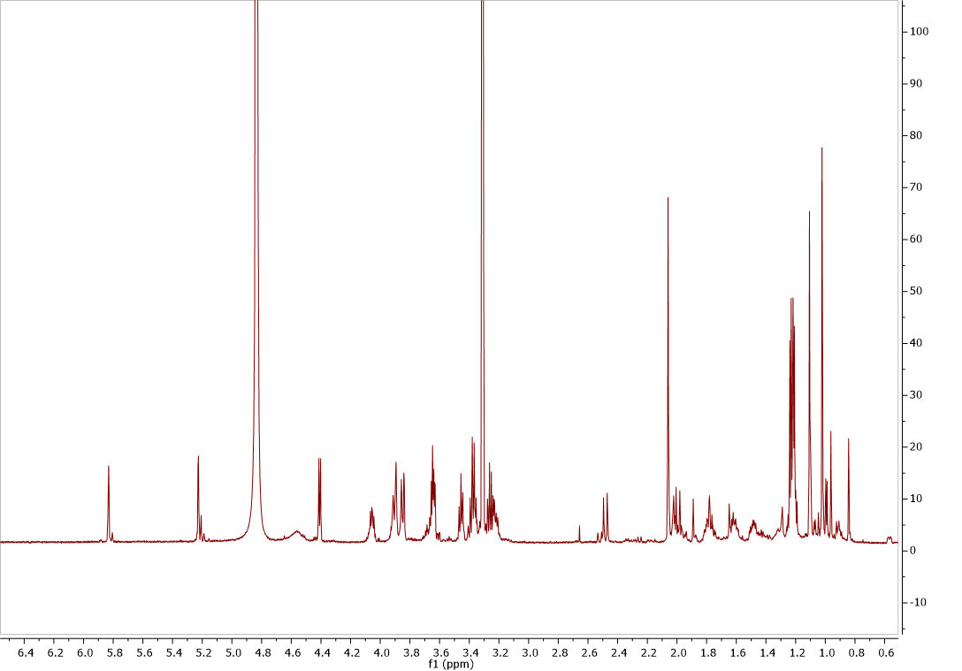
Figure 1. ¹H spectrum of 1
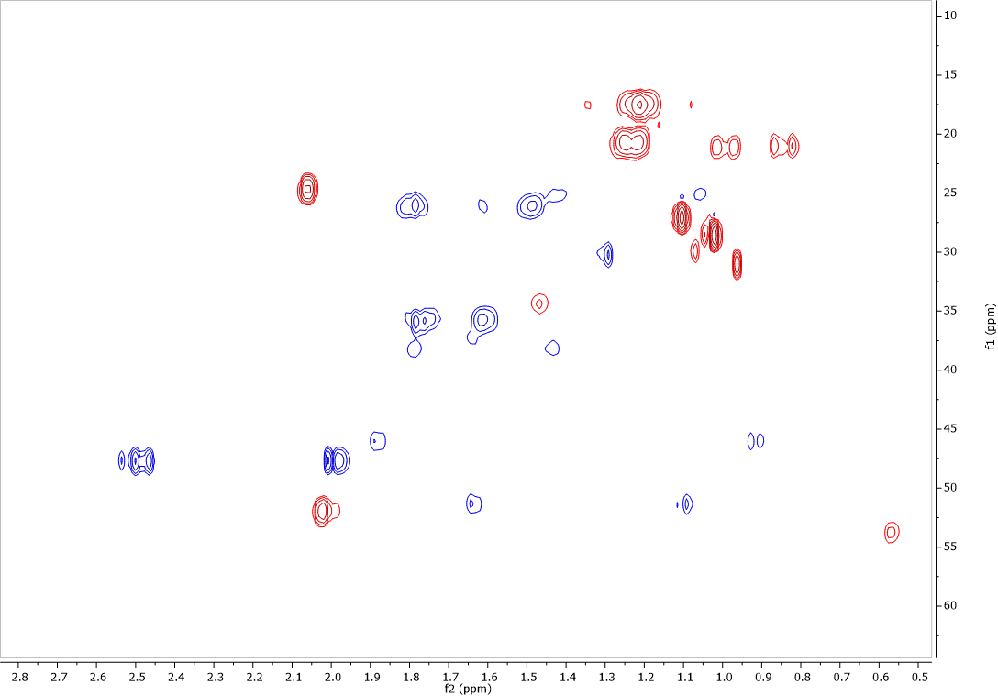
Figure 2. HSQC spectrum of 1
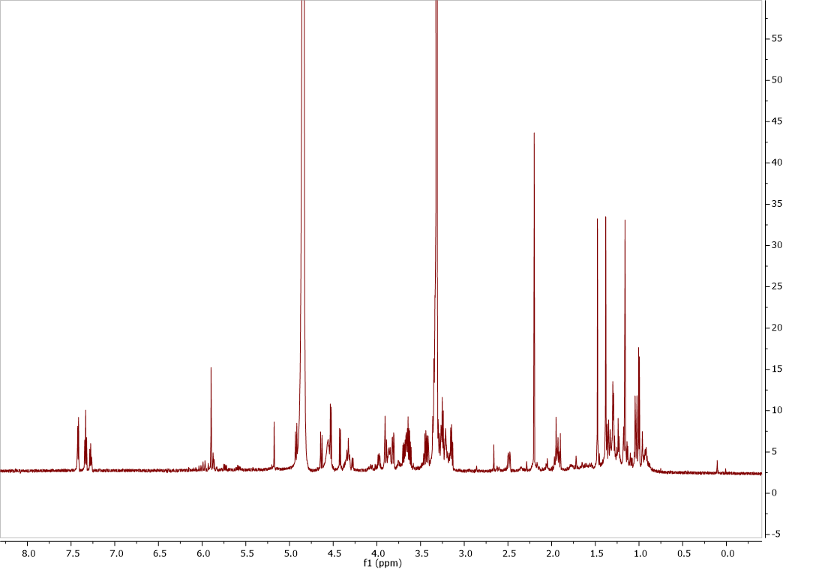
Figure 3. ¹H NMR spectrum of 2 and 3
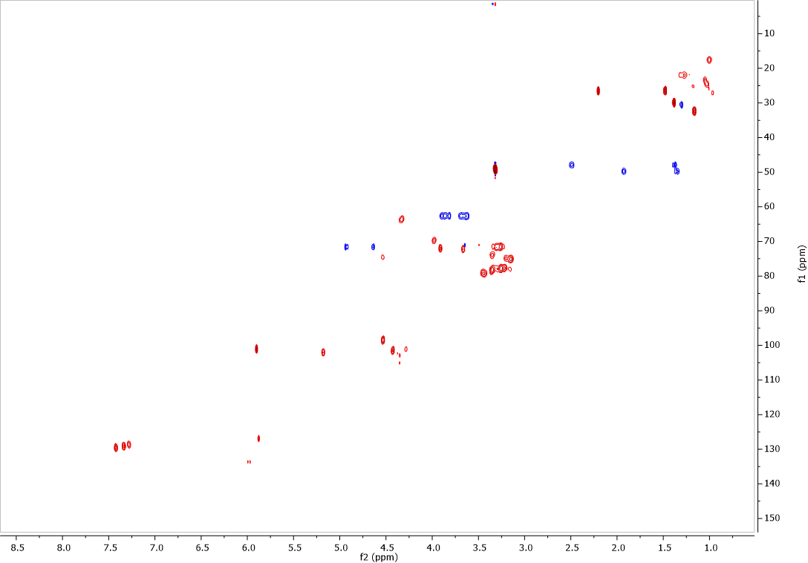
Figure 4. HSQC spectrum of 2 and 3

Figure S5. GC-MS chromatogram of identified megastigmane aglycones 10-13.

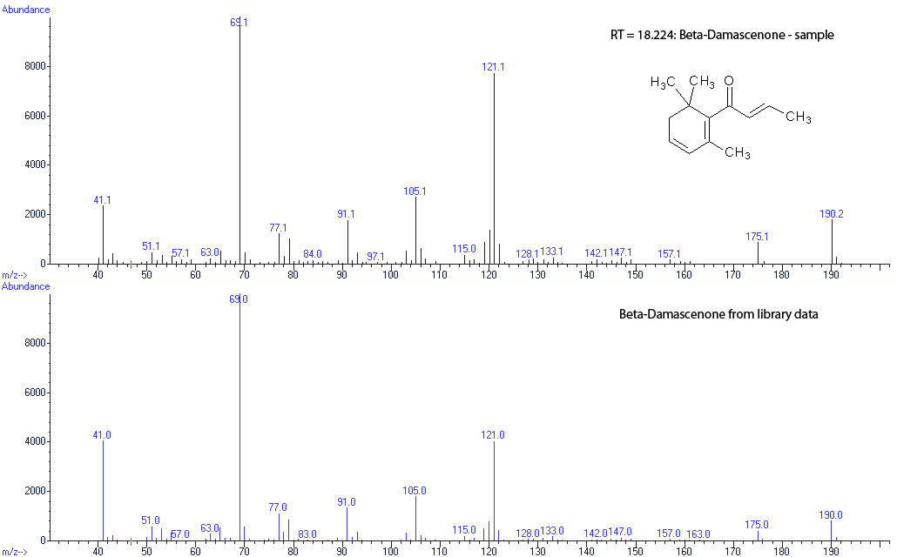
Figure S6. EI Mass spectrum (GC-MS) of β-damascenone (10) compared to library data
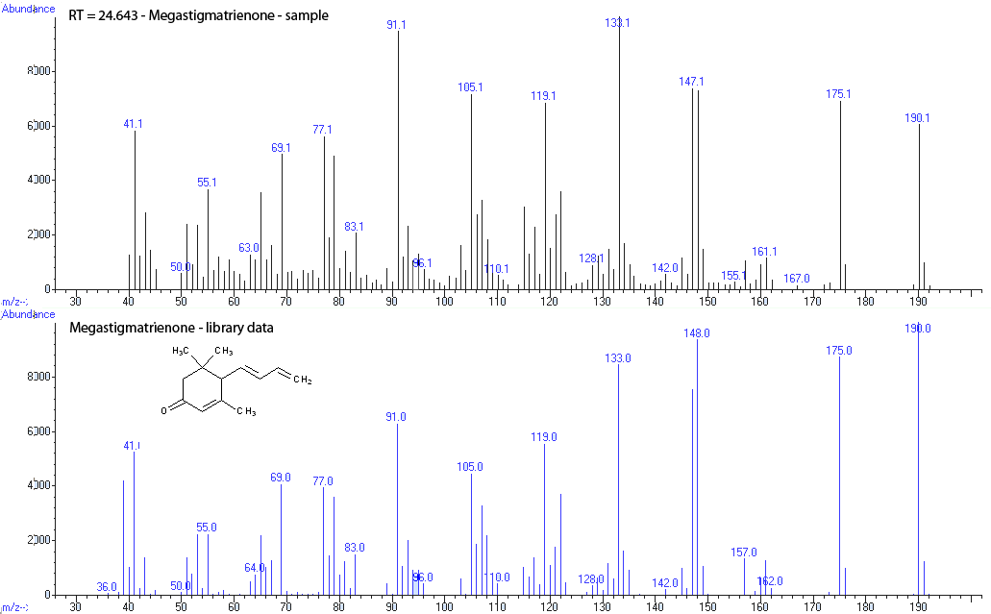
Figure S7. EI Mass spectrum (GC-MS) of megastigmatrienone (11) compared to library data
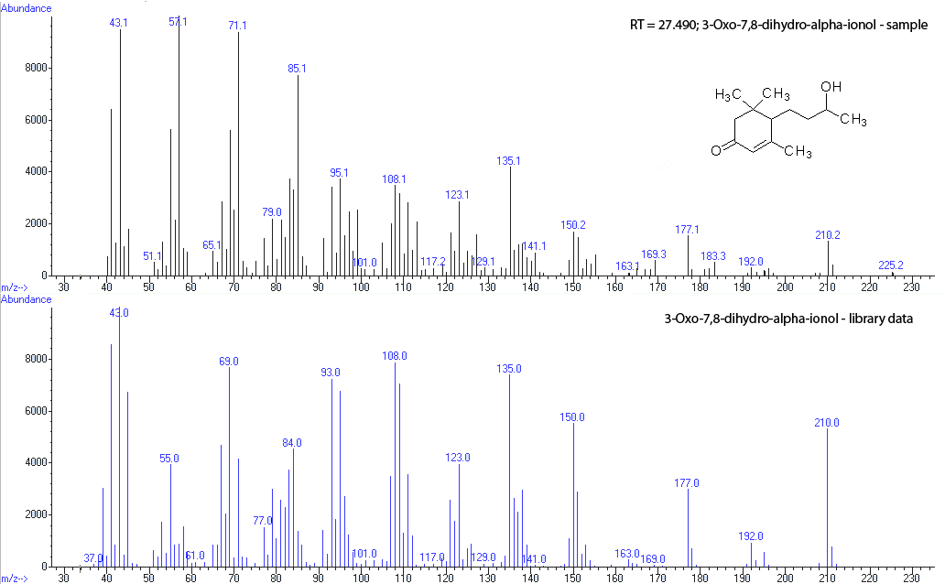
Figure S8. EI Mass spectrum (GC-MS) of 3-Oxo-7,8-dihydro-alpha-ionol (12) compared to library data
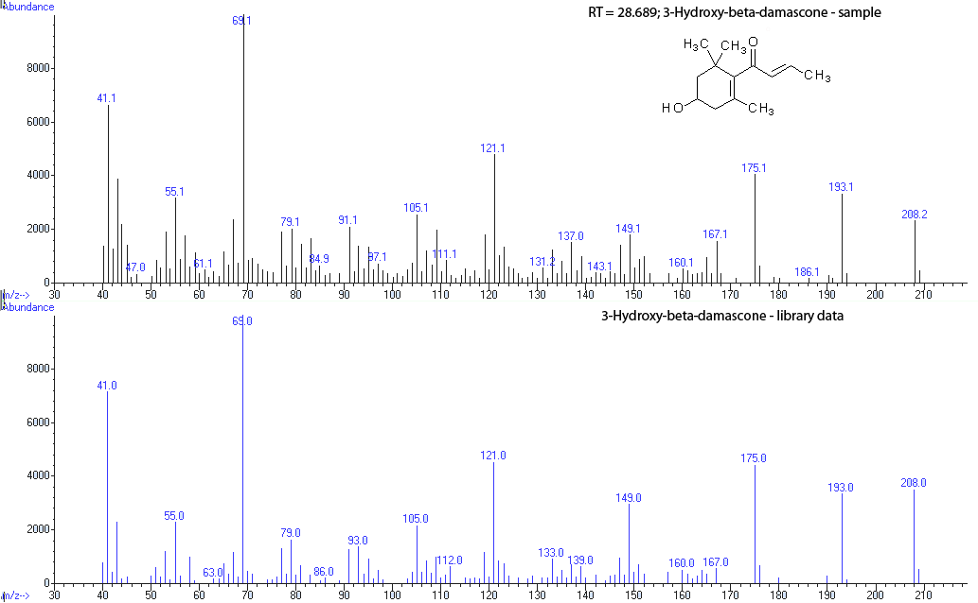
Figure S9. EI Mass spectrum (GC-MS) of 3-Hydroxy-beta-damascone (13) compared to library data
Table S1. NMR spectroscopic data [methanol-d₄, 599.85 MHz (¹H) and 150.84 MHz (¹³C), δ (ppm)] of 1 - 3
 | Gusanlungionoside C  (1) |  | Phenylmethyl-2-O-(6-O-rhamnosyl)-ß-D-galactopyranoside (2) |  | Citroside A  (3)
Position | δ_{C} | δ_{H} (J in Hz) | δ_{C} | δ_{H} (J in Hz) | δ_{C} | δ_{H} (J in Hz)
1 | 37.0, C | - | 138.4, C | - | 37.0, C | -
2 | 47.6, CH₂ | 2.50, 1.98 d (16 Hz) | 129.7, C | 7.42 (d; 7.6 Hz) | 49.7, C | 1.95, 1.36
3 | 202.0, C | - | 129.0, C | 7.33 (t; 7.5 Hz) | 63.5, C | 4.35
4 | 125.0, CH | 5.83 s | 128.7, C | 7.28 (t; 7.5 Hz) | 47.9, CH₂ | 2.50, 1.41
5 | 169.6, C | - | 129.0, C | 7.33 (t; 7.5 Hz) | 78.4, C | -
6 | 52.1, C | 2.02 m | 129.7, C | 7.42 (d; 7.6 Hz) | 118.9, C | -
7 | 26.1, CH₂ | 1.80, 1.48 m | 71.5, CH₂ | 4.64 (d; 11.3 Hz)  4.94 (d; 11.3 Hz) | n. d. | -
8 | 35.9, CH₂ | 1.78, 1.62 m |  |  | 101.1, CH | 5.90 s
9 | 75.1, CH | 3.90 m |  |  | 200.4, C | -
10 | 20.7, CH₃ | 1.23 d |  |  | 26.6, CH₃ | 2.20 s
11 | - | - |  |  | 32.4, CH₃ | 1.16 s
12 | - | - |  |  | 29.9, CH₃ | 1.40 s
13 | 24.8, CH₃ | 2.06 s |  |  | 26.4, CH₃ | 1.48 s
1´ | 100.5, CH | 4.40 d (7.8 Hz) | 101.6, CH | 4.42 (d; 7.2 Hz) | 98.6, CH | 4.53 (d; 7.7 Hz)
2´ | 78.3, CH | 3.37 m | 79.2, CH | 3.44 m | 75.1, CH | 3.15
3´ | 78.9, CH | 3.45 t | 77.6, CH | 3.29 m | 78.3, CH | 3.36
4´ | 71.6, CH | 3.26 m | 71.4, CH | 3.28 m | 71.6, CH | 3.26
5´ | 77.3, CH | 3.23 m | n. d. | n. d. | overlapped
6´ | 62.2, CH₂ | 3.84, 3.65 m | 62.6, CH₂ | 3.87, 3.68 m | overlapped
1´´ | 101.4, CH | 5.22 d (1.4 Hz) | 102.1, CH | 5.20 (s; brs)
2´´ | 71.7, CH | 3.90 m | 72.0, CH | 3.91 m
3´´ | 72.0, CH | 3.63 m | 72.2, CH | 3.68 m
4´´ | 73.5, CH | 3.38 m | 73.9, CH | 3.35 m
5´´ | 69.5, CH | 4.06 m | 69.6, CH | 3.98 m
6´´ | 17.5, CH₃ | 1.21 d (6 Hz) | 17.6, CH₃ | 1.00 (d; 6.6 Hz)

