**Supplementary Information**

**Nano-dispersed Ziegler-Natta catalysts for 1 µm-sized ultra-high molecular weight polyethylene particles**

**Patchanee Chammingkwan, Yusuke Bando, Minoru Terano, Toshiaki Taniike\***

Graduate School of Advanced Science and Technology, Japan Advanced Institute of Science and Technology, 1-1 Asahidai, Nomi, Ishikawa 923-1292, Japan

**\* Correspondence:**Toshiaki Taniike  
taniike@jaist.ac.jp

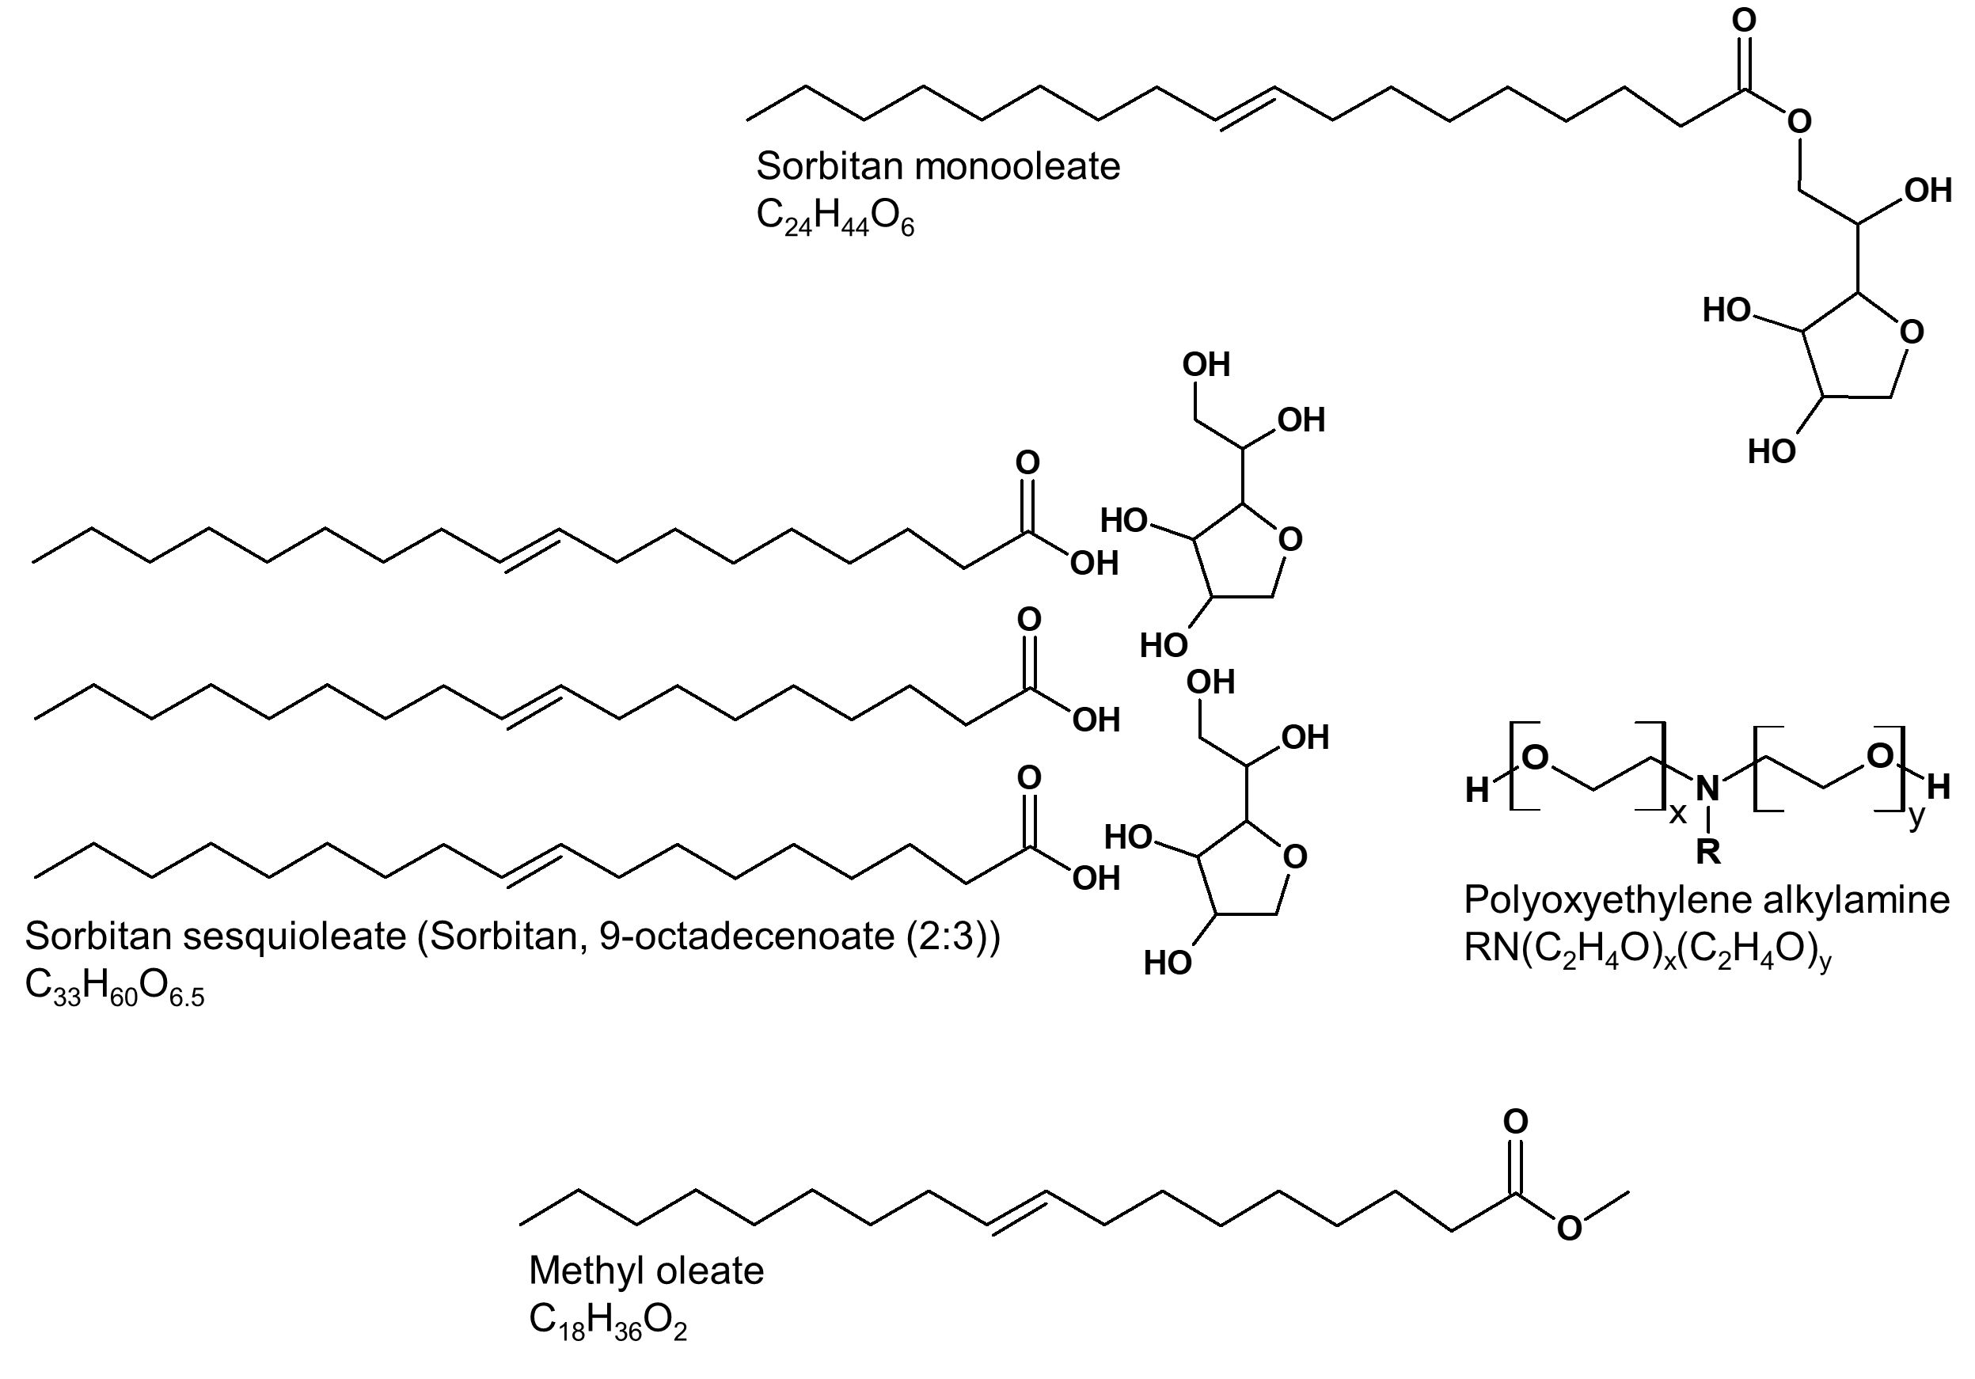

**Figure S1.** Chemical structures of organic modifiers.