Supplementary Data

Synthesis of flower-like AgI/BiOCOOH p-n heterojunctions with enhanced visible-light photocatalytic performance for the removal of toxic pollutants
Shijie Li^{1*}, Wei Jiang¹, Kaibing Xu²*, Shiwei Hu¹, Yu Liu¹, Yingtang Zhou¹, Jianshe Liu³

¹ Key Laboratory of key technical factors in Zhejiang seafood health hazards, Institute of Innovation & Application, Zhejiang Ocean University, Zhoushan, Zhejiang Province, 316022, China.
² State Key Laboratory for Modification of Chemical Fibers and Polymer Materials, Research Center for Analysis and Measurement, Donghua University, Shanghai, 201620, China
³ State Environmental Protection Engineering Center for Pollution Treatment and Control in Textile Industry, College of Environmental Science and Engineering, Donghua University, Shanghai 201620, China.

* Email address: lishijie@zjou.edu.cn (S. Li); xukaibing@dhu.edu.cn (K. Xu)

Table 1 BET surface areas of samples
Samples | BiOCOOH | S1 | S2 | S3 | S4
BET(m²g⁻¹) | 26.13 | 28.27 | 24.26 | 20.72 | 15.21

Figures

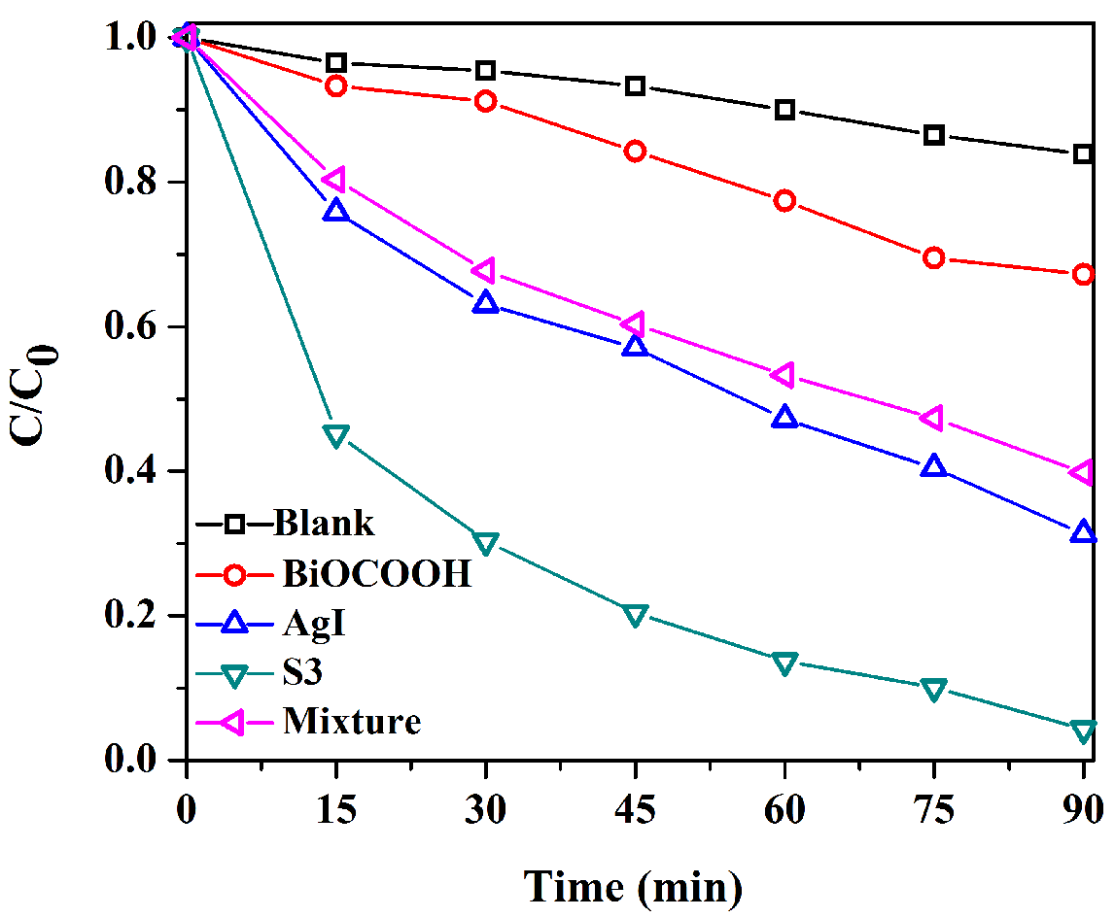
Figure S1. The MB degradation curves over different samples.

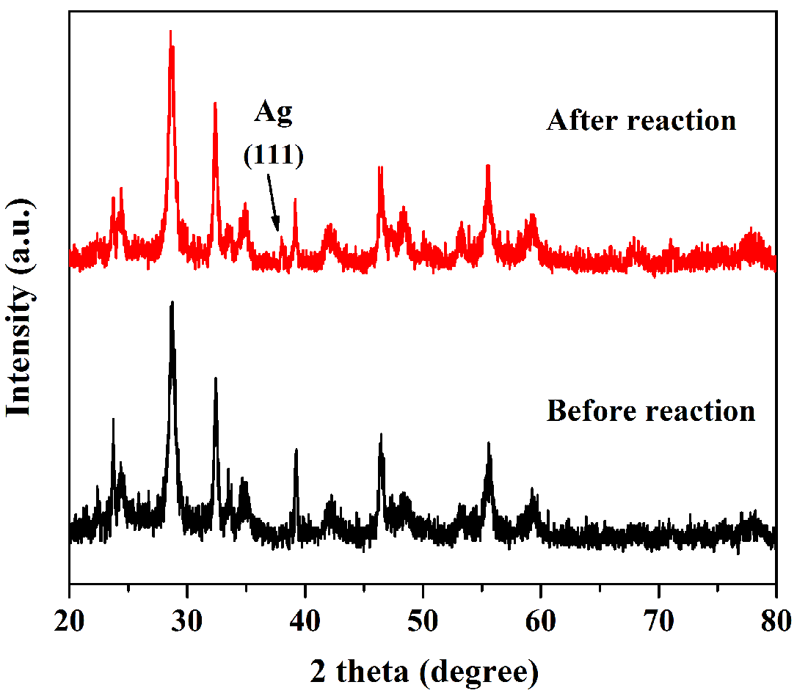
Figure S2. The XRD patterns of S3 before and after 6 successive runs.

