**Supplementary material**

**Frontiers in Microbiology**

**Environmental gradient shaped the vertical stratification of microbial community structure and potential function in** **permeable intertidal sediments, Gloucester Point**

Yiguo Hong1*, Jiapeng Wu1, Stephanie Wilson2 and Bongkeun Song2*

*1College of Environmental Science & Engineering, Guangzhou University, Guangzhou, 510006, P.R. China.*

*2Department of Biological Sciences, Virginia Institute of Marine Science College of William & Mary, Gloucester Point USA*

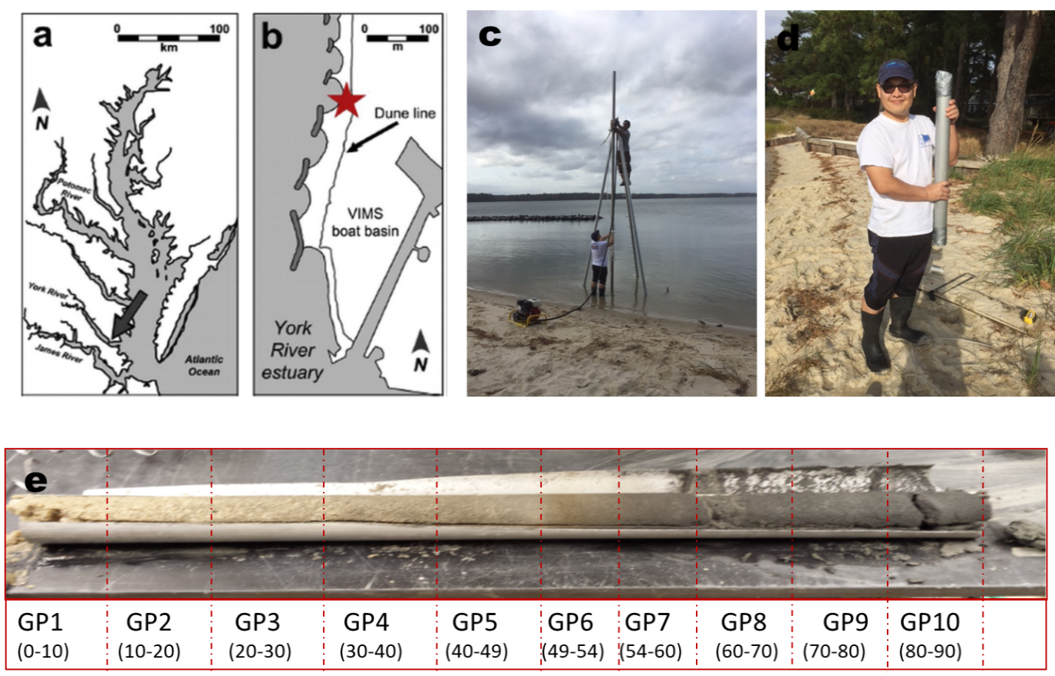

Fig.S1 The Gloucester Point site on the York River estuary (which drains to the Chesapeake Bay). (b) The study site is on VIMS beach. Sediment core were taken at the mid-tide line in the location indicated by the star. (c) and (d) are the scenes of working for sediment core collection. (d). Sediment core was fractioned into 10 subsamples.