Supplementary Material

Automated Detection of High-Frequency Oscillations in Epilepsy Based on a Convolutional Neural Network

Rui Zuo,1,2† Jing Wei,1,2† Xiaonan Li,3,4 Chunlin Li,1,2 Cui Zhao,1,2 Zhaohui Ren,1,2 Ying Liang,1,2 Xinling Geng,1,2 Chenxi Jiang,3,4 Xiaofeng Yang,3,4* and Xu Zhang1,2*

**\* Correspondence:**

Dr. Xiaofeng Yang

[xiaofengyang@yahoo.com](mailto:xiaofengyang@yahoo.com)

Dr. Xu Zhang

[zhangxu@ccmu.edu.cn](mailto:zhangxu@ccmu.edu.cn)

# Supplementary Figure

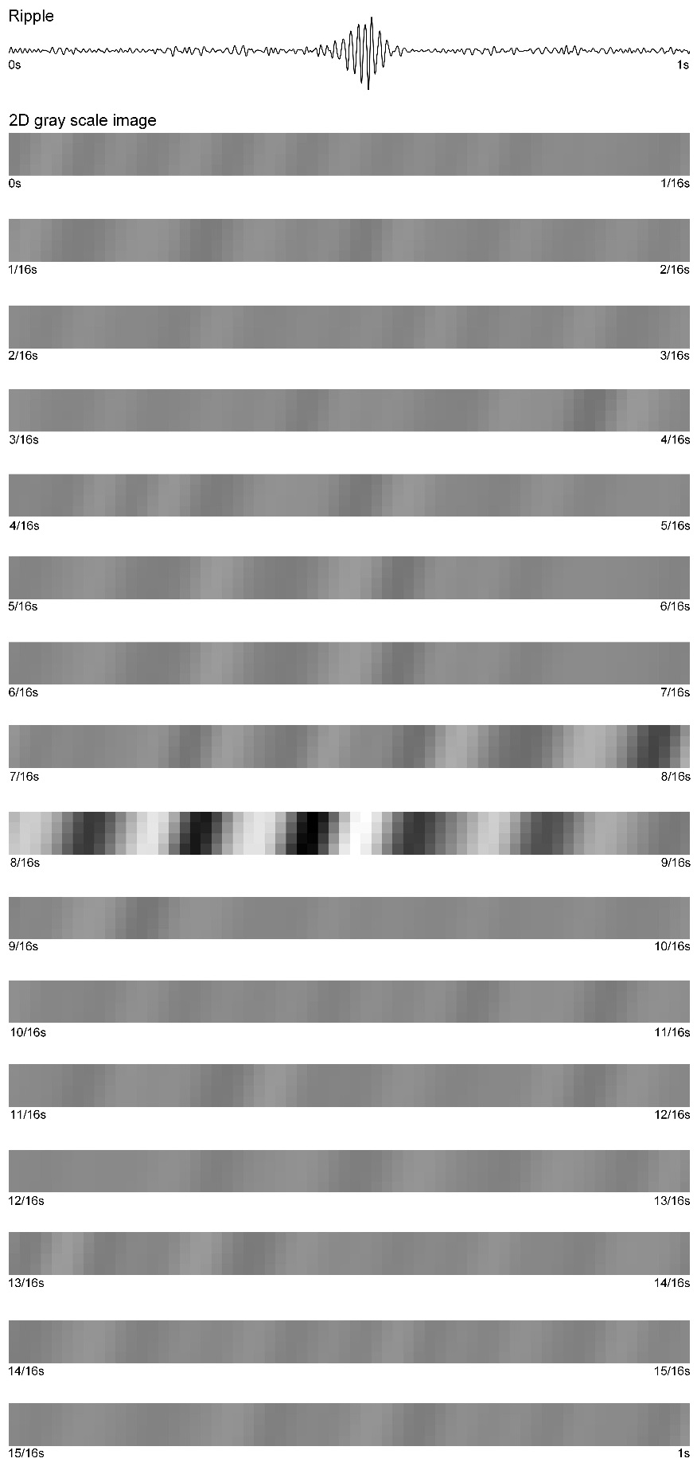

**Supplementary Figure 1.** First row: one second of filtered (80–200 Hz) data. A four-row grayscale image of one second is displayed on the second to last row.

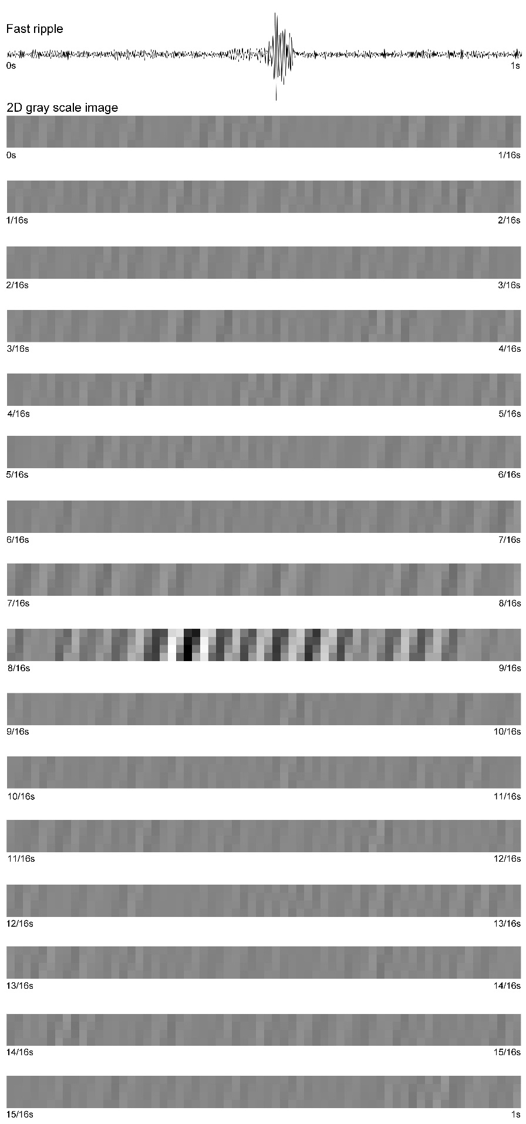

**Supplementary Figure 2.** First row: one second of filtered (200–500 Hz) data. A four-row grayscale image of one second is displayed on the second to last row.