Supplementary Material

Solute fluxes through restored prairie and intensively managed critical zones in Nebraska and Iowa

Ashlee Dere1*, Andrew Miller2, Amy Hemje2, Sara K. Parcher1, Courtney A. Capalli3, E. Arthur Bettis III3

**\* Correspondence:** Corresponding Author:adere@unomaha.edu

# Supplementary Figures and Tables

## Supplementary Figures

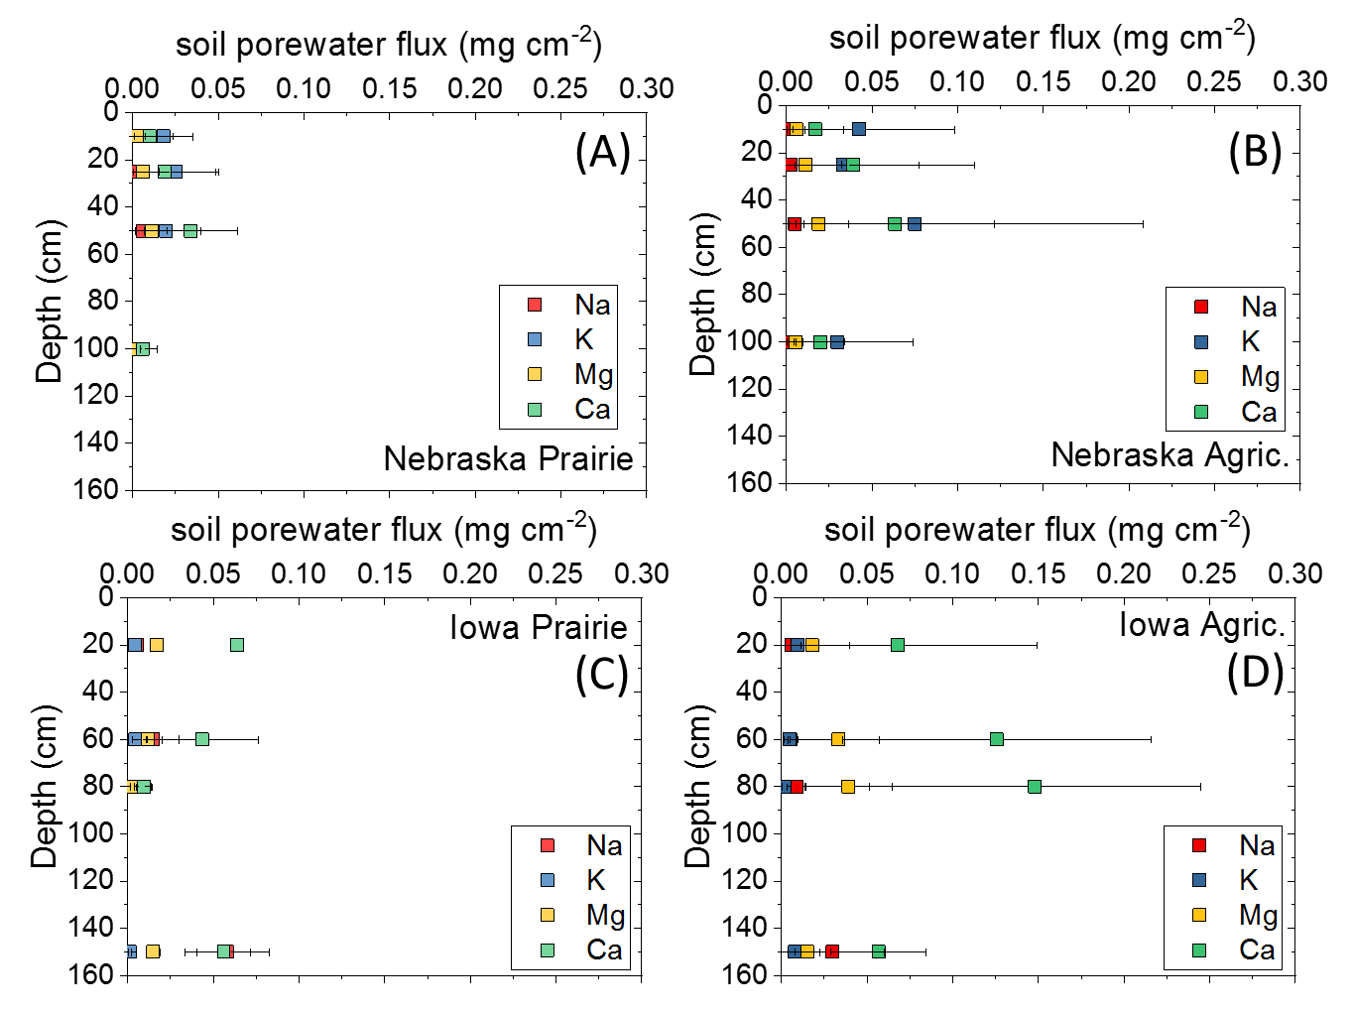

**Supplementary Figure 1.** Soil pore water average cation fluxes with depth in Nebraska (A, B) and Iowa (C, D) study sites. Error bars are standard deviations of the mean.

## Supplementary Tables

**Supplementary Table 1.** Nebraska agriculture soil pore water sampling location, depths, dates, pH, electrical conductivity (EC) and concentrations. A dash indicates variable was not measured and ND means that ion was never detected in sample. IGSN refers to International Geosample Number (www.sesar.org).



**Supplementary Table 1 (cont.).** Nebraska agriculture soil pore water sampling location, depths, dates, pH, electrical conductivity (EC) and concentrations. A dash indicates variable was not measured and ND means that ion was never detected in sample. IGSN refers to International Geosample Number (www.sesar.org).



**Supplementary Table 2.** Nebraska restored prairie soil pore water sampling depths, dates, pH, electrical conductivity (EC) and concentrations. A dash indicates variable was not measured and ND means that ion was never detected in sample. IGSN refers to International Geosample Number (www.sesar.org).



**Supplementary Table 2 (cont.).** Nebraska restored prairie soil pore water sampling depths, dates, pH, electrical conductivity (EC) and concentrations. A dash indicates variable was not measured and ND means that ion was never detected in sample. IGSN refers to International Geosample Number (www.sesar.org).



**Supplementary Table 3.** Iowa agriculture soil pore water sampling depths, dates, pH, electrical conductivity (EC) and concentrations. A dash indicates variable was not measured and ND means that ion was never detected in sample. IGSN refers to International Geosample Number (www.sesar.org).



**Supplementary Table 4.** Iowa restored prairie soil pore water sampling depths, dates, pH, electrical conductivity (EC) and concentrations. A dash indicates variable was not measured and ND means that ion was never detected in sample. IGSN refers to International Geosample Number (www.sesar.org).



**Supplementary Table 5.** Nebraska and Iowa precipitation sampling dates, pH, electrical conductivity (EC) and concentrations. Precipitation volumes were estimated using total precipitation between sampling dates measured by weather stations at each site and an estimated funnel sampling area of 78.5 cm2. A dash indicates variable was not measured (or volume could not be reliably estimated) and ND means that ion was never detected in sample. IGSN refers to International Geosample Number (www.sesar.org).



**Supplementary Table 6.** Nebraska GC2 stream sampling, dates, pH, electrical conductivity (EC) and concentrations. A dash indicates variable was not measured and ND means that ion was never detected in sample. IGSN refers to International Geosample Number (www.sesar.org).



**Supplementary Table 7.** Nebraska GC3 stream sampling, dates, pH, electrical conductivity (EC) and concentrations. A dash indicates variable was not measured and ND means that ion was never detected in sample. IGSN refers to International Geosample Number (www.sesar.org).



**Supplementary Table 8.** Nebraska GC4 stream sampling dates, pH, electrical conductivity (EC) and concentrations. A dash indicates variable was not measured and ND means that ion was never detected in sample. IGSN refers to International Geosample Number (www.sesar.org).



**Supplementary Table 9.** Nebraska GC5 stream sampling dates, pH, electrical conductivity (EC) and concentrations. A dash indicates variable was not measured and ND means that ion was never detected in sample. IGSN refers to International Geosample Number (www.sesar.org).



**Supplementary Table 10.** Nebraska GC6 stream sampling dates, pH, electrical conductivity (EC) and concentrations. A dash indicates variable was not measured and ND means that ion was never detected in sample. IGSN refers to International Geosample Number (www.sesar.org).



**Supplementary Table 11.** Drainage area, total discharge (Qtotal) on the day of sampling, estimated average monthly discharge (Q) for forks of the stream draining agriculture or prairie (determined by ion pairs before and after stream confluence), and monthly cation fluxes from streams draining prairie or agriculture at the Nebraska site. For months where discharge data were unreliable (August, September and October), average monthly flows for each fork were estimated by averaging July, August, and November monthly discharges (considered to represent baseflow conditions). ND means not detected.



**Supplementary Table 12.** Nebraska agriculture soil pore water cation and anion fluxes. A dash indicates variable was not measured and ND means that ion was never detected in sample. IGSN refers to International Geosample Number (www.sesar.org).



**Supplementary Table 13.** Nebraska restored prairie soil pore water cation and anion fluxes. A dash indicates variable was not measured and ND means that ion was never detected in sample. IGSN refers to International Geosample Number (www.sesar.org).



**Supplementary Table 14.** Iowa agriculture and restored prairie soil pore water cation and anion fluxes. A dash indicates variable was not measured and ND means that ion was never detected in sample. IGSN refers to International Geosample Number (www.sesar.org).



**Supplementary Table 15.** Annual average soil volumetric water content (VWC), and annual average soil electrical conductivity (EC) in Nebraska (NE) and Iowa (IA) agriculture and restored prairie study sites. Standard deviations are given in parentheses. A dash indicates variable was not measured. VWC and EC were significantly different (p < 0.05) at each depth between agriculture and prairie land use.

|  |  |  |  |
| --- | --- | --- | --- |
| Site | depth | VWC | EC |
| cm | m3 m-3 | mS cm-1 |
| NE Agriculture | 10 | 0.331 (0.078) | 0.272 (0.12) |
|  | 25 | 0.343 (0.058) | 0.331 (0.10) |
|  | 50 | 0.354 (0.031) | 0.362 (0.082) |
|  | 100 | 0.362 (0.029) | 0.428 (0.086) |
| NE Prairie | 10 | 0.249 (0.073) | 0.0932 (0.040) |
|  | 25 | 0.167 (0.045) | 0.167 (0.045) |
|  | 50 | 0.383 (0.039) | 0.275 (0.049) |
|  | 100 | 0.354 (0.047) | 0.311 (0.042) |
| IA Agriculture | 5 | 0.209 (0.054) | --- |
|  | 20 | 0.221 (0.039) | --- |
|  | 60 | 0.252 (0.061) | --- |
| IA Prairie | 5 | 0.280 (0.084) | 0.170 (0.070) |
|  | 20 | 0.325 (0.057) | 0.311 (0.081) |
|  | 60 | 0.351 (0.057) | 0.219 (0.036) |