Supplementary Material

Grass species flammability, not biomass, drives changes in fire behaviour at tropical forest-savanna transitions

Anabelle W. Cardoso\*1, Imma Oliveras1, Katharine Abernethy2,3, Kathryn J. Jeffery2,3,4, David Lehmann2, Josue Edzang Ndong4, Ian McGregor1, Claire M. Belcher5, William J. Bond6, Yadvinder Malhi1

1School of Geography and the Environment, U.Oxford, South Parks Road, Oxford, OX1 3QY, UK.

2Biological and Environmental Sciences, Faculty of Natural Sciences, U.Stirling, Stirling, FK9 4LA, UK.

3Institut de Recherche en Ecologie Tropicale, CENAREST, Libreville, BP843, Gabon.

4Agence Nationale des Parcs Nationaux, Libreville, BP20379, Gabon.

5wildFIRE Lab, Hatherly Laboratories, U.Exeter, Prince of Wales Road, Exeter, Devon, EX4 4PS, UK.

6Biological Sciences Department, U.Cape Town, Cape Town, 7700, South Africa.

**\* Correspondence:**Anabelle Williamson Cardoso  
anabellecardoso@gmail.com

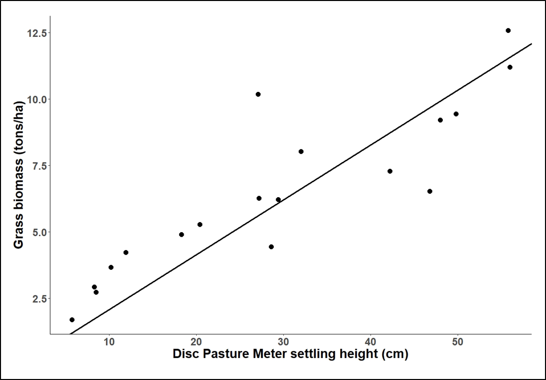Figure S1: Calibration of disc pasture meter (DPM) in the study site, Lopé National Park, Gabon. Each point represents one calibration plot. Each calibration plot was 1 m x 1 m, in which the mean of five DPM measurements (one in each corner and one in the middle of the plot) was associated with the clipped grass biomass of the plot (dry weight after drying to constant mass in oven). The line represents the calibration equation, where the intercept was set to zero: Grass biomass (tons.ha-1) = DPM height (cm) \* 0.2675 (linear model: p<0.0001, adjusted R2 = 0.94, F = 56.3, df = 17).

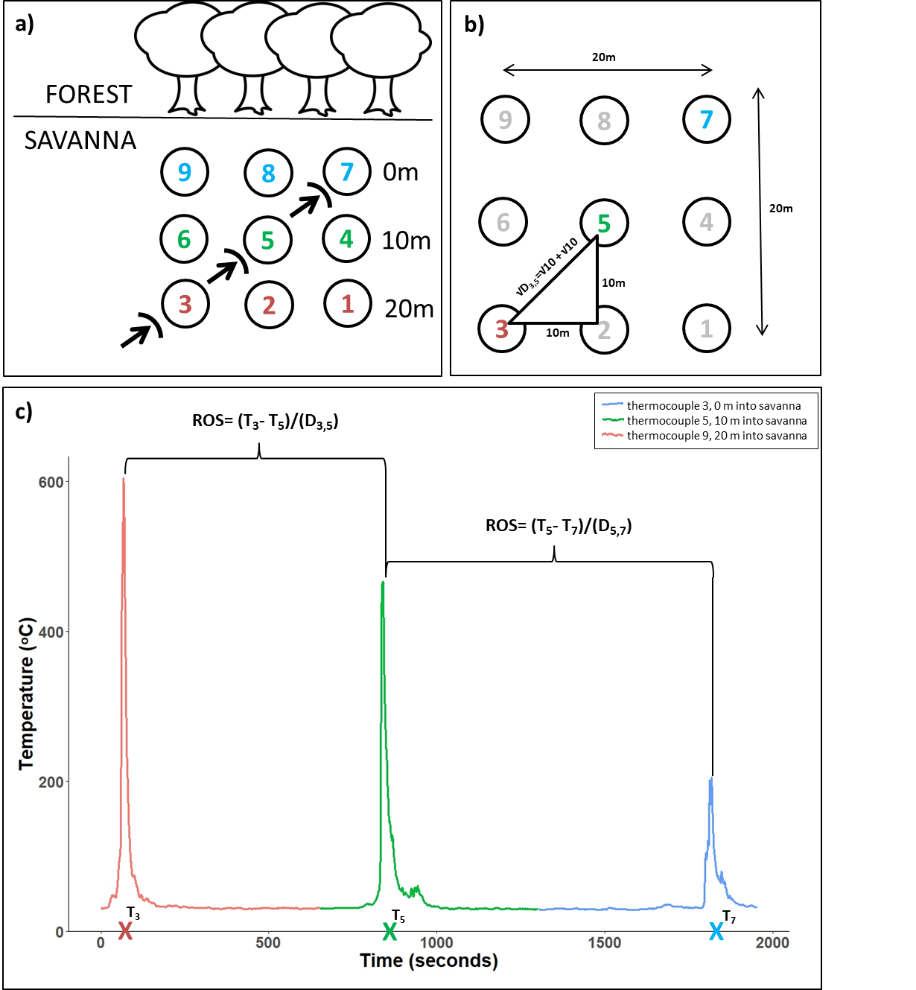Figure S2: The method for calculating rate of spread of the fire front using thermocouples. Rate of spread was determined using the formula: $ROS={T_{x}-T_{y}}/{D_{x, y}}$ where ROS is rate of spread (m.s-1), Tx and Ty are the times (seconds) that thermocouples x and y show their temperature peaks (ie. the time the fire front is assumed to cross the location of each thermocouple), with x being the first and y being the second thermocouple that the fire front passes, and Dx,y being the distance (m) between thermocouple x and y. In this example we calculate two rates of spread for one fire front, the ROS between thermocouples 3 and 5, and between thermocouples 5 and 7. Diagrams show: a) the layout of the thermocouples (labelled 1-9) within the savanna at varying distances (0, 10 and 20 m), and the movement of an approaching fire front (arrows) that crosses first thermocouple 3, then 5, then 7; b) calculation of the distance (D) between thermocouples 3 and 5; and c) calculation of the time that temperature peaks (T) for thermocouples 3, 5, and 7. In each transect, multiple rate of spread calculations could be performed. In this example, for instance, rate of spread could also be calculated between thermocouples 6 and 8, and between thermocouples 2 and 4.

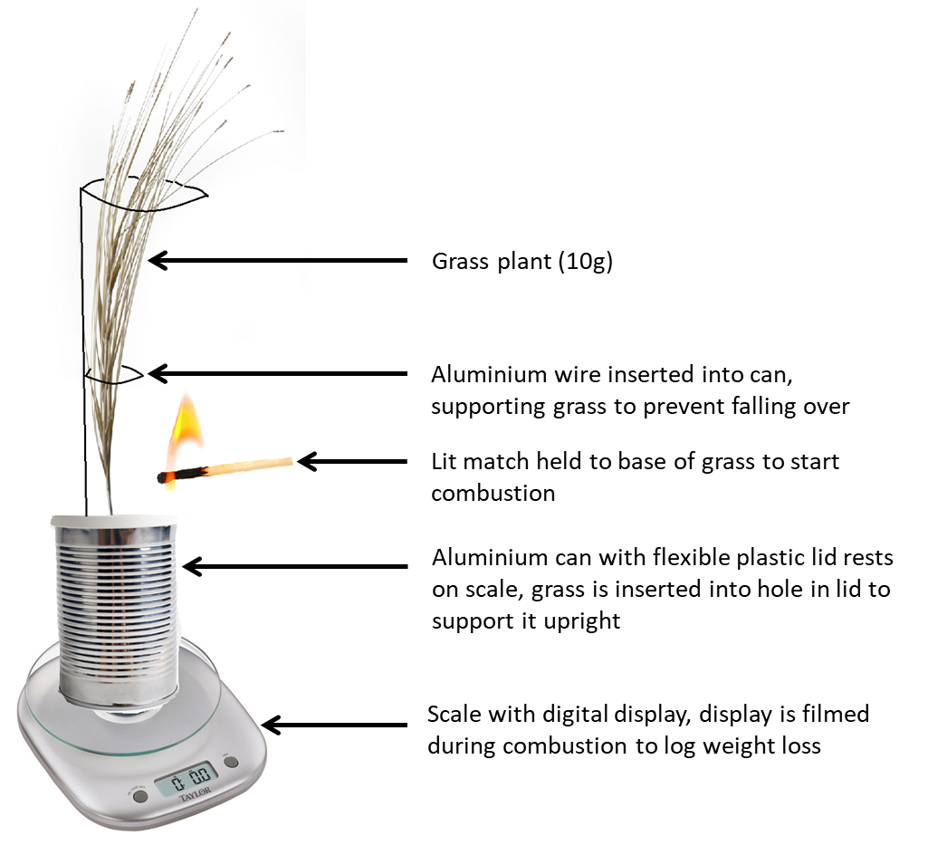Figure S3: Experimental set-up to test plant-scale maximum combustion rate of each grass species.

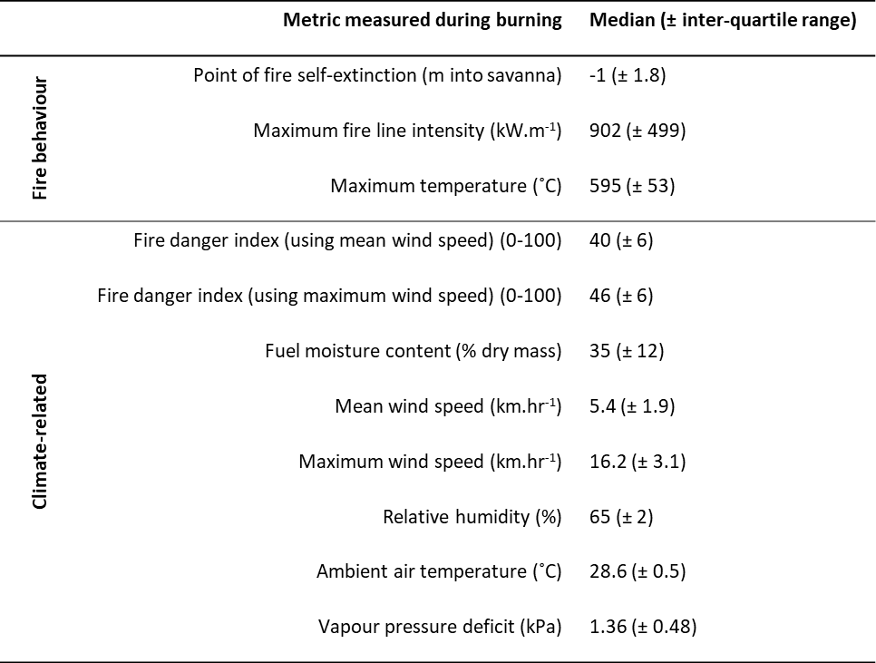Table S1: Fire behaviour and climate-related metrics measured during burning of 18 forest-savanna transition transect sites.

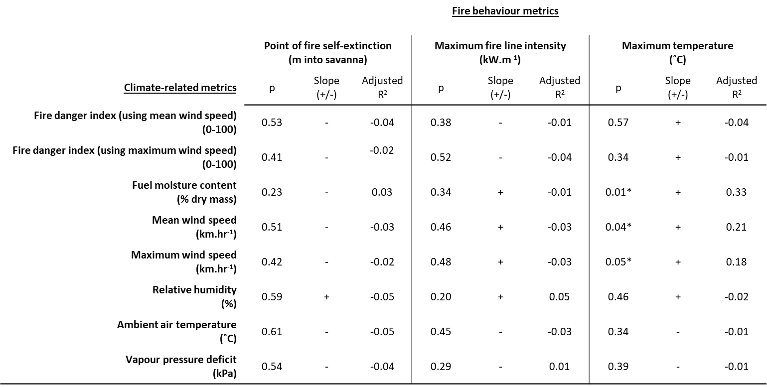Table S2: Linear models where fire behaviour metrics were examined as a function of climate-related metrics. Significant effects (p<0.05) are marked with an \*. With the exception of fuel moisture content and mean and maximum wind speed on maximum temperature, no significant effects of climate-related metrics on fire behaviour metrics were found.

