Supplementary Material
Problem-based learning could tackle the issue of insufficient education and adherence in people living with HIV/AIDS
Yang Zhang, PhD, MD ^{1, 2, 3, 4}, Guangyong Xu, MD³, Jianhua Hou, MS¹, Peirong Shi, MD³, Suhua Chang, PhD⁵, Amos Wu, MS⁶, Aixin Song, BS^{1, 4}, Meixia Gao, BS¹, Xiangpu Cheng, MD ⁷, Dan Cui, MD ⁷, Hao Wu, MD^{1, 4}, Xiaojie Huang, MD^{1,} *, Jie Shi, PhD, MD^{2, 8,} *
¹Center for Infectious Diseases, Beijing You'an Hospital, Capital Medical University, Beijing 100069, China.
²National Institute on Drug Dependence, Peking University, Beijing 100191, China
³Qingdao Infectious Diseases Hospital, Qingdao 266000, China
⁴Beijing Key Laboratory of AIDS Research, Beijing 100069, China
⁵Institute of Mental Health/Peking University Sixth Hospital and Key Laboratory of Mental Health, Peking University, Beijing 100191, China
⁶The Aaron Diamond AIDS Research Center, The Rockfeller University, New York, NY, 10016, United States
⁷Education Department, Beijing You'an Hospital, Capital Medical University, Beijing 100069, China.
⁸Beijing Key Laboratory on Drug Dependence Research, Beijing 100191, China

*Correspondence:
Prof. Jie Shi, National Institute on Drug Dependence, Peking University, 38 Xueyuan Road, Haidian District, Beijing 100191, China. Email: shijie@bjmu.edu.cn
or
Dr. Xiaojie Huang, Center for Infectious Diseases, Beijing You'an Hospital, Capital Medical University, 8 Youanmenwaixitoutiao, Fengtai District, Beijing, 100069, China. Email: huangxiaojie78@126.com

Figure S1 Flow diagram of this study. Note: PBL: problem-based learning.
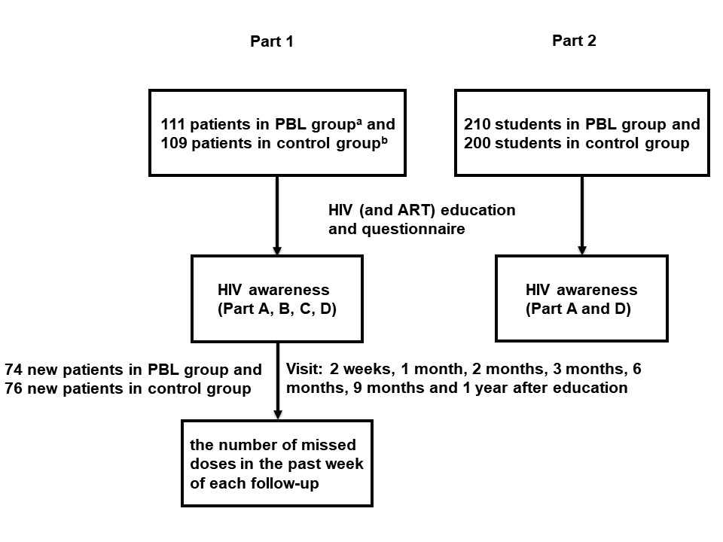

TABLE S1 Linear regression model for baseline factors correlated with ART adherence of other times visit
Visit | Model 1 |  |  | Model 2 |  |  | Model 3
Visit | Estimate | t | P | Estimate | t | P | Estimate | t | P
1 month
HIV education method | 0.141 | 1.676 | 0.096 | 0.162 | 1.859 | 0.065 | N.A. | N.A. | N.A.
Age | 0.054 | 0.642 | 0.522 | 0.064 | 0.751 | 0.454 | 0.042 | 0.489 | 0.626
Gender | -0.069 | -0.833 | 0.406 | -0.074 | -0.892 | 0.374 | -0.062 | -0.744 | 0.458
CD4⁺T cell counts | 0.059 | 0.683 | 0.496 | 0.054 | 0.623 | 0.534 | 0.032 | 0.374 | 0.709
AIDS questionnaire score | N.A. | N.A. | N.A. | 0.079 | 0.915 | 0.362 | 0.036 | 0.426 | 0.671
Compound sulfamethoxazole | -0.029 | -0.318 | 0.751 | -0.035 | -0.373 | 0.71 | -0.065 | -0.709 | 0.48
Times daily medication of ART | 0.205 | 2.337 | 0.021* | 0.199 | 2.259 | 0.025* | 0.211 | 2.379 | 0.019*
2 months
HIV education method | 0.12 | 1.404 | 0.162 | 0.093 | 1.051 | 0.295 | N.A. | N.A. | N.A.
Age | -0.002 | -0.025 | 0.98 | -0.014 | -0.165 | 0.869 | -0.027 | -0.317 | 0.752
Gender | 0.084 | 0.995 | 0.321 | 0.091 | 1.07 | 0.287 | 0.098 | 1.154 | 0.25
CD4⁺T cell counts | -0.001 | -0.015 | 0.988 | 0.005 | 0.056 | 0.955 | -0.007 | -0.085 | 0.932
AIDS questionnaire score | N.A. | N.A. | N.A. | -0.098 | -1.12 | 0.265 | -0.123 | -1.457 | 0.147
Compound sulfamethoxazole | -0.082 | -0.876 | 0.383 | -0.076 | -0.806 | 0.421 | -0.093 | -1.009 | 0.315
Times daily medication of ART | 0.079 | 0.889 | 0.376 | 0.087 | 0.972 | 0.333 | 0.094 | 1.05 | 0.295
3 months
HIV education method | 0.123 | 1.444 | 0.151 | 0.04 | 0.47 | 0.639 | N.A. | N.A. | N.A.
Age | 0.116 | 1.353 | 0.178 | 0.078 | 0.943 | 0.347 | 0.073 | 0.888 | 0.376
Gender | -0.079 | -0.943 | 0.347 | -0.059 | -0.734 | 0.464 | -0.056 | -0.702 | 0.484
CD4⁺T cell counts | -0.072 | -0.831 | 0.407 | -0.053 | -0.632 | 0.528 | -0.058 | -0.703 | 0.483
AIDS questionnaire score | N.A. | N.A. | N.A. | -0.303 | -3.627 | < 0.001* | -0.313 | -3.91 | < 0.001*
Compound sulfamethoxazole | -0.095 | -1.017 | 0.311 | -0.075 | -0.837 | 0.404 | -0.083 | -0.938 | 0.35
Times daily medication of ART | 0.049 | 0.55 | 0.583 | 0.072 | 0.848 | 0.398 | 0.075 | 0.887 | 0.377
6 months
HIV education method | 0.096 | 1.127 | 0.261 | 0.069 | 0.785 | 0.434 | N.A. | N.A. | N.A.
Age | -0.066 | -0.774 | 0.44 | -0.078 | -0.909 | 0.365 | -0.088 | -1.032 | 0.304
Gender | 0.039 | 0.465 | 0.642 | 0.046 | 0.541 | 0.59 | 0.051 | 0.604 | 0.547
CD4⁺T cell counts | -0.17 | -1.952 | 0.053 | -0.163 | -1.878 | 0.062 | -0.172 | -2.004 | 0.047
AIDS questionnaire score | N.A. | N.A. | N.A. | -0.097 | -1.118 | 0.265 | -0.116 | -1.383 | 0.169
Compound sulfamethoxazole | -0.018 | -0.196 | 0.845 | -0.012 | -0.127 | 0.899 | -0.025 | -0.271 | 0.786
Times daily medication of ART | -0.004 | -0.048 | 0.962 | 0.003 | 0.037 | 0.97 | 0.008 | 0.094 | 0.925
9 months
HIV education method | 0.079 | 0.932 | 0.353 | 0.023 | 0.26 | 0.796 | N.A. | N.A. | N.A.
Age | 0.119 | 1.39 | 0.167 | 0.093 | 1.098 | 0.274 | 0.09 | 1.076 | 0.284
Gender | -0.063 | -0.753 | 0.453 | -0.05 | -0.6 | 0.55 | -0.048 | -0.583 | 0.561
CD4⁺T cell counts | -0.08 | -0.915 | 0.362 | -0.066 | -0.774 | 0.441 | -0.069 | -0.818 | 0.415
AIDS questionnaire score | N.A. | N.A. | N.A. | -0.207 | -2.422 | 0.017* | -0.213 | -2.597 | 0.01*
Compound sulfamethoxazole | -0.112 | -1.198 | 0.233 | -0.098 | -1.069 | 0.287 | -0.103 | -1.136 | 0.258
Times daily medication of ART | 0.105 | 1.179 | 0.24 | 0.121 | 1.38 | 0.17 | 0.123 | 1.407 | 0.161
1 year
HIV education method | 0.139 | 1.622 | 0.107 | 0.027 | 0.331 | 0.741 | N.A. | N.A. | N.A.
Age | -0.004 | -0.052 | 0.959 | -0.055 | -0.688 | 0.493 | -0.059 | -0.744 | 0.458
Gender | -0.061 | -0.718 | 0.474 | -0.034 | -0.434 | 0.665 | -0.032 | -0.411 | 0.682
CD4⁺T cell counts | -0.008 | -0.093 | 0.926 | 0.018 | 0.222 | 0.824 | 0.014 | 0.18 | 0.857
AIDS questionnaire score | N.A. | N.A. | N.A. | -0.408 | -5.04 | < 0.001* | -0.415 | -5.343 | < 0.001*
Compound sulfamethoxazole | -0.062 | -0.657 | 0.512 | -0.035 | -0.403 | 0.688 | -0.04 | -0.471 | 0.639
Times daily medication of ART | 0.029 | 0.329 | 0.743 | 0.061 | 0.739 | 0.461 | 0.063 | 0.767 | 0.444
Note: Note: A series of multivariable linear regression models were used to assess the effect of PBL or awareness of HIV on ART adherence after adjustment for potential confounders. In model 1, only study sample (PBL group compared with control group), age, gender, CD4+T cell counts were included. Besides potential factors included in model 1, the AIDS questionnaire score was also included in model 2. Model 3 was identical to model 2 except in education form. ART: antiretroviral therapy; N.A.: not applicable.

