Supplementary Material

Herpes simplex virus type 2 immediate early protein ICP27 inhibits IFN-β production in mucosal epithelial cells by antagonizing IRF3 activation
Xinmeng Guan^{1,2}, Mudan Zhang³, Ming Fu^{1,2}, Sukun Luo⁴, Qinxue Hu^{1,5}
¹ State Key Laboratory of Virology, Wuhan Institute of Virology, Chinese Academy of Sciences, Wuhan, China
² University of Chinese Academy of Sciences, Beijing, China
³The Joint Center of Translational Precision Medicine, Guangzhou Institute of Pediatrics, Guangzhou Women and Children’s Medical Center, Wuhan Institute of Virology, Chinese Academy of Science, Wuhan, China,
⁴Wuhan Children's Hospital (Wuhan Maternal and Child Healthcare Hospital, Tongji Medical College, Huazhong University of Science & Technology, Wuhan, China
⁵Institute for Infection and Immunity, St George’s University of London, London, UK

* Correspondence:
Dr. Qinxue Hu: qhu@wh.iov.cn; Dr. Mudan Zhang: mudan@wh.iov.cn

Supplementary Table.1. Primers used in the study
ICP27-Flag-F | GGCCAAGCTTATGGATTACAAGGATGACGACGATAAGGCTACCGACATTGATATGCT
ICP27-HA-F | GAATTAGGATCCATGTACCCATACGACGTCCCAGACTACGCTGCTACCGACATTGATA
ICP27-Flag-F | GGCCAAGCTTATGGATTACAAGGATGACGACGATAAGGCTACCGACATTGATATGCT
ICP27_{1-138aa}-R | TATAGGATCCCTATCGGGGATGCGGTGCCTTG
ICP27_{1-152aa}-R | AATTAAGGATCCCTAGCCGTATCGACCCCGGCCCC
ICP27_{1-302aa}-R | TTAAGGATCCCTACCCCCCCGCTTGGGTGG
ICP27-R | TATAGGATCCCTAAAATAGGGAGTTGCAGTAGAA
ifnb-F | CAAATTGCTCTCCTGTTGTGCTTC
ifnb-R | AATGCGGCGTCCTCCTTCT
gapdh-F | GGGAAGCTCACTGGCATGG
gapdh-R | TTACTCCTTGGAGGCCATGT
ifit1-F | CCTCCTTGGGTTCGTCTACA
ifit1-R | GGCTGATATCTGGGTGCCTA
isg15-F | GAGAGGCAGCGAACTCATCTT
isg15-R | CCAGCATCTTCACCGTCAGG
cxcl10-F | GCTCTACTGAGGTGCTATGTTC
cxcl10-R | GGAGGATGGCAGTGGAAGTC
Neg-sense | UUC UCC GAA CGU GUC ACG UTT
Neg-anti | ACG UGA CAC GUU CGG AGA ATT
ICP27 siRNA1-sense | GCG UGU CGG AGA UCG ACU ATT
ICP27 siRNA1-anti | UAG UCG AUC UCC GAC ACG CCG
ICP27 siRNA2-sense | GGC GGG UCU CAU UGA AAU ATT
ICP27 siRNA2-anti | UAU UUC AAU GAG ACC CGC CAT

Supplementary Figures

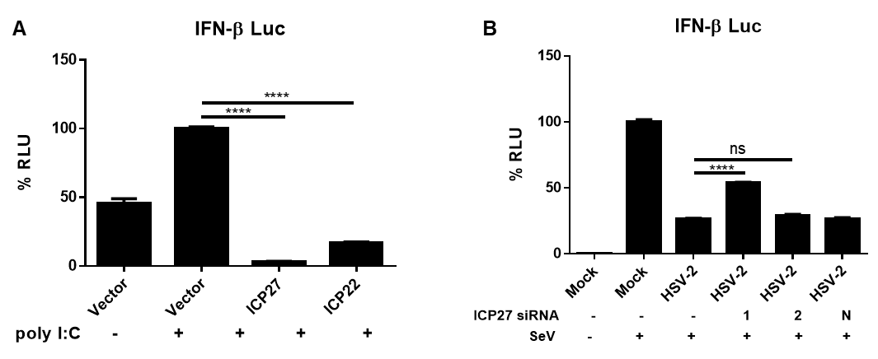
Supplementary Figure 1. HSV-2 ICP27 inhibits IFN-β induction in ME180 cells. (A) HSV-2 inhibits the Poly(I:C)-induced activation of IFN-β promoter. ME180 cells were seeded in 6-well plates and co-transfected with empty vector pcDNA3.1(+), plasmid expressing HSV-2 ICP27 or ICP22, together with the reporter plasmid p125-Luc and the internal control phRL-TK. At 24 h post-transfection, cells were transfected with 2 µg/well Poly(I:C) or mock-transfected for 16 h, and lysed for DLR assay. Data shown are mean ± SD of three independent experiments. ****P<0.0001. (B) Knockdown of ICP27 reduces the capability of HSV-2 in inhibiting IFN-β promoter activation. ME180 cells were seeded in 6-well plates and co-transfected with HSV-2 ICP27 siRNA-1, siRNA-2, or negative control siRNA (N), together with the reporter plasmid p125-Luc and the internal control phRL-TK. At 4 h post-transfection, cells were infected with HSV-2 at an MOI of 0.5 or mock-infected. At 20 h.p.i, cells were stimulated with or without 100 HAU ml⁻¹ SeV for 16 h, and lysed for DLR assay. The data shown are representative of three independent experiments, with each condition performed in triplicate (mean ± SD). ****P<0.0001.
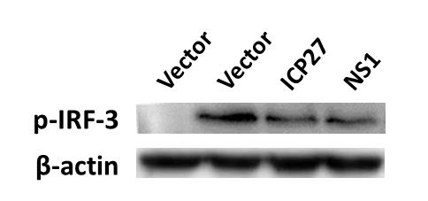
Supplementary Figure 2. HSV-2 ICP27 inhibits IRF3 phosphorylation. HEK 293T cells were seeded in 6-well plates and transfected with pcDNA3.1(+), plasmid expressing HSV-2 ICP27 or influenza virus NS1. At 24 h post-transfection, cells were stimulated with or without 100 HAU ml⁻¹ SeV for 16 h. Cells were lysed and phosphorylated IRF3 was detected with a p-IRF3 mAb.
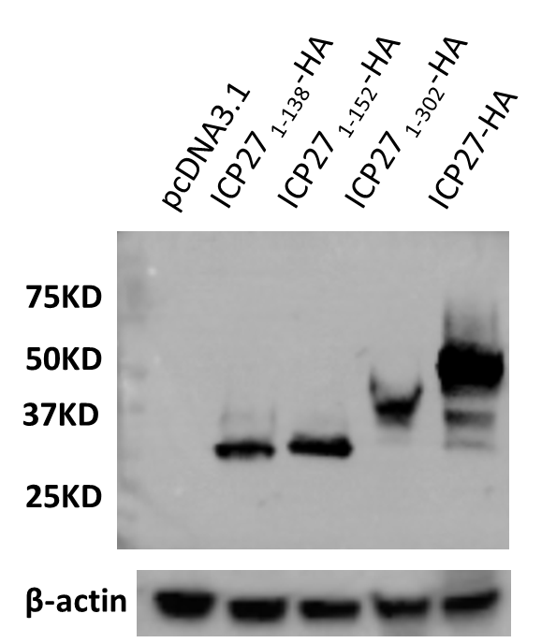
Supplementary Figure 3. The expression of HSV-2 ICP27 mutants. HEK 293T cells were transfected with empty vector pcDNA3.1(+), truncated or full-length HSV-2 ICP27 expression plasmid, followed by stimulation with or without 100 HAU ml⁻¹ SeV for 16 h, and cells were lysed for Western Blot.

