Supplementary materials
Molecular characterization of a chrysovirus isolated from the citrus pathogen Penicillium crustosum and related fungicide resistance analysis
Shengqiang Wang^{1*}, Zhu Yang^{1*}, Tingfu Zhang^{1*}, Na Li², Qianwen Cao¹, Guoqi Li¹, Yongze Yuan^{1**}, Deli Liu^{1**}
¹Hubei Key Laboratory of Genetic Regulation and Integrative Biology, School of Life Sciences, Central China Normal University, Wuhan 430079, P.R.China
²College of Life Science and Technology, Honghe University, Mengzi, 661199, P.R.China
*These authors contributed equally to this work.
**Correspondence: Yongze Yuan (yuan_yongze@163.com) and Deli Liu (ldl@mail.ccnu.edu.cn; deliliu2013@163.com).

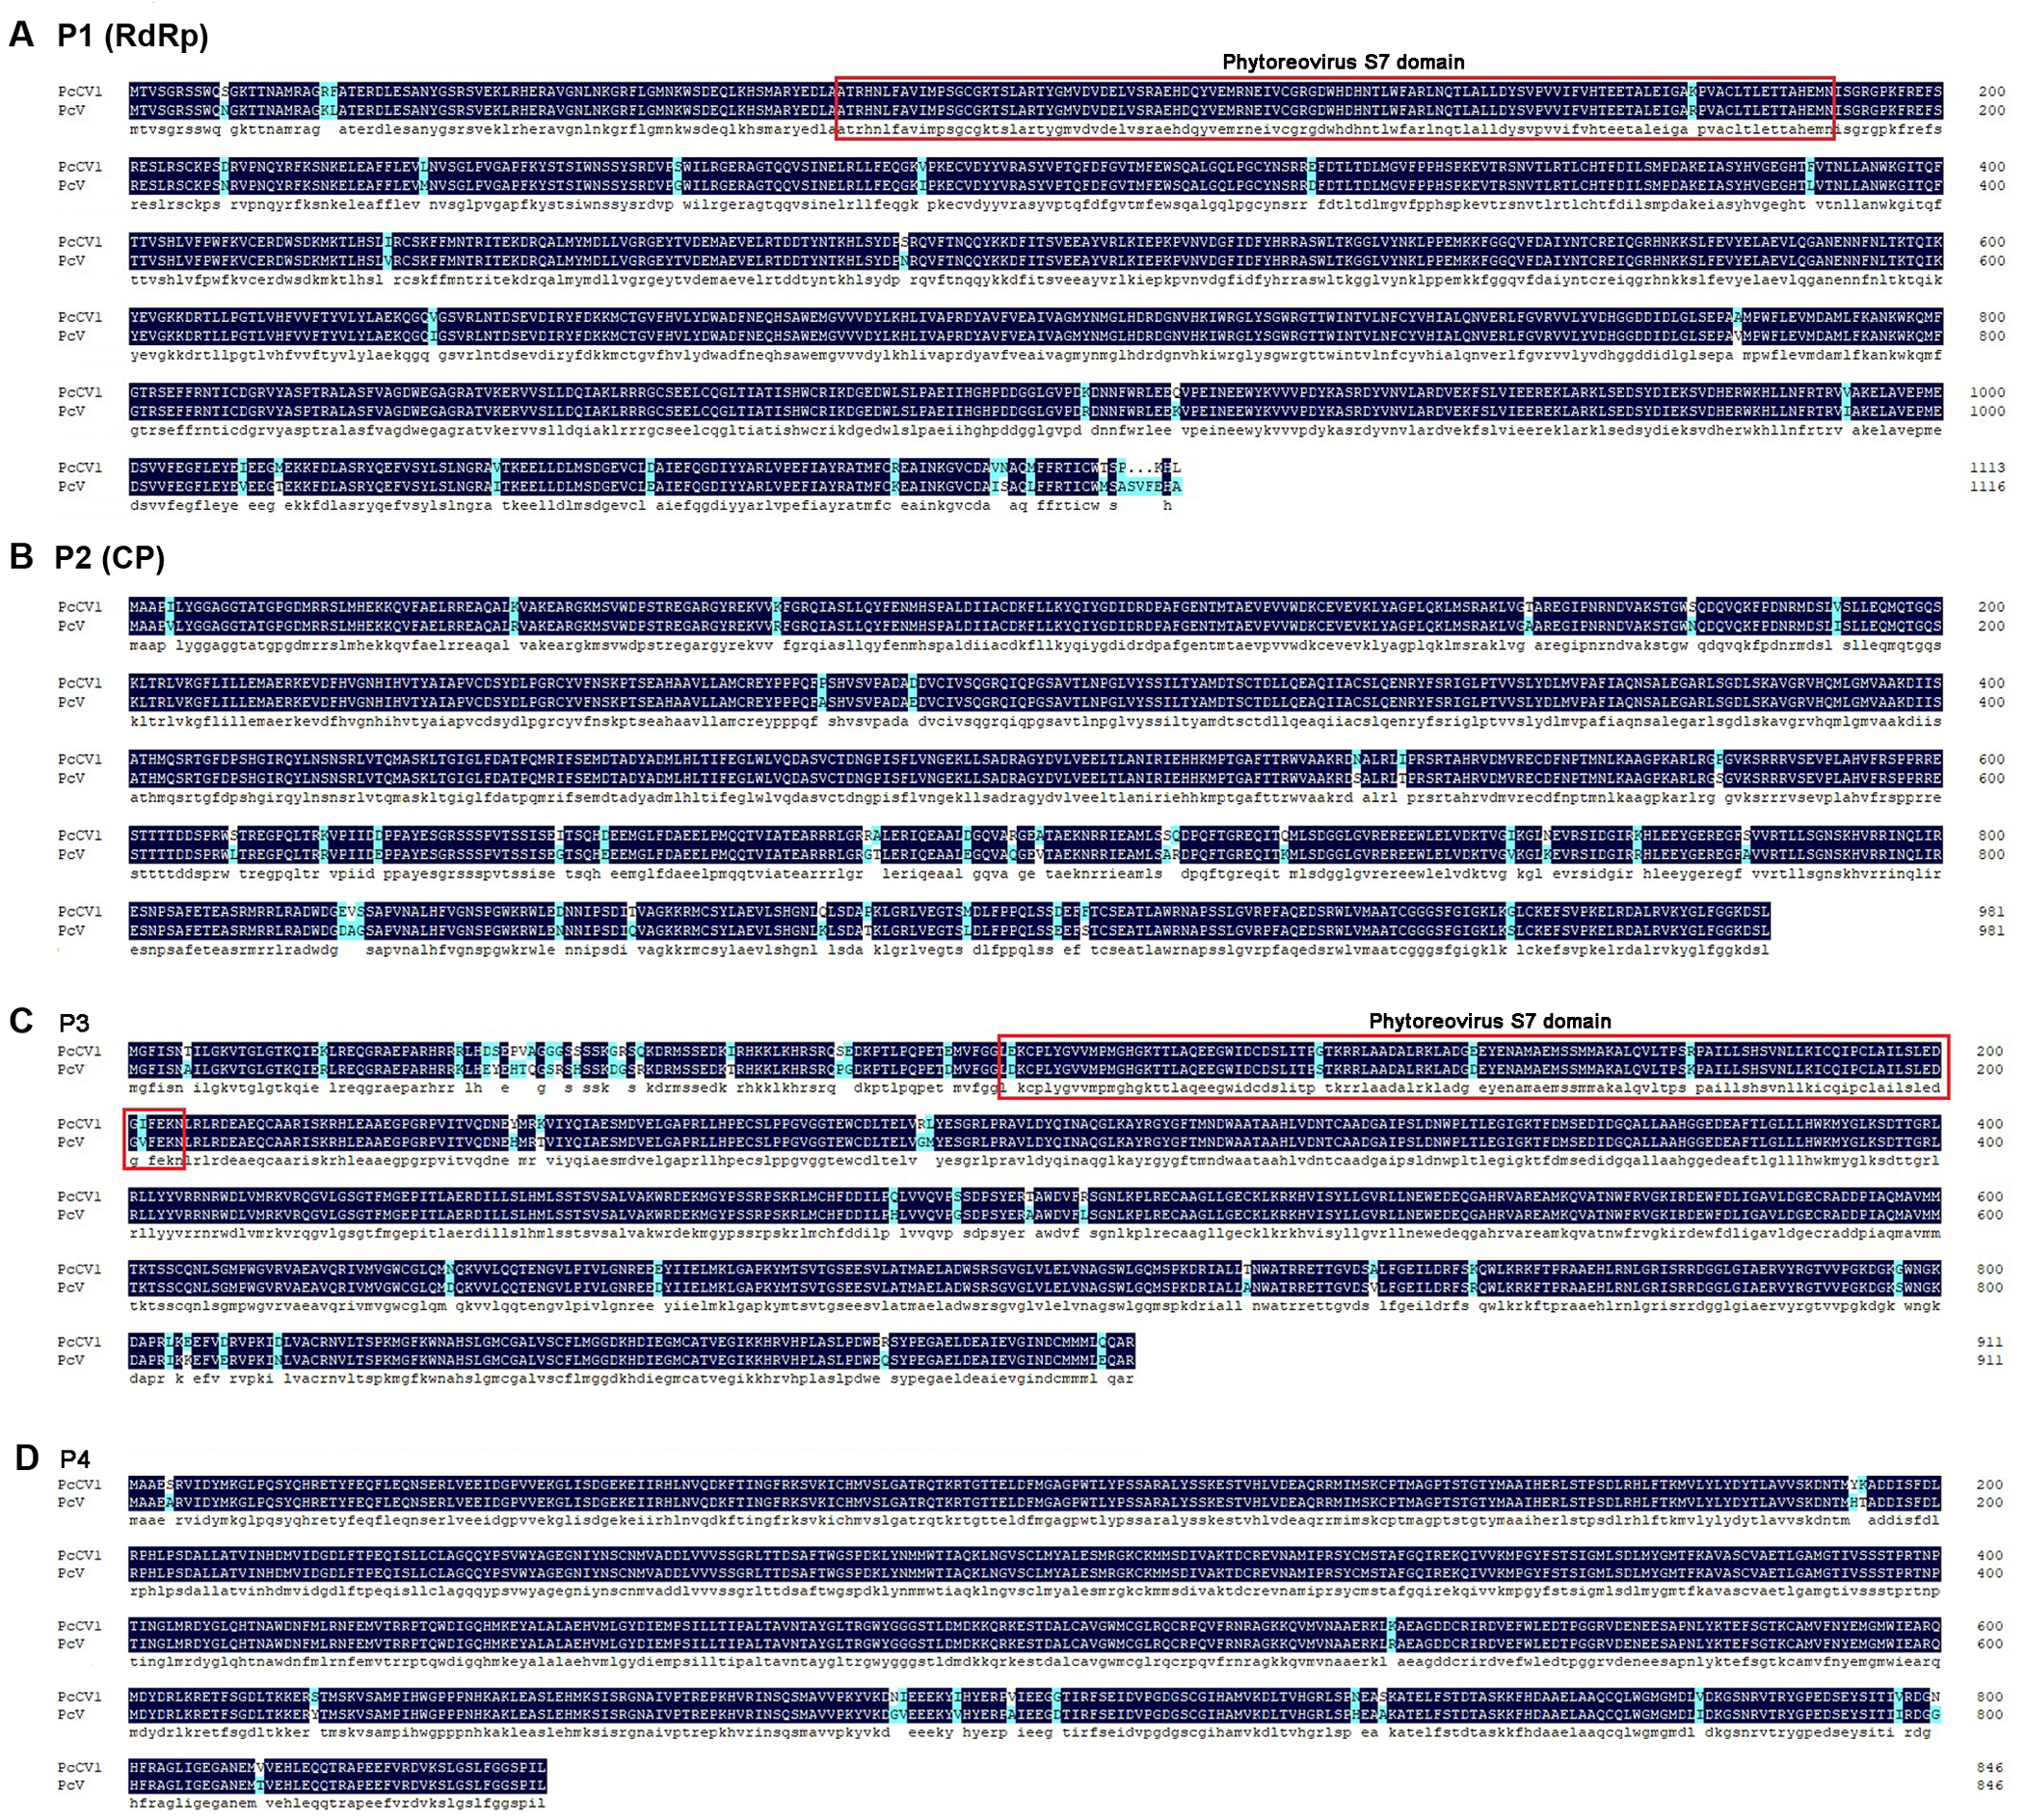
Figure S1 Alignment analysis of putative amino-acid sequences for the corresponding genomic dsRNA-encoding proteins between PcCV1 and PcV. (A) P1 (RdRp) encoded by dsRNA1 of PcCV1 and PcV; (B) P2 (CP) encoded by dsRNA2 of PcCV1 and PcV; (C) P3 encoded by dsRNA3 of PcCV1 and PcV; (D) P4 encoded by dsRNA4 of PcCV1 and PcV. The phytoreovirus S7 domain was highlighted in red box.

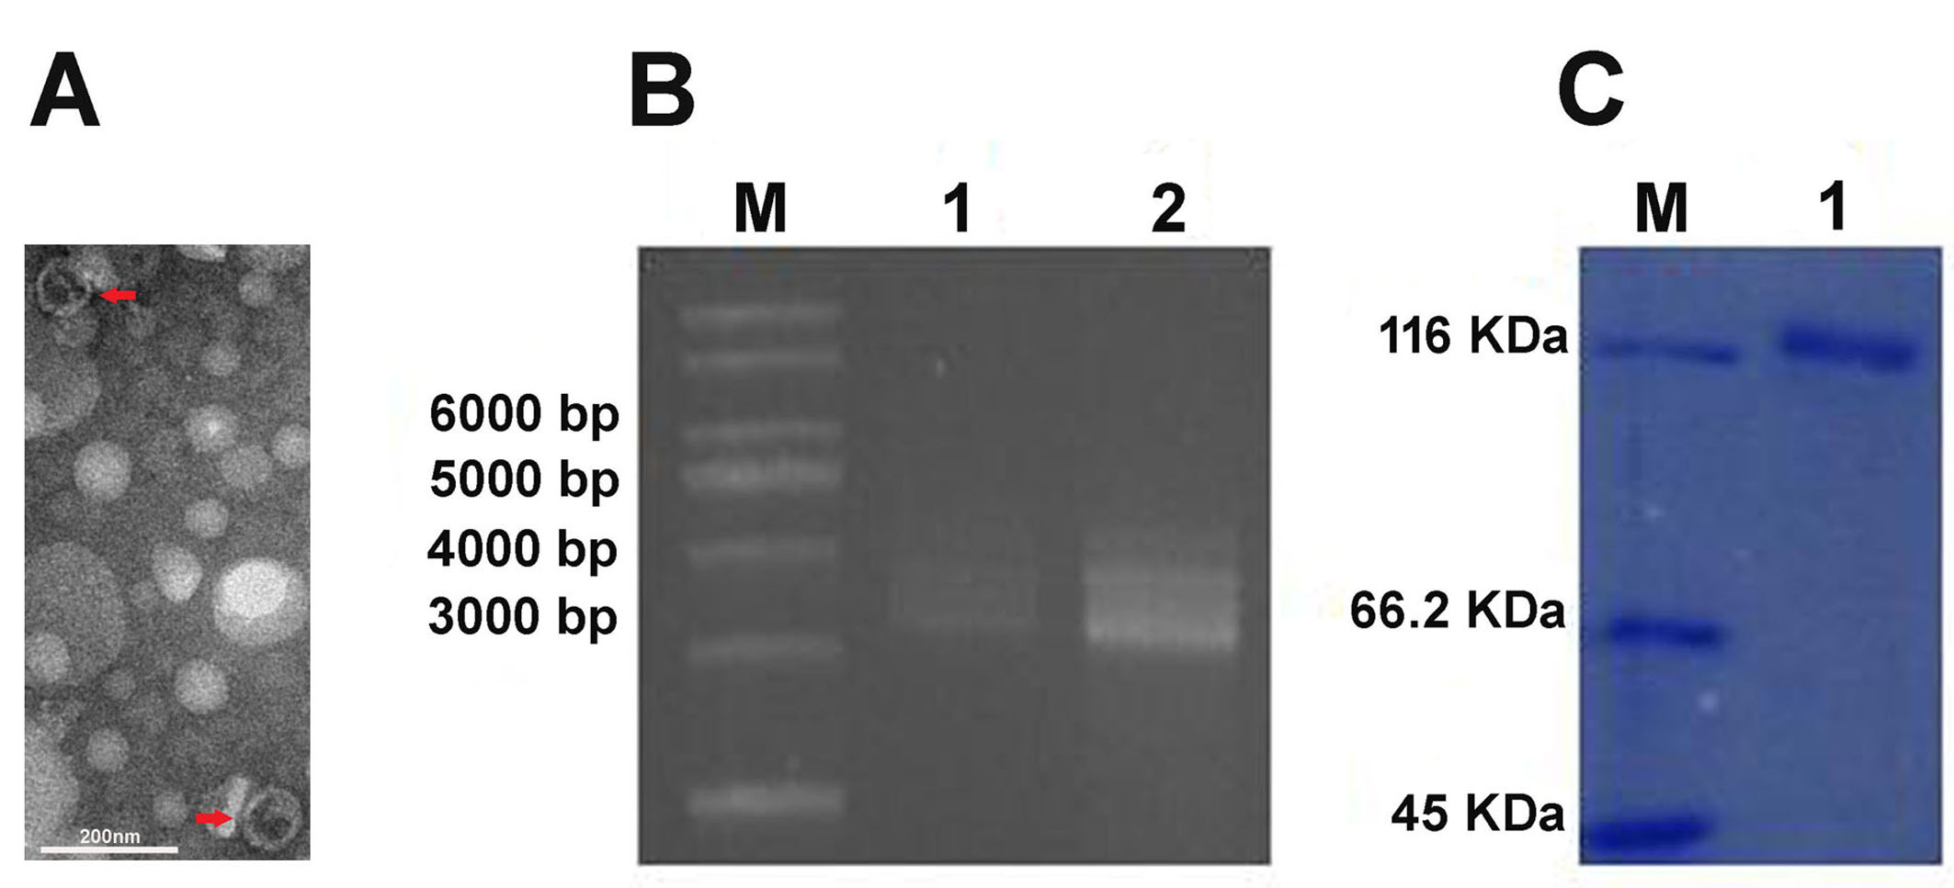
Figure S2 Detection of viral particles (VPs) from virus-infected P. crustosum HS-CQ15. (A) Transmission electron microscopy (TEM) image of VPs purified from HS-CQ15. The VPs in the image are indicated by red arrows. (B) Comparison of mobility patterns of dsRNA extracted from purified VPs of PcCV1 (lane 1) and HS-CQ15 mycelia (lane 2) using 1% (w/v) agarose gel electrophoresis. Lane M indicates DNA marker DS10000 (TaKaRa, Dalian, China). (C) SDS-PAGE analysis of structural proteins of the purified VPs of PcCV1 (lane 1). Lane M indicates PageRuler™ Unstained Protein Ladder (Thermo Fisher Scientiﬁc, USA).

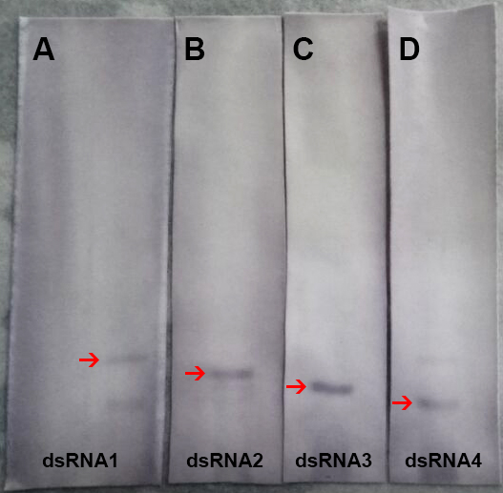

Figure S3 The full-scan of entire original gels for the RNA blots of PcCV1 genomic dsRNAs from fungal host HS-CQ15. Panels A, B, C, and D represent the full-scan of entire original gel for dsRNA1, 2, 3, and 4, respectively, corresponding to the cropped images of blots in Figure 1 panel B. The dsRNAs were separated under denaturing electrophoresis conditions, blotted onto nylon membranes, and probed by DIG-labeled DNA fragments as indicated in Figure 1 panel C.

Table S1 Primers used in this study.
Name | Sequence (5’-3’) | Purpose
P-dsRNA1-F1 | GAATAATTCCTTTGGACCTGAGG | Primers used to determine the sequence gap of the dsRNA1.
P-dsRNA1-R1 | AAGAATTTGCTGCACCGGATC | Primers used to determine the sequence gap of the dsRNA1.
P-dsRNA1-F2 | TGATCCGGTGCAGCAAATTCTT | Primers used to determine the sequence gap of the dsRNA1.
P-dsRNA1-R2 | CGAGCCAACACGTTGACGTAG | Primers used to determine the sequence gap of the dsRNA1.
P-dsRNA2-F1 | GAGAAGAAGCAGGTATTCGCCG | Primers used to determine the sequence gap of the dsRNA2.
P-dsRNA2-R1 | GCTCTATCCTGATATTGGCCA | Primers used to determine the sequence gap of the dsRNA2.
P-dsRNA2-F2 | CCAAATGGCTAGCAAATTGACCG | Primers used to determine the sequence gap of the dsRNA2.
P-dsRNA2-R2 | CGTTTCGCCATGCCAGAGTT | Primers used to determine the sequence gap of the dsRNA2.
P-dsRNA2-F3 | TAGGGGGAAGATGAGCGTAT | Primers used to determine the sequence gap of the dsRNA2.
P-dsRNA2-R3 | GACGGCCTTGTGACACTATAC | Primers used to determine the sequence gap of the dsRNA2.
P-dsRNA2-F4 | CCCTATCAGTTTCTTAGTCAATGG | Primers used to determine the sequence gap of the dsRNA2.
P-dsRNA2-R4 | CCTCAGCCAAGTAACTGCACAT | Primers used to determine the sequence gap of the dsRNA2.
P-dsRNA3-F1 | CCCATTAGGAAGCAACTCAC | Primers used to determine the sequence gap of the dsRNA2.
P-dsRNA3-R1 | CACTATGAATGACTGGGCT | Primers used to determine the sequence gap of the dsRNA2.
P-dsRNA3-F2 | GATACCTTCAAGCGTTAATGGC | Primers used to determine the sequence gap of the dsRNA3.
P-dsRNA3-R2 | AATTGAGGGAGCAGGGTC | Primers used to determine the sequence gap of the dsRNA3.
P-dsRNA3-F3 | CGGTTGTCTCTCTGCGTGT | Primers used to determine the sequence gap of the dsRNA3.
P-dsRNA3-R3 | CCGATGGAGCTATACCGAG | Primers used to determine the sequence gap of the dsRNA3.
P-dsRNA4-F1 | GAATAGCGAAAGACTGGTGGA | Primers used to determine the sequence gap of the dsRNA4.
P-dsRNA4-R1 | GTCGAAGATGAAACAATGGTAC | Primers used to determine the sequence gap of the dsRNA4.
P-dsRNA4-F2 | GCCCGGGTACTTCTCAACTAG | Primers used to determine the sequence gap of the dsRNA4.
P-dsRNA4-R2 | AGAGGGATCCGAGTGACTTGAC | Primers used to determine the sequence gap of the dsRNA4.
P-dsRNA4-F3 | CAACGCCTTCAGACCTACG | Primers used to determine the sequence gap of the dsRNA4.
P-dsRNA4-R3 | CTCTCTACAGTCAGTCTTGGCG | Primers used to determine the sequence gap of the dsRNA4.
P-dsRNA4-F4 | TTGAAATGGTTACACGACG | Primers used to determine the sequence gap of the dsRNA4.
P-dsRNA4-R4 | ATCCGAGTGACTTGACATCT | Primers used to determine the sequence gap of the dsRNA4.
Pt-dsRNA1-1 | ATGGAAGCAGATGTTTGGGACTC | Primers used to determine 5’-terminal sequence of the dsRNA1.
Pt-dsRNA1-2 | TGAGGGCATTATGACAGCGAAG | Primers used to determine 3’-terminal sequence of the dsRNA1.
Pt-dsRNA2-1 | AGACGGAAGCCTCTCGAATG | Primers used to determine 5’-terminal sequence of the dsRNA2.
Pt-dsRNA2-2 | CCGTACTCTTTGCAACGTCATT | Primers used to determine 3’-terminal sequence of the dsRNA2.
Pt-dsRNA3-1 | GTTTCAGGCTGGGGCAATGTAGG | Primers used to determine 5’-terminal sequence of the dsRNA3.
Pt-dsRNA3-2 | TAACTGGGCCACACGCAGAGAG | Primers used to determine 3’-terminal sequence of the dsRNA3.
Pt-dsRNA4-1 | GGTAGTAACCGTGTCACCCGCT | Primers used to determine 5’-terminal sequence of the dsRNA4.
Pt-dsRNA4-2 | CCGTTGATAGTAAACTTGTCCTGG | Primers used to determine 3’-terminal sequence of the dsRNA4.

Table S2 Information on the virus isolates used for sequence alignment and phylogenetic analysis of their RdRps.
Name | Family | Genus | Abbreviation | GenBank accession no.
Amasya cherry disease associated chrysovirus | Chrysoviridae | Chrysovirus | ACDACV | YP_001531163.1
Aspergillus fumigatus chrysovirus | Chrysoviridae | Chrysovirus | AfuCV | CAX48749.1
Cryphonectria nitschkei chrysovirus 1 | Chrysoviridae | Chrysovirus | CnCV1 | ACT79255.1
Fusarium oxysporum chrysovirus 1 | Chrysoviridae | Chrysovirus | FoCV1 | ABQ53134.1
Helminthosporium victoriae 145S virus | Chrysoviridae | Chrysovirus | Hv145SV | AAM68953.1
Penicillium chrysogenum virus | Chrysoviridae | Chrysovirus | PcV | YP_392482
Verticillium dahliae chrysovirus 1 | Chrysoviridae | Chrysovirus | VdCV1 | ADG21213.1
Anthurium mosaic-associated virus-PHA | Chrysoviridae | Unclassified, chrysoviruses-related viruses | AmAV | ACU11563.1
Aspergillus mycovirus 1816 | Chrysoviridae | Unclassified, chrysoviruses-related viruses | AmV1816 | ABX79996.1
Brassica campestris chrysovirus 1-Hubei | Chrysoviridae | Unclassified, chrysoviruses-related viruses | BcCV1 | AKU48197.1
Botryosphaeria dothidea chrysovirus 1- LW-1 | Chrysoviridae | Unclassified, chrysoviruses-related viruses | BdCV1 | AGZ84312.1
Colletotrichum gloeosporioides chrysovirus 1-HZ-1 | Chrysoviridae | Unclassified, chrysoviruses-related viruses | CgCV1 | ALW95408.1
Fusarium graminearum dsRNA mycovirus-2 | Chrysoviridae | Unclassified, chrysoviruses-related viruses | FgV2 | ADW08802.1
Fusarium graminearum mycovirus-China-9 | Chrysoviridae | Unclassified, chrysoviruses-related viruses | FgV-ch9 | ADU54123.1
Fusarium oxysporum f. sp.Dianthi virus-Fod 116 | Chrysoviridae | Unclassified, chrysoviruses-related viruses | FodV1 | AKP45145.1
Magnaporthe oryzae chrysovirus 1-A | Chrysoviridae | Unclassified, chrysoviruses-related viruses | MoCV1-A | BAJ15133.1
Magnaporthe oryzae chrysovirus 1-B | Chrysoviridae | Unclassified, chrysoviruses-related viruses | MoCV1-B | BAO20927.1
Persea americana chrysovirus-Spain | Chrysoviridae | Unclassified, chrysoviruses-related viruses | PaCV | AJA37498.1
Raphanus sativus chrysovirus 1-D13 | Chrysoviridae | Unclassified, chrysoviruses-related viruses | RsCV1 | AFE83590.1
Penicillium stoloniferum virus S | Partitiviridae | Gammapartitivirus | PsV-S | YP_052856.2
Penicillium digitatum Gammapartitivirus 1 | Partitiviridae | Gammapartitivirus | PdGv1

Table S3 Amino acid sequence identity between viral proteins of PcCV1 and PcV.
Proteins | Amino acid sequence identity between PcCV1 and PcV
P1 (RdRp) | 97.05%
P2 (CP) | 96.03%
P3 | 95.29%
P4 | 98.11%

