Supplementary Material
Abiotic and Landscape Factors Constrain Restoration Outcomes Across Spatial Scales of a Widespread Invasive Plant

Christine B. Rohal*, Chad Cranney, Karin M. Kettenring
*Correspondence: Corresponding author: christine.rohal@gmail.com

Supplementary Tables and Figures

Supplementary Table S1. Pearson’s correlations between predictor variables.

 | Scale | HSeas | HTyp | PCA1A | PCA2A | PCA1L | PCA2L | SurVegNat
Management
H Season | -0.01
H Type | 0.00 | 0.50
Abiotic
PCA1_A | -0.81 | 0.00 | 0.01
PCA2_A | 0.26 | 0.08 | -0.09 | 0.00
Landscape
PCA1_L | -0.32 | -0.03 | 0.05 | 0.43 | 0.06
PCA2_L | 0.16 | 0.09 | 0.14 | -0.10 | 0.02 | 0.00
SurVegNative | 0.66 | -0.06 | 0.12 | -0.71 | -0.20 | -0.29 | 0.29
Emergent Marsh | -0.32 | 0.08 | 0.04 | 0.31 | -0.02 | -0.11 | -0.31 | -0.25

Supplementary Table S2. Phragmites cover effect sizes. Significance of terms are identified *** ≤0.001, ** ≤0.01, * ≤0.05.

 |  | Small scale |  |  | Large scale
 |  |  | 95% CI |  |  |  |  | 95% CI
Treatment | Year | Effect size | Lower | Upper | Effect size |  | Lower |  | Upper | Q_{M}
Fall glyphosate | 2013 | -1.53*** | -2.08 | -0.98 | -1.95*** |  | -2.59 |  | -1.31 | 0.95
 | 2014 | -0.75** | -1.21 | -0.29 | -1.15* |  | -2.08 |  | -0.23 | 0.52
 | 2015 | -1.29*** | -1.60 | -0.97 | -1.27* |  | -2.22 |  | -0.32 | 0.17
 | 2016 | -0.85* | -1.54 | -0.15 | -0.73*** |  | -1.07 |  | -0.39 | 0.03
Summer glyphosate | 2013 | -0.90* | -1.68 | -0.12 | -1.94*** |  | -2.68 |  | -1.19 | 3.63
 | 2014 | -0.84* | -1.48 | -0.20 | -1.33*** |  | -1.70 |  | -0.96 | 2.28
 | 2015 | -0.94* | -1.68 | -0.20 | 0.14 |  | -0.47 |  | 0.74 | 4.85*
 | 2016 | -0.41** | -0.71 | -0.11 | -0.07 |  | -0.19 |  | 0.06 | 4.57*
Summer imazapyr | 2013 | -2.18** | -3.59 | -0.78 | -2.34*** |  | -3.40 |  | -1.29 | 0.05
 | 2014 | -1.60*** | -2.44 | -0.77 | -2.00* |  | -3.94 |  | -0.05 | 0.03
 | 2015 | -1.91 | -4.00 | 0.17 | -0.18 |  | -1.12 |  | 0.75 | 2.21
 | 2016 | -1.23 | -2.52 | 0.06 | -0.40 |  | -0.98 |  | 0.19 | 1.23

Supplementary Table S3. Native emergent perennial cover effect sizes. Significance of terms are identified *** ≤0.001, ** ≤0.01, * ≤0.05.

 |  | Small scale |  |  | Large scale
 |  |  | 95% CI |  |  | 95% CI
Treatment | Year | Effect size | Lower | Upper | Effect size | Lower | Upper | Q_{M}
Fall glyphosate | 2013 | 2.23 | -0.08 | 4.43 | 0.62 | -0.67 | 1.92 | 1.34
 | 2014 | 3.78** | 1.20 | 6.46 | 4.29 | -0.38 | 8.96 | 0.04
 | 2015 | 6.97*** | 3.64 | 10.30 | 3.87 | -1.07 | 8.82 | 1.00
 | 2016 | 4.67*** | 2.13 | 7.20 | 4.37 | -0.86 | 9.60 | 0.01
Summer glyphosate | 2013 | 1.54 | -0.65 | 3.74 | 1.34 | -0.46 | 3.14 | 0.02
 | 2014 | 4.33 | -0.58 | 9.24 | 2.29 | -2.65 | 7.24 | 0.33
 | 2015 | 7.02** | 2.58 | 11.45 | 1.16 | -2.75 | 5.07 | 3.79*
 | 2016 | 3.59 | -0.96 | 8.13 | 1.01 | -3.28 | 5.29 | 0.66
Summer imazapyr | 2013 | 2.73 | -0.71 | 6.18 | 2.29 | -1.32 | 5.90 | 0.03
 | 2014 | 5.14 | -0.46 | 10.75 | 1.97 | -3.82 | 7.75 | 0.60
 | 2015 | 6.94** | 2.17 | 11.70 | 2.92 | -2.79 | 8.62 | 1.11
 | 2016 | 5.11** | 1.60 | 8.61 | 3.64 | -1.67 | 8.96 | 0.19

Supplementary Table S4. Species richness effect sizes. Significance of terms are identified *** ≤0.001, ** ≤0.01, * ≤0.05. Species richness was calculated at the plot level, which reduced sample size, making the Qm statistic unable to be calculated for this metric.

 |  | Small Scale |  |  | Large Scale
 |  |  | 95% CI |  |  |  |  | 95% CI
Treatment | Year | Effect size | Lower | Upper | Effect size |  | Lower |  | Upper
Fall Glyphosate, Winter Mow | 2013 | 0.94** | 0.38 | 1.51 | 0.62 |  | -0.18 |  |  | 1.42
 | 2014 | 1.07* | 0.21 | 1.94 | 1.05*** |  | 0.53 |  |  | 1.57
 | 2015 | 2.04*** | 1.49 | 2.58 | 1.06** |  | 0.34 |  |  | 1.77
 | 2016 | 1.63*** | 0.94 | 2.32 | 1.09** |  | 0.41 |  |  | 1.79
Summer Glyphosate, Winter Mow | 2013 | 0.97** | 0.28 | 1.66 | 0.76* |  | 0.03 |  |  | 1.50
 | 2014 | 1.21* | 0.28 | 2.14 | 0.94** |  | 0.34 |  |  | 1.55
 | 2015 | 2.06*** | 1.46 | 2.65 | 0.97* |  | 0.16 |  |  | 1.77
 | 2016 | 1.42*** | 0.64 | 2.20 | 0.77 |  | -0.12 |  |  | 1.66
Summer Imazapyr, Winter Mow | 2013 | 0.83** | 0.30 | 1.36 | 0.54 |  | -0.23 |  |  | 1.30
 | 2014 | 1.07* | 0.24 | 1.91 | 1.15*** |  | 0.55 |  |  | 1.74
 | 2015 | 1.95*** | 1.44 | 2.45 | 0.69 |  | -0.14 |  |  | 1.52
 | 2016 | 1.53*** | 0.92 | 2.14 | 0.69 |  | -0.14 |  |  | 1.53

Supplementary Table S5. Means plus standard errors of vegetation metrics in small and large Phragmites treatment plots. Vegetation metrics were percent cover Phragmites, percent cover native perennials, species richness, and mean C.

 | Control |  | Fall  glyphosate |  | Summer glyphosate |  | Summer  imazapyr
 | Small | Large | Small | Large | Small | Large | Small | Large
% cover Phragmites | 81.2±4.3 | 66.2±18.3 | 18.6±4.4 | 15.9±4.9 | 33.9±13.5 | 62.3±9.4 | 29.9±10.7 | 52.2±17.4
% cover native perennials | 0.8±0.8 | 1.1±1.1 | 21.6±12.3 | 2.5±2.2 | 9.9±5.3 | 0.34±0.2 | 19.1±15.9 | 1.7±1.5
Species richness | 1.2±0.2 | 2±0.6 | 9.2±2.1 | 5.8±1.1 | 9.4±2.4 | 5.3±1.4 | 8.4±1.6 | 4±1.2
Mean C | 0.8±0.8 | 1.4±0.7 | 4.3±0.2 | 3.6±0.4 | 3.5±0.3 | 2.5±0.6 | 3.4±0.4 | 2.7±0.4

Supplementary Table S6. Statistical significance of predictor variables selected from each variable set (scale, management, abiotic, and landscape) for plant community, species richness, mean C, Phragmites cover, and native perennials cover. Open spots indicate that the variable was not selected to be included in the final model.

Predictor Variable | Plant community | Species richness | Mean C | Phragmites | Native perennials
Scale
Spatial scale | #ns | F_{1,25}=19.2  P=0.004 | F_{1,25}=20.6  P<0.001 | F_{1,25}=2.6  P=0.12 | F_{1,25}=17.3  P<0.001
Management
Herbicide season | #ns | F_{1,25}=0.4  P=0.53 | F_{1,25}=3.6  P=0.07 | F_{1,25}=6.9  P=0.01 | F_{1,25}=1.2  P=0.28
Herbicide type
Abiotic Variables
PC1 (hydrology) | #ns | F_{1,25}=24.0  P<0.001 | F_{1,25}=34.9  P<0.001 | F_{1,25}=1.5  P=0.23 | F_{1,25}=36.4  P=<0.001
PC2 (nutrients)
Landscape Variables
PC1 (hydrologic disturbance) | F=3.56  P=0.002 | F_{1,23}=12.2  P=0.002 |  | F_{1,24}=3.3  P=0.08 | F_{1,24}= 11.1  P=0.002
PC2 (developed disturbance) | F=2.39  P=0.018
Proportion emergent marsh |  | F_{1,23}=2.7  P=0.11 |  | F_{1,24}=2.7  P=0.11
% cover surrounding natives | F=3.34  P=0.002 | F_{1,23}=10.7  P=0.003 | F_{1,25}=6.7  P=0.02 |  | F_{1,24}=13.7  P=0.001

% cover native perennials (logit)
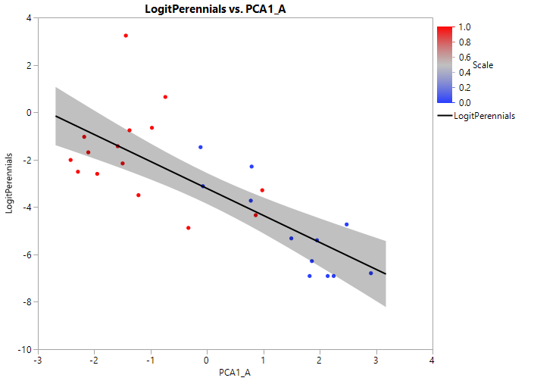
PCA1_Abiotic
% cover native perennials (logit)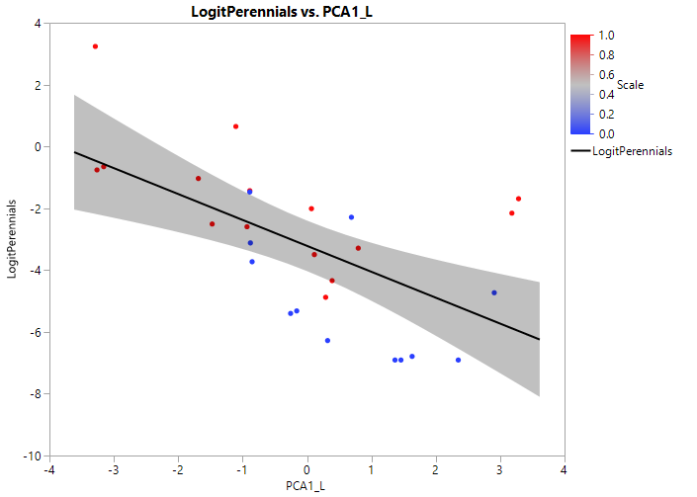

PCA1_Landscape
% cover native perennials (logit)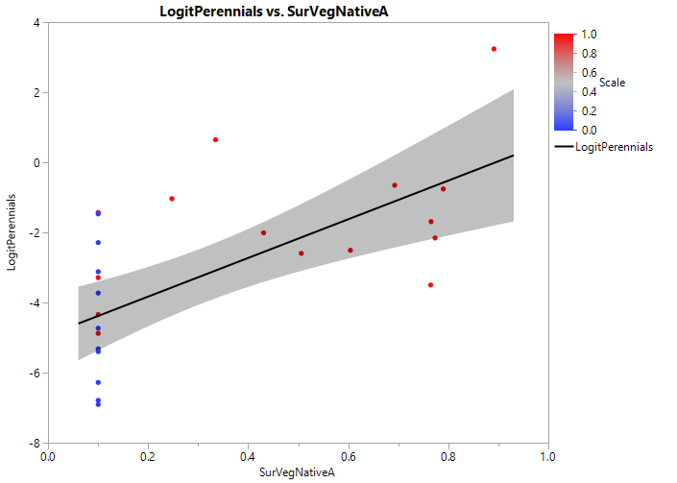
% cover surrounding native perennials (arcsin sqrt)
Supplementary Figure S1. Logit transformed native perennials plotted against abiotic and landscape variables used in variation partitioning. Abiotic and landscape variables are Abiotic PCA1, Landscape PCA1, and cover of surrounding native vegetation. Red points represent data from small plots, blue dots represent data from large plots.

% cover Phragmites (logit)
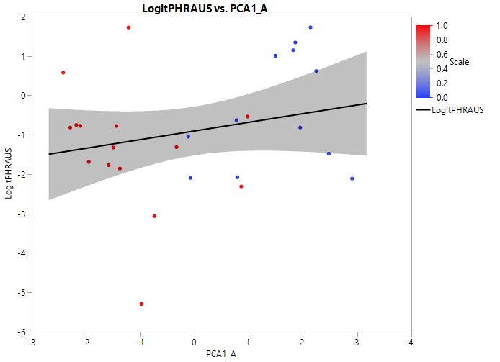
PCA1_Abiotic
% cover Phragmites (logit) 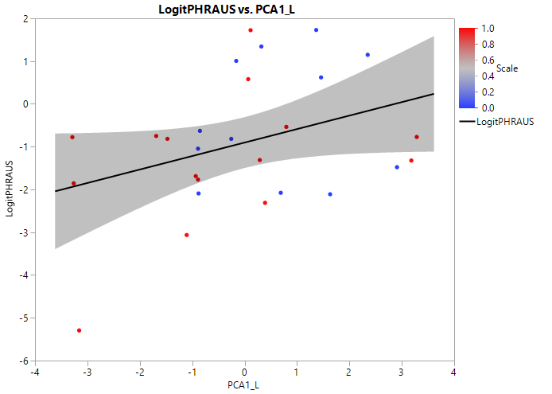

PCA1_Landscape
% cover Phragmites (logit) 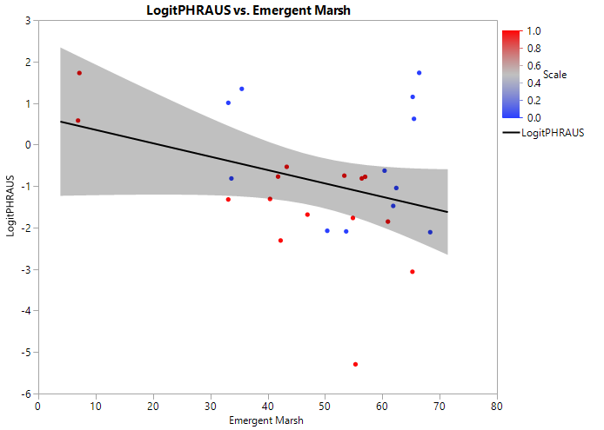
Proportion emergent marsh in landscape
Supplementary Figure S2. Logit transformed Phragmites cover plotted against abiotic and landscape variables used in variation partitioning. Variables included Abiotic PCA1, Landscape PCA1, and proportion emergent marsh in landscape. Red points represent data from small plots, blue dots represent data from large plots.

Species richness  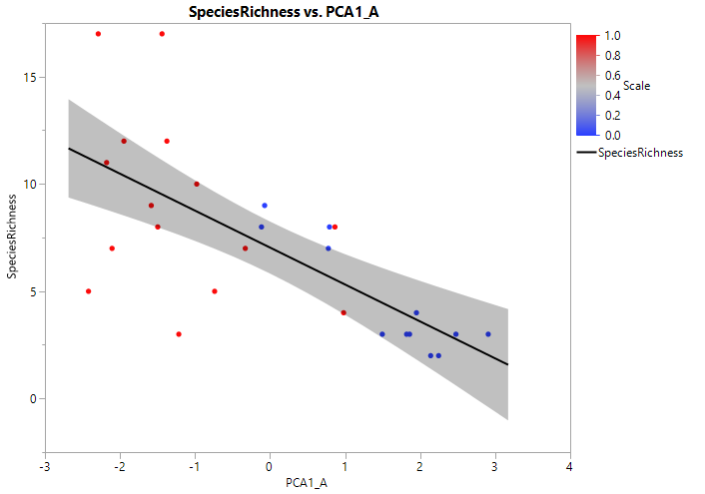 | Species richness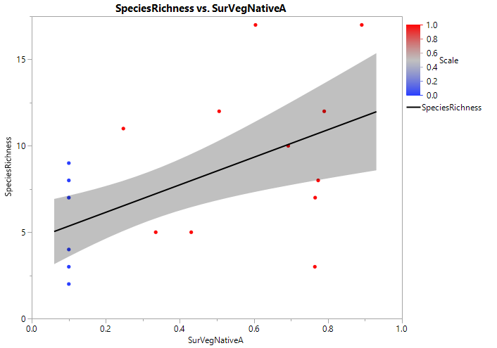
PCA1_Abiotic | Surrounding veg native perennials
Species richness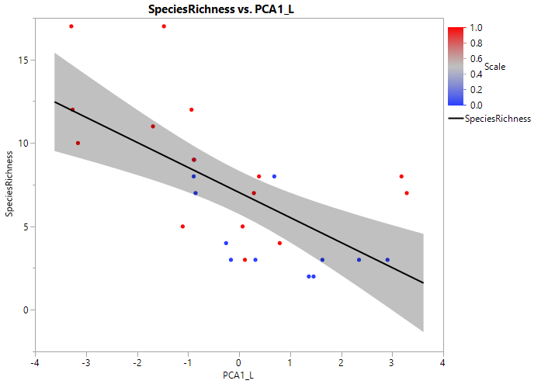 | Species richness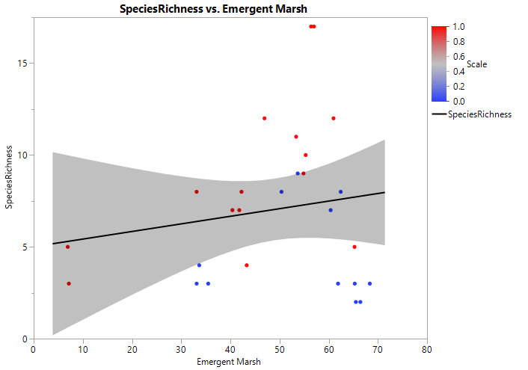
PCA1_Landscape | Proportion emergent marsh in landscape
Supplementary Figure S3. Species richness plotted against abiotic and landscape variables used in variation partitioning. Variables included Abiotic PCA1, Landscape PCA1, surrounding vegetation native perennials, and proportion emergent marsh in landscape. Red points represent data from small plots, blue dots represent data from large plots.

Mean C
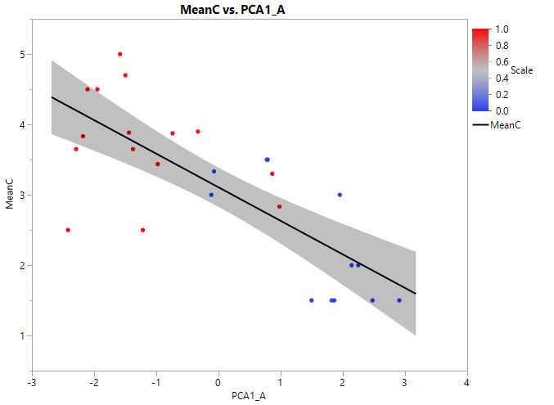
PCA1_Abiotic
Mean C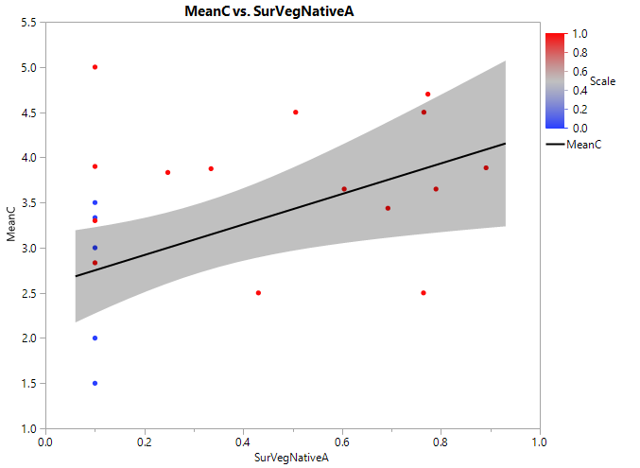
Surrounding veg native perennials
Supplementary Figure S4. Mean C plotted against abiotic and landscape variables used in variation partitioning. Variables included Abiotic PCA1, surrounding vegetation native perennials. Red points represent data from small plots, blue dots represent data from large plots.

