Table S1 Brief statistic results of reference sequence alignments by using RNAs-seq
 | input reads counts |  |  | Uniq mapped reads |  |  | mapping rates
 |  |  |  | counts
Tissues | forward | reverse |  | forward | reverse |  | forward | reverse | forward - reverse
matured egg | 30,873,699 | 30,873,699 |  | 22,394,965 | 21,748,396 |  | 72.54% | 70.44% | 2.10%
cerebellum | 30,798,145 | 30,798,145 |  | 24,644,794 | 24,421,460 |  | 80.02% | 79.30% | 0.72%
gallbladder | 35,862,229 | 35,862,229 |  | 22,645,815 | 22,541,579 |  | 63.15% | 62.86% | 0.29%
kidney | 29,953,007 | 29,953,007 |  | 13,260,148 | 13,090,924 |  | 44.27% | 43.70% | 0.57%
heart | 30,986,431 | 30,986,431 |  | 24,876,592 | 24,969,026 |  | 80.28% | 80.58% | -0.30%
uterus | 33,444,002 | 33,444,002 |  | 24,005,578 | 23,129,484 |  | 71.78% | 69.16% | 2.62%
pancreas | 30,595,568 | 30,595,568 |  | 12,789,115 | 12,277,691 |  | 41.80% | 40.13% | 1.67%
lung | 31,533,498 | 31,533,498 |  | 14,459,381 | 14,218,915 |  | 45.85% | 45.09% | 0.76%
skin | 34,442,464 | 34,442,464 |  | 18,877,527 | 18,709,209 |  | 54.81% | 54.32% | 0.49%
eye | 33,006,509 | 33,006,509 |  | 25,395,810 | 25,111,320 |  | 76.94% | 76.08% | 0.86%
brisket | 34,893,064 | 34,893,064 |  | 28,859,725 | 28,331,694 |  | 82.71% | 81.20% | 1.51%
shin skin | 34,612,367 | 34,612,367 |  | 27,318,226 | 27,176,155 |  | 78.93% | 78.52% | 0.41%
liver | 33,476,266 | 33,476,266 |  | 21,787,722 | 21,644,194 |  | 65.08% | 64.66% | 0.42%
bone marrow | 30,975,506 | 30,975,506 |  | 14,834,302 | 14,525,590 |  | 47.89% | 46.89% | 1.00%
fascia | 33,316,764 | 33,316,764 |  | 24,302,712 | 23,572,203 |  | 72.94% | 70.75% | 2.19%
cerebrum | 30,887,821 | 30,887,821 |  | 15,993,857 | 15,667,693 |  | 51.78% | 50.72% | 1.06%
gizzard | 31,537,118 | 31,537,118 |  | 17,890,098 | 17,613,831 |  | 56.73% | 55.85% | 0.88%
immatured egg | 32,009,437 | 32,009,437 |  | 20,798,084 | 20,241,417 |  | 64.97% | 63.24% | 1.73%
cockscomb | 31,936,332 | 31,936,332 |  | 20,702,519 | 20,177,111 |  | 64.82% | 63.18% | 1.64%
spleen | 36,125,957 | 36,125,957 |  | 26,046,892 | 25,265,226 |  | 72.10% | 69.94% | 2.16%

Table S2 Brief statistic results of DNA methylation calling by using Bismark
 | Reads mapping |  |  |  |  | DNA Methyl-sites calling
 | # of input read pairs | uniquely mapped read pairs | duplicately mapped read pairs | % Aligned |  |  | # of methylated sites |  |  |  |  | # of unmethylated sites
 |  |  |  |  |  | total number of C | CpG | CHG | CHH | unknown |  | CpG | CHG | CHH | unknown
matured egg | 6,246,607 | 3,202,710 | 146,668 | 51.30% |  | 177,424,550 | 10,090,764 | 108,715 | 168,950 | 69,925 |  | 22,972,425 | 49,596,398 | 94,487,298 | 69,925
cerebellum | 6,291,610 | 3,189,875 | 149,156 | 50.70% |  | 176,214,564 | 11,154,650 | 287,582 | 730,298 | 70,425 |  | 21,995,666 | 48,678,410 | 93,367,958 | 70,425
gallbladder | 5,738,180 | 3,013,478 | 121,766 | 52.50% |  | 158,842,095 | 9,906,046 | 108,148 | 184,254 | 60,739 |  | 16,668,585 | 44,823,958 | 87,151,104 | 60,739
kidney | 5,470,502 | 2,775,475 | 124,653 | 50.70% |  | 152,054,891 | 9,266,333 | 101,140 | 163,818 | 59,102 |  | 18,100,440 | 43,135,610 | 81,287,550 | 59,102
heart | 5,462,739 | 2,824,787 | 124,043 | 51.70% |  | 153,050,760 | 9,502,121 | 109,858 | 188,542 | 56,357 |  | 18,413,467 | 43,055,170 | 81,781,602 | 56,357
uterus | 6,046,764 | 3,010,398 | 137,903 | 49.80% |  | 164,719,944 | 10,207,930 | 116,814 | 183,400 | 64,447 |  | 18,658,769 | 46,895,616 | 88,657,415 | 64,447
pancreas | 7,100,215 | 3,689,936 | 145,578 | 52.00% |  | 192,091,263 | 10,633,093 | 115,692 | 198,329 | 76,909 |  | 21,194,789 | 54,711,606 | 105,237,754 | 76,909
lung | 5,640,120 | 2,814,000 | 128,373 | 49.90% |  | 156,476,456 | 10,726,832 | 112,441 | 168,610 | 61,561 |  | 17,672,022 | 44,217,572 | 83,578,979 | 61,561
skin | 7,226,309 | 3,939,683 | 135,998 | 54.50% |  | 209,619,973 | 12,248,531 | 142,113 | 234,731 | 88,986 |  | 20,886,000 | 57,985,048 | 118,123,550 | 88,986
eye | 6,956,141 | 3,724,270 | 156,398 | 53.50% |  | 204,176,024 | 11,928,449 | 149,862 | 290,114 | 82,685 |  | 26,886,495 | 56,866,119 | 108,054,985 | 82,685
brisket | 6,042,106 | 3,075,504 | 137,846 | 50.90% |  | 168,447,005 | 10,221,292 | 115,284 | 191,098 | 62,926 |  | 19,895,840 | 47,359,127 | 90,664,364 | 62,926
shin skin | 5,924,463 | 3,290,884 | 103,509 | 55.50% |  | 163,206,357 | 8,611,448 | 91,870 | 178,921 | 64,236 |  | 13,727,727 | 45,270,794 | 95,325,597 | 64,236
liver | 6,744,208 | 3,709,338 | 58,791 | 55.00% |  | 178,373,598 | 5,066,885 | 70,141 | 169,883 | 93,935 |  | 20,592,744 | 47,784,049 | 104,689,896 | 93,935
bone marrow | 5,736,011 | 3,101,124 | 122,834 | 54.10% |  | 171,958,290 | 11,946,629 | 126,285 | 193,306 | 68,689 |  | 17,351,677 | 47,916,458 | 94,423,935 | 68,689
fascia | 5,720,194 | 2,936,675 | 141,560 | 51.30% |  | 162,946,393 | 9,777,589 | 104,240 | 171,629 | 61,930 |  | 19,511,561 | 44,900,158 | 88,481,216 | 61,930
cerebrum | 6,078,989 | 3,164,808 | 138,464 | 52.10% |  | 175,844,788 | 11,622,932 | 398,627 | 1,051,592 | 69,578 |  | 20,123,525 | 48,954,151 | 93,693,961 | 69,578
gizzard | 5,731,878 | 2,919,286 | 139,198 | 50.90% |  | 157,680,918 | 9,287,318 | 114,491 | 191,388 | 61,553 |  | 17,566,145 | 45,089,221 | 85,432,355 | 61,553
immatured egg | 6,741,258 | 3,376,822 | 157,829 | 50.10% |  | 184,333,531 | 11,639,636 | 127,296 | 199,814 | 69,369 |  | 21,949,289 | 52,673,025 | 97,744,471 | 69,369
cockscomb | 5,948,687 | 3,221,231 | 120,828 | 54.20% |  | 167,236,051 | 10,036,142 | 114,617 | 194,618 | 68,464 |  | 15,448,653 | 47,286,541 | 94,155,480 | 68,464
spleen | 6,307,517 | 3,697,919 | 48,478 | 58.60% |  | 168,693,342 | 5,252,124 | 71,465 | 183,606 | 95,076 |  | 12,725,419 | 44,052,784 | 106,407,944 | 95,076

Table S3 Coverage of CpG site using bismark
 | CpG sites covered reads |  |  |  | over 10 reads covered sites
 | covered read  counts | covered sites | average  depth |  | # of sites | % coverage
matured egg | 9,675,068 | 643,124 | 15.0439 |  | 199,960 | 31.09%
cerebellum | 9,663,846 | 561,945 | 17.1971 |  | 186,121 | 33.12%
gallbladder | 7,716,427 | 833,674 | 9.25593 |  | 157,716 | 18.92%
kidney | 7,999,973 | 561,329 | 14.2518 |  | 154,486 | 27.52%
heart | 8,090,597 | 558,430 | 14.4881 |  | 175,955 | 31.51%
uterus | 8,429,812 | 539,925 | 15.6129 |  | 148,693 | 27.54%
pancreas | 9,421,148 | 971,844 | 9.69409 |  | 175,665 | 18.08%
lung | 8,340,439 | 481,279 | 17.3297 |  | 151,143 | 31.40%
skin | 9,442,747 | 786,485 | 12.0063 |  | 140,994 | 17.93%
eye | 11,776,182 | 696,471 | 16.9084 |  | 183,366 | 26.33%
brisket | 8,718,717 | 517,608 | 16.8442 |  | 173,457 | 33.51%
shin skin | 6,302,115 | 1,154,300 | 5.45969 |  | 142,064 | 12.31%
liver | 7,715,251 | 1,762,606 | 4.37718 |  | 169,345 | 9.61%
bone marrow | 8,305,096 | 545,557 | 15.2231 |  | 161,598 | 29.62%
fascia | 8,160,086 | 579,453 | 14.0824 |  | 205,273 | 35.43%
cerebrum | 9,246,448 | 569,705 | 16.2302 |  | 189,787 | 33.31%
gizzard | 7,628,357 | 614,383 | 12.4163 |  | 130,760 | 21.28%
immatured egg | 9,668,805 | 614,414 | 15.7366 |  | 212,965 | 34.66%
cockscomb | 7,071,690 | 884,061 | 7.9991 |  | 119,845 | 13.56%
spleen | 4,992,523 | 1,652,532 | 3.02114 |  | 83,937 | 5.08%

Table S4 Correlation matrix from transcriptome among the twenty tissues
Tissues |  | brisket | liver | bone marrow | fascia | cerebrum | gizzard | immatured egg | cockscomb | spleen | matured egg | cerebellum | gallbladder | kidney | heart | uterus | pancreas | lung | skin | eye | shin skin
brisket |  | 1 | 0.193 | 0.309 | 0.814 | 0.218 | 0.355 | 0.328 | 0.307 | 0.352 | 0.304 | 0.166 | 0.313 | 0.214 | 0.554 | 0.194 | 0.152 | 0.334 | 0.474 | 0.426 | 0.3
liver |  | 0.1926107 | 1 | 0.271 | 0.256 | 0.088 | 0.379 | 0.26 | 0.278 | 0.325 | 0.265 | 0.062 | 0.426 | 0.471 | 0.195 | 0.231 | 0.272 | 0.28 | 0.263 | 0.061 | 0.255
bone marrow |  | 0.309151 | 0.271 | 1 | 0.351 | 0.148 | 0.394 | 0.448 | 0.375 | 0.574 | 0.341 | 0.162 | 0.447 | 0.291 | 0.334 | 0.27 | 0.223 | 0.567 | 0.431 | 0.311 | 0.35
fascia |  | 0.8139473 | 0.256 | 0.351 | 1 | 0.212 | 0.472 | 0.399 | 0.409 | 0.45 | 0.377 | 0.187 | 0.407 | 0.275 | 0.557 | 0.277 | 0.274 | 0.369 | 0.575 | 0.438 | 0.376
cerebrum |  | 0.2178542 | 0.088 | 0.148 | 0.212 | 1 | 0.255 | 0.23 | 0.187 | 0.188 | 0.192 | 0.819 | 0.217 | 0.094 | 0.219 | 0.119 | 0.124 | 0.269 | 0.227 | 0.278 | 0.171
gizzard |  | 0.3545296 | 0.379 | 0.394 | 0.472 | 0.255 | 1 | 0.428 | 0.406 | 0.442 | 0.385 | 0.22 | 0.513 | 0.365 | 0.387 | 0.356 | 0.337 | 0.493 | 0.489 | 0.297 | 0.369
immatured egg |  | 0.3276428 | 0.26 | 0.448 | 0.399 | 0.23 | 0.428 | 1 | 0.384 | 0.456 | 0.638 | 0.235 | 0.429 | 0.269 | 0.378 | 0.337 | 0.296 | 0.472 | 0.473 | 0.29 | 0.385
cockscomb |  | 0.3066604 | 0.278 | 0.375 | 0.409 | 0.187 | 0.406 | 0.384 | 1 | 0.445 | 0.453 | 0.278 | 0.465 | 0.313 | 0.33 | 0.254 | 0.24 | 0.432 | 0.629 | 0.23 | 0.613
spleen |  | 0.3520442 | 0.325 | 0.574 | 0.45 | 0.188 | 0.442 | 0.456 | 0.445 | 1 | 0.46 | 0.208 | 0.464 | 0.343 | 0.39 | 0.37 | 0.273 | 0.531 | 0.543 | 0.237 | 0.437
matured egg |  | 0.3036865 | 0.265 | 0.341 | 0.377 | 0.192 | 0.385 | 0.638 | 0.453 | 0.46 | 1 | 0.229 | 0.47 | 0.263 | 0.368 | 0.297 | 0.232 | 0.469 | 0.451 | 0.223 | 0.393
cerebellum |  | 0.1660998 | 0.062 | 0.162 | 0.187 | 0.819 | 0.22 | 0.235 | 0.278 | 0.208 | 0.229 | 1 | 0.206 | 0.116 | 0.212 | 0.14 | 0.112 | 0.256 | 0.247 | 0.256 | 0.214
gallbladder |  | 0.3125633 | 0.426 | 0.447 | 0.407 | 0.217 | 0.513 | 0.429 | 0.465 | 0.464 | 0.47 | 0.206 | 1 | 0.462 | 0.347 | 0.371 | 0.331 | 0.567 | 0.504 | 0.214 | 0.374
kidney |  | 0.2135884 | 0.471 | 0.291 | 0.275 | 0.094 | 0.365 | 0.269 | 0.313 | 0.343 | 0.263 | 0.116 | 0.462 | 1 | 0.272 | 0.294 | 0.299 | 0.367 | 0.338 | 0.105 | 0.284
heart |  | 0.5543102 | 0.195 | 0.334 | 0.557 | 0.219 | 0.387 | 0.378 | 0.33 | 0.39 | 0.368 | 0.212 | 0.347 | 0.272 | 1 | 0.219 | 0.257 | 0.394 | 0.531 | 0.409 | 0.314
uterus |  | 0.1941629 | 0.231 | 0.27 | 0.277 | 0.119 | 0.356 | 0.337 | 0.254 | 0.37 | 0.297 | 0.14 | 0.371 | 0.294 | 0.219 | 1 | 0.286 | 0.39 | 0.364 | 0.205 | 0.305
pancreas |  | 0.1518205 | 0.272 | 0.223 | 0.274 | 0.124 | 0.337 | 0.296 | 0.24 | 0.273 | 0.232 | 0.112 | 0.331 | 0.299 | 0.257 | 0.286 | 1 | 0.292 | 0.283 | 0.246 | 0.248
lung |  | 0.3342512 | 0.28 | 0.567 | 0.369 | 0.269 | 0.493 | 0.472 | 0.432 | 0.531 | 0.469 | 0.256 | 0.567 | 0.367 | 0.394 | 0.39 | 0.292 | 1 | 0.511 | 0.325 | 0.39
skin |  | 0.4744756 | 0.263 | 0.431 | 0.575 | 0.227 | 0.489 | 0.473 | 0.629 | 0.543 | 0.451 | 0.247 | 0.504 | 0.338 | 0.531 | 0.364 | 0.283 | 0.511 | 1 | 0.402 | 0.635
eye |  | 0.4262754 | 0.061 | 0.311 | 0.438 | 0.278 | 0.297 | 0.29 | 0.23 | 0.237 | 0.223 | 0.256 | 0.214 | 0.105 | 0.409 | 0.205 | 0.246 | 0.325 | 0.402 | 1 | 0.288
shin skin |  | 0.3002092 | 0.255 | 0.35 | 0.376 | 0.171 | 0.369 | 0.385 | 0.613 | 0.437 | 0.393 | 0.214 | 0.374 | 0.284 | 0.314 | 0.305 | 0.248 | 0.39 | 0.635 | 0.288 | 1

Table S5 Enrichment terms of unsupervised k-means clustering
cluster number |  | Name | # of Entities | Overlap | Percent Overlap(%) | Overlapping Entities | p-value | Hit type
cluster1 |  | sarcomere | 47 | 8 | 17 | MYLK2;ACTN2;KLHL40;OBSCN;MYL1;CKMT2;ABRA;MYOM1 | 1.13E-10 | cellular_component
 |  | muscle contraction | 114 | 10 | 8 | ACTN2;MYOM2;CKMT2;MYOM1;MYLK2;MYH13;CLCN1;KCNJ12;TNNT3;MYL1 | 5.30E-10 | biological_process
 |  | myofibril | 47 | 7 | 14 | MYH13;OBSCN;ANKRD1;MYL1;NRAP;ABRA;MYOD1 | 4.60E-09 | cellular_component
cluster2 |  | myofibril | 47 | 8 | 17 | MYL2;MYBPC3;TMOD1;LRRC10;MYH7;CAPN3;MYH15;TNNT2 | 6.54E-12 | cellular_component
 |  | muscle filament sliding | 39 | 7 | 17 | MYL2;MYBPC3;TMOD1;TNNC1;MYH7;TNNI1;TNNT2 | 9.69E-11 | biological_process
 |  | cardiac muscle contraction | 51 | 7 | 13 | MYL2;CSRP3;MYBPC3;TNNC1;TNNT2;NKX2-5;SCN5A | 7.04E-10 | biological_process
cluster3 |  | cellular response to gonadotropin stimulus | 19 | 6 | 31 | STAR;HSD3B3;CYP17A1;CYP11A1;PGR;LHCGR | 5.67E-11 | biological_process
 |  | structural constituent of muscle | 52 | 7 | 13 | MYL2;MYL3;PDLIM3;TPM1;NEXN;TPM4;MYH11 | 8.78E-10 | molecular_function
 |  | testosteron biosynthetic process | 6 | 4 | 66 | STAR;HSD3B2;HSD17B1;CYP11A1 | 2.62E-09 | biological_process
cluster4 |  | small molecule metabolic process | 1392 | 55 | 3 | GSTZ1;ACMSD;PEX11A;EPT1;ABCG8;GYS2;CAT;HAAO;HMGCL;PCBD1;SLC25A;ENPP7;DIO1;FABP1;HAL;IYD;AMDHD1;KYNU;MTTP;SLC2A2;HMGCS2;XDH;ADH6;CYP1A1;FAH;NUDT5;AMN;HAO1;SHMT1;HSD3B7;HGD;AGMAT;GATM;AGXT;UPP2;FTCD;APOB;KMO;UROC1;ABCB11;PEMT;CYB5A;ACOX2;GALE;IDO2;FBP1;TCN2;LTC4S;AHCY;PAH;APOA5;ALDOB;HPD;ABCG5;MAT1A | 5.02E-26 | biological_process
 |  | cellular nitrogen compound metabolic process | 185 | 24 | 12 | GSTZ1;ACMSD;HAL;IYD;HAO1;AMDHD1;SHMT1;KYNU;IDO2;HGD;HAAO;AGMAT;GATM;AGXT;PCBD1;AHCY;PAH;FTCD;FAH;KMO;HPD;UROC1;MAT1A;DIO1 | 4.18E-24 | biological_process
 |  | catalytic activity | 713 | 32 | 4 | GSTZ1;ACMSD;ACSM3;GYS2;ECI2;HMGCL;ENPP7;HAL;KYNU;HMGCS2;XDH;habp2;CYP1A1;FAH;HAO1;SHMT1;SLC3A1;PROZ;AGXT;CFI;UPP2;FTCD;HGFAC;HOGA1;C2;GALE;FBP1;LIPC;PAH;HAO2;MASP2;ALDOB | 1.09E-17 | molecular_function
cluster5 |  | sequence-specific DNA binding transcription factor activity | 1135 | 17 | 1 | CDX2;ISL1;NROB2;FOXF1;PDX1;PTF1A;BARX1;MYRFL;SPDEF;HNF1B;NKX6-3;RBPJL;FOXB1;HMX3;TBX4;TSHZ3;NKX2-8;SLC26A3;NR5A2 | 2.25E-07 | molecular_function
 |  | pancreas development | 43 | 5 | 11 | ISL1;FOXF1;PDX1;IHH;PTF1A | 9.99E-0.7 | biological_process
 |  | endocrine pancreas development | 45 | 5 | 11 | HNF1B;INS;NR5A2;PDX1;PTF1A | 1.26E-06 | biological_process
cluster6 |  | synaptic transmission | 452 | 15 | 3 | NEFL;RIT2;HTR7;NPY5R;DRD2;KCNK10;SLC1A3;OPRK1;NPTX2;PDYN;CHRM2;GABRA5;AKAP5;HAP1;KCNG1 | 1.20E-09 | biological_process
 |  | neuromodulator | 61 | 7 | 11 | PDYN;AGT;GIP;IAPP;GRP;AVP;CCK | 7.36E-09 | Pathway Studio Ontology
 |  | transmembrane transport | 717 | 17 | 2 | SLC26A1;SLC1A3;UNC79;RYR2;SLC3OA2;SLCO4A1;GABRA5;SLC3OA10;ATP2A2;SLCO1B;SLC4A5;SLCO1A2;MFSD4;SLC6A7;ATP7B;AVP;KCNG1 | 1.35E-08 | biological_process
cluster7 |  | hemoglobin complex | 15 | 4 | 26 | HBG1;HBE1;HBB;HBZ | 1.25E-07 | cellular_component
 |  | cytokine receptor activity | 40 | 5 | 12 | IL21R;CSF3R;IL2RB;IL7R;FLT3 | 1.69E-07 | molecular_function
 |  | oxygen transporter activity | 18 | 4 | 22 | HBG1;HBE1;HBB;HBZ | 2.75E-07 | molecular_function
cluster8 |  | lipid metabolic process | 495 | 12 | 2 | SRD5A1;ACER1;ELOVL3;TTPA;FADS1;ELOVL4;ELOVL6;OLAH;CIDEA;FADS6;SPTL3;CERS3 | 3.11E-08 | biological_process
 |  | fatty acid biosynthesis | 15 | 4 | 26 | ELOVL6;ELOVL4;OLAH;ELOVL3 | 6.78E-08 | Pathway Studio Ontology
 |  | fatty acid elongation, stuated fatty acid | 5 | 3 | 60 | ELOVL6;ELOVL4;ELOVL3 | 2.70E-07 | biological_process
cluster9 |  | axonemal dynein complex | 16 | 4 | 25 | DNAH1;DNAH5;DNAI2;DNAH10 | 1.34E-07 | cellular_component
 |  | dynein complex | 35 | 4 | 11 | DNAH1;DNAH5;DNAI2;DNAH10 | 3.70E-06 | cellular_component
 |  | cilium or flagellum-dependent cell motility | 21 | 3 | 14 | DNAH1;ROPN1L;DNAH5 | 3.28E-05 | biological_process
cluster10 |  | visual perception | 211 | 37 | 17 | PPEF2;CRYBB2;RS1;VSX2;GLRA1;SLC24A1;SIX6;GUCA1C;PDC;GUCA1A;RDH8;KERA;NR2E3;RRH;C2orf71;VSX1;RBP3;SAG;GABRR1;GUCY2F;IMPG1;MYO3A;CABP4;CNGB3;OPN5;ARR3;CRYBB1;CRYAA;FSCN2;PDE6H;PDE6B;CRX;PRPH2;RPE65;CRYBB3;RGR;GUCA1B | 1.58E-50 | biological_process
 |  | phtotransduction, visible light | 89 | 11 | 12 | GUCY2F;CNGB3;SLC24A1;GUCA1C;GUCA1A;RDH8;PDE6B;RPE65;RBP3;GUCA1B;SAG | 1.27E-13 | biological_process
 |  | phtotransduction | 34 | 8 | 23 | CABP4;OPN5;PDC;GUCA1A;NR2E3;RRH;RGR;GUCA1B | 1.30E-12 | biological_process
cluster11 |  | ion transduction | 650 | 22 | 3 | GRIK2;SLC5A11;SLC5A9;SLC26A6;SLC5A12;GRID2;ATP6V1G3;SLC6A20;SLC12A3;KCNJ1;SLC7A9;SLC12A1;SLC5A10;SLC9A3;SLC6A18;SLC6A19;SLC4A9;CLDN16;CACNA1I;SLC22A7;SLC26A4;SLC34A1 | 2.80E-20 | biological_process
 |  | transmembrane transport | 717 | 20 | 2 | SLC5A11;SLC25A48;SLC5A9;RHCG;SLC26A6;SLC5A12;ATP6V1G3;SLC6A20;SLC12A3;SLC7A9;SLC12A1;SLC5A10;SLC9A3;SLC6A18;SLC6A19;SLC4A9;SLC22A7;SLC26A4;SLC34A1;BSND | 1.00E-16 | biological_process
 |  | Na+ influx co-transport | 96 | 11 | 11 | SLC5A12;SLC12A1;SLC5A10;SLC9A3;SLC5A11;SLC6A20;SLC12A3;SLC6A19;SLC4A9;SLC5A9;SLC34A1 | 9.45E-16 | Pathway Studio Ontology
cluster12 |  | synapse | 422 | 35 | 8 | GRIK2;GABRA1;LRRC7;SLC17A6;SLC32A1;SNAP26;GSG1L;GAP43;GABRG2;PHACTR1;SYN3;SNCA;CADM2;KCTD16;GRIN2B;SEPT3;TRIM9;GRIN1;SV2C;CNTN2;RIMS3;GABRB3;NETO1;GLRB;GAD2;CPLX2;CPLX3;SYN2;GRIK3;DLGAP2;CPLX;GRIA4;CALB1;BCAN;GLRA3 | 7.83E-31 | cellular_component
 |  | synaptic transmission | 452 | 32 | 7 | GRIK2;GABRA1;SLC32A1;SNAP25;SLC5A11;GRM1;GABRG2;KCNAB1;HTR2C;SNCA;GRIN2B;GRIN1;SV2C;PLP1;GABRB3;GLRB;GAD2;DRD5;GRM3;SYN2;GRM5;GRIK3;CACNA1B;CACNA1E;CACNG3;KCNJ6;CPLX1;ADCY8;GRIA4;TAC1;GRM4;GLRA3 | 5.25E-26 | biological_process
 |  | cell junction | 664 | 30 | 4 | GRIK2;GABRA1;LRRC7;SLC17A6;SNAP25;GSG1L;GAP43;GABRG2;PHACTR1;SYN3;SNCA;CADM2;KCTD16;GRIN2B;SEPT3;TRIM9;GRIN1;SV2C;RIMS3;GABRB3;NETO1;GLRB;GAD2;CPLX2;CPLX3;SYN2;GRIK3;DLGAP2;GRIA4;GLRA3 | 8.00E-19 | cellular_component
Table S6 Enrichment terms of DEGs from clustered tissues
sample names |  | Name | # of Entities | Overlap | Percent Overlap(%) | Overlapping Entities | p-value | Hit type
bone marrow vs spleen |  | extracellular matrix organaization | 290 | 11 | 3 | COL12A;ITGB8;COL21A1;RXFP1;NRXN1;FBLN5;DST;DMD;ABI3BP;NPNT;COL14A1 | 2.57E-08 | biological_process
 |  | positive regulation of synaptic transmission, glutamatergic | 22 | 4 | 18 | EGFR;NTRK2;NLGN1;NRXN1 | 1.72E-06 | biological_process
 |  | presynaptic membrane assembly | 9 | 3 | 33 | NLGN1;NRXN1;PTPRD | 5.24E-06 | biological_process
brisket vs heart |  | structural constituent of muscle | 52 | 9 | 17 | MYL3;MYBPC3;JPH1;MYL2;MYBPH;TPM1;TPM4;MYL1;SORBS2 | 1.69E-10 | molecular_function
 |  | muscle filament sliding | 39 | 8 | 20 | MYL3;MYBPC3;MYL2;TPM1;ACTA1;TPM4;TNNT3;MYL1 | 4.27E-10 | biological_process
 |  | sarcomere | 47 | 8 | 17 | MYL3;MYBPC3;MYL2;TPM1;ACTA1;RYR2;MYL1;MEF2C | 2.07E-09 | cellular_component
eye vs cerebellum |  | proteinaceous extracellular matrix | 318 | 19 | 5 | PODN;ECM2;LTBP2;MATN2;DMBT1;COL1A2;THBS4;COCH;COL3A1;MMP7;SMOC2;CCDC80;WNT10A;WNT3A;MATN1;COL14A1;LAMA3;IMPG2;COL4A4 | 5.62E-12 | cellular_component
 |  | extracellular matrix organaization | 290 | 17 | 5 | ECM2;COL4A5;NRXN1;COL1A2;COL3A1;MMP7;SMOC2;MUSK;CCDC80;RXFP1;ABI3BP;WNT3A;MATN1;COL14A1;COL6A3;LAMA3;COL4A4 | 1.04E-10 | biological_process
 |  | extracellular matrix polymerization | 97 | 10 | 10 | ECM2;COL4A5;MATN2;COL1A2;THBS4;MATN1;COL3A1;COL14A1;COL6SA3;COL4A4 | 3.26E-09 | Pathway Studio Ontology
eye vs cerebrum |  | proteinaceous extracellular matrix | 318 | 16 | 5 | PODN;ECM2;SPARCL1;LTBP2;MATN2;DMBT1;COCH;MMP7;SMOC2;CPA6;CCDC80;WNT10A;WNT3A;COL14A1;IMPG2;COL4A4 | 1.05E-08 | cellular_component
 |  | transmembrane receptor protein tyrosine kinase signaling pathway | 99 | 9 | 9 | MUSK;EPHA7;NTRK2;EPHA6;ADCYAP1R1;SHC3;EPHA5;NRG1;CNKSR1 | 1.37E-07 | biological_process
 |  | sarcomere organization | 33 | 6 | 18 | MYBPC3;FHOD3;OBSCN;XIRP1;LDB3;TNNT2 | 2.73E-07 | biological_process
fascia vs brisket |  | extracellular matrix polymerization | 97 | 5 | 5 | COL12A1;COL1A2;SPON2;MATN2;COL6A3 | 4.21E-07 | Pathway Studio Ontology
 |  | collagen | 98 | 4 | 4 | COL12A1;COL1A2;EMID1;COL6A3 | 2.03E-05 | cellular_component
 |  | sarcolemma | 107 | 4 | 3 | DMD;COL6A3;DTNA;SGCZ | 2.87E-05 | cellular_component
fascia vs heart |  | muscle filament sliding | 39 | 7 | 17 | MYBPC3;TPM1;ACTA1;TPM4;TNNT3;MYL1;TNNT2 | 5.62E-10 | biological_process
 |  | sarcomere | 47 | 7 | 14 | MYBPC3;TPM1;LRRC10;ACTA1;RYR2;MYL1;TNNT2 | 2.23E-09 | cellular_component
 |  | muscle contraction | 114 | 8 | 7 | MYBPC3;TPM1;ACTA1;TPM4;CHRND;TNNT3;MYL1;TNNT2 | 6.64E-08 | biological_process
kidney vs liver |  | synaptic transmission | 452 | 51 | 11 | HCN1;GRIK2;CHRNA4;RIMS1;GABRG2;CHAT;KCNV2;DTNA;CDH8;GABRA2;KCNK3;CHRM2;CHRM3;GRM3;SLC1A2;KCNC1;UNC13C;KCND3;GRIA4;SYT1;GRM4;PANX2;EPB41L1;DLG2;KCNJ11;GABRG1;KCNQ3;KCNC4;SLC5A7;GRM8;KCNA4;GABRA6;CACNB2;KCNH5;KCNQ2;GRIN2B;GJD2;CHRND;SV2C;KCNC2;RASGRF1;GAD2;AMPH;GNGT2;KCNQ4;CLSTN2;CACNG3;UNC13A;FGF14;KCNF1;KCNA1 | 6.29E-22 | biological_process
 |  | synapse | 422 | 46 | 10 | GRIK2;OLFM1;NMNAT2;CHRNA4;SYNPR;RIMS1;GABRG2;DTNA;CADM2;CADPS;NLGN1;GABRA2;NETO1;SYT11;CHRM2;CHRM3;LRRC4C;CBLN4;SLC1A2;NRCAM;GLRA2;UNC13C;DMD;LIN7A;GRIA4;SYT1;DLG2;GABRG1;ZNRF2;SPARCL1;GABRA6;SYN3;VWC2L;MAGI2;GLRA4;SYT7;NBEA;BRIN2B;CHRND;SV2C;SYT9;GAD2;AMPH;SYT10;RPH3A;UNC13A | 2.89E-19 | cellular_component
 |  | ion transport | 650 | 56 | 8 | HCN1;GRIK2;SLC38A4;CHRNA4;SLC24A3;GABRG2;KCNV2;CNGA1;SLC24A2;TRPM3;SLC6A15;TRPM1;RYR2;CACNA2D1;GABRA2;KCNK3;SLCO3A1;SLC1A2;KCNC1;SLC4A11;GLRA2;KCND3;GRIA4;PANX2;SLC7A10;KCNJ11;GABRG1;KCNQ3;KCNIP4;KCNC4;SLC5A7;SLC3A1;SLCO1B3;KCNA4;GABRA6;CACNB2;KCNH5;ATP7A;KCNQ2;ATP2B2;AQP9;GLRA4;ANO1;GRIN2B;CHRND;SLCO1A2;LRRC38;KCNC2;SLCO1C1;KCNQ4;CACNG3;TRPC7;SCN3A;KCNF1;SLC4A10;KCNA1 | 2.04E-18 | biological_process
matured egg vs immatured egg |  | regulation of mitosis | 22 | 2 | 9 | KIF20B;BORA | 1.32E-04 | biological_process
 |  | STC | 1 | 1 | 100 | STC1 | 6.08E-04 | Pathway Studio Ontology
 |  | positive regulation of histone H4K20 methylation | 1 | 1 | 100 | BRCA1 | 7.82E-04 | biological_process
shin skin vs scockscomb |  | extracellular matrix | 250 | 5 | 1 | SMOC2;ALPL;ABI3BP;ACAN;ADAMTSL2 | 1.07E-05 | cellular_component
 |  | D1 dopamine receptor binding | 11 | 2 | 18 | AGTR1;PPP1R1B | 7.41E-05 | molecular_function
 |  | interstitial matrix | 20 | 2 | 10 | SMOC2;ABI3BP | 2.58E-04 | cellular_component
skin vs shin skin |  | M band | 21 | 4 | 19 | OBSCN;CMYA4;SMPX;MYOM1 | 1.66E-08 | cellular_component
 |  | striated muscle myosin thick filament | 4 | 2 | 50 | OBSCN;MYOM1 | 1.07E-05 | cellular_component
 |  | sarcomere | 47 | 3 | 6 | OBSCN;MYLK2;MYOM1 | 3.55E-05 | cellular_component

Table S7 Number of alternative splicing events by filtering critera.
Splicing events | Alternative 3‘ exon | Alternative 5‘ exon | Mutually Exclusive Exon | Retained intron | cassette exon
total observationsª | 6,859 | 4,188 | 2,303 | 9,213 | 22,482
canonical splice sites filtering (GT-AG, CT-AC)^{b} | 5,541 | 3,237 | 1,919 | 6,720 | 21,688
Calculable exons in total tissues^{c} | 2,471 | 1,516 | 471 | 3,460 | 7,338
Read depth filtering^{d} | 669 | 479 | NA | 1,107 | 2,910
ª The number of sites that appeared to be pair-wise comparison using rMATS (FDR <= 0.05)
^{b} Criteria that the exon splice site and complementary sequence of thes were canonical splice sites.
^{C} Excluding sites that were not calculated due to lack of depth
^{d} Evidence reads(reads split or paired reads) depth were insufficient.
Table S8 The number of DEUs in developmental stage.
Type |  | Computable exonsª | Alternatively Used Exons^{b}
exon skipping |  | 6,726 | 82
alternative 3' exon |  | 3,117 | 29
alternative 5' exon |  | 1,908 | 29
ªDNA methylated sites that pass the read depth filtering criteria.
^{b}FDR <= 0.05

Table S9 Enrichment terms of developmental stage DEUs
Enrichment Score: 3.1835226982388805
REFSEQ_MRNAª | Gene Name
NM_001031380 | poly(U) binding splicing factor 60KDa(PUF60)
NM_001001305 | serine/arginine-rich splicing factor 2(SRSF2)
NM_204678 | transformer 2 beta homolog (Drosophila)(TRA2B)
NM_001080861 | eukaryotic translation initiation factor 4H(EIF4H)
NM_001031296 | serine/arginine-rich splicing factor 11(SRSF11)
NM_001252015 | chromosome 2 C6orf52 homolog(C2H6orf52)
NM_001195554 | serine/arginine-rich splicing factor 3(SRSF3)
ª Ensembl Gene Names were converted to refSeq Names

Table S10 GSEA results of 160 switch-like exons
Name | # of Entities | Overlap | Percent  Overlap(%) | Overlapping Entities | p-value
positive regulation of mitotic metaphase-anaphase transition | 8 | 2 | 25 | NSMCE2;CENPE | 6.63386E-05
histone H3-K36 demethylation | 8 | 2 | 25 | KDM4B;KDM2B | 6.63386E-05
poly(A) RNA binding | 1249 | 9 | 0 | DDX17;SORBS2;LSM14B;C4BPA;SRSF3;TRA2B;EIF4ENIF1;FLNB;EIF4H | 0.000102843
npBAF complex | 12 | 2 | 16 | SMARCA2;SS18 | 0.000155753
nucleus | 6977 | 22 | 0 | ALOX5;CENPE;SPECC1;MED12L;FGFR1;LRMP;PPP2R5D;SS18;TAF2;NSMCE2;SRSF3;TRA2B;SMARCA2;PICALM;SORBS2;DDX17;SLU7;SORBS1;KDM4B;FBXO25;EIF4ENIF1;KDM2B | 0.000161295
cytosol | 3691 | 15 | 0 | ALOX5;SORBS1;CENPE;SEC31A;FGFR1;FLNB;VPS29;PPM1B;PPP2R5D;EIF4ENIF1;EIF4H;TPM3;PIP5K1B;URM1;FAM126A | 0.000244484
stress fiber | 78 | 3 | 3 | FLNB;TPM3;SORBS1 | 0.000247849
dioxygenase activity | 83 | 3 | 3 | KDM4B;KDM2B;ALOX5 | 0.000297731
phosphatidylinositol phosphorylation | 97 | 3 | 3 | FGFR1;FAM126A;PIP5K1B | 0.00047061
histone demethylase activity | 23 | 2 | 8 | KDM4B;KDM2B | 0.000590603

Table S11 GSEA of significant negative correlated DNA methylations
Name | # of Entities | Overlap | Percent Overlap(%) | Overlapping Entities | p-value
liver development | 143 | 5 | 3 | NOTCH1;ICMT;PDX1;CITED2;FSCN1 | 3.97E-04
negative regulation of neuron differentiation | 81 | 4 | 4 | NOTCH1;FOXG1;LSM1;MEIS1 | 4.25E-04
D-glucose transmembrane transporter activity | 8 | 2 | 25 | SLC2A10;SLC2A3 | 5.10E-04
pivalyl-CoA mutase activity | 8 | 2 | 25 | DKC1;TRUB2 | 5.10E-04
o-hydroxylaminobenzoate mutase activity | 8 | 2 | 25 | DKC1;TRUB2 | 5.10E-04
lupeol synthase activity | 8 | 2 | 25 | DKC1;TRUB2 | 5.10E-04
baruol synthase activity | 8 | 2 | 25 | DKC1;TRUB2 | 5.10E-04
beta-amyrin synthase activity | 8 | 2 | 25 | DKC1;TRUB2 | 5.10E-04
signal complex assembly | 8 | 2 | 25 | NCK2;PXN | 5.10E-04
cardiac ventricle morphogenesis | 9 | 2 | 22 | NOTCH1;GRHL2 | 6.53E-04
cytosol | 3691 | 29 | 0 | APEH;ATOX1;ABCD2;MAP1LC3C;DOCK1;WIPI2;PALD1;LSM1;PDX1;IRF6;MOV10;GMPPA;NOTCH1;NTRK2;ANAPC5;POLR2E;SNX33;RPLP0;RNF114;PXN;FSCN1;PRDM16;MLST8;SOCS3;NCK2;RILP;SH2B3;ARPC1B;NLRC5 | 7.61E-04
coenzyme A biosynthetic process | 10 | 2 | 20 | COASY;PANK3 | 8.14E-04
cytoplasm | 7242 | 47 | 0 | APEH;ATOX1;KIF1A;B2M;SYTL4;DKC1;DOCK1;PDX1;IRF6;MMP2;MOV10;NOTCH1;NTRK2;NTSR1;MST1;PNN;RASSF3;SNX33;RPLP0;PXN;SLC2A3;FSCN1;TUBB2B;MLX;DND1;ELL;SOCS3;NCK2;ARPC1B;AP5Z1;CITED2;STK25;LURAP1;WIPI2;ABHD14A;THUMPD3;PALD1;LSM1;TRUB2;GMPPA;RNF114;MLST8;PANK3;MOB2;COASY;SLC2A10;NLRC5 | 8.28E-04
regulation of membrane depolarization | 11 | 2 | 18 | NTSR1;B2M | 9.93E-04
cardiac septum morphogenesis | 11 | 2 | 18 | CITED2;NOTCH1 | 9.93E-04
Vitamin B5 (Pantothenate) Metabolism and Biosynthesis of CoA and Holo-ACP | 35 | 2 | 4 | COASY;PANK3 | 1.07E-03
signaling adaptor activity | 12 | 2 | 16 | SH2B3;Sh2b3 | 1.19E-03
prostate gland epithelium morphogenesis | 12 | 2 | 16 | NOTCH1;MMP2 | 1.19E-03
GTP biosynthetic process | 13 | 2 | 15 | NME4;DECR2 | 1.40E-03
UTP biosynthetic process | 13 | 2 | 15 | NME4;DECR2 | 1.40E-03
CTP biosynthetic process | 13 | 2 | 15 | NME4;DECR2 | 1.40E-03
pyrimidine nucleotide metabolic process | 13 | 2 | 15 | NME4;DECR2 | 1.40E-03
isomerase activity | 114 | 4 | 3 | EBP;DKC1;FKBP8;TRUB2 | 1.53E-03
purine nucleotide metabolic process | 14 | 2 | 14 | NME4;DECR2 | 1.63E-03
endocardial cushion development | 14 | 2 | 14 | CITED2;NOTCH1 | 1.63E-03
dorsal-ventral pattern formation | 54 | 3 | 5 | FKBP8;FOXG1;CHRD | 1.66E-03
neural tube development | 55 | 3 | 5 | NOTCH1;FKBP8;GRHL2 | 1.75E-03
SMAD binding | 56 | 3 | 5 | COL1A2;CITED2;PRDM16 | 1.84E-03
pseudouridine synthase activity | 15 | 2 | 13 | DKC1;TRUB2 | 1.87E-03
regulation of Notch signaling pathway | 15 | 2 | 13 | NOTCH1;TSPAN15 | 1.87E-03
left-right axis specification | 15 | 2 | 13 | CITED2;NOTCH1 | 1.87E-03
glucose import | 15 | 2 | 13 | SLC2A10;SLC2A3 | 1.87E-03
nucleoside triphosphate biosynthetic process | 16 | 2 | 12 | NME4;DECR2 | 2.14E-03
RNA modification | 16 | 2 | 12 | DKC1;TRUB2 | 2.14E-03
pseudouridine synthesis | 16 | 2 | 12 | DKC1;TRUB2 | 2.14E-03
cell differentiation | 934 | 11 | 1 | CITED2;ANKS4B;PDX1;IRF6;RNF114;Sh2b3;SH2B3;NOTCH1;FOXG1;NTRK2;PRDM16 | 2.38E-03
glucose transmembrane transporter activity | 17 | 2 | 11 | SLC2A10;SLC2A3 | 2.41E-03
lens morphogenesis in camera-type eye | 17 | 2 | 11 | CITED2;MEIS1 | 2.41E-03
substrate-specific transmembrane transporter activity | 18 | 2 | 11 | SLC2A10;SLC2A3 | 2.71E-03
central nervous system neuron development | 18 | 2 | 11 | FOXG1;NTRK2 | 2.71E-03
negative regulation of anoikis | 18 | 2 | 11 | NOTCH1;NTRK2 | 2.71E-03
in utero embryonic development | 322 | 6 | 1 | ELL;ICMT;CITED2;NOTCH1;GRHL2;RAD51B | 2.78E-03
nucleoside diphosphate phosphorylation | 19 | 2 | 10 | NME4;DECR2 | 3.02E-03
collagen catabolic process | 68 | 3 | 4 | COL1A2;COL11A1;MMP2 | 3.21E-03
cell migration | 231 | 5 | 2 | DOCK1;MMP2;LURAP1;NCK2;FSCN1 | 3.33E-03

Table S12 Three genes crossed when searching for GSMs in the imprintome database
species | gene name | aliases | location | status | expressed allele
Homo sapiens | FOXG1 | BF1,BF2,QIN,FKH2,HBF2,HFK1,HFK2,HFK3,KHL2,FHKL3,FKHL1,FKHL2,FKHL3,FKHL4,HBF-1,HBF-2,HBF-3,FOXG1A,FOXG1B,FOXG1C,HBF-G2 | 14q13 | Predicted | Paternal
Monodelphis domestica | MEIS1 |  | AS | Imprinted | Maternal
Homo sapiens | PRDM16 | MEL1,PFM13,KIAA1675,MGC166915 | 1p36.23-p33 | Predicted | Paternal

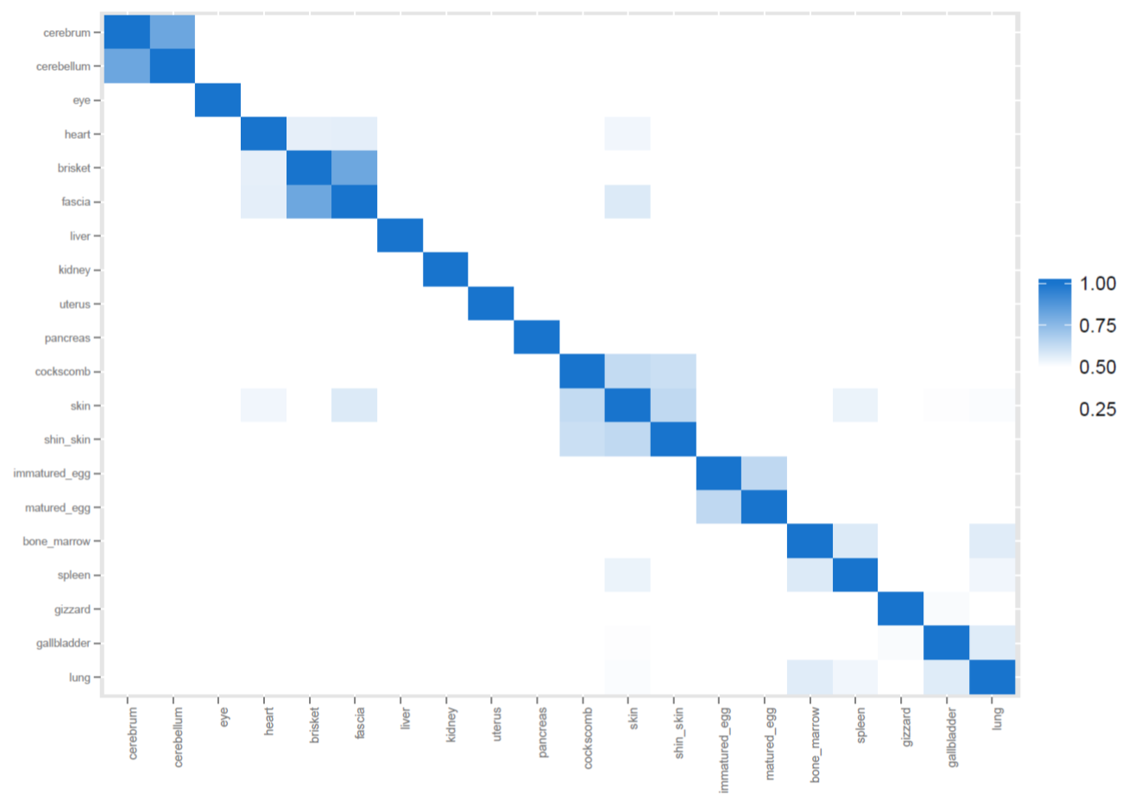
Figure S1 Correlation plot among the twenty tissues using Gene Expression Values

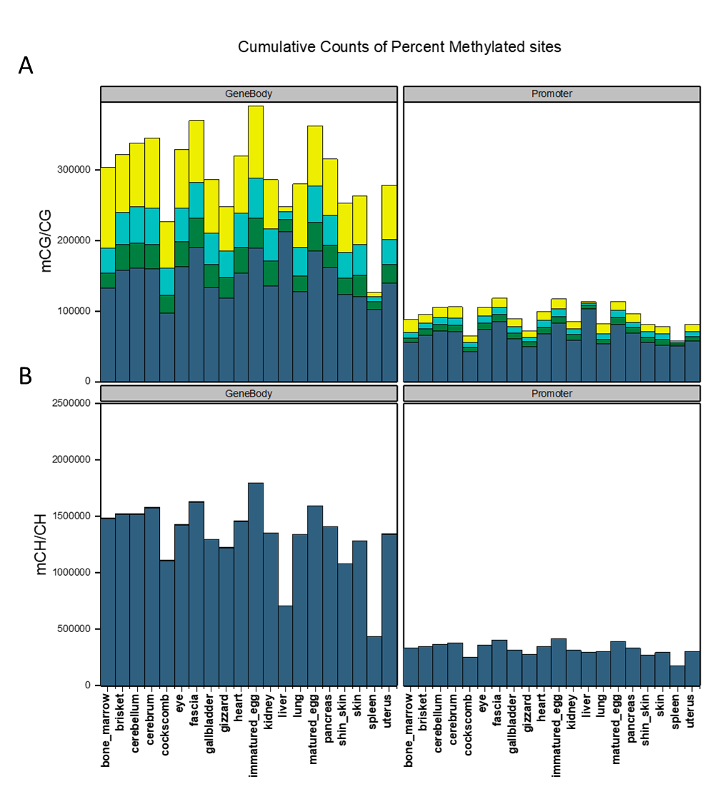
Figure S2 Cumulative count of DNA methylation Calling results.
The number of CpG sites(A) and non-CpG sites(B) were counted according to the converted genome information from bismark. The interval was divided and displayed every 0.25(Bright yellow: hypo-methylated DNA; dark blue: hyper-methylated DNA. Cyan: DNA methylation level 0.25–0.5; green: 0.5–0.75).

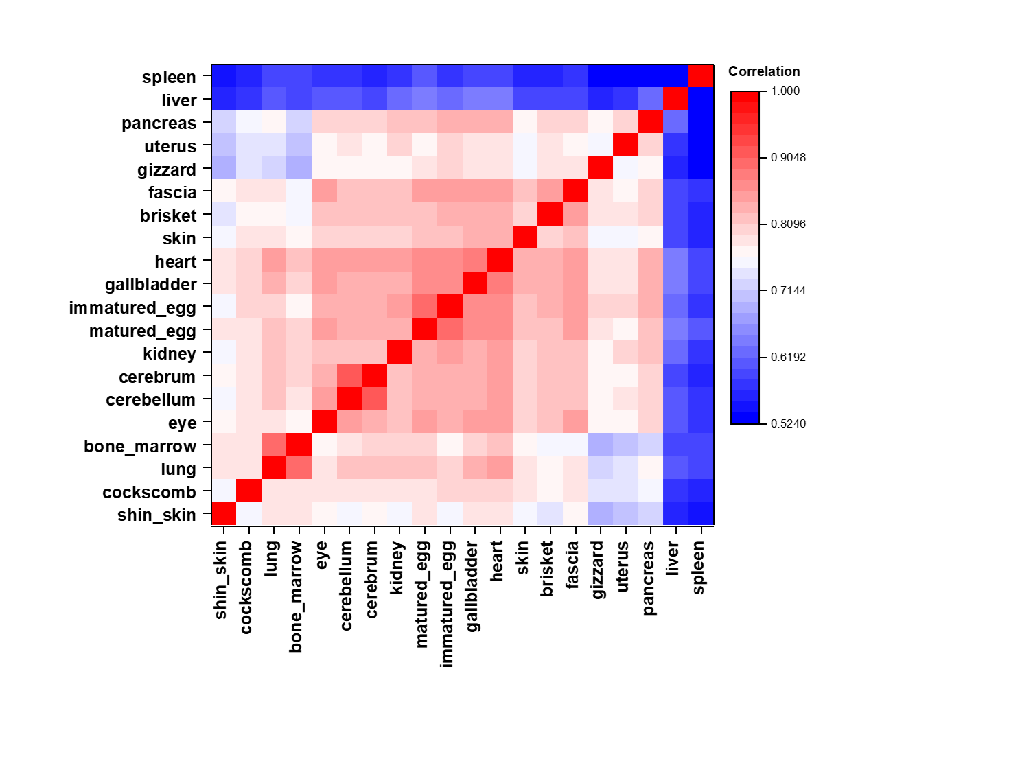
Figure S3 Correlation plot among the twenty tissues using DNA methylation levels

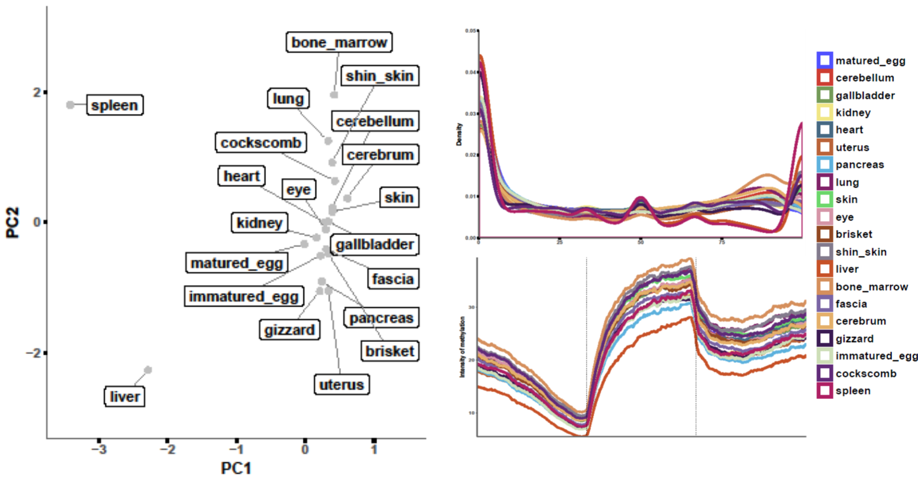
C
B
A
Figure S4 Overview of DNA methylation levels
(A) Principal Component Analysis plot of DNA methylation levels. (B) Smoothed and estimated density of DNA methylation in CpG sites. Density estimation was performed by geom_density from ggplot. Each lines represents accumulated intensity from hypo-methylation to hyper-methylation. (C) We assumed the all genes to be same length, and represents an average of DNA-methylation percentages from upstream 2000bp to downstream 2000bp around Transcription Start Site(TSS) and Transcription End Site(TES).

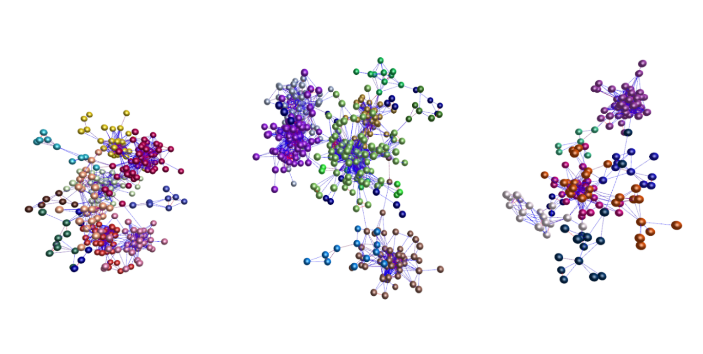
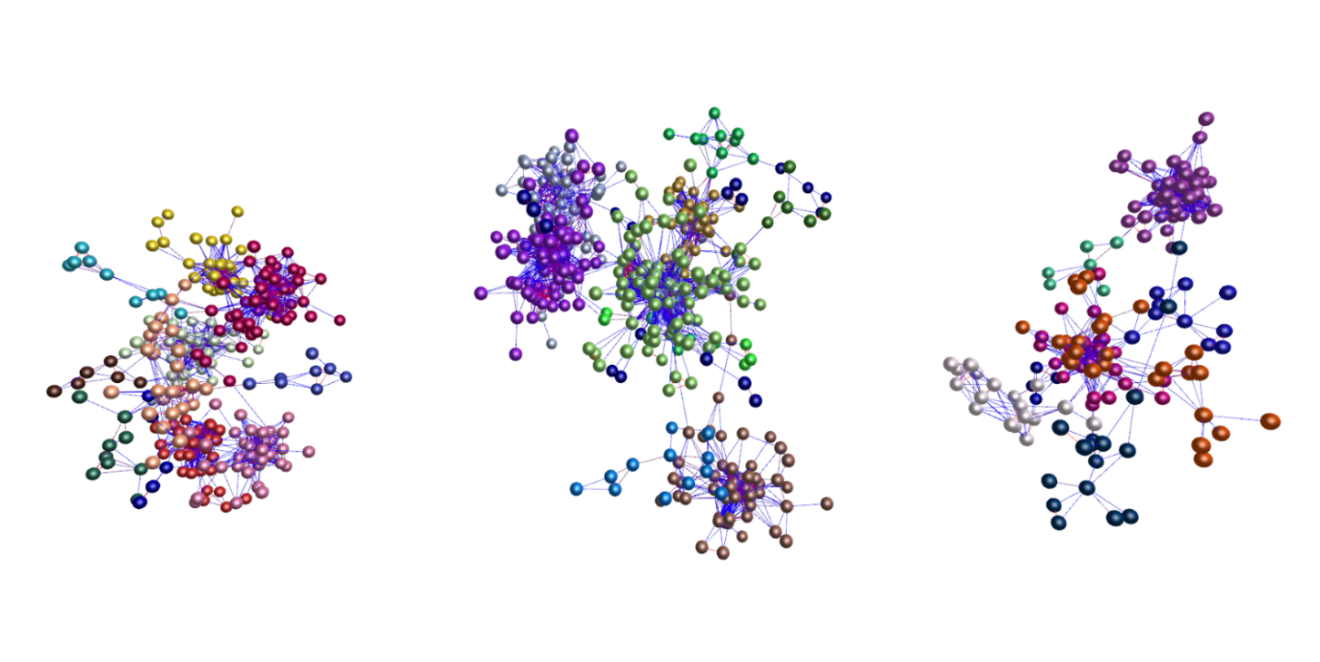
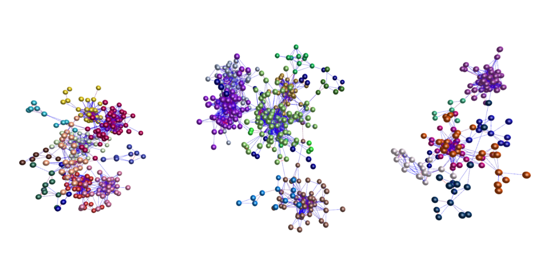
Figure S5 subnetworks and GSEAs of the GSMs.
6
12
13
9
10
4
1
2
3
7
5
11
8
A
B
C

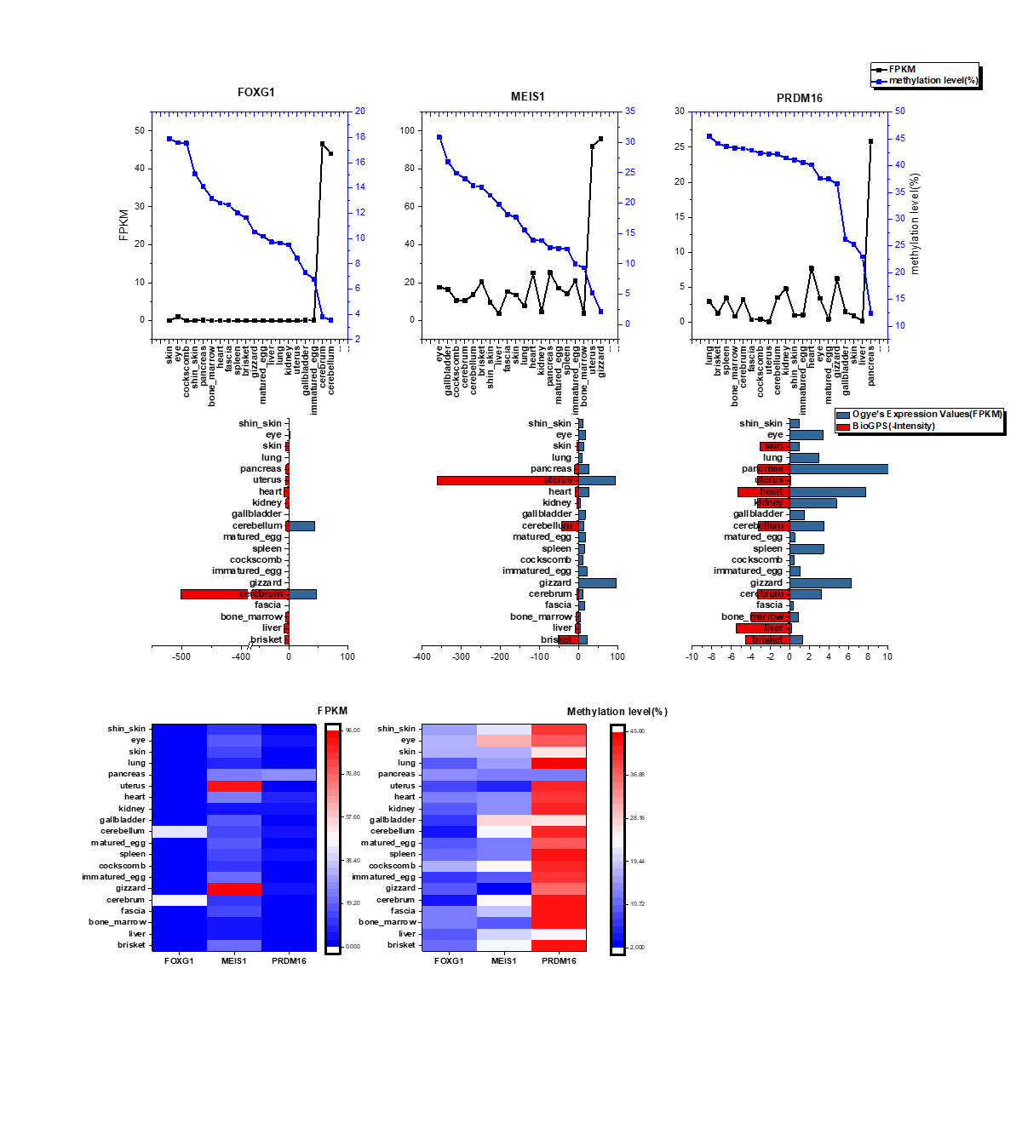
C
B
Figure S6 Correlation and tissue specific characteristics of three genes which searching for GSMs in the imprintome database.
(A) DNA methylation and Gene expression values per tissues. We sorted tissues based on DNA methylation levels. (B) Comparison of gene expression values of BioGPS and imprinted genes. The tissues that perform the same function in human were selected and compared with.( SmoothMuscle, Retina, Uterus, CerebellumPeduncles, Bonemarrow, Pancreas, SkeletalMuscle, Liver, Heart, Cerebellum, Skin and Kidney) (C) Comparison of DNA methylation and Gene expression values between the imprinted genes.
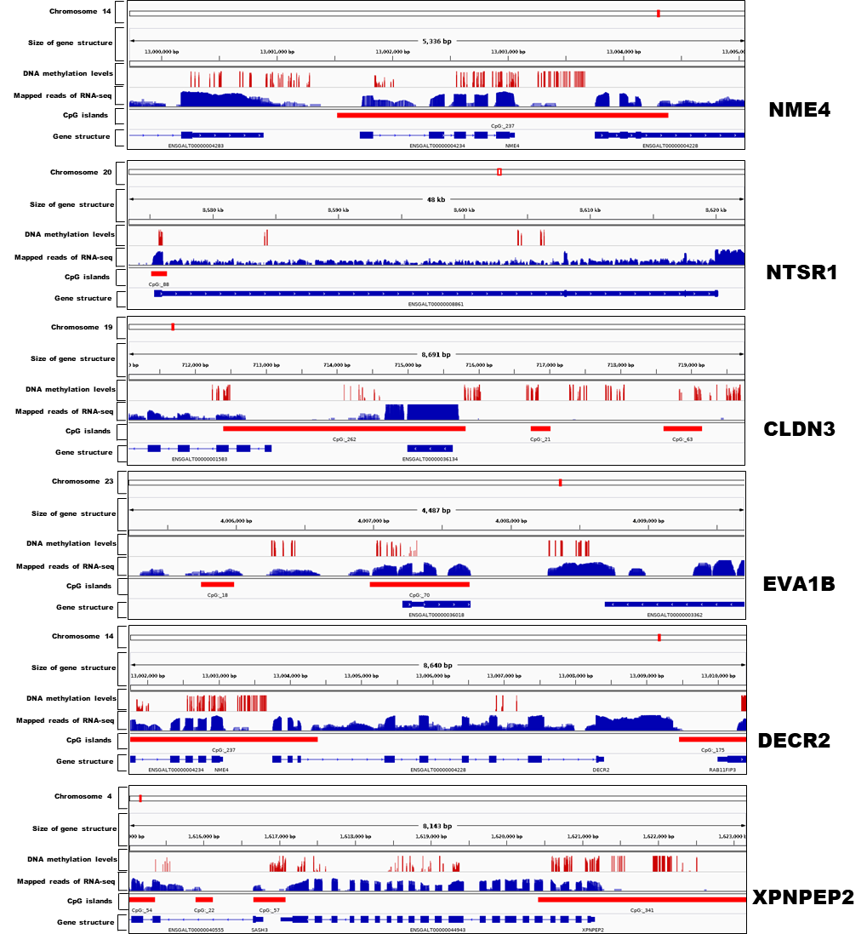
Figure S7 Gene structures of the 6 highly correlated GSMs.

