**Appendix 1. Flowchart of PRISMA-P Meta-Analysis Protocol**

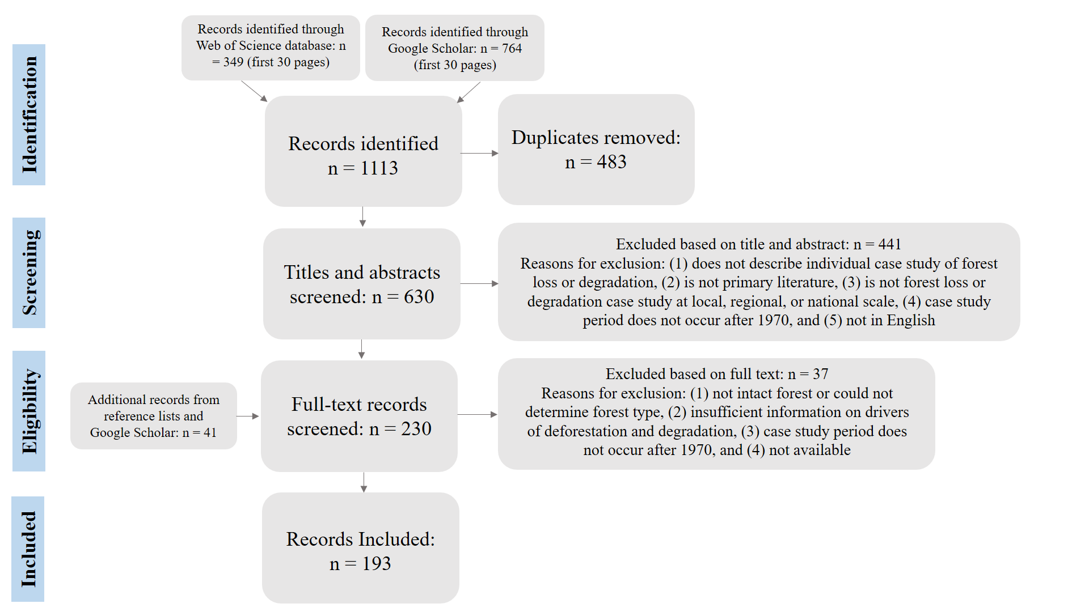

The figure above shows the flowchart of the PRISMA literature search process conducted to develop the case study database of regional cases of IF loss.

**Appendix 2. Geographical Location of Meta-Analysis Case Studies**

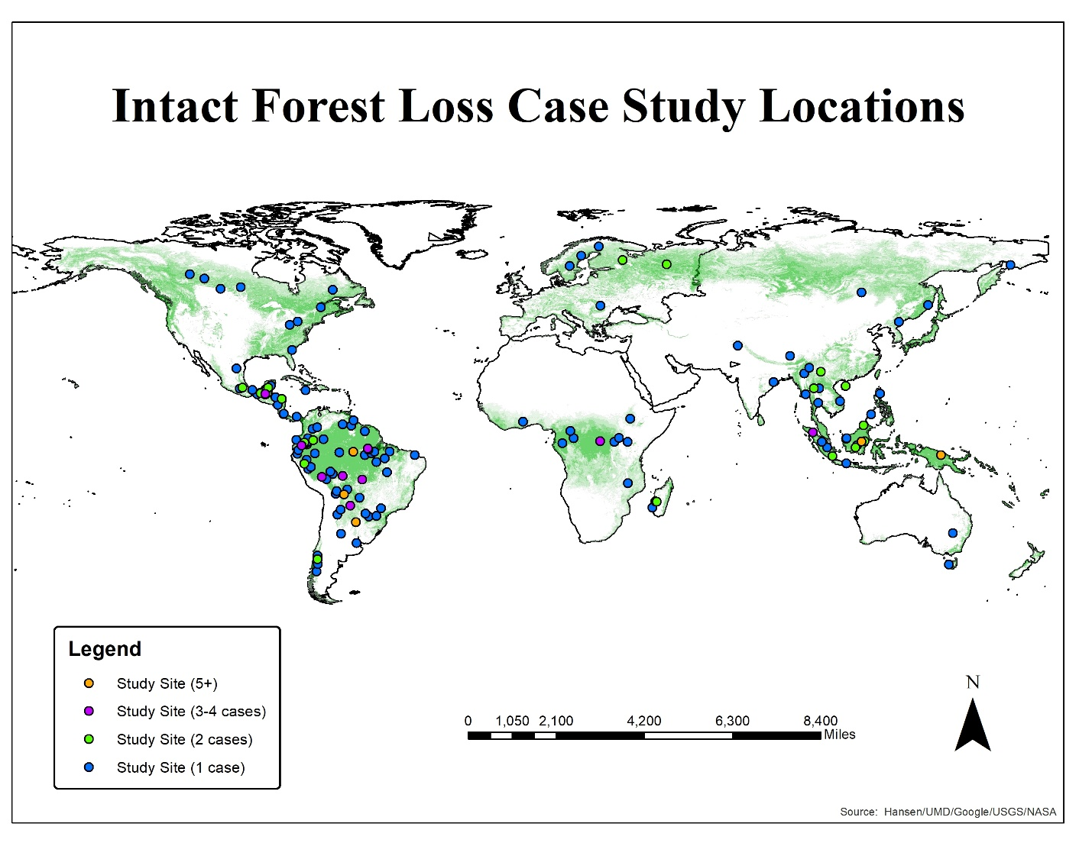

Appendix 2. The figure above shows the location of the case studies of intact forest loss assessed. Study locations were plotted based on the study site described in the publication. When precise locations for a study were not given, the nearest known city or province was used. For studies that covered a large geographic area (e.g., Amazon basin), the nearest major city at the center of the study area was used. The forest cover base map is for the year 2000 and was produced by Hansen et al. (2013).

**Appendix 3. Database of Case Studies of Intact Forest Loss Reviewed.** The table below shows the case studies analyzed in this meta-analysis study. Additional information provided for each case study includes the time period of the case and its region, country, and forest type.

|  |  |  |  |  |
| --- | --- | --- | --- | --- |
| **Full Article Citation** | **Period of Study** | **Region** | **Country** | **Forest Type** |
| Abbot, J. I., & Homewood, K. (1999). A history of change: causes of miombo woodland decline in a protected area in Malawi. Journal of Applied Ecology, 36(3), 422-433. | 1982-1990 | Africa | Malawi | Tropical Dry |
| Achard, F., Mollicone, D., Stibig, H. J., Aksenov, D., Laestadius, L., Li, Z., ... & Yaroshenko, A. (2006). Areas of rapid forest-cover change in boreal Eurasia. Forest Ecology and Management, 237(1-3), 322-334. | 1995-2005 | Europe-Russia | Russia | Boreal |
| Aksenov, D. (2002). Atlas of Russia's intact forest landscapes. Biodiversity Conservation Center. | 1999-2001 | Europe-Russia | Russia | Boreal |
| Aldrich, S. P., Walker, R. T., Arima, E. Y., Caldas, M. M., Browder, J. O., & Perz, S. (2006). Land‐cover and land‐use change in the Brazilian Amazon: smallholders, ranchers, and frontier stratification. Economic Geography, 82(3), 265-288. | 1986-2002 | Latin America | Brazil | Tropical Wet |
| Aldrich, S., Walker, R., Simmons, C., Caldas, M., & Perz, S. (2012). Contentious land change in the Amazon's arc of deforestation. Annals of the Association of American Geographers, 102(1), 103-128. | 1984-2003 | Latin America | Brazil | Tropical Wet |
| Ali, J., Benjaminsen, T. A., Hammad, A. A., & Dick, Ø. B. (2005). The road to deforestation: An assessment of forest loss and its causes in Basho Valley, Northern Pakistan. Global Environmental Change, 15(4), 370-380. | 1968-2005 | Asia | Pakistan | Tropical Dry |
| Alvarez, N. L., & Naughton-Treves, L. (2003). Linking national agrarian policy to deforestation in the Peruvian Amazon: a case study of Tambopata, 1986–1997. AMBIO: A Journal of the Human Environment, 32(4), 269-275. | 1986- 2001 | Latin America | Peru | Tropical Wet |
| Angelsen, A. (1995). Shifting cultivation and “deforestation”: a study from Indonesia. World Development, 23(10), 1713-1729. | 1991-1992 | Asia | Indonesia | Tropical Wet |
| Armenteras, D., Rodríguez, N., Retana, J., & Morales, M. (2011). Understanding deforestation in montane and lowland forests of the Colombian Andes. Regional Environmental Change, 11(3), 693-705. | 1985-2005 | Latin America | Colombia | Tropical Wet |
| Armenteras, D., Rudas, G., Rodriguez, N., Sua, S., & Romero, M. (2006). Patterns and causes of deforestation in the Colombian Amazon. Ecological Indicators, 6(2), 353-368. | 1985-2001 | Latin America | Colombia | Tropical Wet |
| Arvor, D., Dubreuil, V., Simões, M., & Bégué, A. (2013). Mapping and spatial analysis of the soybean agricultural frontier in Mato Grosso, Brazil, using remote sensing data. GeoJournal, 78(5), 833-850. | 2000-2006 | Latin America | Brazil | Tropical Wet |
| Barber, C. V., & Schweithelm, J. (2000). Trial by Fire: Forest Fires and Forestry Policy in Indonesia’s Era of Crisis and Reform (World Resources Institute, Forest Frontiers Initiative, Washington, DC). | 1997-1998 | Latin America | Indonesia | Tropical Wet |
| Barbieri, A. F., & Carr, D. L. (2005). Gender-specific out-migration, deforestation and urbanization in the Ecuadorian Amazon. Global and Planetary Change, 47(2-4), 99-110. | 1990-1999 | Latin America | Ecuador | Tropical Wet |
| Barbieri, A. F., Carr, D. L., & Bilsborrow, R. E. (2009). Migration within the frontier: the second generation colonization in the Ecuadorian Amazon. Population Research and Policy Review, 28(3), 291-320. | 1990-1999 | Latin America | Ecuador | Tropical Wet |
| Bass, M. S., Finer, M., Jenkins, C. N., Kreft, H., Cisneros-Heredia, D. F., McCracken, S. F., ... & Di Fiore, A. (2010). Global conservation significance of Ecuador's Yasuní National Park. PloS one, 5(1), e8767. | 2000's | Latin America | Ecuador | Tropical Wet |
| Baumann, M., Gasparri, I., Piquer‐Rodríguez, M., Gavier Pizarro, G., Griffiths, P., Hostert, P., & Kuemmerle, T. (2017). Carbon emissions from agricultural expansion and intensification in the Chaco. Global Change Biology, 23(5), 1902-1916. | 1985-2013 | Latin America | Argentina, Paraguay, Bolivia | Tropical Dry |
| Baumann, M., Israel, C., Piquer-Rodríguez, M., Gavier-Pizarro, G., Volante, J. N., & Kuemmerle, T. (2017). Deforestation and cattle expansion in the Paraguayan Chaco 1987–2012. Regional Environmental Change, 17(4), 1179-1191. | 1987-2012 | Latin America | Paraguay | Tropical Dry |
| Bax, V., Francesconi, W., & Quintero, M. (2016). Spatial modeling of deforestation processes in the Central Peruvian Amazon. Journal for Nature Conservation, 29, 79-88. | 2007–2014 | Latin America | Peru | Tropical Wet |
| Bhagwat, T., Hess, A., Horning, N., Khaing, T., Thein, Z. M., Aung, K. M., ... & Neil, A. (2017). Losing a jewel—Rapid declines in Myanmar’s intact forests from 2002-2014. PloS one, 12(5), e0176364. | 2002-2014 | Asia | Myanmar | Tropical Wet |
| Bianchi, C. A., & Haig, S. M. (2013). Deforestation trends of tropical dry forests in central Brazil. Biotropica, 45(3), 395-400. | 1977-2008 | Latin America | Brazil | Tropical Dry |
| Boletta, P. E., Ravelo, A. C., Planchuelo, A. M., & Grilli, M. (2006). Assessing deforestation in the Argentine Chaco. Forest Ecology and Management, 228(1-3), 108-114. | 1975-1999 | Latin America | Argentina | Tropical Dry |
| Bong, I. W., Felker, M. E., & Maryudi, A. (2016). How are local people driving and affected by forest cover change? Opportunities for local participation in REDD+ measurement, reporting and verification. PloS one, 11(11), e0145330. | 2013-2014 | Asia | Papua New Guinea, Indonesia | Tropical Wet |
| Bouchard, M., & Pothier, D. (2011). Long-term influence of fire and harvesting on boreal forest age structure and forest composition in eastern Québec. Forest Ecology and Management, 261(4), 811-820. | 1800-2000 | North America | Canada | Boreal |
| Boucher, Y., Grondin, P., & Auger, I. (2014). Land use history (1840–2005) and physiography as determinants of southern boreal forests. Landscape Ecology, 29(3), 437-450. | 1840-2005 | North America | Canada | Boreal |
| Bowen, D. (2002). Agricultural expansion in northern Alberta. Geographical Review, 92(4), 503-525. | 1970-2001 | North America | Canada | Boreal |
| Bradley, A., & Millington, A. (2008). Coca and colonists: quantifying and explaining forest clearance under coca and anti-narcotics policy regimes. Ecology and Society, 13(1). | 1963-2003 | Latin America | Bolivia | Tropical Wet |
| Bradshaw, C. J. (2012). Little left to lose: deforestation and forest degradation in Australia since European colonization. Journal of Plant Ecology, 5(1), 109-120. | 19th century-2010 | Australia | Australia | Temperate |
| Brando, P. M., Coe, M. T., DeFries, R., & Azevedo, A. A. (2013). Ecology, economy and management of an agroindustrial frontier landscape in the southeast Amazon. Phil Trans R Soc B 368: 20120152. | 1990-2005 | Latin America | Brazil | Tropical Wet |
| Brandt, J. S., Butsic, V., Schwab, B., Kuemmerle, T., & Radeloff, V. C. (2015). The relative effectiveness of protected areas, a logging ban, and sacred areas for old-growth forest protection in southwest China. Biological Conservation, 181, 1-8. | 1990-2009 | Asia | China | Tropical Wet |
| Brandt, J. S., Kuemmerle, T., Li, H., Ren, G., Zhu, J., & Radeloff, V. C. (2012). Using Landsat imagery to map forest change in southwest China in response to the national logging ban and ecotourism development. Remote Sensing of Environment, 121, 358-369. | 1974-2009 | Asia | China | Temperate |
| Bray, D.B., Klepeis, P. (2005). Deforestation, forest transitions, and institutions for sustainability in Southeastern Mexico, 1900-2000. Environment and History, 11, 195-223. | 1900-2003 | Latin America | Mexico | Tropical Wet |
| Brookfield, H., & Byron, Y. (1990). Deforestation and timber extraction in Borneo and the Malay Peninsula: the record since 1965. Global Environmental Change, 1(1), 42-56. | 1965-1990 | Asia | Indonesia | Tropical Wet |
| Brunner, J., Talbott, K., & Elkin, C. (1998). Logging Burma's frontier forests: resources and the regime. Washington, DC: World Resources Institute. | 1948-1990's | Asia | Myanmar | Tropical Wet |
| Burnett, C., Fall, A., Tomppo, E., & Kalliola, R. (2003). Monitoring current status of and trends in boreal forest land use in Russian Karelia. Conservation Ecology, 7(2). | 1988-1999 | Europe-Russia | Russia | Boreal |
| Caldas, M. M., Goodin, D., Sherwood, S., Campos Krauer, J. M., & Wisely, S. M. (2015). Land-cover change in the Paraguayan Chaco: 2000–2011. Journal of Land Use Science, 10(1), 1-18. | 2000-2011 | Latin America | Paraguay | Subtropical Dry |
| Carr, D. (2009). Population, Rural Development, and Land Use Among Settler Households in an Agricultural Frontier in Guatemala's Maya Biosphere Reserve. Journal of International & Global Studies, 1(1). | 1997-2000 | Latin America | Guatemala | Tropical Wet |
| Carr, D.L. (2008). Farm households and land use in a core conservation zone of the Maya Biosphere Reserve, Guatemala. Human Ecology, 36, 231-248. | 1960-2000 | Latin America | Guatemala | Tropical Wet |
| Cayuela, L., Benayas, J. M. R., & Echeverría, C. (2006). Clearance and fragmentation of tropical montane forests in the Highlands of Chiapas, Mexico (1975–2000). Forest Ecology and Management, 226(1-3), 208-218. | 1975-2000 | Latin America | Mexico | Tropical Wet |
| Chai, S. L., Tanner, E., & McLaren, K. (2009). High rates of forest clearance and fragmentation pre-and post-National Park establishment: The case of a Jamaican montane rainforest. Biological Conservation, 142(11), 2484-2492. | 1983-2002 | Latin America | Jamaica | Tropical Wet |
| Chowdhury, R. R. (2006). Landscape change in the Calakmul Biosphere Reserve, Mexico: Modeling the driving forces of smallholder deforestation in land parcels. Applied Geography, 26(2), 129-152. | 1987-1996 | Latin America | Mexico | Tropical Dry |
| Colchester, M. (1997). Guyana: Fragile frontier. Race & Class, 38(4), 33-56. | 1750-1995 | Latin America | Guyana | Tropical Wet |
| Curran, L. M., Trigg, S. N., McDonald, A. K., Astiani, D., Hardiono, Y. M., Siregar, P., ... & Kasischke, E. (2004). Lowland forest loss in protected areas of Indonesian Borneo. Science, 303(5660), 1000-1003. | 1985-2001 | Asia | Indonesia | Tropical Wet |
| Cushman, S. A., & Wallin, D. O. (2000). Rates and patterns of landscape change in the Central Sikhote-alin Mountains, Russian Far East. Landscape Ecology, 15(7), 643-659. | 1972-1992 | Europe-Russia | Russia | Temperate |
| Delang, C. O. (2002). Deforestation in northern Thailand: The result of Hmong farming practices or Thai development strategies?. Society & Natural Resources, 15(6), 483-501. | 1960-2000 | Asia | Thailand | Tropical Wet |
| Dennis, R. A., & Colfer, C. P. (2006). Impacts of land use and fire on the loss and degradation of lowland forest in 1983–2000 in East Kutai District, East Kalimantan, Indonesia. Singapore Journal of Tropical Geography, 27(1), 30-48. | 1983-2000 | Asia | Indonesia | Tropical Dry |
| Durand, L., & Lazos, E. (2004). Colonization and tropical deforestation in the Sierra Santa Marta, southern Mexico. Environmental Conservation, 31(1), 11-21. | 1960-1998 | Latin America | Mexico | Tropical Wet |
| Echeverría, C., Newton, A., Nahuelhual, L., Coomes, D., & Rey-Benayas, J. M. (2012). How landscapes change: integration of spatial patterns and human processes in temperate landscapes of southern Chile. Applied Geography, 32(2), 822-831. | 1985-2010 | Latin America | Chile | Temperate |
| Eder, J. F. (1990). Deforestation and detribalization in the Philippines: the Palawan case. Population and Environment, 12(2), 99-115. | 1903-1990 | Asia | Philippines | Tropical Wet |
| Eilenberg, M. (2015). Shades of green and REDD: Local and global contestations over the value of forest versus plantation development on the Indonesian forest frontier. Asia Pacific Viewpoint, 56(1), 48-61. | 2001-2013 | Asia | Indonesia | Tropical Wet |
| Environmental Investigation Agency. (2009). Up for Grabs: Deforestation and Exploitation in Papua's Plantations Boom. Telepak Foundation: 1-28. ISBN: 0-9540768-8-5. | 2000's | Asia | Papua New Guinea | Tropical Wet |
| Ericsson, T. S., Berglund, H., & Östlund, L. (2005). History and forest biodiversity of woodland key habitats in south boreal Sweden. Biological Conservation, 122(2), 289-303. | 1867-1999 | Europe-Russia | Sweden | Boreal |
| Essen, P.A., Ehnstrom, B., Ericson, L., Sjoberg, K. (1997). Boreal Forests. Ecological Bulletins, 46, 16-47. | 1600-1990 | Europe-Russia | Sweden, Finland, Norway | Boreal |
| Etter, A., McAlpine, C., Phinn, S., Pullar, D., & Possingham, H. (2006). Characterizing a tropical deforestation wave: a dynamic spatial analysis of a deforestation hotspot in the Colombian Amazon. Global Change Biology, 12(8), 1409-1420. | 1989-2002 | Latin America | Colombia | Tropical Dry |
| Etter, A., McAlpine, C., Phinn, S., Pullar, D., & Possingham, H. (2006). Unplanned land clearing of Colombian rainforests: Spreading like disease?. Landscape and Urban Planning, 77(3), 240-254. | 1989-2002 | Latin America | Colombia | Tropical Wet |
| Etter, A., McAlpine, C., Pullar, D., & Possingham, H. (2006). Modelling the conversion of Colombian lowland ecosystems since 1940: Drivers, patterns and rates. Journal of Environmental Management, 79(1), 74-87. | 1940-2000 | Latin America | Colombia | Tropical Wet |
| Fearnside, P. M. (2005). Deforestation in Brazilian Amazonia: history, rates, and consequences. Conservation Biology, 19(3), 680-688. | 1970-2002 | Latin America | Brazil | Tropical Wet |
| Fischer, A., & Vasseur, L. (2000). The crisis in shifting cultivation practices and the promise of agroforestry: a review of the Panamanian experience. Biodiversity & Conservation, 9(6), 739-756. | 1980-1999 | Latin America | Panama | Tropical Wet |
| Flamenco-Sandoval, A., Ramos, M. M., & Masera, O. R. (2007). Assessing implications of land-use and land-cover change dynamics for conservation of a highly diverse tropical rain forest. Biological Conservation, 138(1-2), 131-145. | 1986-2000 | Latin America | Mexico | Tropical Wet |
| Fox, J., Krummel, J., Yarnasarn, S., Ekasingh, M., & Podger, N. (1995). Land-use and landscape dynamics in northern Thailand: Assessing change in three upland watersheds since 1954. AMBIO: A Journal of the Human Environment, 24(6), 328-334. | 1954-1992 | Asia | Thailand | Tropical Wet |
| Fujisaka, S., Bell, W., Thomas, N., Hurtado, L., & Crawford, E. (1996). Slash-and-burn agriculture, conversion to pasture, and deforestation in two Brazilian Amazon colonies. Agriculture, Ecosystems & Environment, 59(1-2), 115-130. | 1990-1995 | Latin America | Brazil | Tropical Wet |
| Fuller, D. O., Jessup, T. C., & Salim, A. (2004). Loss of forest cover in Kalimantan, Indonesia, since the 1997–1998 El Nino. Conservation Biology, 18(1), 249-254. | 1996-2002 | Asia | Indonesia | Tropical Wet |
| Galford, G. L., Melillo, J. M., Kicklighter, D. W., Mustard, J. F., Cronin, T. W., Cerri, C. E., & Cerri, C. C. (2011). Historical carbon emissions and uptake from the agricultural frontier of the Brazilian Amazon. Ecological Applications, 21(3), 750-763. | 1901-2006 | Latin America | Brazil | Subtropical Wet |
| Galicia, L., & García-Romero, A. (2007). Land use and land cover change in highland temperate forests in the Izta-Popo National Park, central Mexico. Mountain Research and Development, 48-57. | 1970-2000 | Latin America | Mexico | Temperate |
| Galicia, L., & García-Romero, A. (2007). Land use and land cover change in highland temperate forests in the Izta-Popo National Park, central Mexico. Mountain Research and Development, 48-57. | 1970-2000 | Latin America | Mexico | Temperate |
| Gasparri, N. I., & Grau, H. R. (2009). Deforestation and fragmentation of Chaco dry forest in NW Argentina (1972–2007). Forest Ecology and Management, 258(6), 913-921. | 1972-2007 | Latin America | Argentina | Tropical Dry |
| Gaveau, D. L., Kshatriya, M., Sheil, D., Sloan, S., Molidena, E., Wijaya, A., ... & Guariguata, M. R. (2013). Reconciling forest conservation and logging in Indonesian Borneo. PloS one, 8(8), e69887. | 2000-2010 | Asia | Indonesia | Tropical Wet |
| Gaveau, D. L., Linkie, M., Levang, P., & Leader-Williams, N. (2009). Three decades of deforestation in southwest Sumatra: effects of coffee prices, law enforcement and rural poverty. Biological Conservation, 142(3), 597-605. | 1972-2006 | Asia | Indonesia | Tropical Wet |
| Gill, L. (1987). Frontier expansion and settlement in lowland Bolivia. The Journal of Peasant Studies, 14(3), 380-398. | 1952-1984 | Latin America | Bolivia | Tropical Wet |
| Godar, J., Tizado, E. J., & Pokorny, B. (2012). Who is responsible for deforestation in the Amazon? A spatially explicit analysis along the Transamazon Highway in Brazil. Forest Ecology and Management, 267, 58-73. | 1986-2007 | Latin America | Brazil | Tropical Wet |
| Godoy, R., Groff, S., & O'neill, K. (1998). The role of education in neotropical deforestation: Household evidence from Amerindians in Honduras. Human Ecology, 26(4), 649-675. | 1995-1996 | Latin America | Honduras | Tropical Wet |
| Godoy, R., O'neill, K., Groff, S., Kostishack, P., Cubas, A., Demmer, J., ... & Martinez, M. (1997). Household determinants of deforestation by Amerindians in Honduras. World Development, 25(6), 977-987. | 1994-1996 | Latin America | Honduras | Tropical Wet |
| Grau, H. R., Gasparri, N. I., & Aide, T. M. (2008). Balancing food production and nature conservation in the Neotropical dry forests of northern Argentina. Global Change Biology, 14(5), 985-997. | 1970-2002 | Latin America | Argentina | Tropical Dry |
| Grau, H.R., Gasparri, N.I., Aide, T.M. (2005). Agricultural expansion and deforestation in seasonally dry forests of north-west Argentina. Environmental Conservation. 32(2), 140-148. | 1972-2001 | Latin America | Argentina | Tropical Dry |
| Hammond, D. S., Gond, V., De Thoisy, B., Forget, P. M., & DeDijn, B. P. (2007). Causes and consequences of a tropical forest gold rush in the Guiana Shield, South America. AMBIO: A Journal of the Human Environment, 36(8), 661-671. | 1930-2005 | Latin America | Guyana | Tropical Wet |
| Hartter, J., Ryan, S. J., Southworth, J., & Chapman, C. A. (2011). Landscapes as continuous entities: forest disturbance and recovery in the Albertine Rift landscape. Landscape Ecology, 26(6), 877. | 1984-2008 | Africa | Uganda | Tropical Dry |
| Hecht, S. B. (2005). Soybeans, development and conservation on the Amazon frontier. Development and Change, 36(2), 375-404. | 1990s | Latin America | Bolivia | Tropical Wet |
| Hobson, K. A., Bayne, E. M., & Van Wilgenburg, S. L. (2002). Large‐scale conversion of forest to agriculture in the boreal plains of Saskatchewan. Conservation Biology, 16(6), 1530-1541. | 1966-1994 | North America | Canada | Boreal |
| Hobson, K. A., Bayne, E. M., & Van Wilgenburg, S. L. (2002). Large‐scale conversion of forest to agriculture in the boreal plains of Saskatchewan. Conservation Biology, 16(6), 1530-1541. | 1916-1994 | North America | Canada | Boreal |
| Holland, T. G., Coomes, O. T., & Robinson, B. E. (2016). Evolving frontier land markets and the opportunity cost of sparing forests in western Amazonia. Land Use Policy, 58, 456-471. | 2003-2013 | Latin America | Peru | Tropical Wet |
| Hough, P. A. (2011). Disarticulations and commodity chains: cattle, coca, and capital accumulation along Colombia's agricultural frontier. Environment and Planning A, 43(5), 1016-1034. | 1960-1990 | Latin America | Colombia | Tropical Wet |
| Huang, C., Kim, S., Altstatt, A., Townshend, J. R., Davis, P., Song, K., ... & Musinsky, J. (2007). Rapid loss of Paraguay's Atlantic forest and the status of protected areas—A Landsat assessment. Remote sensing of Environment, 106(4), 460-466. | 1973-2000 | Latin America | Paraguay | Tropical Wet |
| Humphries, S. (1998). Milk cows, migrants, and land markets: unraveling the complexities of forest-to-pasture conversion in Northern Honduras. Economic Development and Cultural Change, 47(1), 95-124. | 1993-1994 | Latin America | Honduras | Tropical Wet |
| Imbernon, J. (1999). A comparison of the driving forces behind deforestation in the Peruvian and the Brazilian Amazon AMBIO: A Journal of the Human Environment, 28(6), 509-13. | 1989-1996 | Latin America | Brazil | Tropical Wet |
| Janssen, T. A., Ametsitsi, G. K., Collins, M., Adu-Bredu, S., Oliveras, I., Mitchard, E. T., & Veenendaal, E. M. (2018). Extending the baseline of tropical dry forest loss in Ghana (1984–2015) reveals drivers of major deforestation inside a protected area. Biological Conservation, 218, 163-172. | 1984-2015 | Africa | Ghana | Tropical Dry |
| Jokisch, B. D., & Lair, B. M. (2002). One last stand? Forests and change on Ecuador's Eastern Cordillera. Geographical Review, 92(2), 235-256. | 1987-1998 | Latin America | Ecuador | Tropical Wet |
| Kaimowitz, D., & Smith, J. (2001). Soybean Technology and the Loss of Natural Vegetation in Brazil and Bolivia. Agricultural Technologies and Tropical Deforestation, Wallingford, Oxon, UK. | 1970-1998 | Latin America | Bolivia, Brazil | Tropical Dry |
| Killeen, T. J., Villegas, Z., Soria, L., Guerra, A., Calderón, V., Siles, T. M., ... & Moreno, A. G. R. (2005). Land-Use Change in Chiquitanía (Santa Cruz, Bolivia): indigenous lands, private property, and the failure of governance on the agricultural frontier. Museo de Historia Natural Noel Kempff Mercado, Santa Cruz, Bolivia. | 1975-2004 | Latin America | Bolivia | Tropical Dry |
| Kinnaird, M. F., Sanderson, E. W., O'brien, T. G., Wibisono, H. T., & Woolmer, G. (2003). Deforestation trends in a tropical landscape and implications for endangered large mammals. Conservation Biology, 17(1), 245-257. | 1985-1999 | Asia | Indonesia | Tropical Wet |
| Kirby, K. R., Laurance, W. F., Albernaz, A. K., Schroth, G., Fearnside, P. M., Bergen, S., ... & Da Costa, C. (2006). The future of deforestation in the Brazilian Amazon. Futures, 38(4), 432-453. | 1990-2003 | Latin America | Brazil | Tropical Wet |
| Kleinschroth, F., Healey, J. R., Gourlet‐Fleury, S., Mortier, F., & Stoica, R. S. (2017). Effects of logging on roadless space in intact forest landscapes of the Congo Basin. Conservation Biology, 31(2), 469-480. | 1999-2015 | Africa | Republic of Congo, Cameroon, Central African Republic | Tropical Wet |
| Knorn, J., Kuemmerle, T., Radeloff, V.C., Keeton, W.S., Gancz, V., Biris, I.A., Svoboda, M., ... Hostert, P. (2012). Continued loss of temperate old-growth forests in the Romanian Carpathians despite an increasing protected area network. Environmental Conservation, 40(2), 182-193. | 2000-2010 | Europe-Russia | Romania | Temperate |
| Landers, J. L., Van Lear, D. H., & Boyer, W. D. (1995). The longleaf pine forests of the southeast: requiem or renaissance?. Journal of Forestry 93 (11): 39-44. | Late 1800s - 1995 | North America | United States of America | Temperate |
| Laurance, W. F., Alonso, A., Lee, M., & Campbell, P. (2006). Challenges for forest conservation in Gabon, Central Africa. Futures, 38(4), 454-470. | 1990's to early 2000's | Africa | Gabon | Tropical Wet |
| Laurance, W. F., Kakul, T., Keenan, R. J., Sayer, J., Passingan, S., Clements, G. R., ... & Sodhi, N. S. (2011). Predatory corporations, failing governance, and the fate of forests in Papua New Guinea. Conservation Letters, 4(2), 95-100. | 1990's-2000's | Asia | Papua New Guinea | Tropical Wet |
| Laurance, W. F., Kakul, T., Tom, M., Wahya, R., & Laurance, S. G. (2012). Defeating the ‘resource curse’: Key priorities for conserving Papua New Guinea’s native forests. Biological Conservation, 151(1), 35-40. | 1995-2010 | Asia | Papua New Guinea | Tropical Wet |
| Le Polain de Waroux, Y., Baumann, M., Gasparri, N. I., Gavier-Pizarro, G., Godar, J., Kuemmerle, T., ... & Meyfroidt, P. (2018). Rents, actors, and the expansion of commodity frontiers in the Gran Chaco. Annals of the American Association of Geographers, 108(1), 204-225. | 1985-2016 | Latin America | Bolivia, Paraguay, Argentina | Tropical Wet |
| Li, H., Aide, T. M., Ma, Y., Liu, W., & Cao, M. (2006). Demand for rubber is causing the loss of high diversity rain forest in SW China. In Plant Conservation and Biodiversity (pp. 157-171). Springer, Dordrecht. | 1976-2003 | Asia | China | Tropical Wet |
| Locher-Krause, K. E., Volk, M., Waske, B., Thonfeld, F., & Lautenbach, S. (2017). Expanding temporal resolution in landscape transformations: Insights from a landsat-based case study in Southern Chile. Ecological Indicators, 75, 132-144. | 1985-2011 | Latin America | Chile | Temperate |
| Mäki, S., Kalliola, R., & Vuorinen, K. (2001). Road construction in the Peruvian Amazon: process, causes and consequences. Environmental Conservation, 28(3), 199-214. | 1990-2001 | Latin America | Peru | Tropical Wet |
| Margono, B. A., Potapov, P. V., Turubanova, S., Stolle, F., & Hansen, M. C. (2014). Primary forest cover loss in Indonesia over 2000–2012. Nature Climate Change, 4(8), 730. | 2000-2012 | Asia | Indonesia | Tropical Wet |
| Margono, B. A., Turubanova, S., Zhuravleva, I., Potapov, P., Tyukavina, A., Baccini, A., ... & Hansen, M. C. (2012). Mapping and monitoring deforestation and forest degradation in Sumatra (Indonesia) using Landsat time series data sets from 1990 to 2010. Environmental Research Letters, 7(3), 034010. | 1990-2010 | Asia | Indonesia | Tropical Wet |
| Marquardt, K., Pain, A., Bartholdson, Ö., & Rengifo, L. R. (2019). Forest Dynamics in the Peruvian Amazon: Understanding Processes of Change. Small-scale Forestry, 18(1), 81-104. | 1960-2015 | Latin America | Peru | Tropical Wet |
| Marquette, C. M. (1998). Land use patterns among small farmer settlers in the Northeastern Ecuadorian Amazon. Human Ecology, 26(4), 573-598. | 1990 | Latin America | Ecuador | Tropical Wet |
| McMorrow, J., & Talip, M. A. (2001). Decline of forest area in Sabah, Malaysia: relationship to state policies, land code and land capability. Global Environmental Change, 11(3), 217-230. | 1890-2000 | Asia | Malaysia | Tropical Wet |
| Mena, C. F., Bilsborrow, R. E., & McClain, M. E. (2006). Socioeconomic drivers of deforestation in the Northern Ecuadorian Amazon. Environmental Management, 37(6), 802-815. | 1986-2002 | Latin America | Ecuador | Tropical Wet |
| Mertens, B., Poccard‐Chapuis, R., Piketty, M. G., Lacques, A. E., & Venturieri, A. (2002). Crossing spatial analyses and livestock economics to understand deforestation processes in the Brazilian Amazon: the case of Sao Felix do Xingu in South Para. Agricultural Economics, 27(3), 269-294. | 1980's-1990's | Latin America | Brazil | Tropical Wet |
| Mertens, B., Sunderlin, W. D., Ndoye, O., & Lambin, E. F. (2000). Impact of macroeconomic change on deforestation in South Cameroon: Integration of household survey and remotely-sensed data. World Development, 28(6), 983-999. | 1970's-1990's | Africa | Republic of Cameroon | Tropical Wet |
| Messina, J. P., Walsh, S. J., Mena, C. F., & Delamater, P. L. (2006). Land tenure and deforestation patterns in the Ecuadorian Amazon: Conflicts in land conservation in frontier settings. Applied Geography, 26(2), 113-128. | 1970-1999 | Latin America | Ecuador | Tropical Wet |
| Meyfroidt, P., Vu, T. P., & Hoang, V. A. (2013). Trajectories of deforestation, coffee expansion and displacement of shifting cultivation in the Central Highlands of Vietnam. Global Environmental Change, 23(5), 1187-1198. | 2000-2010 | Asia | Vietnam | Tropical Wet |
| Miettinen, J., Shi, C., & Liew, S. C. (2012). Two decades of destruction in Southeast Asia's peat swamp forests. Frontiers in Ecology and the Environment, 10(3), 124-128. | 1990-2010 | Asia | Malaysia, Indonesia | Tropical Wet |
| Miettinen, J., Wang, J., Hooijer, A., & Liew, S. (2013). Peatland conversion and degradation processes in insular Southeast Asia: a case study in Jambi, Indonesia. Land Degradation & Development, 24(4), 334-341. | 1970-2009 | Asia | Indonesia | Tropical Wet |
| Miranda, A., Altamirano, A., Cayuela, L., Pincheira, F., & Lara, A. (2015). Different times, same story: Native forest loss and landscape homogenization in three physiographical areas of south-central of Chile. Applied Geography, 60, 20-28. | 1973- 2008 | Latin America | Chile | Temperate |
| Miranda, M., Blanco, U. Q., Hernández, L., Ochoa, G., & Yerena, E. (1998). All that glitters is not gold: balancing conservation and development in Venezuela's frontier forests. World Resources Institute. | 1980-1990's | Latin America | Guyana | Tropical Wet |
| Moran, E. F. (1993). Deforestation and land use in the Brazilian Amazon. Human Ecology, 21(1), 1-21. | 1970's to early 1990's | Latin America | Brazil | Tropical Wet |
| Müller, D., & Mburu, J. (2009). Forecasting hotspots of forest clearing in Kakamega Forest, Western Kenya. Forest Ecology and Management, 257(3), 968-977. | 1989-2001 | Africa | Kenya | Tropical Wet |
| Müller, H., Griffiths, P., & Hostert, P. (2016). Long-term deforestation dynamics in the Brazilian Amazon—Uncovering historic frontier development along the Cuiabá–Santarém highway. International Journal of Applied Earth Observation and Geoinformation, 44, 61-69. | 1984-2012 | Latin America | Brazil | Tropical Wet |
| Müller, R., Pistorius, T., Rohde, S., Gerold, G., & Pacheco, P. (2013). Policy options to reduce deforestation based on a systematic analysis of drivers and agents in lowland Bolivia. Land Use Policy, 30(1), 895-907. | 1992-2004 | Latin America | Bolivia | Tropical Wet |
| Mwavu, E. N., & Witkowski, E. T. F. (2008). Land‐use and cover changes (1988–2002) around Budongo forest reserve, NW Uganda: Implications for forest and woodland sustainability. Land degradation & development, 19(6), 606-622. | 1988-2002 | Africa | Uganda | Tropical Wet |
| Nackoney, J., Molinario, G., Potapov, P., Turubanova, S., Hansen, M. C., & Furuichi, T. (2014). Impacts of civil conflict on primary forest habitat in northern Democratic Republic of the Congo, 1990–2010. Biological Conservation, 170, 321-328. | 1990-2010 | Africa | Democratic Republic of Congo | Tropical Wet |
| Naughton-Treves, L. (2004). Deforestation and carbon emissions at tropical frontiers: a case study from the Peruvian Amazon. World Development, 32(1), 173-190. | 1986-1997 | Latin America | Peru | Tropical Wet |
| Neira, E., Verscheure, H., & Revenga, C. (2002). Chile's frontier forests: conserving a global treasure (pp. 56). Global Forest Watch, World Resources Institute. | 1990's | Latin America | Chile | Temperate |
| Nolte, C., Gobbi, B., de Waroux, Y. L. P., Piquer-Rodríguez, M., Butsic, V., & Lambin, E. F. (2017). Decentralized Land Use Zoning Reduces Large-scale Deforestation in a Major Agricultural Frontier. Ecological Economics, 136, 30-40. | 1996-2007 | Latin America | Argentina | Tropical Dry |
| Nordberg, M., Angelstam, P., Elbakidze, M., & Axelsson, R. (2013). From logging frontier towards sustainable forest management: experiences from boreal regions of North-West Russia and North Sweden. Scandinavian Journal of Forest Research, 28(8), 797-810. | 1950-1990 | Europe-Russia | Russia | Boreal |
| Norton, T.W. (1996). Conserving biological diversity in Australia's temperate eucalypt forests. Forest Ecology and Management, 85, 21-33. | 1900-1995 | Australia | Australia | Temperate |
| Novotny, V. (2010). Rain forest conservation in a tribal world: why forest dwellers prefer loggers to conservationists. Biotropica, 42(5), 546-549. | 2000-2010 | Asia | Papua New Guinea | Tropical Wet |
| NZamorano-Elgueta, C., Benayas, J. M. R., Cayuela, L., Hantson, S., & Armenteras, D. (2015). Native forest replacement by exotic plantations in southern Chile (1985–2011) and partial compensation by natural regeneration. Forest Ecology and Management, 345, 10-20. | 1985-2011 | Latin America | Chile | Temperate |
| Ometto, J. P., Aguiar, A. P. D., & Martinelli, L. A. (2011). Amazon deforestation in Brazil: effects, drivers and challenges. Carbon Management, 2(5), 575-585. | 1971-2011 | Latin America | Brazil | Tropical Dry |
| Östlund, L., Zackrisson, O., & Axelsson, A. L. (1997). The history and transformation of a Scandinavian boreal forest landscape since the 19th century. Canadian Journal of Forest Research, 27(8), 1198-1206. | Late 1800s to Late 1900s | Europe-Russia | Sweden | Boreal |
| Pacheco, P. (2002). Deforestation and forest degradation in lowland Bolivia. Deforestation and land use in the Amazon. In Deforestation and Land Use in the Amazon (pp. 66-94). University of Florida Press. | 1975-1993 | Latin America | Bolivia | Tropical Wet |
| Pacheco, P. (2006). Agricultural expansion and deforestation in lowland Bolivia: the import substitution versus the structural adjustment model. Land Use Policy, 23(3), 205-225. | 1950-1999 | Latin America | Bolivia | Tropical Dry |
| Pacheco, P. (2009). Agrarian change, cattle ranching and deforestation: Assessing their linkages in southern Para. Environment and History, 15(4), 493-520. | 1960-2002 | Latin America | Brazil | Tropical Dry |
| Pacheco, P. (2012). Actor and frontier types in the Brazilian Amazon: Assessing interactions and outcomes associated with frontier expansion. Geoforum, 43(4), 864-874. | 2003-2010 | Latin America | Brazil | Tropical Wet |
| Parayil, G., & Tong, F. (1998). Pasture-led to logging-led deforestation: the dynamics of socio-environmental change in the Brazilian Amazon. Global Environmental Change, 8(1), 63-79. | 1978-1994 | Latin America | Brazil | Tropical Wet |
| Pedlowski, M. A., Dale, V. H., Matricardi, E. A., & da Silva Filho, E. P. (1997). Patterns and impacts of deforestation in Rondônia, Brazil. Landscape and Urban Planning, 38(3-4), 149-157. | 1978-1993 | Latin America | Brazil | Tropical Wet |
| Pedlowski, M. A., Matricardi, E. A. T., Skole, D., Cameron, S. R., Chomentowski, W., Fernandes, C., & Lisboa, A. (2005). Conservation units: A new deforestation frontier in the Amazonian state of Rondônia, Brazil. Environmental Conservation, 32(2), 149-155. | 1992-2002 | Latin America | Brazil | Tropical Wet |
| Peterson, G. D., & Heemskerk, M. (2001). Deforestation and forest regeneration following small-scale gold mining in the Amazon: the case of Suriname. Environmental Conservation, 28(2), 117-126. | 1985-2010 | Latin America | Suriname | Tropical Wet |
| Pichón, F. J. (1997). Settler households and land-use patterns in the Amazon frontier: farm-level evidence from Ecuador. World Development, 25(1), 67-91. | 1990 | Latin America | Ecuador | Tropical Wet |
| Pichon, F.J. (1997). Colonist land-allocation decisions, land use, and deforestation in the Ecuadorian Amazon frontier. Economic Development and Cultural Exchange, 45(4), 707-744. | 1970-1995 | Latin America | Ecuador | Tropical Wet |
| Pickell, P. D., Andison, D. W., Coops, N. C., Gergel, S. E., & Marshall, P. L. (2015). The spatial patterns of anthropogenic disturbance in the western Canadian boreal forest following oil and gas development. Canadian Journal of Forest Research, 45(6), 732-743. | 1949-2012 | North America | Canada | Boreal |
| Pinto-Ledezma, J. N., & Mamani, M. L. R. (2014). Temporal patterns of deforestation and fragmentation in lowland Bolivia: implications for climate change. Climatic Change, 127(1), 43-54. | 1976-2008 | Latin America | Bolivia | Tropical Dry |
| Réau, B. (2002). Burning for zebu: the complexity of deforestation issues in western Madagascar. Norsk Geografisk Tidsskrift, 56(3), 219-229. | 1950-2002 | Africa | Madagascar | Tropical Dry |
| Reddy, C. S., Rao, K. R. M., Pattanaik, C., & Joshi, P. K. (2009). Assessment of large-scale deforestation of Nawarangpur district, Orissa, India: a remote sensing based study. Environmental Monitoring and Assessment, 154(1-4), 325. | 1973-2004 | Asia | India | Tropical Dry |
| Redo, D., Millington, A. C., & Hindery, D. (2011). Deforestation dynamics and policy changes in Bolivia's post-neoliberal era. Land Use Policy, 28(1), 227-241. | 1985-2005 | Latin America | Bolivia | Tropical Wet |
| Reusing, M. (2000). Change detection of natural high forests in Ethiopia using remote sensing and GIS techniques. International Archives of Photogrammetry and Remote Sensing, 33(B7/3; PART 7), 1253-1258. | 1971-1997 | Africa | Ethiopia | Tropical Dry |
| Reynolds, G., Payne, J., Sinun, W., Mosigil, G., & Walsh, R. P. (2011). Changes in forest land use and management in Sabah, Malaysian Borneo, 1990–2010, with a focus on the Danum Valley region. Philosophical Transactions of the Royal Society B: Biological Sciences, 366(1582), 3168-3176. | 1990-2010 | Asia | Malaysia | Tropical Wet |
| Richards, P. (2015). What drives indirect land use change? How Brazil's agriculture sector influences frontier deforestation. Annals of the Association of American Geographers, 105(5), 1026-1040. | 1970s to present | Latin America | Brazil | Tropical Dry |
| Richards, P. D. (2011). Soy, cotton, and the final Atlantic forest frontier. The Professional Geographer, 63(3), 343-363. | 1945-2000 | Latin America | Paraguay | Tropical Wet |
| Rigg, J. (1993). Forests and farmers, land and livelihoods, changing resource realities in Thailand. Global Ecology and Biogeography Letters, 277-289. | 1960's-1980's | Asia | Thailand | Tropical Wet |
| Rozon, C., Lucotte, M., Davidson, R., Paquet, S., Oestreicher, J. S., Mertens, F., ... & Romana, C. (2015). Spatial and temporal evolution of family-farming land use in the Tapajós region of the Brazilian Amazon. Acta Amazonica, 45(2), 203-214. | 1986-2009 | Latin America | Brazil | Tropical Wet |
| Rudel, T. K. (1995). When do property rights matter? Open access, informal social controls, and deforestation in the Ecuadorian Amazon. Human Organization, 187-194. | 1965-1990 | Latin America | Ecuador | Tropical Wet |
| Sader, S. A., & Joyce, A. T. (1988). Deforestation rates and trends in Costa Rica, 1940 to 1983. Biotropica, 11-19. | 1940-1983 | Latin America | Costa Rica | Tropical Wet |
| Sader, S. A., Sever, T., Smoot, J. C., & Richards, M. (1994). Forest change estimates for the northern Petén region of Guatemala—1986–1990. Human Ecology, 22(3), 317-332. | 1986-1990 | Latin America | Guatemala | Tropical Wet |
| Scales, I. R. (2011). Farming at the forest frontier: Land use and landscape change in Western Madagascar, 1896-2005. Environment and History, 17(4), 499-524. | 1896-2005 | Africa | Madagascar | Tropical Dry |
| Schelhas, J., & Sánchez-Azofeifa, G. A. (2006). Post-frontier forest change adjacent to Braulio Carrillo National Park, Costa Rica. Human Ecology, 34(3), 407. | 1980's-2000's | Latin America | Costa Rica | Tropical Wet |
| Schwartzman, S., Boas, A. V., Ono, K. Y., Fonseca, M. G., Doblas, J., Zimmerman, B., ... & Torres, M. (2013). The natural and social history of the indigenous lands and protected areas corridor of the Xingu River basin. Phil. Trans. R. Soc. B, 368(1619), 20120164. | 1950s to Present | Latin America | Brazil | Tropical Wet |
| Scullion, J. J., Vogt, K. A., Sienkiewicz, A., Gmur, S. J., & Trujillo, C. (2014). Assessing the influence of land-cover change and conflicting land-use authorizations on ecosystem conversion on the forest frontier of Madre de Dios, Peru. Biological Conservation, 171, 247-258. | 2006-2011 | Latin America | Peru | Tropical Wet |
| Seddon, N., Tobias, J., Yount, J. W., Ramanampamonjy, J. R., Butchart, S., & Randrianizahana, H. (2000). Conservation issues and priorities in the Mikea Forest of south-west Madagascar. Oryx, 34(4), 287-304. | 1962-2000 | Africa | Madagascar | Tropical Dry |
| Shearman, P. L., Ash, J., Mackey, B., Bryan, J. E., & Lokes, B. (2009). Forest conversion and degradation in Papua New Guinea 1972–2002. Biotropica, 41(3), 379-390. | 1972-2002 | Asia | Papa New Guinea | Tropical Dry |
| Shriar, A. J. (2002). Food security and land use deforestation in northern Guatemala. Food Policy, 27(4), 395-414. | 1960's-1970's | Latin America | Guatemala | Tropical Wet |
| Shriar, A. J. (2011). Economic integration, rural hardship, and conservation on Guatemala's agricultural frontier. Journal of Sustainable Forestry, 30(1-2), 133-157. | 1998-2005 | Latin America | Guatemala | Tropical Wet |
| Sierra, R., & Stallings, J. (1998). The dynamics and social organization of tropical deforestation in Northwest Ecuador, 1983-1995. Human Ecology, 26(1), 135-161. | 1983-1995 | Latin America | Ecuador | Tropical Wet |
| Songer, M., Aung, M., Senior, B., DeFries, R., & Leimgruber, P. (2009). Spatial and temporal deforestation dynamics in protected and unprotected dry forests: a case study from Myanmar (Burma). Biodiversity and Conservation, 18(4), 1001-1018. | 1972-2005 | Asia | Myanmar | Tropical Dry |
| Southgate, D., Sierra, R., & Brown, L. (1991). The causes of tropical deforestation in Ecuador: A statistical analysis. World Development, 19(9), 1145-1151. | 1980's | Latin America | Ecuador | Tropical Wet |
| Steininger, M. K., Tucker, C. J., Ersts, P., Killeen, T. J., Villegas, Z., & Hecht, S. B. (2001). Clearance and fragmentation of tropical deciduous forest in the Tierras Bajas, Santa Cruz, Bolivia. Conservation Biology, 15(4), 856-866. | 1975-1998 | Latin America | Bolivia | Tropical Dry |
| Steininger, M. K., Tucker, C. J., Townshend, J. R., Killeen, T. J., Desch, A., Bell, V., & Ersts, P. (2001). Tropical deforestation in the Bolivian Amazon. Environmental Conservation, 28(2), 127-134. | 1985-1995 | Latin America | Bolivia | Tropical Wet |
| Tang, L., Shao, G., Piao, Z., Dai, L., Jenkins, M. A., Wang, S., ... & Zhao, J. (2010). Forest degradation deepens around and within protected areas in East Asia. Biological Conservation, 143(5), 1295-1298. | 1985-2007 | Asia | North Korea, China | Temperate |
| Tian, H., Xu, H., & Hall, C. A. S. (1995). Pattern and change of a boreal forest landscape in northeastern China. In Boreal Forests and Global Change (pp. 465-476). Springer, Dordrecht. | 1955-1980 | Asia | China | Boreal |
| Timoney, K. P. (2003). The changing disturbance regime of the boreal forest of the Canadian Prairie Provinces. The Forestry Chronicle, 79(3), 502-516. | 1950s to Present | North America | Canada | Boreal |
| Trejo, I., Dirzo, R. (2000). Deforestation of seasonally dry tropical forest: A national and local analysis in Mexico. Biological Conservation, 94, 133-142. | 1973-2000 | Latin America | Mexico | Tropical Wet |
| Tsuyuki, S., Goh, M. H., Teo, S., Kamlun, K. U., & Phua, M. H. (2011). Monitoring deforestation in Sarawak, Malaysia using multitemporal Landsat data. Kanto Forest Research, 62, 87-90. | 1990-2009 | Asia | Malaysia | Tropical Wet |
| Turner Ii, B. L., Villar, S. C., Foster, D., Geoghegan, J., Keys, E., Klepeis, P., ... & Plotkin, A. B. (2001). Deforestation in the southern Yucatán peninsular region: an integrative approach. Forest Ecology and Management, 154(3), 353-370. | 1960's-1990's | Latin America | Mexico | Tropical Dry |
| Turubanova, S., Potapov, P. V., Tyukavina, A., & Hansen, M. C. (2018). Ongoing primary forest loss in Brazil, Democratic Republic of the Congo, and Indonesia. Environmental Research Letters, 13(7), 074028. | 2001-2014 | Latin America, Asia, Africa | Brazil, Democratic Republic of Congo, Indonesia | Tropical Wet |
| Van der Ploeg, J., Van Weerd, M., Masipiqueña, A. B., & Persoon, G. A. (2011). Illegal logging in the Northern Sierra Madre Natural Park, the Philippines. Conservation and Society, 9(3), 202-215. | 2005-2010 | Asia | Philippines | Tropical Wet |
| VanWey, L. K., Spera, S., de Sa, R., Mahr, D., & Mustard, J. F. (2013). Socioeconomic development and agricultural intensification in Mato Grosso. Philosophical Transactions of the Royal Society B: Biological Sciences, 368(1619), 20120168. | 2000-2010 | Latin America | Brazil | Tropical Wet |
| Verbist, B., Putra, A. E. D., & Budidarsono, S. (2005). Factors driving land use change: Effects on watershed functions in a coffee agroforestry system in Lampung, Sumatra. Agricultural Systems, 85(3), 254-270. | 1970's-2001 | Asia | Indonesia | Tropical Wet |
| Veríssimo, A., Barreto, P., Mattos, M., Tarifa, R., & Uhl, C. (1992). Logging impacts and prospects for sustainable forest management in an old Amazonian frontier: the case of Paragominas. Forest Ecology and Management, 55(1-4), 169-199. | 1960's- 1990's | Latin America | Brazil | Tropical Wet |
| Vieira, I. C. G., Toledo, P. D., Silva, J. D., & Higuchi, H. (2008). Deforestation and threats to the biodiversity of Amazonia. Brazilian Journal of Biology, 68(4), 949-956. | 1950-2006 | Latin America | Brazil | Tropical Wet |
| Viña, A., & Cavelier, J. (1999). Deforestation Rates (1938–1988) of Tropical Lowland Forests on the Andean Foothills of Colombia 1. Biotropica, 31(1), 31-36. | 1938-1988 | Latin America | Colombia | Tropical Wet |
| Viña, A., Echavarria, F. R., & Rundquist, D. C. (2004). Satellite change detection analysis of deforestation rates and patterns along the Colombia–Ecuador border. AMBIO: A Journal of the Human Environment, 33(3), 118-126. | 1973-1996 | Latin America | Ecuador, Colombia | Tropical Wet |
| Volante, J. N., Mosciaro, M. J., Gavier-Pizarro, G. I., & Paruelo, J. M. (2016). Agricultural expansion in the Semiarid Chaco: Poorly selective contagious advance. Land Use Policy, 55, 154-165. | 1985-2015 | Latin America | Argentina | Tropical Dry |
| Whitney, G. G. (1990). The history and status of the hemlock-hardwood forests of the Allegheny Plateau. The Journal of Ecology, 443-458. | 1880-1930 | North America | United States of America | Temperate |
| Whitney, G.G., Somerlot, W.J. (1985). A case study of woodland continuity and change in the American Midwest. Biological Conservation, 31, 265-287. | 1805-1985 | North America | United States of America | Temperate |
| Wolfire, D., Brunner, J., Sizer, N. 1998. Forests and the Democratic Republic of Congo Opportunity in a time of Crisis. World Resource Institute. | 1960's-1990's | Africa | Democratic Republic of Congo | Tropical Wet - Dry |
| Yamada, I. (2006). Peat swamp forests in Borneo and Sumatra-Original state, development and disasters during the past 50 years with a proposal for future eco-resource management. Tropics, 15(4), 329-336. | 1970-2006 | Asia | Indonesia | Tropical Wet |
| Yaroshenko, A. Y., Potapov, P. V., & Turubanova, S. A. (2001). The last intact forest landscapes of Northern European Russia. Greenpeace Russia and Global Forest Watch, Moscow. The last large intact forests in North-West Russia, 93. | 1997-2000 | Europe-Russia | Russia | Boreal |
| Zak, M. R., Cabido, M., & Hodgson, J. G. (2004). Do subtropical seasonal forests in the Gran Chaco, Argentina, have a future?. Biological Conservation, 120(4), 589-598. | 1969-1999 | Latin America | Argentina | Subtropical Dry |
| Zak, M. R., Cabido, M., Cáceres, D., & Díaz, S. (2008). What drives accelerated land cover change in central Argentina? Synergistic consequences of climatic, socioeconomic, and technological factors. Environmental Management, 42(2), 181-189. | 1969-1999 | Latin America | Argentina | Tropical Dry |
| Zambrano, Angelica M.A, 2004. Land Use and Land Cover in Inapari, Peru, and Assis Brazil, Brazil, Southwest Amazonia. University of Florida (Master of Arts Thesis): 1-134 | 2004 | Latin America | Brazil | Tropical Wet |
| Zeledon, E. B., & Kelly, N. M. (2009). Understanding large-scale deforestation in southern Jinotega, Nicaragua from 1978 to 1999 through the examination of changes in land use and land cover. Journal of Environmental Management, 90(9), 2866-2872. | 1978-1999 | Latin America | Nicaragua | Tropical Wet |
| Zeng, Z., Gower, D. B., & Wood, E. F. (2018). Accelerating forest loss in Southeast Asian Massif in the 21st century: A case study in Nan Province, Thailand. Global Change Biology, 24(10), 4682-4695. | 2001–2016 | Asia | Thailand | Tropical Wet |
| Zhai, D. L., Cannon, C. H., Dai, Z. C., Zhang, C. P., & Xu, J. C. (2015). Deforestation and fragmentation of natural forests in the upper Changhua watershed, Hainan, China: implications for biodiversity conservation. Environmental Monitoring and Assessment, 187(1), 4137. | 1988-2005 | Asia | China | Tropical Wet |
| Zhang, M., Fellowes, J. R., Jiang, X., Wang, W., Chan, B. P., Ren, G., & Zhu, J. (2010). Degradation of tropical forest in Hainan, China, 1991–2008: Conservation implications for Hainan Gibbon (*Nomascus hainanus*). Biological Conservation, 143(6), 1397-1404. | 1991-2008 | Asia | China | Tropical Wet |
| Zinner, D., Wygoda, C., Razafimanantsoa, L., Rasoloarison, R., Andrianandrasana, H. T., Ganzhorn, J. U., & Torkler, F. (2014). Analysis of deforestation patterns in the central Menabe, Madagascar, between 1973 and 2010. Regional Environmental Change, 14(1), 157-166. | 1973-2010 | Africa | Madagascar | Tropical Dry |

**Appendix 4. Direct Drivers of IF Loss**

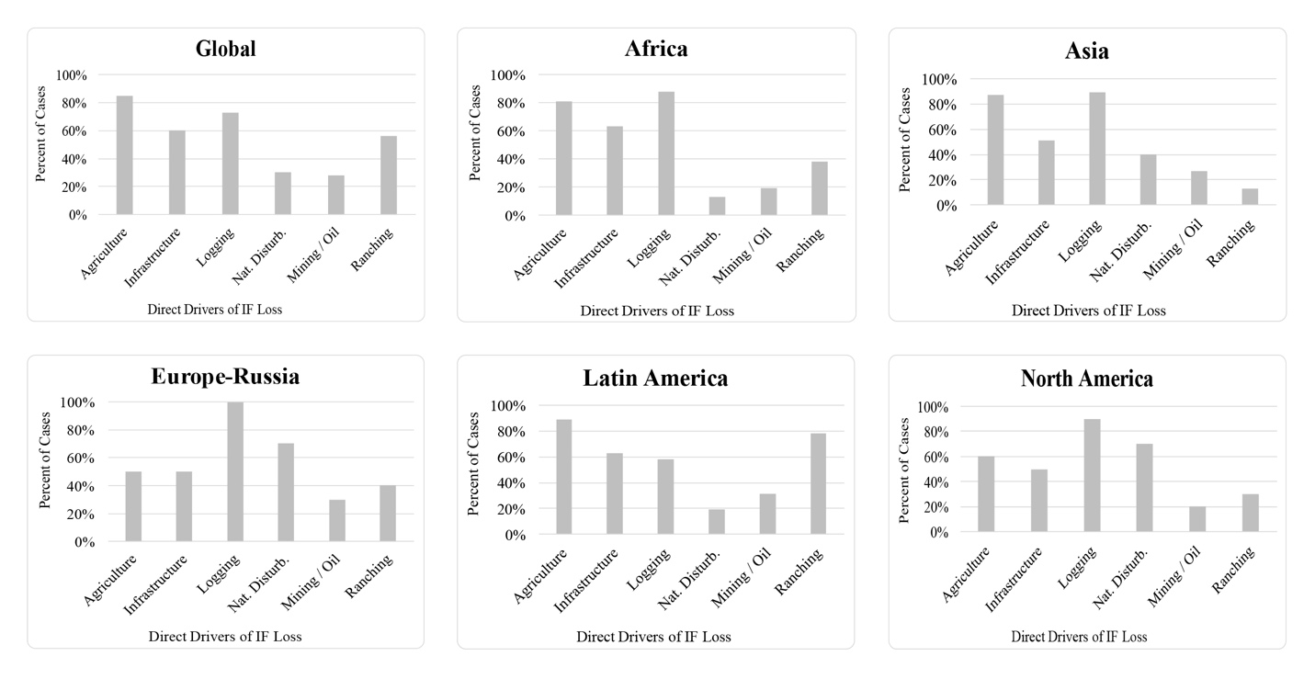

Appendix 4. The figure above shows the reported frequency of direct drivers of IF loss globally and regionally by percent of case studies.

**Appendix 5. Indirect Drivers of IF Loss**

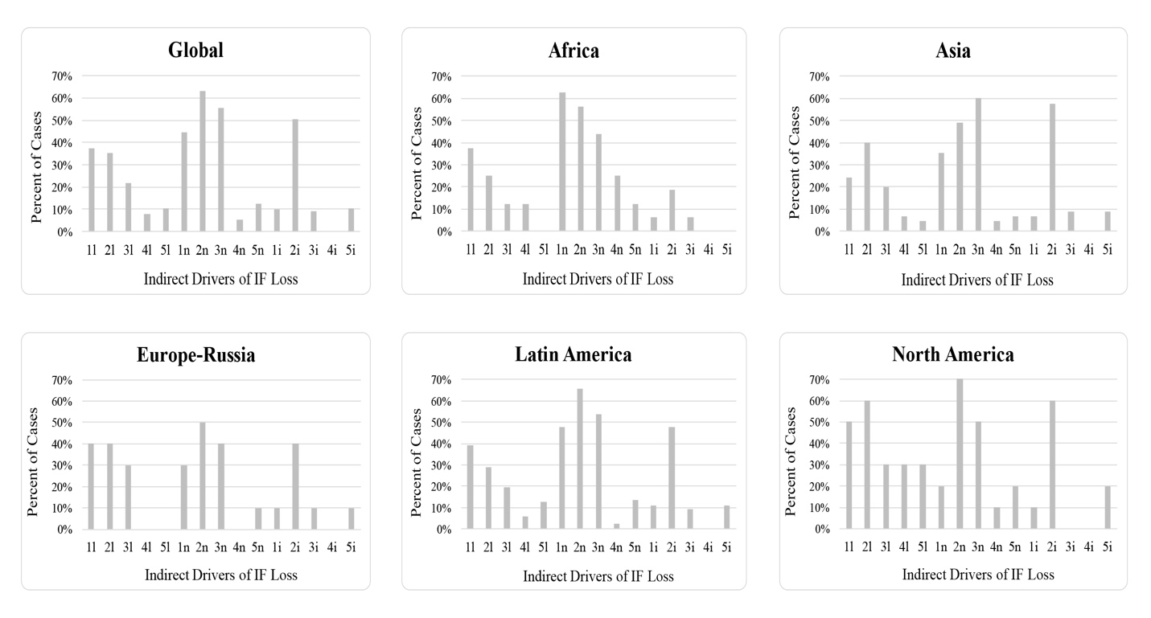

Appendix 5. The figure above shows the reported indirect drivers of IF loss by percent of case studies by spatial scale (L = Local, N= National, and I = International). The indirect drivers are: (1) demographic, (2) economic, (3) sociopolitical, (4) cultural and religious, (5) scientific and technological.

**Appendix 6 IF Conservation Interventions Proposed by Sector.** The table below provides and overview of prospective IF conservation interventions based on the relative frequency of their recommendation in the case studies and their ability to address the prominent IF deforestation drivers described.

|  |  |  |
| --- | --- | --- |
| **Interventions Proposed by Sector** | **% of Total Proposed** | **Example Policies and Activities Proposed** |
| **Forest-Conservation Sector** | **53** |  |
| - Forest Governance | 20 | (1) Incentives for private landowners to conserve IFs; (2) balance timber exports with forest protection; (3) stop issuing logging permits |
| - Forest Management | 15 | (1) Reduced-impact logging practices; (2) lower harvest rate; (3) retain IF stands and landscapes |
| - Protected Areas | 10 | (1) Expand protected areas (PAs); (2) create new PAs; (3) increase PA status; (4) create corridors |
| - Market-Based Conservation | 4 | (1) Establish jurisdictional REDD+ programs; (2) Incentives for ecotourism; (3) implement payments for ecosystem services programs |
| - Forest Planning | 4 | (1) Identify and designate priority areas; (2) ensure forest connectivity through planning; (3) optimize areas designated for use and protection |
| **Inter-sectoral Actions** | **13** |  |
| - Collaboration and Landscape Governance | 7 | (1) Open dialogue among stakeholders; (2) create institutions to engage stakeholders; (3) restructure relationships between stakeholders |
| - Land Tenure and Reform | 4 | (1) strengthen traditional property rights; (2) remove land clearing as a condition to claim land; (3) formalize existing landholding |
| - Sustainable Land-Use Planning | 2 | (1) Devise landscape-scale regulations; (2) create regional land management plans; (3) plan infrastructure projects to reduce fragmentation |
| **Finance Sector** | **8** |  |
| - Redesign Subsidies and Tax Incentives | 5 | (1) Provide landowners tax relief or subsidies to reforest and conserve; (2) impose taxes to limit land speculation; (3) eliminate tax holidays |
| - Promote Jobs and Economic Alternatives | 3 | (1) Improve labor opportunities in urban areas; (2) create non-agricultural jobs; (3) reduce raw log exports and increase local manufacturing |
| **Public Education & Science** | **8** |  |
| - Developing/Using Scientific Knowledge | 5 | (1) Understand causes of local forest change; (2) improve agricultural productivity; (3) integrate research into land planning and management |
| - General Education and Local Training | 4 | (1) Encourage reduced deforestation by locals; (2) educate farmers to increase agricultural productivity; (3) increase agency staff training |
| **Judicial Sector** | **7** |  |
| - Law Enforcement and Monitoring | 7 | (1) Strengthen park enforcement; (2) regional satellite-based monitoring; (3) manned checkpoints and increased forest monitoring |
| - Address Corruption | 1 | (1) Conduct corruption investigations; (2) increase government transparency; (3) improve corruption controls for granting concessions |
| **Agricultural Sector** | **4** |  |
| - Change Agricultural Incentives | 2 | (1) Eliminate plantation subsidies; (2) incentives for responsible agricultural production; (3) incentives for agroforestry and crop certification |
| - Increase Crop/Land-Use Intensity | 2 | (1) Expand double-cropping; (2) promote cattle intensification; (3) increase crop profitability |
| **Transport Sector - Roads Policies** | **3** | (1) Avoid building roads and bridges; (2) undertake robust impact assessments of infrastructure proposals; (3) improve local roads |
| **Social Welfare Sector - Social Welfare Policies** | **3** | (1) Create family planning services; (2) offer healthcare to increase human capital; (3) discourage colonization and immigration |
| **Advocacy and Lobbying - Forest Advocacy** | **1** | (1) Increase global concern for IFs; (2) support local grassroots organizations; (3) promote sustainable resource use and development |