Supplementary Material

N,N-Dimethylaminoxy carbonyl, a polar protecting group for efficient peptide coupling reactions
Ryo Okamoto¹*, Emiko Ono¹, Masayuki Izumi¹, Yasuhiro Kajihara¹
¹Department of Chemistry, Osaka University, Toyonaka, Osaka, JAPAN
* Correspondence:
Ryo Okamoto
rokamoto@chem.sci.osaka-u.ac.jp

Abbreviations
DCM Dichloromethane
DIEA N,N-Diisopropylethylamine
DMF N,N-Dimethylformamide
HATU 1-[Bis(dimethylamino)methylene]-1H-1,2,3-triazolo[4,5-b]pyridinium 3-oxide hexafluorophosphate
HBTU 1-[Bis(dimethylamino)methylene]-1H-benzotriazolium 3-oxide hexafluorophosphate
HOOBt 3-Hydroxy-1,2,3-benzotriazine-4(3H)-one
FA Formic Acid
TFA Trifluoroacetic acid
EtOAc Ethyl acetate
DTT (±)-Dithiothreitol
ODS Octadecyl-functionalized silica gel
LCMS Liquid chromatography-mass spectrometry
SPPS Solid phase peptide synthesis

General procedures
Thin layer chromatography was performed using Silica gel 60 F₂₅₄ (Merck TLC plates) and visualizations were performed with UV light (254 nm) and/or sulfuric acid stain (3 % H₂SO₄ in CH₃OH). All reagents were purchased from commercial suppliers and were used without further purification. All the reaction solvents were dried over activated molecular sieves prior to use. Solvents were removed under reduced pressure at < 40 ^{º}C. ¹H and ¹³C NMR spectra were recorded on Bruker Avance III spectrometer (400 MHz for ¹H, 100 MHz for ¹³C). All NMR signals were assigned on the basis of ¹H NMR, COSY, HMBC and HSQC. HRMS was recorded on Q-TOF mass spectrometry by electron spray ionization (ESI) method.
Analytical LCMS
The purities and masses of synthesized Lys derivatives and peptides were confirmed by analytical LCMS as following. Chromatographic separations were performed by using a linear gradient of buffer B in buffer A over 15 or 20 min. Buffer A: 0.1 % FA in water, buffer B: 0.09 % FA in 90% acetonitrile and 10 % water. Proteonavi C4 silica gel with column dimension 2.0 x 150 mm was used for the analytical column. The eluent was monitoring by UV-absorbance at 218 nm for peptides and 280 nm for Fmoc-Lys derivatives, with on-line ESI-MS. Reported mass measurements are the sum of the ion currents across the major UV peak in each chromatogram.

The synthesis of N^{α}-(9-fluorenylmethyloxycarbonyl)-L-lysine tert-butyl ester (4)
To a solution of Fmoc-Lys(Boc) 2 (6.0 g) in DCM (128 mL) was added tert-butyl 2,2,2-trichloroacetamidate (11.5 mL, 5.0 fold excess) and boron trifluoride ethyl ether complex (0.32 mL). This solution was stirred for 1.5 h in ice-salt bath (ca. -5 ℃) under Ar atmosphere. Then, the mixture was diluted with DCM, washed with sat. NH₄Cl aq., H₂O and brine. The organic phase was dried over MgSO₄ and concentrated in vacuo. The crude Fmoc-Lys(Boc)-OtBu 3 thus obtained was dissolved in dichloromethane (25 mL) chilled by an ice-salt bath. To the solution was added the solution of TFA (18 mL) and dichloromethane (25 mL). After stirring for 30 min, the solution was concentrated in vacuo. Purification of the residue by silica gel chromatography (EtOAc only → EtOAc : MeOH = 10:1) afforded compound 4 (3.1 g, 86 % over 2 steps) as a white solid. Analytical data: ¹H(CD₃CN): δ [ppm] = 7.82 (d, 2H), 7.67 (dd, 2H), 7.56 (br, 2H), 7.40 (t, 2H), 7.32 (t, 2H), 6.18 (d, 1H), 4.35-4.24 (m, 2H), 4.21 (t, 1H), 3.98 (m, 1H), 2.91 (br, 2H), 1.81-1.50 (s, 4H), 1.40 (2, 11H); ¹³C(CD₃CN) δ 172.6, 157.2, 145.1, 145.0, 142.1, 128.7, 128.1, 126.2, 121.0, 82.2, 67.2, 55.5, 47.9, 40.3, 31.7, 28.1, 27.4, 23.2; HRMS (ESI-QTOF) m/z: [M+H]⁺ calcd for C₂₅H₃₃N₂O₄ 425.2435; Obsd 425.2407.

The synthesis of N^{α}-(9-fluorenylmethyloxycarbonyl)-N^{ε}-(dimethylaminoxycarbonyl) -L-lysine tert-butyl ester (5)
To the solution of 4 (10.9 g) in acetonitrile (256 mL) was added to N,N'-carbonyldiimidazole (4.57 g, 1.1 eq.). This mixture was stirred at room temperature under Ar for 1 h. Then, the reaction solution was added to N,N-dimethyl hydroxylamine hydrochloride (7.49 g, 3 eq.) and stirred for 10 h. The resultant mixture was diluted with EtOAc (2-3 times), extracted with sat. NH₄Cl aq., water and brine (two times for each step), and dried over Na₂SO₄, filtered, and concentrated in vacuo. The crude residue was purified by flash column chromatography (EtOAc /hexane = 1:1 → 3:2) to give 5 (6.0 g, 46 %). Analytical data: ¹H (CDCl₃): δ [ppm] = 7.77 (d, 2H), 7.61 (dd, 2H), 7.41 (t, 2H), 7.32 (t, 2H), 6.66 (br, 1H), 5.40 (d, 1H), 4.38 (m, 2H), 4.31-4.19 (m, 2H), 3.23 (dd, 2H), 2.71 (s, 6H), 1.86 (m, 1H), 1.75-1.31 (m, 14H); ¹³C(CDCl₃) δ 171.5, 156.3, 155.9, 143.8, 143.7, 141.2, 127.7, 127.0, 125.1, 119.9, 82.2, 66.9, 54.0, 48.1, 47.1, 40.5, 32.4, 29.4, 27.9, 22.2; HRMS (ESI-QTOF) m/z: [M+H]⁺ calcd for C₂₈H₃₈N₃O₆ 512.2765; Obsd 512.2755.

The synthesis of N^{α}-(9-fluorenylmethyloxycarbonyl)-N^{ε}-(dimethylaminoxycarbonyl) -L-lysine (1)
Fmoc-Lys(Dmaoc)-OtBu 5 (440 mg) was dissolved in 6 M HCl aq. /1,4-dioxane (1 : 1, 4.3 mL). The mixture was concentrated after 30 min. The solution was diluted with 1,4-dioxine and concentrated in vacuo. Purification of the residue by ODS column chromatography (100 % H₂O→ H₂O: acetonitrile = 80 % : 20 % →H₂O: acetonitrile = 60 % : 40 %) afforded 1 (358 mg, 91%) after lyophilize. Analytical data: ¹H(CD₃CN) : δ [ppm] = 7.83 (d, 2H), 7.68 (dd, 2H), 7.42 (t, 2H), 7.34 (t, 2H), 6.90 (br, 1H), 6.04 (d, 1H), 4.32 (m, 2H), 4.23 (t, 1H), 4.10 (m, 1H), 3.12 (dd, 2H), 2.66 (s, 6H), 1.80 (m, 1H), 1.68 (m, 1H), 1.53-1.32 (m, 4H); ¹³C(CD₃CN) δ 174.5, 157.3, 145.3, 145.2, 142.2, 128.8, 128.2, 126.3, 121.1, 67.3, 55.0, 48.4, 48.1, 41.0, 31.9, 30.1, 23.6; HRMS (ESI-QTOF) m/z: [M+H]⁺ calcd for C₂₄H₃₀N₃O₆ 456.2129; Obsd 456.2124.

Fmoc SPPS of Dmaoc-proteced peptides
The synthesis of Dmaoc-protected peptides 6 and 13 were carried out on a 0.05 mmol of Dawson Dbz AM resin (Merk Millipore) by essentially same manner with the Fmoc SPPS protocol reported by Blanco-Canosa et al (Angew. Chem. Int. Ed. 2008, 47, 6851) as following.
The synthesis of peptide 6
Fmoc-Pro-OH (0.2 mmol, 4 fold excess), HATU (0.2 mmol, 4 fold excess) and DIEA (52 μL, 0.3 mmol, 6 fold excess) were dissolved in DMF (1 mL). After 1 min pre-activation, this solution was added to Fmoc-Dawson resin and reacted for 1 h under gentle shaking (ca. 200 rpm). The following coupling was performed using 0.2 M HBTU/HOBt in DMF (975 μL), 0.2 M DIEA in DMF (1.5 mL, in DMF) and Fmoc-aa (4 fold excess to the resin used). Pre-activation was performed for 1 min prior to add to the resin and coupling was performed for 40 min. For the coupling of Fmoc-Lys(Dmaoc)-OH, 0.2 M HBTU/HOBt (1:1) in DMF (488 μL), 0.2 M DIEA in DMF (0.75 mL, in DMF) and Fmoc- Lys(Dmaoc)-OH (46 mg, 2 fold excess) were used. Removal of Fmoc group was performed by treatment with 20 % piperidine/DMF solution for 10 min in each step. After the completion of peptide chain assembly, the resin was washed with DMF and DCM. To the resin was added an acid cocktail containing TFA (1.9 mL), triisopropylsilane (50 μL) and H₂O (50 μL) at ambient temperature. The mixture was gentely shaking for 60 min. The TFA solution containing the peptide was concentrated in vacuo to a minimal volume, added over cold ether and precipitated by centrifugation. The supernatant was removed and the residue was lyophilized. Purification of the resultant material by preparative LC (Proteonavi C4 10 × 250 mm, isocratic of 0.1 % TFA : 90 % CH₃CN, 0.09 % TFA from 70:30 for 10 min followed by a linear gradient 0.1 % TFA : 90 % CH₃CN, 0.09 % TFA from 70:30 to 20:80 over 60 min at a flow rate of 2.5 ml/min) afforded Dmaoc protected tetra-peptide 6 (29 mg, 66 % isolated). HRMS for 6 (ESI-QTOF) m/z: [M+H]⁺ calcd for C₄₅H₆₀N₉O₉ 870.4509; Obsd 870.4469.
The synthesis of peptide 13
The sythesis of SFTI peptide was also peformed by the essentially same manner with the synthesis of the tetrapeptide 6 afforded Dmaoc proteceted SFTI peptide 13 (10 mg, 11 % isolated for 0.05 mmol scale synthesis). Purification condition: Proteonavi C4 Φ10 × 250 mm, linear gradient 0.1 % TFA : 90 % CH₃CN, 0.09 % TFA from 80:20 to 40:60 over 120 min at a flow rate of 2.5 ml/min). HRMS for 13 (ESI-QTOF) m/z: [M+H]⁺ calcd for C₇₇H₁₂₁N₂₂O₂₁S₂ 1753.8513; Obsd 1753.8114.

Coupling of peptide 6 and 8
DMF (393 μL) and 4 M HCl in 1,4-dioxane (10 μL) were mixed and chilled in an ice bath. This acidic DMF solution was added NaNO₂ (1.4 mg, 5 fold excess) and sonicated for 30 sec. The resultant suspension was chilled in an ice ethanol bath (ca. -17 ℃) and was added to the peptide 6 (3.5 mg, 4.0 μmol). After 5 min reaction under the same temperature, this reaction mixture was added to the peptide 8 dissolved in DMF (403 μL) containing HOOBt (6.6 mg, 10 fold excess) and DIEA (7.0 μL, 10 fold excess), and was left for 14 h at 0 ℃. The reaction mixture was subjected to ether precipitation by adding chilled ether (ca. 14 mL). After centrifugation of this crude suspension, the ether layer was removed by decantation to separate afforded precipitate. This ether-washing was repeated for 3 times. The resultant crude peptide 9 was dissolved in 0.1 M sodium phosphate buffer containing 6 M guanidine hydrochloride and 0.2 M DTT (pH 6.9, 806 μL) and reacted for 2 h at 37 ℃. To the solution was added piperidine (81 μL) and left for additional 40 min. After neutralization by adding 5 M HCl (186 μL), the reaction mixture was subjected to semi preparative RP-HPLC purification and afforded peptide 12 (2.8 mg, 60% isolated yield).

Cyclization of peptide 13 (synthesis of SFTI)
The solution of DMF (167 μL) and 4 M HCl/1,4-dioxane (4 μL) was added NaNO₂ (0.6 mg, 5 fold excess) and sonicated for 30 sec followed by chilled in an ice-ethanol bath (ca. -15 ℃). The resultant suspension was added to the peptide 13 (3 mg, 1.7 μmol) and was left for 5 min in the same ice/ethanol bath (ca. -15 ℃). The mixture was subsequently added DMF (684 μL) containing HOOBt (2.8 mg, 10 fold excess) and DIEA (3.0 μL, 10 fold excess), then left for 30 min at 0 ℃. The reaction mixture was subjected to ether precipitation by adding chilled ether (ca. 14 mL). After centrifuge of this crude suspension, the afforded precipitate was separated. This step was repeated for 3 times. The resultant crude material was dissolved in 0.1 M sodium phosphate buffer containing 6 M guanidine hydrochloride and 0.2 M DTT (pH 7.0, 855 μL) and reacted for 3.5 h at 37 ℃. Purification of this reaction mixture by semi preparative RP-HPLC purification and afforded 1.3 mg of peptide 17 (43 % isolated yield).

Oxidation of the cyclic SFTI 17
Reduced form of SFTI 17 (1.3 mg) was dissolved in the mixed solution of 50 % CH₃CN aq. (430 μL) and DMSO (107 μL). This mixture was left for 48 h under stirring at toom temperature, and then directly liophilized.

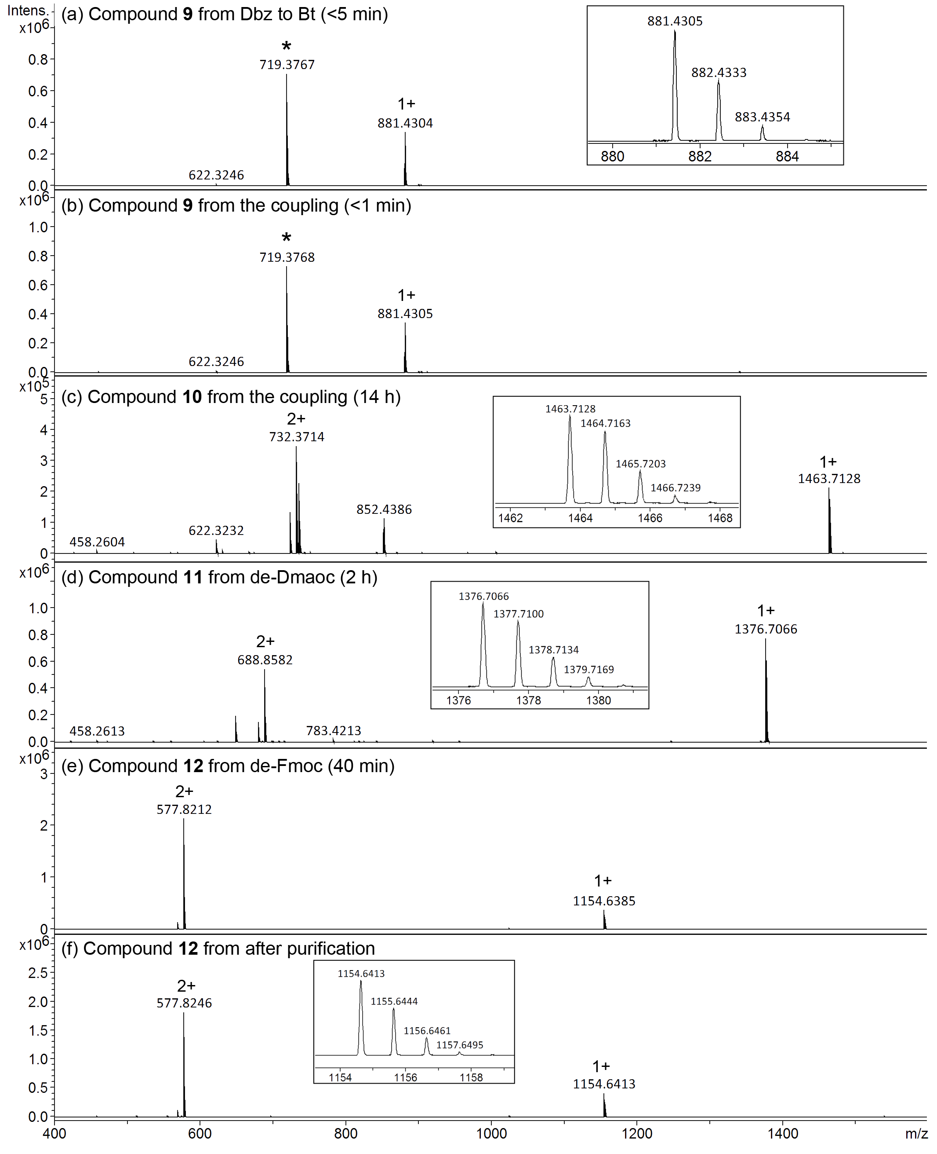
Figure S-1. HRMS spectra for the direct coupling of peptide 6 and 8. The data were acquired from LC-MS analysis, of which the profile is shown in Figure 5 (main text). Peak labelded with asterisk is the hydrolized product of compound 9 plausibly generated in MS spectrometer. Insets: Expanded view of [M+H]⁺ ion peak of each spectrum. Calculated m/z (mono isotopic): [M+H]⁺ for compound 9 C₄₅H₅₇N₁₀O₉⁺ 881.4304; for compound 10 C₆₉H₁₀₃N₁₄O₂₁⁺ 1463.7417; for compound 11 C₆₆H₉₈N₁₃O₁₉⁺ 1376.7096; for compound 12 C₅₁H₈₇N₁₃O₁₇ 1154.6416
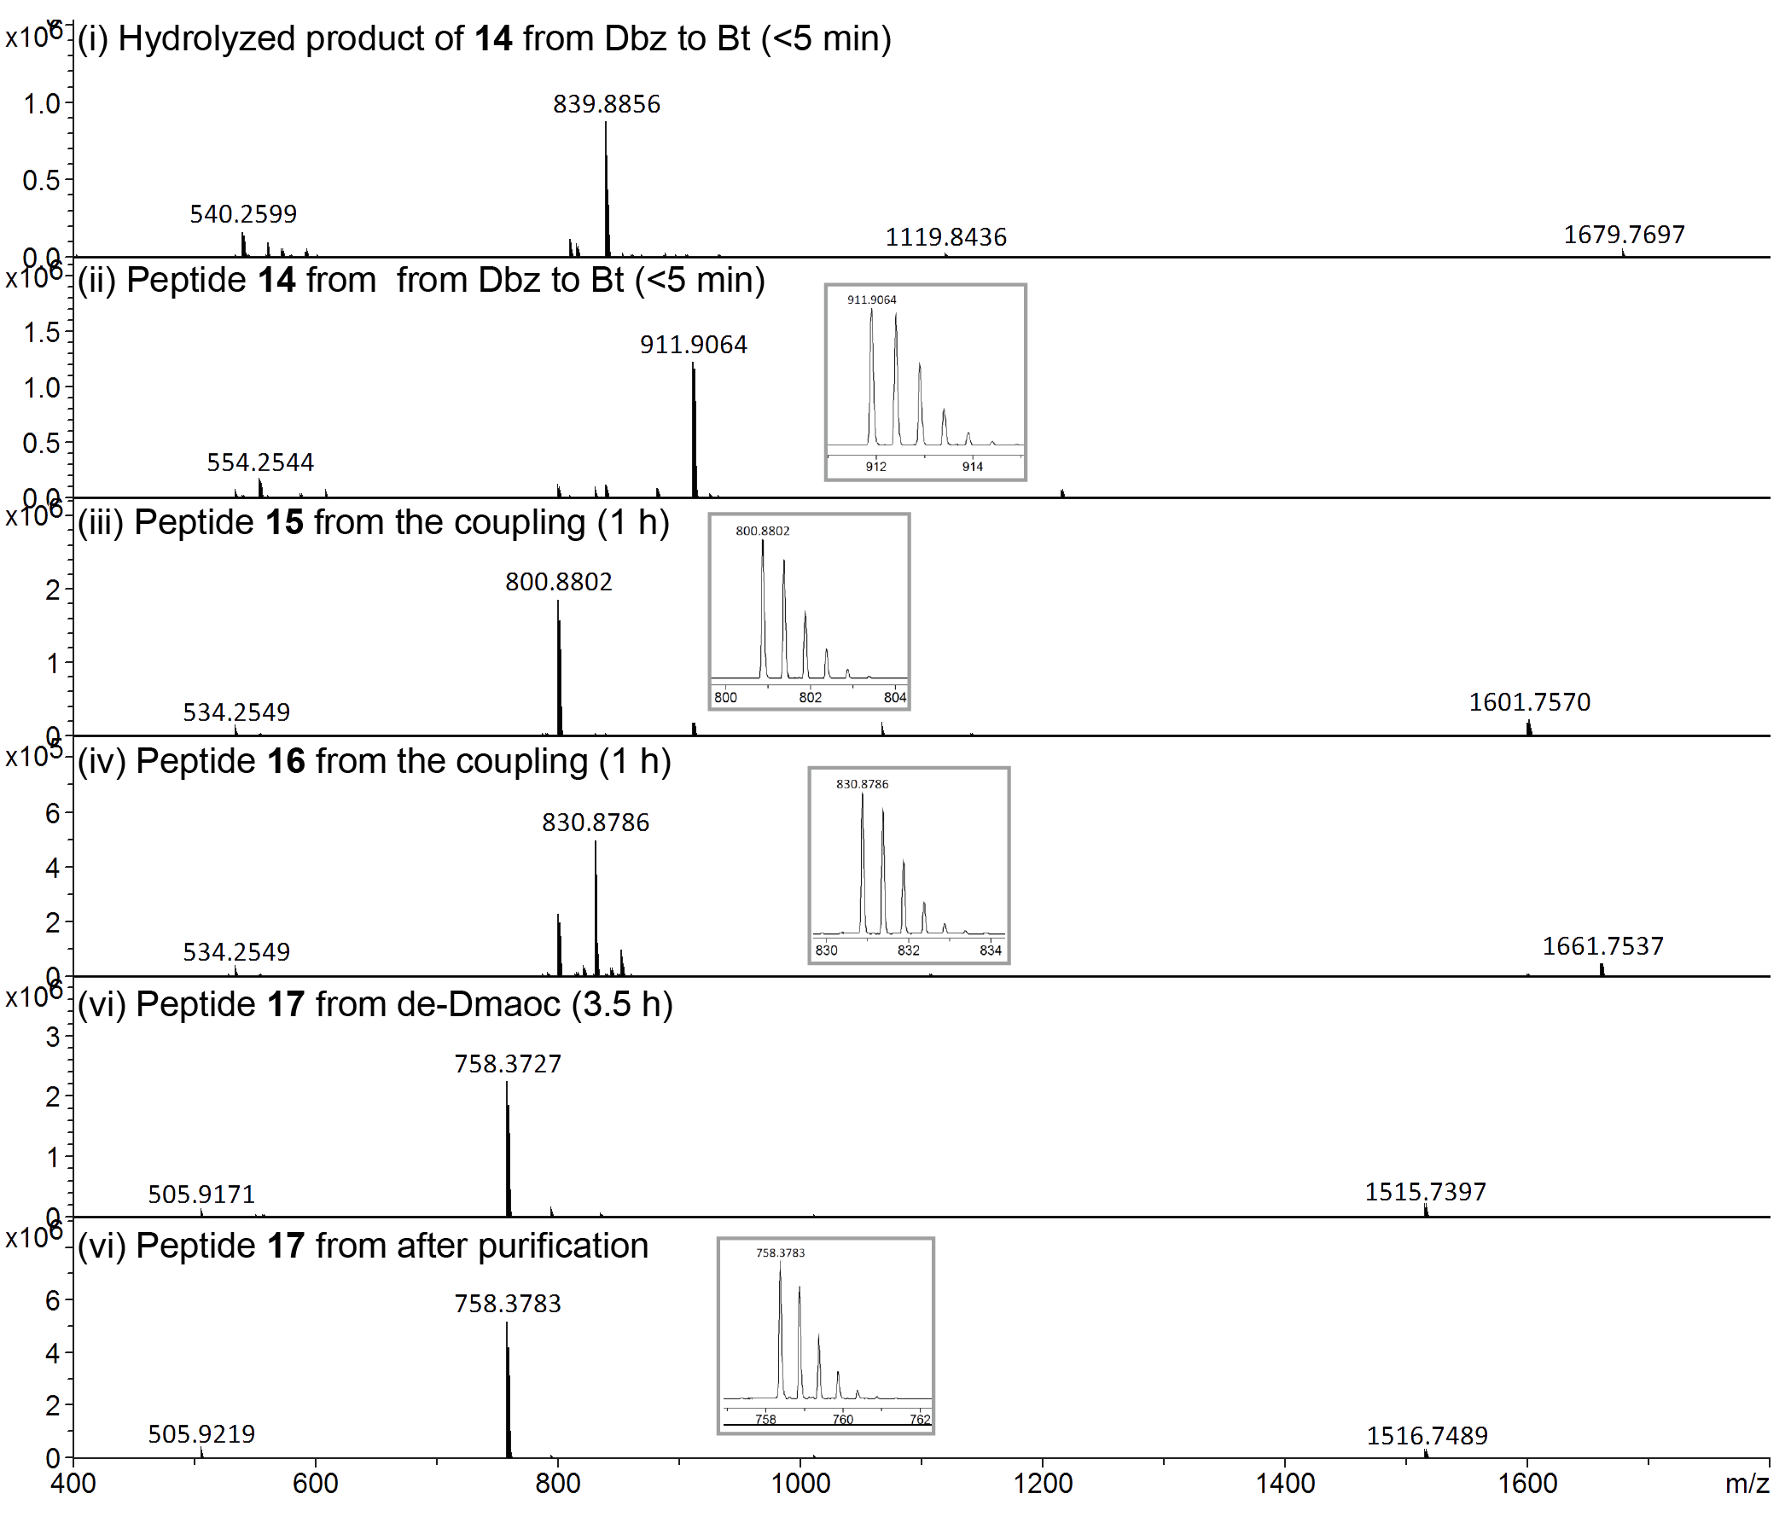
Figure S-2. HRMS spectra for the cyclization of peptide 13. The data was acquired from LC-MS analysis, of which LC profile is shown in Figure 4 (main text). Hydrolyzed form of peptide 14 (spectrum (i) and Figure 4 (B-a)) was observed during the conversion of Dbz to Bt of peptide 13. This was plausibly afforded during LC-MS analysis and not from reaction mixture, since this product was not pbserved in the following coupling step. Insets are expanded view of [M+2H]²⁺ ion peaks acquired by on-line ESI-HRMS from each peak labeled with compound number. Calculated m/z (mono isotopic): [M+2H]²⁺ for 14 C₇₇H₁₁₇N₂₅O₂₃S₂ 911.9092; for 15 C₇₀H₁₁₁N₁₉O₂₀S₂ 800.8841; for 16 C₇₀H₁₁₁N₂₁O₂₂S₂ 830.8821; for 17 C₆₇H₁₀₈N₁₈O₁₈S₂ 758.3760; Analytical condition: Linear gradient 0.1 % HCOOH aq.: 90 % acetonitrile aq. containing 0.09 % HCOOH from 90:10 to 30:70 over 15 min at a flow rate of 0.3 ml/min.

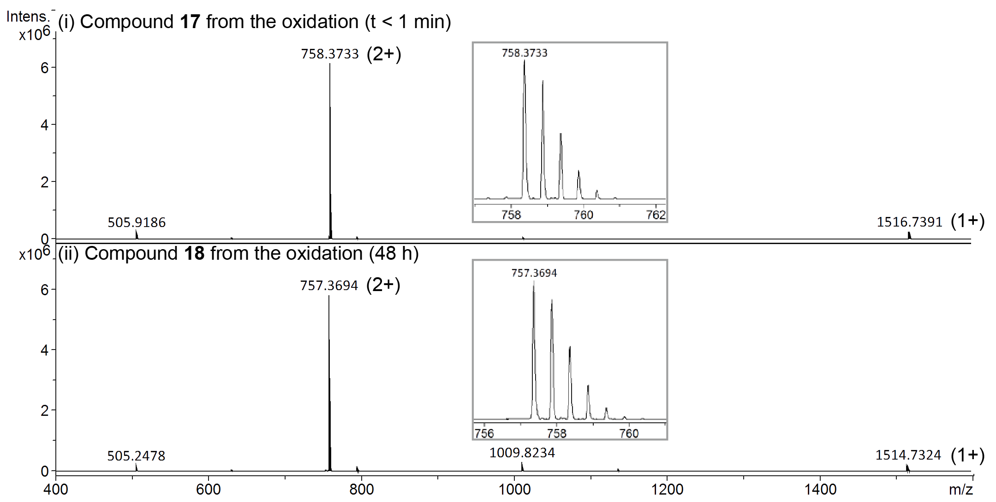
Figure S-3. HRMS spectra for the oxidation of SFTI 17. Each spectrum was corresponding with LC peak shown in Figure 4 (main text). Insets are expanded view of [M+2H]²⁺ ion peak acquired by on-line ESI-HRMS from each peak labeled with compound number. Calculated m/z (mono isotopic): [M+2H]²⁺ for 17 C₆₇H₁₀₈N₁₈O₁₈S₂ 758.3760 and for 18 C₆₇H₁₀₆N₁₈O₁₈S2 757.3681.

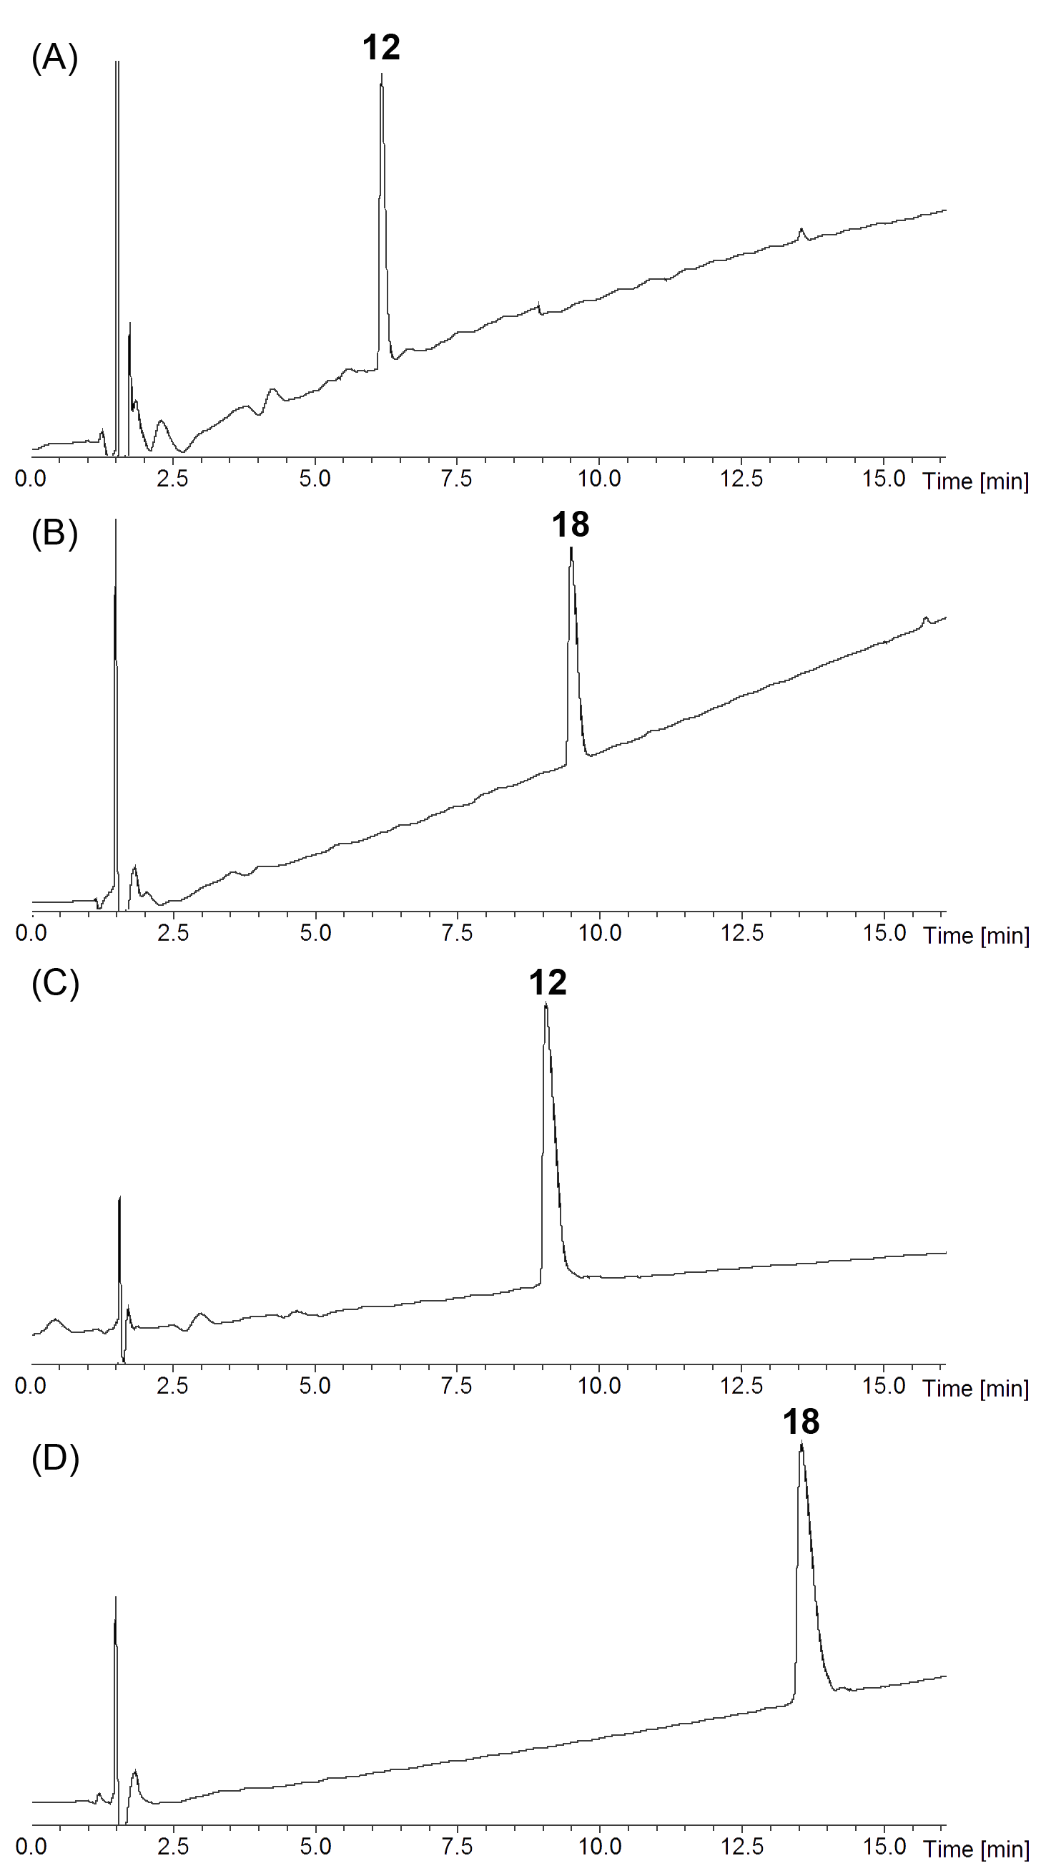
Figure S-4. RP-HPLC chromatograms for the peptide products 12 and 18. The chromatographic separation was performed using linear gradient of solvent A : solvent B from 90:10 to 30:70 over 15 min at a flow rate of 0.3 ml/min; For solvent A and B, two different systems were used: 0.1 % HCOOH aq. / 90 % acetonitrile aq. containing 0.09 % HCOOH (condition a) and 0.1 % HCOOH aq. / 90 % methanol aq. containing 0.09 % HCOOH (condition b). (A) RP-HPLC chromatogram for peptide 12 using the condition a; (B) RP-HPLC chromatogram for peptide 12 using the condition b; (C) RP-HPLC chromatogram for peptide 18 using the condition a; (D) RP-HPLC chromatogram for peptide 18 using the condition b. The eluent was monitoring by UV-absorbance at 218 nm with on-line ESI-MS.

