Supplementary Material

Effects of Carbon Pore Size on the Contribution of Ionic Liquid Electrolyte Phase Transitions to Energy Storage in Supercapacitors

Konstantin Schutjajew, Runyu Yan, Markus Antonietti, Christina Roth, Martin Oschatz

**\* Correspondence:** Martin Oschatz, martin.oschatz@mpikg.mpg.de

# Supplementary Figures

\\HOME\schutjajew$\My Documents\2_PhD\Frontiers 2018\CustomCellModel_small.tif

**Figure S1: Schematic cut through the employed custom-built three-electrode cell.**

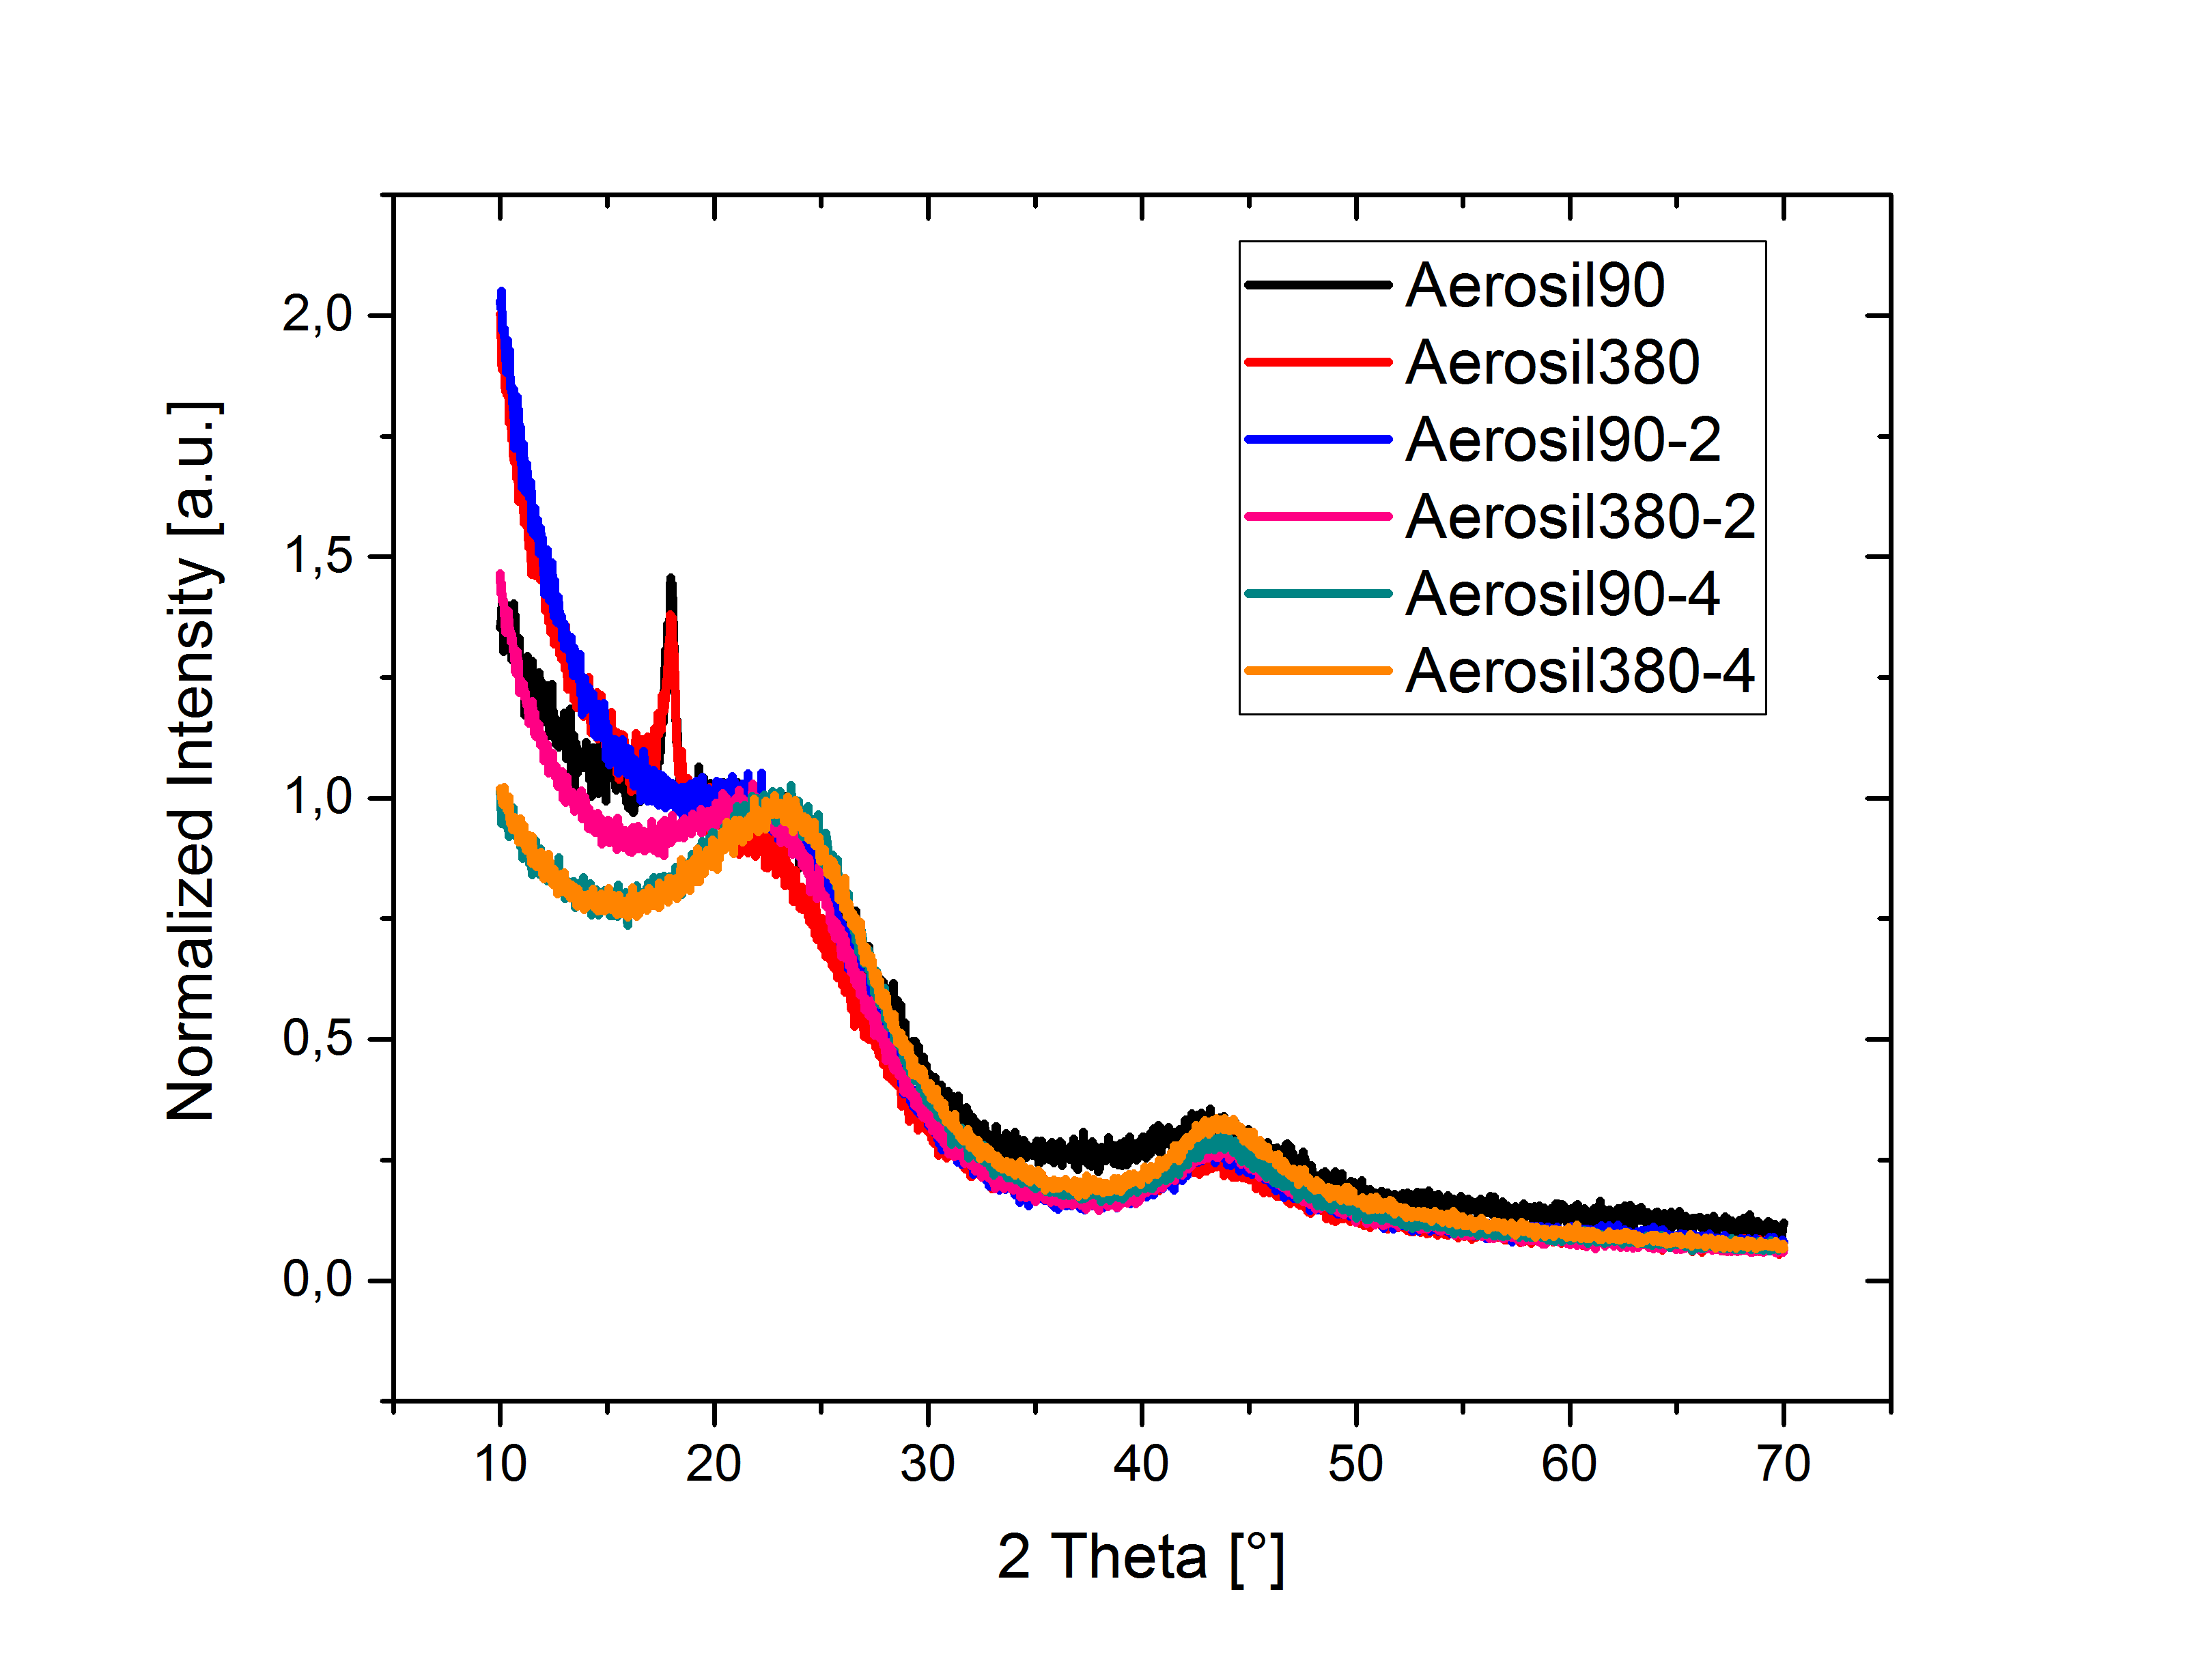

**Figure S2**: X-ray diffraction patterns of the synthesized carbon materials.

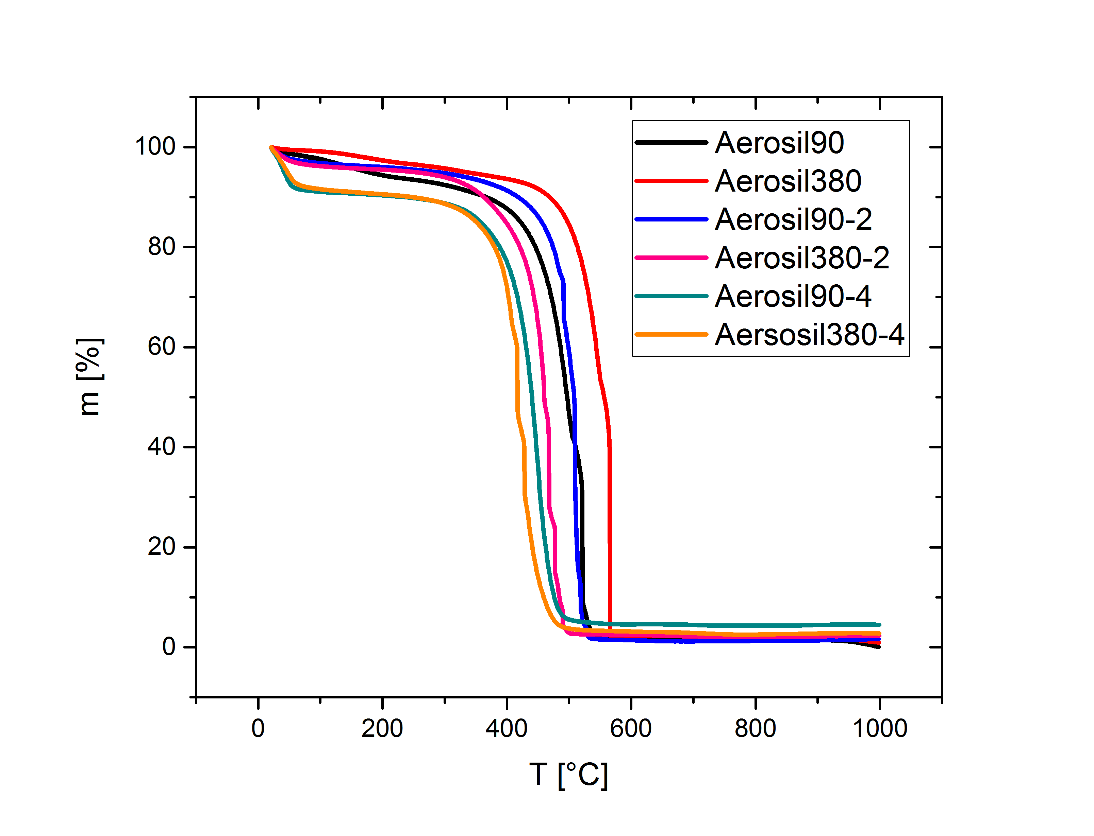

**Figure S3**: Thermogravimetric analysis of the synthesized carbon materials (synthetic air flow, 5 K min-1).

**Table S1**: Elemental analysis of the synthesized carbons.

|  |  |  |  |  |
| --- | --- | --- | --- | --- |
| Carbon | N [wt%] | C [wt%] | H [wt%] | S [wt%] |
| Aerosil90-1 | 0.33 | 84.62 | 1.849 | 0.996 |
| Aerosil90-2 | 0.18 | 90.53 | 1.271 | 0.895 |
| Aerosil90-4 | 0.18 | 88.55 | 1.285 | 0.800 |
| Aerosil380-1 | 0.25 | 84.15 | 1.248 | 0.818 |
| Aerosil380-2 | 0.16 | 88.81 | 1.198 | 0.759 |
| Aerosil380-4 | 0.18 | 88.54 | 1.177 | 0.757 |

|  |  |
| --- | --- |
| S4a\\HOME\schutjajew$\My Documents\2_PhD\Frontiers 2018\Raman\raman_90-1.tif | S4b\\HOME\schutjajew$\My Documents\2_PhD\Frontiers 2018\Raman\raman_90-2.tif |
| S4c\\HOME\schutjajew$\My Documents\2_PhD\Frontiers 2018\Raman\raman_90-4.tif | S4d\\HOME\schutjajew$\My Documents\2_PhD\Frontiers 2018\Raman\raman_380-1.tif |
| S4e\\HOME\schutjajew$\My Documents\2_PhD\Frontiers 2018\Raman\raman_380-2.tif | S4f\\HOME\schutjajew$\My Documents\2_PhD\Frontiers 2018\Raman\raman_380-4.tif |

**Figure S4**: Raman spectra and the corresponding fitting curves of the synthesized carbons.

|  |  |  |
| --- | --- | --- |
| D:\4_Paper\ILs_in_aerosil\SI\SI_ABBS\aerosil_1_emimbf4.png | D:\4_Paper\ILs_in_aerosil\SI\SI_ABBS\aerosil_2_emimbf4.png | D:\4_Paper\ILs_in_aerosil\SI\SI_ABBS\aerosil_4_emimbf4.png |
| S5a Aerosil‑1 | S5b Aerosil‑2 | S5c Aerosil‑4 |

**Figure S5**: Comparison of cyclic voltammograms of Aerosil® templated carbons in EMImBF4 depending on pore sizes and pore volumes (0 - 5.0 V, ν = 2 mV s-1).

|  |  |  |
| --- | --- | --- |
| D:\4_Paper\ILs_in_aerosil\SI\SI_ABBS\aerosil_1_bmimbf4.png | D:\4_Paper\ILs_in_aerosil\SI\SI_ABBS\aerosil_2_bmimbf4.png | D:\4_Paper\ILs_in_aerosil\SI\SI_ABBS\aerosil_4_bmimbf4.png |
| S6a Aerosil‑1 | S6b Aerosil‑2 | S6c Aerosil‑4 |

**Figure S6**: Comparison of cyclic voltammograms of Aerosil® templated carbons in BMImBF4 depending on pore sizes and pore volumes (0 5.0 V, ν = 2 mV s-1).

|  |  |  |
| --- | --- | --- |
| \\HOME\schutjajew$\My Documents\2_PhD\Frontiers 2018\Figures Arbeitsordner\scanrate_2E_2mVs.tif | \\HOME\schutjajew$\My Documents\2_PhD\Frontiers 2018\Figures Arbeitsordner\scanrate_2E_5mVs.tif | \\HOME\schutjajew$\My Documents\2_PhD\Frontiers 2018\Figures Arbeitsordner\scanrate_2E_10mVs.tif |
| S7a 2 mV s-1 | S7b 5 mV s-1 | S7c 10 mV s-1 |
| \\HOME\schutjajew$\My Documents\2_PhD\Frontiers 2018\Figures\old and more\scanrate\scanrate_3E_2mVs.tif | \\HOME\schutjajew$\My Documents\2_PhD\Frontiers 2018\Figures\old and more\scanrate\scanrate_3E_5mVs.tif | \\HOME\schutjajew$\My Documents\2_PhD\Frontiers 2018\Figures\old and more\scanrate\scanrate_3E_10mVs.tif |
| S7d 2 mV s-1 | S7e 5 mV s-1 | S7f 10 mV s-1 |

**Figure S7**: Comparison of cyclic voltammograms of Aerosil380‑1 in EMImBF4 depending on scanrate (0 - 5.0 V). (a)-(c) two-electrode-, (d)-(f) three-electrode setup.

\\HOME\schutjajew$\My Documents\2_PhD\Frontiers 2018\Figures Arbeitsordner\NegativeScan.tif

**Figure S8**:Result of CV measurement of Aerosil380‑1 in EMImBF4, if the working electrode is negatively polarized in the first scan.

\\HOME\schutjajew$\My Documents\2_PhD\Frontiers 2018\SI\SI_ABBS\3E_pureRTIL.tif

**Figure S9**: Cyclic voltammograms of Aerosil380-1, -2, and-4 with purified EMImBF4 as the electrolyte in three-electrode setup. Inset shows magnification of the measurement of Aerosil380-4.