*Supplementary Material*

**1 Supplementary Data**

**1.1 Supplementary information on the sampling site, experimental set up and sampling procedure**

Sediment was collected in Perspex cores (3.6 cm ID x 30 cm length) from the mudflats in the lower reach of the Ythan estuary, Aberdeenshire, Scotland, UK (57° 20.085’N, 02° 0.206’W) in February 2017. All necessary permissions for work on the Ythan and Forvie National Nature Reserve were obtained from Scottish Natural Heritage. The sediments at the experimental location have a mean particle size of 50 µm and 1.5% OC by dry weight (silt content 60.0%) in the upper 1 cm. The carbon to nitrogen ratio was 7.3. The macrofaunal community is dominated by the burrow-dwelling amphipod *Corophium volutator* (17000 ind. m-2) and the gastropod *Hydrobia ulvae* (21000 ind. m-2) (Biles et al., 2003). *C. volutator* is known to play a prominent role in downward particle transport and organic matter transformation at densities >15000 ind. m-2 through its ventilating activity (De Backer et al., 2011). However, previous studies at the Ythan estuary mudflats have concluded that the effect of bioturbation by *C. volutator* on sediment characteristics, redox potential and meio- and macro-fauna were weak and not always consistent (Limia and Raffaelli, 1997).

The basic design of the experimental units is shown in Fig. S2. Seawater in the cores and reservoirs was 10 μm-filtered, UV-sterilized seawater collected from the estuary at high tide. Each core was connected to a corresponding water reservoir in a closed system through a peristaltic pump and water was circulated continuously at 10 ml/min. The seawater in reservoirs was replaced every other day. The volume of water in cores ranged between 175 and 200 ml and the reservoirs volume was 250 ml. Each core was capped with a rubber lid which was pierced by stainless steel tubing, a long tube positioned at ~5 cm above the sediment surface and a short tube at ~5 cm from the top of the core. Circulation of water between the cores and the reservoirs is shown in Fig S2. The tubes were connected to valves in order to isolate the cores from the environment during incubations and to sample seawater at the start and end of each incubation. During incubations, circulation was halted, and tubing was closed with valves for 4-6 hours. Samples were taken at the start and end of each incubation through the long tube on the lid.

**1.2 Supplementary information on the statistical analysis**

Statistical models to study the effect of treatment and incubation day on total mineralization (Total DIC) and 13C-wheat mineralisation (DI13C) were developed for each response variable. Τreatment and incubation day were treated as nominal variables (Treatment levels: Ctrl (TotalDIC analysis only), 13C-Ctrl, Pulse, Dose; Incubation day levels: 6, 8, 14, 20). Day 8 was excluded from analysis due to loss of 2 replicates from Dose treatment on that sampling point. Due to the importance of this particular time point that followed algae addition on day 7, we also performed an analysis testing differences in total and 13C-wheat mineralisation without Dose treatment but including Day 8. Sampling of seawater from each core gave an a priori reason to analyse Total DIC and DI13C datasets using linear mixed-effect models (LME) (Zuur et al., 2009). This approach allowed a correlation structure to be imposed on all observations within each core by incorporating core identity as a random effect. Variance covariate terms were also included where data exploration revealed instances of unequal variance. This technique allows the residual spread to vary between individual levels of a particular explanatory variable, or combinations thereof. In other words, variance covariate terms permit heterogeneity by explicitly modelling the change in variance as a function of an explanatory variable. The appropriate variance structure for nominal explanatory variables is varIdent (Pinheiro and Bates, 2000).

The protocol for model selection in LME modelling is described elsewhere (Zuur et al., 2009). In brief, the optimal random structure of the model was identified before the optimal fixed structure was determined. Full models with and without Core identity as a random effect were compared using a likelihood ratio (L. ratio) test using restricted maximum likelihood estimation (REML). The same procedure was followed in order to determine the optimal variance covariate structure. The significance of the random effect was reassessed after the incorporation of variance covariate terms. The fixed structures of the optimal models, which initially incorporated treatment, incubation day and the interaction term, were determined using backwards selection based on the L. ratio test using maximum likelihood estimation (ML). Model parameters were generated using REML estimation. Coefficient tables are presented without correction for the alpha-error, as Bonferroni correction increases the beta error and tends to obscure multiple significant results if p-values are moderate and the statistical power is low (Moran, 2003). The analysis was performed using the ‘‘*nlme*’’ package (Pinheiro et al., 2018) in the ‘‘R’’ programming environment (R Core Team, 2018).

**1.3 Model output for the total mineralization (Total DIC) data analysis (dataset excluding day 8)**

The optimal model was a LME that incorporated Core identity as a random effect (L. ratio = 6.78, df1, p = 0.9999) and allowed the residual spread to vary by treatment and incubation day (L. ratio = 30.66, df1, p = 0.0012). Random effects for Core identity were included even though not statistically significant to control for possible dependence due to repeated measures effects. Total mineralization was significantly affected by incubation day (L. ratio = 13.59, df1, p = 0.0011) and treatment (L. ratio = 12.28, df1, p = 0.0065).

Optimal model:

lme (TotalDIC~treatment+day,

random = ~1|Core identity,

weights=varIdent (form=~1|day*treatment), method="REML")

Intercept ± SE (when baseline is Ctrl and day 6): 4.31 ± 0.9, t = 4.78, p = 0.0001

Coefficient table for Treatment(estimate±SE, t-value, **p-value**)

|  |  |  |  |  |
| --- | --- | --- | --- | --- |
|  | Ctrl | 13C-Ctrl | Pulse | Dose |
| Ctrl | ― | 1.25±0.80  1.56  **0.1562** | 0.82±0.73  1.12  **0.2938** | -0.81±0.72  -1.12  **0.2935** |
| 13C-Ctrl | -1.25±0.80  -1.56  **0.1562** | ― | -0.42±0.48  0.88  **0.4039** | -2.06±0.47  -4.34  **0.0025** |
| Pulse | -0.82±0.73  -1.12  **0.2938** | 0.42±0.48  0.88  **0.4039** | ― | -1.64±0.28  -5.83  **0.0004** |
| Dose | 0.81±0.72  1.12  **0.2935** | 2.06±0.47  4.34  **0.0025** | 1.64±0.28  5.83  **0.0004** | ― |

Coefficient table for Day (estimate±SE, t-value, **p-value**)

|  |  |  |  |
| --- | --- | --- | --- |
|  | Day 6 | Day 14 | Day 20 |
| Day 6 | ― | 2.13±0.61  3.47  **0.0027** | 0.08±0.89  0.09  **0.9265** |
| Day 14 | -2.13±0.61  -3.47  **0.0027** | ― | -2.05±0.70  2.91  **0.0093** |
| Day 20 | -0.08±0.89  -0.09  **0.9265** | 2.05±0.70  2.91  **0.0093** | ― |

**1.4 Model output for the total mineralization (Total DIC) data analysis excluding Dose treatment (including day 8)**

The optimal model was a LME that incorporated Core identity as a random effect (L. ratio = 9.15, df1, p = 0.9999) and allowed the residual spread to vary by treatment and incubation day (L. ratio = 32.23, df1, p<0.0001). Random effects for Core identity were included even though not statistically significant to control for possible dependence due to repeated measures effects. Total mineralization was not significantly different between treatments (L. ratio = 1.01, df1, p = 0.6032) but was affected by incubation day (L. ratio = 16.13, df1, p = 0.0011).

Optimal model:

lme (TotalDIC~day,

random = ~1|Core identity,

weights=varIdent (form=~1|day*treatment), method="REML")

Intercept ± SE (when baseline is day 6): 3.05 ± 0.48, t = 6.26, p < 0.0001

Coefficient table for Day (estimate±SE, t-value, **p-value**)

|  |  |  |  |  |
| --- | --- | --- | --- | --- |
|  | Day 6 | Day 8 | Day 14 | Day 20 |
| Day 6 | ― | -6.13±2.62  -2.33  **0.0288** | 1.77±0.52  3.39  **0.0026** | -1.18±0.53  -2.23  **0.0357** |
| Day 8 | 6.13±2.62  2.33  **0.0288** | ― | 7.91±2.58  3.06  **0.0057** | 4.95±2.58  1.91  **0.0688** |
| Day 14 | -1.77±0.52  -3.39  **0.0026** | -7.91±2.58  -3.06  **0.0057** | ― | -2.96±0.28  -10.39  **0.0000** |
| Day 20 | 1.18±0.53  2.23  **0.0357** | -4.95±2.58  -1.91  **0.0688** | 2.96±0.28  10.39  **0.0000** | ― |

**1.5 Model output for the 13C-wheat mineralization (DI13C) data analysis (dataset excluding day 8)**

The optimal model was a LME that incorporated Core identity as a random effect (L. ratio = 1.21, df1, p = 0.9999) and allowed the residual spread to vary by treatment and incubation day (L. ratio = 23.39, df1, p = 0.0029). Random effects for Core identity were included even though not statistically significant to control for possible dependence due to repeated measures effects. 13C-wheat mineralization was not significantly different between treatments (L. ratio = 4.31, df1, p = 0.1158) or incubation day (L. ratio = 4.15, df1, p = 0.1254).

Optimal model:

lme (DI13C~1,

random = ~1|Core identity,

weights=varIdent (form=~1|day*treatment), method="REML")

Intercept ± SE: 6.78 ± 1.19, t = 5.69, p < 0.0001

**1.6 Model output for the 13C-wheat mineralization (DI13C) data analysis (dataset excluding Dose treatment (including day 8)**

The optimal model was a LME that incorporated Core identity as a random effect (L. ratio = 3.30, df1, p = 0.9999) and allowed the residual spread to vary by treatment and incubation day (L. ratio = 25.28, df1, p <0.0001). Random effects for Core identity were included even though not statistically significant to control for possible dependence due to repeated measures effects. 13C-wheat mineralization was affected by incubation day (L. ratio = 20.38, df1, p < 0.0001) but not treatment (L. ratio = 2.49, df1, p = 0.1143).

Optimal model:

lme (DI13C~day,

random = ~1|Core identity,

weights=varIdent (form=~1|day*treatment), method="REML")

Intercept ± SE (when baseline is day 6): 6.96 ± 1.02, t = 6.71, p < 0.0001

Coefficient table for Day(estimate±SE, t-value, **p-value**)

|  |  |  |  |  |
| --- | --- | --- | --- | --- |
|  | **Baseline** | | | |
|  | Day 6 | Day 8 | Day 14 | Day 20 |
| Day 6 | ― | -23.38±2.15  -10.87  **<0.0001** | 4.45±1.99  2.23  **0.045** | -21.64±13.22  -1.63  **0.12** |
| Day 8 | 23.38±2.15  10.87  **<0.0001** | ― | 27.83±2.54  10.94  **<0.0001** | 1.74±3.32  0.13  **0.8981** |
| Day 14 | -4.45±1.99  -2.23  **0.045** | -27.83±2.54  -10.94  **<0.0001** | ― | -26.09±13.29  -1.96  **0.0733** |
| Day 20 | 21.64±13.22  1.63  **0.12** | -1.74±13.32  -0.13  **0.8981** | 26.09±13.29  1.96  **0.0733** | ― |

# **2 Supplementary Figures and Tables**

**2.1 Supplementary Figures**

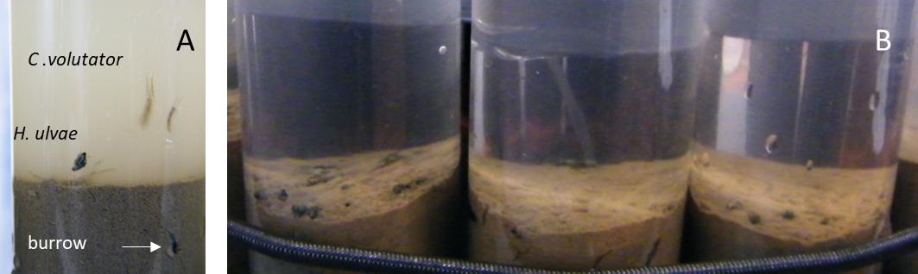

**Figure S1. A)** *Hydrobia ulvae* and *Corophium volutator* in sediment cores immediately after filling with seawater. A burrow in the top cm, possibly due to *C. volutator* activity, is also visible B) Sediment cores after the sediment has settled with visible *H. ulvae* individuals at the surface.

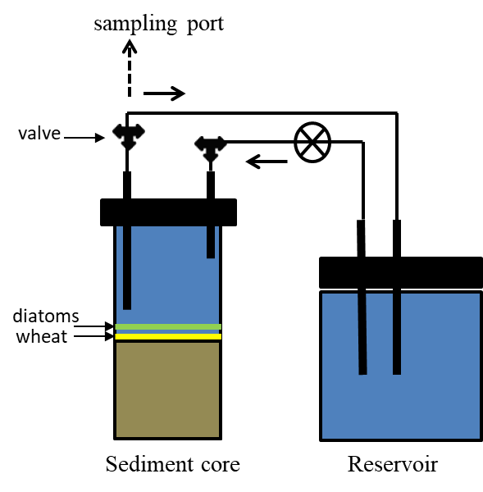

**Figure S2**. Basic design of experimental unit. Each core was connected to a corresponding water reservoir in a closed system through a peristaltic pump and water was circulated continuously.

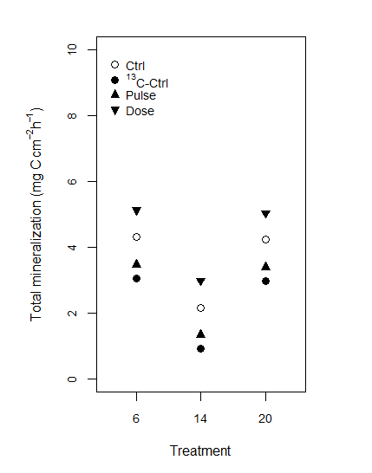

**Figure S3.** Model-predicted estimates (mean fitted value for the variable under consideration adjusted for all other variables in the analysis) of total mineralisation rate on days 6, 14 and 20. Analysis did not include Day 8. (section SI 1.3).



**Figure S4.** Model-predicted estimates (mean fitted value for the variable under consideration adjusted for all other variables in the analysis) of total mineralisation rate on days 6, 8, 14 and 20. Total mineralization was only affected by incubation day (L. ratio = 16.13, df1, p = 0.0011). Analysis did not include the Dose treatment. (section SI 1.4).



**Figure S5.** Model-predicted estimates (mean fitted value for the variable under consideration adjusted for all other variables in the analysis) of 13C-wheat mineralization rate on days 6, 8, 14 and 20. 13C-wheat mineralization was only affected by incubation day (L. ratio = 20.38, df1, p < 0.0001). Analysis did not include the Dose treatment. (section SI 1.6).

* 1. **Supplementary Tables**

**Table S1.** Carbon and nitrogen content by dry weight of wheat and diatom substrates used as proxies for terrestrial- and marine-derived organic matter respectively.

|  |  |  |  |
| --- | --- | --- | --- |
|  | %C | %N | C:N |
| Wheat (13C-labelled) | 42.83 | 0.25 | 169 |
| Diatoms (unlabelled) | 30.46 | 5.65 | 5 |

**Table S2**. Experimental set-up. Treatments (each n=3), type and amount of substrate (in mg C), and day of substrate addition in each treatment.

|  |  |  |
| --- | --- | --- |
| **Treatment** | **Substrates** | |
| 13C-wheat | Diatoms |
| Ctrl | ― | ― |
| 13C-Ctrl | 4.2 (day 0) | ― |
| Pulse | 4.2 (day 0) | 4.2 (day 7) |
| Dose | 4.2 (day 0) | 0.6 x 7 = 4.2 (days 7, 9, 11, 13, 15, 17, 19) |

**Table S3.** Raw data. Labelling is as follows: Treatment name (Ctrl, 13C-Ctrl, Pulse Dose) – replicate number (1,2,3) followed by S or E for Start or End of the incubation. Seawater volume (ml) in each sediment core was: Ctrl-1: 178.0, Ctrl-2: 173.0, Ctrl-3: 203.5, 13C-Ctrl-1: 188.2, 13C-Ctrl-2: 193.3, 13C-Ctrl-3: 173.0, Pulse-1: 183.1, Pulse-2: 183.1, Pulse-3: 193.3, Dose-1: 188.2, Dose-2: 193.3, Dose-3: 173.0.

|  |  |  |  |  |  |
| --- | --- | --- | --- | --- | --- |
| Sample | Incubation day | δ13C (‰) | atom % 13C | Total DIC (µg C ml-1) | Duration of incubation (h) |
| Ctrl-1-S | 6 | -4,653 | 1,101 | 24,546 | 4 |
| Ctrl-1-E | 6 | -4,479 | 1,101 | 25,050 | 4 |
| Ctrl-2-S | 6 | -5,786 | 1,099 | 25,378 | 4 |
| Ctrl-2-E | 6 | -5,312 | 1,100 | 28,704 | 4 |
| Ctrl-3-S | 6 | -4,691 | 1,101 | 22,993 | 4 |
| Ctrl-3-E | 6 | -4,429 | 1,101 | 23,421 | 4 |
| 13C-Ctrl-1-S | 6 | 103,062 | 1,218 | 25,167 | 4 |
| 13C-Ctrl-1-E | 6 | 107,644 | 1,223 | 25,684 | 4 |
| 13C-Ctrl-2-S | 6 | 51,845 | 1,162 | 24,195 | 4 |
| 13C-Ctrl-2-E | 6 | 56,179 | 1,167 | 23,369 | 4 |
| 13C-Ctrl-3-S | 6 | 77,424 | 1,190 | 25,316 | 4 |
| 13C-Ctrl-3-E | 6 | 77,808 | 1,191 | 26,137 | 4 |
| Pulse-1-S | 6 | 190,150 | 1,313 | 24,209 | 4 |
| Pulse-1-E | 6 | 185,907 | 1,309 | 25,488 | 4 |
| Pulse-2-S | 6 | 139,802 | 1,258 | 25,314 | 4 |
| Pulse-2-E | 6 | 142,711 | 1,261 | 26,244 | 4 |
| Pulse-3-S | 6 | 74,083 | 1,187 | 24,623 | 4 |
| Pulse-3-E | 6 | 79,307 | 1,192 | 24,678 | 4 |
| Dose-1-S | 6 | 107,904 | 1,224 | 24,109 | 4 |
| Dose-1-E | 6 | 104,617 | 1,220 | 25,972 | 4 |
| Dose-2-S | 6 | 146,830 | 1,266 | 24,949 | 4 |
| Dose-2-E | 6 | 146,257 | 1,265 | 27,587 | 4 |
| Ctrl-1-S | 8 | -8,681 | 1,096 | 22,065 | 4,5 |
| Ctrl-1-E | 8 | -8,089 | 1,097 | 22,662 | 4,5 |
| Ctrl-2-S | 8 | -8,300 | 1,097 | 22,270 | 4,5 |
| Ctrl-2-E | 8 | -8,274 | 1,097 | 23,425 | 4,5 |
| Ctrl-3-S | 8 | -7,613 | 1,097 | 17,034 | 4,5 |
| Ctrl-3-E | 8 | -7,711 | 1,097 | 19,852 | 4,5 |
| 13C-Ctrl-1-S | 8 | 133,681 | 1,252 | 23,282 | 4,5 |
| 13C-Ctrl-1-E | 8 | 140,038 | 1,259 | 23,434 | 4,5 |
| 13C-Ctrl-2-S | 8 | 228,933 | 1,355 | 17,721 | 4,5 |
| 13C-Ctrl-2-E | 8 | 249,175 | 1,377 | 21,538 | 4,5 |
| 13C-Ctrl-3-S | 8 | 78,969 | 1,192 | 18,860 | 4,5 |
| 13C-Ctrl-3-E | 8 | 83,553 | 1,197 | 22,972 | 4,5 |
| Pulse-1-S | 8 | 160,753 | 1,281 | 19,140 | 4,5 |
| Pulse-1-E | 8 | 165,925 | 1,287 | 22,546 | 4,5 |
| Pulse-2-S | 8 | 89,724 | 1,204 | 19,363 | 2,75 |
| Pulse-2-E | 8 | 89,553 | 1,203 | 22,877 | 2,75 |
| Pulse-3-S | 8 | 85,538 | 1,199 | 19,197 | 2,75 |
| Pulse-3-E | 8 | 87,344 | 1,201 | 23,028 | 2,75 |
| Dose-1-S | 8 | 338,155 | 1,474 | 16,685 | 2,75 |
| Dose-1-E | 8 | 317,181 | 1,451 | 20,207 | 2,75 |
| Ctrl-1-S | 14 | -7,539 | 1,097 | 16,979 | 5,5 |
| Ctrl-1-E | 14 | -7,827 | 1,097 | 17,297 | 5,5 |
| Ctrl-2-S | 14 | -9,231 | 1,096 | 17,063 | 5,5 |
| Ctrl-2-E | 14 | -8,825 | 1,096 | 17,724 | 5,5 |
| Ctrl-3-S | 14 | -6,577 | 1,098 | 14,392 | 5,5 |
| Ctrl-3-E | 14 | -7,720 | 1,097 | 16,046 | 5,5 |
| 13C-Ctrl-1-S | 14 | 342,662 | 1,479 | 16,370 | 5,5 |
| 13C-Ctrl-1-E | 14 | 323,835 | 1,459 | 16,680 | 5,5 |
| 13C-Ctrl-2-S | 14 | 143,089 | 1,262 | 16,316 | 5,5 |
| 13C-Ctrl-2-E | 14 | 144,644 | 1,264 | 16,819 | 5,5 |
| 13C-Ctrl-3-S | 14 | 39,708 | 1,149 | 17,333 | 5,5 |
| 13C-Ctrl-3-E | 14 | 40,442 | 1,150 | 17,339 | 5,5 |
| Pulse-1-S | 14 | 135,377 | 1,253 | 16,799 | 5,5 |
| Pulse-1-E | 14 | 103,414 | 1,219 | 17,172 | 5,5 |
| Pulse-2-S | 14 | 169,895 | 1,291 | 14,567 | 5,5 |
| Pulse-2-E | 14 | 243,472 | 1,371 | 14,870 | 5,5 |
| Pulse-3-S | 14 | 34,959 | 1,144 | 16,916 | 5,5 |
| Pulse-3-E | 14 | 40,714 | 1,150 | 17,418 | 5,5 |
| Dose-1-S | 14 | 324,234 | 1,459 | 15,312 | 5,5 |
| Dose-1-E | 14 | 375,787 | 1,515 | 16,175 | 5,5 |
| Dose-2-S | 14 | 77,039 | 1,190 | 17,222 | 5,5 |
| Dose-2-E | 14 | 90,324 | 1,204 | 18,013 | 5,5 |
| Dose-3-S | 14 | 45,750 | 1,156 | 16,520 | 5,5 |
| Dose-3-E | 14 | 54,411 | 1,165 | 17,605 | 5,5 |
| Ctrl-1-S | 20 | -9,507 | 1,095 | 17,104 | 4,25 |
| Ctrl-1-E | 20 | -9,581 | 1,095 | 18,229 | 4,25 |
| Ctrl-2-S | 20 | -9,315 | 1,095 | 17,339 | 4,25 |
| Ctrl-2-E | 20 | -8,883 | 1,096 | 18,320 | 4,25 |
| Ctrl-3-S | 20 | -8,693 | 1,096 | 18,250 | 4,25 |
| Ctrl-3-E | 20 | -9,605 | 1,095 | 19,110 | 4,25 |
| 13C-Ctrl-1-S | 20 | 427,067 | 1,570 | 17,465 | 4,25 |
| 13C-Ctrl-1-E | 20 | 439,023 | 1,583 | 19,343 | 4,25 |
| 13C-Ctrl-2-S | 20 | 133,325 | 1,251 | 18,126 | 4,25 |
| 13C-Ctrl-2-E | 20 | 139,459 | 1,258 | 18,593 | 4,25 |
| 13C-Ctrl-3-S | 20 | 91,153 | 1,205 | 17,374 | 4,25 |
| 13C-Ctrl-3-E | 20 | 81,927 | 1,195 | 18,005 | 4,25 |
| Pulse-1-S | 20 | 412,920 | 1,555 | 17,390 | 4,25 |
| Pulse-1-E | 20 | 479,486 | 1,627 | 18,313 | 4,25 |
| Pulse-2-S | 20 | 290,339 | 1,422 | 16,957 | 4,25 |
| Pulse-2-E | 20 | 328,157 | 1,463 | 15,433 | 4,25 |
| Pulse-3-S | 20 | 156,147 | 1,276 | 17,467 | 4,25 |
| Pulse-3-E | 20 | 146,299 | 1,265 | 18,862 | 4,25 |
| Dose-1-S | 20 | 324,846 | 1,460 | 16,088 | 4,25 |
| Dose-1-E | 20 | 334,297 | 1,470 | 16,795 | 4,25 |
| Dose-2-S | 20 | 297,385 | 1,430 | 18,695 | 4,25 |
| Dose-2-E | 20 | 321,336 | 1,456 | 18,679 | 4,25 |
| Dose-3-S | 20 | 161,161 | 1,282 | 17,722 | 4,25 |
| Dose-3-E | 20 | 184,949 | 1,307 | 19,135 | 4,25 |

**References**

Biles, C. L., Solan, M., Isaksson, I., Paterson, D. M., Emes, C., and Raffaelli, D. G. (2003). Flow modifies the effect of biodiversity on ecosystem functioning: An in situ study of estuarine sediments. in *Journal of Experimental Marine Biology and Ecology* doi:10.1016/S0022-0981(02)00525-7.

De Backer, A., Van Coillie, F., Montserrat, F., Provoost, P., Van Colen, C., Vincx, M., et al. (2011). Bioturbation effects of Corophium volutator: Importance of density and behavioural activity. *Estuar. Coast. Shelf Sci.* doi:10.1016/j.ecss.2010.10.031.

Limia, J., and Raffaelli, D. (1997). The effects of burrowing by the amphipod Corophium volutator on the ecology of intertidal sediments. *J. Mar. Biol. Assoc. United Kingdom* 77, 409. doi:10.1017/S0025315400071769.

Moran, M. D. (2003). Arguments for rejecting the sequential bonferroni in ecological studies. *Oikos*. doi:10.1034/j.1600-0706.2003.12010.x.

Pinheiro, J., Bates, D., DebRoy, S., Sarkar, D., and R Core Team (2018). nlme: Linear and Nonlinear Mixed Effects Models. R package version 3.1-137.

Pinheiro, J., and Bates, D. M. (2000). *Mixed-Effects Models in S and S-PLUS*. Springer Berlin / Heidelberg.

R Core Team (2018). R: A language and environment for statistical computing. Available at: https://www.r-project.org/.

Zuur, A. F., Ieno, E. N., Walker, N. J., Saveliev, A. A., and Smith, G. M. (2009). *Mixed Effects Model and Extensions in Ecology with R*. New York: Springer Science+Business Media.