Supplemental Figures

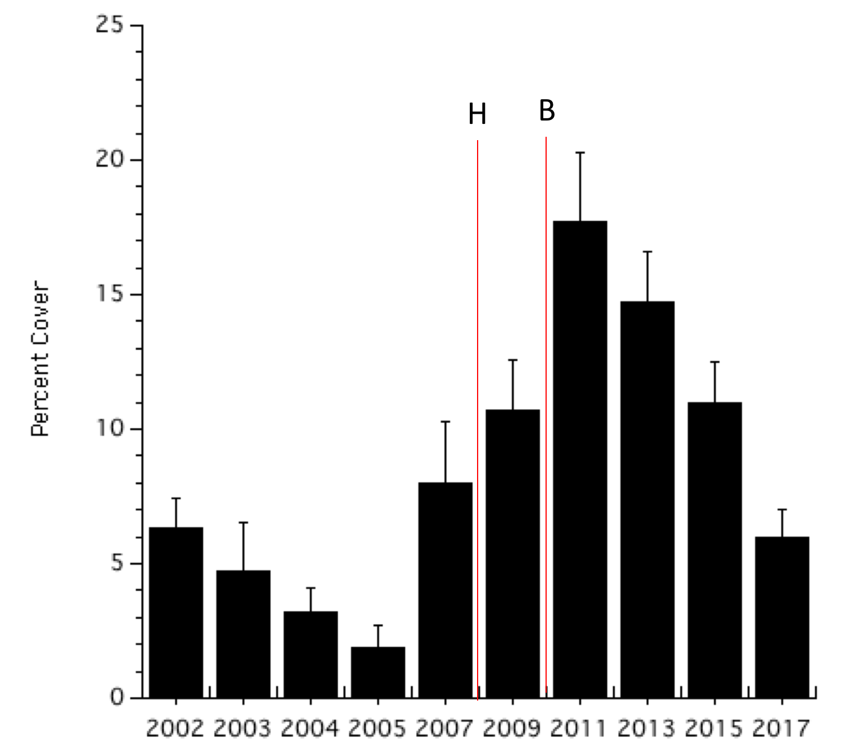

Figure S1. Percent cover of macroalgae at all monitored sites (see Figure 1). Vertical lines denoting the hurricane (H) and bleaching events (B) and SE variance are as in Figure 2. The average for the Caribbean is 20% or higher (Jackson et al 2014).

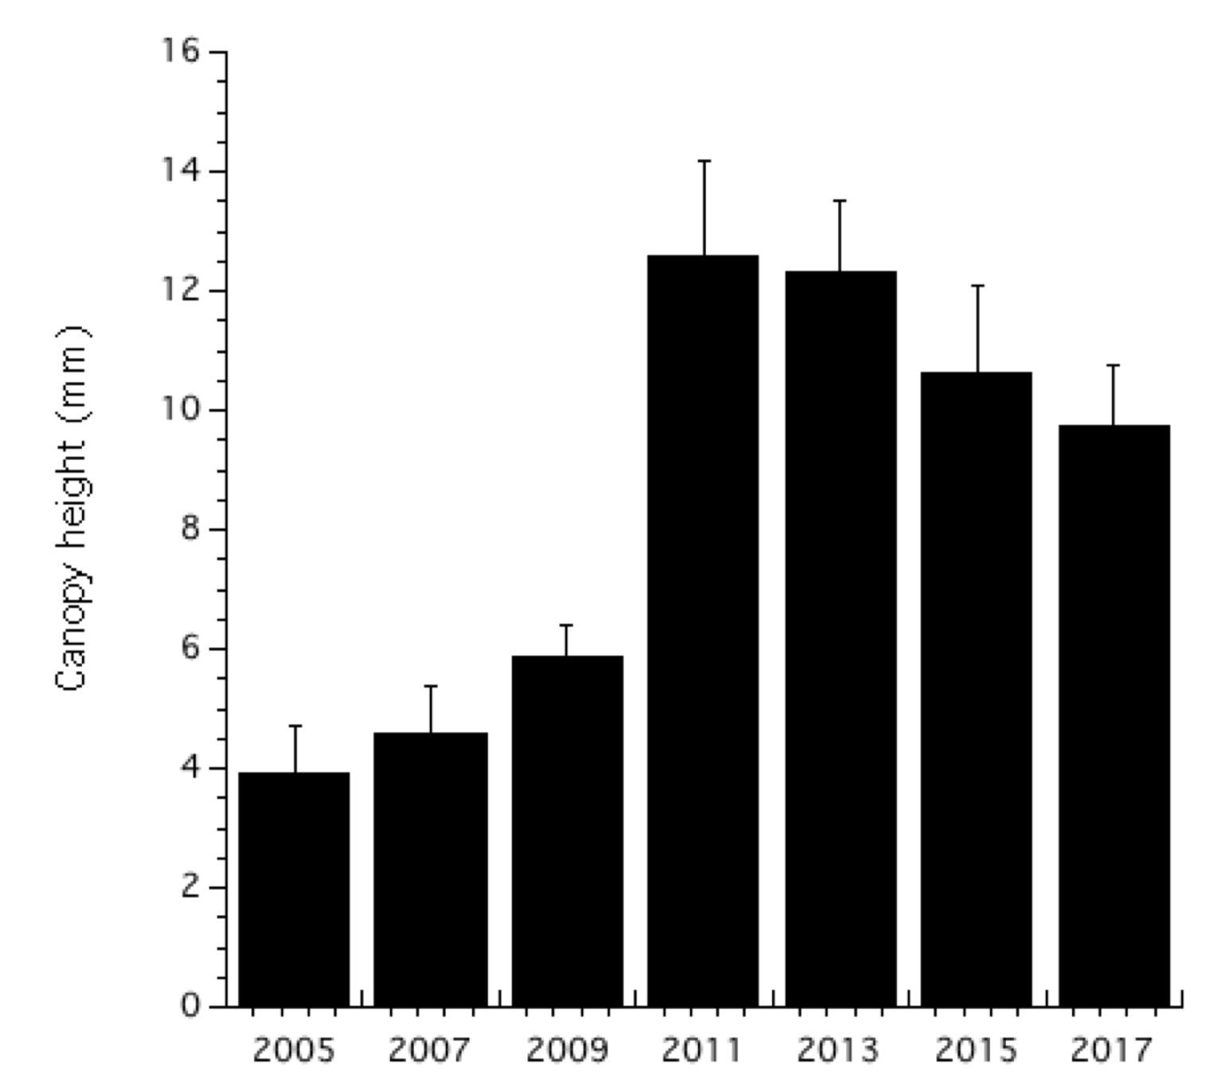

Figure S2. Canopy heights of macroalgae at all monitored sites (see Figure 1); SE variance are as in Figure 2.