Design of an antifungal surface embedding liposomal amphotericin B through a mussel adhesive-inspired coating strategy

Diana Alves*, Ana Teresa Vaz, Tânia Grainha, Célia F Rodrigues, Maria Olívia Pereira

*Correspondence: Diana Alves: [dianalves@ceb.uminho.pt](mailto:dianalves@ceb.uminho.pt)

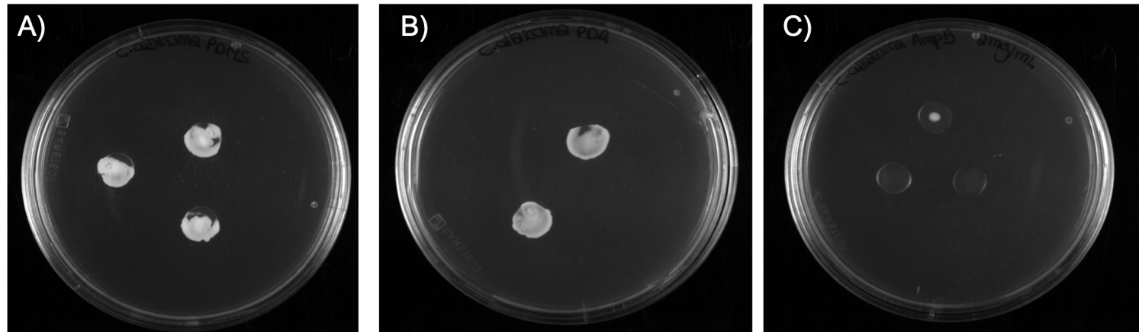

**Supplementary Figure 1.** Representative pictures of contact-killing assay. Fungal growth can be observed on SDA plates containing the PDMS samples (A) and pDA-coated coupons (B) and no significant visible growth was evidenced on pDA-coated PDMS surfaces further functionalized with LAmB (C) at 2 mg.mL-1.

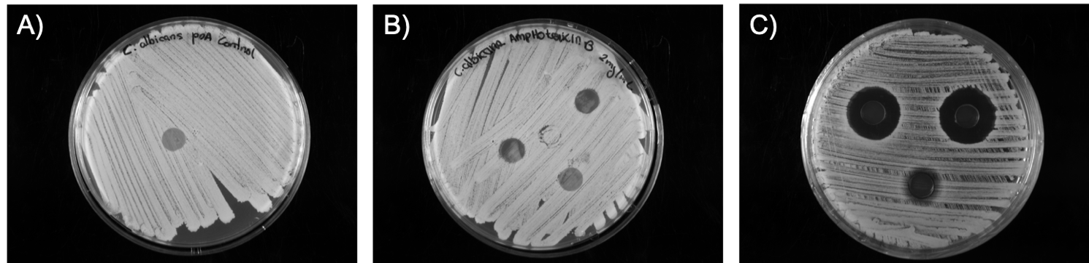

**Supplementary Figure 2.** Representative pictures of leaching assay. No evidence of inhibition zone was observed on pDA coupon (A) as well as on pDA-coated PDMS further functionalized with LAmB at 2 mg.mL-1 (B). On the other hand, the presence of an inhibition zone is evident around the surfaces functionalized with free AmB deoxycholate at the same concentration (C).