Supplementary Figures

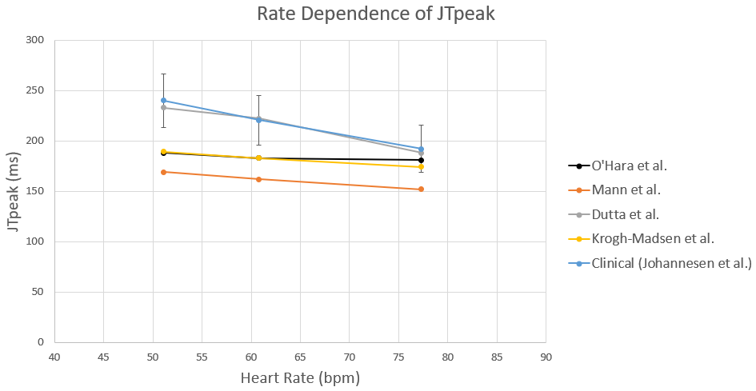
Fig. S1. Rate dependence of JTpeak. JTpeak was obtained for different heart rates with different cell models. Simulation results were compared with clinical data by Johannesen et al. (2014)

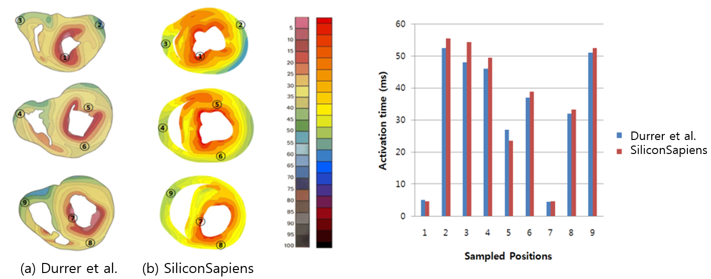
Fig. S2. Comparison of activation times in the ventricular model. The activation times obtained from the current ventricular model were compared with those in the literature (Durrer et al., 1970).

References
Durrer, D., van Dam, R.T., Freud, G.E., Janse, M.J., Meijler, F.L., Arzbaecher, R.C. (1970), Total excitation of the isolated human heart. Circulation 41, 899-912.
Johannesen, L., Vicente, J., Gray, R.A., Galeotti, L., Loring, Z., Garnett, C.E., Florian, J., Ugander, M., Stockbridge, N., Strauss, D.G. (2014). Improving the assessment of heart toxicity for all new drugs through translational regulatory science. Clinical Pharmacology & Therapeutics 95, 501-508.

