**Supplementary Information**

**Organic farming provides reliable environmental benefits but increases variability in crop yields: a global meta-analysis**

Olivia M. Smith, Abigail L. Cohen, Cassandra J. Rieser, Alexandra Davis, Joseph M. Taylor,Adekunle W. Adesanya, Matthew S. Jones, Amanda Meier, John P. Reganold, Robert J. Orpet, Tobin Northfield, David W. Crowder

**Supplementary Methods**

We generated data to use in our analysis of ecosystem services in organic and conventional agroecosystems from the following meta-analyses.

S1. Batary, P., Baldi, A., Kleijn, D. & Tscharntke, T. Landscape-moderated biodiversity effects of agri-environmental management: a meta-analysis. *Proc. R. Soc. B Biol. Sci.* **278,** 1894–1902 (2011).

S2. Crowder, D. W. & Reganold, J. P. Financial competitiveness of organic agriculture on a global scale. *Proc. Natl. Acad. Sci.* **112,** 7611–7616 (2015).

S3. Crowder, D. W., Northfield, T. D., Gomulkiewicz, R. & Snyder, W. E. Conserving and promoting evenness: organic farming and fire-based wildland management as case studies. *Ecology* **93,** 2001–2007 (2012).

S4. Gattinger, A., *et al.* Enhanced top soil carbon stocks under organic farming. *Proc. Natl. Acad. Sci.* **109,** 18226-18231 (2012).

S5. Lichtenberg, E. M. *et al.* A global synthesis of the effects of diversified farming systems on arthropod diversity within fields and across agricultural landscapes. *Glob. Chang. Biol.* **23,** 4946–4957 (2017).

S6. Lori, M., Symnaczik, S., Mäder, P., Deyn, G. De & Gattinger, A. Organic farming enhances soil microbial abundance and activity – A meta-analysis and meta-regression. *PLoS ONE* **12,** 1–25 (2017).

S7. Ponisio, L. C. *et al.* Diversification practices reduce organic to conventional yield gap. *Proc. R. Soc. B Biol. Sci.* **282,** 20141396–20141396 (2014).

S8. Tuck, S.L., *et al.* Land-use intensity and the effects of organic farming on biodiversity: A hierarchical meta-analysis. *J. Appl. Ecol.* **51,** 746-755 (2014).

S9. Smith, O.M., *et al.* Landscape context affects the sustainability of organic farming systems*. (in review)*

**Table S1.** List of variables used in data collection for meta-analysis for studies on biotic abundance, biotic richness, crop yields, and profitability

|  |  |  |
| --- | --- | --- |
| **Category** | **Class** | **Definition** |
| Pub.id |  | ID assigned to study |
| Study.name |  | Format as  Last Name YEAR  Last Name and Last Name YEAR  Last Name et al YEAR |
| Country | |  | | --- | | Argentina | | Australia | | Belgium | | Belgium and the Netherlands | | Bolivia | | Brazil | | Canada | | China | | Costa Rica | | Costa Rica and Guatemala | | Croatia | | Czech Republic | | Denmark | | Estonia | | Finland | | France | | Germany | | Greece | | India | | Ireland | | Italy | | Japan | | Kenya | | New Zealand | | Romania | | South Africa | | Spain | | Sweden | | Switzerland | | Taiwan | | Thailand | | The Netherlands | | Tunisia | | Turkey | | UK | | USA | | Country or countries study took place in |
| Continent | |  | | --- | | Africa | | Asia | | Australia | | Europe | | North America | | South America | | Zealandia | | Continent on which study took place |
| EU_US | Europe  USA  NA | If study occurred in the European Union, United States, or neither (N/A) |
| Study.type | Experimental Station  On Farm  Survey | Location in which data were collected |
| Crop | Alfalfa  Amaranth  Apple  Apricot  Banana  Barley  Bean  Beetroot  Broccoli  Cabbage  Cacao  Canola  Cantaloupe  Carrot  Cauliflower  Cereals  Citrus  Clover  Coffee  Corn  Cotton  Cowpea  Dairy  Elephant foot Yam  Flax  Grapes  Grass  Green beans  Guarana  Leek  Lentil  Lettuce  Lupin  Melon  Multi  Oat  Okra  Olive  Onion  Pea  Peach  Pepper  Peppermint  Plum  Potato  Pumpkin  Rice  Rye  Safflower  Soybean  Spinach  Squash  Strawberry  Sweet corn  Sweet potato  Taro  Tea  Tomato  Water spinach  Wheat  Yam | Crop type(s) in study |
| Crop.type | Beverages  Cereals  Fiber  Forage  Fruit and nuts  Multi  Oil crops  Other  Pulses  Root  Sugar  Vegetables | Followed FAO definitions  http://www.fao.org/fileadmin/templates/ess/documents/world_census_of_agriculture/appendix3_r7.pdf |
| Annual.perennial | Annual  Perennial  Annual/perennial | Followed NRCS classifications |

**Table S2.** List of variables used in data collection for studies on abundance and richness.

|  |  |  |
| --- | --- | --- |
| **Category** | **Class** | **Definition** |
| Org.grp | Arth - Arthropod  Microbe – Archaea, bacteria, fungi  NA – not listed in paper or groups with poor replication (< 6 observations)  Plant  Vert – vertebrate | Organismal group |
| Funct.grp | Decomp – decomposer, detritivore  Enemy – natural enemy including parasitoids and predators  Herbivore  Pollinator  Producer  NA – not listed in paper or poor replication (< 6) | Used classifications from primary studies or used in meta-data; binned into fewer groups |
| AbundRR | Numeric value | Abundance effect size calculated as log response ratio  Log(Abundance.org/Abundance/conv) |
| AbundsdRR | Numeric value | Abundance standard deviation effect size calculated as log response ratio |
| AbundRR | Numeric value | Abundance effect size calculated as log response ratio  Log(Abundance.org/Abundance/conv) |
| cvRR | Numeric value | Abundance coefficient of variation effect size (ln(Cvorg/Cvcon)) |
| RichRR | Numeric value | Mean richness effect size calculated as log response ratio (ln(Richness.org/Richness.conv)) |
| RichsdRR | Numeric value | Richness standard deviation effect size calculated as log response ratio |
| cvRR | Numeric value | Richness coefficient of variation effect size (ln(Cvorg/Cvcon)) |

**Table S3.** List of variables used in data collection for studies on soil carbon sequestration.

|  |  |  |
| --- | --- | --- |
| **Category** | **Class** | **Definition** |
| SOC_RR | Numeric value | Soil organic carbon mean response ratio (ln(Org_SOC/Con_SOC)) |
| SOC_sd_RR | Numeric value | Soil organic carbon standard deviation response ratio (ln(Org_SOC_sd/Con_SOC_sd) |
| SOC_CV_RR | Numeric value | Soil organic carbon coefficient of variation response ratio (ln(Org_SOC_CV/Con_SOC_CV) |
| C_stock_RR | Numeric value | Carbon stock mean response ratio (ln(Org_C_stock/Con_C_stock)) |
| C_stock_sd_RR | Numeric value | Carbon stock mean standard deviation response ratio (ln(Org_C_stock_sd/Con_C_stock_sd)) |
| C_stock_CV_RR | Numeric value | Carbon stock mean coefficient of variation response ratio (ln(Org_C_stock_CV/Con_C_stock_CV)) |

**Table S4.** List of variables used in data collection for studies on yield.

|  |  |  |
| --- | --- | --- |
| **Category** | **Class** | **Definition** |
| YieldRR | Numeric value | Yield log response ratio |
| YieldsdRR | Numeric value | Yield standard deviation effect size calculated as log response ratio |
| CVRR | Numeric value | Abundance coefficient of variation effect size (ln(Cvorg/Cvcon)) |

**Table S5.** List of variables used in data collection for studies on profit.

|  |  |  |
| --- | --- | --- |
| **Category** | **Class** | **Definition** |
| BCPRR | Numeric value | Benefit:cost ratio with premiums log response ratio (ln(OrgBCP/ConBCP)) |
| BCPsdRR | Numeric value | Benefit:cost ratio with premiums standard deviation log response ratio (ln(OrgBCP_SD/ConBCP_SD) |
| BCPcvRR | Numeric value | Benefit:cost ratio with premiums coefficient of variation response ratio (ln(OrgBCPCV/ConBCPCV)) |
| CostRR | Numeric value | Production cost log response ratio (ln(OrgCost/ConvCost)) |
| CostsdRR | Numeric value | Production cost standard deviation log response ratio (ln(OrgCostSD/ConvCostSD)) |
| CostcvRR | Numeric value | Production cost coefficient of variation log response ratio (ln(CostOrgCV/CostConCV) |

**Table S6.** Number of studies for abundance, richness, soil, yield, and profit mean and standard deviations/coefficient of variation

|  |  |  |  |  |  |  |  |
| --- | --- | --- | --- | --- | --- | --- | --- |
|  | Abundance | Richness | SOC | C Stock | Yield | Costs | Profit |
| Mean | 116 | 154 | 74 | 74 | 157 | 33 | 33 |
| sd/CV | 52 | 102 | 31 | 15 | 118 | 17 | 14 |

**Table S7.** Number of estimates for abundance, richness, yield, profit, and soil mean and standard deviations/coefficient of variation

|  |  |  |  |  |  |  |  |
| --- | --- | --- | --- | --- | --- | --- | --- |
|  | Abundance | Richness | SOC | C Stock | Yield | Costs | Profit |
| Mean | 239 | 290 | 209 | 209 | 295 | 82 | 82 |
| sd/CV | 106 | 207 | 91 | 50 | 230 | 45 | 30 |

**Table S8.** Number of estimates by taxonomic group for abundance and richness mean and standard deviations with combined organismal groups, each having ≥ 6 replicates

|  |  |  |  |  |
| --- | --- | --- | --- | --- |
| **Taxa** | **Abundance mean** | **Abundance sd/CV** | **Richness mean** | **Richness sd/CV** |
| Arthropod | 112 | 68 | 139 | 111 |
| Microbe | 62 | 16 | 34 | 23 |
| Plants | 18 | 7 | 68 | 50 |
| Vertebrate | 14 | 1 | 24 | 15 |

**Table S9.** Number of estimates by functional group for abundance and richness mean and standard deviations having ≥ 6 replicates

|  |  |  |  |  |
| --- | --- | --- | --- | --- |
| **Functional Group** | **Abundance mean** | **Abundance sd/CV** | **Richness mean** | **Richness sd/CV** |
| Decomposer | 19 | 9 | 23 | 18 |
| Natural enemy | 65 | 34 | 70 | 50 |
| Herbivore | 16 | 9 | 18 | 13 |
| Pollinator | 19 | 17 | 31 | 29 |
| Producer | 17 | 6 | 64 | 49 |

**Table S10.** Number of estimates by crop type for abundance, richness, yield, profit, and soil mean and standard deviations

|  |  |  |  |  |  |  |  |  |  |  |  |  |  |  |
| --- | --- | --- | --- | --- | --- | --- | --- | --- | --- | --- | --- | --- | --- | --- |
| **Crop type** | **Abundance mean** | **Abundance sd/CV** | **Richness mean** | **Richness sd/CV** | **Yield mean** | **Yield sd/CV** | **Profit BCP Mean** | **Profit BCP sd/CV** | **Cost mean** | **Cost sd/CV** | **SOC mean** | **SOC sd/cv** | **C Stock mean** | **C Stock sd/cv** |
| Annual | 157 | 74 | 172 | 129 | 260 | 201 | 71 | 23 | 71 | 37 | 138 | 52 | 138 | 34 |
| Annual/perennial | 7 | 2 | 18 | 16 | 6 | 5 | 0 | 0 | 0 | 0 | 1 | 1 | 1 | 0 |
| Perennial | 37 | 18 | 40 | 20 | 28 | 24 | 11 | 7 | 11 | 8 | 54 | 32 | 54 | 10 |
| N/A | 38 | 12 | 60 | 42 | 1 | 0 | 0 | 0 | 0 | 0 | 16 | 6 | 16 | 6 |

**Table S11.** Number of estimates by experimental stations versus working farms for abundance, richness, yield, profit, and soil mean and standard deviations

|  |  |  |  |  |  |  |  |  |  |  |  |  |  |  |
| --- | --- | --- | --- | --- | --- | --- | --- | --- | --- | --- | --- | --- | --- | --- |
| **Study Scale** | **Abundance mean** | **Abundance sd/CV** | **Richness mean** | **Richness sd/CV** | **SOC mean** | **SOC sd/cv** | **C Stock mean** | **C Stock sd/cv** | **Yield mean** | **Yield sd/cv** | **Cost mean** | **Cost sd/cv** | **Profit mean** | **Profit sd/cv** |
| Experimental Station | 96 | 31 | 52 | 34 | 56 | 13 | 56 | 16 | 224 | 170 | 59 | 32 | 59 | 18 |
| On Farm | 142 | 75 | 235 | 171 | 145 | 72 | 145 | 28 | 52 | 46 | 5 | 5 | 5 | 4 |
| Survey | 0 | 0 | 0 | 0 | 0 | 0 | 0 | 6 | 19 | 14 | 18 | 8 | 18 | 8 |
| N/A | 1 | 0 | 3 | 2 | 8 | 6 | 8 | 0 | 0 | 0 | 0 | 0 | 0 | 0 |

**Table S12.** Number of estimates by European Union and United States for 7 sustainability metrics: biotic abundance, biotic richness, soil organic carbon, yield, costs, and profitability.

|  |  |  |  |  |  |  |  |  |  |  |  |  |  |  |
| --- | --- | --- | --- | --- | --- | --- | --- | --- | --- | --- | --- | --- | --- | --- |
| **Location** | **Abundance mean** | **Abundance sd/CV** | **Richness mean** | **Richness sd/CV** | **SOC mean** | **SOC sd/CV** | **C Stock mean** | **C Stock sd/CV** | **Yield mean** | **Yield sd/CV** | **Profit BCP Mean** | **Profit BCP sd/CV** | **Cost mean** | **Cost sd/CV** |
| European Union | 114 | 41 | 192 | 141 | 108 | 60 | 108 | 32 | 110 | 94 | 8 | 5 | 8 | 6 |
| United States | 67 | 21 | 57 | 38 | 47 | 11 | 47 | 11 | 112 | 87 | 49 | 12 | 49 | 29 |

**Table S13.** Number of estimates by FAO crop type for abundance, richness, yield, profit, and soil mean and standard deviations

|  |  |  |  |  |  |  |  |  |  |  |  |  |  |  |
| --- | --- | --- | --- | --- | --- | --- | --- | --- | --- | --- | --- | --- | --- | --- |
| **FAO Crop Type** | **Abundance mean** | **Abundance sd/CV** | **Richness mean** | **Richness sd/CV** | **Yield mean** | **Yield sd/CV** | **Profit BCP Mean** | **Profit BCP sd/CV** | **Cost mean** | **Cost sd/CV** | **SOC mean** | **SOC sd/cv** | **C Stock mean** | **C Stock sd/cv** |
| Beverage | 6 | 5 | 5 | 2 | 2 | 2 | 1 | 1 | 1 | 0 | 9 | 0 | 9 | 0 |
| Cereals | 96 | 41 | 121 | 89 | 121 | 92 | 33 | 9 | 33 | 17 | 22 | 2 | 22 | 0 |
| Fiber | 0 | 0 | 0 | 0 | 4 | 4 | 3 | 2 | 3 | 2 | 2 | 0 | 2 | 0 |
| Forage | 6 | 1 | 17 | 15 | 6 | 5 | 0 | 0 | 0 | 0 | 1 | 1 | 1 | 0 |
| Fruits | 27 | 12 | 32 | 18 | 31 | 22 | 8 | 5 | 8 | 7 | 25 | 11 | 25 | 10 |
| Multi | 5 | 3 | 3 | 2 | 0 | 0 | 0 | 0 | 0 | 0 | 105 | 47 | 105 | 34 |
| Oil crops | 12 | 4 | 5 | 2 | 38 | 32 | 15 | 2 | 15 | 9 | 13 | 13 | 13 | 0 |
| Other | 21 | 18 | 12 | 1 | 3 | 3 | 0 | 0 | 0 | 0 | 3 | 0 | 3 | 0 |
| Pulses | 4 | 0 | 1 | 1 | 11 | 9 | 3 | 1 | 3 | 2 | 2 | 2 | 2 | 0 |
| Root | 8 | 2 | 11 | 5 | 8 | 8 | 0 | 0 | 0 | 0 | 0 | 0 | 0 | 0 |
| Vegetables | 25 | 17 | 22 | 18 | 71 | 53 | 19 | 10 | 19 | 8 | 5 | 3 | 5 | 0 |
| N/A | 29 | 3 | 61 | 44 | 0 | 0 | 0 | 0 | 0 | 0 | 22 | 12 | 22 | 6 |

**Table S14.** Mean response ratio, standard deviation response ratio, and coefficient of variation response ratio mean and 90% confidence interval (CI) for richness and abundance of 4 organismal groups

|  |  |  |  |  |  |  |  |
| --- | --- | --- | --- | --- | --- | --- | --- |
| **Group** | **Biotic metric** | **Mean** | **90% CI** | **sd** | **90% CI** | **cv** | **90% CI** |
| Arthropod | Abundance | 0.21 | **(0.10, 0.32)** | 0.10 | (-0.080, 0.29) | -0.12 | (-0.24, 0.002) |
| Microbe | Abundance | 0.31 | **(0.16, 0.45)** | 0.30 | **(0.020, 0.58)** | -0.18 | (-0.41, 0.050) |
| Plant | Abundance | 0.62 | **(0.33, 0.91)** | 0.60 | (-0.32, 1.53) | -0.35 | (-0.80, 0.11) |
| Vertebrate | Abundance | 0.30 | **(0.12, 0.48)** | N/A | N/A | N/A | N/A |
| Arthropod | Richness | 0.16 | **(0.11, 0.21)** | 0.13 | **(0.005, 0.25)** | -0.04 | (-0.15, 0.072) |
| Microbe | Richness | 0.07 | (-0.093, 0.23**)** | 0.34 | **(0.035, 0.74)** | 0.12 | (-0.21, 0.53) |
| Plant | Richness | 0.43 | **(0.32, 0.55)** | 0.10 | (-0.036, 0.24) | -0.42 | **(-0.56, -0.27)** |
| Vertebrate | Richness | 0.33 | **(0.022, 0.64)** | 0.62 | (-0.048, 1.28) | 0.10 | (-0.19, 0.39) |

**Table S15.** Mean response ratio, standard deviation response ratio, and coefficient of variation response ratio mean and 90% confidence interval (CI) for richness and abundance of 5 functional groups.

|  |  |  |  |  |  |  |  |
| --- | --- | --- | --- | --- | --- | --- | --- |
| **Group** | **Service** | **Mean** | **90% CI** | **sd** | **90% CI** | **cv** | **90% CI** |
| Decomposer | Abundance | 0.54 | **(0.16, 0.92)** | 0.61 | (-0.50, 1.72) | 0.14 | (-0.54, 0.83) |
| Natural enemy | Abundance | 0.26 | **(0.12, 0.39)** | 0.014 | (-0.24, 0.26) | -0.20 | (-0.40, 0.007) |
| Herbivore | Abundance | 0.19 | (-0.24, 0.62) | 0.28 | (-0.56, 1.11) | 0.12 | (-0.16, 0.39) |
| Pollinator | Abundance | 0.33 | **(0.025, 0.63)** | 0.39 | **(0.12, 0.66)** | -0.12 | (-0.34, 0.11) |
| Producer | Abundance | 0.59 | **(0.28, 0.89)** | 0.51 | (-0.60, 1.62) | -0.40 | (-0.95, 0.14) |
| Decomposer | Richness | 0.54 | (-0.005, 0.18) | 0.61 | (-0.18, 0.47) | 0.14 | (-0.29, 0.42) |
| Natural enemy | Richness | 0.097 | **(0.032, 0.16)** | 0.058 | (-0.15, 0.27) | -0.039 | (-0.25, 0.17) |
| Herbivore | Richness | 0.19 | **(0.069, 0.44)** | 0.28 | **(0.16, 0.92)** | 0.12 | (-0.023, 0.47) |
| Pollinator | Richness | 0.33 | **(0.12, 0.39)** | 0.39 | (-0.006, 0.29) | -0.12 | (-0.26, 0.031) |
| Producer | Richness | 0.59 | **(0.39, 0.60)** | 0.51 | (-0.37, 0.24) | -0.40 | **(-0.56, -0.27)** |

**Table S16.** Mean response ratio, standard deviation response ratio, and coefficient of variation response ratio mean and 90% confidence interval (CI) for 7 sustainability metrics by annual and perennial crop types.

|  |  |  |  |  |  |  |  |
| --- | --- | --- | --- | --- | --- | --- | --- |
| **Crop type** | **Service** | **Mean** | **90% CI** | **sd** | **90% CI** | **CV** | **90% CI** |
| Annual | Abundance | 0.30 | **(0.21, 0.39)** | 0.32 | **(0.14, 0.49)** | -0.12 | (-0.25, 0.017) |
| Annual | Richness | 0.26 | **(0.20, 0.33)** | 0.16 | **(0.038, 0.28)** | -0.16 | **(-0.28, -0.040)** |
| Annual | SOC | 0.15 | **(0.12, 0.19)** | 0.32 | **(0.11, 0.52)** | 0.20 | **(0.010, 0.40)** |
| Annual | C stock | 0.14 | **(0.11, 0.18)** | 0.34 | **(0.076, 0.61)** | 0.18 | **(0.055, 0.30)** |
| Annual | Yield | -0.27 | **(-0.30, -0.23)** | -0.007 | (-0.097, 0.082) | 0.28 | **(0.19, 0.38)** |
| Annual | Cost | -0.01 | (-0.070, 0.042) | -0.01 | (-0.27, 0.24) | 0.05 | (-0.19, 0.29) |
| Annual | Profit | 0.32 | **(0.22, 0.42)** | 0.25 | (-0.019, 0.53) | 0.29 | (-0.007, 0.59) |
| Perennial | Abundance | 0.50 | **(0.25, 0.75)** | 0.003 | (-0.36, 0.37) | -0.31 | **(-0.49, -0.12)** |
| Perennial | Richness | 0.15 | **(0.004, 0.30)** | 0.24 | (-0.009, 0.48) | -0.017 | (-0.25, 0.21) |
| Perennial | SOC | 0.05 | (-0.006, 0.11) | -0.15 | (-0.33, 0.040) | -0.15 | **(-0.29, -0.001)** |
| Perennial | C stock | 0.22 | (-0.017, 0.082) | -0.15 | (-0.50, 0.20) | -0.11 | (-0.28, 0.071) |
| Perennial | Yield | -0.15 | (-0.30, 0.004) | 0.002 | (-0.23, 0.24) | 0.18 | (-0.030, 0.38) |
| Perennial | Cost | -0.10 | (-0.22, 0.032) | -0.01 | (-0.44, 0.42) | 0.05 | (-0.30, 0.39) |
| Perennial | Profit | 0.26 | **(0.10, 0.43)** | -0.07 | (-0.49, 0.35) | -0.23 | (-0.65, 0.19) |

**Table S17.** Welch’s *t*-tests or likelihood ratio tests (LRT; type indicated in table) examining differences in annual/perennial crop types for seven sustainability metrics.

|  |  |  |  |  |  |  |  |  |  |  |  |  |
| --- | --- | --- | --- | --- | --- | --- | --- | --- | --- | --- | --- | --- |
| Response variable | Mean | | | | Standard deviation | | | | Coefficient of Variation | | | |
| Test | Test statistic | df | *P* | Test | Test statistic | df | *P* | Test | Test statistic | df | *P* |
| Abundance | LTR | -1.24 | 46.14 | 0.22 | LTR | 1.33 | 26.29 | 0.19 | LTR | 1.43 | 38.75 | 0.16 |
| Richness | LTR | 1.19 | 54.37 | 0.24 | LTR | -0.47 | 30.38 | 0.64 | Welch’s | -0.96 | 31.84 | 0.35 |
| SOC | LTR | **2.49** | **100.08** | **0.014** | LTR | **2.81** | **80.39** | **0.006** | LTR | **2.43** | **81.84** | **0.017** |
| C Stock | LTR | **3.11** | **103.26** | **0.002** | LTR | **2.01** | **23.01** | **0.057** | LTR | 1.31 | 30.71 | 0.20 |
| Yields | LTR | -1.29 | 30.51 | 0.21 | LTR | -0.065 | 30.60 | 0.95 | LTR | 0.78 | 33.74 | 0.44 |
| Costs | LTR | 1.04 | 15.02 | 0.31 | LTR | -0.017 | 14.25 | 0.99 | LTR | 0.032 | 16.71 | 0.98 |
| Profit | LTR | 0.48 | 20.41 | 0.64 | LTR | 1.21 | 13.22 | 0.25 | LTR | **1.89** | **14.69** | **0.079** |

**Table S18.** Mean response ratio, standard deviation response ratio, and coefficient of variation response ratio mean and 90% confidence interval (CI) for 5 sustainability metrics for studies conducted on experimental stations versus working farms.

|  |  |  |  |  |  |  |  |
| --- | --- | --- | --- | --- | --- | --- | --- |
| Metric | Study type | Mean | 90% CI | sd | 90% CI | CV | 90% CI |
| Abundance | Experimental Station | 0.40 | **(0.27, 0.52)** | 0.39 | **(0.079, 0.71)** | -0.33 | **(-0.51, -0.14)** |
| Abundance | On Farm | 0.27 | **(0.17, 0.36)** | 0.17 | **(0.0003, 0.35)** | -0.07 | (-0.19, 0.056) |
| Richness | Experimental Station | 0.18 | **(0.051, 0.32)** | 0.09 | (-0.17, 0.34) | -0.26 | **(-0.47, -0.042)** |
| Richness | On Farm | 0.24 | **(0.18, 0.29)** | 0.19 | **(0.088, 0.29)** | -0.09 | (-0.18, 0.001) |
| SOC | Experimental Station | 0.14 | **(0.094, 0.19)** | 0.01 | (-0.39, 0.40) | -0.07 | (-0.50, 0.37) |
| SOC | On Farm | 0.12 | **(0.085, 0.16)** | 0.16 | **(0.0002, 0.33)** | 0.09 | (-0.052, 0.23) |
| C Stock | Experimental Station | 0.14 | (0.097, 0.18) | 0.20 | (-0.076, 0.48) | 0.09 | (-0.20, 0.38) |
| C Stock | On Farm | 0.10 | (0.071, 0.14) | 0.25 | (-0.074, 0.57) | 0.13 | (-0.18, 0.44) |
| Yield | Experimental Station | -0.24 | **(-0.28, -0.20)** | 0.00 | (-0.096, 0.096) | 0.31 | **(0.21, 0.41)** |
| Yield | On Farm | -0.31 | **(-0.40, -0.21)** | -0.06 | (-0.22, 0.18) | 0.26 | **(0.075, 0.44)** |

**Table S19.** Welch’s *t*-tests or likelihood ratio tests (LRT; type indicated in table) examining differences in studies conducted on experimental stations versus working farms for 5 sustainability metrics.

|  |  |  |  |  |  |  |  |  |  |  |  |  |
| --- | --- | --- | --- | --- | --- | --- | --- | --- | --- | --- | --- | --- |
| Response variable | Mean | | | | Standard deviation | | | | Coefficient of Variation | | | |
| Test | Test statistic | df | *P* | Test | Test statistic | df | *P* | Test | Test statistic | df | *P* |
| Abundance | LTR | 1.37 | 193.29 | 0.17 | LTR | 1.03 | 50.07 | 0.31 | Welch’s | **-1.93** | **57.93** | **0.059** |
| Richness | LTR | -0.62 | 69.08 | 0.54 | LTR | -0.63 | 44.52 | 0.53 | Welch’s | -1.22 | 45.85 | 0.23 |
| SOC | LTR | 0.50 | 131.12 | 0.61 | LTR | -0.64 | 17.02 | 0.53 | LTR | -0.61 | 15.06 | 0.55 |
| C Stock | LTR | 1.06 | 129.86 | 0.29 | LTR | -0.20 | 41.55 | 0.84 | LTR | -0.16 | 40.37 | 0.87 |
| Yields | LTR | 1.01 | 71.61 | 0.32 | LTR | 0.17 | 68.27 | 0.86 | LTR | 0.17 | 76.68 | 0.86 |

**Table S20.** Mean response ratio, standard deviation response ratio, and coefficient of variation response ratio mean and 90% confidence interval (CI) for 7 sustainability metrics for the United States and European Union.

|  |  |  |  |  |  |  |  |
| --- | --- | --- | --- | --- | --- | --- | --- |
| Service | Location | Mean RR | 90% CI | SD RR | 90% CI | CV RR | 90% CI |
| Abundance | EU | 0.31 | **(0.19, 0.42)** | 0.41 | **(0.13, 0.69)** | -0.08 | (-0.27, 0.11) |
| Abundance | USA | 0.43 | **(0.30, 0.56)** | 0.34 | **(0.096, 0.58)** | -0.22 | (-0.43, -0.013) |
| Richness | EU | 0.25 | **(0.18, 0.31)** | 0.23 | **(0.11, 0.35)** | -0.08 | (-0.19, 0.030) |
| Richness | USA | 0.19 | **(0.097, 0.29)** | 0.14 | (-0.041, 0.33) | -0.15 | (-0.31, 0.007) |
| SOC | EU | 0.09 | **(0.047, 0.13)** | -0.04 | (-0.19, 0.11) | -0.09 | (-0.23, 0.053) |
| SOC | USA | 0.22 | **(0.16, 0.28)** | 0.07 | (-0.32, 0.45) | 0.0009 | (-0.33, 0.33) |
| C stock | EU | 0.09 | **(0.052, 0.13)** | 0.03 | (-0.19, 0.26) | -0.07 | (-0.28, 0.15) |
| C stock | USA | 0.19 | **(0.13, 0.24)** | 0.17 | (-0.15, 0.50) | 0.16 | (-0.11, 0.44) |
| Yield | EU | -0.31 | **(-0.36, -0.25)** | 0.03 | (-0.10, 0.16) | 0.33 | **(0.20, 0.46)** |
| Yield | USA | -0.23 | **(-0.29, -0.17)** | -0.05 | (-0.18, 0.070) | 0.28 | **(0.17, 0.40)** |
| Cost | EU | 0.11 | (-0.034, 0.26) | 0.05 | (-0.33, 0.43) | 0.03 | (-0.34, 0.41) |
| Cost | USA | -0.003 | (-0.068, 0.062) | 0.06 | (-0.23, 0.34) | 0.07 | (-0.20, 0.34) |
| Profit | EU | 0.20 | (-0.017, 0.41) | 0.40 | **(0.20, 0.60)** | 0.32 | (-0.045, 0.69) |
| Profit | USA | 0.46 | **(0.34, 0.58)** | 0.41 | (-0.031, 0.86) | 0.54 | **(0.088, 1.00)** |

**Table S21.** Welch’s *t*-tests or likelihood ratio tests (LRT; type indicated in table) examining differences studies conducted within the European Union versus United States for 7 sustainability metrics.

|  |  |  |  |  |  |  |  |  |  |  |  |  |
| --- | --- | --- | --- | --- | --- | --- | --- | --- | --- | --- | --- | --- |
| Response variable | Mean | | | | Standard deviation | | | | Coefficient of Variation | | | |
| Test | Test statistic | df | *P* | Test | Test statistic | df | *P* | Test | Test statistic | df | *P* |
| Abundance | LTR | -1.17 | 150.47 | 0.24 | LTR | 0.33 | 58.52 | 0.74 | LTR | 0.85 | 51.05 | 0.40 |
| Richness | LTR | 0.72 | 113.13 | 0.47 | LTR | 0.67 | 72.05 | 0.50 | Welch’s | 0.64 | 77.18 | 0.53 |
| SOC | LTR | **-2.89** | **95.59** | **0.0048** | LTR | -0.45 | 13.95 | 0.66 | LTR | -0.44 | 14.65 | 0.67 |
| C Stock | LTR | **-2.45** | **91.96** | **0.016** | LTR | -0.64 | 21.62 | 0.53 | Welch’s | -1.18 | 25.01 | 0.25 |
| Yields | LTR | -1.60 | 216.04 | 0.11 | LTR | 0.78 | 178.84 | 0.44 | LTR | 0.96 | 178.86 | 0.34 |
| Costs | LTR | 1.32 | 11.00 | 0.21 | LTR | -0.023 | 14.13 | 0.98 | LTR | -0.15 | 13.19 | 0.89 |
| Profit | LTR | **-1.92** | **13.32** | **0.077** | LTR | -0.61 | 9.97 | 0.56 | LTR | -0.21 | 8.36 | 0.84 |

**Table S22.** Mean response ratio, standard deviation response ratio, and coefficient of variation response ratio mean and 90% confidence interval (CI) for biotic abundance by FAO crop type.

|  |  |  |  |  |  |  |
| --- | --- | --- | --- | --- | --- | --- |
| FAO Crop | Mean RR | 90% CI | SD RR | 90% CI | CV RR | 90% CI |
| Cereals | 0.32 | **(0.21, 0.43)** | 0.31 | **(0.035, 0.58)** | -0.12 | (-0.32, 0.085) |
| Fruits | 0.52 | **(0.19, 0.86)** | 0.13 | (-037, 0.63) | -0.28 | **(-0.54. -0.027)** |
| Vegetables | 0.60 | **(0.42, 0.78)** | 0.58 | **(0.21, 0.91)** | -0.09 | (-0.34, 0.17) |

**Table S23.** Mean response ratio, standard deviation response ratio, and coefficient of variation response ratio mean and 90% confidence interval (CI) for biotic richness by FAO crop type.

|  |  |  |  |  |  |  |
| --- | --- | --- | --- | --- | --- | --- |
| FAO Crop | Mean RR | 90% CI | SD RR | 90% CI | CV RR | 90% CI |
| Cereals | 0.31 | **(0.23, 0.39)** | 0.21 | **(0.068, 0.35)** | -0.17 | **(-0.31, -0.015)** |
| Forage | 0.21 | **(0.10, 0.31)** | 0.17 | (-0.18, 0.52) | -0.056 | (-0.45, 0.34) |
| Fruits | 0.13 | (-0.056, 0.31) | 0.24 | (-0.032, 0.52) | -0.01 | (-0.26, 0.25) |
| Vegetables | 0.27 | **(0.16, 0.38)** | 0.15 | (-0.26, 0.56) | -0.09 | (-0.45, 0.28) |

**Table S24.** Mean response ratio, standard deviation response ratio, and coefficient of variation response ratio mean and 90% confidence interval (CI) for soil organic carbon by FAO crop type.

|  |  |  |  |  |  |  |
| --- | --- | --- | --- | --- | --- | --- |
| Type | Mean RR | 90% CI | SD RR | 90% CI | CV RR | 90% CI |
| Fruits | 0.12 | **(0.021, 0.21)** | -0.23 | (-0.63, 0.18) | -0.21 | (-0.11, 0.47) |
| Oil crops | 0.12 | **(0.005, 0.23)** | 0.12 | (-0.14, 0.39) | 0.003 | (0.16, 0.61) |

**Table S25.** Mean response ratio, standard deviation response ratio, and coefficient of variation response ratio mean and 90% confidence interval (CI) for crop yields by FAO crop type.

|  |  |  |  |  |  |  |
| --- | --- | --- | --- | --- | --- | --- |
| FAO Crop type | Mean RR | 90% CI | SD RR | 90% CI | CV RR | 90% CI |
| Cereals | -0.32 | **(-0.37, -0.27)** | -0.01 | (-0.14, 0.13) | 0.40 | **(0.27, 0.53)** |
| Fruits | -0.06 | (-0.21, 0.080) | 0.0012 | (-0.26, 0.26) | 0.07 | (-0.19, 0.34) |
| Oil crops | -0.28 | **(-0.39, -0.18)** | 0.07 | (-0.091, 0.22) | 0.38 | **(0.19, 0.56)** |
| Pulses | -0.15 | **(-0.26, -0.043)** | -0.07 | (-0.41, 0.27) | 0.06 | (-0.21, 0.33) |
| Root | -0.25 | (-0.55, 0.059) | -0.25 | (-0.81, 0.30) | -0.01 | (-0.32, 0.30) |
| Vegetables | -0.23 | **(-0.30, -0.16)** | 0.01 | (-0.20, 0.23) | 0.27 | **(0.065, 0.48)** |

**Table S26.** Mean response ratio, standard deviation response ratio, and coefficient of variation response ratio mean and 90% confidence interval (CI) for production costs by FAO crop type.

|  |  |  |  |  |  |  |
| --- | --- | --- | --- | --- | --- | --- |
| FAO Crop type | Mean RR | 90% CI | sd RR | 90% CI | CV RR | 90% CI |
| Cereals | -0.06 | (-0.14, 0.017) | 0.06 | (-0.25, 0.37) | 0.11 | (-0.17, 0.38) |
| Oil crops | -0.07 | (-0.15, 0.011) | -0.48 | (-1.13, 0.17) | -0.39 | (-0.96, 0.19) |
| Vegetables | 0.14 | (-0.004, 0.28) | 0.56 | (-0.14, 1.25) | 0.60 | (-0.10, 1.30) |
| Fruits | 0.03 | (-0.039, 0.10) | 0.10 | (-0.25, 0.45) | 0.09 | (-0.21, 0.39) |

**Table S27.** Mean response ratio, standard deviation response ratio, and coefficient of variation response ratio mean and 90% confidence interval (CI) for profitability by FAO crop type.

|  |  |  |  |  |  |  |
| --- | --- | --- | --- | --- | --- | --- |
| FAO Crop type | Mean RR | 90% CI | sd RR | 90% CI | CV RR | 90% CI |
| Cereals | 0.39 | **(0.22. 0.55)** | 0.25 | (-0.0039, 0.51) | 0.19 | (-0.10, 0.48) |
| Vegetables | 0.01 | (-0.16, 0.19) | 0.47 | (-0.073, 1.02) | 0.69 | **(0.14, 1.23)** |

**Figure S1.** Map showing European study locations. European study locations are shown separately for clarity due to greater study densities than in other continents.



**Figure S2.** Pairwise scatterplots between mean, standard deviation, and coefficient of variation response ratio for abundance, richness, yield, cost, profitability, and organic carbon stock.

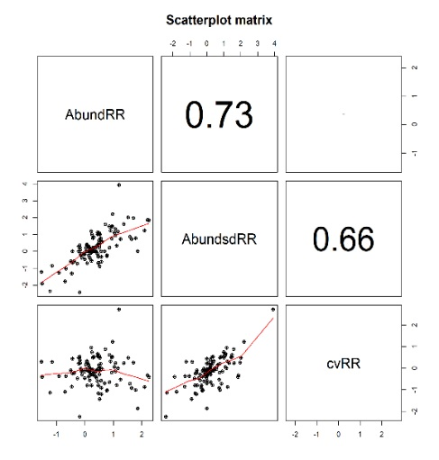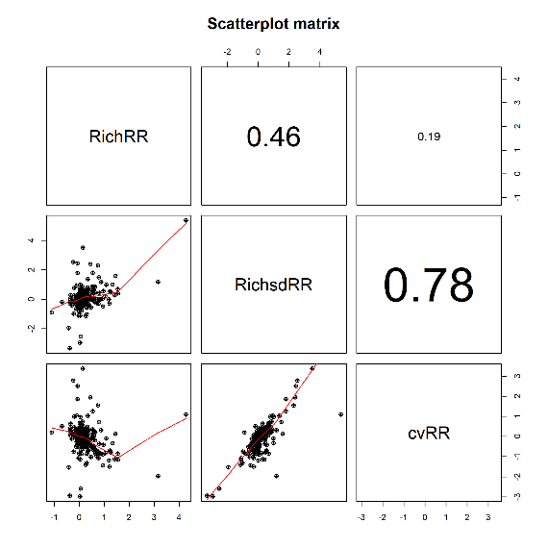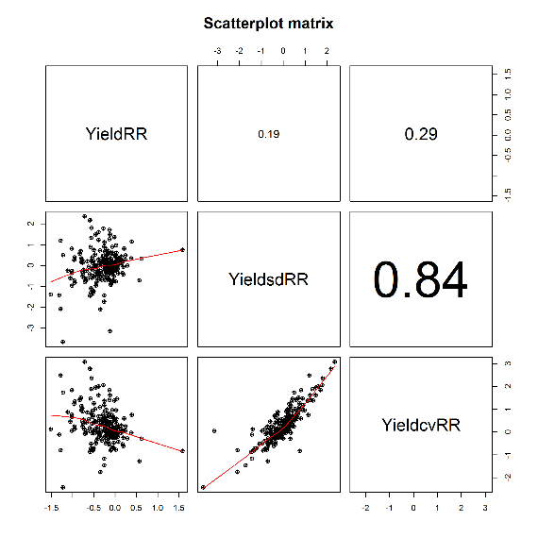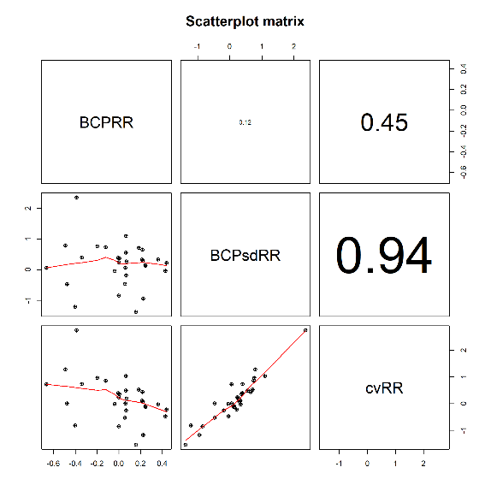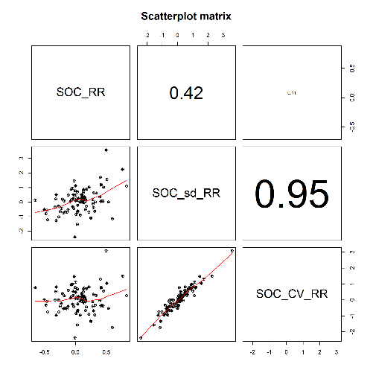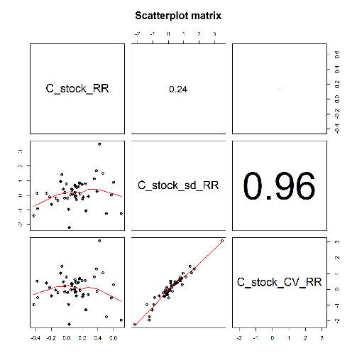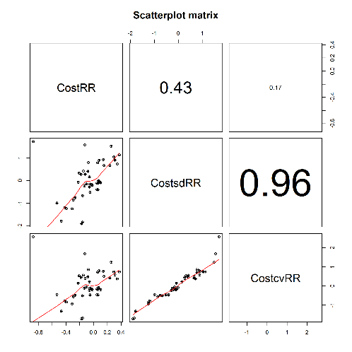

**Figure S3.** Organismal group (a) abundance mean response ratio, (b) abundance standard deviation response ratio, (c) abundance coefficient of variation response ratio, (d) richness mean response ratio, (e) richness standard deviation response ratio, and (f) richness coefficient of variation response ratio. Mean response ratio (± 90% CI black, 95% CI gray). Response ratio is calculated as ln(organic/conventional). * indicates 90% CI does not overlap zero; ** indicates 95% CI does not overlap zero.

**Figure S4.** Response ratio for standard deviation of sustainability (± 90% CI black, 95% CI gray) for (a) annual crop types, (b) perennial crop types, (c) on experimental stations, (d) on farms, (e) studies in the United States, and (f) studies in the European Union. * indicates 90% CI does not overlap zero; ** indicates 95% CI does not overlap zero.

**Figure S5.** Mean, standard deviation, and coefficient of variation for (a-b) cereals, (c-d) vegetables, and (e-f) fruits. Mean response ratio (± 90% CI black; 95% CI gray). Response ratio is calculated as ln(organic/conventional). * indicates 90% CI does not overlap zero; ** indicates 95% CI does not overlap zero.

