Supplementary Material

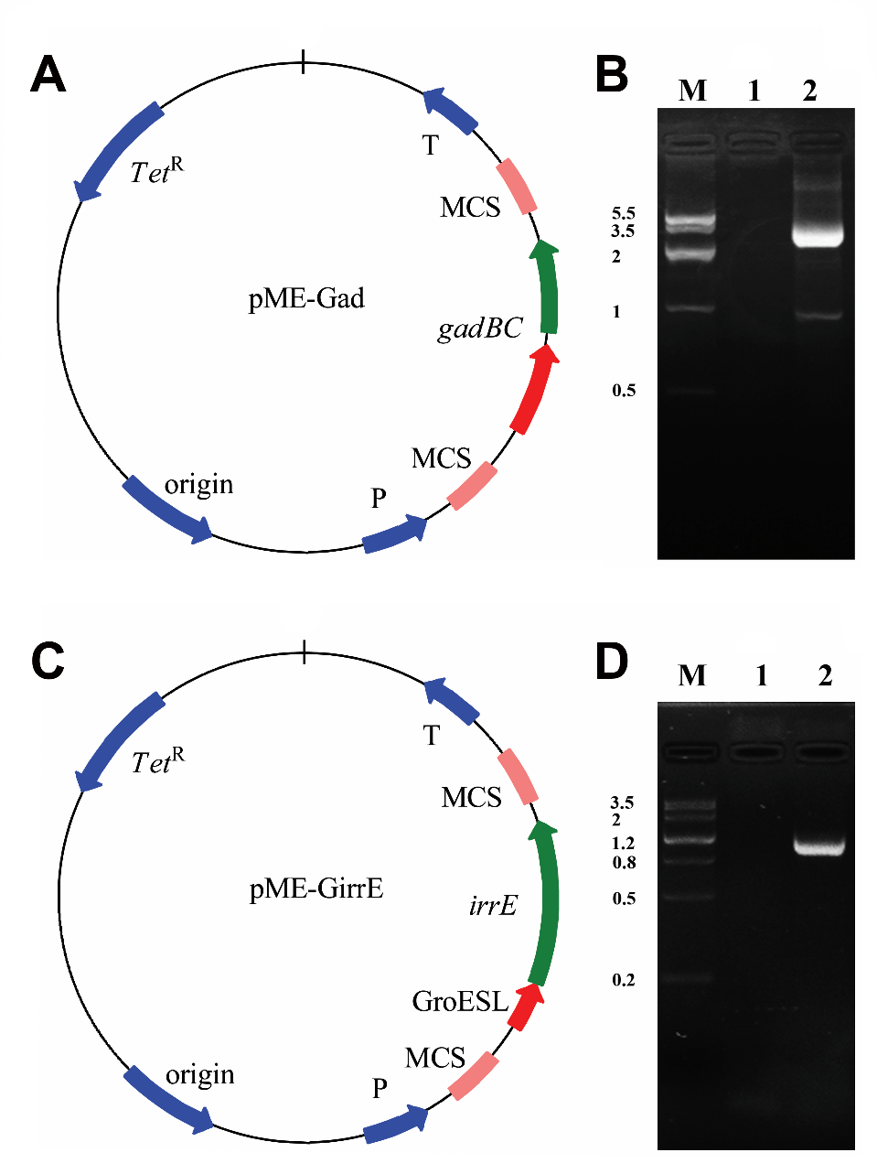

**Figure S1.** The recombinant construction. **A**. and **C**. The recombinant plasmid pME-Gad (plasmid pME6032 inserted with *gadBC*) and the recombinant plasmid pME-GirrE (plasmid pME6032 inserted with GroESL-*irrE*). (‘-’ represents wild type *P. putida* S16, ‘*gadBC*’ represents the *gadBC* expressing strains and ‘*irrE*’ represents the *irrE* expressing strains). **B**. ad **D**. Verification of plasmid pME-Gad and pME-GirrE transformation

(‘-’ represents wild type *P. putida* S16, ‘*gadBC*’ represents the *gadBC* expressing strains and ‘*irrE*’ represents the *irrE* expressing strains).

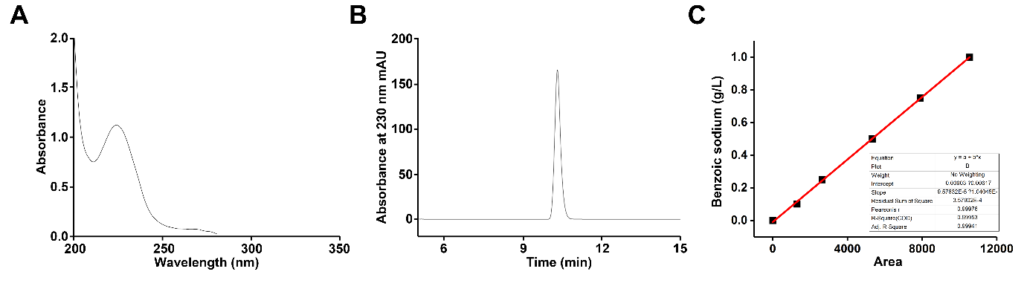

**Figure. S2** The standard curve of benzoic sodium. **A**. the full wavelength scanning shows benzoic sodium absorbance peak at 230 nm. **B**. HPLC spectrum of standard sample of benzoic sodim. **C**. the standard curve with R2 = 0.99953, performed by Origin 8.5.

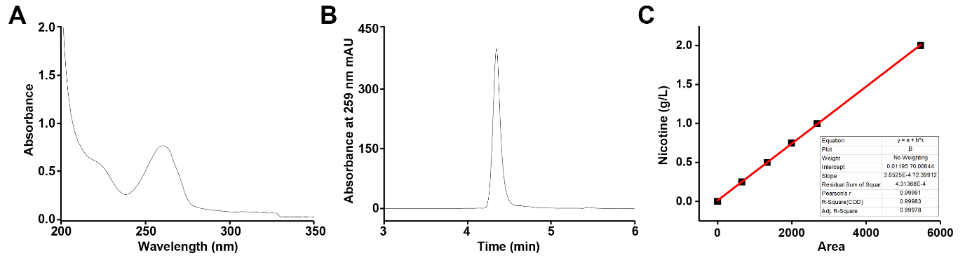

**Figure. S3** The standard curve of nicotine. **A**. the full wavelength scanning shows nicotine absorbance peak at 259 nm. **B**. HPLC spectrum of standard sample of nicotine. **C**. the standard curve with R2 = 0.99983, performed by Origin 8.5