**Appendix**

a) b)

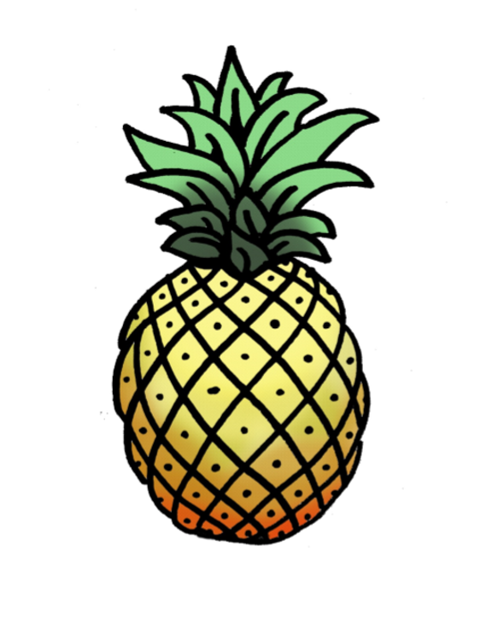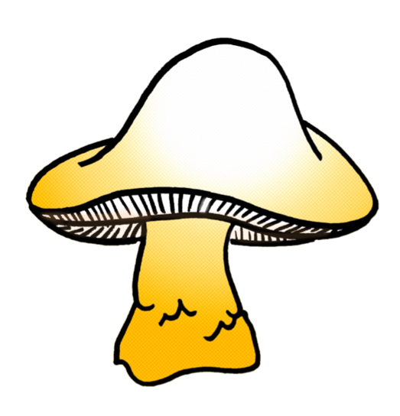

*Figure 1*. Examples from Task 1 – Picture Naming. Task 1a requires an oral response (pineapple) and Task 1b requires a written response (mushroom).

a) b)

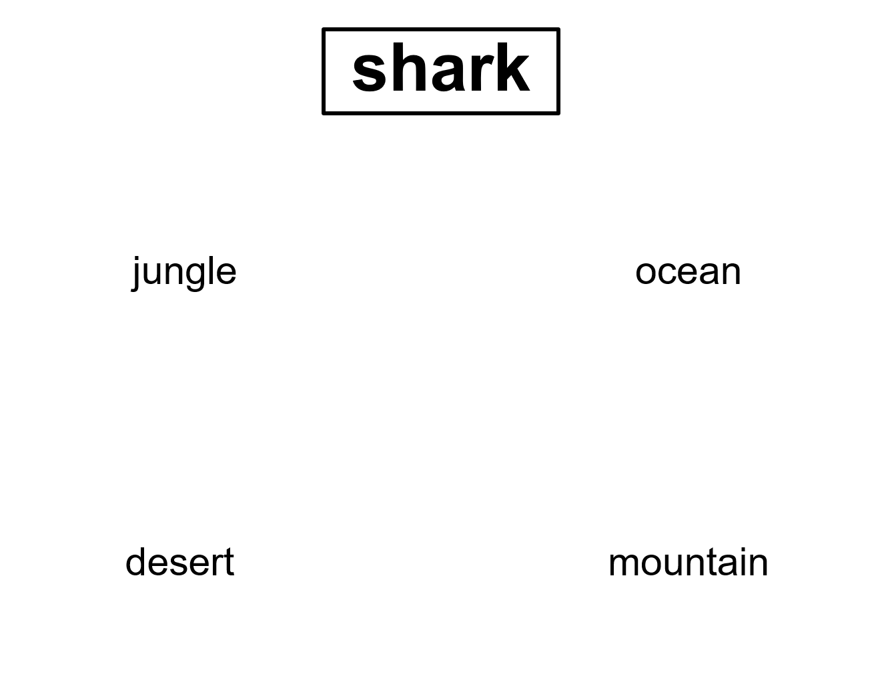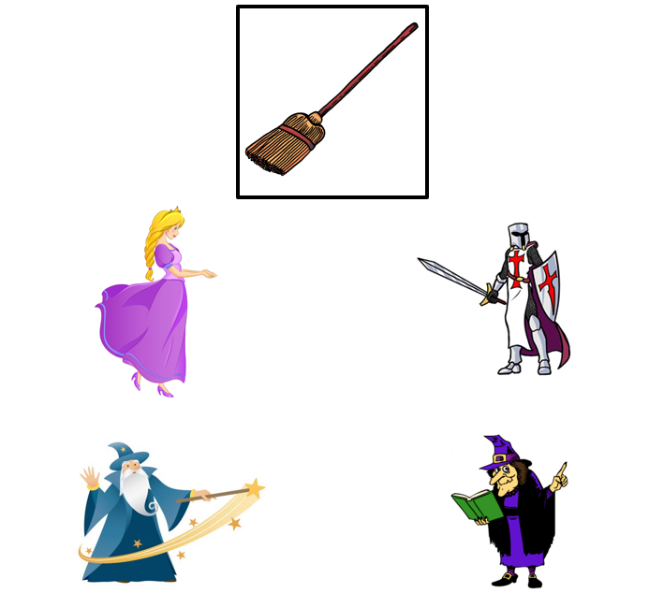

*Figure 2*. Example from Task 2 – Associative Matching. Task 2a is word-word association (shark-ocean) and Task 2b is picture-picture association (broom-witch)

TABLE 1. Tasks of Semantic Function with Stimulus Items in the Neuropsychological Battery.

|  |  |  |  |
| --- | --- | --- | --- |
| Task | Subtask | Stimulus type | Stimulus |
| Task 1: Picture naming | Spoken | Action | Crawl |
| Knit |
| Swim |
| Shave |
| Yawn |
| Juggle |
| Biological | Pepper |
| Peacock |
| Seahorse |
| Pineapple |
| Dragonfly |
| Duck |
| Artifact | Salt Shaker |
| Axe |
| Well |
| Doorknob |
| Watering Can |
| Sled |
| Written | Action | Drink |
| Smile |
| Skate |
| Stretch |
| Wave |
| Cook |
| Biological | Mushroom |
| Sheep |
| Lobster |
| Butterfly |
| Pumpkin |
| Squirrel |
| Artifact | Thimble |
| Record Player |
| Spinning Wheel |
| Ring |
| Spool |
| Bow |
| Task 2: Associative matching | Picture-picture | Biological | Horse |
| Chicken |
| Milk |
| Banana |
| Caterpillar |
| Elephant |
| Artifact | Broom |
| Nail |
| Crown |
| Pillow |
| Net |
| Helmet |
| Word-word | Biological | Shark |
| Pine |
| Apple |
| Rabbit |
| Deer |
| Bee |
| Artifact | Sleigh |
| Tweezers |
| Vase |
| Ring |
| Ambulance |
| Glasses |
| Task 3: Common feature identification | Generation | Biological | Eggplant-Plum |
| Chihuahua-Hummingbird |
| Owl-Raccoon |
| Crow-Panther |
| Greyhound-Cheetah |
| Pig-Flamingo |
| Artifact | Banjo-Guitar |
| Lasso-Net |
| Telescope-Glasses |
| Anchor-Dumbbell |
| Piano-Accordion |
| Racquet-Bat |
| Multiple choice | Biological | Bee-Wasp |
| Calf-Puppy |
| Mink-Rabbit |
| Penguin-Panda |
| Leopard-Dalmatian |
| Carrot-Pumpkin |
| Artifact | Envelope-Napkin |
| Bagpipe-Kilt |
| Paperclip-Stapler |
| Broom-Toothbrush |
| Telephone-Alarm |
| Helicopter-Airplane |
| Task 4: Semantic questions |  | Biological | Are monkeys hairy? |
| Do parakeets have stripes? |
| Do sheep have beards? |
| Can whales jump out of the water? |
| Do snails have antennae? |
| Do kangaroos come from China? |
| Do tangerines need to be peeled before eating them? |
| Is lettuce usually cooked? |
| Are squirrels nocturnal? |
| Do hippos have trunks? |
| Are cranberries eaten with turkey? |
| Does garlic have skin? |
| Artifact | Does a cup usually have a lid? |
| Do surfboards float? |
| Does a clarinet have a mouthpiece? |
| Do toasters produce steam? |
| Are canoes used with paddles? |
| Do pianos have strings? |
| Is a spatula round? |
| Are earmuffs usually used in summer? |
| Are limousines usually long? |
| Is a soccer ball usually thrown? |
| Is a buggy usually pulled by horses? |
| Does a wheelbarrow usually have two wheels? |