Supplementary information for:

Predicting nutrient incontinence in the Anthropocene at watershed scales

Rebecca J. Frei1,2*, Benjamin W. Abbott1, Remi Dupas3, Sen Gu4, Gerard Gruau4, Zahra Thomas3, Tamara Kolbe5, Luc Aquilina4, Thierry Labasque4, Anniet Laverman6, Ophelie Fovet3, Florentina Moatar7, Gilles Pinay7

1Brigham Young University, Department of Plant and Wildlife Sciences, Provo, USA

2University of Alberta, Department of Renewable Resources, Edmonton, Canada

3UMR SAS, INRA, AGROCAMPUS OUEST, Rennes, France

4Univ Rennes, CNRS, OSUR, Géosciences Rennes, UMR 6118, F-35000 Rennes, France

5Technische Universität Bergakademie Freiberg, Faculty of Geoscience, Geoengineering and Mining, Freiberg, Germany

6Centre National de la Recherche Scientifique (CNRS), ECOBIO – UMR 6553, Université de Rennes, 35042 Rennes, France

7RiverLy, Irstea, Lyon, France

**\*Corresponding Author: rfrei@ualberta.ca1. Extended Proxy Toolbox:**

**Rare earth elements as proxies of redox conditions and hydrological flowpaths**

Groundwater exhibits a rare earth element (REE) signature that often closely resembles that of the surrounding bedrock but can be complicated by redox conditions and naturally and anthropogenically derived particles (Dia et al., 2000; Gruau et al., 2004). For these reasons, bulk measurements and analysis of individual REEs have become important indirect tracers of redox conditions and hydrological flowpaths, especially when combined with other tracers. Cerium (Ce) in particular is a REE that readily oxidizes to Ce+4 and precipitates to cerianite in the presence of oxygen (Braun et al., 1998; De Carlo et al., 1997; Moffett, 1990). This process creates a Ce deficiency or negative Ce anomaly in REE concentrations, indicative of redox conditions—though exposure to dissolved organic matter (DOM) causes the anomaly to decrease or even disappear in anoxic, organic-rich media such as wetland areas or riparian zones (Abbott et al., 2016; Gruau et al., 2004; Pinay et al., 2015). We calculated the Ce anomaly using the following equation:

Eq. 1 $\frac{Ce}{{Ce}^{*}}=\frac{{Ce}_{N}}{{{(La}_{N}* {Pr}_{N})}^{0.5}}$

Where ${Ce}_{N}$, ${La}_{N}$, and ${Pr}_{N}$ are the concentrations of Ce, La and Pr measured from our water samples divided by the concentration of Ce, La, and Pr in a reference standard (typically the North American Shale Composite; Gruau et al., 2004).

Because redox conditions and organic matter availability strongly influence N and P retention/removal processes (e.g. denitrification; P adsorption on soil Fe-oxyhydroxides (Gu et al., 2019; Pinay et al., 2015; Stumm and Sulzberger, 1992), the Ce anomaly of stream waters could be an important proxy for predicting permanent and temporary nutrient retention at the watershed scale.

**Nitrate isotopes as proxies of denitrification and nutrient source**

Stable isotopes of NO3-(δ15N and δ18O) have been widely used to quantify denitrification, a biochemical process that permanently removes reactive N from a watershed (Frey et al., 2014; Lehmann et al., 2003; Mariotti et al., 1981). Denitrification occurs when N oxides (NO3-or NO2-), anoxic conditions, an electron donor, and denitrifying bacteria are present (See Knowles 1982 for a review). Heterotrophic denitrification, where DOM acts as the electron donor, primarily occurs near the surface, while autotrophic denitrification, involving pyrite or other compounds, occurs deeper in aquifers, creating SO43- as a byproduct (Hosono et al. 2014. As denitrifying bacteria use N oxides as electron acceptors, lighter isotopes are preferentially used, enriching both δ15N and δ18O in the residual NO3- (Mariotti et al. 1981). Therefore, we reasoned that watersheds with relatively enriched isotopic values of NO3- were more likely to have the conditions necessary for denitrification (Lehmann et al., 2003), potentially increasing N retention but decreasing P retention via increased P mobility and lower stoichiometric demand. For example, dissolved P is commonly released through bacteria-mediated reduction of soil Fe-oxhydroxides during anoxia (Gu et al., 2019). Alternatively, the presence of NO3- in soils and riparian areas could prevent highly reducing conditions from developing, which would remobilize P (Randall et al., 2019).

Besides indicating denitrification, δ15N and δ18O also vary with NO3- source. Livestock and human manure have distinct initial values of δ15N and δ18O compared with inorganic fertilizers (Denk et al., 2017). Because both organic and inorganic N inputs are common in Brittany, higher δ15N and δ18O could indicate greater manure use as much as nutrient retention (Bedard-Haughn et al., 2003).

**Dissolved silica, radon, and hydrograph analysis as proxies of groundwater influence**

Hydrological residence time in a watershed is an influential characteristic affecting biogeochemical reaction rates and removal capacity (Marçais et al., 2018; Thomas et al., 2016). Increased residence time can increase nutrient retention by increasing exposure time for biogeochemical transformation of N and P within the watershed (Oldham et al., 2013; Zarnetske et al., 2012). Residence time in groundwater, which is typically the largest component of watershed residence time for water, is commonly measured using atmospheric tracers such as chlorofluorocarbons (CFCs). However, these estimates are costly and becoming imprecise in the 5-20 year range (Aquilina et al., 2012; Marçais et al., 2018), and other proxies of residence time have been developed to improve precision and data availability (Abbott et al., 2016). In many different geologic and climatic contexts, dissolved silica (DSi) concentration has been found to strongly correlate with groundwater residence time estimates derived from CFCs and other dissolved gases (Ayraud et al., 2008). In the present study we estimated groundwater residence time using the following equation from Marçais et al. (2018):

Eq. 2 $MRT=4.55\overline{DSi}-18.18$

where MRT is mean residence time in years and $\overline{DSi}$ is the mean DSi concentration in µg L-1 across the three field campaigns. Our results agreed with estimates from other studies in this region (Ben Maamar et al., 2015; Kolbe et al., 2016; Molénat et al., 2013).

Radon-222 is another tool to constrain groundwater-surface water interactions (Bertin and Bourg, 1994; Cable et al., 1996; Stieglitz et al., 2010). 222Rn is a product of natural radioactive decay of Uranium-238 in igneous bedrock and has a half-life of 3.82 days, making it an ideal tracer of deep flowpaths (Oyarzún et al., 2014). As groundwater interacts with rock, weathering increases concentrations of 222Rn, and as groundwater mixes with surface water 222Rn is degassed to come into equilibrium with the atmosphere and decomposes via radioactive decay. Variable degassing rates at the surface can obscure detection of 222Rn in some circumstances, but generally the relative abundance of 222Rn in surface waters indicates groundwater inputs. Deep and long flowpaths increase the likelihood of encountering redox conditions for N removal pathways such as denitrification.

Time-series analysis of river discharge and nutrient concentrations can provide information about water source, flowpath, and residence time (Moatar et al., 2017). Higher peak flows during storm events can indicate greater near-surface runoff, while less responsive hydrographs and higher base flows between events can indicate longer residence and greater proportion of subsurface flow (Feijoó et al., 2018; Kirchner, 2019). Characteristics of flow regime directly influence concentration-discharge relationships and therefore nutrient flux and nutrient retention attributes (Moatar et al., 2013, 2017; Raymond et al., 2016). Here, we calculated annual discharge, W2, and the Magnificent Seven to analyze our flow time series dataset. W2 is an index of hydrologic reactivity that is the percentage of annual discharge that occurs during the highest 2% of flows (Moatar et al., 2017). The Magnificent Seven are a group of non-redundant parameters based on stochastic properties of daily stream flow including (i) the mean, (ii) coefficient of variation, (iii) skewness, (iv) kurtosis, (v) the autoregressive lag-one (AR1) correlation coefficient, (vi) the amplitude, and (vii) the phase of the seasonal signal (Archfield et al., 2014).

**Dissolved organic matter as a proxy of biogeochemical transformation and flowpaths**

DOM includes dissolved organic compounds that contain C, N, P and other nutrients in molecular forms ranging from complex organic molecules to simple compounds (e.g. CH4). DOM concentration is often characterized by bulk measurements of dissolved organic C (DOC), but not all C in DOM compounds is equally available for biologic uptake (Abbott et al., 2014; Vonk et al., 2015). Furthermore, while C is the primary compound in DOM molecules, other nutrients can become biologically available as DOM is mineralized (Harjung et al., 2019; Wymore et al., 2018). DOM bioavailability can be directly assessed in DOM decomposition experiments that measure the fraction of biodegradable DOC (BDOC) in a sample, and several optical proxies have been proposed, using absorbance data from spectrophotometers and fluorometers to determine molecular structure. For example, Weishaar et al. (2003) found that specific ultra-violet absorbance at 254 nm (SUVA254) was closely correlated with aromaticity of organic compounds and Helms et al. (2008) found that the spectral ratio (SR) of slopes within the 275-290 nm and 350-400 nm range were closely related with molecular weight. In addition to bioavailability, these DOM characteristics can reveal hydrological flowpaths and prior processing because DOM is less abundant in groundwater and reactive in surface and subsurface environments (Coble et al., 2019; Shen et al., 2015). We used BDOC, SUVA254, and SR analyses to characterize DOM availability, which we then correlated with nutrient retention. Highly labile DOM can be used as an electron donor for important biogeochemical processes such as denitrification, effectively removing nutrients within a watershed. On the other hand, degradation or mineralization of organic molecules could also release N and P, potentially masking any retentive capacities.

**Ecosystem stoichiometry as proxy of biogeochemical transformation and flowpaths**

Nutrient stoichiometry is based on laws of conservation of mass and constant proportions, allowing prediction of retention or release of different compounds based on availability and relative demand (Allen and Gillooly, 2009; Helton et al., 2015; Sterner and Elser, 2002). A negative relationship between DOC and NO3- has been widely observed in freshwater and estuarine ecosystems (Sterner and Elser, 2002; Stubbins, 2016; Taylor and Townsend, 2010). This relationship has been primarily attributed to stoichiometric controls, where abundant DOC promotes NO3- removal via denitrification since DOC is the most common electron donor and in high-DOC watersheds oxygen could be depleted more rapidly due to mineralization of DOC, resulting in more anoxic zones where denitrification can occur (Arango et al., 2007; Fork and Heffernan, 2013; Helton et al., 2015). Alternatively, the negative relationship between DOC and NO3- could simply be caused by a negative correlation between sources, where watersheds that favor deeper hydrological flowpaths have a carbon-poor and nitrogen-rich signal (Abbott et al., 2018). The prevalence of this stoichiometric trend makes it a strong candidate as a proxy for nutrient retention and can be considered a proxy of both biogeochemical reactivity and hydrologic flowpaths. 

**References**

Abbott, B. W., Baranov, V., Mendoza-Lera, C., Nikolakopoulou, M., Harjung, A., Kolbe, T., et al. (2016). Using multi-tracer inference to move beyond single-catchment ecohydrology. *Earth-Sci. Rev.* 160, 19–42. doi:10.1016/j.earscirev.2016.06.014.

Abbott, B. W., Larouche, J. R., Jones, J. B., Bowden, W. B., and Balser, A. W. (2014). Elevated dissolved organic carbon biodegradability from thawing and collapsing permafrost: Permafrost carbon biodegradability. *J. Geophys. Res. Biogeosciences* 119, 2049–2063. doi:10.1002/2014JG002678.

Abbott, B. W., Moatar, F., Gauthier, O., Fovet, O., Antoine, V., and Ragueneau, O. (2018). Trends and seasonality of river nutrients in agricultural catchments: 18years of weekly citizen science in France. *Sci. Total Environ.* 624, 845–858. doi:10.1016/j.scitotenv.2017.12.176.

Allen, A. P., and Gillooly, J. F. (2009). Towards an integration of ecological stoichiometry and the metabolic theory of ecology to better understand nutrient cycling. *Ecol. Lett.* 12, 369–384. doi:10.1111/j.1461-0248.2009.01302.x.

Aquilina, L., Vergnaud-Ayraud, V., Labasque, T., Bour, O., Molénat, J., Ruiz, L., et al. (2012). Nitrate dynamics in agricultural catchments deduced from groundwater dating and long-term nitrate monitoring in surface‐ and groundwaters. *Sci. Total Environ.* 435–436, 167–178. doi:10.1016/j.scitotenv.2012.06.028.

Arango, C. P., Tank, J. L., Schaller, J. L., Royer, T. V., Bernot, M. J., and David, M. B. (2007). Benthic organic carbon influences denitrification in streams with high nitrate concentration. *Freshw. Biol.* 52, 1210–1222. doi:10.1111/j.1365-2427.2007.01758.x.

Archfield, S. A., Kennen, J. G., Carlisle, D. M., and Wolock, D. M. (2014). An Objective and Parsimonious Approach for Classifying Natural Flow Regimes at a Continental Scale. *River Res. Appl.* 30, 1166–1183. doi:10.1002/rra.2710.

Ayraud, V., Aquilina, L., Labasque, T., Pauwels, H., Molenat, J., Pierson-Wickmann, A.-C., et al. (2008). Compartmentalization of physical and chemical properties in hard-rock aquifers deduced from chemical and groundwater age analyses. *Appl. Geochem.* 23, 2686–2707. doi:10.1016/j.apgeochem.2008.06.001.

Bedard-Haughn, A., van Groenigen, J. W., and van Kessel, C. (2003). Tracing 15N through landscapes: potential uses and precautions. *J. Hydrol.* 272, 175–190. doi:10.1016/S0022-1694(02)00263-9.

Ben Maamar, S., Aquilina, L., Quaiser, A., Pauwels, H., Michon-Coudouel, S., Vergnaud-Ayraud, V., et al. (2015). Groundwater Isolation Governs Chemistry and Microbial Community Structure along Hydrologic Flowpaths. *Front. Microbiol.* 6. doi:10.3389/fmicb.2015.01457.

Bertin, Clotilde., and Bourg, A. C. M. (1994). Radon-222 and Chloride as Natural Tracers of the Infiltration of River Water into an Alluvial Aquifer in Which There Is Significant River/Groundwater Mixing. *Environ. Sci. Technol.* 28, 794–798. doi:10.1021/es00054a008.

Braun, J.-J., Viers, J., Dupré, B., Polve, M., Ndam, J., and Muller, J.-P. (1998). Solid/Liquid REE Fractionation in the Lateritic System of Goyoum, East Cameroon: The Implication for the Present Dynamics of the Soil Covers of the Humid Tropical Regions. *Geochim. Cosmochim. Acta* 62, 273–299. doi:10.1016/S0016-7037(97)00344-X.

Cable, J. E., Burnett, W. C., Chanton, J. P., and Weatherly, G. L. (1996). Estimating groundwater discharge into the northeastern Gulf of Mexico using radon-222. *Earth Planet. Sci. Lett.* 144, 591–604. doi:10.1016/S0012-821X(96)00173-2.

Coble, A. A., Koenig, L. E., Potter, J. D., Parham, L. M., and McDowell, W. H. (2019). Homogenization of dissolved organic matter within a river network occurs in the smallest headwaters. *Biogeochemistry* 143, 85–104. doi:10.1007/s10533-019-00551-y.

De Carlo, E. H., Wen, X.-Y., and Irving, M. (1997). The Influence of Redox Reactions on the Uptake of Dissolved Ce by Suspended Fe and Mn Oxide Particles. *Aquat. Geochem.* 3, 357–389. doi:10.1023/A:1009664626181.

Denk, T. R. A., Mohn, J., Decock, C., Lewicka-Szczebak, D., Harris, E., Butterbach-Bahl, K., et al. (2017). The nitrogen cycle: A review of isotope effects and isotope modeling approaches. *Soil Biol. Biochem.* 105, 121–137. doi:10.1016/j.soilbio.2016.11.015.

Dia, A., Gruau, G., Olivié-Lauquet, G., Riou, C., Molénat, J., and Curmi, P. (2000). The distribution of rare earth elements in groundwaters: assessing the role of source-rock composition, redox changes and colloidal particles. *Geochim. Cosmochim. Acta* 64, 4131–4151. doi:10.1016/S0016-7037(00)00494-4.

Feijoó, C., Messetta, M. L., Hegoburu, C., Gómez Vázquez, A., Guerra-López, J., Mas-Pla, J., et al. (2018). Retention and release of nutrients and dissolved organic carbon in a nutrient-rich stream: A mass balance approach. *J. Hydrol.* 566, 795–806. doi:10.1016/j.jhydrol.2018.09.051.

Fork, M. L., and Heffernan, J. B. (2013). Direct and Indirect Effects of Dissolved Organic Matter Source and Concentration on Denitrification in Northern Florida Rivers. *Ecosystems* 17, 14–28. doi:10.1007/s10021-013-9705-9.

Frey, C., Hietanen, S., Jürgens, K., Labrenz, M., and Voss, M. (2014). N and O Isotope Fractionation in Nitrate during Chemolithoautotrophic Denitrification by Sulfurimonas gotlandica. *Environ. Sci. Technol.* 48, 13229–13237. doi:10.1021/es503456g.

Gruau, G., Dia, A., Olivié-Lauquet, G., Davranche, M., and Pinay, G. (2004). Controls on the distribution of rare earth elements in shallow groundwaters. *Water Res.* 38, 3576–3586. doi:10.1016/j.watres.2004.04.056.

Gu, S., Gruau, G., Dupas, R., Petitjean, P., Li, Q., and Pinay, G. (2019). Respective roles of Fe-oxyhydroxide dissolution, pH changes and sediment inputs in dissolved phosphorus release from wetland soils under anoxic conditions. *Geoderma* 338, 365–374. doi:10.1016/j.geoderma.2018.12.034.

Harjung, A., Perujo, N., Butturini, A., Romaní, A. M., and Sabater, F. (2019). Responses of microbial activity in hyporheic pore water to biogeochemical changes in a drying headwater stream. *Freshw. Biol.* 64, 735–749. doi:10.1111/fwb.13258.

Helms, J. R., Stubbins, A., Ritchie, J. D., Minor, E. C., Kieber, D. J., and Mopper, K. (2008). Absorption spectral slopes and slope ratios as indicators of molecular weight, source, and photobleaching of chromophoric dissolved organic matter. *Limnol. Oceanogr.* 53, 955–969. doi:10.4319/lo.2008.53.3.0955.

Helton, A. M., Ardón, M., and Bernhardt, E. S. (2015). Thermodynamic constraints on the utility of ecological stoichiometry for explaining global biogeochemical patterns. *Ecol. Lett.* 18, 1049–1056. doi:10.1111/ele.12487.

Kirchner, J. W. (2019). Quantifying new water fractions and transit time distributions using ensemble hydrograph separation: theory and benchmark tests. *Hydrol. Earth Syst. Sci.* 23, 303–349. doi:https://doi.org/10.5194/hess-23-303-2019.

Kolbe, T., de Dreuzy, J.-R., Abbott, B. W., Aquilina, L., Babey, T., Green, C. T., et al. (2019). Stratification of reactivity determines nitrate removal in groundwater. *Proc. Natl. Acad. Sci.* 116, 2494–2499. doi:10.1073/pnas.1816892116.

Kolbe, T., Marçais, J., Thomas, Z., Abbott, B. W., de Dreuzy, J.-R., Rousseau-Gueutin, P., et al. (2016). Coupling 3D groundwater modeling with CFC-based age dating to classify local groundwater circulation in an unconfined crystalline aquifer. *J. Hydrol.* 543, 31–46. doi:10.1016/j.jhydrol.2016.05.020.

Lehmann, M. F., Reichert, P., Bernasconi, S. M., Barbieri, A., and McKenzie, J. A. (2003). Modelling nitrogen and oxygen isotope fractionation during denitrification in a lacustrine redox-transition zone. *Geochim. Cosmochim. Acta* 67, 2529–2542. doi:10.1016/S0016-7037(03)00085-1.

Malone, E. T., Abbott, B. W., Klaar, M. J., Kidd, C., Sebilo, M., Milner, A. M., et al. (2018). Decline in Ecosystem δ13C and Mid-Successional Nitrogen Loss in a Two-Century Postglacial Chronosequence. *Ecosystems* 21, 1659–1675. doi:10.1007/s10021-018-0245-1.

Marçais, J., Gauvain, A., Labasque, T., Abbott, B. W., Pinay, G., Aquilina, L., et al. (2018). Dating groundwater with dissolved silica and CFC concentrations in crystalline aquifers. *Sci. Total Environ.* 636, 260–272. doi:10.1016/j.scitotenv.2018.04.196.

Mariotti, A., Germon, J. C., Hubert, P., Kaiser, P., Letolle, R., Tardieux, A., et al. (1981). Experimental determination of nitrogen kinetic isotope fractionation: Some principles; illustration for the denitrification and nitrification processes. *Plant Soil* 62, 413–430. doi:10.1007/BF02374138.

Moatar, F., Abbott, B. W., Minaudo, C., Curie, F., and Pinay, G. (2017). Elemental properties, hydrology, and biology interact to shape concentration-discharge curves for carbon, nutrients, sediment, and major ions. *Water Resour. Res.* 53, 1270–1287. doi:10.1002/2016WR019635.

Moatar, F., Meybeck, M., Raymond, S., Birgand, F., and Curie, F. (2013). River flux uncertainties predicted by hydrological variability and riverine material behaviour. *Hydrol. Process.* 27, 3535–3546. doi:10.1002/hyp.9464.

Moffett, J. W. (1990). Microbially mediated cerium oxidation in sea water. *Nature* 345, 421. doi:10.1038/345421a0.

Molénat, J., Gascuel-Odoux, C., Aquilina, L., and Ruiz, L. (2013). Use of gaseous tracers (CFCs and SF6) and transit-time distribution spectrum to validate a shallow groundwater transport model. *J. Hydrol.* 480, 1–9. doi:10.1016/j.jhydrol.2012.11.043.

Oldham, C. E., Farrow, D. E., and Peiffer, S. (2013). A generalized Damköhler number for classifying material processing in hydrological systems. *Hydrol. Earth Syst. Sci.* 17, 1133–1148. doi:10.5194/hess-17-1133-2013.

Oyarzún, R., Jofré, E., Maturana, H., Oyarzún, J., and Aguirre, E. (2014). Use of 222radon as a simple tool for surface water–groundwater connectivity assessment: a case study in the arid Limarí basin, north-central Chile. *Water Environ. J.* 28, 418–422. doi:10.1111/wej.12057.

Pinay, G., Peiffer, S., De Dreuzy, J.-R., Krause, S., Hannah, D. M., Fleckenstein, J. H., et al. (2015). Upscaling Nitrogen Removal Capacity from Local Hotspots to Low Stream Orders’ Drainage Basins. *Ecosystems* 18, 1101–1120. doi:10.1007/s10021-015-9878-5.

Randall, M. C., Carling, G. T., Dastrup, D. B., Miller, T., Nelson, S. T., Rey, K. A., et al. (2019). Sediment potentially controls in-lake phosphorus cycling and harmful cyanobacteria in shallow, eutrophic Utah Lake. *PLOS ONE* 14, e0212238. doi:10.1371/journal.pone.0212238.

Raymond, P. A., Saiers, J. E., and Sobczak, W. V. (2016). Hydrological and biogeochemical controls on watershed dissolved organic matter transport: pulse-shunt concept. *Ecology* 97, 5–16. doi:10.1890/14-1684.1.

Shen, Y., Chapelle, F. H., Strom, E. W., and Benner, R. (2015). Origins and bioavailability of dissolved organic matter in groundwater. *Biogeochemistry* 122, 61–78. doi:10.1007/s10533-014-0029-4.

Sterner, R. W., and Elser, J. J. (2002). *Ecological Stoichiometry: The Biology of Elements from Molecules to the Biosphere*. Princeton University Press.

Stieglitz, T. C., Cook, P. G., and Burnett, W. C. (2010). Inferring coastal processes from regional-scale mapping of 222Radon and salinity: examples from the Great Barrier Reef, Australia. *J. Environ. Radioact.* 101, 544–552. doi:10.1016/j.jenvrad.2009.11.012.

Stubbins, A. (2016). A carbon for every nitrogen. *Proc. Natl. Acad. Sci.* 113, 10736–10738. doi:10.1073/pnas.1612995113.

Stumm, W., and Sulzberger, B. (1992). The cycling of iron in natural environments: Considerations based on laboratory studies of heterogeneous redox processes. *Geochim. Cosmochim. Acta* 56, 3233–3257. doi:10.1016/0016-7037(92)90301-X.

Taylor, P. G., and Townsend, A. R. (2010). Stoichiometric control of organic carbon–nitrate relationships from soils to the sea. *Nature* 464, 1178–1181. doi:10.1038/nature08985.

Thomas, Z., Rousseau-Gueutin, P., Kolbe, T., Abbott, B. W., Marçais, J., Peiffer, S., et al. (2016). Constitution of a catchment virtual observatory for sharing flow and transport models outputs. *J. Hydrol.* 543, 59–66. doi:10.1016/j.jhydrol.2016.04.067.

Vonk, J. E., Tank, S. E., Mann, P. J., Spencer, R. G. M., Treat, C. C., Striegl, R. G., et al. (2015). Biodegradability of dissolved organic carbon in permafrost soils and aquatic systems: a meta-analysis. *Biogeosciences* 12, 6915–6930. doi:10.5194/bg-12-6915-2015.

Weishaar, J. L., Aiken, G. R., Bergamaschi, B. A., Fram, M. S., Fujii, R., and Mopper, K. (2003). Evaluation of Specific Ultraviolet Absorbance as an Indicator of the Chemical Composition and Reactivity of Dissolved Organic Carbon. *Environ. Sci. Technol.* 37, 4702–4708. doi:10.1021/es030360x.

Wells, N. S., Baisden, W. T., and Clough, T. J. (2015). Ammonia volatilisation is not the dominant factor in determining the soil nitrate isotopic composition of pasture systems. *Agric. Ecosyst. Environ.* 199, 290–300. doi:10.1016/j.agee.2014.10.001.

Wymore, A. S., Potter, J., Rodríguez‐Cardona, B., and McDowell, W. H. (2018). Using In-Situ Optical Sensors to Understand the Biogeochemistry of Dissolved Organic Matter Across a Stream Network. *Water Resour. Res.* 54, 2949–2958. doi:10.1002/2017WR022168.

Zarnetske, J. P., Haggerty, R., Wondzell, S. M., Bokil, V. A., and González-Pinzón, R. (2012). Coupled transport and reaction kinetics control the nitrate source-sink function of hyporheic zones: HYPORHEIC N SOURCE-SINK CONTROLS. *Water Resour. Res.* 48. doi:10.1029/2012WR011894.

**Supplementary Figures**

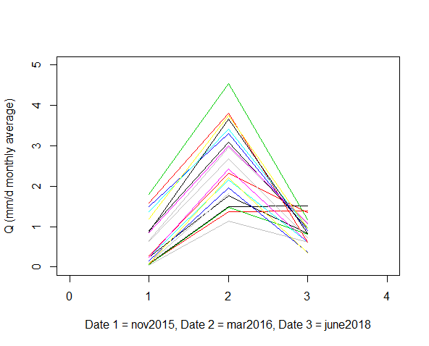

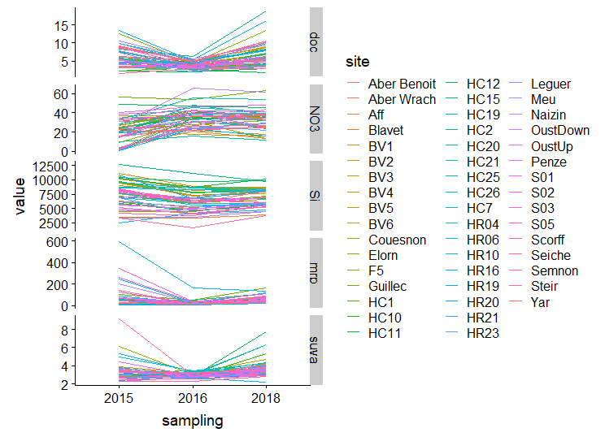

**Fig. S1** Monthly average discharge (Q) and nutrient concentration time series across the three sampling periods. Lines have been added to aid in visually grouping sites between sampling dates.

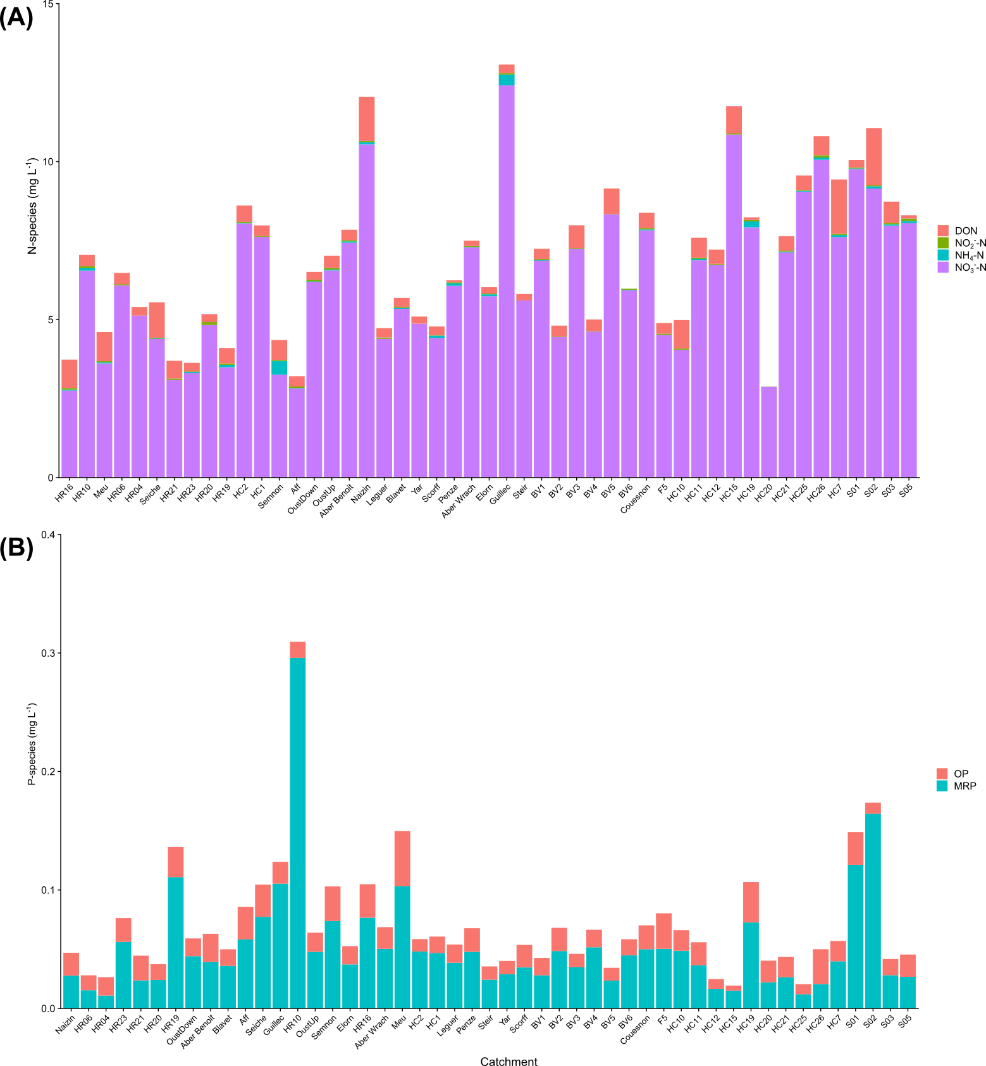

**Fig. S2** Nitrogen (N) and phosphorus (P) concentrations partitioned by species. Plot A shows N species for catchments ordered from high to low N retention. Plot B shows P species for catchments ordered from high to low P retention.

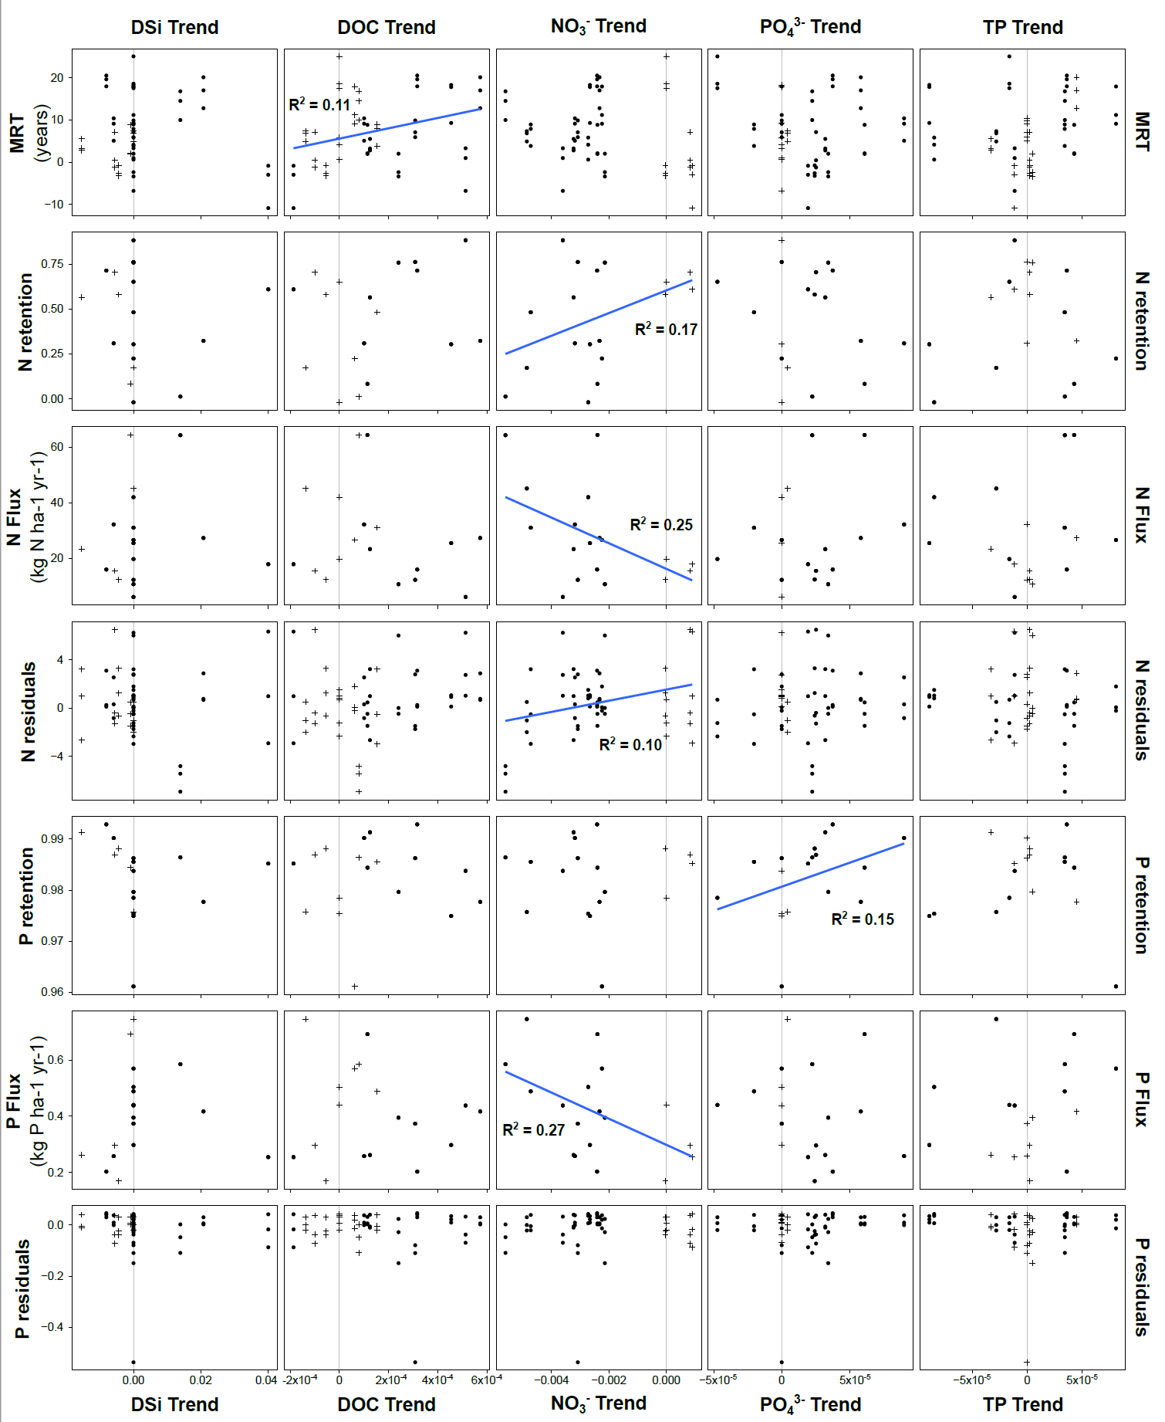

**Fig. S3** Decadal nutrient trends of Theil-Sen slopes and their relationship with mean residence time, nutrient retention, and fluxes. Significant Theil-Sen slopes are shown as circular points and non-significant points are shown as crosses. Significant linear relationships are shown and R2 values reported. Vertical gray lines are located at 0 to indicate no trends.

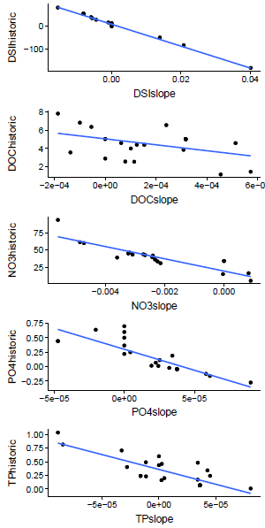

**Fig. S4** Regression of Theil-Sen slopes and intercepts for DSi, DOC, NO3-, PO43-, and TP. Intercepts are estimates of concentrations at the beginning of the time series and slopes indicate nutrient trends over the past decade. Strong inverse relationships between initial concentrations and slopes indicate that catchments with highest initial concentrations also have the fastest decreases in concentration through time.

|  |  |  |  |  |  |  |  |  |  |  |  |  |  |  |  |
| --- | --- | --- | --- | --- | --- | --- | --- | --- | --- | --- | --- | --- | --- | --- | --- |
| **Table S1**: Catchment characteristics for all 49 catchments | | | | | | | | | | | | | | | |
| Catchment # | Catchment name | Catchment Area (km2) | % Agriculture | % Artificial | % Forest | % Wetland | % Water | % Other | % Granite | % Micaschist | % Schist | Stream Length (km) | Channel Density (km/km2) | Relief | Slope |
| 1 | HC1 | 372.99 | 88.19 | 5.97 | 5.84 | 0.25 | 0.00 | 8.82 | 33.48 | 0.00 | 55.82 | 443.45 | 1.19 | 37.57 | 4.80 |
| 2 | HC2 | 325.39 | 87.39 | 6.49 | 6.12 | 0.25 | 0.00 | 9.94 | 26.37 | 0.00 | 61.55 | 381.89 | 1.17 | 38.14 | 4.83 |
| 3 | HC10 | 47.75 | 93.89 | 1.44 | 4.67 | 0.34 | 0.00 | 26.03 | 0.00 | 0.00 | 73.97 | 41.98 | 0.88 | 17.76 | 3.74 |
| 4 | HC11 | 26.11 | 94.23 | 1.54 | 4.22 | 0.42 | 0.00 | 33.70 | 0.00 | 0.00 | 66.30 | 22.79 | 0.87 | 12.34 | 3.18 |
| 5 | HC12 | 10.13 | 89.23 | 10.77 | 0.00 | 0.29 | 0.00 | 0.00 | 73.40 | 0.00 | 26.60 | 10.83 | 1.07 | 17.07 | 3.81 |
| 6 | HC15 | 6.95 | 98.04 | 1.96 | 0.00 | 0.19 | 0.00 | 0.09 | 17.61 | 0.00 | 82.30 | 7.96 | 1.15 | 29.50 | 5.77 |
| 7 | HC7 | 16.76 | 96.75 | 3.25 | 0.00 | 0.22 | 0.00 | 0.00 | 0.00 | 0.00 | 72.39 | 15.92 | 0.95 | 24.62 | 5.37 |
| 8 | HC26 | 10.63 | 99.73 | 0.27 | 0.00 | 0.23 | 0.00 | 0.00 | 0.00 | 0.00 | 99.55 | 8.42 | 0.79 | 27.78 | 4.80 |
| 9 | HC25 | 19.09 | 97.68 | 2.32 | 0.00 | 0.15 | 0.00 | 0.00 | 47.52 | 0.00 | 42.44 | 27.58 | 1.44 | 31.92 | 7.51 |
| 10 | HC21 | 4.56 | 95.84 | 3.91 | 0.25 | 0.18 | 0.00 | 0.00 | 93.54 | 0.00 | 6.46 | 6.70 | 1.47 | 16.02 | 3.98 |
| 11 | HC20 | 14.31 | 37.58 | 1.25 | 61.18 | 0.17 | 0.00 | 0.00 | 97.94 | 0.00 | 2.06 | 22.07 | 1.54 | 19.75 | 4.37 |
| 12 | HC19 | 14.75 | 96.30 | 1.59 | 2.11 | 0.30 | 0.00 | 0.00 | 100.00 | 0.00 | 0.00 | 19.13 | 1.30 | 7.73 | 3.35 |
| 13 | BV1 | 11.89 | 98.91 | 1.09 | 0.00 | 0.21 | 0.00 | 0.00 | 45.68 | 0.00 | 54.32 | 9.23 | 0.78 | 25.88 | 4.36 |
| 14 | BV2 | 14.13 | 36.43 | 1.71 | 61.86 | 0.20 | 0.00 | 0.00 | 84.55 | 0.00 | 15.45 | 12.80 | 0.91 | 17.58 | 4.33 |
| 15 | BV4 | 16.03 | 44.03 | 1.50 | 54.46 | 0.21 | 0.00 | 0.00 | 74.44 | 0.00 | 25.56 | 14.73 | 0.92 | 26.01 | 4.32 |
| 16 | BV5 | 2.33 | 100.00 | 0.00 | 0.00 | 0.32 | 0.00 | 0.00 | 16.77 | 0.00 | 83.23 | 3.37 | 1.45 | 34.09 | 4.13 |
| 17 | BV3 | 15.50 | 95.86 | 4.14 | 0.00 | 0.20 | 0.00 | 0.00 | 34.93 | 0.00 | 65.07 | 12.29 | 0.79 | 28.95 | 4.15 |
| 18 | BV6 | 35.48 | 72.80 | 2.49 | 24.72 | 0.22 | 0.00 | 0.00 | 50.16 | 0.00 | 49.84 | 32.39 | 0.91 | 31.62 | 4.16 |
| 19 | Couesnon | 1039.25 | 90.08 | 3.95 | 5.75 | 0.23 | 0.00 | 4.83 | 43.51 | 0.00 | 41.28 | 1160.22 | 1.12 | 40.27 | 4.46 |
| 20 | S01 | 10.75 | 98.54 | 1.46 | 0.00 | 0.32 | 0.00 | 0.00 | 7.33 | 0.00 | 92.67 | 8.10 | 0.75 | 15.01 | 3.21 |
| 21 | S02 | 9.57 | 98.36 | 1.64 | 0.00 | 0.34 | 0.00 | 0.00 | 8.22 | 0.00 | 91.78 | 6.82 | 0.71 | 14.53 | 3.10 |
| 22 | S03 | 7.12 | 99.33 | 0.67 | 0.00 | 0.36 | 0.00 | 0.00 | 10.81 | 0.00 | 89.19 | 5.10 | 0.72 | 15.01 | 3.19 |
| 23 | S05 | 4.62 | 100.00 | 0.00 | 0.00 | 0.38 | 0.00 | 0.00 | 6.03 | 0.00 | 93.97 | 4.04 | 0.88 | 14.74 | 2.85 |
| 24 | HR16 | 18.18 | 83.62 | 1.71 | 14.67 | 0.26 | 0.00 | 0.00 | 0.00 | 0.00 | 100.00 | 15.85 | 0.87 | 9.86 | 2.50 |
| 25 | HR10 | 22.84 | 92.96 | 2.07 | 4.96 | 0.21 | 0.00 | 0.00 | 0.00 | 0.00 | 100.00 | 19.55 | 0.86 | 12.77 | 2.91 |
| 26 | HR23 | 12.22 | 88.76 | 0.78 | 10.46 | 0.23 | 0.00 | 0.07 | 0.00 | 0.00 | 99.93 | 9.45 | 0.77 | 20.95 | 3.65 |
| 27 | F5 | 6.37 | 99.93 | 0.00 | 0.07 | 0.24 | 0.00 | 0.00 | 100.00 | 0.00 | 0.00 | 3.29 | 0.52 | 5.18 | 2.56 |
| 28 | HR19 | 16.59 | 80.16 | 3.12 | 16.72 | 0.24 | 0.00 | 1.96 | 0.27 | 23.18 | 74.58 | 11.05 | 0.67 | 14.37 | 2.78 |
| 29 | HR20 | 6.87 | 98.36 | 1.64 | 0.00 | 0.35 | 0.00 | 0.00 | 0.00 | 0.00 | 100.00 | 1.92 | 0.28 | 21.59 | 3.93 |
| 30 | HR21 | 10.31 | 87.55 | 0.00 | 12.45 | 0.21 | 0.00 | 0.00 | 0.00 | 0.00 | 100.00 | 6.26 | 0.61 | 19.72 | 4.29 |
| 31 | HR06 | 17.99 | 98.49 | 1.51 | 0.00 | 0.19 | 0.00 | 25.21 | 7.15 | 31.34 | 36.31 | 11.84 | 0.66 | 18.89 | 4.36 |
| 32 | HR04 | 8.48 | 84.15 | 4.84 | 11.01 | 0.14 | 0.00 | 0.00 | 0.00 | 99.02 | 0.98 | 6.95 | 0.82 | 34.83 | 7.36 |
| 33 | Meu | 762.47 | 83.59 | 4.39 | 11.48 | 0.22 | 0.54 | 15.64 | 0.00 | 0.40 | 83.97 | 630.71 | 0.83 | 32.34 | 3.60 |
| 34 | Seiche | 804.68 | 90.53 | 6.15 | 3.09 | 0.24 | 0.24 | 6.40 | 2.42 | 0.00 | 86.67 | 712.89 | 0.89 | 22.60 | 3.43 |
| 35 | Semnon | 482.61 | 89.66 | 3.13 | 6.93 | 0.21 | 0.28 | 20.31 | 0.00 | 0.00 | 53.04 | 428.40 | 0.89 | 20.04 | 4.08 |
| 36 | Aff | 344.88 | 58.17 | 4.06 | 37.40 | 0.22 | 0.37 | 41.21 | 0.00 | 0.00 | 58.79 | 333.90 | 0.97 | 45.76 | 5.35 |
| 37 | OustDown | 2080.53 | 84.60 | 3.53 | 11.74 | 0.20 | 0.13 | 10.82 | 9.29 | 10.77 | 69.12 | 1801.86 | 0.87 | 58.42 | 5.66 |
| 38 | OustUp | 1143.33 | 86.97 | 3.66 | 9.32 | 0.19 | 0.06 | 10.84 | 12.57 | 13.51 | 63.08 | 1030.22 | 0.90 | 56.23 | 6.32 |
| 39 | Naizin | 4.94 | 98.88 | 0.00 | 1.12 | 0.22 | 0.00 | 0.00 | 0.00 | 0.00 | 100.00 | 3.68 | 0.75 | 10.42 | 3.03 |
| 40 | Blavet | 1929.08 | 81.48 | 3.46 | 14.73 | 0.21 | 0.32 | 3.63 | 35.89 | 11.13 | 49.36 | 1838.18 | 0.95 | 61.07 | 6.91 |
| 41 | Scorff | 377.88 | 71.78 | 2.83 | 25.38 | 0.20 | 0.00 | 0.00 | 83.40 | 16.60 | 0.00 | 448.36 | 1.19 | 46.57 | 8.18 |
| 42 | Steir | 185.05 | 89.18 | 2.82 | 7.86 | 0.24 | 0.00 | 1.56 | 44.58 | 4.11 | 49.74 | 165.01 | 0.89 | 34.26 | 7.77 |
| 43 | Elorn | 260.67 | 76.20 | 6.97 | 16.36 | 0.24 | 0.47 | 2.11 | 34.19 | 2.62 | 61.08 | 241.41 | 0.93 | 54.25 | 6.99 |
| 44 | Aber Benoit | 72.37 | 90.15 | 8.43 | 1.42 | 0.30 | 0.00 | 45.20 | 54.80 | 0.00 | 0.00 | 74.12 | 1.02 | 17.31 | 3.37 |
| 45 | Aber Wrach | 88.22 | 84.50 | 8.46 | 7.04 | 0.31 | 0.00 | 36.15 | 63.85 | 0.00 | 0.00 | 102.54 | 1.16 | 16.36 | 3.55 |
| 46 | Guillec | 71.60 | 93.92 | 4.71 | 1.37 | 0.23 | 0.00 | 74.66 | 14.78 | 10.55 | 0.00 | 64.85 | 0.91 | 23.20 | 4.31 |
| 47 | Penze | 142.33 | 77.06 | 3.54 | 19.40 | 0.19 | 0.00 | 1.39 | 57.14 | 0.24 | 41.23 | 135.79 | 0.95 | 64.75 | 8.41 |
| 48 | Yar | 58.28 | 77.68 | 1.66 | 20.67 | 0.19 | 0.00 | 4.90 | 91.68 | 0.00 | 3.42 | 54.04 | 0.93 | 46.70 | 7.51 |
| 49 | Leguer | 392.14 | 81.61 | 2.55 | 15.74 | 0.19 | 0.10 | 12.69 | 73.98 | 0.00 | 13.34 | 313.21 | 0.80 | 58.73 | 7.52 |

|  |  |  |  |  |  |  |  |  |  |
| --- | --- | --- | --- | --- | --- | --- | --- | --- | --- |
| **Table S2**: Pearson correlations for Qmm and the eight calculated flow metrics from time series. | | | | | | | | | |
|  | Qmm | W2 | Amplitude | AR1 | Mean | Phase | CV | Kurtosis | Skewness |
| Qmm | 1.00 | -0.81 | 0.51 | 0.57 | 0.43 | -0.19 | -0.79 | -0.56 | -0.68 |
| W2 | -0.81 | 1.00 | -0.72 | -0.55 | -0.30 | -0.20 | 0.79 | 0.77 | 0.83 |
| Amplitude | 0.51 | -0.72 | 1.00 | 0.63 | 0.17 | 0.57 | -0.49 | -0.96 | -0.82 |
| AR1 | 0.57 | -0.55 | 0.63 | 1.00 | 0.39 | -0.06 | -0.31 | -0.64 | -0.55 |
| Mean | 0.43 | -0.30 | 0.17 | 0.39 | 1.00 | 0.01 | -0.22 | -0.09 | -0.08 |
| Phase | -0.19 | -0.20 | 0.57 | -0.06 | 0.01 | 1.00 | -0.09 | -0.51 | -0.38 |
| CV | -0.79 | 0.79 | -0.49 | -0.31 | -0.22 | -0.09 | 1.00 | 0.64 | 0.85 |
| Kurtosis | -0.56 | 0.77 | -0.96 | -0.64 | -0.09 | -0.51 | 0.64 | 1.00 | 0.94 |
| Skewness | -0.68 | 0.83 | -0.82 | -0.55 | -0.08 | -0.38 | 0.85 | 0.94 | 1.00 |