Supporting information for

Application of in-situ Solid-Phase Microextraction on Mediterranean Sponges for Untargeted Exometabolome Screening and Environmental Monitoring
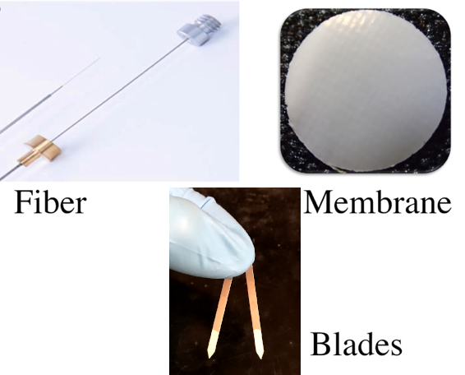

Figure S1. A representative image of a fiber, a membrane, and blades that were used during the experimental protocols of this report. The image of the fiber is derived from (Piri-Moghadam et al., 2017).

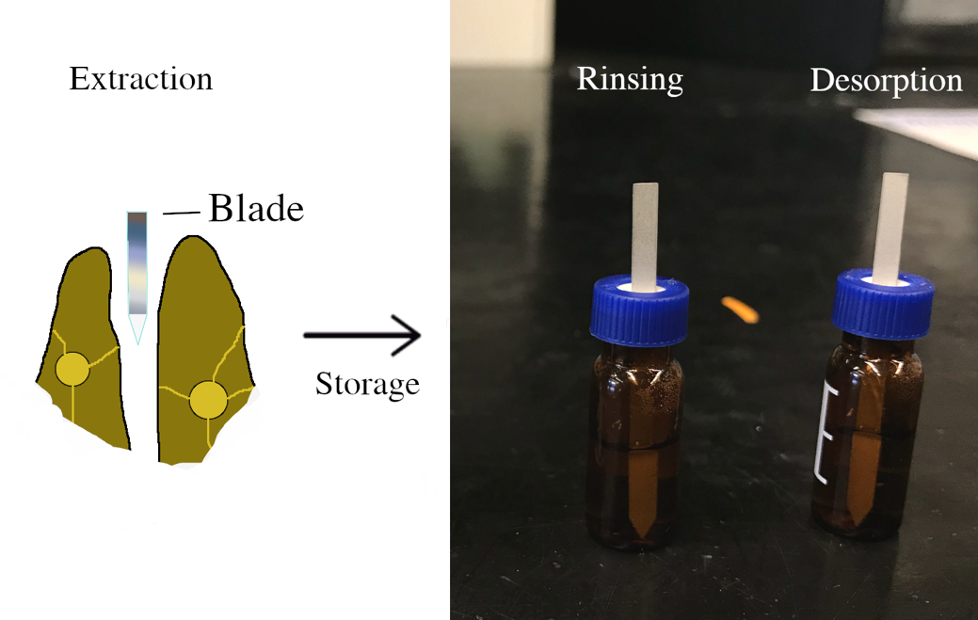
Figure S2. A scheme describing how extraction over sponges, and rinsing and desorption has been carried out by using the blade SPME devices. The protocol for membranes and fibers were carried out similarly.
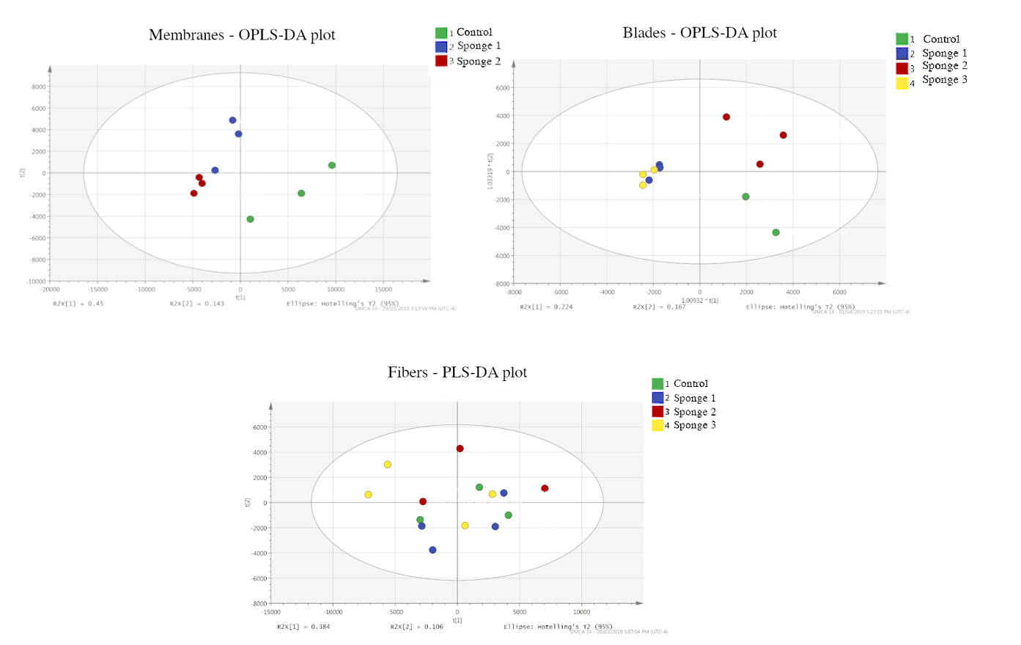

Figure S3. OPLS-DA plots showing the feature separation among the analytes extracted by the membranes and blades for the different experimental groups and the control group; the PLS-DA plot displays feature separation for the analytes extracted using the fibers. As can be seen, the blade and membrane devices show clear separation, while fibre-based groups do not.

m/z 137.0599 MS/MS spectrum (ESI+, 20 eV) (annotated as Toluate or Vinylcathecol)
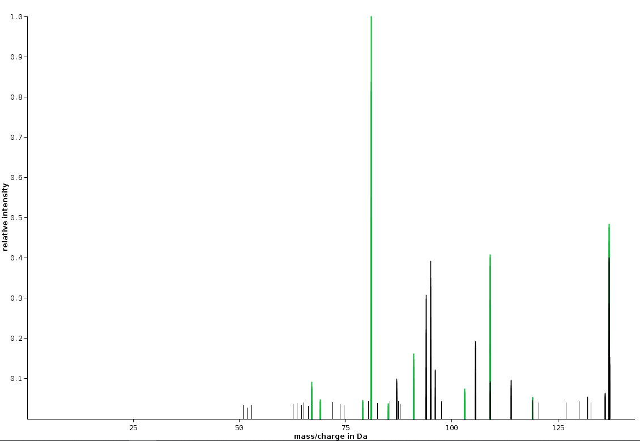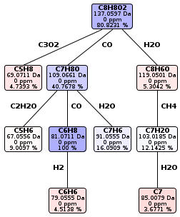

m/z 149.06 MS/MS spectrum (ESI+, 20 eV) (annotated as 3-isochromanone)

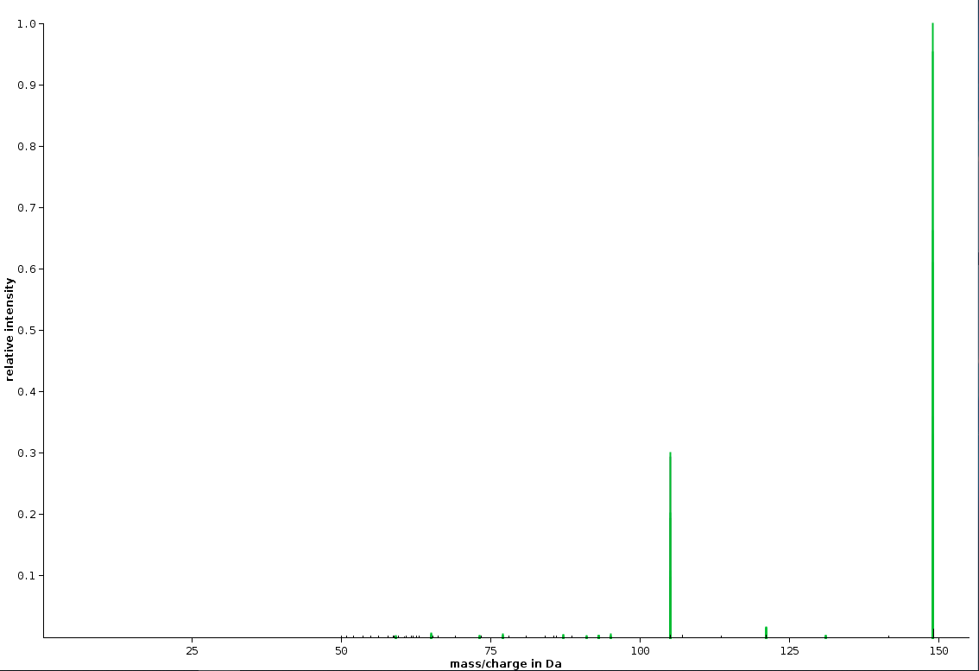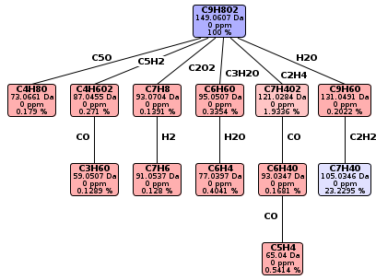

m/z 251.1641 MS/MS spectrum (ESI+, 40 eV) (annotated as (+)-12,15 Dihydroxycurcuphenol or abscisic alcohol)

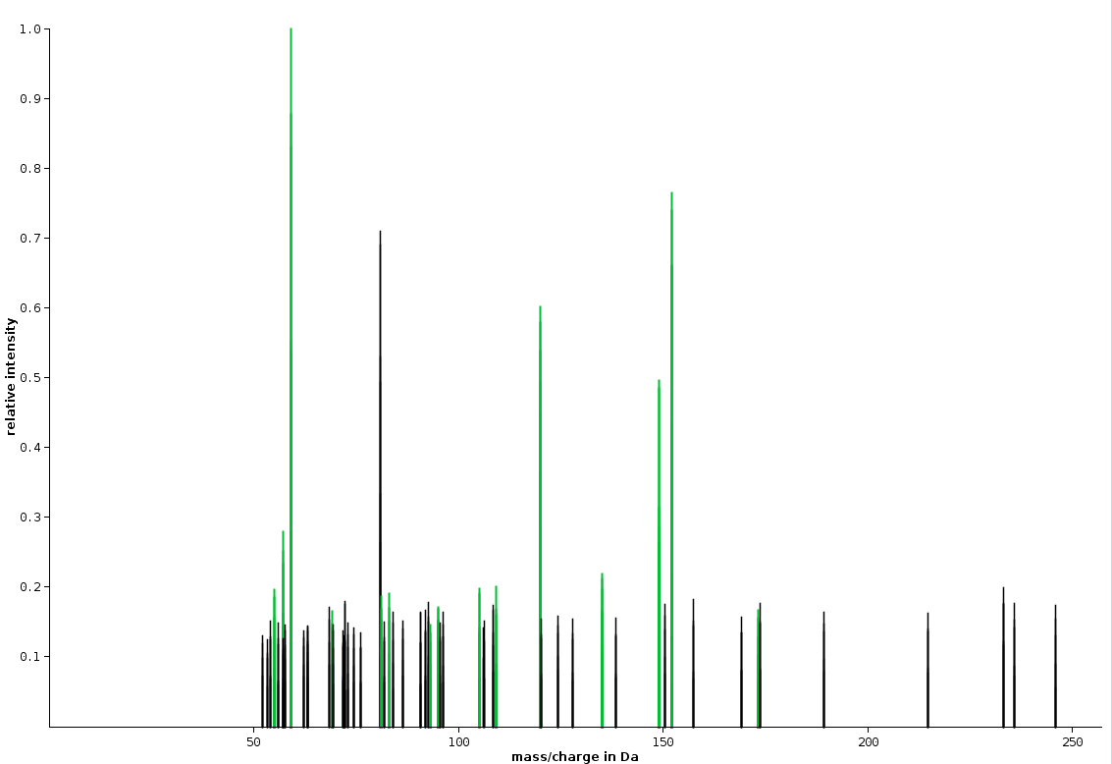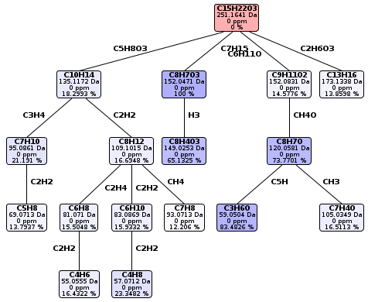

m/z 340.2846 MS/MS spectrum (ESI+, 20 eV) (annotated as Elmiric acid or N-hexadecanoyl-L-Homoserine lactone)
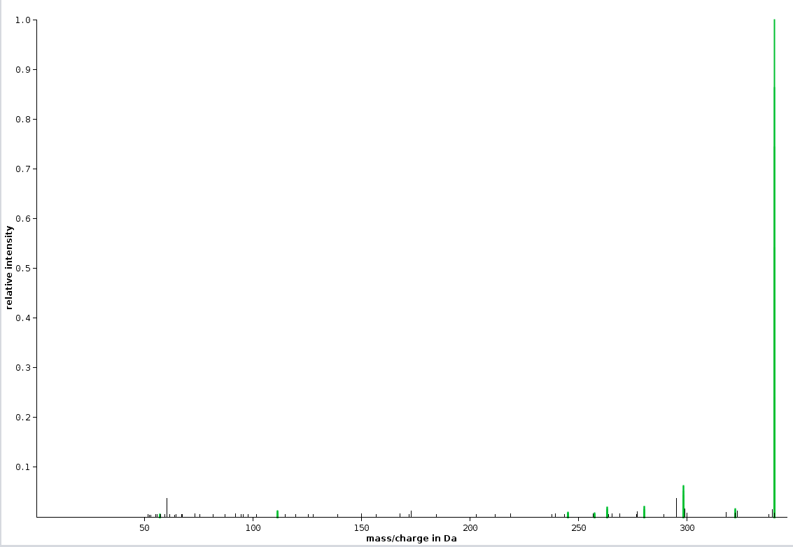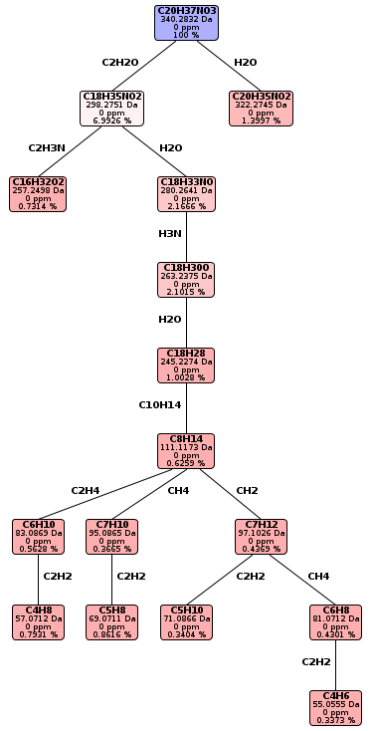
Figure S4. MS/MS fragmentation spectra and in-silico-predicted fragmentation patterns of the analytes predicted by the Sirius software. Green peaks indicate the m/z values of the parent ion and the daughter ions that fit the in-silico-predicted peaks. The fragmentation schemes on the right-hand side of the figure depict the predicted daughter ion molecular formulas, with molecular weight, ppm deviation, and peak intensities as the relative percentage of the highest peak. The sample graphics represent m/z values of 137.0599, 149.06, 251.1641, and 340.2846.

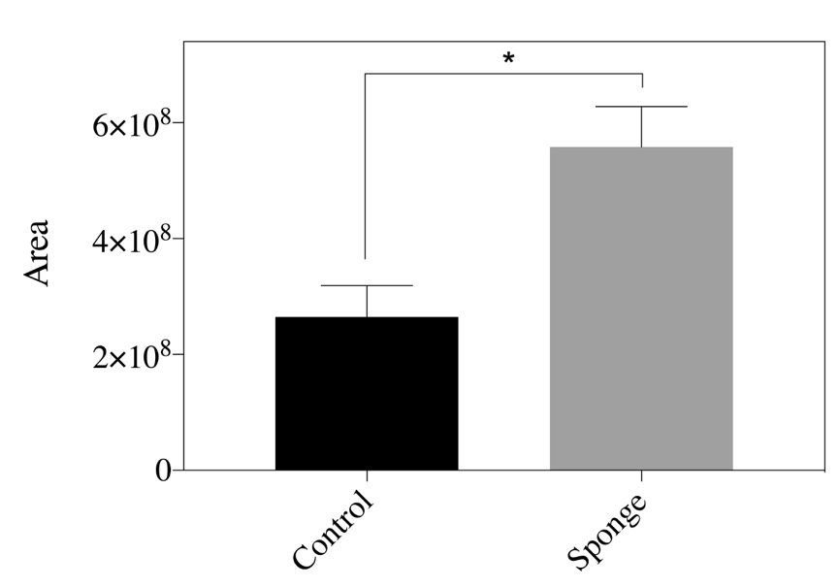

Figure S5. Column graph displaying the comparison of GC-MS ion chromatogram peak areas between sponge 2 and the control group for retention time of 8.7. The NIST-predicted compound was propyl benzene. The column data were compared via a two-way t-test (*p < 0.05).

Table S1. List of identified compounds analyzed via high-resolution LC-MS in ESI (+) mode. Under “identification method”, M indicates that the compound was identified using the METLIN database and S indicates that identification was achieved using Sirius software. The level of significance and the fold change of the peak areas among the experimental groups and the control groups are also provided. The fold change values are presented using a “heat map” format, wherein intense red coloring corresponds to an increase and an intense green coloring corresponds to a decrease.

Membrane SPME devices

m/z | Retention time | Compound | Importance | Molecular formula | Adduct | Identification method | Level of significance (p value) | Fold change (exp./control)
102.0915 | 15.38 | Methylbutanamide |  | C13H23NO | [M + H]+ | M, S | 0.03899 | 0.49634727
 |  | Ethylpropanamide |  |  | [M + H]+ | M, S
 |  | Ethyl N-ethylmethanimidate |  |  | [M + H]+ | M, S
105.0701 | 15.58 | Styrene | Polystyrene degradation | C8H8 | [M + H]+ | M, S | 0.03899 | 0.21371997
107.0005 | 2.29 | Amino(cyano)phosphinate |  |  | [M + H]+ | S | 0.02732 | 2.48830081
 |  | (Cyanoamino)phosphonous acid |  |  | [M + H]+ | S
109.1013 | 18.23 | 4-Vinylcyclohexene | Carcinogen |  | [M + H]+ | M, S | 0.03899 | 0.31569549
114.0915 | 7.07 |  |  | C6H11NO | [M + H]+ | S | 0.02732 | 0.32850738
115.0755 | 9.44 | Hexenoic acid | Fatty acid |  | [M + H]+ | M, S | 0.02732 | 0.21240164
116.071 | 16.37 | 1-Aminocyclobutane Carboxylic Acid |  |  | [M + H]+ | M, S | 0.02732 | 0.16248656
122.0965 | 12.24 | 2,4-Xylidine | Carcinogen |  | [M + H]+ | M, S | 0.05 | 0.72997552
 |  | N,N-Dimethylaniline | Carcinogen |  | [M + H]+ | M, S
123.1169 | 18.24 | Santene |  |  | [M + H]+ | M | 0.03899 | 0.31658874
129.0203 | 2.25 | Chloromethylpyrazine |  |  | [M + H]+ | M, S | 0.02732 | 2.84100212
129.0584 | 20.04 | Isoquinoline | Isoquinoline alkaloid biosynthesis |  | [M + H]+ | M, S | 0.03899 | 0.47396958
 |  | Quinolines | Synthesis of quinolines |  | [M + H]+ | M, S
131.1064 | 12.1 | Heptanoic acid | Lipid metabolism |  | [M + H]+ | M, S | 0.02732 | 0.47396958
 |  | Ethyl isovalerate | Biosynthesis of alkaloids derived from histidine and purine, protein digestion and absorption |  | [M + H]+ | M, S
 |  | α,α-dimethyl valeric acid |  |  | [M + H]+ | M, S
134.081 | 16.37 | Isoamyl nitrate |  |  | [M + H]+ | S | 0.03899 | 0.22028488
 |  | A type of carbamate | Carcinogens | C5H11NO3 | [M + H]+ | S
137.0599 | 13.9 | Toluate | Xylene degradation, degradation of aromatic compounds |  | [M + H]+ | M, S | 0.03899 | 1.99334355
 |  | Vinylcathecol | Styrene degradation, degradation of aromatic compounds |  | [M + H]+ | M, S
137.1325 | 18.24 | Sabinene | A monoterpenoid |  | [M + H]+ | M, S | 0.03899 | 0.34449021
147.0295 | 2.25 | Oxoglutaric acid | TCA cycle, amino acid biosynthesis, furfural degradation |  | [M + H]+ | M | 0.02732 | 2.68718571
149.1295 | 18.24 | Cyclononane |  |  | [M + H]+ | S | 0.03899 | 0.32305903
150.0269 | 17.05, 20.63 | I-Methyl-4-nitro-imidazole | Azathioprine and 6-mercaptopurine metabolism |  | [M + Na]+ | M, S | 0.02732 | 0.11160983
 |  | 5-Amino-4-imidazole carboxylate | purine metabolism |  | [M + Na]+ | M, S
153.032 | 2.25 | Glufosinate metabolite | Metabolite of organophosphorous herbicide |  | [M + H]+ | S | 0.02732 | 2.63352018
153.1274 | 16.84 | (+)-cis-Isopulegone | Monoterpenoid biosynthesis |  | [M + H]+ | M, S | 0.03899 | 0.38436477
 |  | Pulegone | Monoterpenoid biosynthesis |  | [M + H]+ | M, S
 |  | d-Piperitone | Menthane monoterpenoid |  | [M + H]+ | M, S
156.1379 | 18.23 | n-Octylisocyanate |  |  | [M + H]+ | S | 0.03899 | 0.22328982
159.0658 | 12.24 | 2-Isopropylmaleate | Valine, leucine and isoleucine biosynthesis; 2-Oxocarboxylic acid metabolism |  | [M + H]+ | M, S | 0.03899 | 0.18855645
163.0419 | 14.79 |  |  | C6H10O3S | [M + H]+ | S | 0.02732 | 0.24399524
163.0755 | 13.84 | Methyl cinnamate | Plant phenolics |  | [M + H]+ | S | 0.02732 | 6.35477038
 |  | 4-Hydroxycinnamoylmethane | Ubiquinone and other terpenoid-quinone biosynthesis; lignin, flavone, capsaicin biosynthesis; degradation of aromatic compounds |  | [M + H]+ | S
165.1639 | 18.23 |  |  | C12H2O | [M + H]+ | S | 0.03899 | 0.24309628
168.1377 | 20.86 |  |  | C10H17NO | [M + H]+ | M, S | 0.03899 | 0.68031492
169.0626 | 15.04 | 2,2-dimethylpropyl phosphate |  |  | [M + H]+ | S | 0.02732 | 0.02839653
173.081 | 11.24 | 4-Octenedioic acid | Dicarboxylic acids; lipids |  | [M + H]+ | M, S | 0.02732 | 0.31132417
177.0558 | 17.04 | 2-formylcinnamic acid |  |  | [M + H]+ | S | 0.02732 | 0.12461092
 |  | 3-acetylphthalaldehyde |  |  | [M + H]+ | S
177.1639 | 14.52 | A type of adamantane |  | C13H20 | [M + H]+ | S | 0.03899 | 0.11077631
178.0996 | 13.93 |  |  | C7H16NO2P | [M + H]+ | S | 0.02732 | 0.08918165
179.1766 | 18.24 | Dimethylnonane | Hydrocarbon |  | [M + Na]+ | M, S | 0.03899 | 0.26284995
181.11 | 13.84, 15.55 | Bis(3-aminopropyl)-phosphinic acid |  |  | [M + H]+ | S | 0.02732 | 1.0730918
 |  | 1-diaminophosphoryloxyhexane |  |  | [M + H]+ | S
183.1017 | 20.25 | Dihydroconiferyl alcohol | Monolignol, a phytochemical compound |  | [M + H]+ | M, S | 0.02732 | 1.88578128
183.1378 | 13.32 | Undecynoic acid | A hydrocarbon |  | [M + H]+ | M, S | 0.02732 | 0.22644267
 |  | Decahydro-2-naphthoic acid | Naphthalene degradation |  | [M + H]+ | M, S
183.1744 | 15.58 | Dodecanal | A hydrocarbon |  | [M + H]+ | M, S | 0.03899 | 0.29117133
184.0772 | 17.09 | Triethylborate |  |  | [M + K]+ | S | 0.02732 | 0.18379455
 |  | Dipropoxyborinic acid |  |  | [M + K]+ | S
184.1697 | 16.57, 20.85 | Tecostanine | A phytochemical compound |  | [M + H]+ | M, S | 0.02732 | 0.1610159
 |  | 2-isocyanatodecane | Hydrocarbon |  | [M + H]+ | M, S
186.1484 | 16.97 | 5-(butylamino)-2-methylidenepentanoic acid |  |  | [M + H]+ | S | 0.02732 | 0.09912611
 |  | 2-hexyliminobutanoic acid |  |  | [M + H]+ | S
188.0478 | 15.52 | D-Cathinone | Phenylalanine metabolism; biosynthesis of alkaloids derived from shikimate pathway |  | [M + K]+ | M, S | 0.02732 | 0.0890244
 |  | 3-Phenylpropionaldoxim | Glucosinolate biosynthesis; 2-Oxocarboxylic acid metabolism |  | [M + K]+ | M, S
188.1647 | 11.31 | 2-aminodecenoic acid |  |  | [M + H]+ | M, S | 0.02732 | 0.43934137
191.0783 | 17.03 | Pyridoxamine | Vitamin B6 metabolism |  | [M + Na]+ | M, S | 0.02732 | 0.14227879
191.1066 | 16.99 | Ligustilide | Natural drug |  | [M + H]+ | M, S | 0.02732 | 0.1442698
 |  | 3-Dimethylallyl-4-hydroxybenzaldehyde | Novobiocin (antibiotic) biosynthesis |  | [M + H]+ | M, S
193.0731 | 17.04 | 6,7-dimethyllumazine | Could be related with 6,7-Dimethyl-8-(D-ribityl)lumazine which takes role in riboflavin metabolism |  | [M + H]+ | S | 0.02732 | 0.17477224
197.1173 | 12.19 | Hexyl 2-furoate |  | C11H16O3 | [M + H]+ | M, S | 0.02732 | 0.00650311
199.1203 | 11.12 |  |  | C8H14N4O2 | [M + H]+ | S | 0.02732 | 0.2679473
199.1804 | 15.39 | Cycluron | Urea herbicides |  | [M + H]+ | M, S | 0.02732 | 0.47477647
 |  | 1-cyclohexyl-1,3-diethylurea |  |  | [M + H]+ | M, S
202.0137 | 2.23 | S-Carboxymethyl-L-cysteine | Respiratory drug |  | [M + Na]+ | M, S | 0.02732 | 1.33962551
202.1794 | 14.58 | 11-amino-undecanoic acid |  |  | [M + H]+ | M, S | 0.02732 | 0.0859411
207.1745 | 20.05 | Irone | Sesquiterpenoid |  | [M + H]+ | M, S | 0.03899 | 0.87330128
211.1121 | 18.98 | N-Boc-2-pyrroleboronic acid |  |  | [M + H]+ | S | 0.03899 | 0.63459613
212.2006 | 18.29 | N-cyclopropyldecanamide |  |  | [M + H]+ | S | 0.02732 | 0.23684587
 |  | N-cyclooctylpentanamide |  |  | [M + H]+ | S
214.1803 | 14.52 | An aminododecanoic acid |  |  | [M + H]+ | S | 0.03899 | 0.11621793
215.1643 | 15.74 | 9-ketolauric acid |  |  | [M + H]+ | S | 0.02732 | 0.47002592
 |  | 11-oxododecanoic acid | Fatty acyl |  | [M + H]+ | S
217.1071 | 11.24 |  | A 10-carbon fatty acid | C10H16O5 | [M + H]+ | S | 0.02732 | 0.34844865
217.997 | 2.25 | 2-cyanoethyl dimetyl phosphate |  |  | [M + K]+ | S | 0.02732 | 2.26178507
219.112 | 11.22 | Primidone | Antiepileptic drug |  | [M + H]+ | M, S | 0.02732 | 0.36883364
219.9826 | 2.23 | Pifithrin-mu | Heat shock protein 70 inhibitor |  | [M + K]+ | M, S | 0.02732 | 4.94098619
220.1466 | 17.25 | Cimaterol | Adrenergic receptor agonist |  | [M + H]+ | S | 0.02732 | 0.10172762
221.1631 | 17.29 | 1-butan-2-yl-3-(2,4-dimethylphenyl)urea |  |  | [M + H]+ | S | 0.02732 | 0.19137235
223.0966 | 17.05 | Apiole | Algae or plant metabolite |  | [M + H]+ | M, S | 0.02732 | 0.13782576
 |  | Dillapiole | Algae or plant metabolite |  | [M + H]+ | M, S
 |  | Diethyl phthalate | plasticizers and plastics |  | [M + H]+ | M, S
 |  | Diglycidyl resorcinol ether | Carcinogen |  | [M + H]+ | M, S
227.1279 | 20.14 | 5-nonaxypentanenitrile |  |  | [M + H]+ | S | 0.02732 | 1.69468582
 |  | N-cyclohexyloctaneamide |  |  | [M + H]+ | S
 |  | 3,7-Dimethyl-2E,6E-decadien-1,10-dioic acid |  |  | [M + H]+ | S
 |  | 12-hydroxyjasmonic acid | Plant hormone-based metabolite |  | [M + H]+ | S
227.1754 | 13.37 | 1,8-Diazacyclotetradecane-2,9-dione | Caprolactam degradation |  | [M + H]+ | M, S | 0.03899 | 0.06679637
230.2109 | 14.51 | A 13-carbon fatty acid |  | C13H27NO2 | [M + H]+ | M, S | 0.03899 | 0.12436593
233.1067 | 16.66 | 3,6-diphenylpyridazine |  |  | [M + H]+ | S | 0.02732 | 0.14035595
234.1332 | 11.24 | Atraton | Herbicide |  | [M + Na]+ | M, S | 0.02732 | 0.3699997
 |  | Hydroxypropazine |  |  | [M + Na]+ | M, S
234.162 | 18.11 | Cimbuterol | Drug |  | [M + H]+ | S | 0.02732 | 0.16420546
234.9612 | 2.24 | Carboxyphosphoenolpyruvate | Phosphonate and phosphinate metabolism; antibiotic biosynthesis | C4H5O7P | [M + Na]+ | S | 0.02732 | 7.13343277
235.1658 | 18.11 |  |  | C10H22N2O4 | [M + H]+ | S | 0.02732 | 0.18028178
235.9634 | 2.22 | Ethenyl-N-[ethenyl(hydroxy)phosphoryl]phosphonamidic acid |  | C4H9NO4P2 | [M + H]+ | S | 0.02732 | 2.38028468
236.1412 | 15.22 | (1-Amino-4-tert-butylcyclohexyl)phosphonic acid |  | C10H22NO3P | [M + H]+ | M, S | 0.02732 | 0.06735115
236.1591 | 18.11 |  |  | C9H21N3O4 | [M + H]+ | S | 0.02732 | 0.16615398
237.1855 | 19.73 | N-pentyl-N-propylpentan-1-amine |  |  | [M + K]+ | S | 0.03899 | 0.52657939
238.1429 | 15.21 | Gigantine | Isoquinoline alkoloid (phytochemical compound) |  | [M + H]+ | M, S | 0.02732 | 0.06047338
 |  | Pellotine | Isoquinoline alkoloid (phytochemical compound) |  | [M + H]+ | M, S
239.0891 | 11.24 |  |  | C12H14O5 | [M + H]+ | S | 0.02732 | 0.29304322
245.0795 | 17.04 | [methoxy-(2-phenylhydrazinyl)phosphoryl]urea |  |  | [M + H]+ | S | 0.02732 | 0.13582365
251.1519 | 18.07 | 1-diethoxyphosphoroyl-1,5-diazocane |  |  | [M + H]+ | S | 0.02732 | 0.10914319
251.1641 | 18.05 | (+)-12,15 Dihydroxycurcuphenol |  |  | [M + H]+ | M, S | 0.02732 | 0.10930448
 |  | Abscisic alcohol | Cyclofarnesane sesquiterpenoids |  | [M + H]+ | M, S
255.0641 | 11.22 | 7,8-dihydroxyflavone | Flavonoid biosynthesis |  | [M + H]+ | M, S | 0.02732 | 0.36200973
 |  | 3,7-dihydroxyflavone | Flavonoid biosynthesis |  | [M + H]+ | M, S
 |  | Chrysin | Flavonoid biosynthesis |  | [M + H]+ | M, S
255.1746 | 21.01 | 3-(3-phenylpropoxy)propylbenzene |  | C18H22O | [M + H]+ | S | 0.03899 | 1.25111204
257.2287 | 17.43 | 2-N-Dodecyltetrahydrothiophene |  | C16H32S | [M + H]+ | M, S | 0.02732 | 0.28973772
258.9887 | 2.25 | 3-(Imidazol-4-yl)-2-oxopropyl phosphate | Histidine metabolism | C6H9N2O5P | [M + K]+ | M, S | 0.03899 | 3.50139608
261.0633 | 17.07 | 5"-chloro-5"deoxy thymidine | A thymidine derivative |  | [M + H]+ | S | 0.02732 | 0.20254654
262.165 | 11.22 | 4-(1-Oxo-2,2,6,6-tetramethylpiperidyl)-3-isocyano-n-propyl ether (ICSL) |  | C13H23N2O2 | [M + Na]+ | S | 0.02732 | 0.42753969
267.1566 | 10.8 | A purine derivative |  | C11H18N6O2 | [M + H]+ | S | 0.03899 | 3.19584331
271.1923 | 14.64 | Piroglirida | An oral hypoglycemic drug | C16H22N4 | [M + H]+ | S | 0.03899 | 0.1371771
274.9675 | 2.25 | A bromo hexanoate |  | C8H13BrO3 | [M + K]+ | M | 0.02732 | 3.33864013
275.2204 | 18.57 | 2-mono-laurin | A monoglyceride |  | [M + H]+ | S | 0.02732 | 0.69927259
276.2315 | 16.97, 19.76, 20.17 | N-benzylundecanamide |  | C18H29NO | [M + H]+ | S | 0.03899 | 0.37697232
 |  | Lauranilide |  | C18H29NO | [M + H]+ | S
277.182 | 18.93 | A sulfonated fatty acid |  | C14H28O3S | [M + H]+ | S | 0.03899 | 0.68346899
279.0206 | 11.69 | Bentazone | A herbicide | C10H12N2O3S | [M + K]+ | M, S | 0.03899 | 0.14829511
279.232 | 19.04 | alpha-Linoleate | Biosynthesis of unsaturated fatty acids; Biosynthesis of plant hormones; Jasmonic acid biosynthesis |  | [M + H]+ | M, S | 0.03899 | 0.26351684
 |  | Pinolenic acid | A fatty acid |  | [M + H]+ | M, S
280.1166 | 11.24 | Niazirin | Bioactive nitrile glycoside |  | [M + Na]+ | M, S | 0.02732 | 0.35038333
280.9925 | 2.24 | 3-(Phosphoacetylamido)-L-alanine | A phospho amino acid |  | [M + K]+ | M, S | 0.03899 | 6.69127287
284.222 | 16.49 | N-lauroyl-L-homoserine lactone | Quorum sensing among Gram-negative bacteria |  | [M + H]+ | S | 0.02732 | 0.11801489
291.2646 | 19.34 | A type of octadecenol |  | C18H36O | [M + Na]+ | M | 0.03899 | 0.24525743
294.2074 | 20.26 | N-pelargonoyldopamine | Drug |  | [M + H]+ | S | 0.03899 | 0.23505291
 |  | Trypsin, O-methyl-, heptyl ester | Hepthyl ester of amino acids |  | [M + H]+ | S
295.2197 | 20.25 | Isopropyl dodecylphosphonofluoridate (IDFP) | Drug |  | [M + H]+ | M, S | 0.03899 | 0.41281876
296.2583 | 19.05 | Linoelate-hydroxamic acid | Biosynthesis of unsaturated fatty acids |  | [M + H]+ | M, S | 0.03899 | 0.25658492
 |  | (4E,8E,10E-d18:3)sphingosine | Sphingolipid metabolism; signalling |  | [M + H]+ | M, S
299.1996 | 16.46 | Norethindrone | Steroid |  | [M + H]+ | M, S
 |  | Ocestrol | Synthetic estrogen |  | [M + H]+ | M, S
300.2896 | 18.81 | Sphingosine | Sphingolipid metabolism; Apoptosis; Signalling |  | [M + H]+ | M, S | 0.02732 | 0.14101849
 |  | Impulsin | Drug |  | [M + H]+ | M, S
301.1411 | 20.63 | Dibutyl phthalate | Pesticide |  | [M + Na]+ | M | 0.03899 | 0.45705058
 |  | Diisobutyl phthalate | Pesticide |  | [M + Na]+ | M
313.9747 | 2.23 |  |  | C9H14ClNOP2S2 | [M + H]+ | S | 0.03899 | 2.12170568
326.2685 | 20.22 | N-pentadecanoyl-L-Homoserine lactone | Quorum sensing in bacteria |  | [M + H]+ | M, S | 0.02732 | 2.18990066
 |  | N,N-diacetyl pentadecanamide |  |  | [M + H]+ | M, S
340.2846 | 20.8 | Elmiric acid | Anandamide analog |  | [M + H]+ | M, S | 0.02732 | 1.63511782
 |  | N-hexadecanoyl-L-Homoserine lactone | Quorum sensing in bacteria |  | [M + H]+ | M, S
342.1711 | 20.63 | Isocorydine | Isoquinoline alkaloid; Natural toxin |  | [M + H]+ | M | 0.02732 | 0.50921606
 |  | Caseadine | Isoquinoline alkaloid |  | [M + H]+ | M
347.1838 | 18.27 |  |  | C16H28N4O2 | [M + K]+ | S | 0.02732 | 1.23239934
375.2506 | 20.17 | 16-dimethylprostaglandin A1 | A prostaglandin | C22H36O4 | [M + H]+ | S | 0.02732 | 1.72069545
392.3641 | 22.54 |  |  | C21H47N2O4 | [M + H]+ | S | 0.02732 | 3.0561359
398.2911 | 21.89 | AMP-deoxynojirimycin | Biosynthesis of antibiotics |  | [M + H]+ | M, S | 0.03899 | 2.57989795
 |  | PGE1-ethanolamine | A prostaglandin |  | [M + H]+ | M, S
 |  | PGF2alpha | A prostaglandin |  | [M + H]+ | M, S
419.3731 | 22.45 |  |  | C24H50O5 | [M + H]+ | S | 0.02732 | 2.91696166
430.9137 | 1.8 | (2,6-dioxo-3H-purin-9-yl) [hydroxy(phosphonooxy)phosphoryl] hydrogen phosphate |  | C5H7N4O12P3 | [M + Na]+ | S | 0.02732 | 3.75296048
436.3996 | 22.44 |  |  | C22H51N4O4 | [M + H]+ | S | 0.02732 | 2.92821277
450.3709 | 21.54 |  |  | C24H52NO4P | [M + H]+ | S | 0.02732 | 1.65473441

Blade SPME devices

m/z | Retention time | Compound | Importance | Molecular formula | Adduct | Identification method | Level of significance (p value) | Fold change (exp./control)
149.06 | 18.93 | 3-Isochromanone | polycyclic aromatic hydrocarbon degradation |  | [M + H]+ | M, S | 0.04229 | 1.27883417
163.0757 | 20.44 | Allyl benzoate |  |  | [M + H]+ | M, S | 0.02266 | 3.01480724
177.1644 | 19.85 | Heptylbenzene |  |  | [M + H]+ | S | 0.04745 | 1.09957214
184.061 | 4.59 |  |  | C5H12N3OP | [M + Na]+ | S | 0.04051 | 2.13118285
197.0415 | 2.04 | Thiophene A |  |  | [M + H]+ | S | 0.03142 | 1.67846823
199.0397 | 2.93 | 2-Dechloroethylifosfamide | Drug metabolism on cytochrome P450; Metabolite of Ifosfamide |  | [M + H]+ | M, S | 0.02398 | 1.56577681
203.1508 | 3.13 | N,N"-Dimethylarginine | Amino acid biosynthesis |  | [M + H]+ | M, S | 0.01213 | 90.7854719
231.066 | 2.91 | Visnagin | Biosynthesis of plant secondary metabolites |  | [M + H]+ | M, S | 0.01561 | 0.46811533
245.1855 | 15.69 | N-(6-aminohexanoyl)-6-aminohexanoic acid |  |  | [M + H]+ | M, S | 0.03523 | 3.73844619
249.0392 | 2.92 | A S-bearing compound with two benzene groups |  | C13H12OS2 | [M + H]+ | S | 0.0426 | 2.88887565
249.1856 | 20.02 | A hexadecatetraenoic acid | Diterpenoid biosynthesis |  | [M + H]+ | M, S | 0.01302 | 1.1401516
252.1093 | 7.58 | 3'-deoxy-Adenosine | Purine metabolism |  | [M + H]+ | M, S | 0.01112 | 8.56785884
261.222 | 19.54 | 6-[5]-ladderane-1-hexanol | Biomarker for Anammox bacteria |  | [M + H]+ | M, S | 0.01426 | 1.30725409
263.0839 | 17.20 | Diphenylethyl phosphonic acid |  |  | [M + H]+ | S | 0.04475 | 2.15369048
264.1022 | 18.28 |  |  | C14H14FN3 | [M + H]+ | S | 0.03585 | 1.42988991
264.1097 | 12.60 | Diacetylguanine or diacetylglucosamine |  |  | [M + H]+ | S | 0.03735 | 0.80101855
264.2063 | 20.94 | Tripentenol |  |  | [M + H]+ | M, S | 0.0145 | 0.90853648
283.0281 | 2.88 |  |  | C9H14O6S2 | [M + H]+ | S | 0.0186 | 2.67493153
296.2592 | 19.03 | (4E,8E,10E-d18:3)sphingosine | Sphingosine |  | [M + H]+ | M, S | 0.00000671 | 0.50285198
302.1462 | 20.61 |  |  | C16H25Cl2N | [M + H]+ | M, S | 0.01584 | 0.89168079
315.1236 | 18.93 | Compound bearing 2 benzyl groups |  | C18H18O5 | [M + H]+ | S | 0.04325 | 1.30533207
 |  | A guanine-bearing compound |  | C11H17N5O6 | [M + H]+ | S | 0.04202 | 1.27637455
316.2839 | 18.70 | Dehydrophytosphingosine | Sphingosine |  | [M + H]+ | M, S | 0.01261 | 1.05163254
332.1496 | 18.94 | Pretazettine | Plant metabolite |  | [M + H]+ | M, S | 0.0481 | 1.2870166
 |  | Ambelline | Isoquinoline alkaloid |  | [M + H]+ | M, S
 |  | Tazettine | Isoquinoline alkaloid; Natural phytochemical toxin |  | [M + H]+ | M, S
337.1055 | 18.93 | Phaseol | A flavonoid lipid molecule | C20H16O5 | [M + H]+ | S | 0.02725 | 1.19794933
339.113 | 18.93 |  |  | C14H18N4O4S | [M + H]+ | S | 0.04791 | 1.15501986
343.1705 | 20.46 |  |  | C9H25N7O5P | [M + H]+ | S | 0.01015 | 1.12192285
344.1768 | 20.46 | A phosphatidylinositol |  |  | [M+2Na]2+ | M | 0.00966 | 1.11883386
351.2439 | 20.83 | Capnine | Phytochemical compound |  | [M]+ | S | 0.02627 | 1.06538938
352.2467 | 20.84 | N-3-oxo-hexadec-11(Z)-enoyl-L-Homoserine lactone | Quorum sensing in bacteria |  | [M + H]+ | M, S | 0.02459 | 1.04934607
367.1438 | 20.45 | Methotrimeprazine sulfoxide | A metabolite of Methotrimeprazine (antipsychotic) |  | [M + Na]+ | M | 0.01566 | 0.98799185
485.3481 | 19.90 | (25S)-5alpha-cholestan-3beta,6alpha,7beta,8beta,15alpha,16beta,26-heptol | A sterol |  | [M + H]+ | M, S | 0.04925 | 1.2282552
 |  | (25S)-5alpha-cholestan-3beta,4beta,6alpha,8beta,15alpha,16beta,26-heptol | A sterol |  | [M + H]+ | M, S
651.2225 | 18.93 | Gnidicin | Terpenoid |  | [M + H]+ | M, S | 0.02084 | 1.18890282

Fiber SPME devices
m/z | Retention time | Compound | Importance | Molecular formula | Adduct | Identification method | Level of significance (p value) | Fold change (exp./control)
139.0503 | 7.27 | Dicyanobutanoic acids |  | C6H6N2O2 | [M + H]+ | S | 0.04991 | 0.04991

Table S2. NIST database predictions for GC-MS analyte analysis. The columns labeled “Sponge 1” and “Sponge 2” display features that were found in the sponges, but not the control. Conversely, the “Control” column displays features that were found in the control groups, but not in the sponges. The retention times for each predicted compound and their prediction percentage scores are given for the top three predictions.

Sponge 1 |  |  | Sponge 2 |  |  | Control
Retention time | Predicted compound | Score of identification | Retention time | Predicted compound | Score of identification | Retention time | Predicted compound | Score of identification
8.379 | 3-Carene | 7.57 | 16.64 | 2,6-Dihydroxyacetophenone, 2TMS derivative | 17.2 | 2.84 | 1,6-Anhydro-2,3-dideoxy-β-D-erythro-hexopyranose | 30.9
 | α-Pinene | 7.28 |  | 3,3,5,5,7,7,9,9,11,11,13,13-Dodecamethyl-1,15-bis(1,3,3,5,5-pentamethyl-2,4,6-trioxa-1,3,5-trisilacyclohexyl0-4,6,8,10, | 13.5 |  | 1,6-Anhydro-2,3-dideoxy-β-D-threo-hexopyranose | 22.1
 | (1R)-2,6,6-Trimethylbicyclo[3.1.1]hept-2-ene | 7.28 |  | 2-Propenoic acid, 2-[(trimethylsilyl)oxy]-3-[4-[(trimethylsilyl)oxy]phenyl]-, trimethylsilyl ester | 12.5 |  | 2-Isobutoxyethyl acetate | 5.04
9.41 | Mesitylene | 22.8 | 16.76 | Benzenepropanol, α-methyl-β-nitro-, (R*,R*)-(.+-.)- | 9.67 | 7.04 | n-Butyl ether | 62.2
 | Benzene, 1,2,3-trimethyl- | 19.3 |  | 2-Butanone, 4-phenyl- | 8.17 |  | Isobutyl ether | 15.9
 | Benzene, 1-ethyl-3-methyl- | 12.1 |  | 3-Buten-2-ol, 4-phenyl-, (E)- | 5.76 |  | Propanoic acid, 2-methylpropyl ester | 3.15
11.2 | 1-Hexanol, 2-ethyl- | 36 | 19.54 | Benzenemethanol, α-(bromomethyl)- | 28.9 | 9.14 | Benzene, 1-ethyl-3-methyl- | 35.2
 | 2-Ethyl-1-hexanol | 9.22 |  | 1,2-Ethanediol, 1-phenyl- | 9.68 |  | Benzene, 1-ethyl-2-methyl- | 23.4
 | 2-Propyl-1-pentanol | 7.24 |  | Benzenemethanol, α-(chloromethyl)- | 5.86 |  | Benzene, 1-ethyl-4-methyl- | 18.4
11.8 | Dodecane | 6.48 | 20.1 | Propanoic acid, 2-methyl-, 3-hydroxy-2,2,4-trimethylpentyl ester | 78 | 10.32 | 1-Trimethylsilyl-4-(1-methyl-1-silacyclobutyl)benzene | 37.1
 | Undecane | 5.73 |  | Propanoic acid, 2-methyl-, 2-ethyl-3-hydroxyhexyl ester | 15 |  | 4-Hydroxycoumarin, TMS derivative | 8.76
 | Tridecane | 4.61 |  | Butanoic acid, butyl ester | 2.1 |  | 3,5-di-tert-Butyl-4-hydroxybenzaldehyde | 5.83
11.85 | 1-Phenyl-1-butene | 8.75 | 20.329 | Biphenyl | 27.8 | 12.56 | 17-Octadecynoic acid | 6.25
 | 3a,6-Methano-3aH-indene, 2,3,6,7-tetrahydro- | 8.07 |  | Benzene, (2,4-cyclopentadien-1-ylidenemethyl)- | 14.4 |  | Ethanol, 2-(9-octadecenyloxy)-, (Z)- | 5.77
 | Benzene, (1-methylenepropyl)- | 6.18 |  | Naphthalene, 2-ethenyl- | 5.67 |  | Debrisoquine | 4.65
15.14 | Levomenthol | 9.34 | 23.55 | 8-Octadecenal | 15 | 13.54 | Benzaldehyde, 2-chloro- | 60.4
 | Cyclohexanol, 5-methyl-2-(1-methylethyl)- | 8.62 |  | 10-Octadecenal | 10.6 |  | Benzaldehyde, 3-chloro- | 17.8
 | Cyclohexanol, 5-methyl-2-(1-methylethyl)-, (1α,2β,5β)- | 7.61 |  | 14-Octadecenal | 9.78 |  | Benzaldehyde, 4-chloro- | 9.7
22.44 | Heptacosane | 7.9 | 26.3 | Benzophenone | 81.9 | 15.06 | 1-(1-Adamantyl)-2-triisopropylsilyloxyethane | 11.6
 | Tetradecane, 2,6,10-trimethyl- | 5.42 |  | 1,2,4-Trioxolane, 3,3,5-triphenyl- | 9.99 |  | 1-(1-Adamantyl)-2-tripropylsilyloxyethane | 10.7
 | Disulfide, di-tert-dodecyl | 5 |  | Benzopinacol | 3.04 |  | Yohimban-17-one | 9.02
24.04 | Geranyl isovalerate | 10.9 | 26.82 | Cyclopentaneacetic acid, 3-oxo-2-pentyl-, methyl ester | 58.6 | 17.9 | 9-Octadecenoic acid (Z)-, phenylmethyl ester | 12.8
 | Tetradecane, 2,6,10-trimethyl- | 8.13 |  | 8-Octadecenal | 3.07 |  | 9-Hexadecenoic acid, phenylmethyl ester, (Z)- | 9.78
 | 3-(2-Methyl-propenyl)-1H-indene | 6.87 |  | 12-Octadecenal | 2.95 |  | Dodecanoic acid, phenylmethyl ester | 7.49
25.04 | Oleic Acid | 12.8 | 29.34 | Hexanoic acid, 3,5,5-trimethyl-, nonyl ester | 38.6 | 18.52 | 1-Decanol, 2-hexyl- | 6.19
 | 3-Cyclohexen-4-ol-1-one, 3-tridecanoyl- | 11.8 |  | Nonanoic acid, tridecyl ester | 7.47 |  | 1-Eicosanol | 4.49
 | Estra-1,3,5(10)-trien-17β-ol | 10.4 |  | Hexadecyl nonanoate | 6.02 |  | 1-Hexadecanol, 2-methyl- | 3.79
26.3 | 3-Cyclohexen-4-ol-1-one, 3-tridecanoyl- | 27 | 29.52 | tert-Hexadecanethiol | 21.4 | 18.73 | 1-Decanol, 2-hexyl- | 7.12
 | Dodecanoic acid, tetradecyl ester | 7.65 |  | 1-Dodecanol, 3,7,11-trimethyl- | 7.82 |  | 1-Decanol, 2-octyl- | 4.74
 | Estra-1,3,5(10)-trien-17β-ol | 4.94 |  | Eicosanoic acid, 2-(acetyloxy)-1-[(acetyloxy)methyl]ethyl ester | 4.74 |  | 1-Octanol, 2-butyl- | 4
27.26 | 7-Methyl-Z-tetradecen-1-ol acetate | 16.7 | 30.82 | 2-Ethylhexyl salicylate | 91.8 | 18.84 | Tetradecane, 2,6,10-trimethyl- | 6.49
 | tert-Hexadecanethiol | 13.5 |  | 4-Octyloxybenzoic acid | 1.61 |  | Hexadecane | 5.47
 | 1-Hexadecanol, 2-methyl- | 6.12 |  | Benzoic acid, 2-hydroxy-, 2-methylbutyl ester | 1.1 |  | Dodecane, 2,6,11-trimethyl- | 5.26
27.46 | 1,1'-Biphenyl, 3,4-diethyl- | 40.6 | 31.28 | Octadecanal | 15.9 | 19.72 | Dodecanoic acid, 2,3-bis(acetyloxy)propyl ester | 12.4
 | 1-Oxaspiro[4.4]non-8-ene-4,7-dione, 9-hydroxy-6-(3-methyl-2-butenyl)-2-(1-methylethyl)-8-(3-methyl-1-oxobutyl)- | 11.5 |  | Hexadecanal | 11.5 |  | Estra-1,3,5(10)-trien-17β-ol | 11.4
 | 2-Cyclopenten-1-one, 3,4-dihydroxy-5-(3-methyl-2-butenyl)-2-(3-methyl-1-oxobutyl)-4-(4-methyl-1-oxo-3-pentenyl)- | 8.34 |  | Tetradecanal | 7.2 |  | Tetradecanoic acid, 2-hydroxy- | 8.99
27.56 | 1,1-Cyclobutanedicarboxamide, 2-phenyl-N,N'-bis(1-phenylethyl)- | 16.1 | 31.57 | Isopropyl myristate | 89.7 | 20.68 | n-Decylsuccinic anhydride | 8.99
 | Tertbutyloxyformamide, N-methyl-N-[4-(1-pyrrolidinyl)-2-butynyl]- | 14.9 |  | i-Propyl 12-methyl-tridecanoate | 6.45 |  | Dodecylsuccinic anhydride | 8.29
 | Octadecanoic acid, 4-hydroxy-, methyl ester | 12 |  | Tetradecanoic acid, propyl ester | 1.33 |  | 2,6,10-trimethylundecanoic Acid, 2,2,2- trifluoroethyl ester | 5.69
27.68 | 9-Hexadecenoic acid | 6.78 | 33.05 | Homosalate | 73.4 | 21.42 | Naphthalene, 1,7-dimethyl- | 16.4
 | 1-Heptatriacotanol | 5.33 |  | 3,3,5-Trimethylcyclohexyl 2-acetoxybenzoate | 10 |  | Naphthalene, 2,6-dimethyl- | 15.1
 | Hexadecane, 1,1-bis(dodecyloxy)- | 5.33 |  | Menthyl salicylate | 1.42 |  | Naphthalene, 1,8-dimethyl- | 9.17
29.3 | Falcarinol | 45.3 | 34.31 | Hexadecanoic acid, methyl ester | 48 | 22.02 | 5,9-Undecadien-2-one, 6,10-dimethyl-, (E)- | 31
 | Octanal, 2-(phenylmethylene)- | 10.7 |  | Pentadecanoic acid, 14-methyl-, methyl ester | 40.5 |  | 5,9-Undecadien-2-one, 6,10-dimethyl- | 24.4
 | 2,9-Heptadecadiene-4,6-diyn-8-ol, (Z,E)- | 6.9 |  | Pentadecanoic acid, 13-methyl-, methyl ester | 6.27 |  | 5,9-Undecadien-2-one, 6,10-dimethyl-, (Z)- | 22.5
30.66 | Behenic alcohol | 6.15 | 37.119 | Isopropyl palmitate | 55.2 | 22.14 | Tetradecane, 2,6,10-trimethyl- | 10.4
 | Hexadecane, 1,1-bis(dodecyloxy)- | 4.95 |  | i-Propyl 14-methyl-pentadecanoate | 26.8 |  | 7-Methyl-Z-tetradecen-1-ol acetate | 10.4
 | 5-Octadecenal | 3.89 |  | Hexadecanoic acid, propyl ester | 4.75 |  | 1-Dodecanol, 3,7,11-trimethyl- | 6.27
31.3 | Ethyl iso-allocholate | 9.44 |  |  |  | 22.85 | Tetradecane, 2,6,10-trimethyl- | 11.5
 | 1-Heptatriacotanol | 6.85 |  |  |  |  | 7-Methyl-Z-tetradecen-1-ol acetate | 8.35
 | Oleic Acid | 3.94 |  |  |  |  | tert-Hexadecanethiol | 7.7
31.6 | Isopropyl myristate | 88.2 |  |  |  | 23.48 | 2,4-Di-tert-butylphenol | 24
 | i-Propyl 12-methyl-tridecanoate | 7.38 |  |  |  |  | Phenol, 3,5-bis(1,1-dimethylethyl)- | 18.4
 | Tetradecanoic acid, propyl ester | 1.45 |  |  |  |  | Phenol, 2,6-bis(1,1-dimethylethyl)- | 13.4
34.17 | 8β-Podocarpan-7α-ol, 13,13-dimethyl- | 34.5 |  |  |  | 23.88 | Oxiraneoctanoic acid, 3-octyl-, methyl ester, cis- | 12.8
 | Azuleno[4,5-b]furan-2,9-dione, 9a-[(acetyloxy)methyl]decahydro-6-methyl-3-methylene-, [3as-(3aα,6β,6aα,9aβ,9bα)]- | 29.2 |  |  |  |  | Oxiraneoctanoic acid, 3-octyl-, cis- | 9.29
 | Androstane, (5β)- | 5.71 |  |  |  |  | Geranyl isovalerate | 8.57
36.482 | Z-5-Methyl-6-heneicosen-11-one | 15.6 |  |  |  | 24.45 | tert-Hexadecanethiol | 13.8
 | Octadecane, 3-ethyl-5-(2-ethylbutyl)- | 7.09 |  |  |  |  | 1-Hexadecanol, 2-methyl- | 6.68
 | Oleic acid, 3-(octadecyloxy)propyl ester | 6.07 |  |  |  |  | Tetradecane, 2,6,10-trimethyl- | 6.42
36.69 | Ethyl iso-allocholate | 11.8 |  |  |  | 25.72 | Hexadecane | 13.7
 | Octadecanal, 2-bromo- | 7.88 |  |  |  |  | Tetradecane, 2,6,10-trimethyl- | 8.57
 | 1-Heptatriacotanol | 5.41 |  |  |  |  | Nonadecane | 6.73
37.6 | Cholesta-8,24-dien-3-ol, 4-methyl-, (3β,4α)- | 15.9 |  |  |  | 28.11 | Tetradecane, 2,6,10-trimethyl- | 7.73
 | Cinnamic acid, 4-hydroxy-3-methoxy-, (5-hydroxy-2-hydroxymethyl-6-[2-(4-hydroxy-3-methoxyphenyl)ethoxy]-4-(6-methyl-3,4,5 | 15.3 |  |  |  |  | tert-Hexadecanethiol | 5.92
 | Z-5-Methyl-6-heneicosen-11-one | 5.13 |  |  |  |  | 1-Hexadecanol, 2-methyl- | 5.92
 |  |  |  |  |  | 28.36 | tert-Hexadecanethiol | 11.6
 |  |  |  |  |  |  | 1-Hexadecanol, 2-methyl- | 7.23
 |  |  |  |  |  |  | 1-Dodecanol, 3,7,11-trimethyl- | 6.11
 |  |  |  |  |  | 29.3 | tert-Hexadecanethiol | 33.4
 |  |  |  |  |  |  | 4,4,6-Trimethyl-6-phenyltetrahydro-1,3-oxazine-2-thione | 6.25
 |  |  |  |  |  |  | Geranyl isovalerate | 4.66
 |  |  |  |  |  | 29.58 | 3,5-di-tert-Butyl-4-hydroxybenzaldehyde | 33.6
 |  |  |  |  |  |  | Phenol, 2,6-bis(1,1-dimethylethyl)-4-ethyl- | 25.1
 |  |  |  |  |  |  | 2,3,5,6-Detetrahydrocyclohexanone, 2,6-di-t-butyl-4-hydroxymethylene- | 24.1
 |  |  |  |  |  | 29.87 | Adipic acid, butyl 2-ethylhexyl ester | 6.55
 |  |  |  |  |  |  | Dibutyl adipate | 5.15
 |  |  |  |  |  |  | Hexanedioic acid, bis(2-methylpropyl) ester | 4.75
 |  |  |  |  |  | 30.06 | Heptadecane, 3-methyl- | 9.67
 |  |  |  |  |  |  | Heptadecane, 2,3-dimethyl- | 7.79
 |  |  |  |  |  |  | Heptacosane | 5.66
 |  |  |  |  |  | 30.19 | 2-Silabicyclo[2.2.2]-[5.6,7.8]dibenzo-2-chlor-3-neopentyl-2-vinyl-octa-5,7-diene | 43.3
 |  |  |  |  |  |  | 9,10-Ethanoanthracene, 9,10-dihydro-11,12-diacetyl- | 29.7
 |  |  |  |  |  |  | L-Lysine, N(6)-[(1,1-dimethylethoxy)carbonyl]-N(2)-[(9H-fluoren-9-ylmethoxy)carbonyl]- | 5.98
 |  |  |  |  |  | 30.5 | Cholestan-3-one, cyclic 1,2-ethanediyl aetal, (5β)- | 45.4
 |  |  |  |  |  |  | i-Propyl 11,12-methylene-octadecanoate | 12.9
 |  |  |  |  |  |  | Hexadeca-2,4,15-trienoic acid, ethyl ester | 7.02
 |  |  |  |  |  | 32.46 | 1,2-Benzenedicarboxylic acid, bis(2-methylpropyl) ester | 18.6
 |  |  |  |  |  |  | Phthalic acid, hept-4-yl isobutyl ester | 7.89
 |  |  |  |  |  |  | Phthalic acid, 5-methylhex-2-yl isobutyl ester | 4.78
 |  |  |  |  |  | 33.58 | 7,9-Di-tert-butyl-1-oxaspiro(4,5)deca-6,9-diene-2,8-dione | 12.5
 |  |  |  |  |  |  | 1-Heptatriacotanol | 5.3
 |  |  |  |  |  |  | cis-13-Eicosenoic acid | 3.74
 |  |  |  |  |  | 33.7 | Phthalic acid, butyl tetradecyl ester | 17.8
 |  |  |  |  |  |  | Phthalic acid, butyl undecyl ester | 12.5
 |  |  |  |  |  |  | Phthalic acid, isobutyl octadecyl ester | 10.1
 |  |  |  |  |  | 34.18 | 8β-Podocarpan-7α-ol, 13,13-dimethyl- | 24.9
 |  |  |  |  |  |  | 1H-Indene-4-acetic acid, 6-(1,1-dimethylethyl)-2,3-dihydro-1,1-dimethyl- | 22
 |  |  |  |  |  |  | Androstane, (5β)- | 13.8
 |  |  |  |  |  | 34.43 | Ethyl iso-allocholate | 35.5
 |  |  |  |  |  |  | Digitoxin | 10.8
 |  |  |  |  |  |  | Oleic acid, 3-(octadecyloxy)propyl ester | 5.8
 |  |  |  |  |  | 35.56 | Octadecanal, 2-bromo- | 17.5
 |  |  |  |  |  |  | Oleic Acid | 5.86
 |  |  |  |  |  |  | Oxiranedodecanoic acid, 3-octyl-, cis- | 5.18
 |  |  |  |  |  | 35.66 | Ethanol, 2-(octadecyloxy)- | 10.2
 |  |  |  |  |  |  | Z-5-Methyl-6-heneicosen-11-one | 6.62
 |  |  |  |  |  |  | Octadecane, 1,1'-[(1-methyl-1,2-ethanediyl)bis(oxy)]bis- | 6.36
 |  |  |  |  |  | 39.74 | 2-Methyl-E,E-3,13-octadecadien-1-ol | 29.1
 |  |  |  |  |  |  | 2-Heptanone, 6-(3-acetyl-2-methyl-1-cyclopropen-1-yl)-6-methyl- | 24.6
 |  |  |  |  |  |  | 2-Cyclohexyl-4-hydroxymethyl-8a-methyloctahydrobenzo[e][1,2]oxazine-3-carbonitrile | 5.89

References

Piri-Moghadam, H., Alam, M. N., and Pawliszyn, J. (2017). Review of geometries and coating materials in solid phase microextraction: Opportunities, limitations, and future perspectives. Anal. Chim. Acta. doi:10.1016/j.aca.2017.05.035.

