**Supplementary Material**

**Journal name：Frontiers in Bioengineering and Biotechnology**

**Article title:** Ammonium impacts methane oxidation and methanotrophic community in freshwater sediment

**Author names:** Yuyin Yang1, Tianli Tong1, Jianfei Chen1, Yong Liu2,*, Shuguang Xie1,*

1State Key Joint Laboratory of Environmental Simulation and Pollution Control, College of Environmental Sciences and Engineering, Peking University, Beijing 100871, China

2Key Laboratory of Water and Sediment Sciences (Ministry of Education), College of Environmental Sciences and Engineering, Peking University, Beijing 100871, China

**Corresponding author.**  Tel: 86-10-62758599. Fax: 86-10-62758599.

Email: yongliu@pku.edu.cn (Y. Liu); xiesg@pku.edu.cn (S. Xie)

**Methods**

In pilot experiments, the widely used enzyme *Msp*I for T-RFLP anaylsis of *pmoA* gene could not perform well with our samples. Very few T-RFs was generated, making it hard to demonstrate MOB community diversity. Therefore, we applied in-silico analysis to determine which enzyme was more suitable for our samples. A previous NGS result (under accession number SRP131884) of methanotrophic community in the same geographic region was used as a reference. The *pmoA* sequences were grouped into OTUs at 0.03 cutoff, and the representative sequences and relative abundance of each OTU were used in further analysis. We tested all the enzymes listed in <http://www.restrictionmapper.org>. For each enzyme, we predicted the length of T-RF it generated with each representative sequence, and calculated the proportion of each different length of T-RF, resulting in a predicted T-RF profiling with each enzyme on our test dataset. A simplified T-RF map (including the enzymes which could cut over 80% of total sequences) was shown in Fig S4.

**Discussion**

T-RFLP has been a popular approach to capture microbial community diversity. It has been also widely used in community studies of methanotrophs (Mohanty et al. 2006; Pester et al. 2004; Shrestha et al. 2010). Compared with NGS (next generation sequencing), T-RLFP analysis requires much less time and sampling preparation, making it an efficient tool for monitoring community shift at short time intervals. However, the most widely used digestive enzyme, *Msp*I, could not perform satisfactorily for all kinds of samples. It either resulted in only a few T-RFs, or could not efficiently tell between different taxon. For example, only a few T-RFs were retrieved from samples from littoral Lake Constance. And most of the clones from Type I were at the same T-RF length of 248 bp (Pester et al. 2004). *Msp*I enzyme also generated very few T-RFs for the sediment samples from Dianchi Lake. The number of T-RFs based on a certain digestive enzyme might partly depend on the in-situ microbial community features. Therefore, it is of great importance to choose enzyme according to sampling source.

Since T-RF was only related to the first cleavage site, if a specific point mutation got widespread (especially when the population was limited), it might notably impact the T-RF pattern. Efforts were made to avoid some of the weakness of T-RFLP and improve the taxonomic resolution, including the application of multiplex T-RFLP (Elliott et al. 2012) and the usage of primers labelled with different fluorochromes (Deutzmann et al. 2011). Here, we tried to choose a suitable enzyme based on in-silico analysis. We expected that a suitable digestive enzyme should: (1) generate no or few T-RFs smaller than 50 bp or larger than 500 bp; (2) generate T-RFs having at least 2 bp differences among each other; (3) generate more T-RFs to retrieve the diversity; (4) be consistent with taxon and phylogenetic tree (i.e., the same T-RF should not be affiliated to very distantly related taxa). Based on these rules, most of the enzymes were easy to exclude. *Msp*I and *BciT130*I, which shared the same cleavage sites with *Hpa*II and *EcoR*II, respectively, were among the enzymes performed best with rules (1)-(3). And they were further tested based on a neighbor-joining tree. *BciT130*I had a better taxonomic resolution than *Msp*I did. Several subgroups of Type I methanotrophs could be well distinguished. It was able to generate more different T-RFs, and thus could more ideally reflect methanotrophic diversity. Therefore, we considered the *Msp*I enzyme most suitable for samples from the studied lakes. The in-silico prediction of TRFLP digestion was also proven to be an effective approach to choose proper digestive enzyme.

**References**

Deutzmann, J. S. S., Wörner, S. and Schink, B., 2011. Activity and diversity of methanotrophic bacteria at methane seeps in eastern Lake Constance sediments, Appl. Environ. Microbiol. 77, 2573-2581.

Elliott, G., Thomas, N., MacRae, M., Campbell, C., Ogden, I., Singh, B., 2012. Multiplex T-RFLP Allows for increased target number and specificity: Detection of *Salmonella enterica* and six species of *Listeria* in a single test. Plos One, 7, e43672.

Mohanty, S.R., Bodelier, P.L., Floris, V., Conrad, R., 2006. Differential effects of nitrogenous fertilizers on methane-consuming microbes in rice field and forest soils. Appl. Environ. Microbiol. 72, 1346–1354.

Pester, M., Friedrich, M., Schink, B., Brune, A., 2004. *pmoA*-based analysis of methanotrophs in a littoral lake sediment reveals a diverse and stable community in a dynamic environment, Appl. Environ. Microbiol. 70, 3138-3142.

[Shrestha, M](http://apps.webofknowledge.com/DaisyOneClickSearch.do?product=WOS&search_mode=DaisyOneClickSearch&colName=WOS&SID=8CPhC4vbj1daMb534yc&author_name=Shrestha,%20M&dais_id=4569386&excludeEventConfig=ExcludeIfFromFullRecPage)., [Shrestha, P.M](http://apps.webofknowledge.com/DaisyOneClickSearch.do?product=WOS&search_mode=DaisyOneClickSearch&colName=WOS&SID=8CPhC4vbj1daMb534yc&author_name=Shrestha,%20PM&dais_id=3336831&excludeEventConfig=ExcludeIfFromFullRecPage)., [Frenzel, P](http://apps.webofknowledge.com/DaisyOneClickSearch.do?product=WOS&search_mode=DaisyOneClickSearch&colName=WOS&SID=8CPhC4vbj1daMb534yc&author_name=Frenzel,%20P&dais_id=769472&excludeEventConfig=ExcludeIfFromFullRecPage)., [Conrad, R](http://apps.webofknowledge.com/DaisyOneClickSearch.do?product=WOS&search_mode=DaisyOneClickSearch&colName=WOS&SID=8CPhC4vbj1daMb534yc&author_name=Conrad,%20R&dais_id=41654&excludeEventConfig=ExcludeIfFromFullRecPage)., 2010. Effect of nitrogen fertilization on methane oxidation, abundance, community structure, and gene expression of methanotrophs in the rice rhizosphere. ISME J 4, 1545–1556.

**Table S1** Physicochemical parameters of sediment samples.

|  |  |  |  |  |  |  |
| --- | --- | --- | --- | --- | --- | --- |
| TOC  (g/kg) | TN  (g/kg) | TOC/TN | NO3−-N  (mg/kg) | NH4+-N  (mg/kg) | TP  (g/kg) | pH |
| 41.3 | 3.95 | 10.5 | 12.3 | 364 | 0.60 | 7.2 |

**Table S2** Multiple comparison of treatments by means of Student-Newman-Keuls post-hoc testing. In each column, different characters indicate significant difference at 0.05 level.

|  |  |  |  |  |  |  |
| --- | --- | --- | --- | --- | --- | --- |
| treatment | MOP | | *pmoA* abundance | | transcript abundance | |
| Day 1 | Day 14 | Day 7 | Day 14 | Day 1 | Day 7 |
| A | a | b | b | ab | d | b |
| B | a | ab | b | b | c | b |
| C | a | b | b | b | a | b |
| D | a | b | b | b | b | b |
| E | a | ab | b | b | b | b |
| F | b | a | a | a | b | a |

**Fig. S1.** Geographic location of sampling site

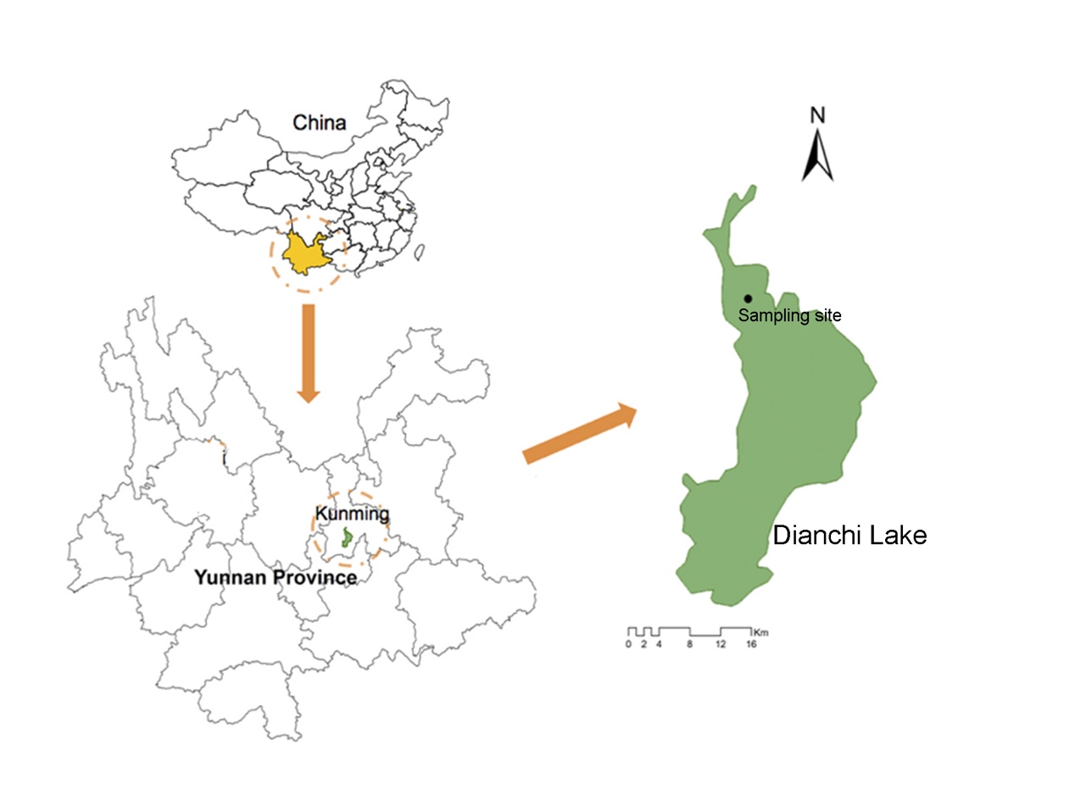

**Fig. S2**. Change of ammonium concentration of pore water in the microcosms with different treatments

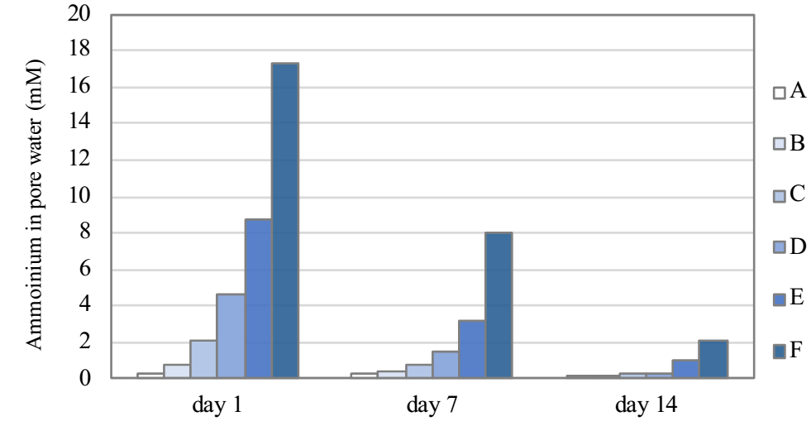

**Fig. S3.** The ratio of transcripts to *pmoA* gene in the microcosms with different treatments

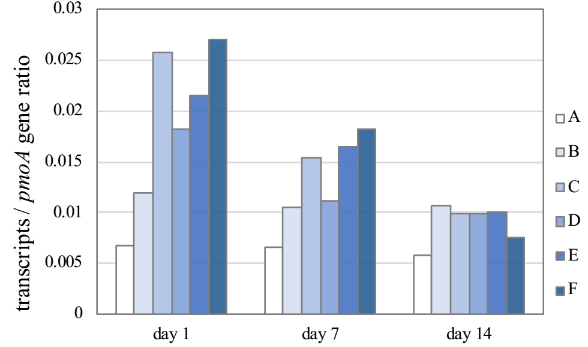

**Fig. S4.** Prediction of NGS representative sequences based on T-RFs. Sequencing data was from a previous study considering the same area, and was deposited in GenBank database under accession number SRP131884.

