Supplementary figure

Fig. S1: Proportion of cultivars per decade and quality class within the cultivar collection representing the breeding history of German winter wheat, oldest cultivar from 1966 and youngest from 2013, in total 174 cultivars including 5 hybrids.

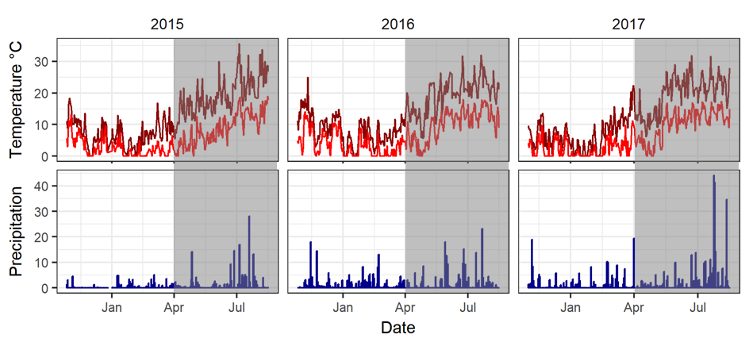
Fig. S2: Summary of minimum (above 0°C) and maximum temperature and daily precipitation sum during the experimental periods, grey area: approximately generative phase.

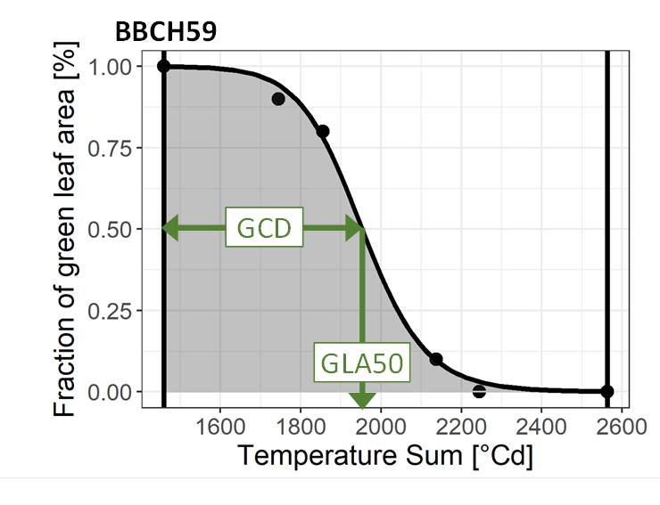
Fig. S3: Explanation graph for parameters describing the senescence pattern. The black dots are visually scored green leaf area (%). A logistic power function (black line) with two parameters was fitted to the data. For each cultivar, integral of green canopy area (grey area) was calculated between its heading (BBCH59) and harvest date in each season. GLA50 is the temperature sum when 50% green was reached and green canopy duration (GCD) is the temperature sum from heading to GLA50.
Fig. S4: Pearson correlations of yield and stay green parameters, A: means for cultivars over all three seasons and two replications each, B: means for cultivars within 2015, C: means for cultivars within 2016, D: means for cultivars within 2017, crossed values were not significant.
Fig. S5: Linear relationship between the grain filling duration (temperature sum of BBCH87 – temperature sum of BBCH59) and the green canopy duration for a subset of 20 cultivars. Each dot represents a mean value of three seasons and 2 replications (n=6).

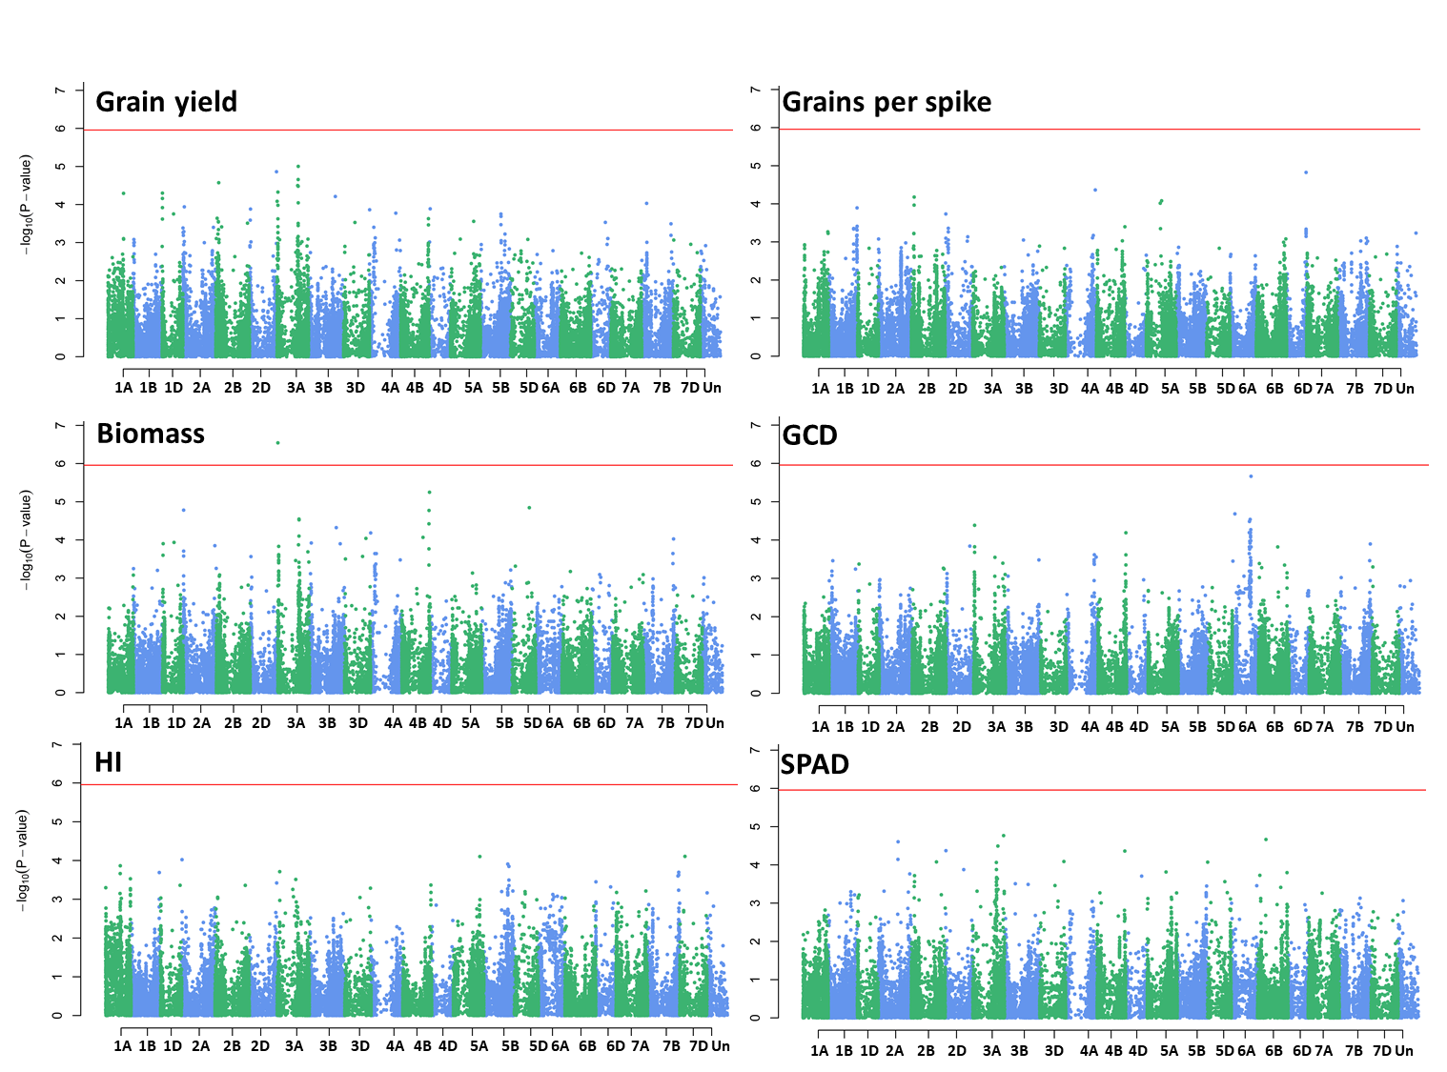
Fig. S6: Manhattan plots for genome wide marker - trait associations. P-values shown on a -log10(p-values) scale and the red line indicates the significance threshold (Bonferroni, 0.05)

Table S1: Complete list of cultivars, Bh= breeding history collection, Hyb= hybrid cultivar, org= cultivars with recommendation for use in organic farming, *= excluded from the breeding history analyses because of remarkable below-average yields for the corresponding year of registration, double bar indicates the distinction between cultivars used for breeding history analyses and the supplementary diverse cultivars for the GWAS
Cultivar name | Year of reg. | Breeder or representative in Germany according to the respective volume of the German Variety List (BSL) | Qualilty class | Country of registration | sub-group (field) | sub-set (analyses)
Diplomat | 1966 | Firlbeck | A | DE | late, tall | Bh
Pantus | 1966 | Streng | A | DE | late, short | Bh
Admiral | 1968 | Firlbeck | A | DE | late, tall | Bh
Caribo | 1968 | Heidenreich und Eger | B | DE | late, tall | Bh
Progress | 1969 | Hege, H.-U. | A | DE | late, short | Bh
Kranich | 1969 | Lochow-Petkus | A | DE | late, short | Bh
Joss | 1972 | Breustedt | C | DE | late, short | Bh
Topfit | 1972 | Strube, Dr. H. | B | DE | late, tall | Bh
Benno | 1973 | Bauer, G. | E | DE | late, tall | Bh
Kormoran | 1973 | Lochow-Petkus | A | DE | late, tall | Bh
Saturn | 1973 | MPI | C | DE | late, short | Bh
Disponent | 1975 | Bayrische Saatzuchtgesellschaft | A | DE | late, tall | Bh
Monopol | 1975 | Firlbeck | E | DE | late, tall | Bh
Nimbus | 1975 | Firlbeck | B | DE | early, short | Bh
Vuka | 1975 | Franck | A | DE | late, tall | Bh
Carimulti | 1975 | Heidenreich und Eger | C | DE | late, tall | Bh
Carisuper | 1975 | Heidenreich und Eger | A | DE | late, tall | Bh
Maris Huntsman | 1975 | Nordsaat Saatzucht | A | DE | late, short | Bh
Götz | 1978 | Bayrische Saatzuchtgesellschaft | B | DE | late, short | Bh
Kobold | 1978 | Firlbeck | B | DE | late, tall | Bh
Aquila | 1979 | Nickerson | C | UK, IT | late, tall | Bh
Tabor | 1979 | Strube, Dr. H. | A | DE | late, short | Bh
Camp Remy | 1980 | Unisigma | B | DE | early, short | Bh
Severin | 1980 | Bauer, G. | E | DE | late, short | Bh
Urban | 1980 | Bauer, G. | E | DE | late, short | Bh
Kronjuwel | 1980 | Bayrische Saatzuchtgesellschaft | B | DE | late, short | Bh
Rektor | 1980 | Firlbeck | E | DE | late, tall | Bh
Basalt | 1980 | Hege, H.-U. | B | DE | late, tall | Bh
Kanzler | 1980 | Saatzucht Engelen Büchling e.K. | B | DE | late, tall | Bh
Oberst | 1980 | Saatzucht Engelen Büchling e.K. | A | DE | late, tall | Bh
Granada | 1980 | Saatzucht Schweiger GbR | B | DE | late, short | Bh
Sperber | 1982 | Lochow-Petkus | A | DE | late, short | Bh
Kraka | 1982 | Petersen, A.S. | A | DE | late, tall | Bh
Ares | 1983 | Strube, Dr. H. | B | DE | late, tall | Bh
Apollo | 1984 | Saatzucht Josef Breun | C | DE | late, tall | Bh
Knirps | 1985 | Semundo | B | DE | late, tall | Bh
Sorbas | 1985 | Strube, Dr. H. | B | DE | late, short | Bh
Herzog | 1986 | Saatzucht Josef Breun | A | DE | late, short | Bh
Alidos | 1987 | Saatzucht Hadmersleben | E | DE | late, tall | Bh
Obelisk | 1987 | Strube, Dr. H. | B | NL, DE | late, short | Bh
Orestis | 1988 | Strube, Dr. H. | B | DE | late, short | Bh
Greif | 1989 | Lochow-Petkus | B | DE | late, short | Bh
Zentos | 1989 | Saatzucht Hadmersleben | E | DE | late, tall | Bh
Astron | 1989 | Strube, Dr. H. | A | DE | late, tall | Bh
Kontrast | 1990 | Saatzucht Hadmersleben | A | DE | early, short | Bh
Contra | 1990 | Saatzucht Josef Breun | C | DE | late, short | Bh
Toronto | 1990 | Strengs Erben | A | DE | late, short | Bh
Konsul | 1990 | SW Seeds | B | DE | late, tall | Bh
Ibis | 1991 | Lochow-Petkus | A | DE | late, tall | Bh
Tarso | 1992 | Saatzucht Hadmersleben | A | DE | late, short | Bh
Aron | 1992 | Semundo | E | DE | late, tall | Bh
Ritmo | 1993 | Cebeco | B | DE | late, short | Bh
Tambor | 1993 | Semundo | A | DE | late, tall | Bh
Piko | 1994 | Nordsaat Saatzucht | B | DE | early, short | Bh
Transit | 1994 | Saatzucht Josef Breun | A | DE | late, short | Bh
Pegassos | 1994 | Strube, Dr. H. | A | AT, CH, DE, LT, PL, SI, SK | early, short | Bh
Isengrain | 1996 | Florimond-Desprez | B | FR, SI, ES | early, short | Bh
Flair | 1996 | Saatzucht Schweiger GbR | B | DE | late, short | Bh
Apache | 1997 | Nickerson | A | CZ | early, short | Bh
Aristos | 1997 | Strube, Dr. H. | A | DE | late, tall | Bh
Ludwig | 1998 | Probstdorfer Saatzucht | A | AT, DE, CZ, HR, PL, HU and SI | late, tall | Bh
Cardos | 1998 | Saatzucht Hadmersleben | A | DE | early, short | Bh
Asketis | 1998 | Strube, Dr. H. | A | DE | late, tall | Bh
Dekan | 1999 | Lochow-Petkus | B | DE | late, short | Bh
Drifter | 1999 | Nickerson | B | DE | late, short | Bh
Skater | 2000 | Limagrain GmbH | B | DE | late, short | Bh
Biscay | 2000 | Lochow-Petkus | C | DE | late, short | Bh
Magnus | 2000 | Saatzucht Engelen Büchling e.K. | A | DE | late, tall | Bh
Altos | 2000 | Syngenta Seeds GmbH | E | DE | late, short | Bh
Terrier | 2001 | Nickerson | B | DE | late, short | Bh
Sokrates | 2001 | Saatzucht Engelen Büchling e.K. | A | DE | late, tall | Bh
Winnetou | 2002 | Firlbeck | C | DE | late, short | Bh
Cubus | 2002 | Lochow-Petkus | A | DE | late, short | Bh
Tommi | 2002 | Nordsaat Saatzucht | A | DE | late, short | Bh
Ellvis | 2002 | Saatzucht Josef Breun | A | DE | late, short | Bh
Enorm | 2002 | Saatzucht Schweiger GbR | E | DE | late, short | Bh
SW Topper | 2002 | SW Seeds | E | DE | late, short | Bh
Akteur | 2003 | DSV | E | DE | late, tall | Bh
Limes | 2003 | Innoseeds | B | DE | late, short | Bh
Paroli | 2004 | DSV | A | DE | late, short | Bh
Türkis | 2004 | SW Seeds | A | DE | late, short | Bh
Magister | 2005 | Bauer, G. | E | DE | late, short | Bh
Chevalier | 2005 | DSV | A | AT, CZ, LT, LU | late, short | Bh
Anthus | 2005 | KWS Lochow GmbH | B | DE | late, short | Bh
Tuareg | 2005 | Nordsaat Saatzucht | A | DE | late, short | Bh
Schamane | 2005 | Saatzucht Engelen Büchling e.K. | A | DE | late, short | Bh
Impression | 2005 | Saatzucht Schweiger GbR | A | DE | late, short | Bh
Brillant | 2005 | SW Seeds | A | DE | late, short | Bh
Torrild | 2005 | W. von Borries-Eckendorf | A | DE | late, short | Bh
Carenius | 2006 | Dieckmann | B | DE | late, short | Bh
Potenzial | 2006 | DSV | A | DE | late, short | Bh
Skalmeje | 2006 | KWS Lochow GmbH | C | DE | late, short | Bh
Mulan | 2006 | Nordsaat Saatzucht | B | DE | late, short | Bh
Premio | 2006 | RAGT | B | FR | early, short | Bh
Manager | 2006 | Saatzucht Schweiger GbR | B | DE | late, short | Bh
Lucius | 2006 | Secobra Recherches | A | DE | late, short | Bh
Zobel | 2006 | Syngenta Seeds GmbH | A | DE | late, short | Bh
Skagen | 2006 | W. von Borries-Eckendorf | E | DE | late, short | Bh
Jenga | 2007 | Ackermann Saatzucht | A | DE | late, short | Bh
Boregar | 2007 | RAGT | A | FR | early, short | Bh
Esket | 2007 | RAGT | A | DE | late, short | Bh
Inspiration | 2007 | Saatzucht Josef Breun | B | DE | late, short | Bh
Fedor | 2007 | W. von Borries-Eckendorf | A | DE | late, short | Bh
Profilus | 2008 | RAGT | A | DE | late, short | Bh
JB Asano | 2008 | Saatzucht Josef Breun | A | DE | late, short | Bh
Jafet | 2008 | Sandra Senghaas-Kirschenlohr | E | DE | late, short | Bh
Tabasco | 2008 | W. von Borries-Eckendorf | C | DE | late, short | Bh
Zappa | 2009 | Ackermann Saatzucht | C | DE | late, short | Bh
Primus | 2009 | DSV | B | DE | late, short | Bh
Kredo | 2009 | Nordsaat Saatzucht | B | DE | late, short | Bh
Global | 2009 | RAGT | B | DE, AT | late, short | Bh
Event | 2009 | Saatzucht Josef Breun | E | DE | late, short | Bh
Arktis | 2010 | DSV | E | DE | late, short | Bh
Matrix | 2010 | DSV | B | DE | late, short | Bh
Muskat | 2010 | DSV | C | DE | early, short | Bh
KWS Pius | 2010 | KWS Lochow GmbH | A | DE | late, short | Bh
Edgar | 2010 | Limagrain GmbH | B | DE | late, short | Bh
Kalahari | 2010 | Limagrain GmbH | B | DE, BE | late, short | Bh
Linus | 2010 | RAGT | A | DE | late, short | Bh
Oxal | 2010 | RAGT | B | DE | late, short | Bh
Orcas | 2010 | Secobra Recherches | B | DE | early, short | Bh
Alves | 2010 | SW Seeds | A | DE | late, tall | Bh
KWS Santiago | 2011 | KWS Lochow GmbH | C | UK | late, short | Bh
Colonia | 2011 | Limagrain GmbH | B | DE, BE, HU | late, short | Bh
Intro | 2011 | RAGT | B | DE, FR DE, FR | late, short | Bh
Kometus | 2011 | Saatzucht Schweiger GbR | A | DE | late, short | Bh
Nelson | 2011 | Saatzucht Schweiger GbR | E | DE | late, short | Bh
Xanthippe | 2011 | Sejet Planteforaedling I/S | C | DE | late, short | Bh
Glaucus | 2011 | Strube, Dr. H. | A | DE | late, short | Bh
Tobak | 2011 | W. von Borries-Eckendorf | B | DE | late, short | Bh
Joker | 2012 | DSV | A | DE | late, short | Bh
Patras | 2012 | DSV | A | DE | late, short | Bh
KWS Ferrum | 2012 | KWS Lochow GmbH | B | DE | early, short | Bh
Atomic | 2012 | Limagrain GmbH | A | DE | late, short | Bh
Capone | 2012 | Limagrain GmbH | A | DE | late, short | Bh
Forum | 2012 | Nordsaat Saatzucht | A | DE, EE, PL, SE | late, short | Bh
Mentor | 2012 | RAGT | B | DE | late, short | Bh
WW 4180 | 2012 | Saatzucht Josef Breun | NA | DE | early, short | Bh
Bombus | 2012 | Secobra Recherches | C | DE | late, short | Bh
Estivus | 2012 | Strube, Dr. H. | A | DE | late, short | Bh
SY Ferry | 2012 | Syngenta Seeds GmbH | B | DE | late, short | Bh
Boxer | 2013 | Ackermann Saatzucht | C | DE | late, tall | Bh
KWS Cobalt | 2013 | KWS Lochow GmbH | A | DE | late, short | Bh
Kurt | 2013 | Limagrain GmbH | B | DE | late, short | Bh
Anapolis | 2013 | Nordsaat Saatzucht | C | DE | late, short | Bh
Rebell | 2013 | RAGT | A | DE | late, short | Bh
Avenir | 2013 | Saatzucht Josef Breun | A | DE | late, short | Bh
Gourmet | 2013 | Secobra Recherches | E | DE | late, short | Bh
Landsknecht | 2013 | Secobra Recherches | C | DE | late, short | Bh
Memory | 2013 | Secobra Recherches | B | DE | late, short | Bh
Apertus | 2013 | Strube, Dr. H. | A | DE | late, short | Bh
Rumor | 2013 | Strube, Dr. H. | B | DE | early, short | Bh
Desamo | 2013 | Syngenta Seeds GmbH | B | DE | late, short | Bh
Gordian | 2013 | Syngenta Seeds GmbH | B | DE | late, short | Bh
Edward | 2013 | W. von Borries-Eckendorf | B | DE | late, short | Bh
Hybred | 2003 | Nordsaat Saatzucht | B | DE, FR | early, short | Bh^{Hyb}
Hystar | 2007 | Saaten Union Recherche | B | FR | early, short | Bh^{Hyb}
Hyland | 2009 | Nordsaat Saatzucht | B | DE, HU | early, short | Bh^{Hyb}
Hybery | 2010 | Saaten Union Recherche | B | FR | early, short | Bh^{Hyb}
Hylux | 2012 | Saaten Union | B | FR | early, short | Bh^{Hyb}
Bussard | 1990 | Lochow-Petkus | E | DE | late, tall | Bh^{Org}
Batis | 1994 | Strube, Dr. H. | A | DE | late, tall | Bh^{Org}
Tiger | 2001 | Franck | A | DE | late, tall | Bh^{Org}
Hermann | 2004 | Nickerson | C | DE | late, short | Bh^{Org}
Kerubino | 2004 | Saatzucht Schmid Landau | E | DE | late, short | Bh^{Org}
Akratos | 2004 | Strube, Dr. H. | A | DE | late, tall | Bh^{Org}
Discus | 2007 | Pflanzenzucht SaKa GmbH&Co.KG | A | DE | late, short | Bh^{Org}
Famulus | 2010 | DSV | E | DE | late, short | Bh^{Org}
Florian | 2010 | Nordsaat Saatzucht | E | DE | late, short | Bh^{Org}
Genius | 2010 | Nordsaat Saatzucht | E | DE | late, short | Bh^{Org}
Meister | 2010 | RAGT | A | DE | late, short | Bh^{Org}
Elixer | 2012 | W. von Borries-Eckendorf | C | DE | late, short | Bh^{Org}
Pionier | 2013 | DSV | A | DE | late, short | Bh^{Org}
KWS Milaneco | 2013 | KWS Lochow GmbH | E | DE | late, tall | Bh^{Org}
Naturastar | 2002 | Saatzucht Schweiger GbR | A | DE | late, tall | Bh^{Org*}
Aszita | 2005 | Getreidezüchtung Peter Kunz | B | DE | late, tall | Bh^{Org*}
Butaro | 2009 | Landbauschule Dottenfelderhof e.V. | E | DE | late, tall | Bh^{Org*}
Soissons | 1987 | Florimond-Desprez | NA | BE, ES, FR, IE, IT, SI | early, short | Div^{europ. reg.}
Tremie | 1991 | Serasem | NA | ES, FR, IT | early, short | Div^{europ. reg.}
Gaucho | 1993 | USDA-ARS, Oklahoma AES | NA | US | late, short | Div^{europ. reg.}
Sponsor | 1994 | Unisigma | NA | FR, IE | late, short | Div^{europ. reg.}
Ivanka | 1998 | Inst. of Field and Veg. Crops, Novi Sad | NA | CS | early, short | Div^{europ. reg.}
Claire | 1999 | Nickerson | C | IE, UK | late, short | Div^{europ. reg.}
Caphorn | 2000 | RAGT | NA | FR | early, short | Div^{europ. reg.}
Solstice | 2001 | Limagrain GmbH | NA | UK | late, short | Div^{europ. reg.}
Cordiale | 2003 | KWS UK | NA | UK | early, short | Div^{europ. reg.}
Robigus | 2004 | KWS UK | B | UK | late, short | Div^{europ. reg.}
Einstein | 2004 | Nickerson | B | UK | late, short | Div^{europ. reg.}
Alixan | 2005 | Limagrain GmbH | A | FR | early, short | Div^{europ. reg.}
Arlequin | 2007 | Limagrain GmbH | NA | FR | early, short | Div^{europ. reg.}
Oakley | 2008 | KWS UK | C | UK, BE | late, short | Div^{europ. reg.}
Phoenix | 1981 | WWAI | NA | AU; US | early, tall | Div
Helios | NA | Arizona Plant Breeders | NA | US | late, short | Div
Mex. 3 | NA | BAZ | NA | MX | early, short | Div
Cajeme 71 | 1971 | CIMMYT | NA | MX | early, short | Div
Mex. 17 bb | NA | CIMMYT | NA | MX | early, short | Div
BCD 1302/83 | NA | Goertzen Seed Research | NA | MD | early, short | Div
Sonalika | 1971 | Indian Agricultural Research Institute | NA | IN | early, short | Div
Lambriego INIA | 1981 | INIA | NA | CL | early, short | Div
Siete Cerros 66 | 1966 | CIMMYT | NA | MX | early, short | Div
Triple dirk \S\"" | NA | INIA | NA | AU | early, short | Div
Pobeda | 1990 | Inst. of Field and Veg. Crops, Novi Sad | NA | SR | early, short | Div
Renesansa | NA | Inst. of Field and Veg. Crops, Novi Sad | NA | SR | early, short | Div
Centurk | 1971 | Nebraska Agr. Exp. Station | NA | US | early, tall | Div
Avalon | 1980 | Plant Breeding Int. Cambridge | NA | GB | early, short | Div
Highbury | 1968 | Plant Breeding Int. Cambridge | A | GB | early, short | Div
Brigand | 1979 | Plant Breeding Int. Cambridge | NA | GB | late, short | Div
TJB 990-15 | NA | Plant Breeding Int. Cambridge | NA | GB | late, short | Div
Benni mult. | NA | Purdue University | NA | US | early, tall | Div
Hope | 1927 | S.Dakota Agr. Exp. Station | NA | US | early, tall | Div
SUR99820 | NA | Saaten Union Recherche | NA | FR | early, short | Div
Cappelle Desprez | NA | SAS Florimond Desprez | C | FR; CH; GB | late, tall | Div
Durin | 1986 | Plant Breeding Int. Cambridge | NA | GN | late, short | Div
Florida | 1985 | Saatzucht Schweiger | NA | US | early, short | Div
INTRO 615 | NA | NA | NA | US | early, short | Div
Mironovskaya 808 | NA | Mironovska Research Institute | NA | UA | early, tall | Div
NS 22/92 | NA | Institute of Field and Vegetable Crops in Novi Sad, Serbia | NA | SR | early, tall | Div
NS 46/90 | NA | Institute of Field and Vegetable Crops in Novi Sad, Serbia | NA | SR | early, short | Div
NS 66/92 | NA | Institute of Field and Vegetable Crops in Novi Sad, Serbia | NA | SR | early, short | Div
Vel | NA | Purdue Univ., Indian | NA | US | early, tall | Div
Table S2: Summary of the plant protection measures
 | Growth stage | Spraying agents
 | Growth stage | 2015 | 2016 | 2017
Herbicide | BBCH 21/25 | 1,2 l/ha Axial | 1,2 l/ha Axial | 1,2 l/ha Axial
Herbicide | BBCH 25/29 | 70 g/ha Biathlon4D | 70 g/ha Biathlon4D | 70 g/ha Biathlon4D
Herbicide |  | 1 l/ha Dash | 1 l/ha Dash
Herbicide |  | 20 g/ha Dirigent SX | 20 g/ha Dirigent SX
Fungicide | BBCH 31/37 | 2 l/ha Capalo | 2 l/ha Capalo | 1,6 l Capalo
Fungicide | BBCH 49/55 | 1,1 l/ha Adexar | 1,1 l/ha Adexar | 2 l/ha Adexar
Fungicide |  | 1,1 l/ha Diamant | 1,1 l/ha Diamant
Fungicide | BBCH59/61 | 1 l/ha Prosaro | 1 l/ha Prosaro | 1 l/ha Prosaro
Growth regulator | BBCH 25/29 | 1,2 l/ha Stabilan 720
Growth regulator | BBCH 31 | 0,5 l/ha Stabilan 720 | 0,5 l/ha Stabilan 720 | 1,5 l/ha Medax Top
Growth regulator |  | 0,5 l/ha Medax Top | 0,5 l/ha Medax Top
Insecticide |  | 0,2 l/ha Sumicidin | 0,2 l/ha Sumicidin | 0,2 l/ha Sumicidin
Insecticide |  |  | 0,075 l/ha Karate Zeon

Table S3: P-values from the ANOVA results for the yield and senescence parameters. No interaction effect for BBCH59 because of only one value per year, p-value for the factor year was calculated with cultivar as random factor. In all other calculations cultivar, year and the interaction were set as fixed in the linear mixed model.
 | p-value for Factor effect
 | Cultivar | Year | Interaction
Seed yield | < 0.001 | < 0.01 | < 0.001
Biomass | < 0.001 | < 0.01 | n.s.
Harvest Index | < 0.001 | < 0.01 | n.s.
TKW | < 0.001 | n.s. | < 0.001
Spikes per m² | < 0.001 | < 0.01 | n.s.
Grains per ear | < 0.001 | < 0.05 | < 0.001
Grains per m² | < 0.001 | n.s. | n.s.
BBCH59 | < 0.001 | < 0.001 | -
LAI_{max} | < 0.001 | < 0.05 | < 0.001
SPAD | < 0.001 | n.s. | < 0.05
GLA₅₀ | < 0.001 | < 0.01 | < 0.001
LAD | < 0.001 | < 0.05 | < 0.001
GCD | < 0.001 | < 0.05 | < 0.001

Table S4: Nitrogen content of the soil in [kg/ha] and amount of fertilized Nitrogen in the last row for every season. Three applications: at vegetation start, at stem elongation and around booting.
 | 2015 | 2016 | 2017
before sowing (0-60 cm depth) | 149.9 | 18.1 | 22.8
at vegetation start (0-90 cm depth) | 70.8 | 29.3 | 43.1
after harvest (0-90 cm depth) | 86.6 | 34.2 | 28.9
 | 150 | 190 | 180 | Fertilization in three applications

Table S5: eather conditions during the experimental periods in comparison with the 30 years mean values from the DWD (DE's National Meteorological Service) for the relevant region.
 | Sowing date | Avg. heading date (BBCH 59) |  |  | Precipitation sum (March - July) [mm] | Avg. Temp. (Oct - July) [°C]
 | Sowing date | days after sowing |  | Tsum [°Cd] | Precipitation sum (March - July) [mm] | Avg. Temp. (Oct - July) [°C]
2015 | 28th Oct 2014 | 221 |  | 1461 | 201.8 | 11.92
2016 | 27th Oct 2015 | 217 |  | 1618 | 235.7 | 12.73
2017 | 2nd Nov 2016 | 213 |  | 1436 | 325.7 | 13.42
30year mean from DWD |  |  |  |  | 296.3 | 11.6

Table S6: Broad-sense heritability (last column ”Overall”) and repeatability calculated within each year, Within each year the repeatability was calculated accordingly but without the cultivar – season interaction σ_{CY}² and the residual variance σ_{e}² divided by two instead.
 | 2015 | 2016 | 2017 | Overall
Seed yield | 0.78 | 0.68 | 0.76 | 0.74
Grains per spike | 0.76 | 0.64 | 0.66 | 0.75
BBCH 59 | - | - | - | 0.87
LAI_{max} | 0.57 | 0.51 | 0.36 | 0.50
SPAD | - | 0.65 | 0.56 | 0.66
LAD | 0.71 | 0.59 | 0.62 | 0.51
GCD | 0.75 | 0.75 | 0.79 | 0.57

Calculated from Harvest Index und final plot yield
only for 2016 and 2017
measured in April, after the first fertilisation

