Supplementary Material

Bio-aviation fuel: A comprehensive review and analysis of the supply chain components
Stephen S. Doliente^{1,2}, Aravind Narayan¹, John Frederick D. Tapia^{1,3}, Nouri J. Samsatli^{4,5}, Yingru Zhao⁶, Sheila Samsatli^{1*}
¹Department of Chemical Engineering, University of Bath, Claverton Down, Bath BA2 7AY, United Kingdom
²Department of Chemical Engineering, College of Engineering and Agro-Industrial Technology, University of the Philippines Los Baños, Los Baños, Laguna 4031, Philippines
³Chemical Engineering Department, De La Salle University-Manila, 2401 Taft Avenue, Malate, Manila, Philippines 1004
⁴Process Systems Enterprise Ltd., London SW7 2AZ, United Kingdom
⁵Samsatli Solutions, Ventonlace, Flatwoods Crescent, Claverton Down, Bath BA2 7AH, United Kingdom
⁶College of Energy, Xiamen University, Xiamen 361005, China
* Correspondence:
Corresponding Author
S.M.C.Samsatli@bath.ac.uk

Supplementary Figures
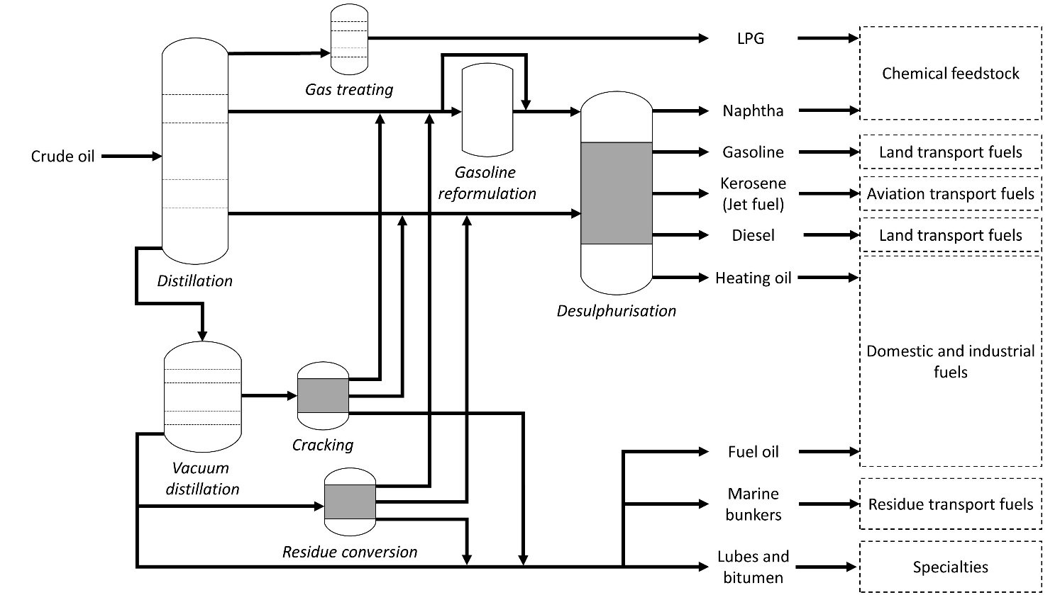
Figure S1: Classical crude oil refinery process to produce chemical feedstock, fuels and specialties (Drawn using data from Wilbrand (2018)).

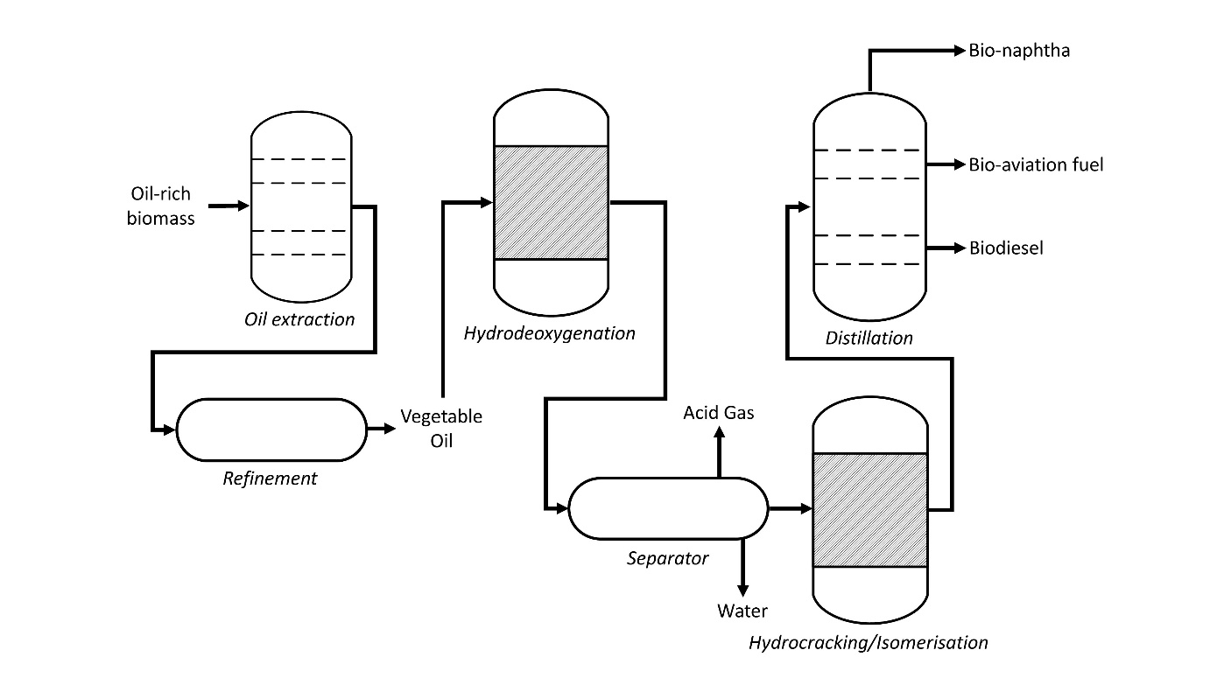
(a)
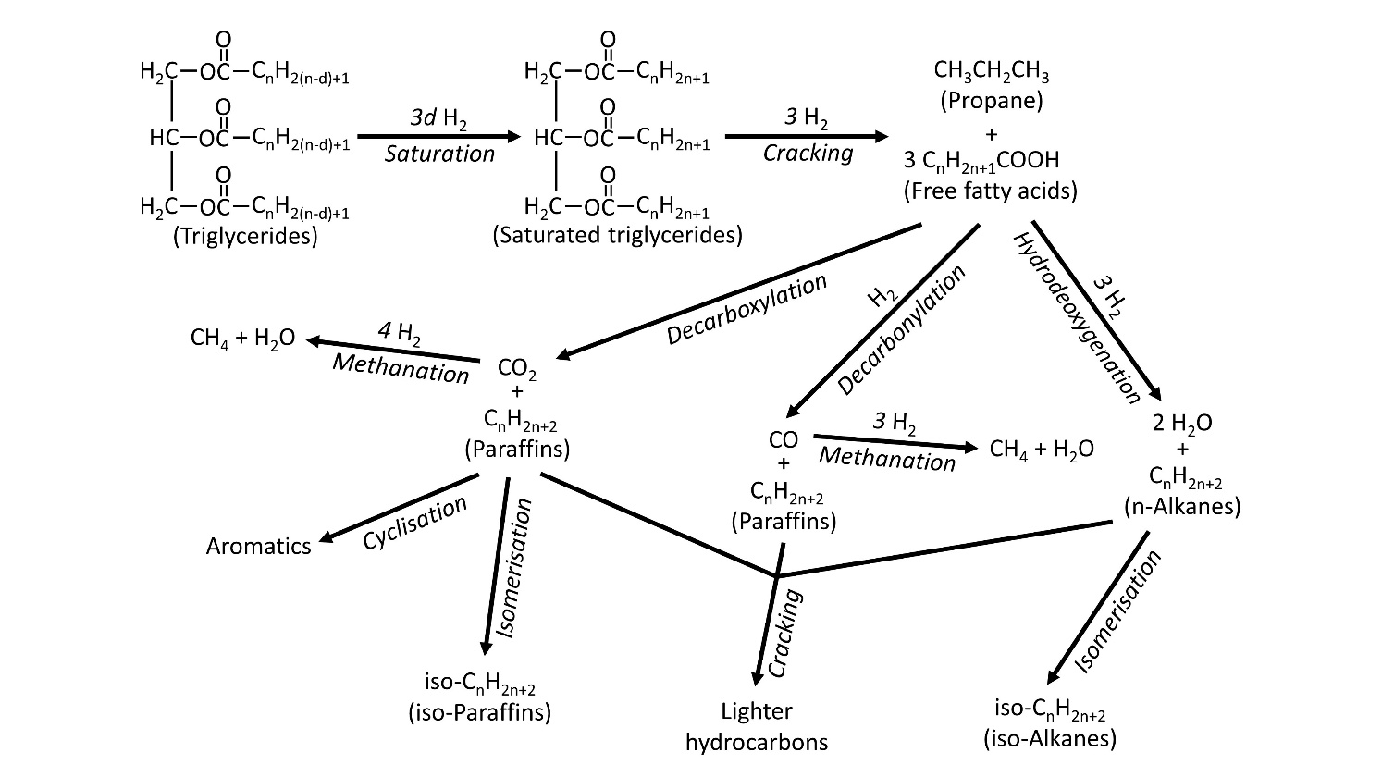
(b)
Figure S2: Hydroprocessed esters and fatty acids production pathway: a) Production process from oil-rich biomass (Drawn using data from Wang and Tao (2016)); and b) Reaction pathways for synthetic paraffinic kerosene production (Drawn using data from Vásquez et al. (2017)).
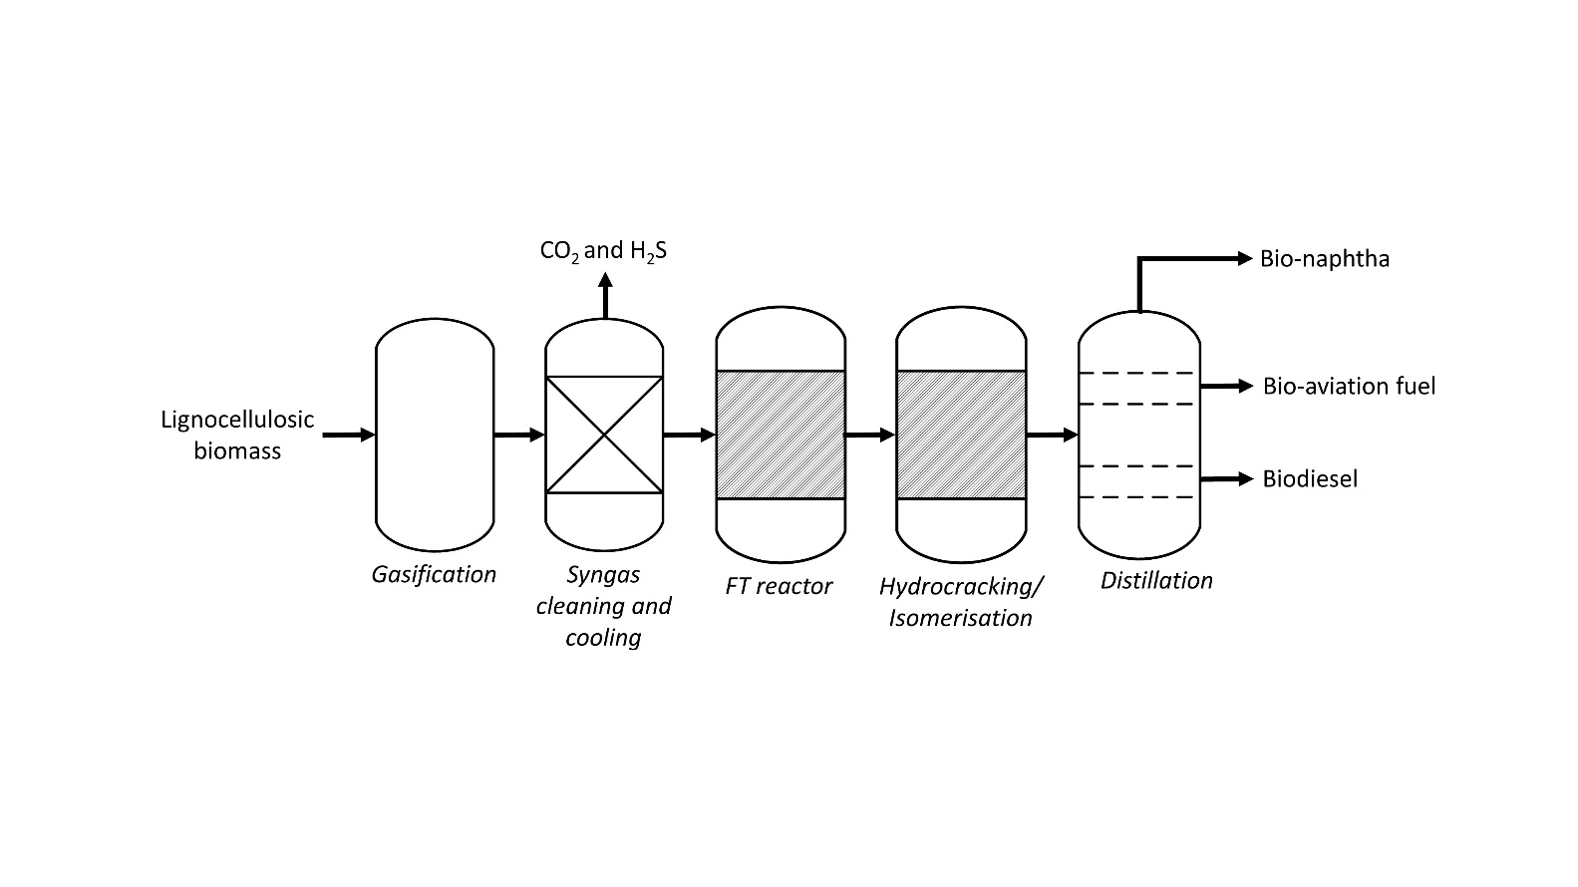
(a)
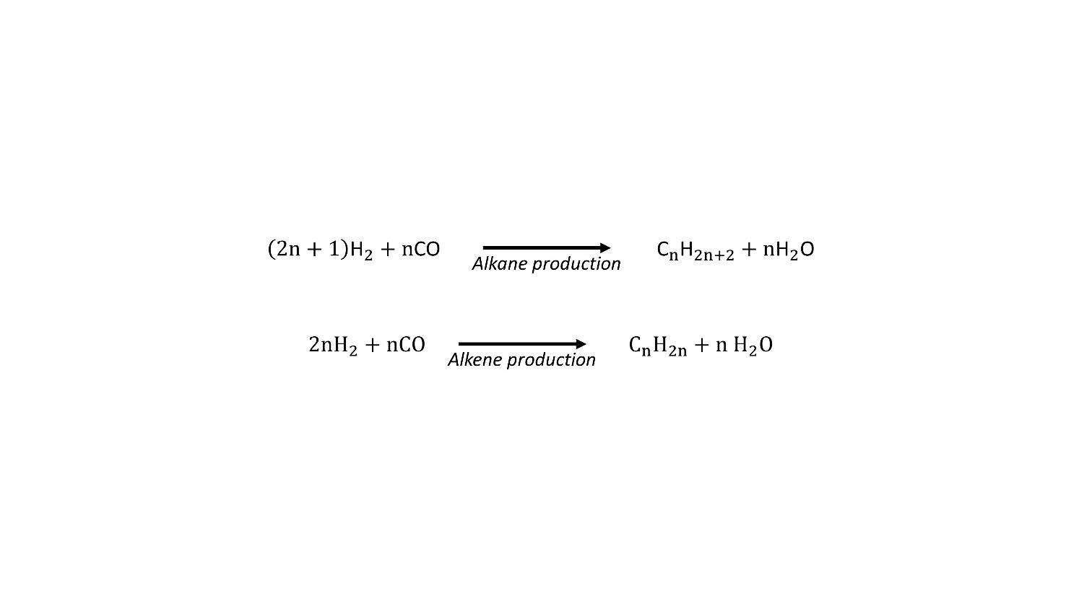
(b)
Figure S3: Fischer-Tropsch production pathway: (a) Production process from lignocellulosic biomass (Drawn using data from Boichenko et al. (2013)); and b) Reaction pathways for synthetic paraffinic kerosene production (Drawn using data from Radich (2015)).

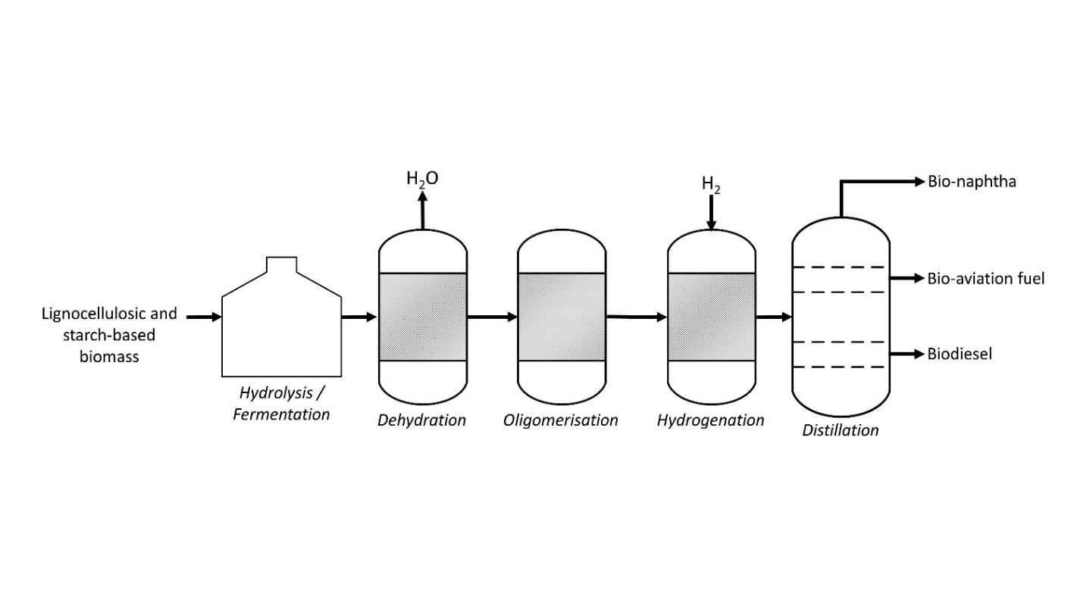
(a)
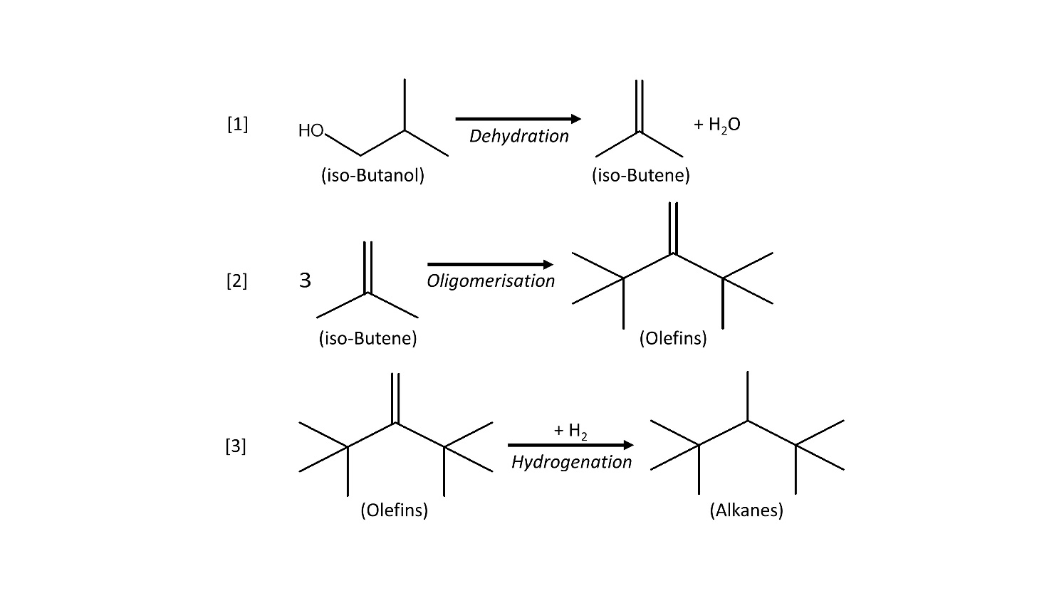
(b)
Figure S4: Alcohol-to-jet production pathway: a) Production process from lignocellulosic and starch-based biomass (Drawn using data from Geleynse et al. (2018)); and b) Reaction pathway for the conversion of iso-butanol to bio-aviation fuel: [1] Iso-butanol dehydration forming alkenes, [2] Isobutene oligomerisation, [3] Saturation of oligomerised molecule to synthetic paraffinic kerosene hydrocarbons (Drawn using data from Richter et al. (2018)).

Supplementary Tables
Table S1. Physicochemical properties of gasoline, jet fuel and diesel (Data from Wilbrand 2018, Yang et al. 2019).
Properties | Gasoline | Jet Fuel | Diesel
Hydrocarbon length | C₃ to C₁₁ | C₁₀ to C₁₈ | C₁₁ to C₂₅
Freezing point (°C) | – | Min. -47 | –
Pour point (°C) | – | – | -35 to -15
Cloud point (°C) | -57 | – | -15 to 5
Flash point (°C) | -43 | Min. 38 | Min. 55
Boiling point (°C) | Max. 210 | Max. 300 | Max. 360
Density at 15°C (g/cm³) | 0.72 to 0.78 | 0.75 to 0.84 | 0.82 to 0.85
Kinematic viscosity (mm²/s) | 0.37 to 0.44 (at 20°C) | Max. 8 (at -20°C) | 2.00 to 4.50 (at 40°C)
Lower heating value (MJ/kg) | 43.4 | 43 | 43.4

Table S2. Standard specifications of conventional jet fuel and bio-aviation fuel (synthetic paraffinic kerosene or SPK) based on ASTM D1655-19a and ASTM D7566-19b, respectively (ASTM 2019, ASTM 2019).
Property |  | Jet A or Jet A-1 | HEFA-SPK | FT-SPK | FT-SPK/A | ATJ-SPK | SIP-SPK | Blended Jet A or Jet A-1
HYDROCARBON COMPOSITION
Aromatics, volume% | Max. | 25 | – | – | – | – | – | 25
Aromatics, mass% | Max. | – | 0.5 | 0.5 | 20 | 0.5 | 0.5 | –
Carbon and hydrogen, mass% | Min. | – | 99.5 | 99.5 | 99.5 | 99.5 | 99.5 | –
Cycloparaffins, mass% | Max. | – | 15 | 15 | 15 | 15 | – | –
Farnesane, mass% | Min. | – | – | – | – | – | 97 | –
Hexahydrofarnesol, mass% | Max. | – | – | – | – | – | 1.5 | –
Olefins, mgBr₂/100 g | Max. | – | – | – | – | – | 300 | –
Paraffins, mass% |  | – | Report | Report | Report | Report | – | –
Saturated hydrocarbon, mass% | Min. | – | – | – | – | – | 98 | –
NON-HYDROCARBON COMPOSITION
Acidity, total mg KOH/g | Max. | 0.10 | 0.015 | 0.015 | 0.015 | 0.015 | 0.015 | 0.10
Halogens, mg/kg | Max. | – | 1 | 1 | 1 | 1 | 1 | –
Metals, ppm per metal | Max. | – | 0.1 | 0.1 | 0.1 | 0.1 | 0.1 | –
Nitrogen, mg/kg | Max. | – | 2 | 2 | 2 | 2 | 2 | –
Sulphur, total mass% | Max. | 0.30 | – | – | – | – | – | 0.30
Sulphur, mg/kg | Max. | – | 15 | 15 | 15 | 15 | 2 | –
Water, mg/kg | Max. | – | 75 | 75 | 75 | 75 | 75 | –
CONTAMINANTS
Existent gum, mg/100 mL | Max. | 7 | 7 | – | – | 4 | 7 | 7
FAME, ppm | Max. | – | <5 | – | – | – | – | –
ADDITIVES
Antioxidants, mg/L | Min. | – | 17 | 17 | 17 | 17 | 17 | –
 | Max. | – | 24 | 24 | 24 | 24 | 24 | –
DISTILLATION
Distillation temperature with 10% recovered, °C | Max. | 205 | 205 | 205 | 205 | 205 | 250 | 205
Distillation temperature with 50% recovered, °C |  | Report | Report | Report | Report | Report | Report | Report
Distillation temperature with 90% recovered, °C |  | Report | Report | Report | Report | Report | Report | Report
Final boiling point, °C | Max. | 300 | 300 | 300 | 300 | 300 | 255 | 300
T90-T10, °C | Min. | – | 22 | 22 | 22 | 21 | 5 | 40
Distillation residue, % | Max. | 1.5 | 1.5 | 1.5 | 1.5 | 1.5 | 1.5 | 1.5
Distillation loss, % | Max. | 1.5 | 1.5 | 1.5 | 1.5 | 1.5 | 1.5 | 1.5
Flash point, °C | Min. | 38 | 38 | 38 | 38 | 38 | 100 | 38
Density at 15°C, kg/m³ |  | 775 to 840 | 730 to 772 | 730 to 770 | 755 to 800 | 730 to 770 | 765 to 780 | 775 to 840
FLUIDITY
Freezing point, °C | Max. | -40 (Jet A);  -47 (Jet A-1) | -40 | -40 | -40 | -40 | -60 | -40 (Jet A);  -47 (Jet A-1)
Viscosity –20°C, mm²/s | Max. | 8.0 | – | – | – | – | – | 8.0
COMBUSTION
Net heat of combustion, MJ/kg | Min. | 42.8 | – | – | – | – | 43.5 | 42.8
(1) Smoke point, mm, or | Min. | 25.0 | – | – | – | – | – | 25.0
(2) Smoke point, mm, and | Min. | 18.0 | – | – | – | – | – | 18.0
Naphthalenes, volume% | Max. | 3.0 | – | – | – | – | – | 3.0
THERMAL STABILITY
2.5 h at control temperature, °C | Min. | 260 | 325 | 325 | 325 | 325 | 355 | 260
Filter pressure drop, mm Hg | Max | 25 | 25 | 25 | 25 | 25 | 25 | 25
CORROSION
Copper strip, 2 h at 100°C |  | – | – | – | – | – | – | –

Table S3: Well-to-wake life-cycle emissions for various feedstocks (Data from Bauen et al. (2009) and de Jong et al. (2017).
Feedstock [Generation] | Production Process | Well-to-wake GHG Emissions (gCO₂eq/MJ fuel)
Crude oil | Conventional | 87.5
Edible oil [1-G] | Hydroprocessing | 40 to 70
Camelina [1-G] | Hydroprocessing | 13.5
Jatropha [2-G] | Hydroprocessing | 30
Tallow [2-G] | Hydroprocessing | 10
Algae in open ponds [3-G] | Hydroprocessing | -21 to 1.5
Energy crops [2-G] | Biomass to Liquid (FT) | 7.3
Forestry waste [2-G] | Biomass to Liquid (FT) | 4.8
Corn stover [2-G] | ATJ | 22*

* Value was reverse calculated using %GHG savings relative to conventional jet fuel.

Table S4: Existing companies producing hydroprocessed esters and fatty acids (Data from Sotelo-Boyas et al. 2012, Richter et al. 2018).
Company | Technology | Process | Feedstock | Capacity (Mt/year) | Fuels Produced
Neste Oil | NExBTL | Hydrotreating | Waste, Residues, Vegetable oils (Palm) | 2.6 | Biodiesel and Bio-aviation fuel
Renewable Energy Group | - | - | Waste, Residues, Vegetable oils (Palm) | 1.6 | Biodiesel only
AltAir Fuels | Ecofining | Hydrotreating + Isomerisation | Inedible agicultural waste/, Waste fats/oils | ~0.13 | Biodiesel and Bio-aviation fuel
Petrixo Oil and Gas | Ecofining | Hydrotreating + Isomerisation | - | 0.5
Eni | Ecofining | Hydrotreating + Isomerisation | Palm oil | 0.315 | Biodiesel and Bio-aviation fuel
Diamond Green Diesel | - | - | Animals fats, Used cooking oil | ~0.45 | Biodiesel
Total | - | - | Used oils, Vegetable oils | 0.5 | -
Solazyme | - | - | Oils from microalgae | 0.1 | -
Tyson Foods Inc. | - | Hydrotreating | Animals fats: Beef tallow, Pork Lard, Chicken Fat, Grease | - | Biodiesel and Bio-aviation fuel
Syntroleum Corporation | - | Hydrotreating | Animals fats: Beef tallow, Pork Lard, Chicken Fat, Grease | - | Biodiesel and Bio-aviation fuel
Haldor Topsøe | - | Hydrotreating | Raw Tall Oil |  | Biodiesel and Bio-aviation fuel

Table S5: Dry feed-to-oil ratio (lb/lb) for a variety of feedstocks (Data from Elgowainy et al. 2012).
Feedstock | Soybean | Palm | Rapeseed | Jatropha | Camelina
Dry feed-to-oil ratio (lb/lb) | 4.7 | 4.5 | 2.4 | 3 | 2.9

References
ASTM (2019). ASTM D1655-19a, Standard Specification for Aviation Turbine Fuels. Pennsylvania, USA, American Society for Testing and Materials (ASTM).
ASTM (2019). ASTM D7566-19b, Standard Specification for Aviation Turbine Fuel Containing Synthesized Hydrocarbons. Pennsylvania, USA, American Society for Testing and Materials (ASTM).
Bauen, A., J. Howes, L. Bertuccioli and C. Chudzia (2009). Review of the potential for biofuels in aviation. London, E4Tech: 1 - 117.
Boichenko, S., V. Oksana and I. Anna (2013). "Overview of innovative technologies for aviation fuels production." Chemistry & Chemical Technology 7(3).
de Jong, S., K. Antonissen, R. Hoefnagels, L. Lonza, M. Wang, A. Faaij and M. Junginger (2017). "Life-cycle analysis of greenhouse gas emissions from renewable jet fuel production." Biotechnology for Biofuels 10(1): 1 - 18.
Elgowainy, A., M. Han, J. Wang, N. Carter, R. Stratton, J. Hileman, A. Malwitz and S. Balasubramanian (2012). Life Cycle Analysis of Alternative Aviation Fuels in GREET. Massachusetts, Energy Systems Division, Argonne National Laboratory, U.S. Department of Energy: 1 - 62.
Geleynse, S., K. Brandt, M. Garcia-Perez, M. Wolcott and X. Zhang (2018). "The Alcohol-to-Jet Conversion Pathway for Drop-In Biofuels: Techno-Economic Evaluation." ChemSusChem 11(21): 3728 - 3741.
Radich, T. (2015). The flight paths for biofuel. Working Paper Series. Washington D.C, U.S. Energy Information Administration: 1 - 17.
Richter, S., M. Braun-Unkhoff, C. Naumann and U. Riedel (2018). "Paths to alternative fuels for aviation." CEAS Aeronautical Journal 9(3): 389 - 403.
Sotelo-Boyas, R., F. Trejo-Zarraga and F. d. Jesus Hernandez-Loyo (2012). Hydroconversion of Triglycerides into Green Liquid Fuels. Hydrogenation, IntechOpen: 187 - 216.
Vásquez, M. C., E. E. Silva and E. F. Castillo (2017). "Hydrotreatment of vegetable oils: A review of the technologies and its developments for jet biofuel production." Biomass and Bioenergy 105: 197 - 206.
Wang, W.-C. and L. Tao (2016). "Bio-jet fuel conversion technologies." Renewable and Sustainable Energy Reviews 53: 801 - 822.
Wilbrand, K. (2018). Potential of Fossil Kerosene. Biokerosene: Status and Prospects. M. Kaltschmitt and U. Neuling. Berlin, Heidelberg, Springer Berlin Heidelberg: 43 - 57.
Yang, J., Z. Xin, Q. S. He, K. Corscadden and H. Niu (2019). "An overview on performance characteristics of bio-jet fuels." Fuel 237: 916 - 936.

