# **Title:** Identifying habitat holdouts for high elevation tree species under climate change

**Authors:** Maxwell, Charles J. Scheller, Robert M.

**Affiliation:** C. J. Maxwell, R. M. Scheller. Department of Forestry and Environmental Resources, North Carolina State University, Raleigh, NC 27695

**Corresponding author’s email:** cjmaxwe3@ncsu.edu

## **Supplemental methods:**

**Creating climate and soil regions for the 90m resolution:**

To create the climate ecoregions, a 30m DEM from the USGS was used to derive aspect in ArcGIS. The DEM was then subset into four elevation classes, every 600m starting around 200 m.a.s.l. up to the highest point around 2500 m.a.s.l. The aspect map was divided into four quadrants, 0 to 90 (N to E), 91-180 (E to S), 181-270 (S to W), and 271-360 (W to N). The combine rasters function in ArcGIS was used to create the product of those elevation and aspect, and the eliminate function was used again to meet a minimum polygon size, which resulted in 16 initial climate regions. Additional soil ecoregions were constructed beyond those used in the 270m model. Soil characteristics were obtained from the SSURGO database available through the Web Soil Survey (https://websoilsurvey.nrcs.usda.gov/; accessed February 2018). The following physical characteristics of the soil were incorporated into the model, including: percent sand, clay and silt; soil depth; field capacity and wilt point among others. More than 20 soil families were present in Marble Mountain Wilderness, but only the 12 largest families were used to create the soil ecoregions for this analysis; related soil families were consolidated and the smallest areas were merged into larger via the eliminate function in ArcGIS. The soil and climate ecoregions were then merged, which resulted in 133 ecoregions total. By accident, the 133 ecoregion shapefile was uploaded to the USGS geodata portal as the basis for downloading climate data.

**Supplemental Tables:**

**Table S1.** LANDIS-II general species parameters

|  |  |  |  |  |  |  |  |  |  |  |  |  |  |  |
| --- | --- | --- | --- | --- | --- | --- | --- | --- | --- | --- | --- | --- | --- | --- |
| Species | Long-evity 1-6 | Sexual maturity 1-3, 5, 7 | Shade tolerance 1, 3 | Fire tolerance 2 | Seed dispersal distance | | Vegetative reproduction probability 1-2, 5 | Sprout age | | Post-fire regener-ation 1-2 | Funct-ional Type | N Fixer | GDD Min 10 | GDD Max 10 |
| Effective 1-3, 8-9 | Max  1-3, 9 | Min 2,5 | Max 1-2 |
| Units: | Years | Years | Unitless  1min – 5 max | Unitless  1min – 5 max | meters | meters | % | Years | Years |  | Links to Table 11 |  | # of degree days |  |
| ABGRC | 500 | 35 | 3 | 3 | 30 | 500 | 0 | 0 | 0 | none | 7 | N | 500 | 2450 |
| APBRSH | 650 | 40 | 3 | 3 | 30 | 500 | 0 | 0 | 0 | none | 6 | N | 550 | 1900 |
| ARME | 350 | 5 | 3 | 2 | 200 | 800 | 0.8 | 4 | 300 | resprout | 4 | N | 900 | 3700 |
| CADE27 | 650 | 30 | 3 | 5 | 30 | 2000 | 0 | 0 | 0 | none | 2 | N | 1150 | 3550 |
| CHCH7 | 250 | 40 | 3 | 3 | 100 | 800 | 0.8 | 2 | 200 | resprout | 4 | N | 950 | 2950 |
| FX_Resp-Deciduous | 250 | 2 | 2 | 1 | 30 | 500 | 0.75 | 5 | 200 | resprout | 5 | Y | 300 | 5000 |
| FX_Seed-Deciduous | 250 | 2 | 2 | 1 | 30 | 800 | 0 | 0 | 200 | none | 5 | Y | 300 | 5000 |
| FX_Seed-Evergreen | 250 | 2 | 2 | 1 | 30 | 800 | 0 | 0 | 200 | none | 5 | Y | 300 | 5000 |
| LIDE3 | 250 | 3 | 4 | 3 | 100 | 400 | 0.8 | 2 | 200 | resprout | 3 | N | 1250 | 3150 |
| NoFX_Resp-Deciduous | 250 | 2 | 2 | 1 | 30 | 550 | 0.85 | 5 | 200 | resprout | 5 | N | 300 | 5000 |
| NoFX_Resp-Evergreen | 250 | 2 | 2 | 1 | 30 | 550 | 0.85 | 5 | 200 | resprout | 5 | N | 300 | 5000 |
| NoFX_Seed-Deciduous | 250 | 2 | 2 | 1 | 30 | 1000 | 0 | 0 | 200 | none | 5 | N | 300 | 5000 |
| NoFX_Seed-Evergreen | 250 | 2 | 2 | 1 | 30 | 1000 | 0 | 0 | 200 | none | 5 | N | 300 | 5000 |
| PILA | 750 | 20 | 3 | 4 | 30 | 400 | 0 | 0 | 700 | none | 2 | N | 1050 | 3300 |
| PIMO3 | 600 | 18 | 3 | 4 | 30 | 800 | 0 | 0 | 550 | none | 1 | N | 155 | 1220 |
| PIPO | 850 | 25 | 4 | 4 | 50 | 300 | 0 | 0 | 800 | none | 2 | N | 500 | 5500 |
| PSME | 650 | 15 | 3 | 3 | 140 | 2000 | 0 | 0 | 600 | none | 2 | N | 300 | 4750 |
| QUCH2 | 250 | 20 | 3 | 2 | 30 | 1000 | 0.95 | 1 | 200 | resprout | 4 | N | 900 | 3050 |
| QUGA4 | 350 | 40 | 2 | 2 | 100 | 400 | 0.8 | 3 | 300 | resprout | 4 | N | 900 | 3050 |
| QUKE | 300 | 30 | 3 | 2 | 100 | 400 | 0.9 | 3 | 250 | resprout | 4 | N | 1250 | 3850 |

**Table S1.** LANDIS-II general species parameters (continued)

|  |  |  |  |  |  |  |  |  |  |  |  |  |  |  |  |  |
| --- | --- | --- | --- | --- | --- | --- | --- | --- | --- | --- | --- | --- | --- | --- | --- | --- |
| Species | Min January Temp 10 | Drought Toler-ance | Leaf Long-evity 11-13 | Epi-cormic Re-sprout 14 | ANPP (g m-2) 15, 16 | Maximum biomass (g m-2) 15, 16 | Lignin Content 17-23 | | | | | C:N Ratio 17-19, 22, 24-37 | | | | |
| Leaf | Fine Root | Wood | Coarse Root | Leaf | | Fine Root | Wood | Coarse Root | Litter |
| Units: | degrees C | % (affects establish-ment success) | Years |  | aboveground NPP | Max cohort biomass | % | % | % | % | ratio of carbon to nitrogen by pool | |  |  |  |  |
| ABGRC | -9 | 0.7 | 6 | N | 200 | 60000 | 0.25 | 0.22 | 0.28 | 0.32 | 42 | | 27 | 400 | 80 | 77 |
| APBRSH | -5 | 0.5 | 5 | N | 200 | 60000 | 0.24 | 0.22 | 0.28 | 0.32 | 50 | | 26 | 400 | 80 | 80 |
| ARME | 1 | 0.8 | 1 | N | 350 | 50000 | 0.18 | 0.22 | 0.28 | 0.32 | 25 | | 30 | 400 | 80 | 100 |
| CADE27 | -2 | 0.7 | 5 | N | 200 | 30000 | 0.24 | 0.26 | 0.28 | 0.32 | 50 | | 48 | 400 | 80 | 80 |
| CHCH7 | -1 | 0.7 | 3 | N | 350 | 40000 | 0.18 | 0.22 | 0.28 | 0.32 | 25 | | 30 | 400 | 80 | 100 |
| FX_Resp-Deciduous | -10 | 0.99 | 1 | N | 550 | 2000 | 0.25 | 0.2 | 0.25 | 0.25 | 20 | | 30 | 80 | 222 | 50 |
| FX_Seed-Deciduous | -10 | 0.99 | 1 | Y | 550 | 2000 | 0.25 | 0.2 | 0.25 | 0.25 | 20 | | 28 | 80 | 222 | 50 |
| FX_Seed-Evergreen | -10 | 0.99 | 5 | N | 550 | 2000 | 0.25 | 0.2 | 0.25 | 0.25 | 59 | | 59 | 80 | 222 | 100 |
| LIDE3 | 2 | 0.9 | 1 | Y | 550 | 60000 | 0.18 | 0.22 | 0.28 | 0.32 | 27 | | 30 | 400 | 80 | 33 |
| NoFX_Resp-Deciduous | -10 | 0.97 | 1 | N | 550 | 2000 | 0.25 | 0.2 | 0.25 | 0.25 | 59 | | 59 | 80 | 222 | 100 |
| NoFX_Resp-Evergreen | -10 | 0.97 | 5 | N | 550 | 2000 | 0.25 | 0.2 | 0.25 | 0.25 | 59 | | 59 | 80 | 222 | 100 |
| NoFX_Seed-Deciduous | -10 | 0.97 | 1 | N | 550 | 2000 | 0.25 | 0.2 | 0.25 | 0.25 | 59 | | 59 | 80 | 222 | 100 |
| NoFX_Seed-Evergreen | -10 | 0.97 | 5 | N | 550 | 2000 | 0.25 | 0.2 | 0.25 | 0.25 | 59 | | 59 | 80 | 222 | 100 |
| PILA | -2 | 0.7 | 5 | N | 175 | 40000 | 0.24 | 0.25 | 0.28 | 0.32 | 50 | | 38 | 400 | 80 | 75 |
| PIMO3 | -18 | 0.82 | 7 | N | 250 | 10000 | 0.31 | 0.2 | 0.25 | 0.25 | 37 | | 37 | 500 | 80 | 100 |
| PIPO | -9 | 0.9 | 5 | N | 175 | 40000 | 0.24 | 0.23 | 0.28 | 0.32 | 50 | | 47 | 400 | 80 | 75 |
| PSME | -12 | 0.7 | 6 | N | 275 | 100000 | 0.24 | 0.3 | 0.28 | 0.32 | 42 | | 36 | 400 | 80 | 77 |
| QUCH2 | 0 | 0.9 | 1 | Y | 500 | 60000 | 0.18 | 0.22 | 0.28 | 0.32 | 27 | | 30 | 400 | 80 | 33 |
| QUGA4 | 0 | 0.9 | 1 | Y | 550 | 30000 | 0.18 | 0.22 | 0.28 | 0.32 | 27 | | 30 | 400 | 80 | 33 |
| QUKE | -1 | 0.9 | 1 | Y | 550 | 60000 | 0.18 | 0.22 | 0.28 | 0.32 | 27 | | 30 | 400 | 80 | 33 |

1 Burns & Honkala 1990

2 Innes 2013

3 Tree Species Compendium

4 Dale *et al.,* 1986

5 Niemiec *et al.,* 1995

6 Franklin & Waring 1980

7 Harrington *et al.,* 2006

8 Beach & Halpern 2001

9 Bonner & Karrfalt 2008

10 Thompson et al 2000a,b

11 Balster & Marshall 2000

12 Harlow *et al.,* 2005

13 Hudiburg *et al.,* 2013

14 Innes 2013

15 Hudiburg *et al.*, 2009

16 Loudermilk *et al.*, 2013

17 NERC 2013

18 Chen *et al.,* 2001

19 Chen *et al.,* 2002

20 Entry *et al.,* 1992

21 Lewis 1950

22 Scheller *et al.,* 2011

23 Schowalter & Morrell 2002

24 Cross & Perakis 2011

25 Debell & Radwan 1984

26 Edmonds 1980

27 Hobbie *et al.,* 2006

28 Keenan *et al.,* 1996

29 Pardo *et al.,* 2005

30 Perakis *et al.,* 2006

31 Pierce *et al.,* 1994

32 Prescott *et al.,* 2000

33 Prescott & Preston 1994

34 Scott *et al*., 2008

35 Thomas & Prescott 2000

36 Valachovic *et al*., 2004

37 Yang *et al*., 2010

**Table S2.** LANDIS-II functional group parameters

|  |  |  |  |  |  |  |  |  |  |  |  |  |  |  |  |  |  |
| --- | --- | --- | --- | --- | --- | --- | --- | --- | --- | --- | --- | --- | --- | --- | --- | --- | --- |
| Group Name | Index | PPDF1 T-Mean | PPDF2 T-Max | PPDF3 T-shape | PPDF4 T-shape | FC-FRAC Leaf | BTO-LAI | K-LAI | MAX-LAI | PPR-  PTS2 | PPR-PTS3 | Woody Decay Rate | Monthly Wood Mortality | Age Mort Shape | Leaf Month Drop | C-root Frac | F-root Frac |
|
|
|  | Links to Table 10 | Temperature growth curve shape parameters | | | | % of ANPP that goes to leaves | Links LAI to leaf biomass | Links wood to LAI | Max  LAI achievable | Precipitation growth curve shape parameters | | Background mortality | Determines age related mortality |  |  | % of ANPP to coarse/fine roots | |
| Conifers mesic | 1 | 15 | 32 | 0.7 | 6 | 0.3 | -0.8 | 33000 | 12 | 0.7 | 0.6 | 0.11 | 0.0001 | 15 | 9 | 0.3 | 0.76 |
| Conifers dry | 2 | 20 | 40 | 0.8 | 4.8 | 0.3 | -0.8 | 22000 | 8 | 0.6 | 0.6 | 0.11 | 0.00019 | 15 | 9 | 0.3 | 0.76 |
| Hard-wood dry | 4 | 20 | 40 | 0.6 | 6.4 | 0.32 | -0.8 | 22000 | 8 | 0.7 | 0.7 | 0.11 | 0.0001 | 15 | 9 | 0.3 | 0.76 |
| Shrub | 5 | 18 | 45 | 0.9 | 6.4 | 0.3 | -0.8 | 4000 | 4 | 0.5 | 0.6 | 0.11 | 0.0001 | 15 | 9 | 0.3 | 0.76 |
| Fir mesic | 6 | 15 | 32 | 0.7 | 6 | 0.3 | -0.8 | 25000 | 15 | 0.9 | 0.8 | 0.11 | 0.00014 | 15 | 9 | 0.3 | 0.76 |

1 Burns & Honkala 1990

2 Innes 2013

3 Tree Species Compendium

4 Dale *et al*., 1986

5 Niemiec *et al*., 1995

6 Franklin & Waring 1980

7 Harrington *et al*., 2006

8 Beach & Halpern 2001

9 Lewis 1985

10 Law *et al.,* 2004

**Table S3.** LANDIS-II Dynamic Fire and Fuels (DFFS) fuel type parameters

|  |  |  |  |  |  |  |  |
| --- | --- | --- | --- | --- | --- | --- | --- |
| Description | a | b | c | q | Mean  BUI | CBH  (m) | Characteristic species |
| Description | Fire spread rate parameters | | | | Weather derived Build-up-index | Crown Base Height in meters |  |
| Conifer | 110 | 0.0282 | 1.5 | 0.5 | 62 | 1 | young mixed conifer |
| Conifer | 110 | 0.0282 | 1.5 | 0.7 | 64 | 2 | mid-aged mixed conifer |
| Conifer | 110 | 0.0282 | 1.5 | 0.7 | 64 | 4 | old mixed conifer |
| Conifer | 110 | 0.0282 | 1.5 | 0.5 | 62 | 1 | young pine |
| Conifer | 72 | 0.05 | 3.5 | 0.7 | 62 | 2 | mid-aged pine |
| Conifer | 72 | 0.05 | 3.5 | 0.7 | 62 | 5 | old pine |
| Deciduous | 14 | 0.12376 | 2.827 | 0.9 | 32 | 1 | young deciduous |
| Deciduous | 14 | 0.12376 | 2.827 | 0.9 | 32 | 2 | old deciduous |
| Deciduous | 14 | 0.12376 | 2.827 | 0.9 | 75 | 2 | oak |
| Conifer | 110 | 0.0282 | 1.5 | 0.7 | 64 | 1 | all evergreen shrubs |
| Conifer | 110 | 0.0282 | 1.5 | 0.7 | 64 | 1 | all [deciduous] shrubs |
| Open | 250 | 0.035 | 1.7 | 1 | 1 | 0 | late summer, fall dry grass |

**Table S4**. Analysis of variance comparing model resolution and climate projection. Resolution indicates whether model had 270m or 90m cells

|  |  |  |  |  |  |
| --- | --- | --- | --- | --- | --- |
| Model: Mean area (in ha) ~ Model Resolution | | | |  |  |
|  | Df | Sum Sq | Mean Sq | F value | Pr(>F) |
| Resolution | 1 | 8.92E+09 | 8.92E+09 | 33.04 | 2.24E-08 |
| Residuals | 298 | 8.04E+10 | 2.70E+08 |  |  |
|  |  |  |  |  |  |
| Model: Mean area (in ha) ~ Resolution + Climate Projection | | | | | |
|  | Df | Sum Sq | Mean Sq | F value | Pr(>F) |
| Resolution | 1 | 8.92E+09 | 8.92E+09 | 32.84 | 2.48E-08 |
| Climate Projections | 4 | 6.01E+08 | 1.50E+08 | 0.55 | 0.6964 |
| Residuals | 294 | 7.98E+10 | 2.71E+08 |  |  |
|  |  |  |  |  |  |
| Model: ABCO (in ha) ~ Resolution + Climate | | | | | |
|  | Df | Sum Sq | Mean Sq | F value | Pr(>F) |
| Resolution | 1 | 1.2318e+10 | 1.2318e+10 | 70.3844 | 4.832e-13 |
| Climate Projections | 4 | 6.8331e+08 | 1.7083e+08 | 0.9761 | 0.4245 |
| Residuals | 94 | 1.6452e+10 | 1.7502e+08 |  |  |
|  |  |  |  |  |  |
| Model: ABPR (in ha) ~ Resolution + Climate | | | | | |
|  | Df | Sum Sq | Mean Sq | F value | Pr(>F) |
| Resolution | 1 | 1616425349 | 1616425349 | 36.768 | 2.756e-08 |
| Climate Projections | 4 | 105348839 | 26337210 | 0.5991 | 0.6642 |
| Residuals | 94 | 4132503064 | 43962799 |  |  |
|  |  |  |  |  |  |
| Model: PIMO3 (in ha) ~ Resolution + Climate | | | | | |
|  | Df | Sum Sq | Mean Sq | F value | Pr(>F) |
| Resolution | 1 | 152448854 | 152448854 | 25.5453 | 2.123e-06 |
| Climate Projections | 4 | 74957397 | 18739349 | 3.1401 | 0.01801 |
| Residuals | 94 | 560972602 | 5967794 |  |  |

## **Supplemental Figures:**

**Figure S1.** Modeled versus measured biomass (in grams per square meter) by ecoregion. Measured biomass is converted from the carbon estimated by Wilson et al. 2013. Orange line shows one-to-one line. Blue dotted line shows line of best fit

**Figure S2.** Mean aboveground biomass (in grams per square meter) by species for the MMW landscape, LANDIS vs. GNN. Error bars represent +/- one standard deviation.

**Figure S3.** Comparison of the climate and soil regions across the landscape between 270m and 90m models

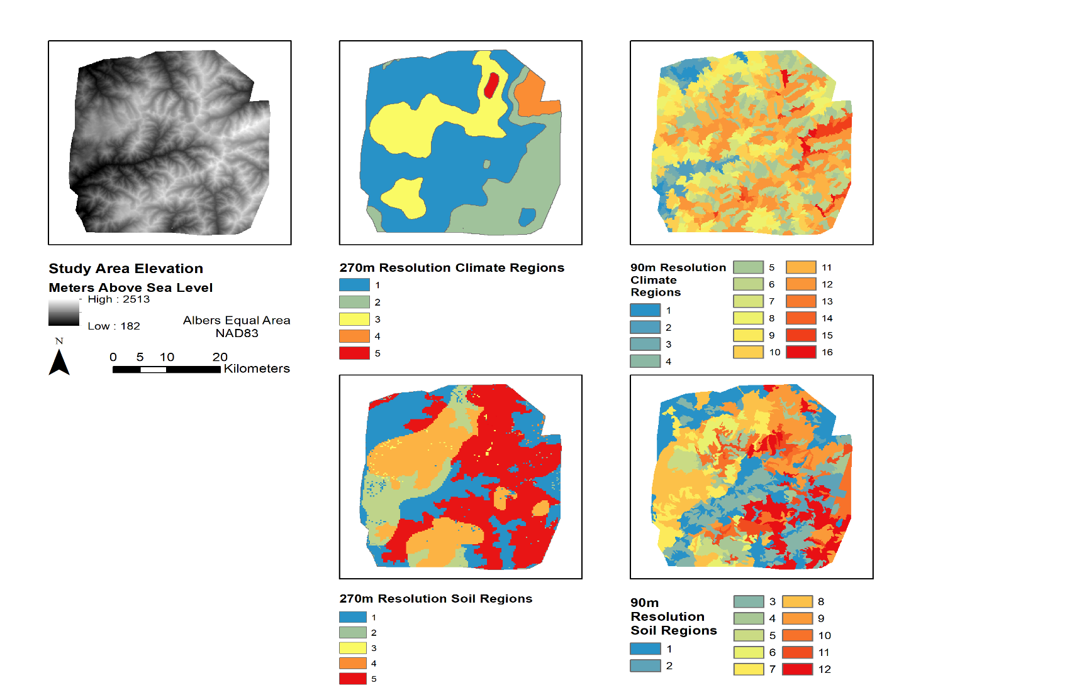

**Figure S4**. Climate projections for the study area, the four projections were chosen to bracket the range of temperature increases and precipitation change. Figure calculated based on mean values across entire period (1950-2010 for Maurer, 2010-2100 for projections). In the manuscript, warmer refers to MIROC5 rcp 2.6 (+1°C over contemporary climate) and CNRM rcp 4.5 (+2°C). Hotter refers to ACCESS rcp 8.5 and CanESM rcp 8.5 (+2.5°C and +3°C, respectively). Wetter refers to the 10-14% increase in average daily precipitation over Contemporary found with CNRM and CanESM. Drier refers to the 5% reduction in precipitation.

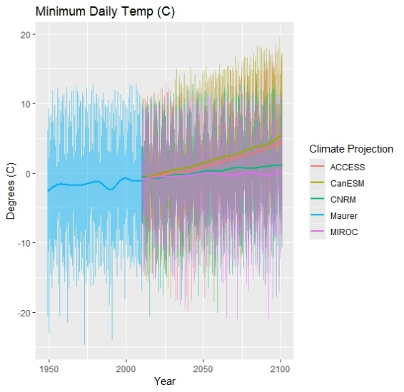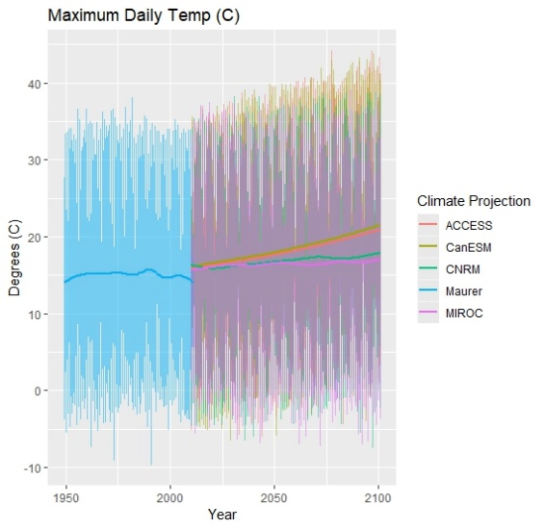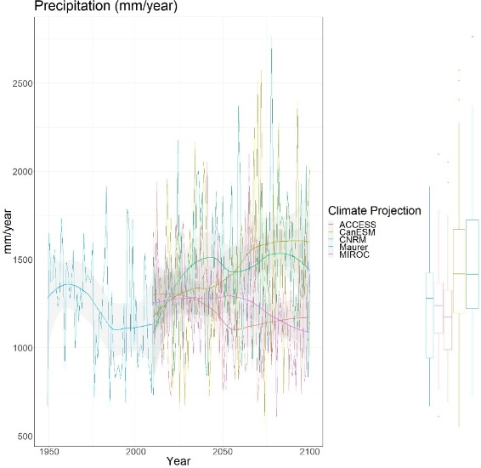

**Figure S5.** Measured versus modeled distribution of fire size by percentiles. All available years (1984-2015) for MTBS were used. Years 1985-2017 were used from the CalFire data

**Figure S6.** Calculated fire rotation period, averaged across model replicates by climate projection

**Figure S7.** Correlation of matrix of potential predictor variables at the ecoregion level for regression. Precipitation (Precip), Mean annual max temperature (Max_temp), Mean ecoregion elevation (MEAN_elev), Majority aspect of ecoregion (MAJ_asp), and Available water capacity (soil_moisture_range) were the final variables chosen. Darker blue means increasing positive correlation, red means increasing negative correlation, and the cross indicates correlation not significant at the 95% level

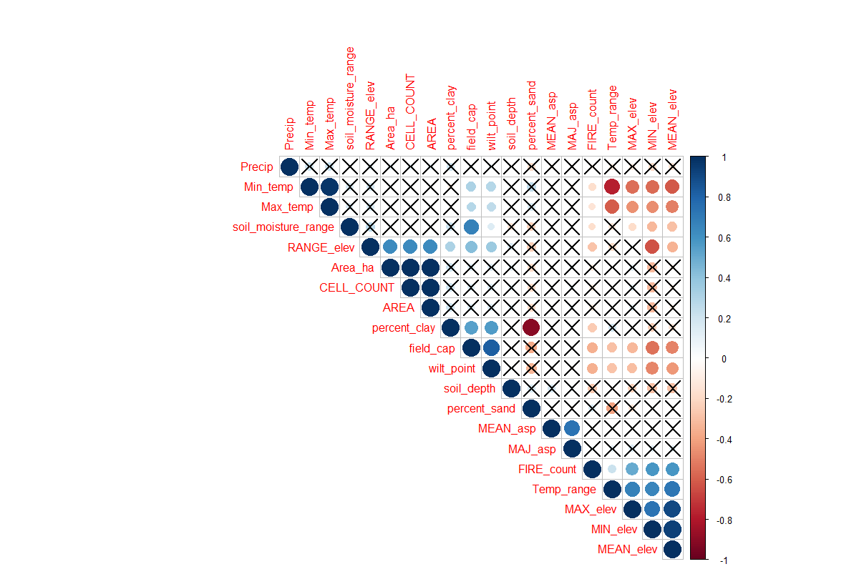

**Figure S8.** a) Average annual probability of establishment per species-age cohort. b) Area occupied by age group (in hectares) for all species through time. Old age group includes trees over 200 years old. Regen age group includes trees between 0 and 20 years old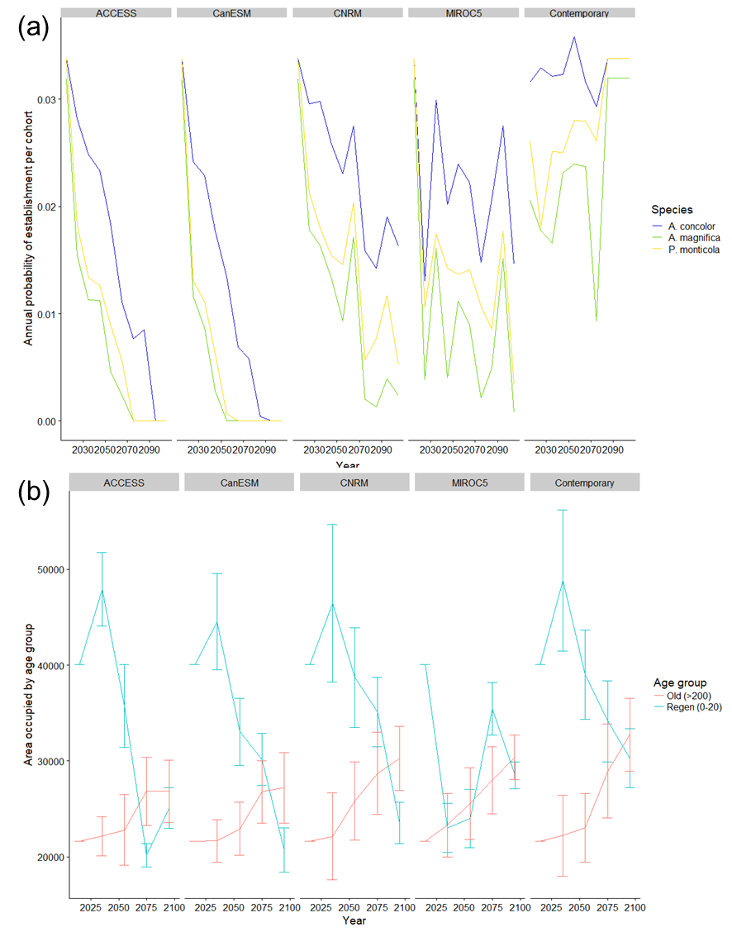

**Figure S9.** Sensitivity to percent area occupied by the three species on tripling the distance of effective and maximum seed dispersal distance within the model. BAU indicates the current parameterized distance. EXT indicates a tripling of distance, where effective seed distance is 90m, and maximum distance is >1500m. Only two replicates of the model were run for the extended dispersal distance

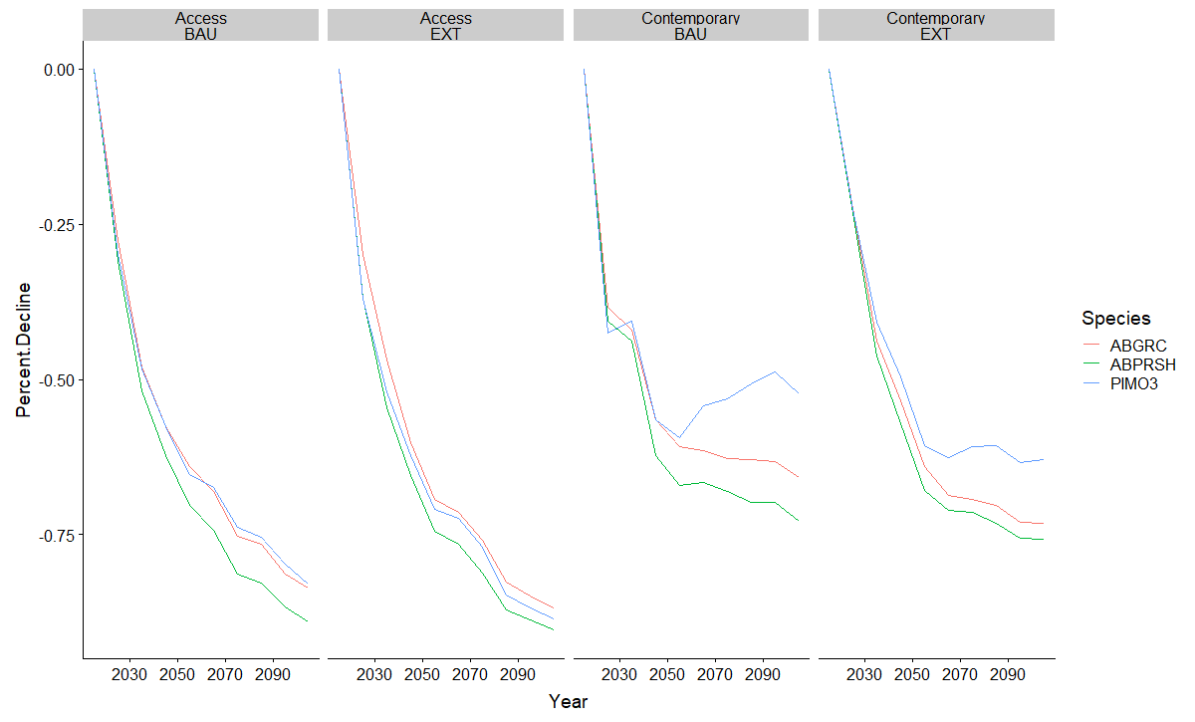

**Figure S10.** Area occupied by species by resolution for all climate projections.

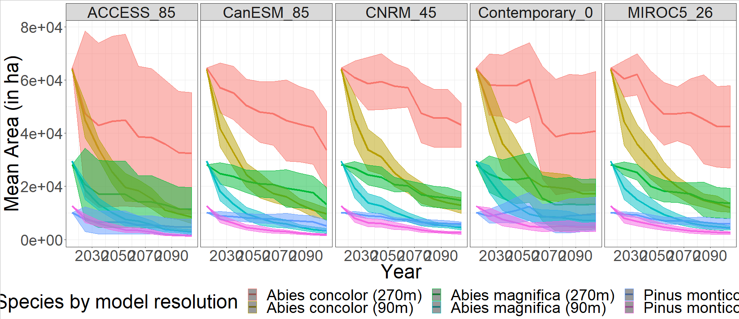

**Figure S11.** Diagnostic plots of Bayesian spatial probit regression. (a) Contains the trace plots for all variables. (b) Contains the autocorrelation function for the draws along the Markov chain. (c) Contains the posterior distribution of variables

**(a) 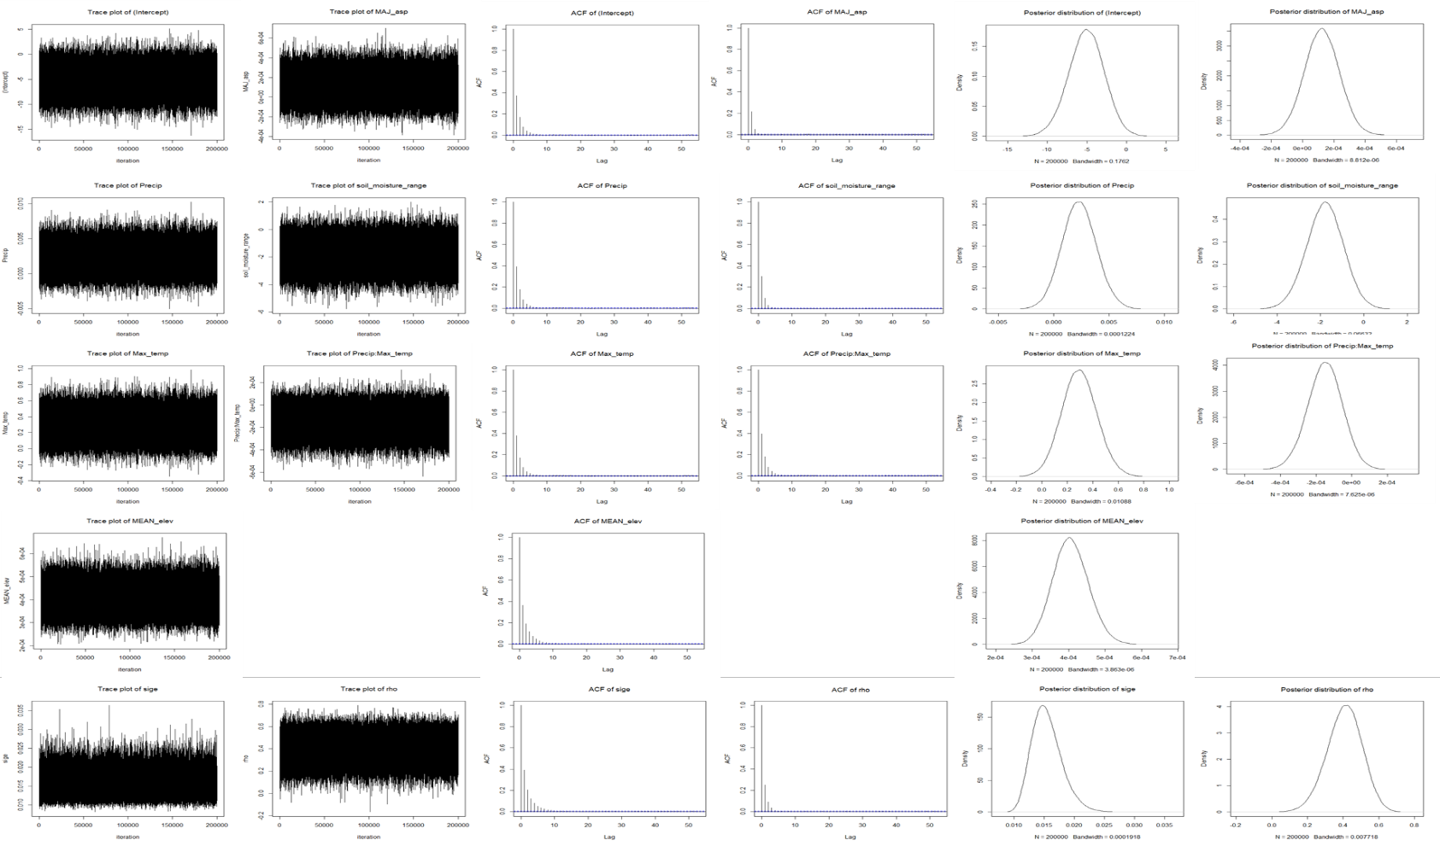(b) 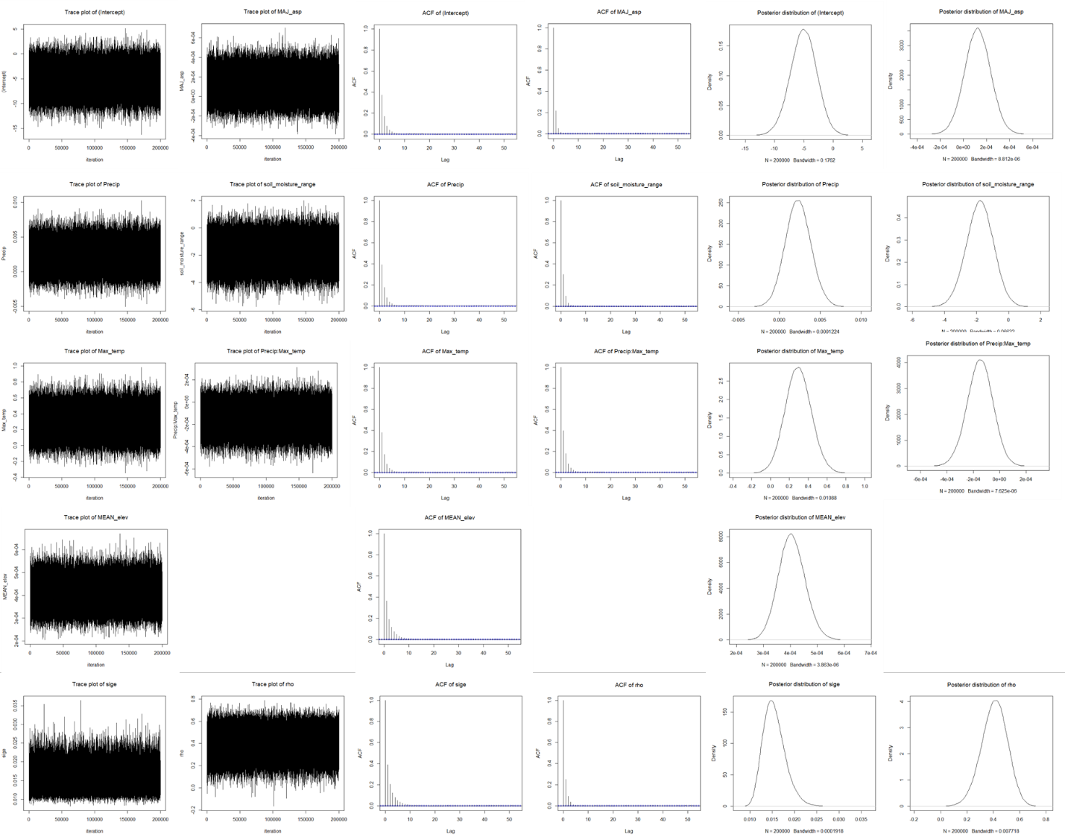(c)** 

## **References:**

Balster NJ, Marshall JD (2000) Decreased needle longevity of fertilized Douglas-fir and grand fir in the northern Rockies. *Tree Physiology,* **20**, 1191-1197.

Beach EW, Halpern CB (2001) Controls on conifer regeneration in managed riparian forests: effects of seed source, substrate, and vegetation. *Canadian Journal of Forest Research,* **31**, 471-482.

Bonner FT, Karrfalt RT (2008) *The Woody Plant Seed Manual. Agriculture Handbook 727*, U.S. Department of Agriculture, Forest Service.

Burns RM, Honkala BH (1990) Silvics of North America: 1. Conifers; 2. Hardwoods. Agriculture Handbook 654. Washington, D.C., U.S. Department of Agriculture, Forest Service. 877 p.

Chen H, Harmon ME, Griffiths RP (2001) Decomposition and nitrogen release from decomposing woody roots in coniferous forests of the Pacific Northwest: a chronosequence approach. *Canadian Journal of Forest Research,* **31**, 246-260.

Chen H, Harmon ME, Sexton J, Fasth B (2002) Fine-root decomposition and N dynamics in coniferous forests of the Pacific Northwest, USA. *Canadian Journal of Forest Research,* **32**, 320-331.

Cross A, Perakis SS (2011) Tree species and soil nutrient profiles in old-growth forests of the Oregon Coast Range. *Canadian Journal of Forest Research,* **41**, 195-210.

Dale VH, Hemstrom M, Franklin J (1986) Modeling the long-term effects of disturbances on forest succession, Olympic Peninsula, Washington. *Canadian Journal of Forest Research,* **16**, 56-67.

Debell DS, Radwan MA (1984) Foliar Chemical Concentrations in Red Alder Stands of Various Ages. *Plant and Soil,* **77**, 391-394.

Edmonds RL (1980) Litter Decomposition and Nutrient Release in Douglas-Fir, Red Alder, Western Hemlock, and Pacific Silver Fir Ecosystems in Western Washington. *Canadian Journal of Forest Research,* **10**, 327-337.

Entry J, Martin N, Kelsey R, Cromack Jr K (1992) Chemical constituents in root bark of five species of western conifer saplings and infection by Armillaria ostoyae. *Phytopathology,* **82**, 393-397.

Harlow BA, Duursma RA, Marshall JD (2005) Leaf longevity of western red cedar (Thuja plicata) increases with depth in the canopy. *Tree Physiology,* **25**, 557-562.

Hudiburg TW, Law BE, Thornton PE (2013) Evaluation and improvement of the Community Land Model (CLM4) in Oregon forests. *Biogeosciences,* **10**, 453-470.

Innes RJ (2013) Fire Effects Information System. U.S. Department of Agriculture, Forest Service, Rocky Mountain Research Station, Fire Sciences Laboratory (Producer). Available at: http://www.fs.fed.us/database/feis.

Law BE, Turner D, Campbell J, Sun OJ, Van Tuyl S, Ritts WD, Cohen WB (2004) Disturbance and climate effects on carbon stocks and fluxes across western Oregon USA. *Global Change Biology,* **10**, 1429-1444.

Lewis H (1950) The significant chemical components of Western Hemlock. Douglas Fir, Western Red Cedar, Loblolly Pine and Black Spruce. *Tappi,* **33**, 299-301.

Loudermilk EL, Scheller RM, Weisberg PJ, Yang J, Dilts TE, Karam SL, Skinner C (2013) Carbon dynamics in the future forest: the importance of long-term successional legacy and climate-fire interactions. Global Change Biology, n/a-n/a.

Niemiec SS, Ahrens GR, Willits S, Hibbs DE (1995) Hardwoods of the Pacific Northwest. Corvallis, OR, Forest Research Laboratory, Oregon State University.

Franklin JF, Waring RH (1980) Distinctive features of the northwestern coniferous forest: development, structure, and function. In: *Forests: Fresh perspectives from ecosystem analysis. Proceedings of the 40th Annual Biology Colloquium.* (ed Waring RH) pp 59-85. Corvallis, Oregon, Oregon State University Press.

Hobbie SE, Reich PB, Oleksyn J, Ogdahl M, Zytkowiak R, Hale C, Karolewski P (2006) Tree species effects on decomposition and forest floor dynamics in a common garden. *Ecology,* **87**, 2288-2297.

Hudiburg T, Law B, Turner DP, Campbell J, Donato D, Duane M (2009) Carbon dynamics of Oregon and Northern California forests and potential land-based carbon storage. *Ecological applications*, **19**, 163–180.

Keenan RJ, Prescott CE, Kimmins JP, Pastor J, Dewey B (1996) Litter decomposition in western red cedar and western hemlock forests on northern Vancouver Island, British Columbia. *Canadian Journal of Botany,* **74**, 1626-1634.

Northeastern Ecosystem Research Cooperative (NERC) foliar chemistry database (2013) USDA Forest Service Northeastern Research Station and University of New Hampshire Complex Systems Research Center. Available online at http://www.folchem.sr.unh.edu.

Parton WJ, Anderson DW, Cole CV, Steward JWB (1983) Simulation of soil organic matter formation and mineralization in semiarid agroecosystems. Special Publication No. 23. In: *Nutrient cycling in agricultural ecosystems.* (eds Lowrance RR, Todd RL, Asmussen LE, Leonard RA). Athens, Georgia, The University of Georgia, College of Agriculture Experiment Stations.

Pardo LH, Robin-Abbott M, Duarte N, Miller EK (2005) *Tree chemistry database (version 1.0). Gen. Tech. Rep. NE-324,* Newtown Square PA, U.S. Department of Agriculture, Forest Service, Northeastern Research Station.

Perakis S, Maguire D, Bullen T, Cromack K, Waring R, Boyle J (2006) Coupled nitrogen and calcium cycles in forests of the Oregon Coast Range. *Ecosystems,* **9**, 63-74.

Pierce LL, Running SW, Walker J (1994) Regional-scale relationships of leaf area index to specific leaf area and leaf nitrogen content. *Ecological Applications,* **4**, 313-321.

Prescott CE, Chappell HN, Vesterdal L (2000) Nitrogen turnover in forest floors of coastal Douglas-fir at sites differing in soil nitrogen capital. *Ecology,* **81**, 1878-1886.

Prescott CE, Preston CM (1994) Nitrogen Mineralization and Decomposition in Forest Floors in Adjacent Plantations of Western Red Cedar, Western Hemlock, and Douglas-Fir. *Canadian Journal of Forest Research,* **24**, 2424-2431.

Scheller RM, Hua D, Bolstad PV, Birdsey RA, Mladenoff DJ (2011) The effects of forest harvest intensity in combination with wind disturbance on carbon dynamics in Lake States mesic forests. *Ecologisilvical Modelling,* **222**, 144-153.

Schowalter TD, Morrell JJ (2002) Nutritional quality of Douglas-fir wood: Effect of vertical and horizontal position on nutrient levels. *Wood and Fiber Science,* **34**, 158-164.

Scott EE, Perakis SS, Hibbs DE (2008) delta N-15 patterns of Douglas-fir and red alder riparian forests in the Oregon coast range. *Forest Science,* **54**, 140-147.

Thomas KD, Prescott CE (2000) Nitrogen availability in forest floors of three tree species on the same site: the role of litter quality. *Canadian Journal of Forest Research,* **30**, 1698-1706.

Thompson RS, Anderson KH, Bartlein PJ (2000a) Atlas of relations between climatic parameters and distributions of important trees and shrubs in North America. In: *U S Geological Survey professional paper 1650 A-B.* Denver, CO, U.S. Department of the Interior, U.S. Geological Survey.

Thompson RS, Anderson KH, Bartlein PJ, Smith SA (2000b) Atlas of relations between climatic parameters and distributions of important trees and shrubs in North America - Additional Conifers, Hardwoods, and Monocots. In: *U S Geological Survey professional paper 1650C.* Denver, CO, U.S. Department of the Interior, U.S. Geological Survey.

Torregrosa A, Combs C, Peters J (2016) GOES-derived fog and low cloud indices for coastal north and central California ecological analyses: COASTAL FLC FREQUENCY. Earth and Space Science, 3, 46–67.

Tree Species Compendium. Available online at http://www.for.gov.bc.ca/hfp/silviculture/Compendium/.

Valachovic YS, Caldwell BA, Cromack K, Griffiths RP (2004) Leaf litter chemistry controls on decomposition of Pacific Northwest trees and woody shrubs. *Canadian Journal of Forest Research,* **34**, 2131-2147.

Yang Y, Luo Y (2011) Carbon : nitrogen stoichiometry in forest ecosystems during stand development. *Global Ecology and Biogeography,* **20**, 354-361.