Supplementary Material

## Supplementary Figure

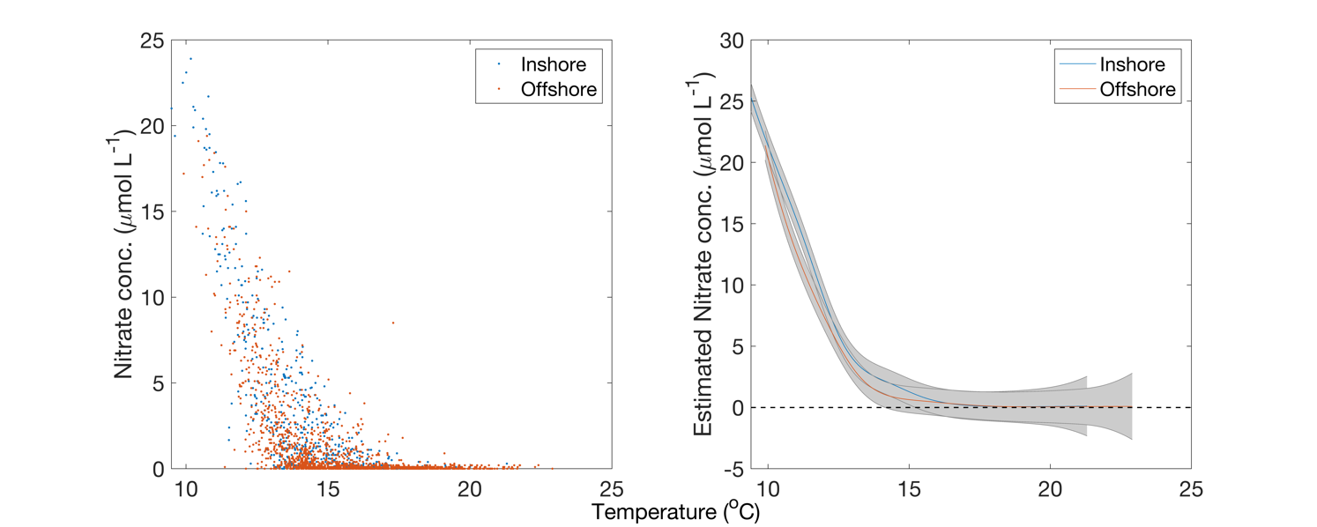

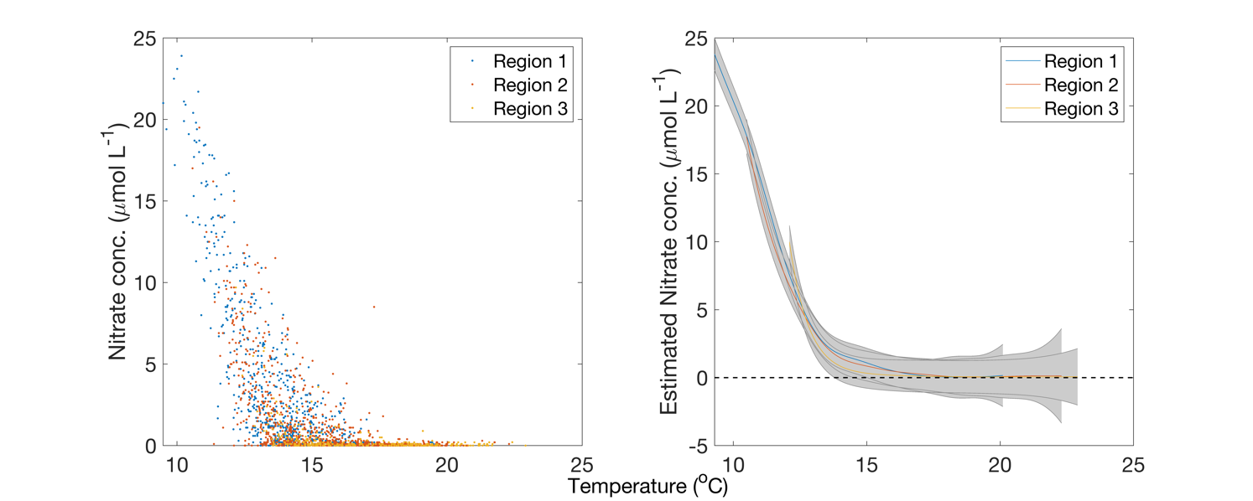

Supplementary Figure . Left column: Temperature and nitrate measurements separated by inshore/offshore in the Southern California Bight (top) and northern, central, and southern regions in the Santa Barbara Channel (bottom). Right column: Generalized Additive Model for temperature to nitrate relationships. Grey bars are the standard error.