Supplementary Material

Table S1 differentially expressed pathways on all the datasets
Entry | Name
hsa00020  hsa00062  hsa00190  hsa00310  hsa00531  hsa00670  hsa00730  hsa00860  hsa04012  hsa04340  hsa04390  hsa04540  hsa04657  hsa04920  hsa04931  hsa05012  hsa05140  hsa05164 | Citrate cycle (TCA cycle)
 | Fatty acid elongation
 | Oxidative phosphorylation
 | Lysine degradation
 | Glycosaminoglycan degradation
 | One carbon pool by folate
 | Thiamine metabolism
 | Porphyrin and chlorophyll metabolism
 | ErbB signaling pathway
 | Hedgehog signaling pathway
 | Hippo signaling pathway
 | Gap junction
 | IL-17 signaling pathway
 | Adipocytokine signaling pathway
 | Insulin resistance
 | Parkinson disease
 | Leishmaniasis
 | Influenza A
hsa05169 | Epstein-Barr virus infection

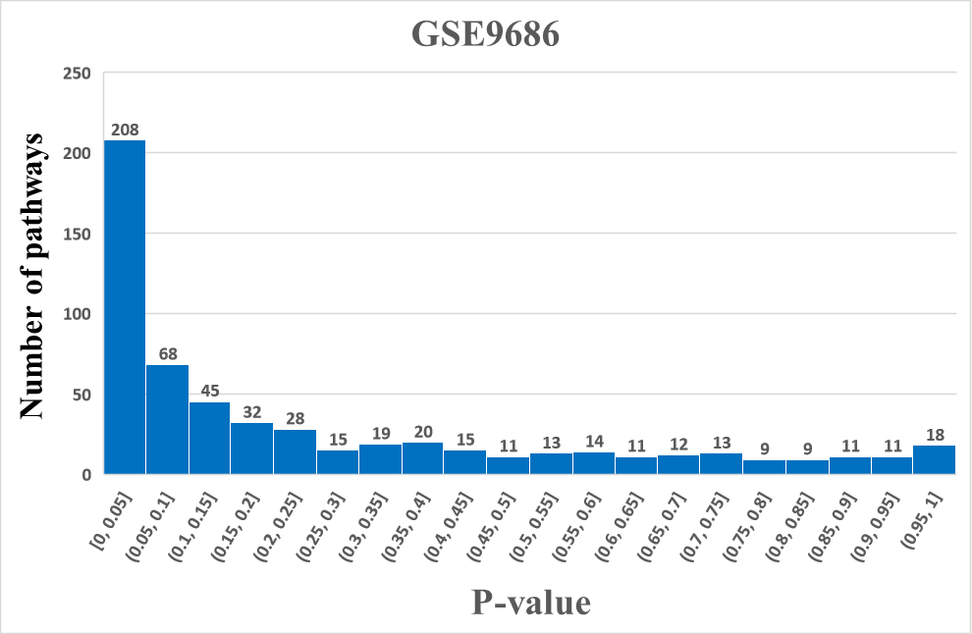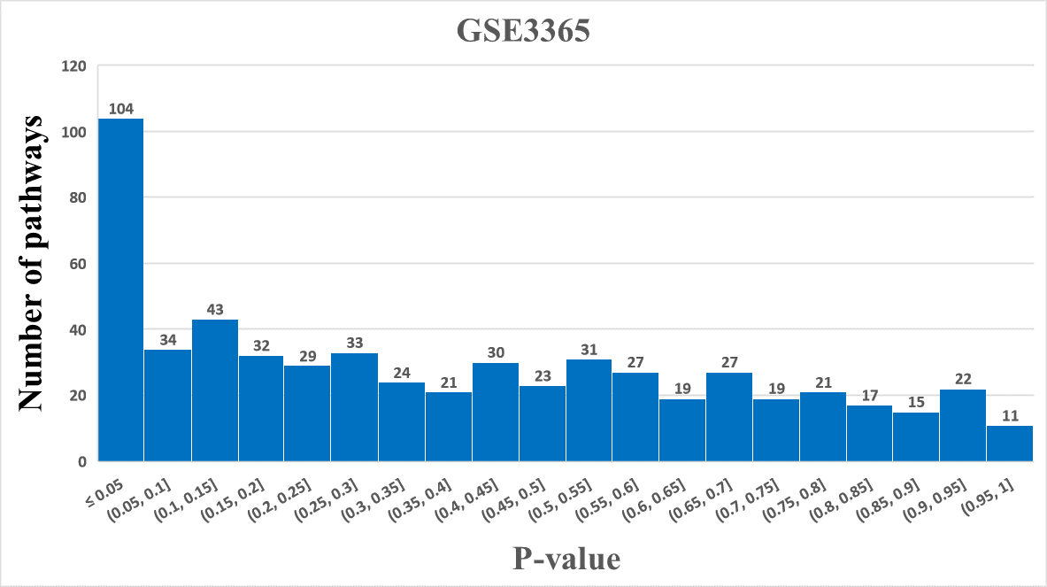

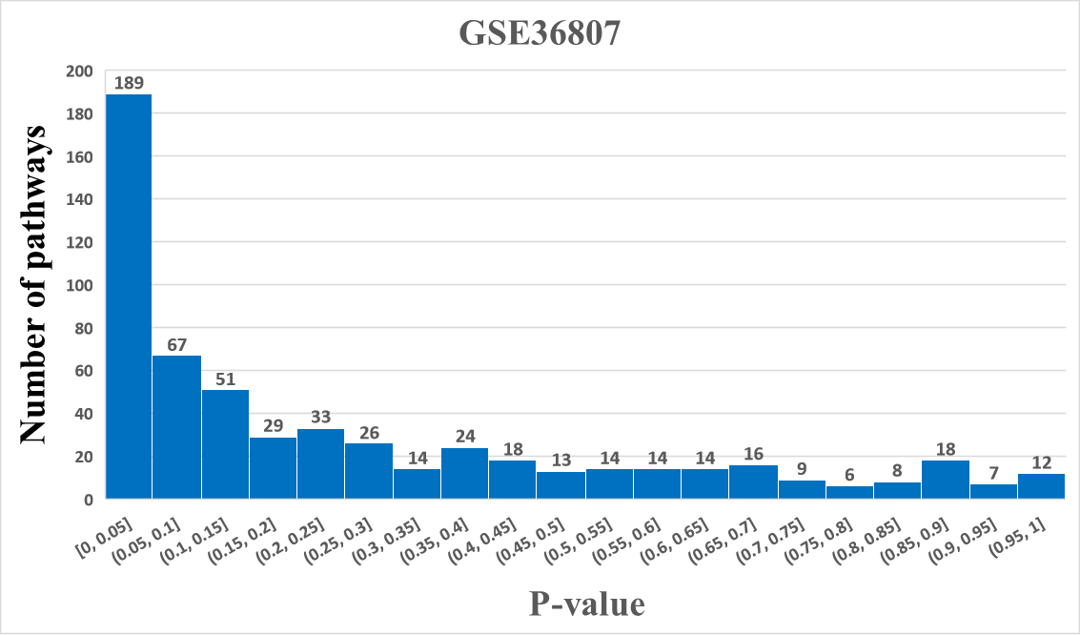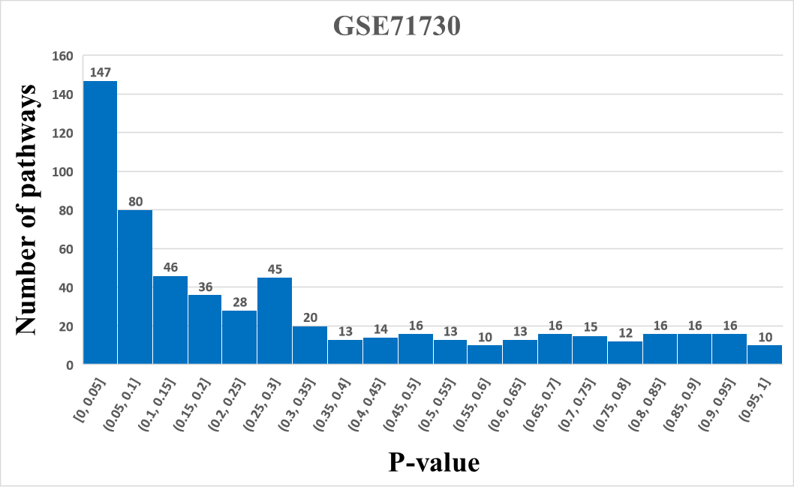
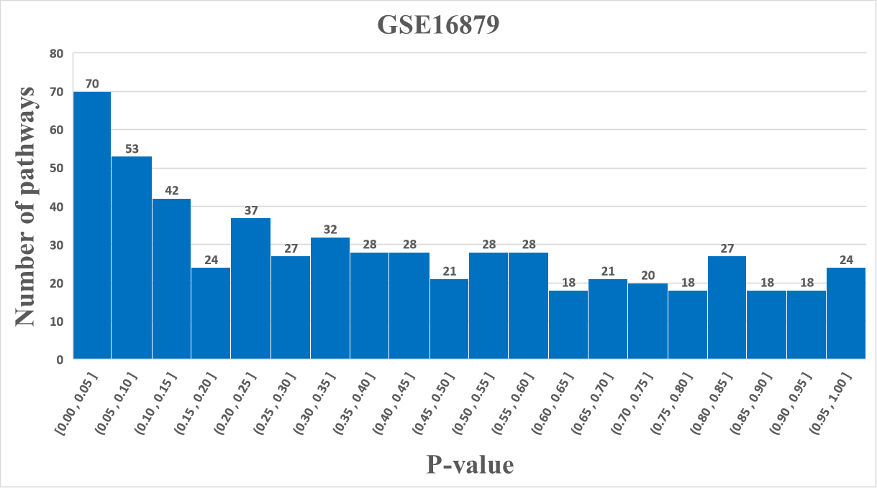
Fig. S1 Quantitative distribution of p-value of differential expression pathways based on the PASS in the five datasets. The interval is set to 0.05, and the P-value is mostly less than 0.05 in the five datasets.
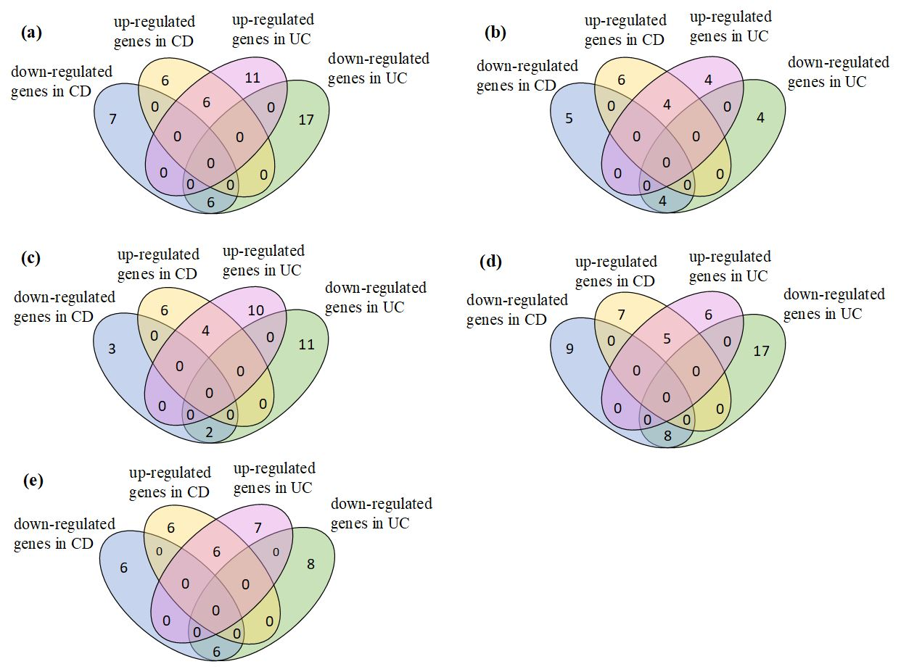
Fig. S2 Expression of genes in Oxidative phosphorylation pathway. (a)GSE9686, (b)GSE3365, (c)GSE36807, (d)GSE71730, (e)GSE16879.
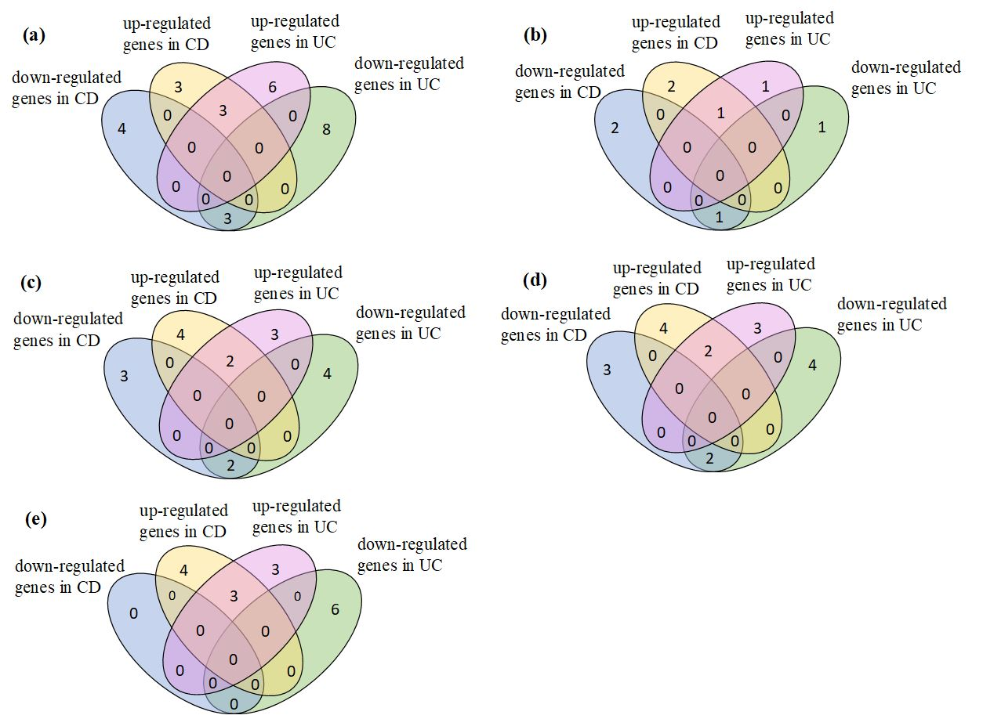
Fig. S3 Expression of genes in Glycosaminoglycan degradation pathway. (a)GSE9686, (b)GSE3365, (c)GSE36807, (d)GSE71730, (e)GSE16879.
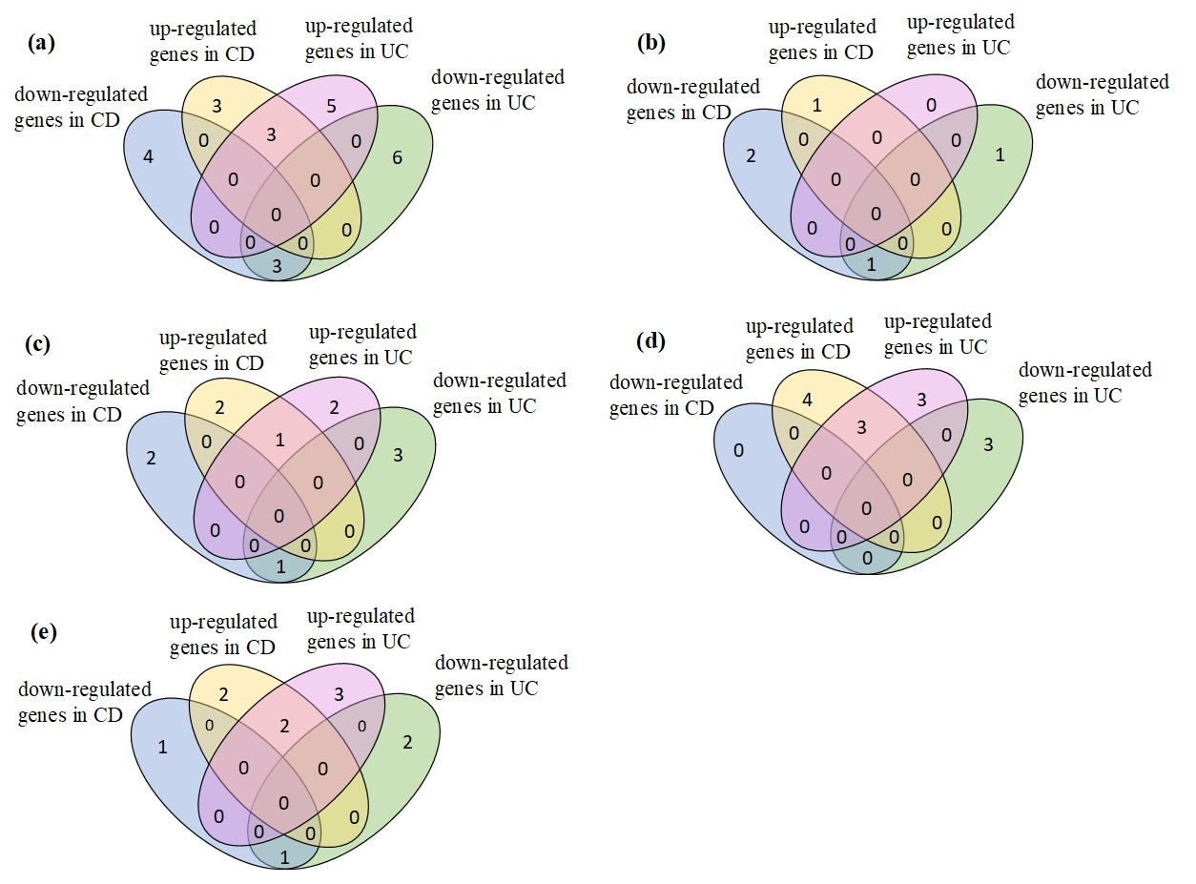
Fig. S4 Expression of genes in Thiamine metabolism pathway. (a)GSE9686, (b)GSE3365, (c)GSE36807, (d)GSE71730, (e)GSE16879.
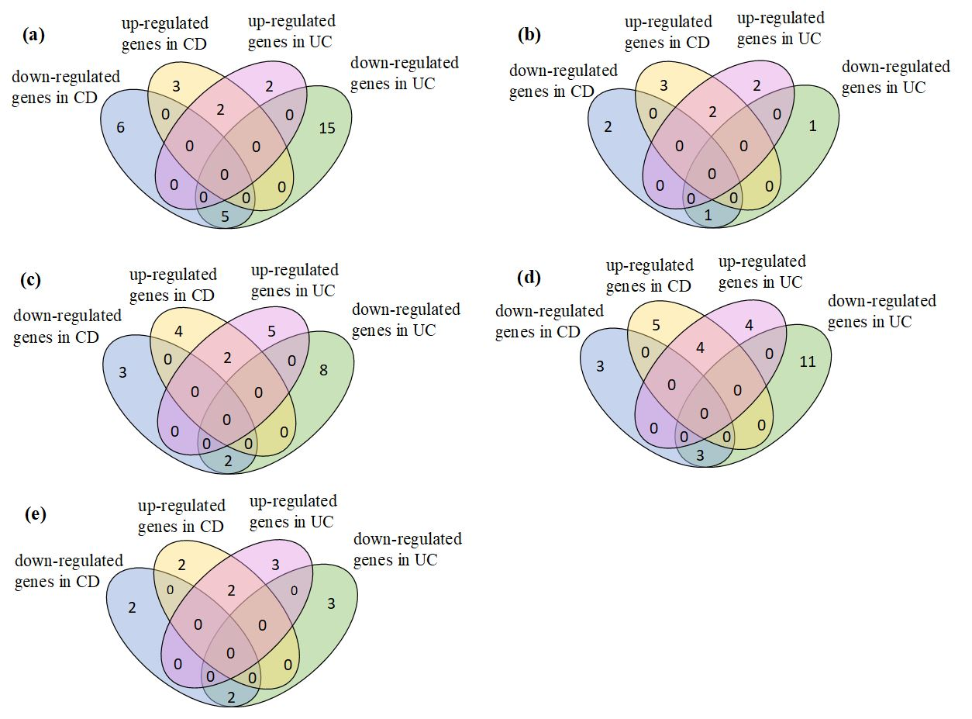
Fig. S5 Expression of genes in Porphyrin and chlorophyll metabolism pathway. (a)GSE9686, (b)GSE3365, (c)GSE36807, (d)GSE71730, (e)GSE16879.
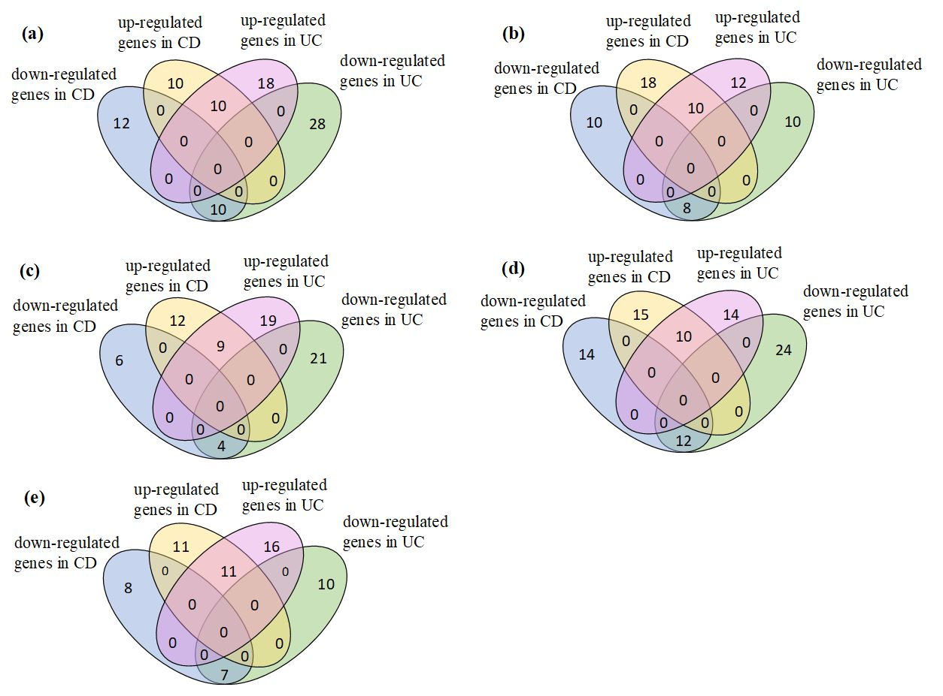
Fig. S6 Expression of genes in ErbB signaling pathway. (a)GSE9686, (b)GSE3365, (c)GSE36807, (d)GSE71730, (e)GSE16879.
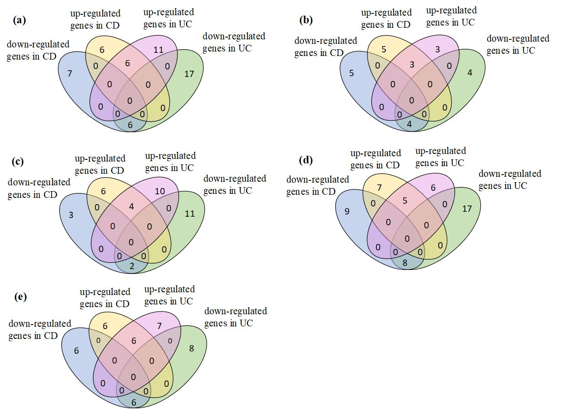
Fig. S7 Expression of genes in Hedgehog signaling pathway. (a)GSE9686, (b)GSE3365, (c)GSE36807, (d)GSE71730, (e)GSE16879.
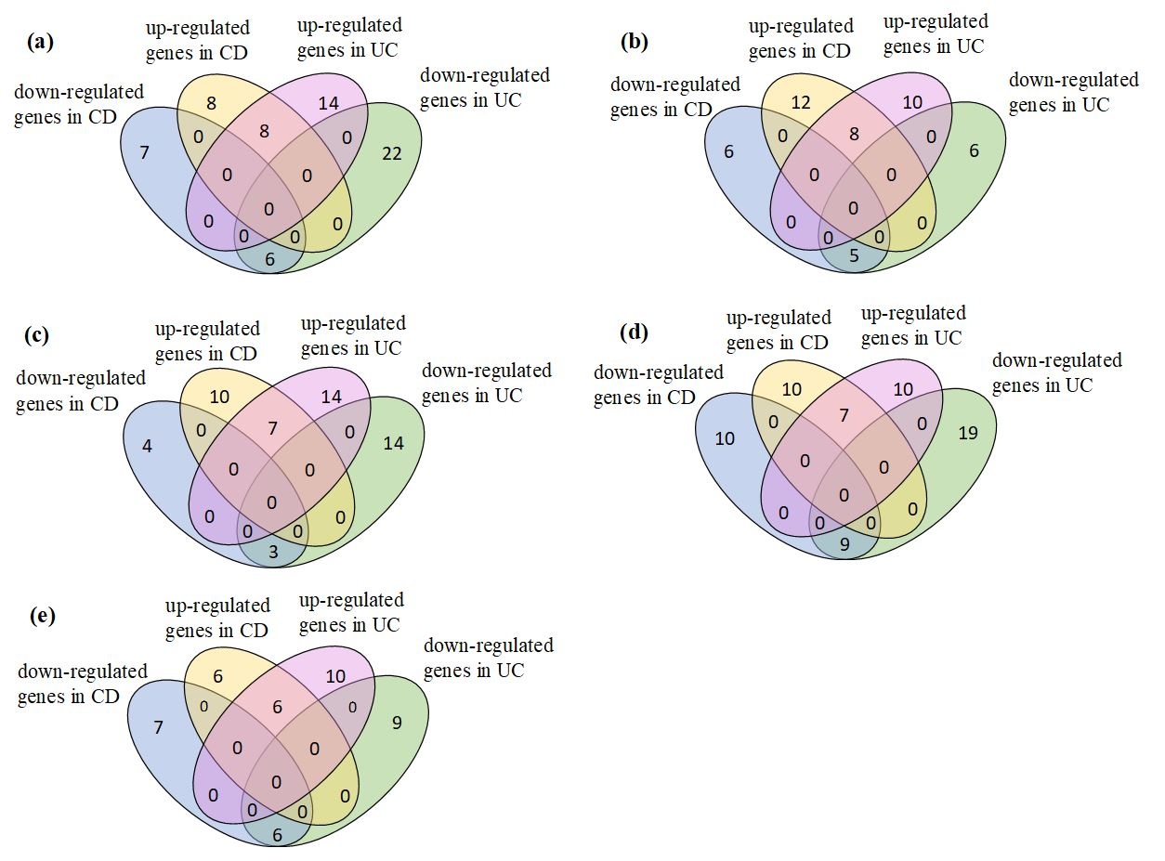
Fig. S8 Expression of genes in Adipocytokine signaling pathway. (a)GSE9686, (b)GSE3365, (c)GSE36807, (d)GSE71730, (e)GSE16879.
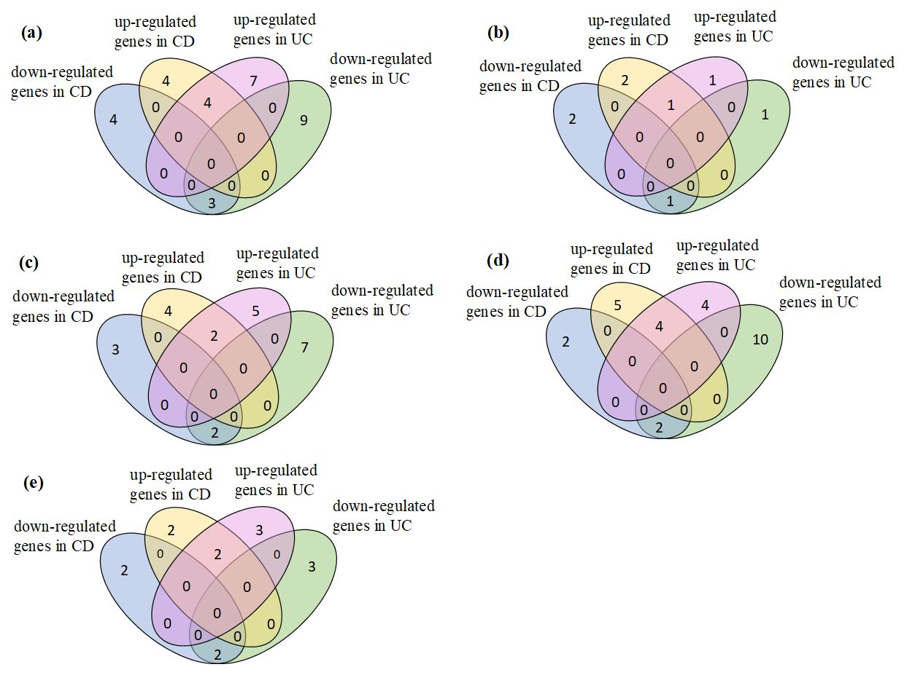
Fig. S9 Expression of genes in Fatty acid elongation pathway. (a)GSE9686, (b)GSE3365, (c)GSE36807, (d)GSE71730, (e)GSE16879.
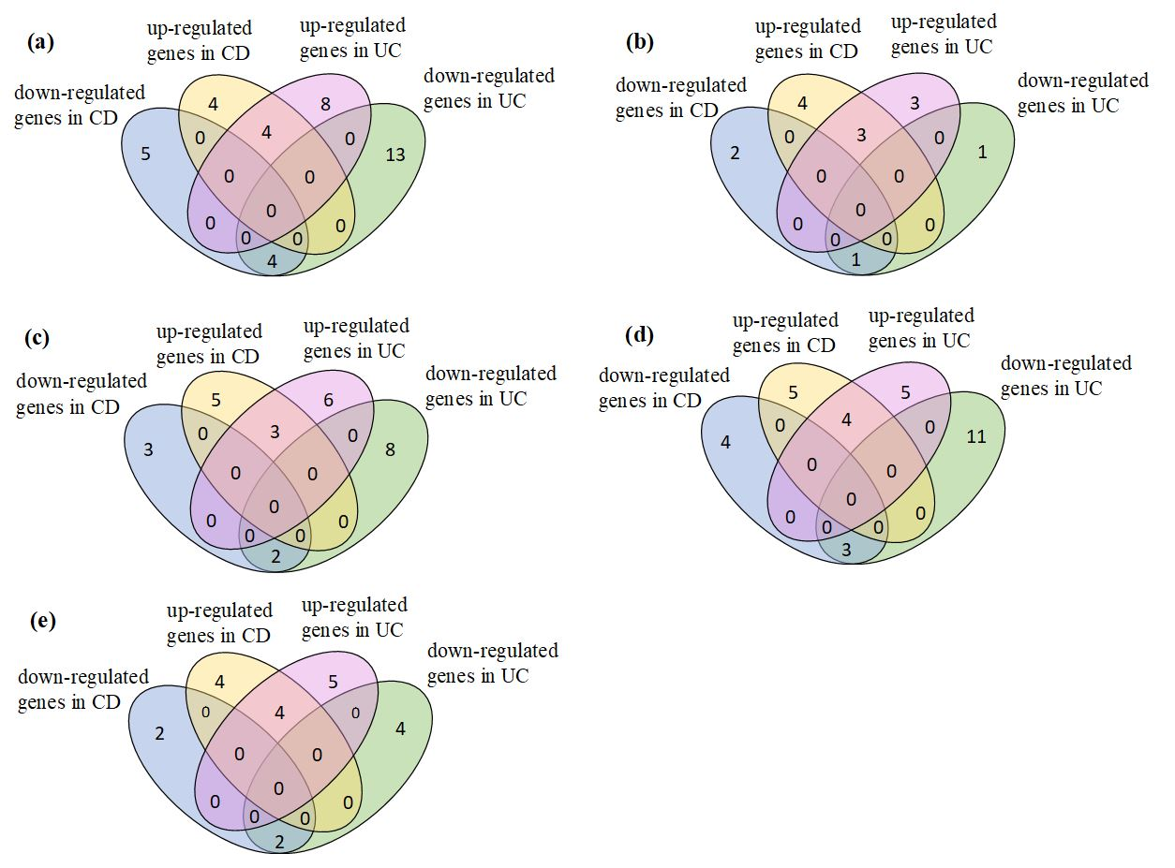
Fig. S10 Expression of genes in Citrate cycle (TCA cycle) pathway. (a)GSE9686, (b)GSE3365, (c)GSE36807, (d)GSE71730, (e)GSE16879.

