**Supplementary materials**

**Table S1** Comparison of PBPK model prediction and clinical pharmacokinetic parameters of imatinib in an interaction study with ritonavir in adult patients a)

|  |  |  |  |  |  |  |  |  |  |
| --- | --- | --- | --- | --- | --- | --- | --- | --- | --- |
|  | **Css,max (mg/L)** | | | **AUC24 (mg.h/L)** | | | **CL/F (L/h)** | | |
| **Imatinib alone** | **With ritonavir** | **Ratio** | **Imatinib alone** | **With ritonavir** | **Ratio** | **Imatinib alone** | **With ritonavir** | **Ratio** |
| **Clinically-observed values** | 2.9  (2.3 - 3.7) | 2.5  (1.9 - 3.2) | 0.86 | 42.6  (33.0 - 54.9) | 41.2  (32.1 - 53.1) | 0.97 | 9.4  (7.3 - 12.1) | 9.7  (7.5 - 12.5) | 1.03 |
| **PBPK model predicted values** | | | | | | | | | |
| Without an MBI of CYP3A4 nor compensatory clearance in the PBPK model of imatinib | | | | | | | | | |
| PBPK prediction | 2.5 | 4.3 | 1.72 | 34.6 | 75.2 | 2.17 | 11.6 | 5.3 | 0.46 |
| **Prediction fold-difference** b) | 0.86 | 1.72 | 2.00 | 0.81 | 1.83 | 2.24 | 1.23 | 0.55 | 0.45 |
| Incorporating an MBI of CYP3A4, but not a compensatory clearance in the PBPK model of imatinib | | | | | | | | | |
| PBPK prediction | 3.6 | 4.0 | 1.11 | 56.2 | 65.0 | 1.16 | 7.1 | 6.2 | 0.87 |
| **Prediction fold-difference** | 1.24 | 1.60 | 1.29 | 1.32 | 1.58 | 1.20 | 0.76 | 0.64 | 0.84 |
| Incorporating both MBI of CYP3A4 and compensatory clearance in the PBPK model of imatinib | | | | | | | | | |
| PBPK prediction | 2.7 | 2.9 | 1.07 | 37.7 | 42.3 | 1.12 | 10.6 | 9.5 | 0.89 |
| **Prediction fold-difference** | **0.93** | **1.16** | **1.24** | **0.88** | **1.03** | **1.15** | **1.13** | **0.98** | **0.86** |

AUC24, area under the plasma concentration-time curve during 24 h after dose; CL/F, apparent clearance; Css,max, peak plasma concentration at steady-state; CYP, cytochrome P450 enzyme; MBI, mechanism-based inhibition.

a) A clinical interaction study in patients with gastrointestinal stromal tumours (GIST; 5 male, 6 female; age 51 – 79 years) receiving 400 mg daily dose of imatinib for at least 2 months. Ritonavir (600 mg/d) was given concomitantly with imatinib for 3 d (van Erp et al., 2007).

b) Prediction-fold differences were expressed as the ratio of PBPK model prediction to clinically-observed values.

**Table S2** PBPK model predictions and clinically-observed pharmacokinetic parameters of carbamazepine and its active metabolite in the presence and absence of CYP2C8 induction

|  |  |  |  |  |  |
| --- | --- | --- | --- | --- | --- |
| **Parameter** | **Clinically-observed values** | **Without CYP2C8 induction** | | **Accounting for CYP2C8 induction** | |
| **PBPK model prediction a)** | **Prediction fold-difference** | **PBPK model prediction** | **Prediction fold-difference** |
| Carbamazepine (300 mg bid) at steady-state (Carlsson et al., 2005) | | | | | |
| **Carbamazepine** | | | | | |
| CL/F (L/h) | 3.6 b) | 3.2 | **0.89** | 3.8 | **1.06** |
| CV of CL/F (%) | 52 c) | 53 |  | 54 |  |
| Carbamazepine (9.5 mg/kg bid) at steady-state (Eeg-Olofsson et al., 1990) | | | | | |
| **Carbamazepine** | | | | | |
| Css,max (µmol/L) | 39.8 ± 10.0 | 45.6 | **1.15** | 40.2 | **1.01** |
| Cmin (µmol/L) | 21.5 ± 5.8 | 26.9 | **1.25** | 19.0 | **0.88** |
| AUC24 (µmol.h/L) | 762.5 ± 163.2 | 870.3 | **1.14** | 742.3 | **0.97** |
| **Carbamazepine-10,11-epoxide** | | | | | |
| Css,max (µmol/L) | 6.0 ± 2.3 | 6.9 | **1.15** | 5.5 | **0.92** |
| Cmin (µmol/L) | 4.0 ± 1.6 | 5.8 | **1.45** | 4.5 | **1.13** |
| AUC24 (µmol.h/L) | 138.0 ± 48.9 | 155.3 | **1.13** | 121.4 | **0.88** |

AUC24, area under the plasma concentration-time curve during 24 h after dose; bid, twice daily; Cmin, trough concentration; Css,max, peak plasma concentration at steady-state; CL/F, apparent clearance; CV, coefficient of variation.

a) Reported as geometric mean values of PBPK model prediction.

b) Typical population value.

c) Based on ω (standard deviation of eta, inter-individual variability) of apparent clearance.

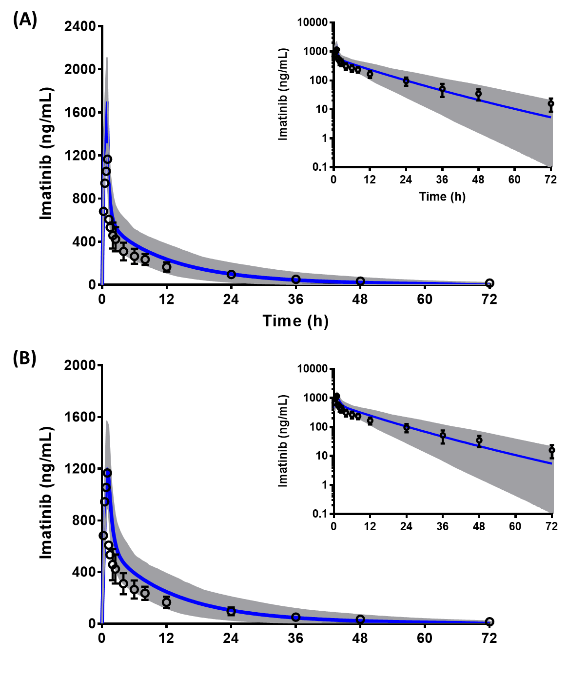

**Figure S1** Clinically-observed concentrations of imatinib (dot: mean, error bar: standard deviation) overlaid with mean (blue line) and 5th to 95th percentiles (grey area) of the PBPK model predicted concentrations using central venous (A) and peripheral sampling site compartments (B). The predictions are depicted in linear scale with the corresponding semi-logarithmic plots as insets. Imatinib was given as a single 1-hour intravenous infusion to healthy people (n = 12, 2 females, aged 40–58 years) (Peng et al., 2004).

**References**

Carlsson, K.C., Hoem, N.O., Glauser, T., and Vinks, A.A. (2005). Development of a population pharmacokinetic model for carbamazepine based on sparse therapeutic monitoring data from pediatric patients with epilepsy. *Clin Ther* 27(5)**,** 618-626.

Eeg-Olofsson, O., Nilsson, H.L., Tonnby, B., Arvidsson, J., Grahn, P.A., Gylje, H., et al. (1990). Diurnal variation of carbamazepine and carbamazepine-10,11-epoxide in plasma and saliva in children with epilepsy: a comparison between conventional and slow-release formulations. *J Child Neurol* 5(2)**,** 159-165.

Peng, B., Dutreix, C., Mehring, G., Hayes, M.J., Ben-Am, M., Seiberling, M., et al. (2004). Absolute bioavailability of imatinib (Glivec) orally versus intravenous infusion. *J Clin Pharmacol* 44(2)**,** 158-162.

van Erp, N.P., Gelderblom, H., Karlsson, M.O., Li, J., Zhao, M., Ouwerkerk, J., et al. (2007). Influence of CYP3A4 inhibition on the steady-state pharmacokinetics of imatinib. *Clin Cancer Res* 13(24)**,** 7394-7400.