Supplementary Material

TEOS modified with nano-calcium oxalate and PDMS to protect concrete based cultural heritage buildings

K. Kapetanaki1, E. Vazgiouraki1, D. Stefanakis1,A. Fotiou1 , G. C. Anyfantis2,   I. García- Lodeiro3, M. T. Blanco-Varela3, I. Arabatzis2 , P. N. Maravelaki1*

1Laboratory of Materials of Cultural Heritage and Modern Building, School of Architecture, Technical University of Crete, Chania, Greece

2 NanoPhos S.A., PO Box 519, Technological and Science Park of Lavrio, 1st km of Lavrio-Athens Ave., Lavrio 19500, Attica, Greece

3[CSIC - Instituto de Ciencias de la Construcción Eduardo Torroja (IETCC)](https://www.scopus.com/affil/profile.uri?afid=60033450), Madrid, Spain

**Correspondence:**Pagona-Noni Maravelaki  
pmaravelaki@isc.tuc.gr

**S.1. Results**

**Table S1.** Chemical composition of CEMI 42.5 (Oxides in wt%) (XRF)

| Oxides | CaO | Al2O3 | SiO2 | SO3 | MgO | Fe2O3 | Na2O | K2O | TiO2 | SrO | Cr2O3 | Cl | ZnO | P2O5 | LOI1 |
| --- | --- | --- | --- | --- | --- | --- | --- | --- | --- | --- | --- | --- | --- | --- | --- |
| Wt % | 62.98 | 5.63 | 18.72 | 3.05 | 0.87 | 2.68 | 0.04 | 0.85 | 0.23 | 0.051 | 0.00 | 0.02 | 0.028 | 0.05 | 2.31 |

1. Loss of ignition 1000 oC

## S1.1 Characterization of the consolidant

**S1.1.1 EDS Analysis**

Qualitative and semiquantitative elemental analysis from individual points on the surface and the bulk of the consolidant was performed by energy dispersive X-ray spectroscopy (EDS) incorporated in the SEM instrument. EDS measurements were carried out in triplicate. The results are presented in Table S2.

Table S2. EDS analysis results

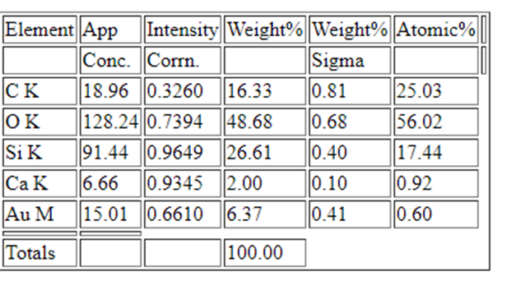

EDS measurements confirmed the existence of calcium and silicon elements, related to CaOx and polymerized TEOS along with PDMS, respectively. The appearance of the characteristic peaks of gold is due to the sputtering process, as this element was used to create a conductive layer.

**S1.1.3 Thermal analysis**

The Thermogravimetry/Differential Thermal Analysis (TG/DTA) curves of FX-C and synthesized CaOx nanoparticles are shown in Fig. S1. Figure S.1a shows the DTA (blue line) and TG curves (black line) of the FX-C xerogel in comparison with the DTA-TG thermogram of the synthesized CaOx nano-particles (Figure S1(b)). Concerning the DTA-TGA curves of CaOx (Figure S1.b), it is observed a weight loss of 13.1% between 30 and 280 oC, due to the evaporation of water. An endothermic peak is present between 280 and 600 oC. It is associated to the transformation of the β-CaC2O4 phase to γ-CaC2O4 and then to CaCO3, according the reaction CaC2O4 🡪 CaCO3+CO. CaOx, exhibited an endothermic peak at temperatures higher than 600 oC. It corresponds to the transformation of CaCO3 to CaO, which is accompanied by the observed weight losses.

The TGA curve of FX-C (Figure S.1a) shows two regions where weight loss is observed, common to silica xerogels (Fina, et al. 2006). FX-C curve displays a 3.05% weight loss between 30 – 280 oC, which is attributed to the loss of water in xerogel, as well as the volatilization of organic constituents, such as ethanol, isopropanol and PDMS. The endothermic peak between 280 and 600 oC is attributed to the decomposition of residual organic components and the decarbonylation of CaOx. A further temperature rise results the transformation of CaCO3 to CaO. The exothermic peak at 900 oC not connected with weight loss, is probably attributed to a phase transformation of the CaOx-silica matrix to a crystalline phase. It is an additional indication of the CaOx incorporation into the FX-C structure.

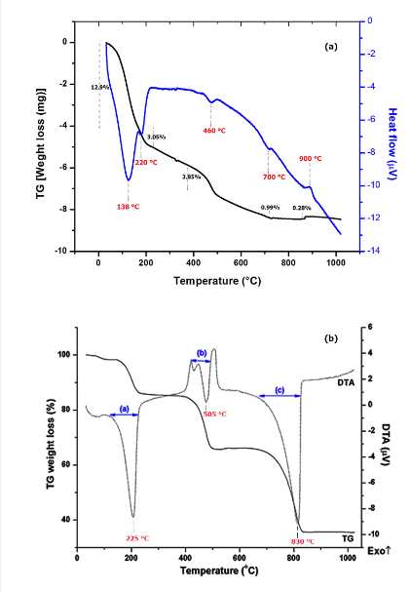

Figure S1. Thermal Analysis: (a) DTA-TG of the xerogel FX-C and (b) the synthesized CaOx

**S1.1.4 DLS Measurements**

The hydrodynamic diameter of FX-C particles has been determined by Dynamic Light Scattering (DLS). Figure S2 has shown the DLS graph, in which an average size of 1.700 nm is observed. This high value of particles size is attributed to the agglomeration of the nanocomposite.

. 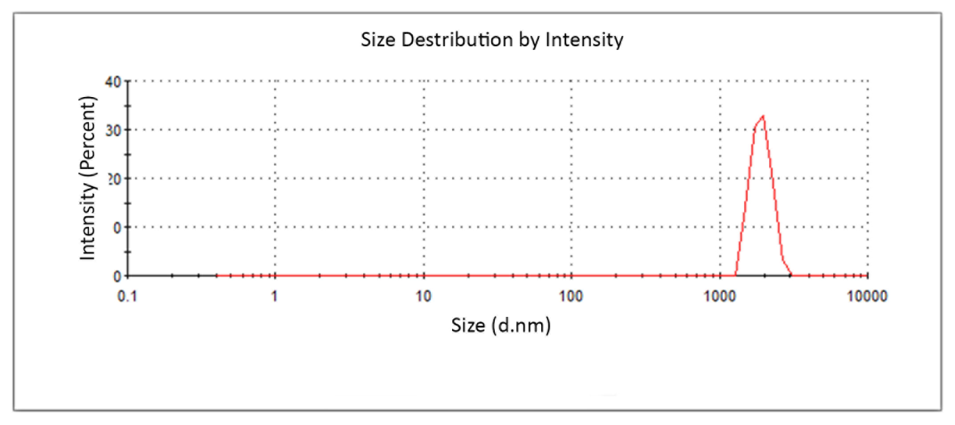

Figure S2. DLS of the FX-C colloidal solution

**S1.2 Evaluation of treatment**

**S1.2.1 Aesthetic parameters**

The differences (before and) of the colorimetric parameters (ΔL*, Δa*, Δb* and ΔΕ*) after consolidation were calculated for all the sample ageing types and are presented on the Table S3.

**Table S3.** Differences of the colorimetric parameters (L*, a* and b*) and the total color variation (ΔΕ*) (±SD) between treated and untreated samples.

|  |  |  |  |  |  |
| --- | --- | --- | --- | --- | --- |
| Sample ageing type | ΔL* | Δa* | Δb* | ΔE* | SD |
| Sound | -1.96 | 0.33 | 1.02 | 3.33 | ±0.32 |
| Freeze-Thaw | -1.49 | 0.21 | 0.75 | 2.55 | ±0.35 |
| Chloride attack | -2.84 | 0.35 | 1.55 | 3.48 | ±0.30 |
| Carbonation | -2.21 | 0.18 | 0.54 | 2.50 | ±0.27 |

All the investigated samples became slightly darker after the treatment, expressed by the decrease of the L* color coordinate. Contrary to this, the a* and b* color parameters increased after the FX-C application meaning that there was a more prominent color component of red and yellow at the samples after the treatment process. Nevertheless, the produced total color differences (ΔΕ*), for all sample ageing types, were insignificant and within the accepted band for the monuments restoration.

**S1.2.2 Water Contact angle quantification**

Water Contact Angle (WCA) measurements were held in all the sample groups treated with FX-C, and the corresponding bar diagram is presented in Fig. S5. WCA tests revealed that FX-C created a hydrophobic layer onto the surface of all the studied group samples, as shown in Figure S3.

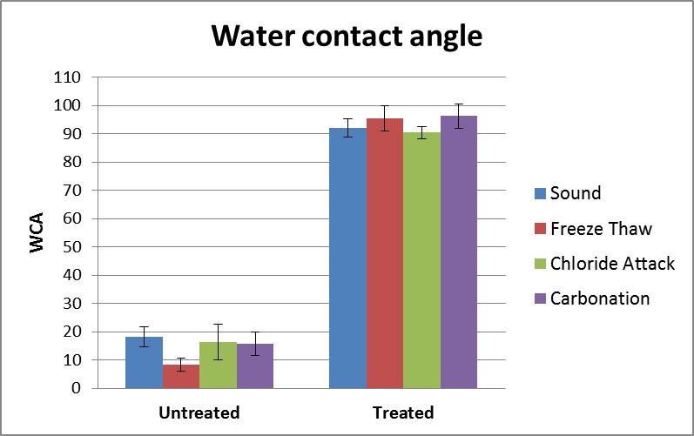

Figure S3. WCA of the treated and untreated sound and aged samples.

**S1.2.3 Penetration depth**

The deconvolution of Si-O-Si band was processed at the FTIR spectra illustrated in Figure 11 of manuscript. As presented in Figure S4 (A), it is clear that the Si-O-Si bands at 1085 cm-1 of FX-C xerogel are properly observed in depths of 0.05, 1.00 and 2.00 cm from the surface of treated sections of samples, in Figures S4 (C), (D) and (E), respectively. On the other hand, as shown in Figure S4 (B) in the untreated sample, the peaks at 985 and 1115 cm-1 attributed to the CSH and quartz, respectively, are predominant.



Figure S4. Deconvolution of Si-O-Si band in spectra of (A) xerogel of FX-C, (B) untreated sample, (C) depth of 0.05 cm, (D) depth of 1 cm and (E) depth of 2 cm.

# Bibliography

Fina, A., D. Tabuani, F. Carniato, A. Frache, and G. Camino. "Polyhedral oligomeric silsequioxanes (POSS) thermal degradation." *Thermochim Acta* 440 (2006): 36-42.