Error estimation in glaciological mass-balance
The error in the mean glacier mass balance, B, includes both measurement and sampling errors. The mass balance at Guanaco glacier has been negative almost everywhere on the glacier for 11 out of the 13 years monitored, and predominantly reflects the ablation of ice. We assume a measurement uncertainty, σ_{b}, of ±0.14 m w.e. for mass-balance at individual stakes, based on repeatability tests made on ablation stakes in ice by Thibert et al. (2008). The sampling error for the mean glacier mass-balance, σ_{samp}, is estimated as:
 | $$σ_{samp}=\frac{σ_{sp}}{\sqrt{n}}$$ | (1)
Where σ_{sp} is the spatial standard deviation of the mass balance and n is the number of stakes (Thibert et al., 2008). $σ_{sp}$ could be estimated from the stake sample data by taking the spatial correlation into account, but instead we follow Thibert et al. (2008) and estimate it from the higher resolution topographic changes over the 1978-2005 period (ΔZ₁₉₇₈₋₂₀₀₈). The number of stakes changed from year to year so that an average of n=12 stakes per year is used to calculate a mean error.$σ_{sp}$ is equal to 0.16 m w.e. and $σ_{samp}$ is equal to 0.05 m w.e. The combined error for the annual glaciological mass balance is thus estimated to be σ_{B =} $\frac{\sqrt{n}}{n}σ_{b}+σ_{samp}$ = ± 0.09 m w.e. The error in the cumulative glaciological mass balance is thus ${\sqrt{n_{years}}σ}_{B}$= ±0.32 m w.e. for the 13 years of measurements.

Absolute accuracy of digital elevation models (DEMs)
Table 1 presents the results for both DEM triangulation using ground control points (GCPs) and validation of elevations over stable terrain using the 2005 Ikonos stereo DEMs as reference. See section 3.3 of main text for details.
Table 1. DEM Triangulation and validation results
Year | 1955 | 1978 | 2005
Calibration
n (GCPs) | 10 | 10 | 1
RMSE X (m) | 1.91 | 0.85 | 0.02
RMSE Y (m) | 1.89 | 0.92 | 0.08
RMSE Z (m) | 4.55 | 2.82 | 0.15
Validation
N | 1879¹ | 9013¹ | 42²
Bias Z (m)³ | 0.09 | 0.01 | -0.42
Std Z (m)³ | 3.40 | 1.03 | 1.19
¹ From comparison with 2005 DEM on stable areas
² From comparison with DGPS points
³ After trend removal, see methods

Uncertainty analysis for Geodetic balance
The uncertainty on the spatially integrated geodetic balance follows Rolstad et al (2009). The standard error σ_{ΔZ} of the elevation difference over bedrock ΔZ is defined as the standard deviation of the measured differences of two DEMs and provides an estimate of the uncertainty at the individual pixel scale. In order to estimate the spatially integrated uncertainty,$σ_{S}^{2}$, the spatial correlation of errors must be considered. $σ_{S}^{2}$ will vary between σ_{ΔZ} for fully correlated errors, and σ_{ΔZ}√N/N for fully independent errors, where N is the number of ΔZ values (number of pixels on a grid) averaged to obtain the geodetic balance. The steps used to estimate the uncertainty in the spatially averaged ΔZ are as follows (Rolstad et al., 2009; Zemp et al., 2013):
- The elevation difference grid over bedrock region is calculated.
- The grid is detrended using a first order polynomial. The computed trend surface is further subtracted from the elevation difference over the glacier to remove the bias (Figure 1, Figure 2).
- The spatial autocorrelation of the residuals (errors) over bedrock is estimated from the empirical semivariogram. A spherical function is fitted to the semivariagram and the parameters of nugget c₀, partial sill c₁ and range a₁ are derived (Figure 3, Figure 4).
- If the correlation range a₁ is greater than the representative radius L of the averaging area S=πL², then the uncertainty of the spatially averaged elevation difference σ_{S} is to be calculated, cf. Equation 11 in Rolstad et al. (2009):
 | $σ_{S}^{2}=c_{0}\frac{∆h^{2}}{L^{2}}+c_{1}\left(1-\frac{L}{a_{1}}+\frac{1}{5}{\left(\frac{L}{a_{1}}\right)}^{3}\right)$ a₁ > L | (2)

where Δh is the pixel size (5 m in our case).
If the correlation range is less than the representative radius of the averaging area (a₁<L), as may be the case when determining the geodetic mass balance over large areas, then σ_{S} is determined using
 | $σ_{S}^{2}=c_{0}\frac{∆h^{2}}{L^{2}}+{\frac{1}{5}c}_{1}\frac{a_{1}^{2}}{L^{2}}$ a₁ < L | (3)
Rolstad et al. (2009) showed that it may be necessary to consider more than one scale of spatial correlation related to the derivation of the DEMs. For Guanaco Glacier two correlation scales were identified from the semivariogram (Figure 3, Figure 4) so that a double nested spherical model was used to model the spatial correlation of errors (see Appendix in Rolstad et al., 2009). The resulting fitted model parameters and calculated spatially integrated uncertainty, (σ_{S} ) are given in Table 2. The standard errors σ_{S} for the area-integrated topographic changes ($\overline{∆Z})$ are ±1.84 m for ${\overline{∆Z}}_{2005-1955}$ and ±0.42 m for ${\overline{∆Z}}_{2005-1978}$.

Table 2. Semivariogram parameters and standard errors
Bedrock elevation difference year | Semivariogram parameters |  |  |  |  |  | Glacier parameters |  | Errors
Bedrock elevation difference year | c0 | c1 | c2 | c | a1 | a2 | Mean area | L | σ_{ΔZ} | σ_{S}
Bedrock elevation difference year | m² | m² | m² | m² | m² | m² | km² | m | m | m
1955-2005 | 0 | 5.45 | 6.98 | 12.43 | 17.5 | 1453 | 2.00 | 798 | 3.40 | 1.84
1978-2005 | 0 | 0.71 | 0.45 | 1.16 | 8.83 | 1142 | 1.91 | 779 | 1.03 | 0.42

Figure 1. Trend analysis of topographic differences (ΔZ) over bedrock (slopes less than 25 degrees). (a) 1978-2005; (b) 1955-2005. A first order polynomial surface was used to detrend the data. Brown dots – horizontal projection of the check points in XY plane (UTM coordinates); green dots – DEM errors plotted against X coordinate; blue dots – DEM errors plotted against Y coordinate.

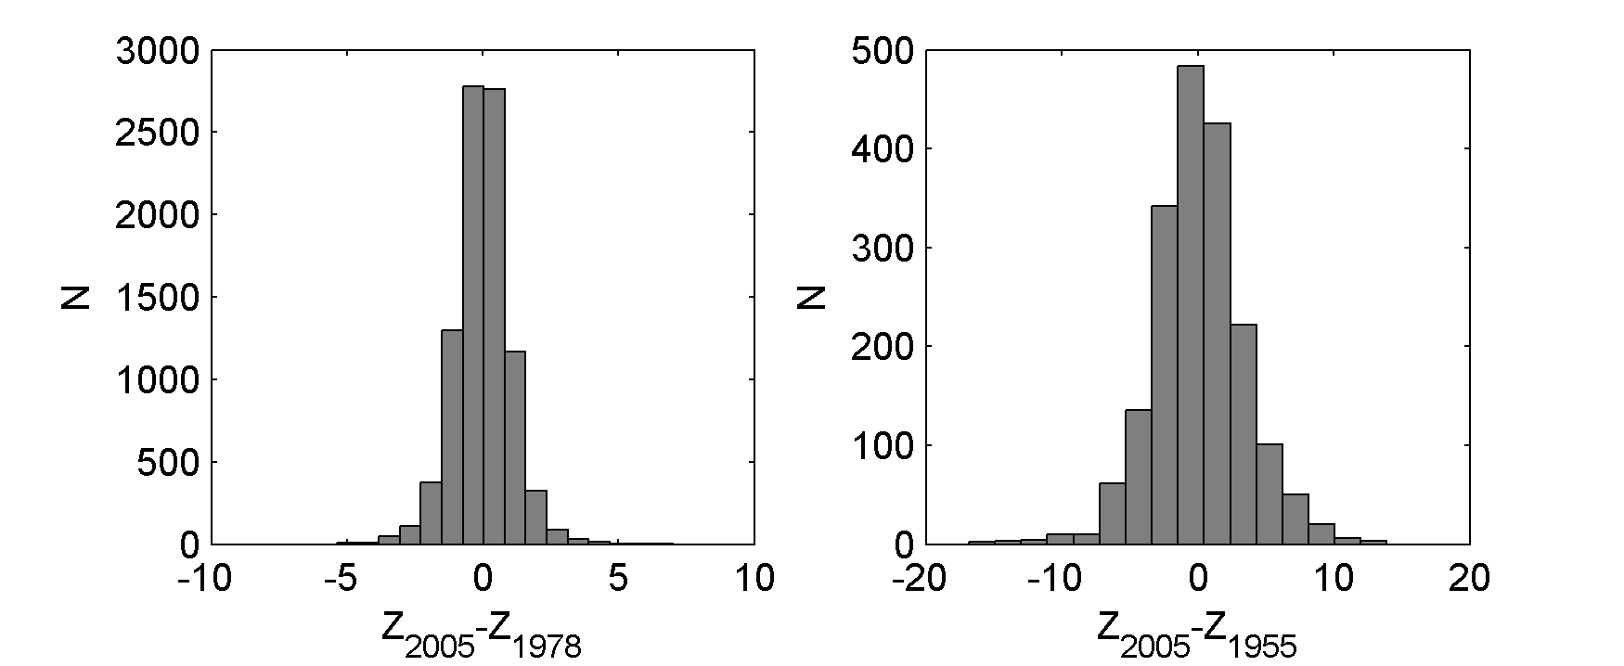
Figure 2. Histograms of topographic differences over bedrock after detrending (a) 1978-2005. Mean = 0.01 m; std. = 1.03 m; (b) 1955-2005. Mean = 0.09 m; std. = 3.40 m.

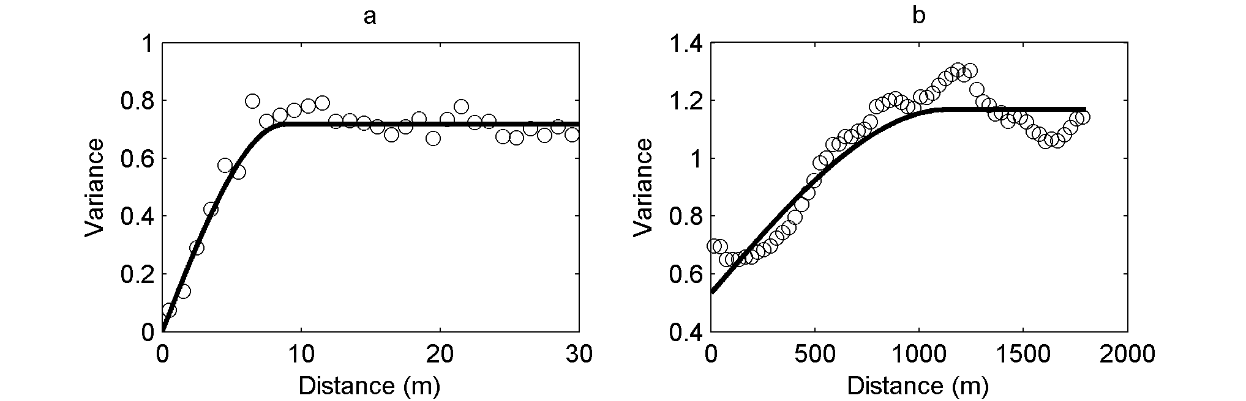
Figure 3. Semivariogram of ΔZ over bedrock areas (slopes less than 25 degrees) for 1978-2005. (a) Short scale semivariogram (values averaged in 1 m bins over a 20 m distance). (b) Long-range semivariogram (values averaged in 30 m bins over a distance of 1800 m).

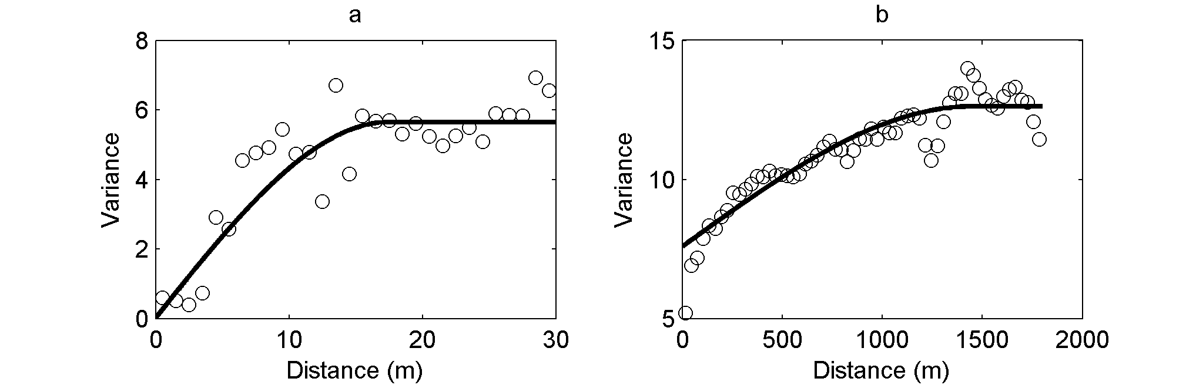
Figure 4. Same as Figure 3 but for 1955-2005.

Tritium analyses in ice core
Table 3 presents Tritium concentrations measured in surface snow and in the ice core. See section 4.3. of main text for details.
Table 3. Results from Tritium analyses of surface snow and near-surface ice
Sample  # | Length  (cm) | Depth  (m) | Sample | Sample 1 |  | Sample 2
 |  |  |  | N°1 | N°2 | N°1 | N°2
 |  |  |  | (TU ± error) | (TU ± error) | (TU ± error) | (TU ± error)
PL114-1 | 13 | 0 | Fresh snow 1x50ml | 4.82 ± 0.39 | 4.56 ± 0.36 | - | -
PL114-2 | 35 | 0.35 | Ice, 2x50ml | -0.03 ± 0.32 | 0.25 ± 0.38 | 0.03 ± 0.32 | 0.02 ± 0.34
PL114-3 | 23 | 0.58 | Ice, 1x50ml | -0.23 ± 0.33 | -0.02 ± 0.33 | - | -
PL114-5 | 38 | 1.34 | Ice, 2x50ml | -0.07 ± 0.33 | -0.03 ± 0.33 | 0.18 ± 0.32 | 0.30 ± 0.35
PL114-6 | 31 | 1.65 | Ice, 2x50ml | 0.19 ± 0.32 | 0.06 ± 0.32 | -0.26 ± 0.32 | -0.02 ± 0.32
PL114-7 | 39 | 2.04 | Ice, 2x50ml | -0.31 ± 0.33 | -0.07 ± 0.32 | 0.54 ± 0.33 | 0.27 ± 0.32

Climate and streamflow records used in mass balance reconstructions.
Figure 5 presents the precipitation record from La Laguna station and the streamflow records used to reconstruct the mass balance of Guanaco glacier.
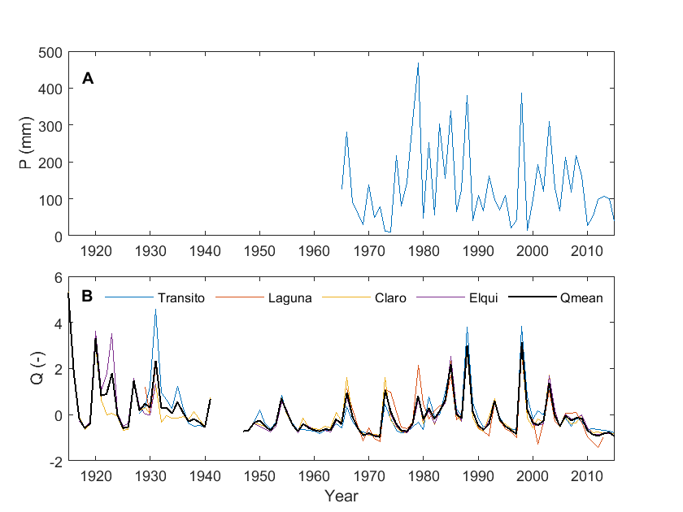
Figure 5. Predictors used for mass balance reconstructions: (A) winter precipitation at La Laguna station; (B) standardized and composite (‘Q mean’) streamflow records in headwater catchments of the Huasco and Elqui rivers. See Figure 1 of article for the location of stations and stream gauges.

Relationships between atmospheric circulation indices, precipitation and glaciological mass balance
The Guanaco glaciological B_{a} record and the winter precipitation at La Laguna were correlated with circulation indices known to influence the regional climate: (i) the Southern Oscillation Index (SOI) (Ropelewski and Jones, 1987); (ii) the Bivariate ENSO index (Smith and Sardeshmukh, 2000), which combines the oceanic Nino 3.4 index and atmospheric SOI index; (iii) the PDO index (Newman et al., 2016); (iv) the station-based SAM index (Marshall, 2003). The correlation between B_{a} and both ENSO indices is higher during winter months and decreases towards summer but the correlation is only significant (p<0.05) in May (Figure 6b). B_{a} correlates poorly with the PDO and SAM indices. The longer precipitation record from La Laguna is significantly correlated with both ENSO indices, and the correlation also peaks in winter (Figure 6a). A positive but weaker correlation is also seen with the PDO. These results are broadly consistent with previously reported correlations between precipitation and ENSO, which at 29°S reach peak values of ~0.5 in winter (Garreaud et al., 2009; Boisier et al., 2018). Hence ENSO cycles explain only about 25% of the variability in winter precipitation which is the prime driver of mass balance variability. The SAM index on the other hand has been found to explain up to 30% of precipitation variability in Chile, but its influence decreases north of ~32°S (Boisier et al., 2018), and has no perceptible influence at La Laguna.
Figure 6. Correlation between ENSO indices and (A) Winter (May-September) precipitation at La Laguna (n=51 years), and (B) Guanaco Glacier annual mass balance (n=13 years). BEST: Bivariate ENSO index (positive index = El Niño conditions); SOI = southern oscillation index (negative index = El Niño conditions); PDO = Pacific decal oscillation (positive index = warm phase); SAM = Southern Annular Mode.

References
Boisier, J.P., Alvarez-Garretón, C., Cordero, R.R., Damiani, A., Gallardo, L., Garreaud, R.D., Lambert, F., Ramallo, C., Rojas, M., and Rondanelli, R. (2018). Anthropogenic drying in central-southern Chile evidenced by long-term observations and climate model simulations. Elem Sci Anth 6.
Garreaud, R.D., Vuille, M., Compagnucci, R., and Marengo, J. (2009). Present-day south american climate. Palaeogeography, Palaeoclimatology, Palaeoecology 281, 180-195.
Marshall, G.J. (2003). Trends in the Southern Annular Mode from Observations and Reanalyses. Journal of Climate 16, 4134-4143.
Newman, M., Alexander, M.A., Ault, T.R., Cobb, K.M., Deser, C., Di Lorenzo, E., Mantua, N.J., Miller, A.J., Minobe, S., and Nakamura, H. (2016). The Pacific decadal oscillation, revisited. Journal of Climate 29, 4399-4427.
Rolstad, C., Haug, T., and Denby, B. (2009). Spatially integrated geodetic glacier mass balance and its uncertainty based on geostatistical analysis: application to the western Svartisen ice cap, Norway. Journal of Glaciology 55, 666-680.
Ropelewski, C.F., and Jones, P.D. (1987). An extension of the Tahiti–Darwin southern oscillation index. Monthly Weather Review 115, 2161-2165.
Smith, C.A., and Sardeshmukh, P.D. (2000). The effect of ENSO on the intraseasonal variance of surface temperatures in winter. International Journal of Climatology 20, 1543-1557.
Thibert, E., Blanc, R., Vincent, C., and Eckert, N. (2008). Glaciological and volumetric mass-balance measurements: error analysis over 51 years for Glacier de Sarennes, French Alps. Journal of Glaciology 54, 522-532.
Zemp, M., Thibert, E., Huss, M., Stumm, D., Rolstad Denby, C., Nuth, C., Nussbaumer, S., Moholdt, G., Mercer, A., and Mayer, C. (2013). Reanalysing glacier mass balance measurement series. The Cryosphere 7, 1227-1245.

