**SUPPLEMENTARY INFORMATION**

Anaerobic digestion of fruit waste mixed with sewage sludge digestate biochar: Influence on biomethane production

Teklit Gebregiorgis Ambayea,b,c*, Eldon R. Renea, *, Capucine Duponta, Suchanya Wongroda, and Eric D. van Hullebuscha,d

a IHE Delft Institute for Water Education, P. O. Box 3015, 2601 DA Delft, The Netherlands

bDepartment of Civil, Environmental, Architectural Engineering and Mathematics, University of Brescia, Via Branze 43, 25123 Brescia, Italy

c Mekelle University, Department of Chemistry, P. O. Box 231 Mekelle, Ethiopia

d Université de Paris, Institut de Physique du Globe de Paris, CNRS, UMR 7154, F-75238 Paris, France

\***Corresponding authors**

Teklit Gebregiorgis Ambaye ([teklitgeb@gmail.com](mailto:teklitgeb@gmail.com)) and Eldon R. Rene ([e.raj@un-ihe.org](mailto:e.raj@un-ihe.org))

**Introduction to the feedstock**

Biomass that contain carbohydrates, proteins, fats, cellulose or hemicelluloses can be treated by anaerobic digestion (Weiland, 2010). The time and rate of the degradation depends on the composition of the substrate (Deublein and Steinhauser, 2011). For example, lignified organic substances (e.g. wood) degrade very slowly and are not good feedstocks for anaerobic digestion (Weiland, 2010). Some substances, for example, short-chain sugars and carbohydrates, degrade in a very short time, while others, like substances rich in cellulose and hemicellulose might require as much as 20 days (Deublein and Steinhauser, 2011). Different feedstocks provide different amounts of biogas and this can be estimated using the biomethane potential (BMP) test (Ward et al., 2008).

**Sample preparation**

The feedstock substrates (tomato, banana, mango, and papaya) were initially selected based on previous literatures and by considering their physiochemical properties such as total solids (TS) and volatile solids (VS). The feedstock was purchased from the local supermarket in Delft city, The Netherlands. The wastes were pre-treated to decrease the size in the range of 1-4 mm (Figure S1).

|  |  |  |  |
| --- | --- | --- | --- |
| https://scontent-amt2-1.xx.fbcdn.net/v/t34.0-12/23146380_10155805446834420_1537515569_n.jpg?oh=1e5b15bcbd70d6825f74d7dc5d11dc90&oe=59FF6633 | https://scontent-amt2-1.xx.fbcdn.net/v/t34.0-12/23113371_10155805446929420_943523161_n.jpg?oh=6db5362e18e3ace5aac862d2a42199bd&oe=59FF948D | https://scontent-amt2-1.xx.fbcdn.net/v/t34.0-12/23140307_10155805447029420_1730578659_n.jpg?oh=0d4cea1001f382d7b03b257dbabe4439&oe=59FF7B9D | https://scontent-amt2-1.xx.fbcdn.net/v/t34.0-12/23113691_10155805447104420_618712465_n.jpg?oh=7fe0d64dfd0517aeb99a215f1a2d7f2b&oe=59FF9514 |

**Figure S1.** Fruit samples of papaya, mango, tomato and banana (from left to right), respectively.

**Characterization of the fruit substrates**

The characteristics of four different fruit substrates are summarized in Table 1. The TS (%) was in the range of 4.6 ± 0.1 to 18.24 ± 0.02 %. The tomato substrate displays the lowest and the banana feedstock displays the highest TS. As expected, the substrate with the highest TS has the lowest moisture content and vice-versa. When the TS increases, the amount of water decreases, thus reducing the level of microbial activity, which subsequently affects the amount of biogas, especially at higher values of the TS. Typically, the TS amount to less than 10% of the total volume. The volatile solids (VS) content, which is used to determine the total organic substances in the substrate, was in the range of 88.52 ± 0.02 to 95.75 ± 0.01 %. The results indicated that the banana feedstock displays the lowest VS content while that of tomato had the highest VS (%).

**Table S1**. Characteristics of fruit substrates (n=3).

|  |  |  |  |  |  |  |
| --- | --- | --- | --- | --- | --- | --- |
| Feedstock | TS, % | Moisture, % | VS, % | Ash, % | VS/TS | pH |
| Tomato | 4.6 ± 0.1 | 95.4 ± 0.1 | 95.75 ± 0.01 | 5.25 ± 0.01 | 95.2 ± 0.1 | 5.0 |
| Banana | 18.24 ± 0.02 | 81.78 ± 0.02 | 88.52 ± 0.02 | 3.27 ± 0.01 | 88.5 ± 0.2 | 5.5 |
| Mango | 17.8 ± 0.1 | 82.2 ± 0.1 | 93.8 ± 0.1 | 6.2 ± 0.1 | 93.4 ± 0.1 | 6.0 |
| Papaya | 10.2 ± 0.1 | 89.8 ± 0.1 | 93.22 ± 0.52 | 6.78 ± 0.01 | 93.2 ± 0.2 | 5.5 |

* The results are in the form of mean ± SD

The non-volatile solids or the ash content of a substrate will occupy the digester volume and will not contribute to biogas production. As it can be seen from Table S1, the ash content ranges from 3.27 to 6.78 %. The highest ash content was obtained for papaya substrate while the lowest was obtained for the banana substrate. The VS/TS indicates the fraction of organic matter that can be converted into biogas by the microorganisms. As seen from Table S1, the VS/TS ratio was in the range of 5.3 to 20.8 for the four different substrates. It was highest for the tomato substrate and lowest for the mango substrate. pH plays an important role in the digestion process as each group of microorganisms survives at different pH ranges. Most microorganisms favor a neutral pH environment. The pH was less than 6.5 for all the substrates. Among the four substrates, the pH was the highest for the substrate obtained from mango followed by banana and papaya, and it was the lowest for tomato. Biogas production from tomato waste is therefore expected to be the lowest.

**Determination of chemical oxygen demand (COD) of the substrates**

Chemical oxygen demand (COD) is the oxygen required to oxidize soluble and particulate organic matter. Higher COD levels mean a greater amount of oxidizable organic material in the sample. The COD values of different fruits are shown in Table S2. The value for the four fruit substrates ranged from 0.88 to 1.37 g/L Among the four fruits, the lowest COD was found for the tomato substrate and the highest value was obtained for mango. The value of the mixture was the highest.

**Table S2**. COD values (g/L) of different substrates

|  |  |
| --- | --- |
| **Feedstock** | **COD, g/L** |
| Tomato | 0.88 ± 0.01 |
| Mango | 1.15 ± 0.02 |
| Banana | 1.12 ± 0.02 |
| Papaya | 1.00 ± 0.00 |
| Slurry mixture | 1.37 ± 0.01 |

**Accumulated methane production from the four fruit substrates and their mixture**

As its fundamental standard, in order to know how much organics within the substrate is capable enough for conversion to methane, the fruit wastes were mixed with the inoculum in a ratio of 2 (i.e. 160 mL of the inoculum and 80 mL of each substrate), and two control experiments were performed (with inoculum only and with inoculum and biochar). The different treatments were incubated in an AMPTS, for 5 d, under mesophilic conditions.

Figure S2 shows the accumulated volume of gas obtained from the four different fruits and their mixture. Comparing the four fruits, the lowest volume of gas was obtained from the tomato substrate and the highest output was obtained from the banana substrate. This could be due to the characteristics of the substrates (Table S1). It was also found that the mixture had the highest methane production, and this was presumably due to co-digestion as compared to the individual substrate. Besides, mango has high biodegradability rate than banana, tomato, and papaya.

**Effect of ammonia in the digester environment**

Protein-rich substrates contribute to nearly most of the nitrogen which enters the solution as NH3 or the NH4+ ions (Fountoulakis et al., 2010; Hagen et al., 2014). The appropriate concentration of ammonia ensures sufficient buffer capacity and it improves the stability of AD. However, high ammonia may cause complete digester failure.

In this study, the pH of the digester increased with biochar addition (Figures S3, S4, and S5) because of the alkaline nature of biochar. The concentration of NH3-N in the digesters increased when compared to the control. This can be endorsed to the higher pH (7.2 to 8.02) with biochar amendment. The dissociation equilibrium of NH3/NH4+ may shift towards free ammonia (NH3) formation. Cell membranes permeability towards free NH3 is high; it can result in an imbalance of intracellular protons and the depletion of potassium (K+). Due to this, it can be considered as the main cause of toxicity, and its inhibition is an operational problem for AD (Chen et al., 2008).

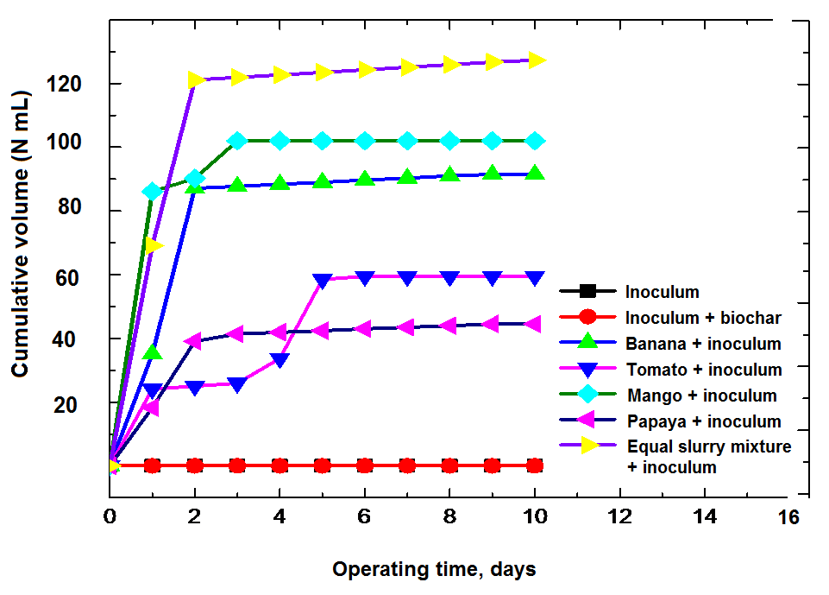

**Figure S2.** Cumulative methane production (mL) from the different substrates



**Figure S3**. Initial and final total ammonia nitrogen (NH4-N) in anaerobic digestion for ISR 2 (a), ISR 1.5 (b), ISR 1 (c) and the addition of different amounts of sludge biochar obtained at 350 and 550 oC. Averages of triplicate measurements are displayed, and error bars correspond to standard deviations

In this study, the biochars were prepared at a pyrolysis temperature of 550 and 350 oC. When they were amended in the AD, there was a 24% increase in the concentration of NH3-N in the control digester after 10 d of incubation (Figures S3 a, b and c). However, the difference was in the range 1.5% to 3.5% in the biochar-mixed digesters and the difference was not significant (*p* > 0.1) for all the treatments and ISR, indicating the feasibility of using biochar to alleviate NH3. Therefore, among the different ammonia inhibition strategies, the optimization of the feedstock for biogas production with the addition of biochar may possibly be the easiest and cost-effective technique to minimize the toxicity and concentration of ammonia.

**References**

Chen, Y., Cheng, J.J., Creamer, K.S., 2008. Inhibition of anaerobic digestion process: A review Bioresoure Technology, 99, 4044-4064. doi: 10.1016/j.biortech.2007.01.057

Deublein, D. and Steinhauser, A., 2011. Biogas from waste and renewable resources: an introduction. John Wiley & Sons.

Fountoulakis, M.S., Petousi, I., Manios, T., 2010. Co-digestion of sewage sludge with glycerol to boost biogas production. Waste Management 30(10), 1849-1853. doi: 10.1016/j.wasman.2010.04.011.

Hagen, L.H., Vivekanand, V., Linjordet, R., Pope, P.B., Eijsink, V.G., Horn, S.J., 2014. Microbial community structure and dynamics during co-digestion of whey permeate and cow manure in continuous stirred tank reactor systems. Bioresource Technology 171, 350-359. doi: 10.1016/j.biortech.2014.08.095

Ward, A.J., Hobbs, P.J., Holliman, P.J., Jones, D.L., 2008. Optimization of the anaerobic digestion of agricultural resources. Bioresource Technology, 99, 7928-7940. doi: 10.1016/j.biortech.2008

Weiland, P., 2010. Biogas production: current state and perspectives. Applied Microbiology and Biotechnology, 85, 849-860. doi: 10.1007/s00253-009-2246-7