**Supplementary materials for “Deep Dehydration as a Plausible Mechanism of the 2013 Mw 8.3 Sea of Okhotsk Deep-focus Earthquake”**

Hao Zhang1,2, Suzan van der Lee2, Craig Bina2, Zengxi Ge3

1 University of Utah Seismograph Stations, University of Utah, Salt Lake City, UT, United States

2 Department of Earth and Planetary Sciences, Northwestern University, Evanston IL, United States

3 School of Earth and Space Sciences, Peking University, Beijing 100871, P.R. China

Corresponding author: H.Z. (zhang@seis.utah.edu)

# Content

This supplement contains additional, supporting figures related to permutations in our modeling and analysis parameters as well as comparisons with predictions from other models. The following figures are included, along with figure captions.

Figure S1. The 12-subevent inversion model.

Figure S2. The waveform fitting for the 12-subevent inversion model.

Figure S3. Waveform misfit (red line) and seismic moment (blue line) both as a function of number of subevents after parameters of the source time function are settled.

Figure S4. The waveform fitting for the final inversion model as shown in Figure 5a.

Figure S5. Comparison of our source models (a) with a source model (b) inverted within the metastable olivine wedge (MOW) and another one (c) derived by Zhan et al. (2014).

Figures S6. Waveform fitting for the source model within the metastable olivine wedge (Figure S5b).

Figure S7. The waveform fitting for the final inversion model (Fig. 5a) without the largest subevent.

Figure S8. The waveform fitting for the final inversion model (Fig. 5a) without the second largest subevent.



Figure S1. The 12-subevent inversion model. The color bar indicates the origin time of subevents. Areas of the subevents are estimated with the equation (1) in the Data and Methodology section. Red dots represent aftershocks, and blue star depicts the hypocenter. Dashed curved lines denote the depth contours of the subducting slab (Hayes et al., 2012).



Figure S2. Waveform fitsfor the 12-subevent inversion model (Figure S1). Red lines represent the synthetic velocity records, while black lines denote the observed waveforms. For each waveform pair, station name and azimuth are labeled on the left and the maximum amplitude (unit: micron/s) is labeled at the top right of the waveforms.



Figure S3. Waveform misfit (red line) and seismic moment (blue line) both as a function of number of subevents after parameters of the source time function are settled. The number of subevents is evaluated to 12 at the inflection point of the misfit curve.



Figure S4. Waveform fits for the final inversion model as shown in Figure 5a. Red lines represent the synthetic velocity records, while black lines denote the observed waveforms. For each waveform pair, station name and azimuth are labeled on the left and the maximum amplitude (unit: micron/s) is labeled at the top right of the waveforms.

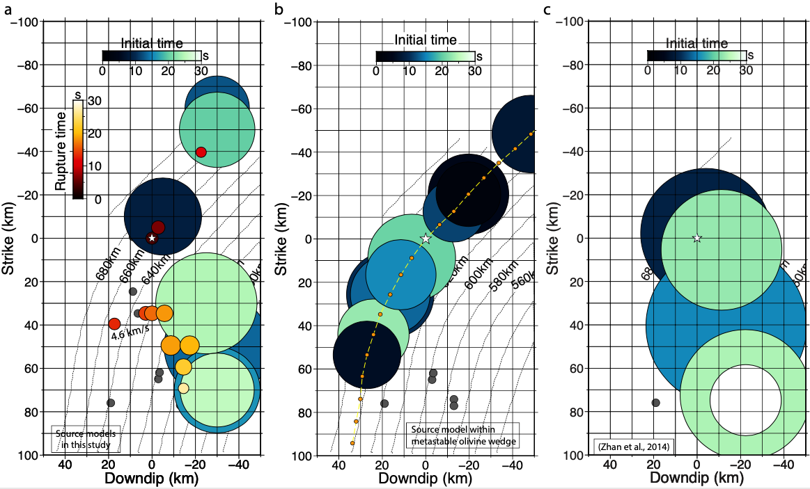

Figure S5. Comparison of source models. a) Two rupture models in this study (Figure 5a). b) The source model with 12 subevents inverted mostly inside the MOW. Orange dots are the source grids used in the inversion, which are linked with a dashed yellow line. c) The multi-subevent source model derived by Zhan et al. (2014). Circles indicate the inverted subevents with color depicting rupture time. The areas of these circles represent the rupture areas calculated with equation (1). White star indicates the hypocenter of the earthquake.



Figure S6. Waveform fits for the inversion model mostly inside the MOW (Figure S5b). Red lines represent the synthetic velocity records, while black lines denote the observed waveforms. For each waveform pair, station name and azimuth are labeled on the left of the waveforms.



Figure S7. Waveform fits for the final inversion model (Figure 5a) without the largest subevent. Red lines represent the synthetic velocity records, while black lines denote the observed waveforms. For each waveform pair, station name and azimuth are labeled on the left and the maximum amplitude (unit: micron/s) is labeled at top right of the waveforms.



Figure S8. Waveform fitting for the final inversion model (Figure 5a) without the second largest subevent. Red lines represent the synthetic velocity records, while black lines denote the observed waveforms. For each waveform pair, station name and azimuth are labeled on the left and the maximum amplitude (unit: micron/s) is labeled at the top right of the waveforms.