**Pan-cancer Analysis and Drug Formulation for GPR139 and GPR142**

**Aman Chandra Kaushik1# | Aamir Mehmood2,3# | Xiaofeng Dai1 | Dong-Qing Wei2,3 \***

1Wuxi School of Medicine, Jiangnan University, Wuxi, China

2School of life Sciences and Biotechnology, Shanghai Jiao Tong University, 800 Dongchuan Road, Shanghai 200240

3Peng Cheng Laboratory, Vanke Cloud City Phase I Building 8, Xili Street, Nanshan District, Shenzhen, Guangdong, 518055, P.R China

**SUPPLEMENTARY INFORMATION**

**TABLE S1** Top10 compounds of GPR142 after screened from 3D Database of GPR142 as well as GPR139, which have same pharmacophoric features

|  |  |
| --- | --- |
| C:\Users\Aman\Desktop\Pharmacophore Paper\TOP5_Compounds_GPR142\1.png  **Compound1** | C:\Users\Aman\Desktop\Pharmacophore Paper\TOP5_Compounds_GPR142\2.png  **Compound2** |
| C:\Users\Aman\Desktop\Pharmacophore Paper\TOP5_Compounds_GPR142\3.png  **Compound3** | C:\Users\Aman\Desktop\Pharmacophore Paper\TOP5_Screned_Compounds_EC50_Value\Compound-001.png  **Compound4** |
| C:\Users\Aman\Desktop\Pharmacophore Paper\TOP5_Screned_Compounds_EC50_Value\2.png  **Compound5** | C:\Users\Aman\Desktop\Pharmacophore Paper\TOP5_Screened_Compounds_DockingScore\1.png  **Compound6** |
| C:\Users\Aman\Desktop\Pharmacophore Paper\TOP5_Screened_Compounds_DockingScore\2.png  **Compound7** | C:\Users\Aman\Desktop\Pharmacophore Paper\TOP5_Screened_Compounds_DockingScore\3.png  **Compound8** |
| C:\Users\Aman\Desktop\Pharmacophore Paper\TOP5_Compounds_GPR139\Compounds-001.png  **Compound9** | C:\Users\Aman\Desktop\Pharmacophore Paper\TOP5_Compounds_GPR139\Compounds-002.png  **Compound10** |

**TABLE S2** represents the activity of developed common pharmacophore hypotheses using PHASE Schrodinger suite software, from experimental EC50 value of chemical structure from the literature. Where plus (+) sign are represents the activity of compounds and minus (-) sign represents the inactivity of compounds. And more the one plus signs are indicating more active compounds.

|  |  |  |  |  |  |
| --- | --- | --- | --- | --- | --- |
| **Compounds** | **Experimental Activity (EC50)** | **Structure** | **Activity** | **Screened Compounds** | **Predicted Activity** |
| 01 | 4.8 | C:\Users\Aman\Desktop\Pharmacophore Paper\EC50_Compounds\1.png | + | Compound01 | +++ |
| 02 | 13 | C:\Users\Aman\Desktop\Pharmacophore Paper\EC50_Compounds\2.png | - | Compound02 | +++ |
| 03 | >33 | C:\Users\Aman\Desktop\Pharmacophore Paper\EC50_Compounds\3.png | - | Compound03 | +++ |
| 04 | >33 | C:\Users\Aman\Desktop\Pharmacophore Paper\EC50_Compounds\4.png | - | Compound04 | +++ |
| 05 | >33 | C:\Users\Aman\Desktop\Pharmacophore Paper\EC50_Compounds\5.png | - | Compound05 | +++ |
| 06 | >33 | C:\Users\Aman\Desktop\Pharmacophore Paper\EC50_Compounds\6.png | - | Compound06 | +++ |
| 07 | >33 | C:\Users\Aman\Desktop\Pharmacophore Paper\EC50_Compounds\7.png | - | Compound07 | +++ |
| 08 | 3.8 | C:\Users\Aman\Desktop\Pharmacophore Paper\EC50_Compounds\8.png | + | Compound08 | +++ |
| 09 | 4.2 | C:\Users\Aman\Desktop\Pharmacophore Paper\EC50_Compounds\9.png | + | Compound09 | ++ |
| 10 | 4.6 | C:\Users\Aman\Desktop\Pharmacophore Paper\EC50_Compounds\10.png | + | Compound10 | +++ |
| 11 | 6.6 | C:\Users\Aman\Desktop\Pharmacophore Paper\EC50_Compounds\11.png | + |
| 12 | 25 | C:\Users\Aman\Desktop\Pharmacophore Paper\EC50_Compounds\12.png | - |
| 13 | >33 | C:\Users\Aman\Desktop\Pharmacophore Paper\EC50_Compounds\13.png | - |
| 14 | >33 | C:\Users\Aman\Desktop\Pharmacophore Paper\EC50_Compounds\14.png | - |
| 15 | 0.76 | C:\Users\Aman\Desktop\Pharmacophore Paper\EC50_Compounds\15.png | +++ |
| 16 | 0.83 | C:\Users\Aman\Desktop\Pharmacophore Paper\EC50_Compounds\16.png | +++ |
| 17 | 0.78 | C:\Users\Aman\Desktop\Pharmacophore Paper\EC50_Compounds\17.png | +++ |
| 18 | 0.093 | C:\Users\Aman\Desktop\Pharmacophore Paper\EC50_Compounds\18.png | +++ |
| 19 | 0.36 | C:\Users\Aman\Desktop\Pharmacophore Paper\EC50_Compounds\19.png | +++ |
| 20 | 0.088 | C:\Users\Aman\Desktop\Pharmacophore Paper\EC50_Compounds\20.png | +++ |
| 21 | 0.089 | C:\Users\Aman\Desktop\Pharmacophore Paper\EC50_Compounds\21.png | +++ |
| 22 | 0.053 | C:\Users\Aman\Desktop\Pharmacophore Paper\EC50_Compounds\22.png | +++ |
| 23 | 0.24 | C:\Users\Aman\Desktop\Pharmacophore Paper\EC50_Compounds\23.png | +++ |
| 24 | 0.11 | C:\Users\Aman\Desktop\Pharmacophore Paper\EC50_Compounds\24.png | +++ |
| 25 | 3.3 | C:\Users\Aman\Desktop\Pharmacophore Paper\EC50_Compounds\25.png | ++ |
| 26 | 0.052 | C:\Users\Aman\Desktop\Pharmacophore Paper\EC50_Compounds\26.png | +++ |
| 27 | 0.21 | C:\Users\Aman\Desktop\Pharmacophore Paper\EC50_Compounds\27.png | +++ |
| 28 | 1.9 | C:\Users\Aman\Desktop\Pharmacophore Paper\EC50_Compounds\28.png | ++ |
| 29 | 0.067 | C:\Users\Aman\Desktop\Pharmacophore Paper\EC50_Compounds\29.png | +++ |
| 30 | 0.18 | C:\Users\Aman\Desktop\Pharmacophore Paper\EC50_Compounds\30.png | +++ |
| 31 | 0.18 | C:\Users\Aman\Desktop\Pharmacophore Paper\EC50_Compounds\31.png | +++ |
| 32 | 0.64 | C:\Users\Aman\Desktop\Pharmacophore Paper\EC50_Compounds\32.png | +++ |
| 33 | 0.067 | C:\Users\Aman\Desktop\Pharmacophore Paper\EC50_Compounds\33.png | +++ |
| 34 | 0.20 | C:\Users\Aman\Desktop\Pharmacophore Paper\EC50_Compounds\34.png | +++ |
| 35 | 0.23 | C:\Users\Aman\Desktop\Pharmacophore Paper\EC50_Compounds\35.png | +++ |
| 36 | 4.8 | C:\Users\Aman\Desktop\Pharmacophore Paper\EC50_Compounds\36.png | + |
| 39 | 0.067 | C:\Users\Aman\Desktop\Pharmacophore Paper\EC50_Compounds\39.png | +++ |
| 40 | 0.93 | C:\Users\Aman\Desktop\Pharmacophore Paper\EC50_Compounds\40.png | +++ |
| 41 | 2.2 | C:\Users\Aman\Desktop\Pharmacophore Paper\EC50_Compounds\41.png | ++ |
| 42 | 0.11 | C:\Users\Aman\Desktop\Pharmacophore Paper\EC50_Compounds\42.png | +++ |
| 43 | 0.21 | C:\Users\Aman\Desktop\Pharmacophore Paper\EC50_Compounds\43.png | +++ |
| 44 | 0.095 | C:\Users\Aman\Desktop\Pharmacophore Paper\EC50_Compounds\44.png | +++ |
| 45 | 0.44 | C:\Users\Aman\Desktop\Pharmacophore Paper\EC50_Compounds\45.png | +++ |
| 46 | 1.32 | C:\Users\Aman\Desktop\Pharmacophore Paper\EC50_Compounds\46.png | ++ |
| 48 | 0.39 | C:\Users\Aman\Desktop\Pharmacophore Paper\EC50_Compounds\48.png | +++ |
| 49 | 1.06 | C:\Users\Aman\Desktop\Pharmacophore Paper\EC50_Compounds\49.png | ++ |
| 50 | 2.23 | C:\Users\Aman\Desktop\Pharmacophore Paper\EC50_Compounds\50.png | + |
| 51 | 0.22 | C:\Users\Aman\Desktop\Pharmacophore Paper\EC50_Compounds\51.png | +++ |
| 52 | 6.0 | C:\Users\Aman\Desktop\Pharmacophore Paper\EC50_Compounds\52.png | - |
| 53 | 0.73 | C:\Users\Aman\Desktop\Pharmacophore Paper\EC50_Compounds\53.png | +++ |
| 54 | 9.45 | C:\Users\Aman\Desktop\Pharmacophore Paper\EC50_Compounds\54.png | - |
| 55 | 0.054 | C:\Users\Aman\Desktop\Pharmacophore Paper\EC50_Compounds\55.png | +++ |
| 56 | 0.099 | C:\Users\Aman\Desktop\Pharmacophore Paper\EC50_Compounds\56.png | +++ |
| 57 | 0.20 | C:\Users\Aman\Desktop\Pharmacophore Paper\EC50_Compounds\57.png | +++ |
| 58 | 0.26 | C:\Users\Aman\Desktop\Pharmacophore Paper\EC50_Compounds\58.png | +++ |
| 59 | 0.28 | C:\Users\Aman\Desktop\Pharmacophore Paper\EC50_Compounds\59.png | +++ |
| 60 | 0.35 | C:\Users\Aman\Desktop\Pharmacophore Paper\EC50_Compounds\60.png | +++ |
| 61 | 0.086 | C:\Users\Aman\Desktop\Pharmacophore Paper\EC50_Compounds\61.png | +++ |
| 62 | 0.036 | C:\Users\Aman\Desktop\Pharmacophore Paper\EC50_Compounds\62.png | +++ |
| 63 | 0.18 | C:\Users\Aman\Desktop\Pharmacophore Paper\EC50_Compounds\63.png | +++ |
| 64 | 0.39 | C:\Users\Aman\Desktop\Pharmacophore Paper\EC50_Compounds\64.png | +++ |
| 66 | 0.095 | C:\Users\Aman\Desktop\Pharmacophore Paper\EC50_Compounds\66.png | +++ |

**TABLE S3** Top10 compounds of GPR142 after screened from 3D Database, which has the same pharmacophoric features, where plus signs represent the activity of compounds.

|  |  |  |  |  |  |  |  |  |  |
| --- | --- | --- | --- | --- | --- | --- | --- | --- | --- |
| **Compounds** | **Molecular Formula** | **Docking Score (VSW)** | **Activity** | **Donor**  **HB** | **Accept**  **HB** | **Molecular Weight** | **Percent of Human Oral Absorption** | **XLogP3** | **QPlog**  **Po/w** |
| Compound1 | C24H24ClN2O3+ | -6.542 | +++ | 2.000 | 6.700 | 423.911g/mol | 92.100 | 4.3 | 4.247 |
| Compound2 | C24H24ClN2O3+ | -7.176 | +++ | 2.000 | 6.700 | 423.911g/mol | 91.966 | 4.3 | 4.254 |
| Compound3 | C24H18N5O2S- | -6.470 | +++ | 3.000 | 8.000 | 440.497g/mol | 93.391 | 4.8 | 3.764 |
| Compound4 | C23H18N2O4 | -6.807 | +++ | 1.000 | 5.250 | 386.400g/mol | 100.000 | 4.2 | 4.503 |
| Compound5 | C24H24ClN2O3+ | -6.542 | +++ | 2.000 | 6.700 | 423.911g/mol | 92.100 | 4.3 | 4.247 |
| Compound6 | C24H24ClN2O3+ | -7.176 | +++ | 2.000 | 6.700 | 423.911g/mol | 91.966 | 4.3 | 4.254 |
| Compound7 | C24H24ClN2O3+ | -6.542 | +++ | 2.000 | 6.700 | 423.911g/mol | 92.100 | 4.3 | 4.247 |
| Compound8 | C26H23FN3O4S+ | -6.177 | +++ | 3.000 | 7.250 | 492.5419g/mol | 100.000 | 5 | 4.198 |
| Compound9 | C24H24ClN2O3+ | -8.911 | ++ | 2.000 | 6.700 | 423.911g/mol | 74.056 | 4.3 | 4.247 |
| Compound10 | C24H28N2O4S | -7.450 | +++ | 1.000 | 8.950 | 440.555g/mol | 90.743 | 3.5 | 3.503 |

**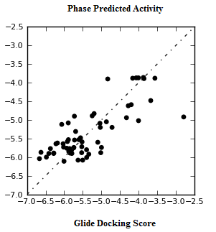**

**FIGURE S1** Automatic generated regression plot of 3D QSAR with respect to Glide Docking Score and phase predicted activity, where X axis represents the Glide Docking Score and Y axis represents the phase predicted activity of chemical structure.

**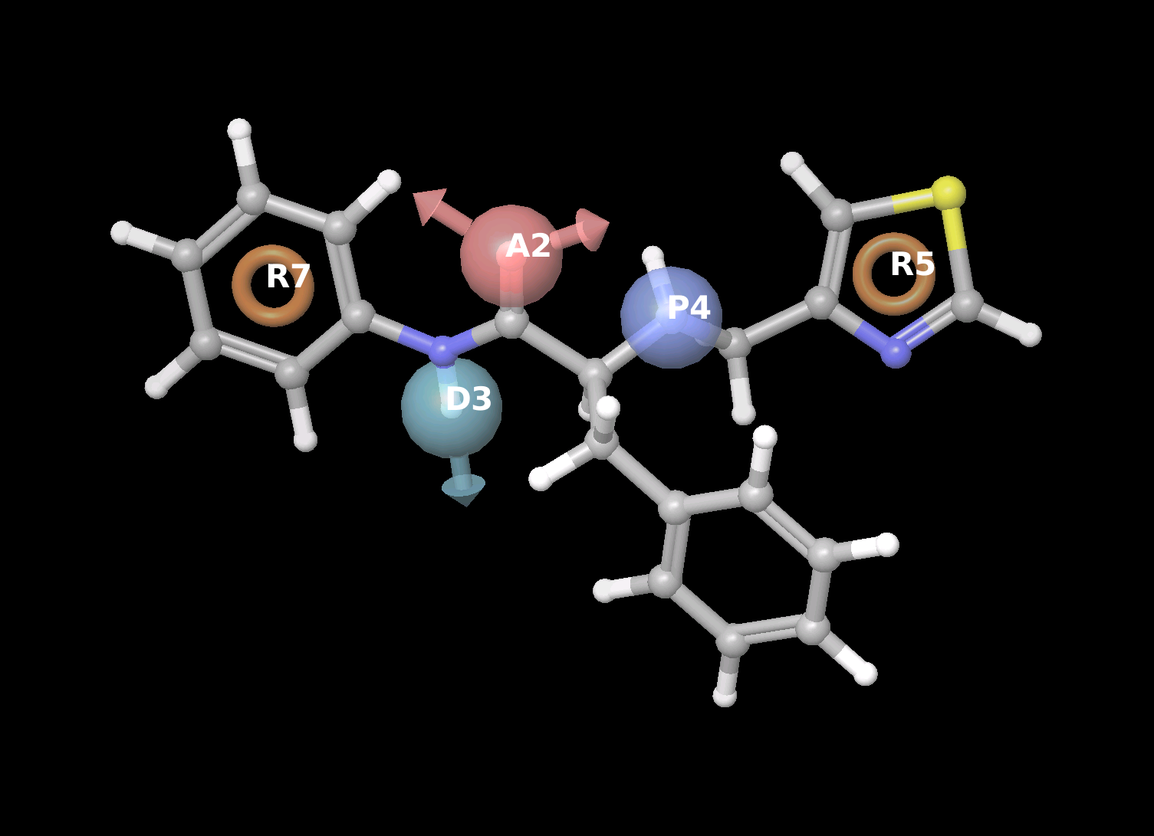**

**FIGURE S2** Represents the common pharmacophore hypotheses, where R5 have most important common pharmacophoric feature that inhibit Type 2 diabetes.