Supplementary Material

## Supplementary Figures

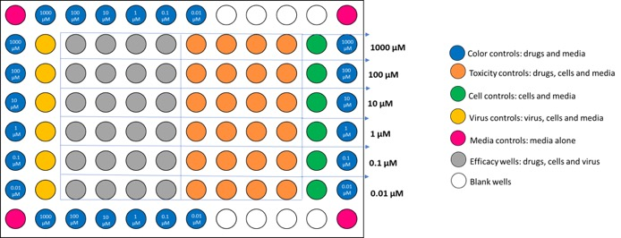

**Supplementary Figure 1.** **Plate layout for testing cytotoxicity and efficacy of iminosugar endoplasmic-reticulum α-glucosidase inhibitors (ER-AGIs) against Zika virus.**

.