Supplementary Material

*1. Determination of the association constants between substrates (****A****,* ***G****,* ***X****,* ***HX, UA****) and* ***CP6***

*1.1 Job plot for* ***CP6****⊃* ***A****/****G****/****X****/****HX/UA***

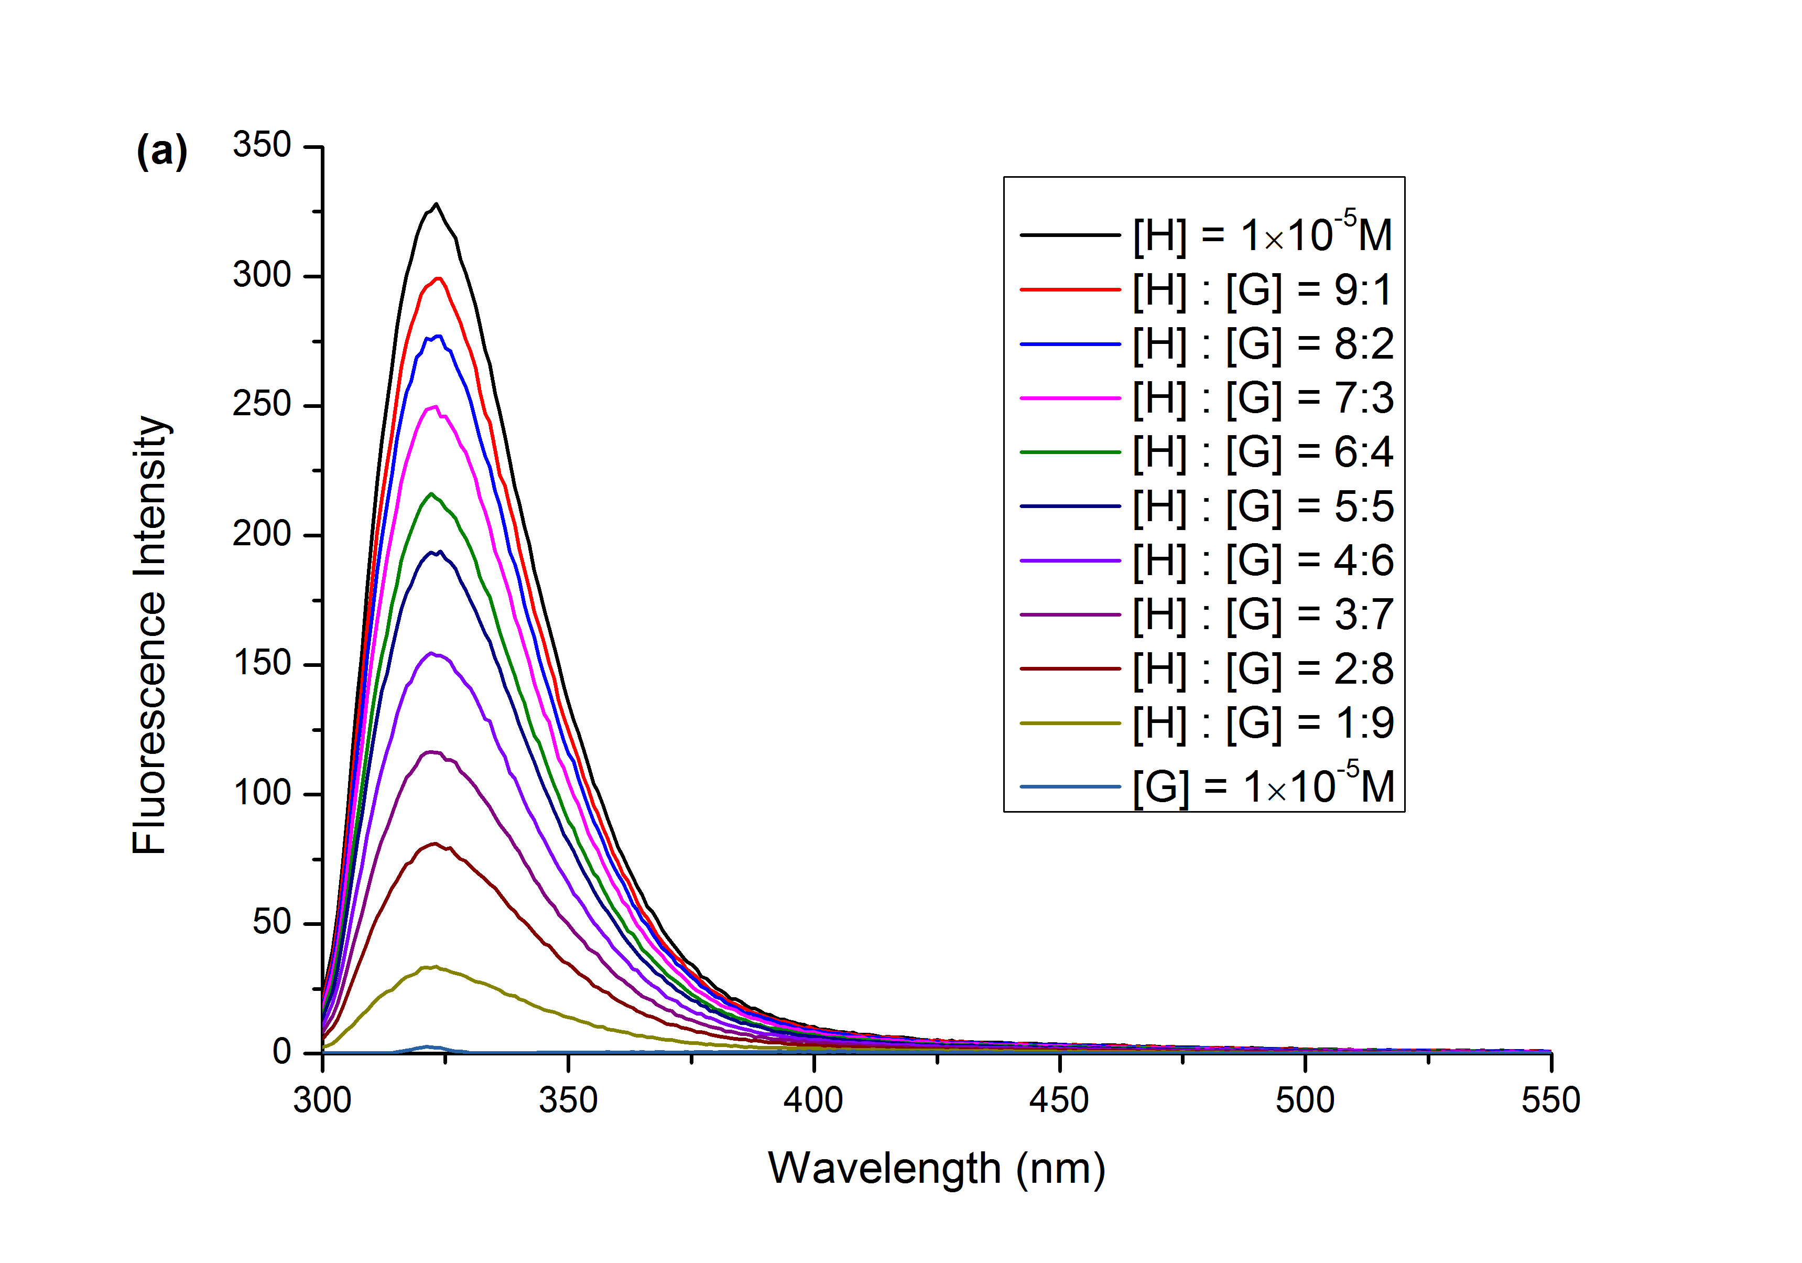 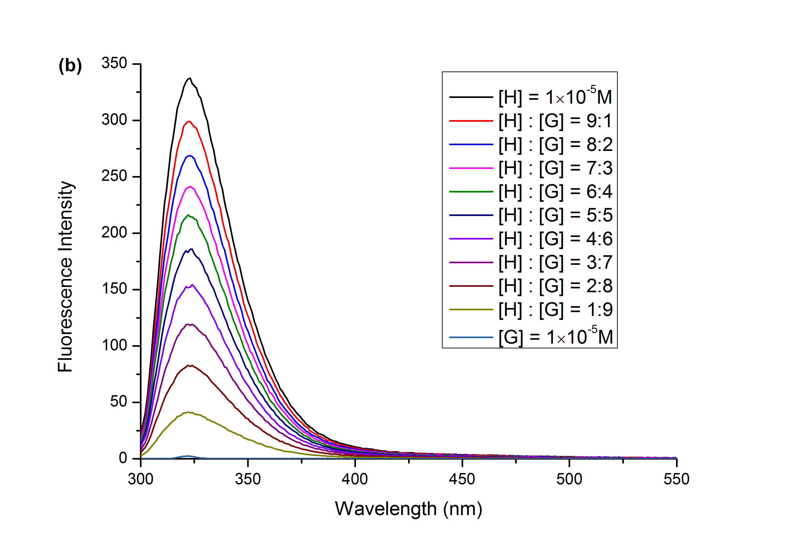

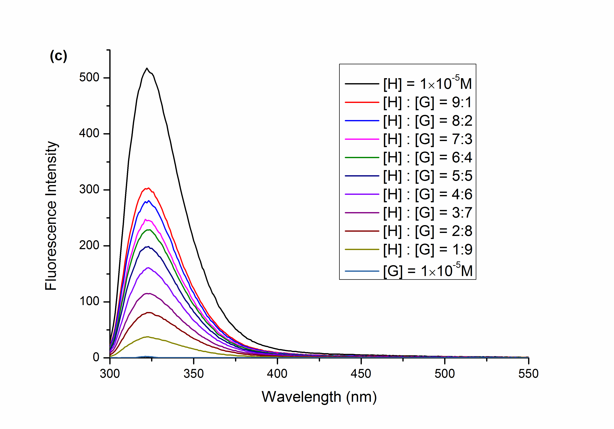 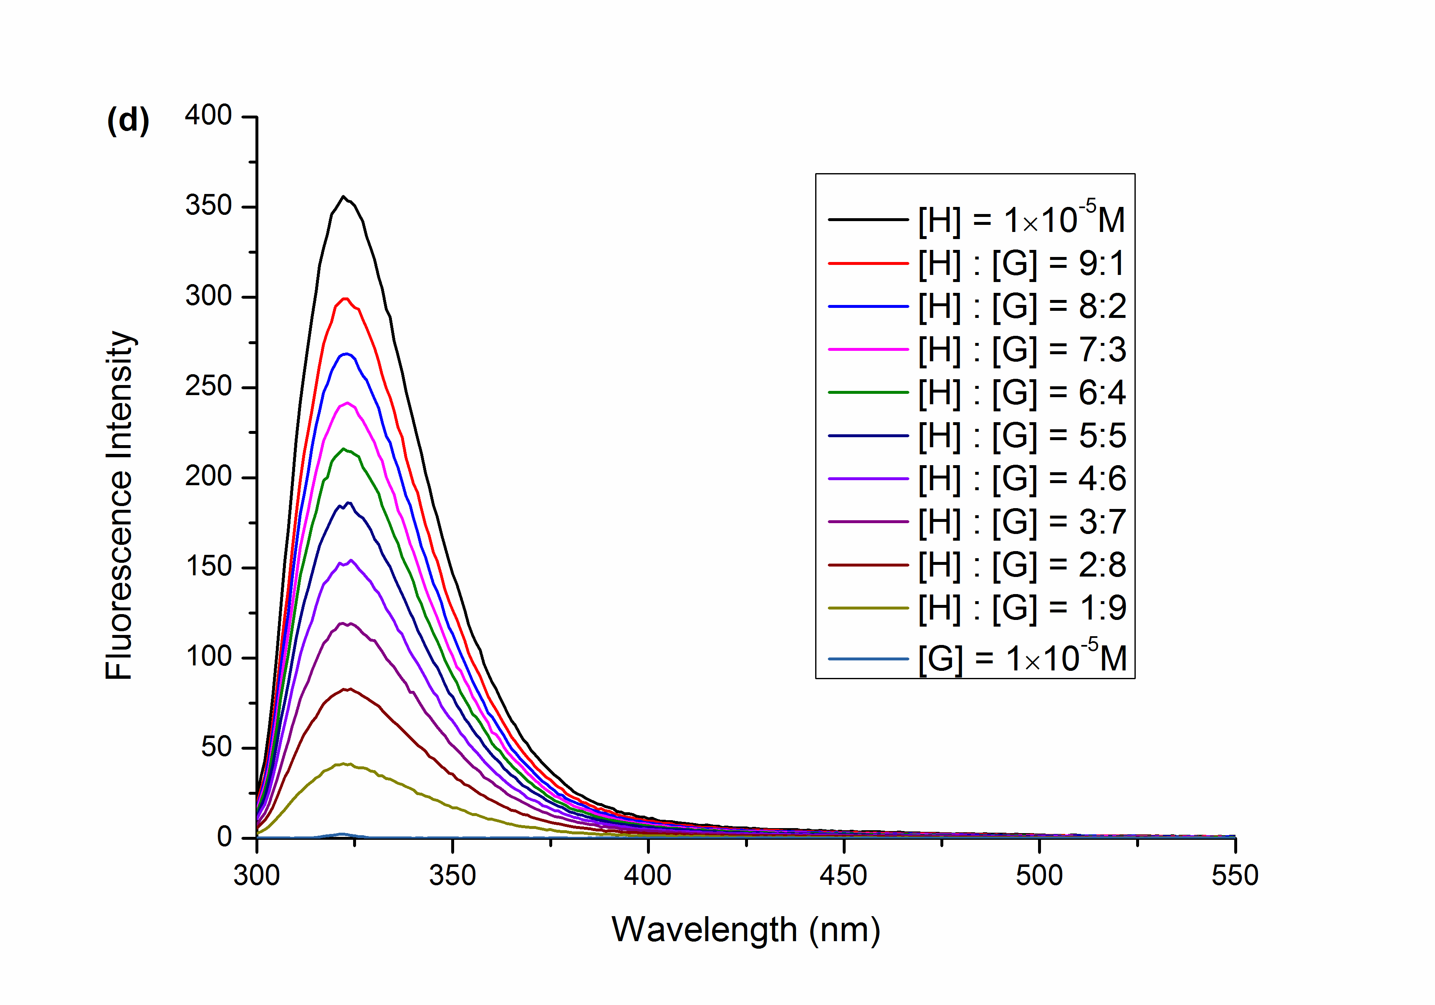

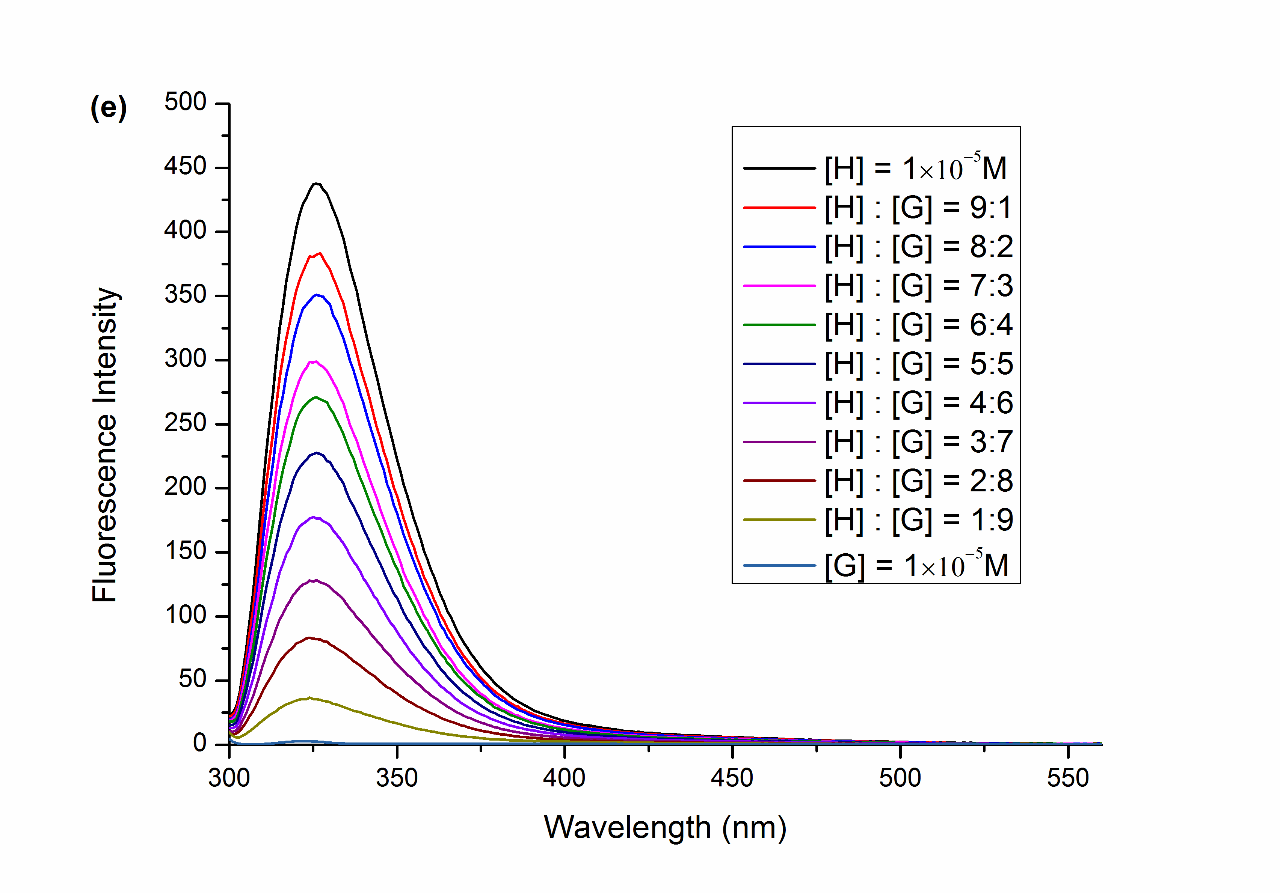

**Supplementary Figure 1.**(a-e) Fluorescence spectra of the mixture of **CP6** and substrates (**A**, **G**, **X**, **HX**, **UA**) in water at different molar ratios while [**CP6**] + [substrates] = 1.0 × 10−5 M, respectively.

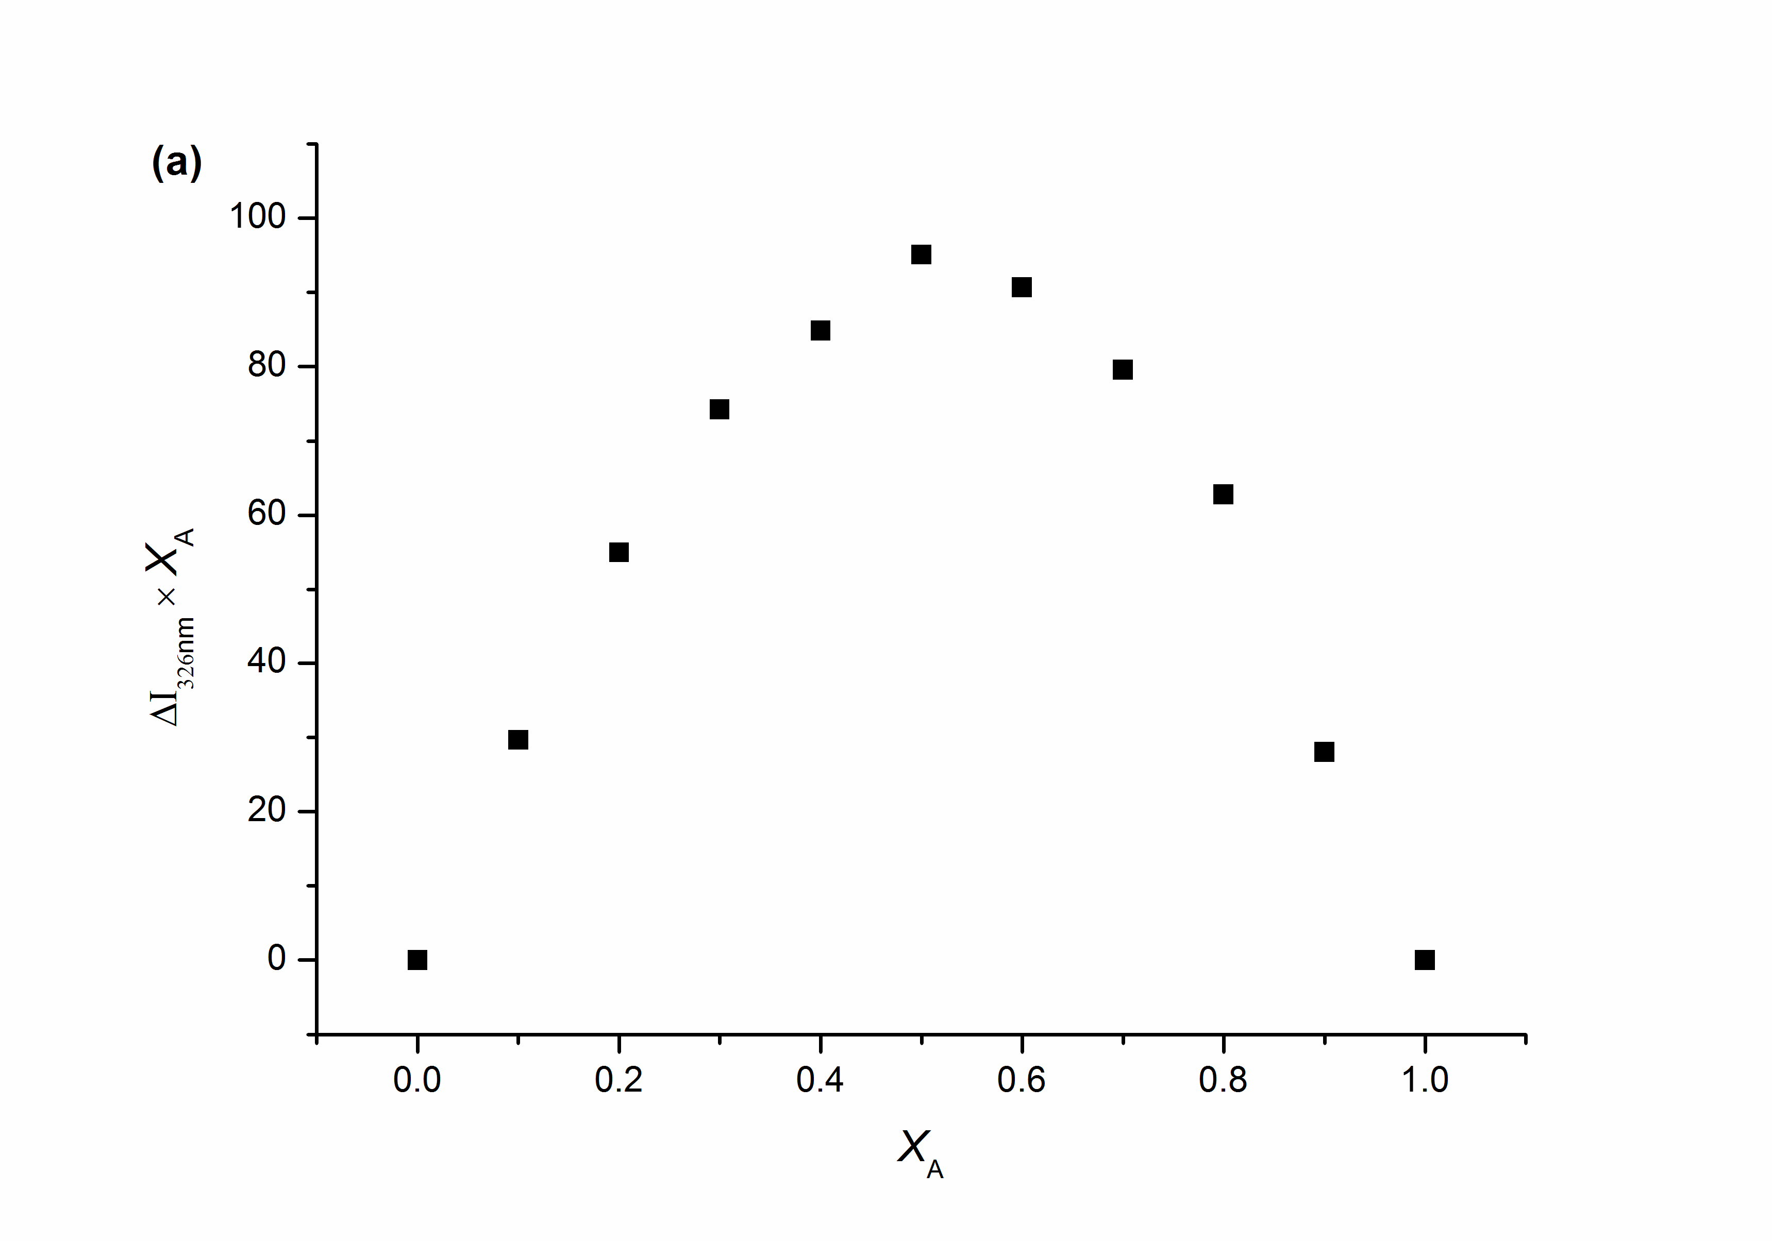 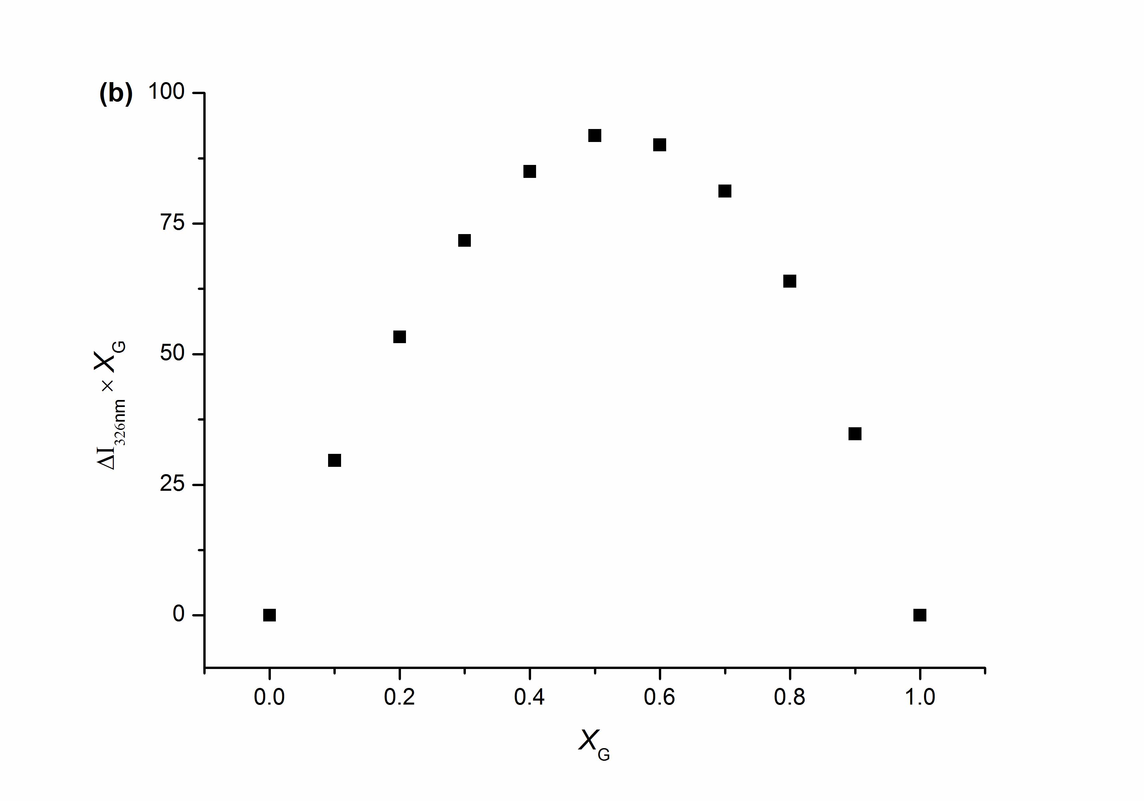

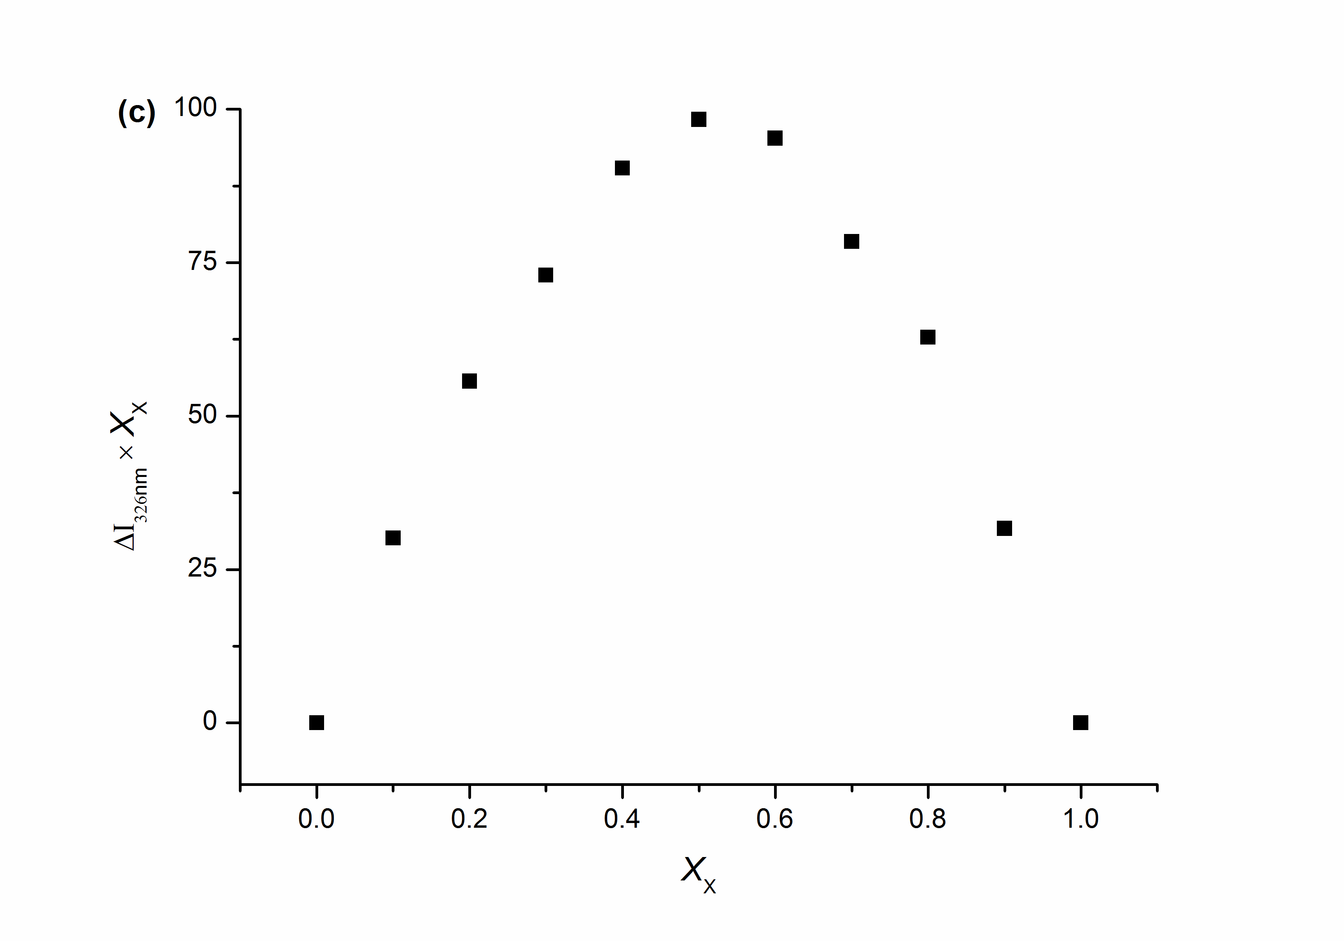 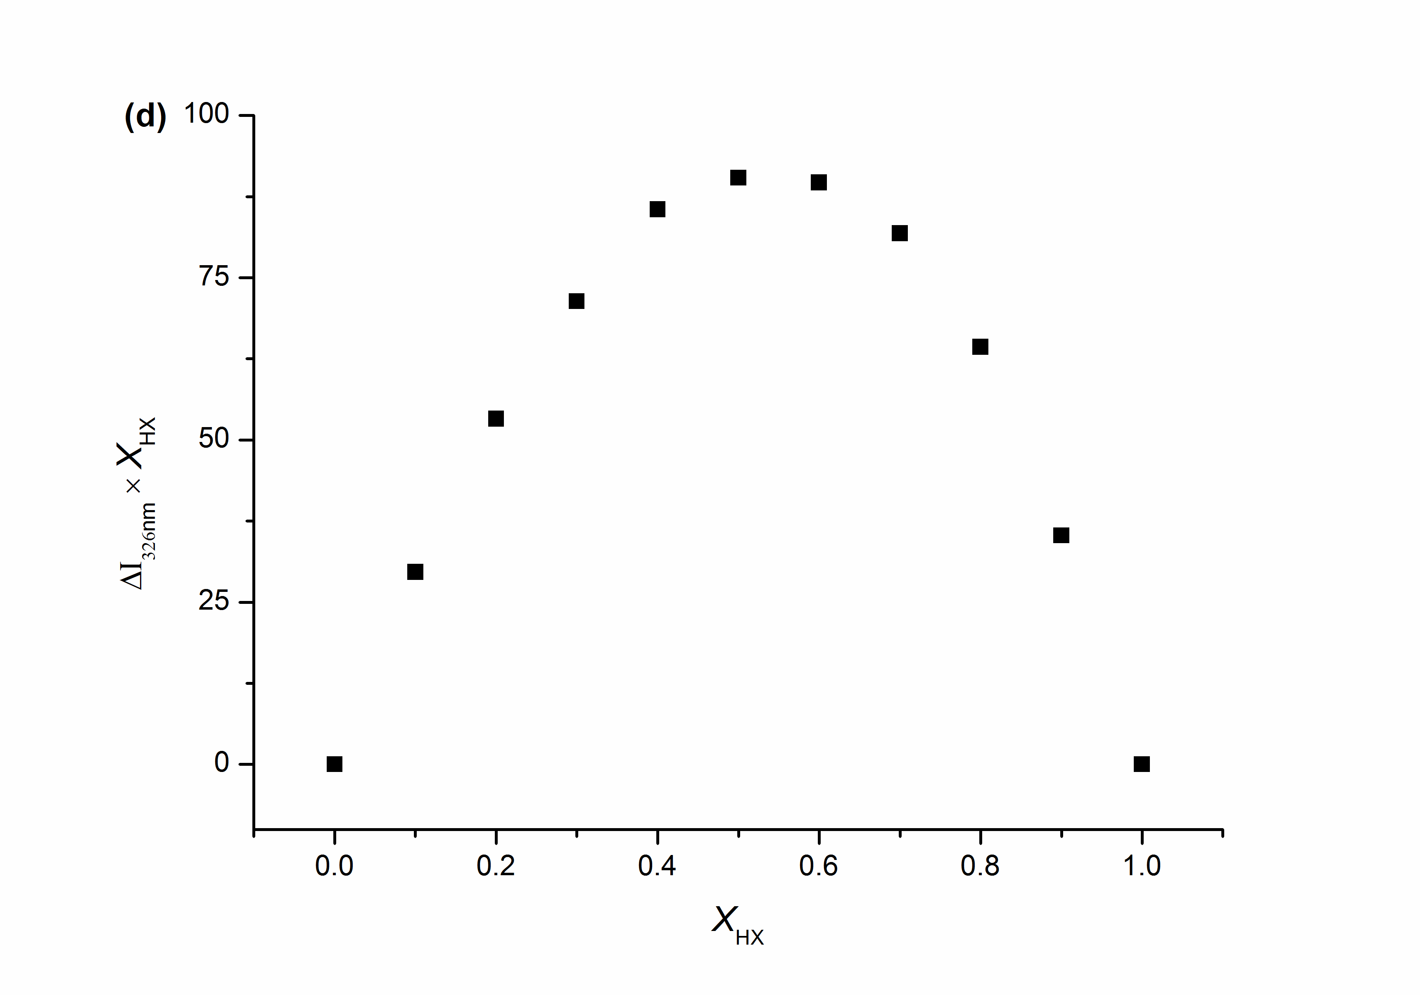

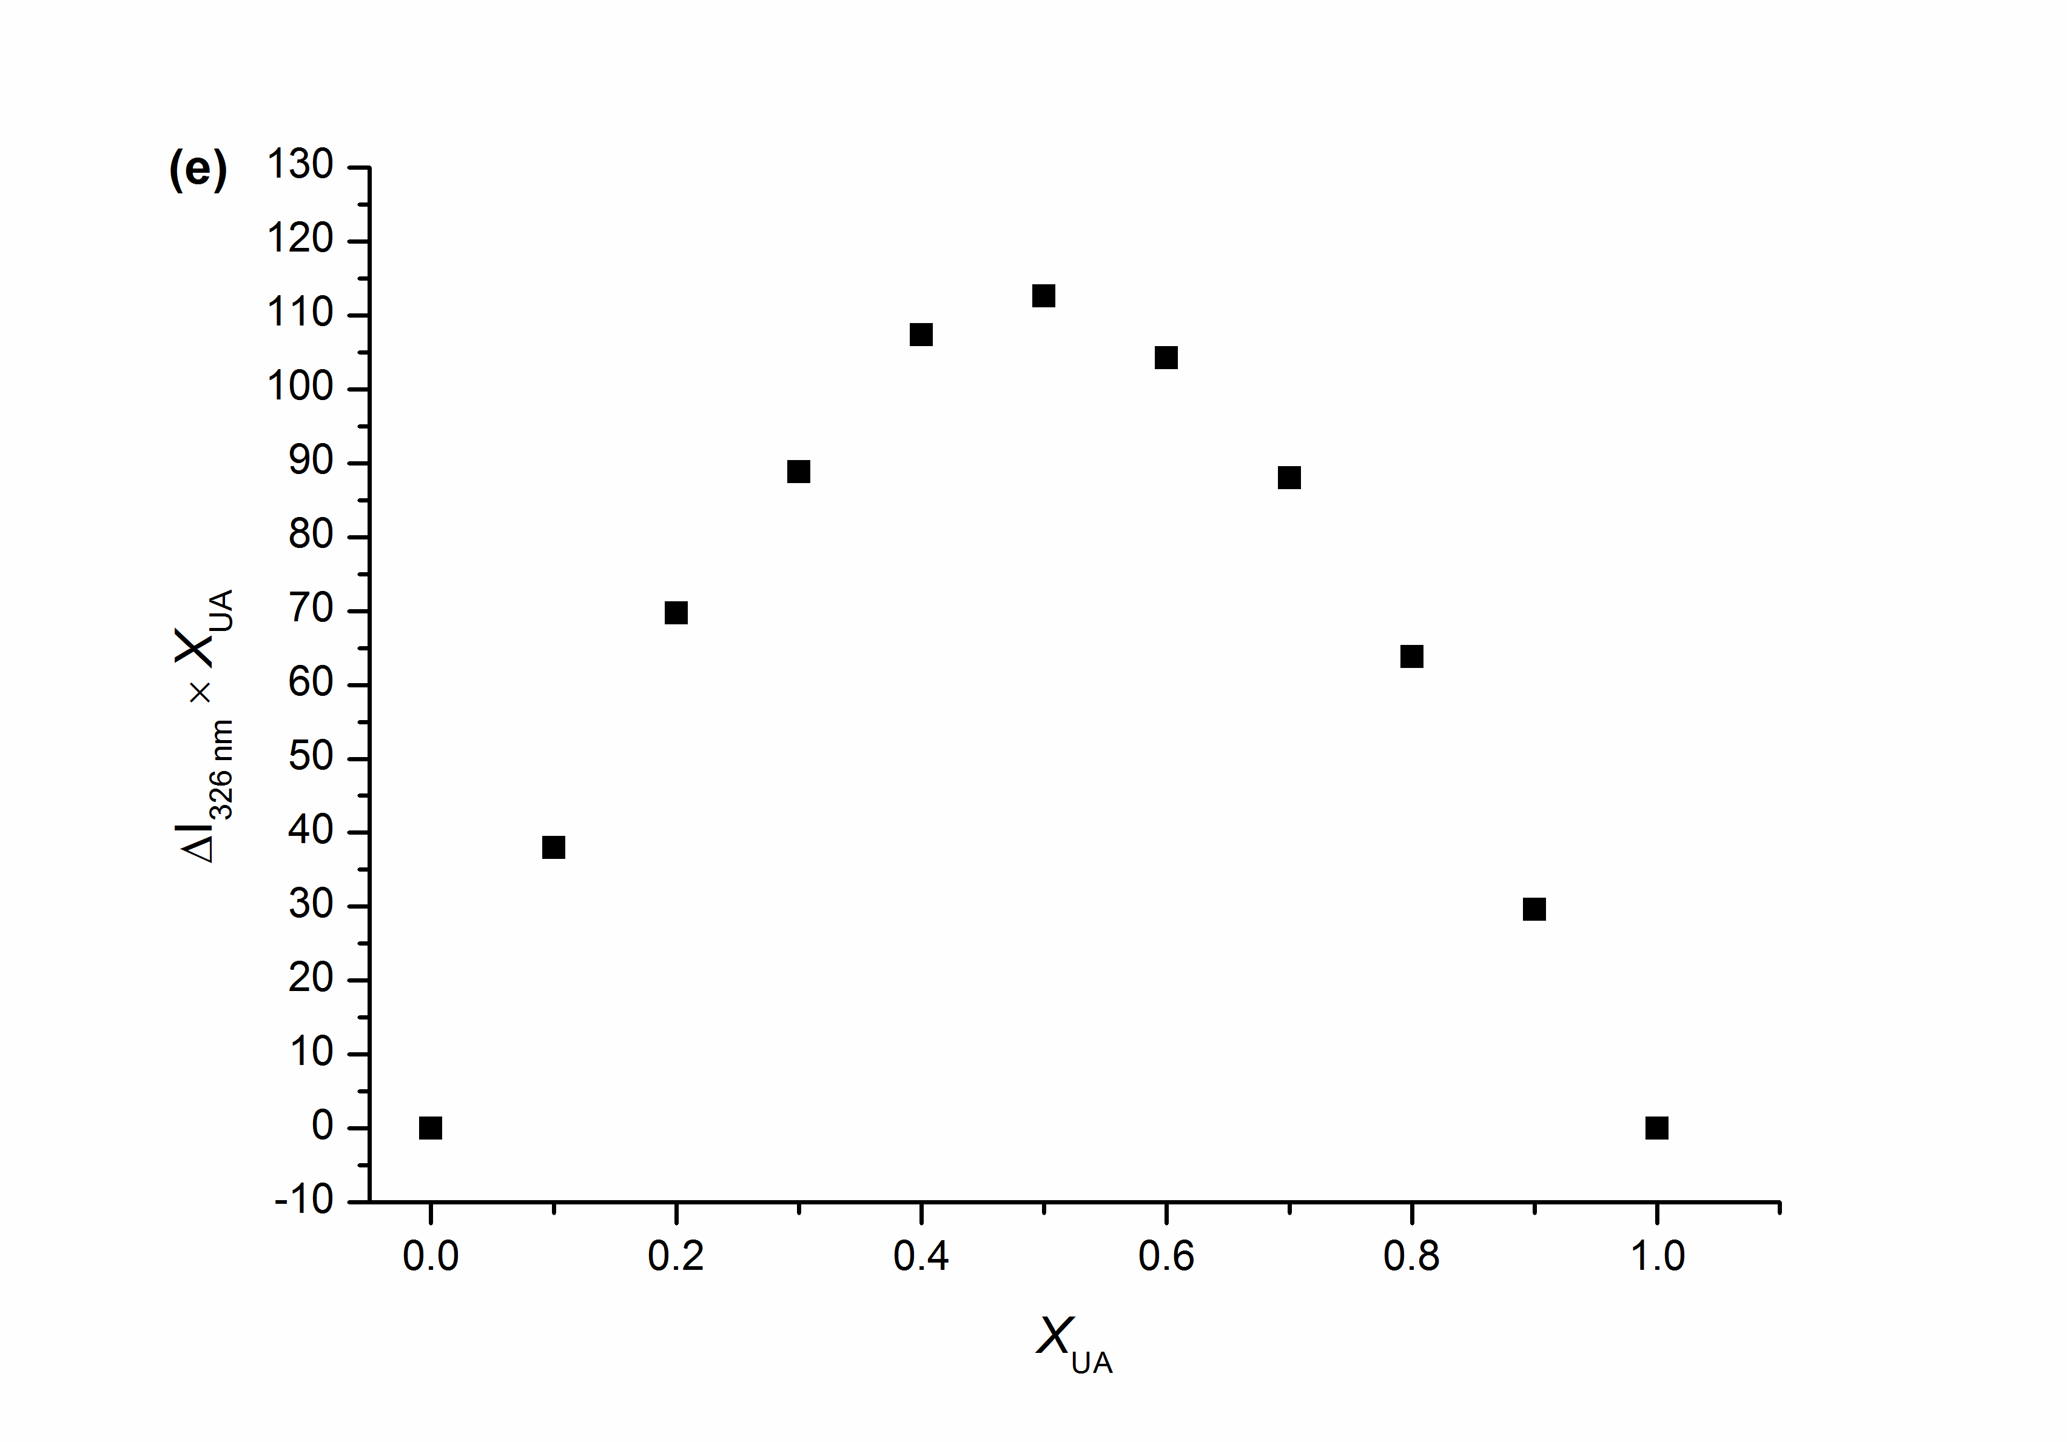

**Supplementary Figure 2.** Job plot showing the 1:1 stoichiometry of the complex between **CP6** and substrates (**A**, **G**, **X**, **HX, UA**) by plotting the difference in fluorescent emission intensity at *λ*emission = 326 nm (*λ*excitation = 290 nm) against the mole fraction of substrates at an invariant total concentration of 0.01 mM in aqueous solution, respectively.

*1.2 Association constants of* ***CP6****⊃* ***A/G/X/HX/UA***

To determine the association constants for the complexation between **CP6** and substrates (**A, G, X, HX,** and **UA**), fluorescence titration experiments were carried out in solutions which had a constant concentration of **CP6** (1.0 × 10–5 M) and varying concentrations of substrates. By a non-linear curve-fitting method, the association constants (*K*a) of **CP6**⊃**A/G/X/HX/UA** were estimated.

The non-linear curve-fittings were based on the equation:

*ΔF* = (*ΔF*∞/[H]0) (0.5[G]0 + 0.5([H]0+1/*K*a)−(0.5 ([G]02+(2[G]0(1/*K*a − [H]0)) + (1/*K*a + [H]0)2) 0.5)) (eq. 1)

Where *ΔF* is the fluorescence intensity changes at 326 nm at [H]0, *ΔF∞* is the fluorescence intensity changes at 326 nm when **CP6** is completely complexed, [G]0 is the initial concentration of substrates (**A, G, X, HX, and UA**), and [H]0 is the fixed initial concentration of **CP6**.S1

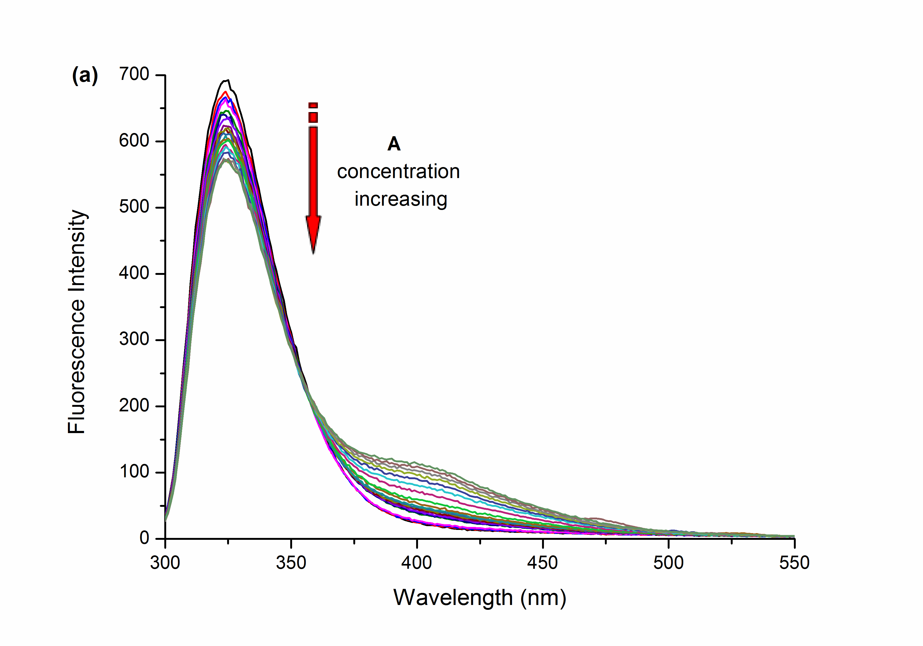 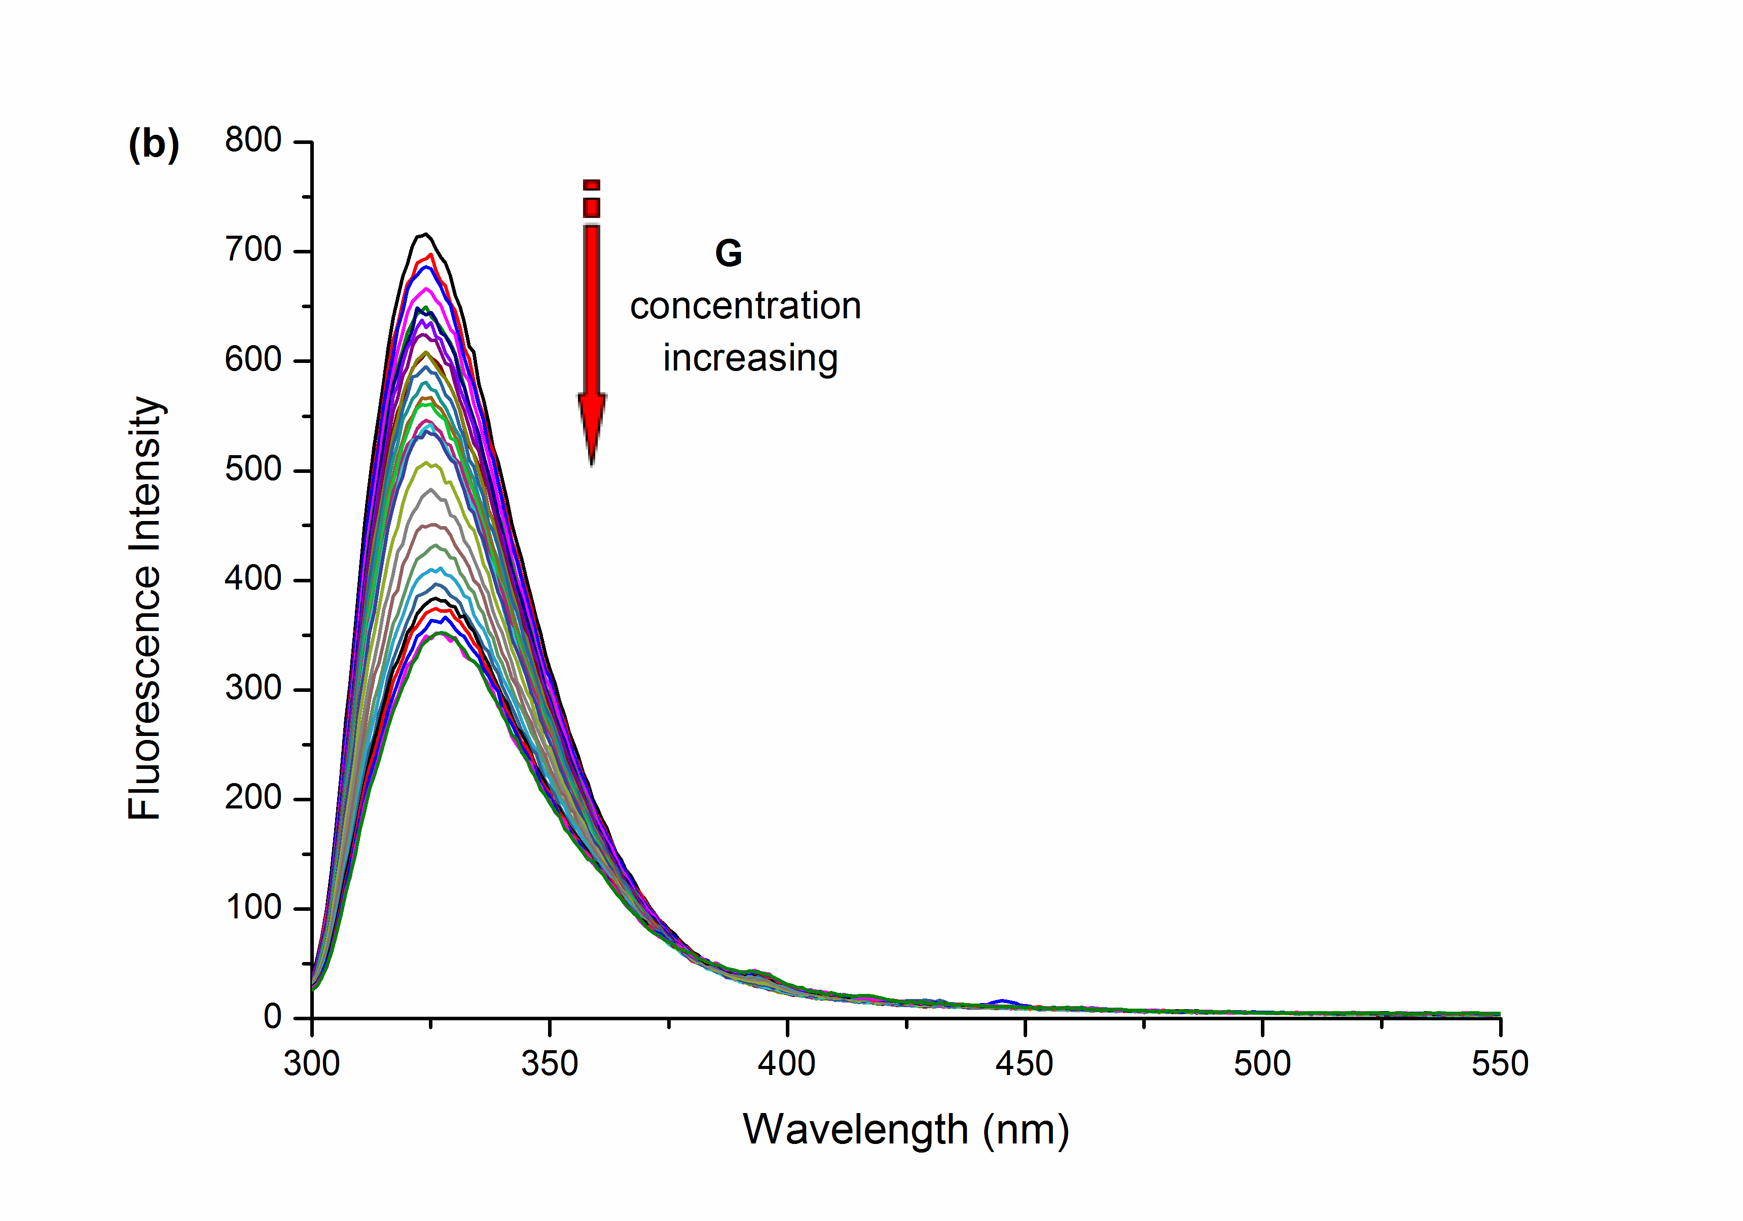

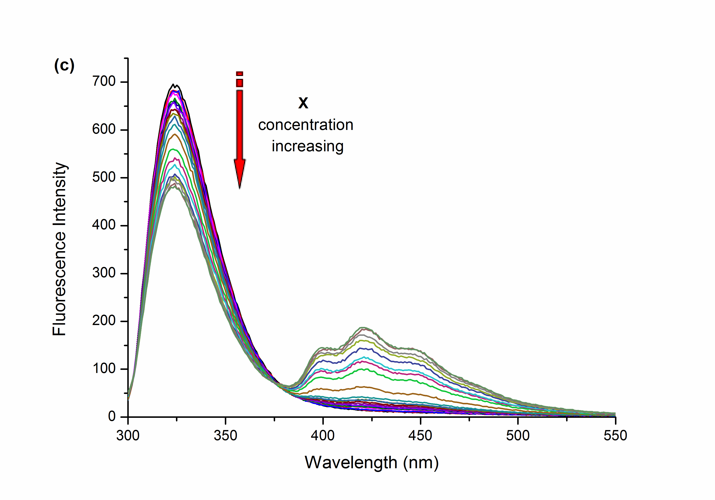 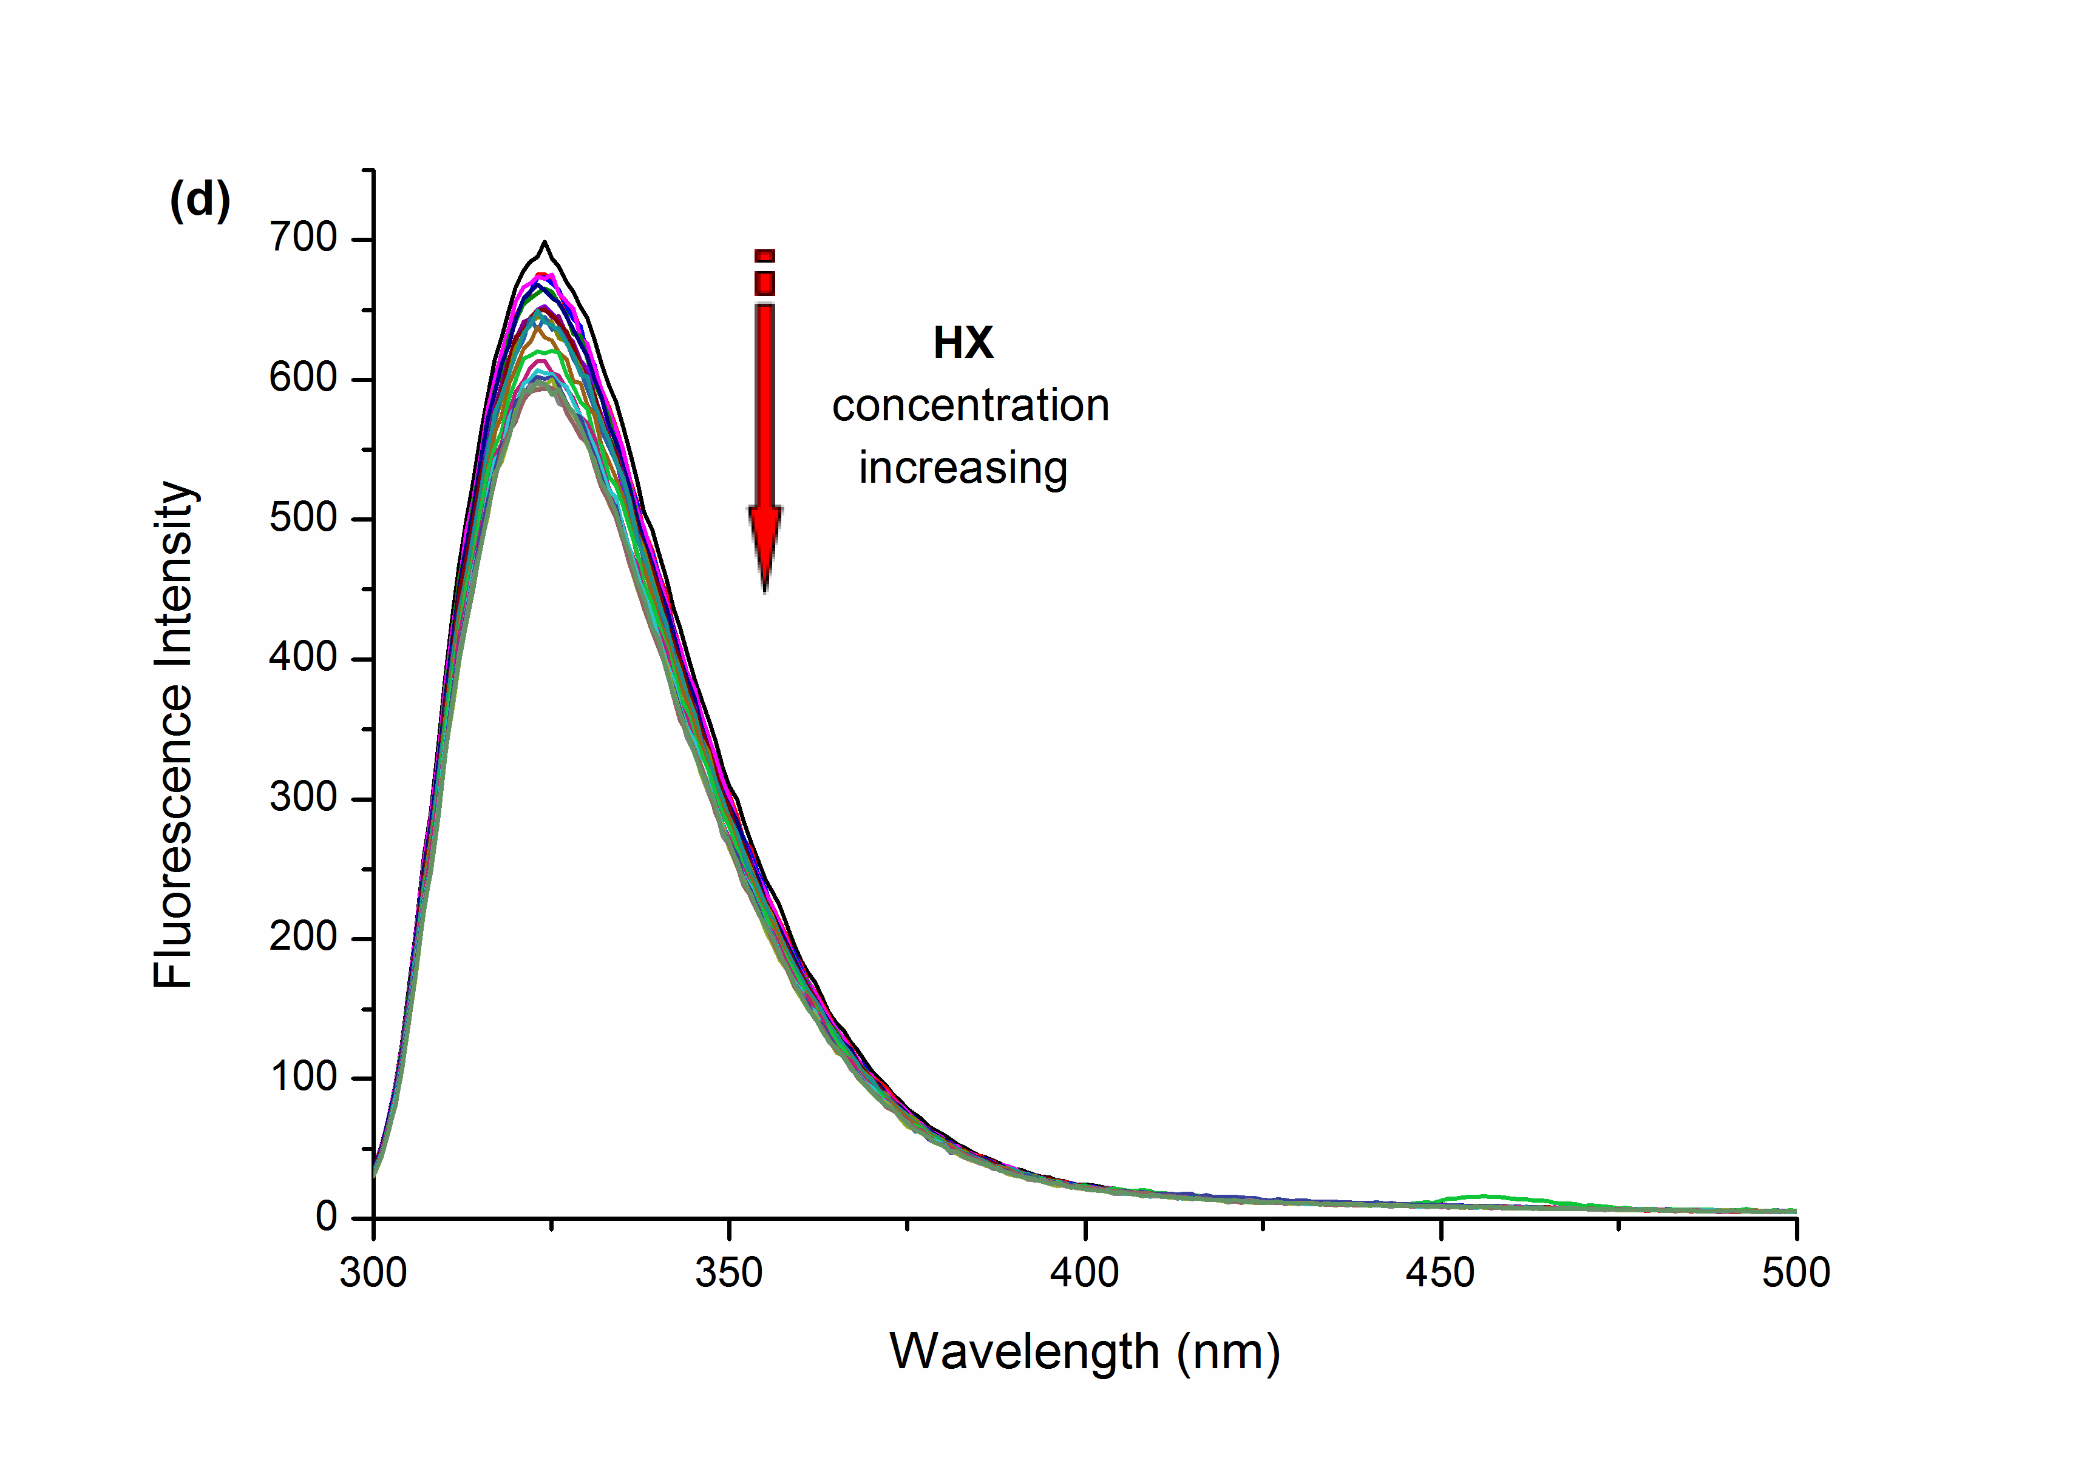

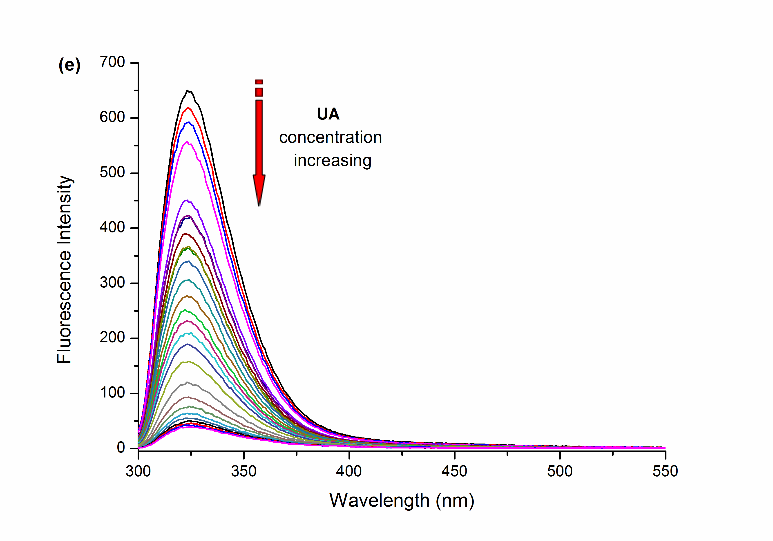

**Supplementary Figure 3.** (a-j) Fluorescence spectra of **CP6** (1.0 × 10–5 M) upon addition of substrates (**A, G, X, HX, UA**) (0-5.43 × 10–4 M) in aqueous solution (excited at 290 nm) at room temperature, respectively.

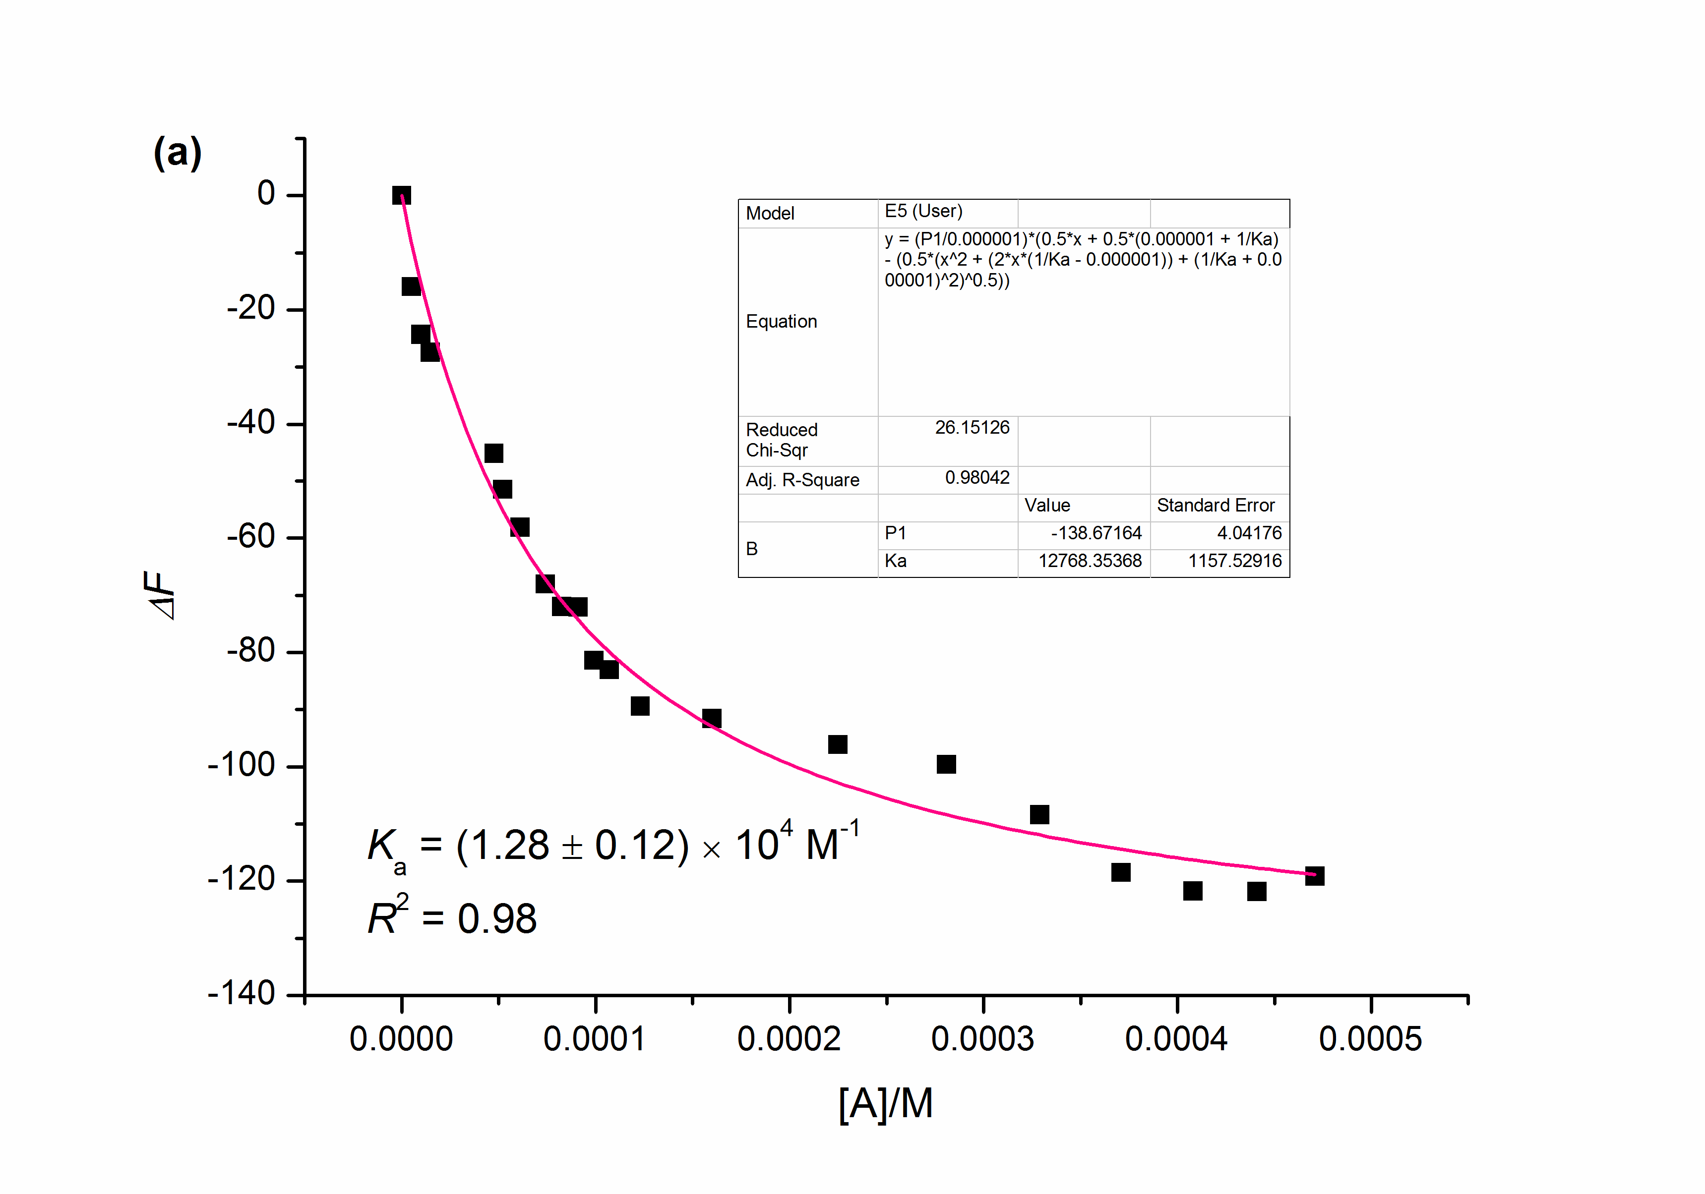 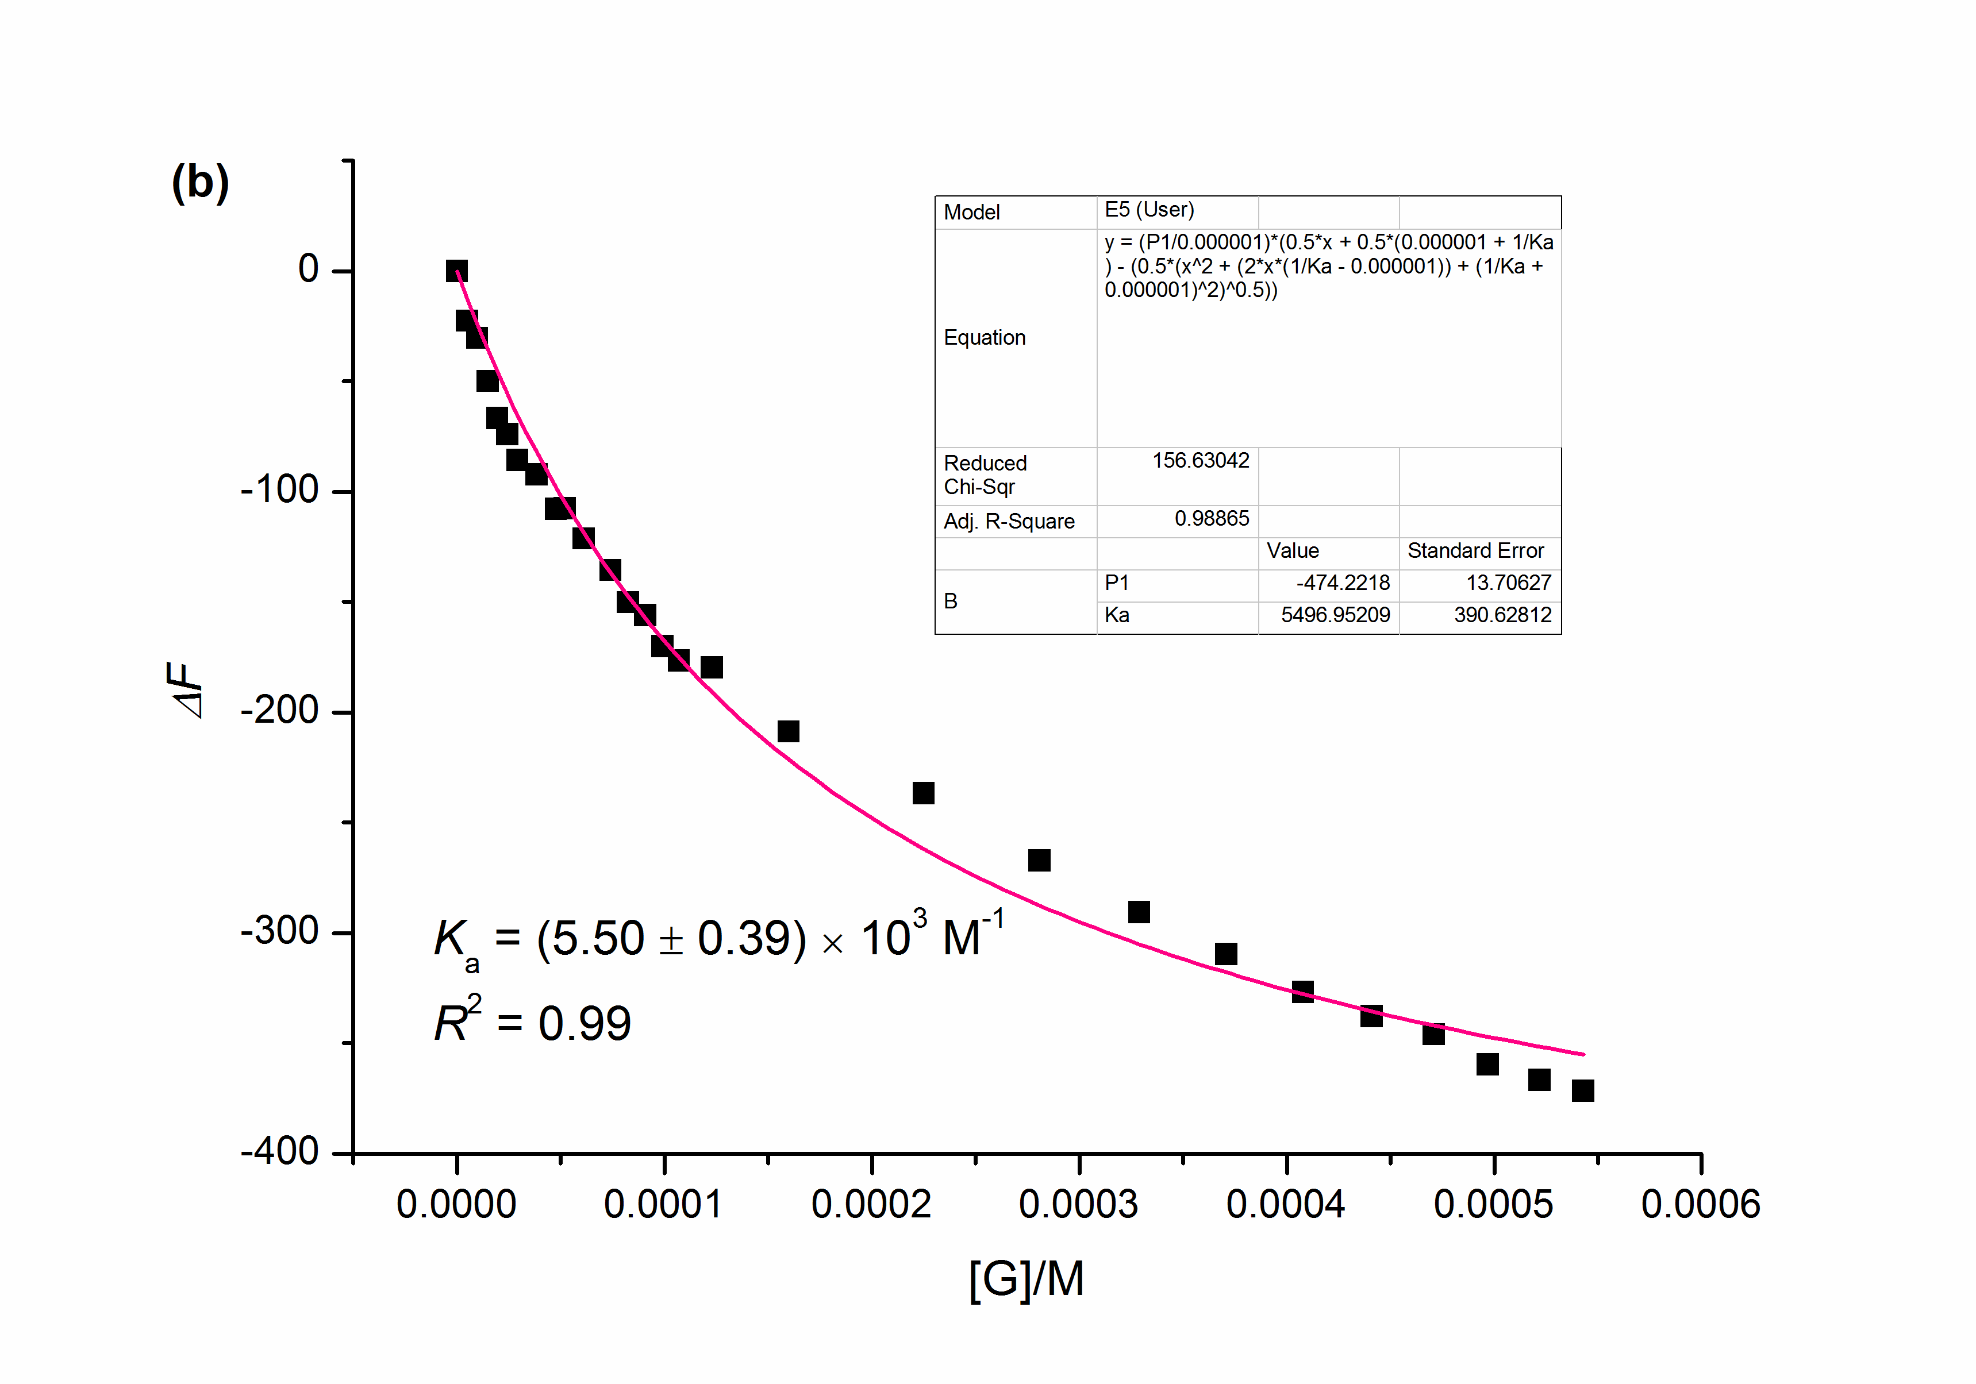

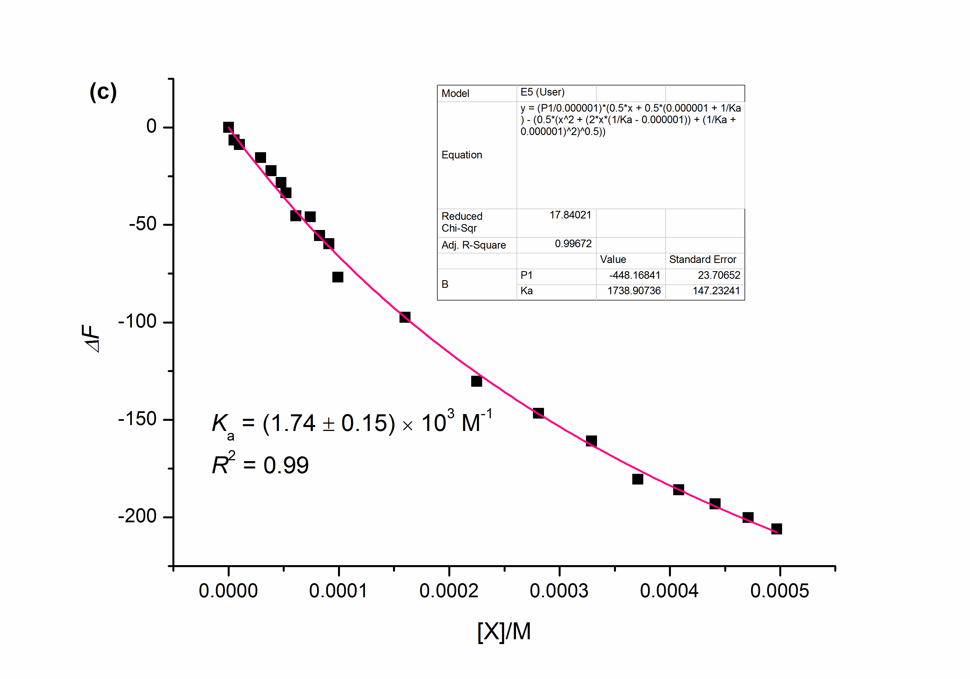 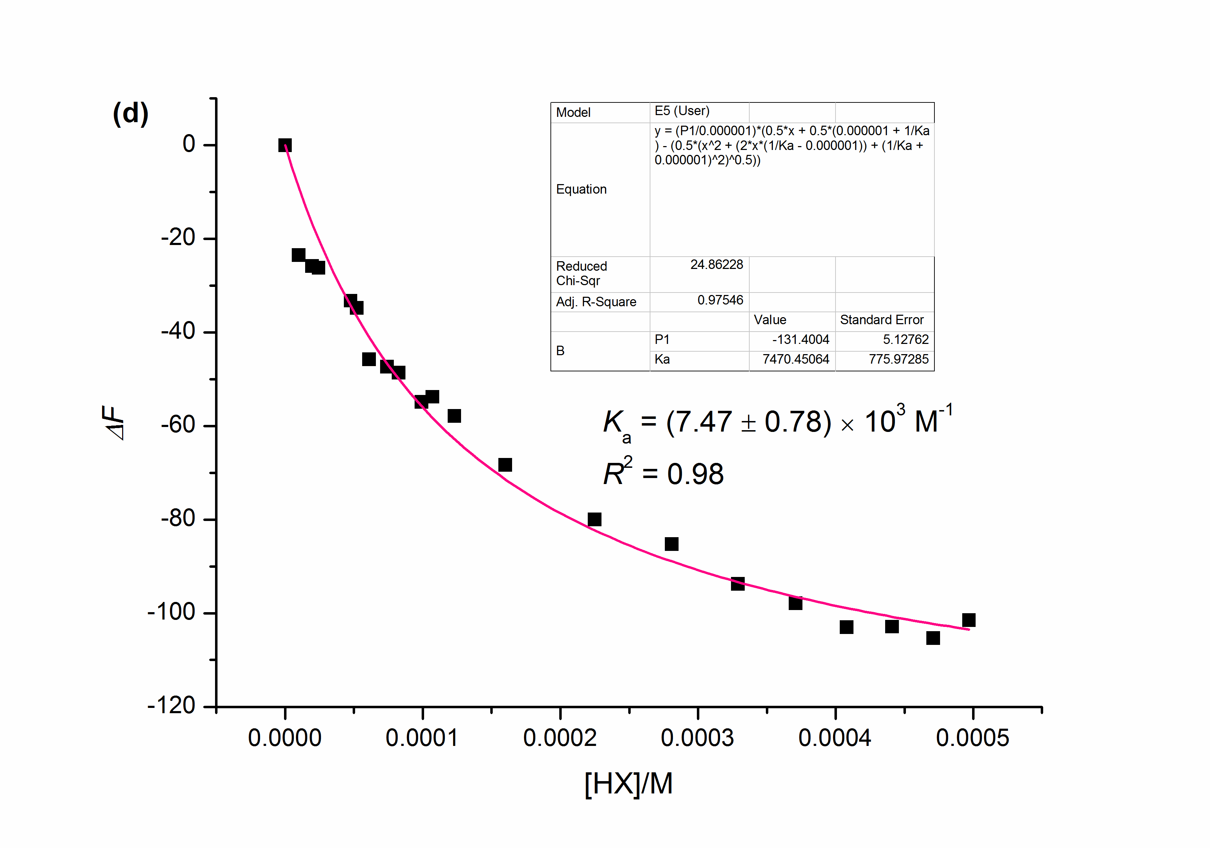

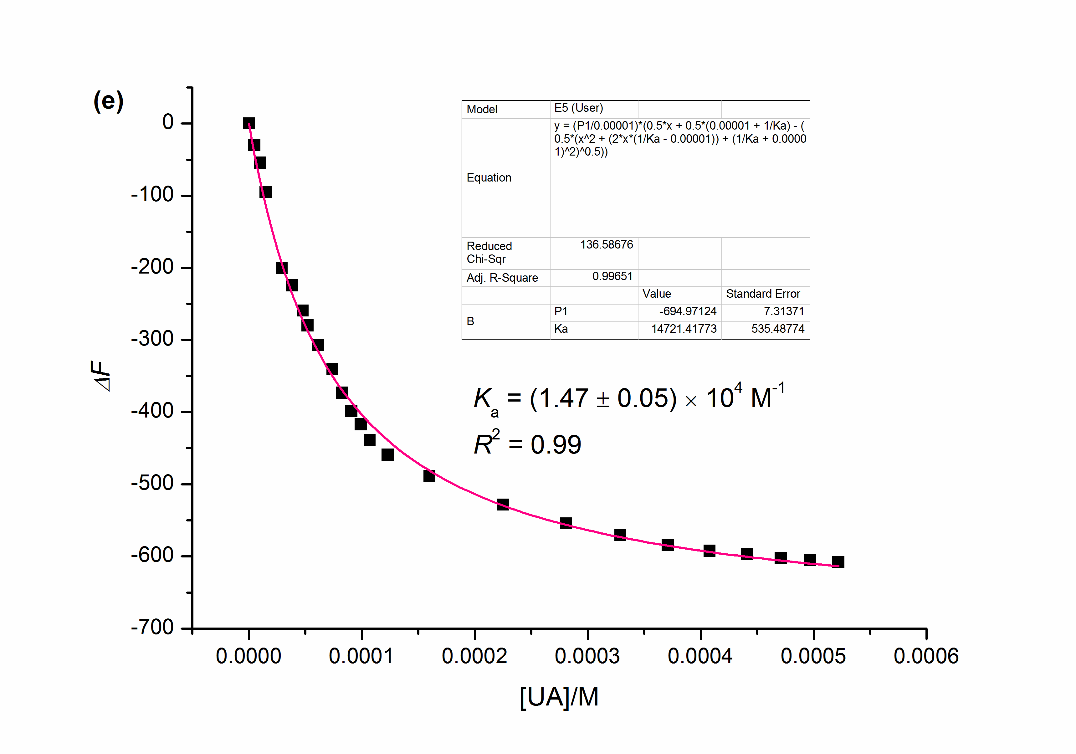

**Supplementary Figure 4.** The fluorescence intensity changes of **CP6** upon addition of substrates (**A, G, X, HX, UA**), respectively. The red solid line was obtained from the non-linear curve-fitting using eq. 1.

**Supplementary Table 1*.*** The association constants between substrates (**A, G, X, HX, UA**) and **CP6** by fluorescence titration experiments.

|  |  |  |  |
| --- | --- | --- | --- |
| Host (guest) | *K*a (L⋅mol-1) | Host (guest) | *K*a (L⋅mol-1) |
| CP6 (A) | (1.28 ± 0.12) × 104 | CP6 (G) | (5.50 ± 0.39) × 103 |
| CP6 (X) | (1.74 ± 0.15) × 103 | CP6 (HX) | (7.47 ± 0.78) × 103 |
| CP6 (UA) | (1.47 ± 0.05) × 104 |  |  |

*References:*

* S1. (a) K. A. Connors, Binding Constants, Wiley: New York, 1987. (b) P. S. Corbin, Ph.D. *Dissertation*, University of Illinois at Urbana-Champaign, Urbana, IL, 1999. (c) P. R. Ashton, R. Ballardini, V. Balzani, M. Belohradsky, M. T. Gandolfi, D. Philp, L. Prodi, F. M. Raymo, M. V. Reddington, N. Spencer, J. F. Stoddart, M. Venturi, D. J. Williams, *J. Am. Chem. Soc.* 118 (1996) 4931−4951. (d) J. Zhang, F. Huang, N. Li, H. Wang, H. W. Gibson, P. Gantzel, A. L. Rheingold, *J. Org. Chem.* 72 (2007) 8935−8938.