Supplementary Material

Connecting crabs, currents, and coastal communities: Examining the impacts of changing ocean conditions on the distribution of U.S. west coast Dungeness crab commercial catch

Magel, Caitlin L.^{1*}, Lee, Elizabeth M.J.², Strawn, Astrea M.³, Swieca, Kelsey¹, & Jensen, Andrew D.⁴

¹ Department of Integrative Biology, Oregon State University, Corvallis, OR, United States
² Department of Fisheries and Wildlife, Coastal Oregon Marine Experiment Station, Hatfield Marine Science Center, Oregon State University, Newport, OR, United States
³ College of Earth, Ocean, and Atmospheric Sciences, Oregon State University, Corvallis, OR, United States
⁴ Department of Mathematics, Oregon State University, Corvallis, OR, United States

* Correspondence:
Caitlin L. Magel
whitecai@oregonstate.edu

Citation:
Magel CL, Lee EMJ, Strawn, AM, Swieca K and Jensen AD (2020) Connecting crabs, currents, and coastal communities: Examining the impacts of changing ocean conditions on the distribution of U.S. west coast Dungeness crab commercial catch. Front. Mar. Sci. 7:401. doi: 10.3389/fmars.2020.00401

Supplementary Tables

Table S1. Descriptions and sources of data used in the analyses.
Data | Scale | Source and/or Contact
Washington Dungeness crab commercial catch data and fish tickets | Spatial (2 regions) and temporal (1981-2017) | Washington Department of Fish and Wildlife (Daniel Ayers)
Oregon Dungeness crab commercial catch data and fish tickets | Spatial (7 ports) and temporal (1981-2017) | Oregon Department of Fish and Wildlife (Kelly Corbett)
California Dungeness crab commercial catch data and fish tickets | Spatial (7 ports) and temporal (1981-2017) | California Department of Fish and Wildlife (Christy Juhasz)
California Dungeness crab commercial catch data | Spatial (7 ports) and temporal (1981-2017) | Pacific Fisheries Information Network (PacFIN)  https://pacfin.psmfc.org/#
Pacific Decadal Oscillation (PDO) Index | Monthly average (1977-2017) | http://research.jisao.washington.edu/pdo/PDO.latest
North Pacific Gyre Oscillation (NPGO) Index | Monthly average (1977-2017) | http://www.o3d.org/npgo/
Multivariate El Niño Southern Oscillation (ENSO) Index (MEI) | Monthly average  (1977-2017) | https://www.esrl.noaa.gov/psd/enso/mei/#data
Southern Oscillation Index (SOI) | Monthly average  (1977-2017) | https://www.ncdc.noaa.gov/teleconnections/enso/indicators/soi/
Sea surface temperature (SST) data | Pacific Ocean spatial and monthly average temporal (1977-2017) | NOAA ERSST-v5: https://www.ncdc.noaa.gov/data-access/marineocean-data/extended-reconstructed-sea-surface-temperature-ersst-v5
Bakun Upwelling Index (Upw) | Annual sum for 3-degree latitude increments (1977-2017) | https://www.pfeg.noaa.gov/products/PFEL/modeled/indices/upwelling/upwelling.html
Spring Transition Index (STI) | Annual day of year for 3-degree latitude increments (1977-2017) | Calculated from upwelling - method based on turning point in cumulative sum of upwelling (i.e., physical transition)
California Current Ekman Transport, Northward Component (EkTrans) | Annual sum for 3-degree latitude increments (1977-2017) | https://www.pfeg.noaa.gov/products/PFELData/arrowmark_indices/monthly.2000
Dungeness crab fishing reliance indices | 2015 values for U.S. west coast communities | Pacific States Marine Fisheries Commission (Anna Varney), NOAA Northwest Fisheries Science Center (Karma Norman)
Community Social Vulnerability Index (CSVI) | 2014 value for U.S. west coast communities | Pacific States Marine Fisheries Commission (Anna Varney)  https://www.webapps.nwfsc.noaa.gov/apex/parrdata/inventory/tables/table/community_social_vulnerability_indicies

Table S2. List of all stationary (S) Generalized Additive Mixed Models (GAMM) and non-stationary (NS) Variable Coefficient GAMM (VC_GAMM) of Dungeness crab commercial catch per unit effort (CPUE) tested, individually, for each ocean condition (OC) variable: PDO, NPGO, MEI, SOI, SST, Upw, STI, and EkTrans.
Model Name | Model of Dungeness crab ln(CPUE) and Ocean Condition (OC)
dcrab_3_ns | gamm(lncpue~s(lat,k=5)+s(lat,by=OC_jan.to.jul_3lag_rescaled,k=5),correlation=corAR1(form= ~ year | flat),data=dcrab)
dcrab_4_ns | gamm(lncpue~s(lat,k=5)+s(lat,by=OC_jan.to.jul_4lag_rescaled,k=5),correlation=corAR1(form= ~ year | flat),data=dcrab)
dcrab_5_ns | gamm(lncpue~s(lat,k=5)+s(lat,by=OC_jan.to.jul_5lag_rescaled,k=5),correlation=corAR1(form= ~ year | flat),data=dcrab)
dcrab_3_s | gamm(lncpue~s(lat,k=5)+OC_jan.to.jul_3lag_rescaled,correlation=corAR1(form= ~ year | flat),data=dcrab)
dcrab_4_s | gamm(lncpue~s(lat,k=5)+OC_jan.to.jul_4lag_rescaled,correlation=corAR1(form= ~ year | flat),data=dcrab)
dcrab_5_s | gamm(lncpue~s(lat,k=5)+OC_jan.to.jul_5lag_rescaled,correlation=corAR1(form= ~ year | flat),data=dcrab)
dcrab_all_ns | -gamm(lncpue~s(lat,k=5)+s(lat,by=OC_jan.to.jul_3lag_rescaled,k=5)+s(lat,by=OC_jan.to.jul_4lag_rescaled,k=5)+s(lat,by=OC_jan.to.jul_5lag_rescaled,k=5),correlation=corAR1(form= ~ year | flat),data=dcrab)
dcrab_3_4_ns | gamm(lncpue~s(lat,k=5)+s(lat,by=OC_jan.to.jul_3lag_rescaled,k=5)+s(lat,by=OC_jan.to.jul_4lag_rescaled,k=5),correlation=corAR1(form= ~ year | flat),data=dcrab)
dcrab_4_5_ns | gamm(lncpue~s(lat,k=5)+s(lat,by=OC_jan.to.jul_4lag_rescaled,k=5)+s(lat,by=OC_jan.to.jul_5lag_rescaled,k=5),correlation=corAR1(form= ~ year | flat),data=dcrab)
dcrab_3_5_ns | gamm(lncpue~s(lat,k=5)+s(lat,by=OC_jan.to.jul_3lag_rescaled,k=5)+s(lat,by=OC_jan.to.jul_5lag_rescaled,k=5),correlation=corAR1(form= ~ year | flat),data=dcrab)
dcrab_all_s | gamm(lncpue~s(lat,k=5)+OC_jan.to.jul_3lag_rescaled+OC_jan.to.jul_4lag_rescaled+OC_jan.to.jul_5lag_rescaled,correlation=corAR1(form= ~ year | flat),data=dcrab)
dcrab_3_4_s | gamm(lncpue~s(lat,k=5)+OC_jan.to.jul_3lag_rescaled+OC_jan.to.jul_4lag_rescaled,correlation=corAR1(form= ~ year | flat),data=dcrab)
dcrab_4_5_s | gamm(lncpue~s(lat,k=5)+OC_jan.to.jul_4lag_rescaled+OC_jan.to.jul_5lag_rescaled,correlation=corAR1(form= ~ year | flat),data=dcrab)
dcrab_3_5_s | gamm(lncpue~s(lat,k=5)+OC_jan.to.jul_3lag_rescaled+OC_jan.to.jul_5lag_rescaled,correlation=corAR1(form= ~ year | flat),data=dcrab)
dcrab_all_s_5 | gamm(lncpue~s(lat,k=5)+OC_jan.to.jul_3lag_rescaled+OC_jan.to.jul_4lag_rescaled+s(lat,by=OC_jan.to.jul_5lag_rescaled,k=5),correlation=corAR1(form= ~ year | flat),data=dcrab)
dcrab_all_s_4 | gamm(lncpue~s(lat,k=5)+OC_jan.to.jul_3lag_rescaled+s(lat,by=OC_jan.to.jul_4lag_rescaled,k=5)+OC_jan.to.jul_5lag_rescaled,correlation=corAR1(form= ~ year | flat),data=dcrab)
dcrab_all_s_3 | gamm(lncpue~s(lat,k=5)+s(lat,by=OC_jan.to.jul_3lag_rescaled,k=5)+OC_jan.to.jul_4lag_rescaled+OC_jan.to.jul_5lag_rescaled,correlation=corAR1(form= ~ year | flat),data=dcrab)
dcrab_all_s_4_5 | gamm(lncpue~s(lat,k=5)+OC_jan.to.jul_3lag_rescaled+s(lat,by=OC_jan.to.jul_4lag_rescaled,k=5)+s(lat,by=OC_jan.to.jul_5lag_rescaled,k=5),correlation=corAR1(form= ~ year | flat),data=dcrab)
dcrab_all_s_3_4 | gamm(lncpue~s(lat,k=5)+s(lat,by=OC_jan.to.jul_3lag_rescaled,k=5)+s(lat,by=OC_jan.to.jul_4lag_rescaled,k=5)+OC_jan.to.jul_5lag_rescaled,correlation=corAR1(form= ~ year | flat),data=dcrab)
dcrab_all_s_3_5 | gamm(lncpue~s(lat,k=5)+s(lat,by=OC_jan.to.jul_3lag_rescaled,k=5)+OC_jan.to.jul_4lag_rescaled+s(lat,by=OC_jan.to.jul_5lag_rescaled,k=5),correlation=corAR1(form= ~ year | flat),data=dcrab)
dcrab_3_4_s_4 | gamm(lncpue~s(lat,k=5)+OC_jan.to.jul_3lag_rescaled+s(lat,by=OC_jan.to.jul_4lag_rescaled,k=5),correlation=corAR1(form= ~ year | flat),data=dcrab)
dcrab_3_4_s_3 | gamm(lncpue~s(lat,k=5)+s(lat,by=OC_jan.to.jul_3lag_rescaled,k=5)+OC_jan.to.jul_4lag_rescaled,correlation=corAR1(form= ~ year | flat),data=dcrab)
dcrab_4_5_s_4 | gamm(lncpue~s(lat,k=5)+s(lat,by=OC_jan.to.jul_4lag_rescaled,k=5)+OC_jan.to.jul_5lag_rescaled,correlation=corAR1(form= ~ year | flat),data=dcrab)
dcrab_4_5_s_5 | gamm(lncpue~s(lat,k=5)+OC_jan.to.jul_4lag_rescaled+s(lat,by=OC_jan.to.jul_5lag_rescaled,k=5),correlation=corAR1(form= ~ year | flat),data=dcrab)
dcrab_3_5_s_5 | gamm(lncpue~s(lat,k=5)+OC_jan.to.jul_3lag_rescaled+s(lat,by=OC_jan.to.jul_5lag_rescaled,k=5),correlation=corAR1(form= ~ year | flat),data=dcrab)
dcrab_3_5_s_3 | gamm(lncpue~s(lat,k=5)+s(lat,by=OC_jan.to.jul_3lag_rescaled,k=5)+OC_jan.to.jul_5lag_rescaled,correlation=corAR1(form= ~ year | flat),data=dcrab)

Table S3. Results of the SST VC_GAMM predictions for ln(CPUE) under two scenarios (+1.7 °C and +2.8 °C) compared to the mean ln(CPUE) of Dungeness crab from 1981-2017 for 16 U.S. west coast ports/regions.
Management Region | Port Community | Port Latitude | Mean ln(CPUE) 1981-2017 | ln(CPUE) +1.7 °C | ln(CPUE) +2.8 °C
Washington | North | 47.8696 | 7.47 | 5.06 | 4.09
 | South | 46.7779 | 6.95 | 4.51 | 3.47
Oregon | Astoria | 46.1873 | 6.97 | 4.33 | 3.25
 | Garibaldi | 45.4562 | 6.09 | 4.14 | 3.01
 | Newport | 44.6368 | 7.00 | 3.75 | 2.57
 | Winchester Bay | 43.6773 | 6.40 | 3.63 | 2.39
 | Coos Bay | 43.3665 | 6.74 | 3.61 | 2.34
 | Port Orford | 42.7493 | 5.72 | 3.35 | 2.04
 | Brookings | 42.0526 | 6.39 | 3.34 | 1.98
Northern California | Crescent City | 41.7558 | 6.89 | 3.33 | 1.95
 | Eureka | 40.8021 | 6.32 | 2.96 | 1.51
 | Fort Bragg | 39.4457 | 6.28 | 2.82 | 1.28
Central California | Bodega Bay | 38.3332 | 6.11 | 2.32 | 0.71
 | San Francisco | 37.7740 | 6.22 | 2.15 | 0.50
 | Monterey | 36.6002 | 4.96 | 1.00 | 0.00
 | Morro Bay | 35.3659 | 5.16 | 0.44 | 0.00

Supplementary Figures
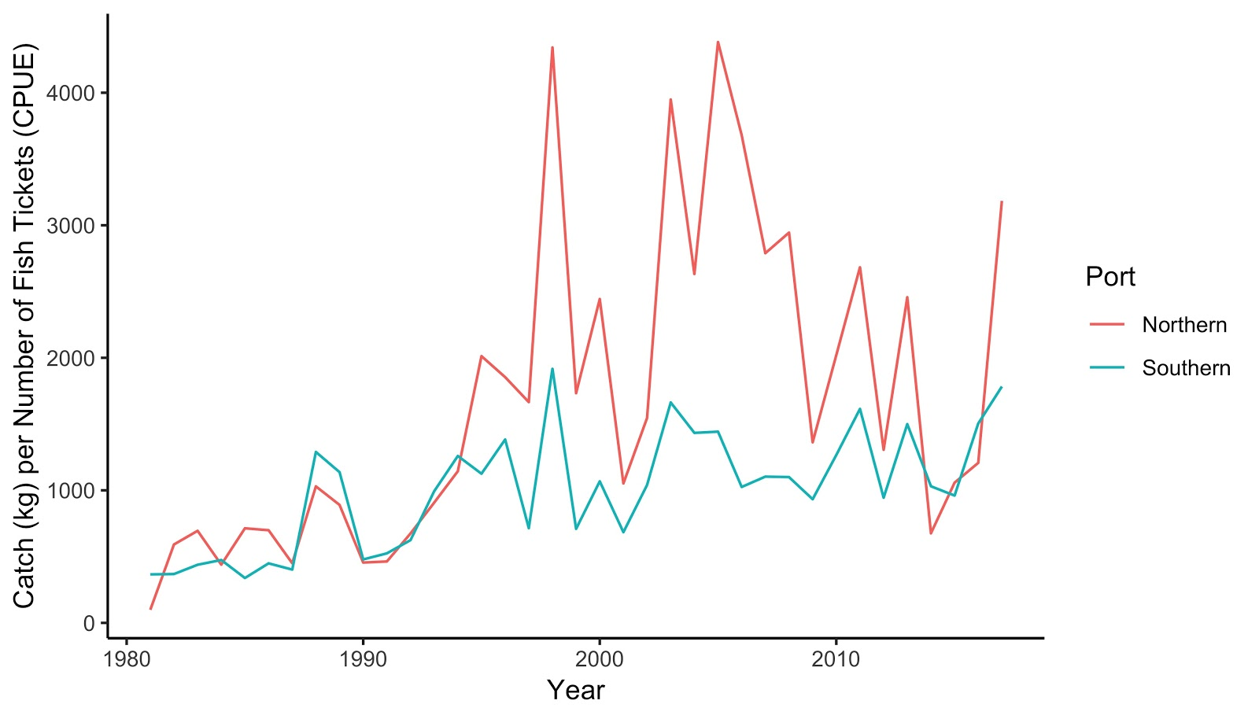
Figure S1. Washington Dungeness crab commercial catch per unit effort (CPUE) by region from 1981 to 2017. Data provided by WDFW 2018.

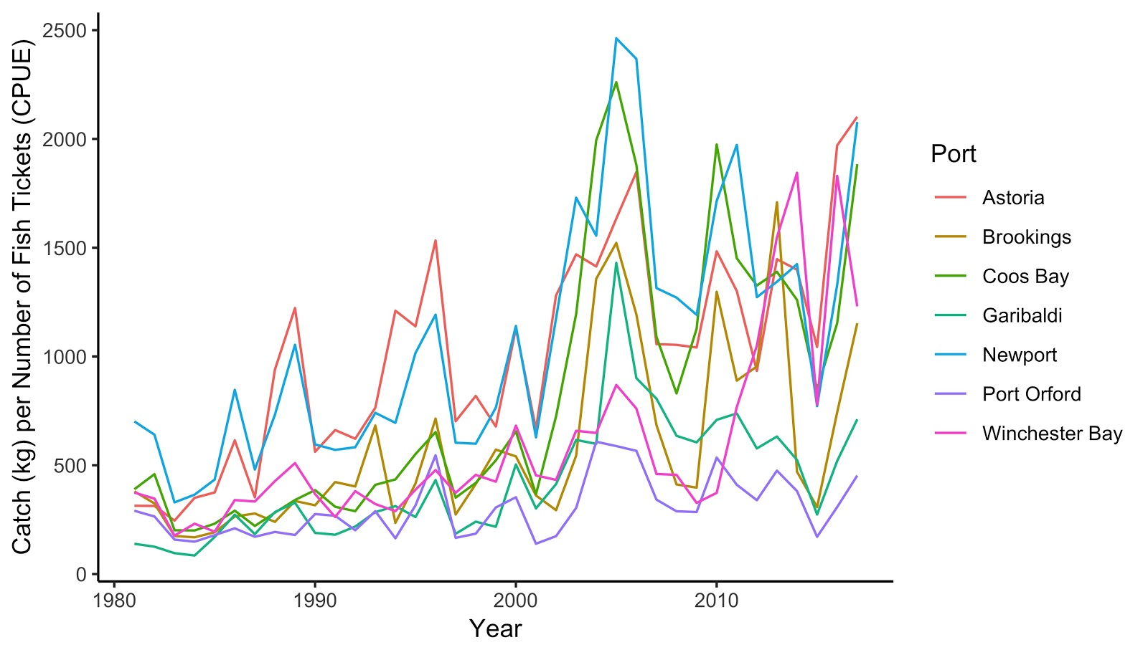
Figure S2. Oregon Dungeness crab commercial catch per unit effort (CPUE) by port from 1981 to 2017. Data provided by ODFW 2018.
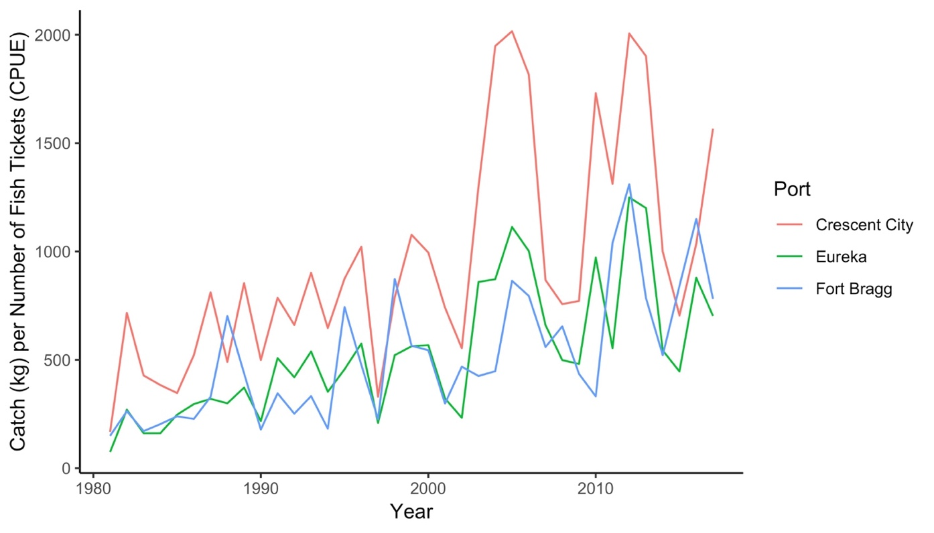
Figure S3. Northern California Dungeness crab commercial catch per unit effort (CPUE) by port from 1981 to 2017. Data provided by CDFW 2018.

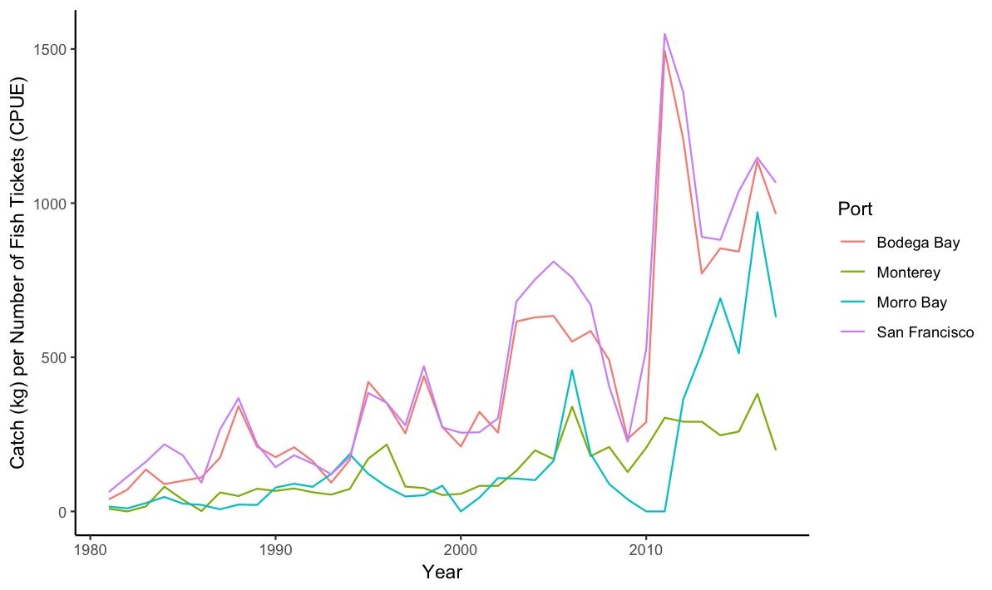
Figure S4. Central California Dungeness crab commercial catch per unit effort (CPUE) by port from 1981 to 2017. Data provided by CDFW 2018.
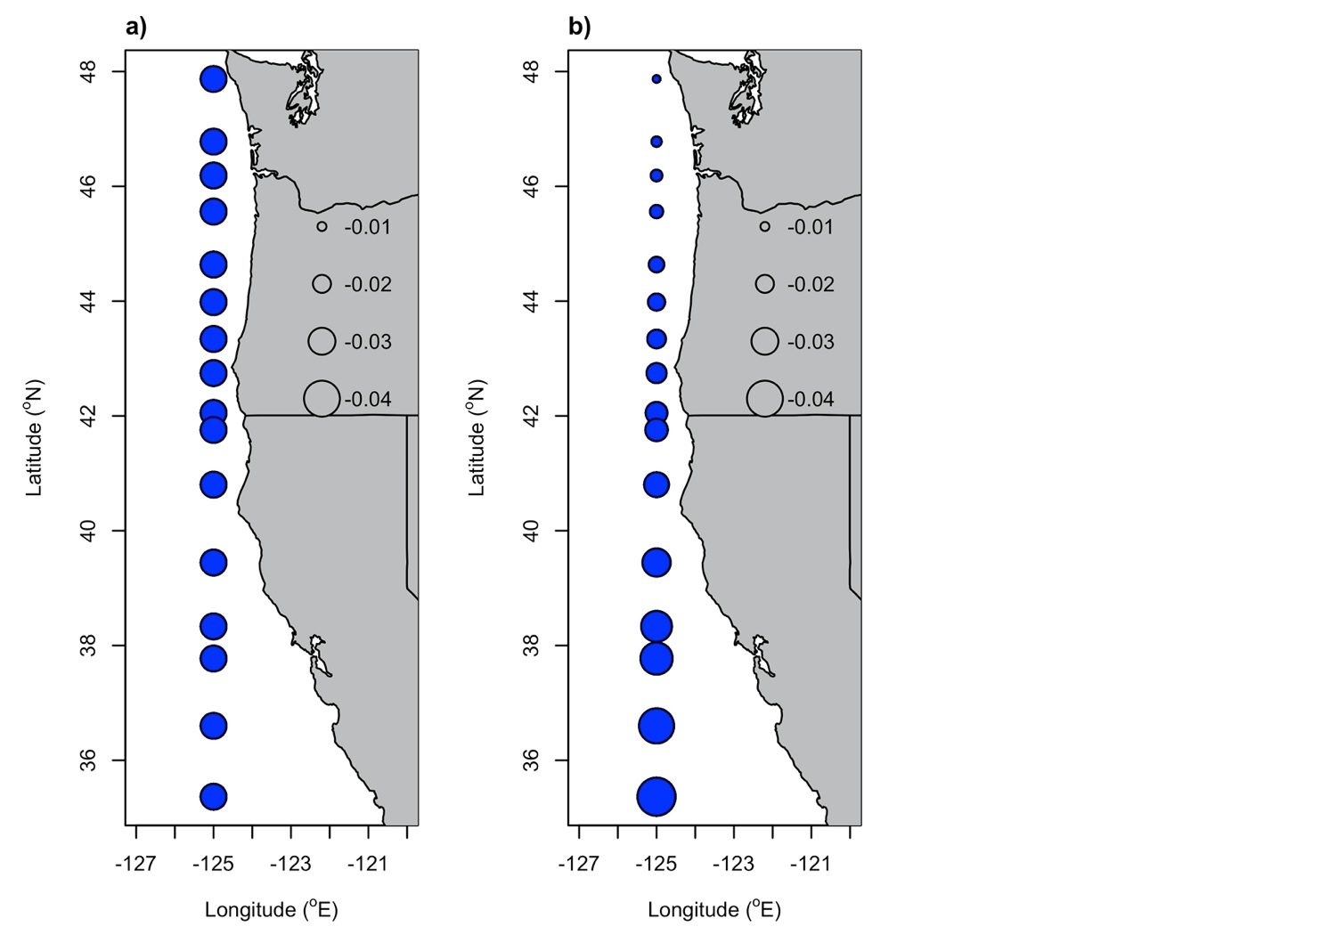
Figure S5. Coefficients of Pacific Decadal Oscillation (PDO) lagged by a) 4 years and b) 5 years in the selected model of Dungeness crab commercial ln(CPUE) along the U.S. west coast. The latitude of ports corresponding to each of the circular symbols are listed in Table 4. Blue symbols represent negative coefficients and the size of the symbol scales with the magnitude of the coefficient.

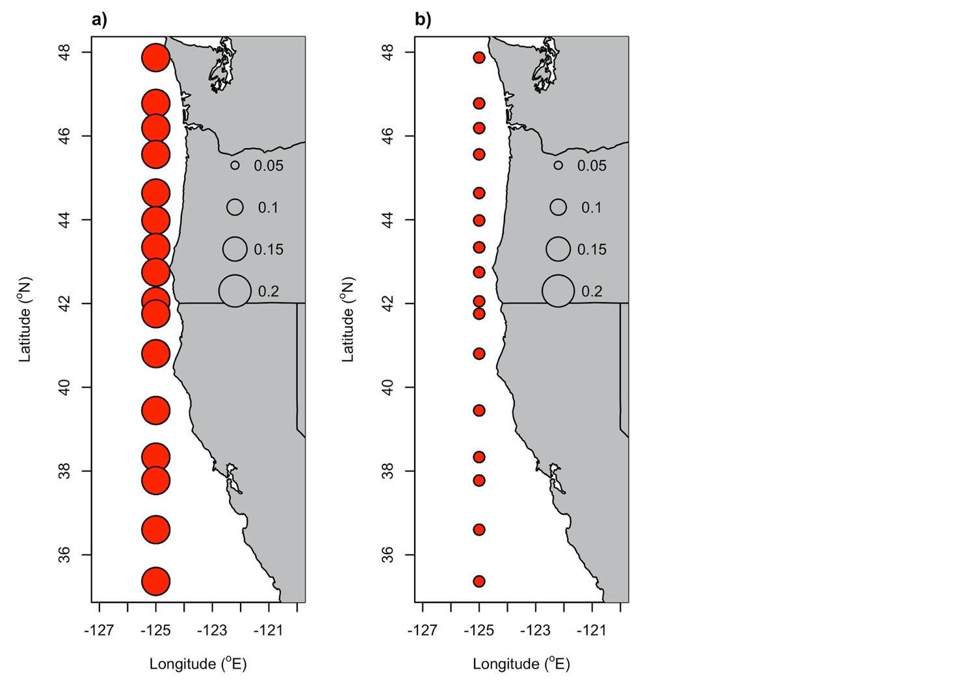
Figure S6. Coefficients of North Pacific Gyre Oscillation (NPGO) lagged by a) 4 years and b) 5 years in the selected model of Dungeness crab commercial ln(CPUE) along the U.S. west coast. The latitude of ports corresponding to each of the circular symbols are listed in Table 4. Red symbols represent positive coefficients and the size of the symbol scales with the magnitude of the coefficient.

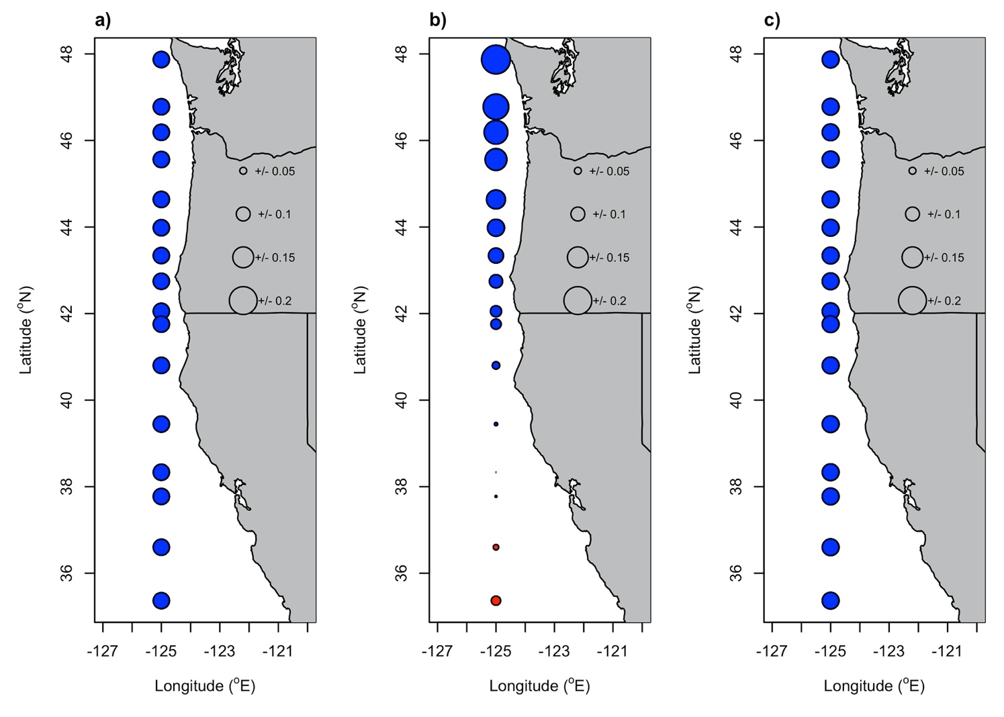
Figure S7. Coefficients of Multivariate El Niño Southern Oscillation Index (MEI) lagged by a) 3 years, b) 4 years, and c) 5 years in the selected model of Dungeness crab commercial ln(CPUE) along the U.S. west coast. The latitude of ports corresponding to each of the circular symbols are listed in Table 4. Blue symbols represent negative coefficients, red symbols represent positive coefficients, and the size of the symbol scales with the magnitude of the coefficient.

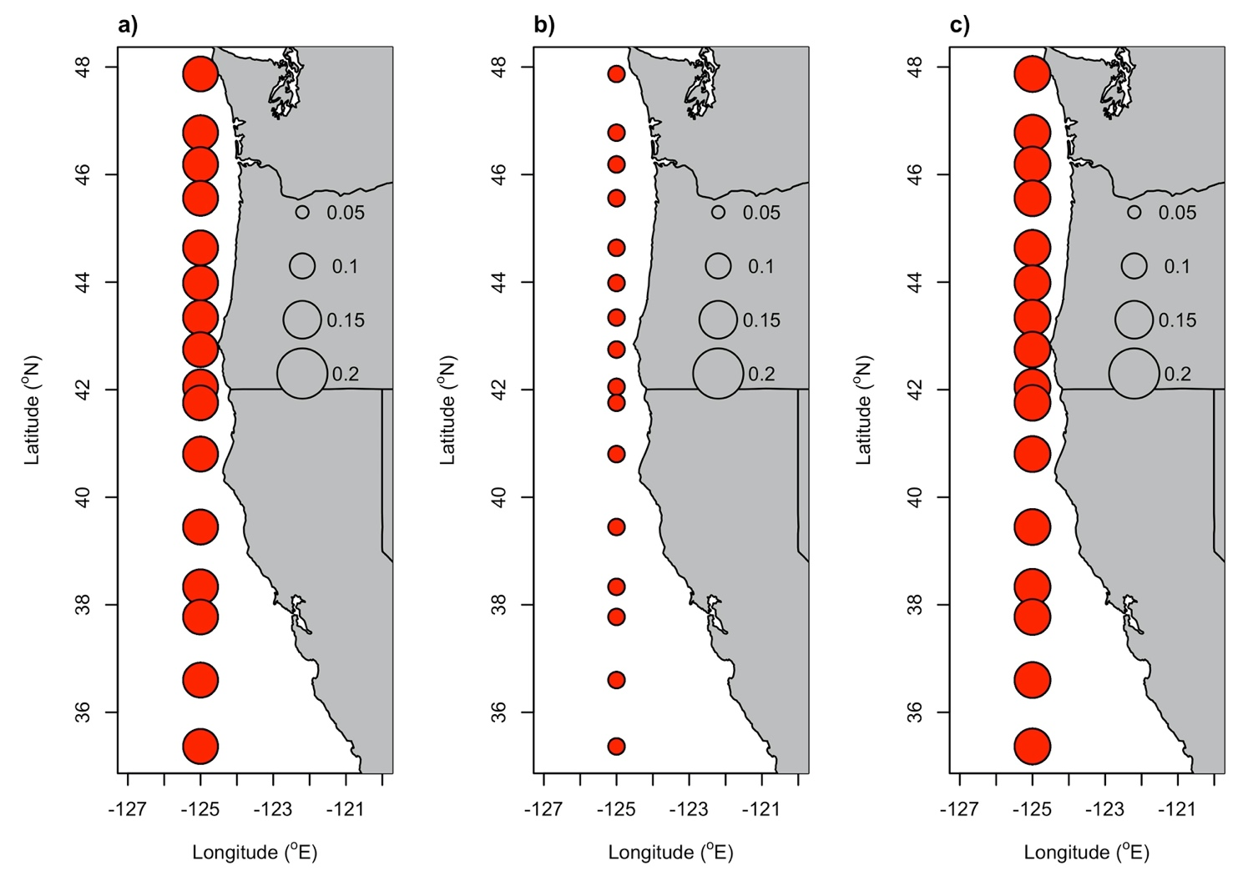
Figure S8. Coefficients of Southern Oscillation Index (SOI) lagged by a) 3 years, b) 4 years, and c) 5 years in the selected model of Dungeness crab commercial CPUE along the U.S. west coast. The latitude of ports corresponding to each of the circular symbols are listed in Table 4. Red symbols represent positive coefficients and the size of the symbol scales with the magnitude of the coefficient.

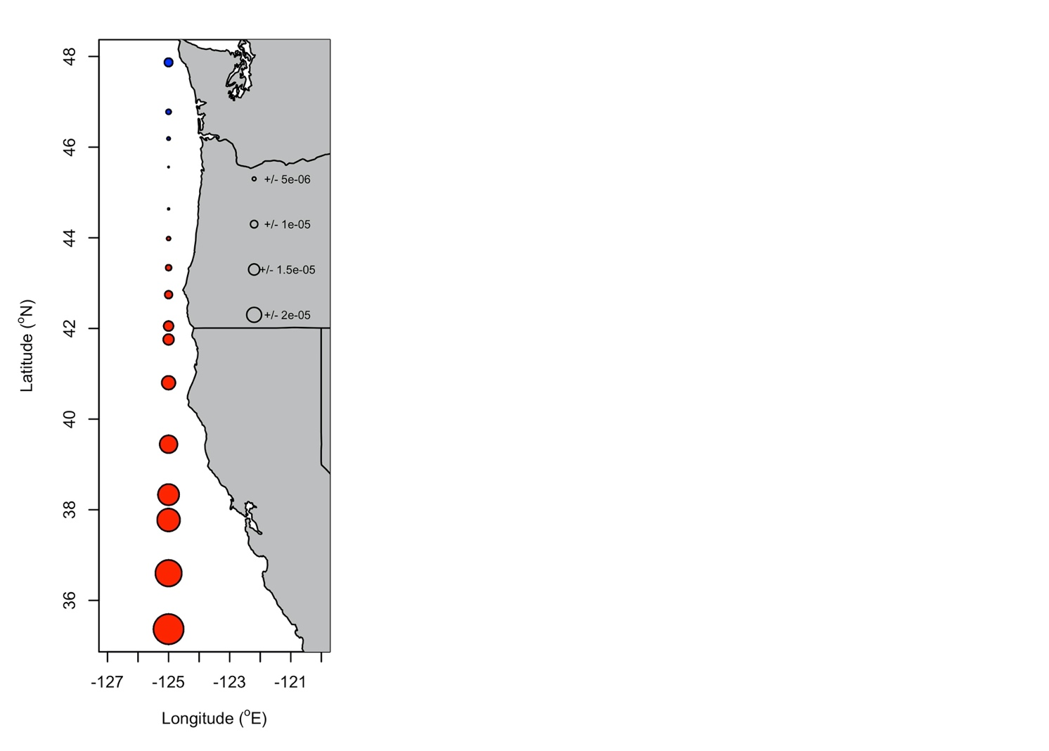
Figure S9. Coefficients of upwelling (Upw) lagged by 5 years in the selected model of Dungeness crab commercial ln(CPUE) along the U.S. west coast. The latitude of ports corresponding to each of the circular symbols are listed in Table 4. Blue symbols represent negative coefficients, red symbols represent positive coefficients, and the size of the symbol scales with the magnitude of the coefficient.
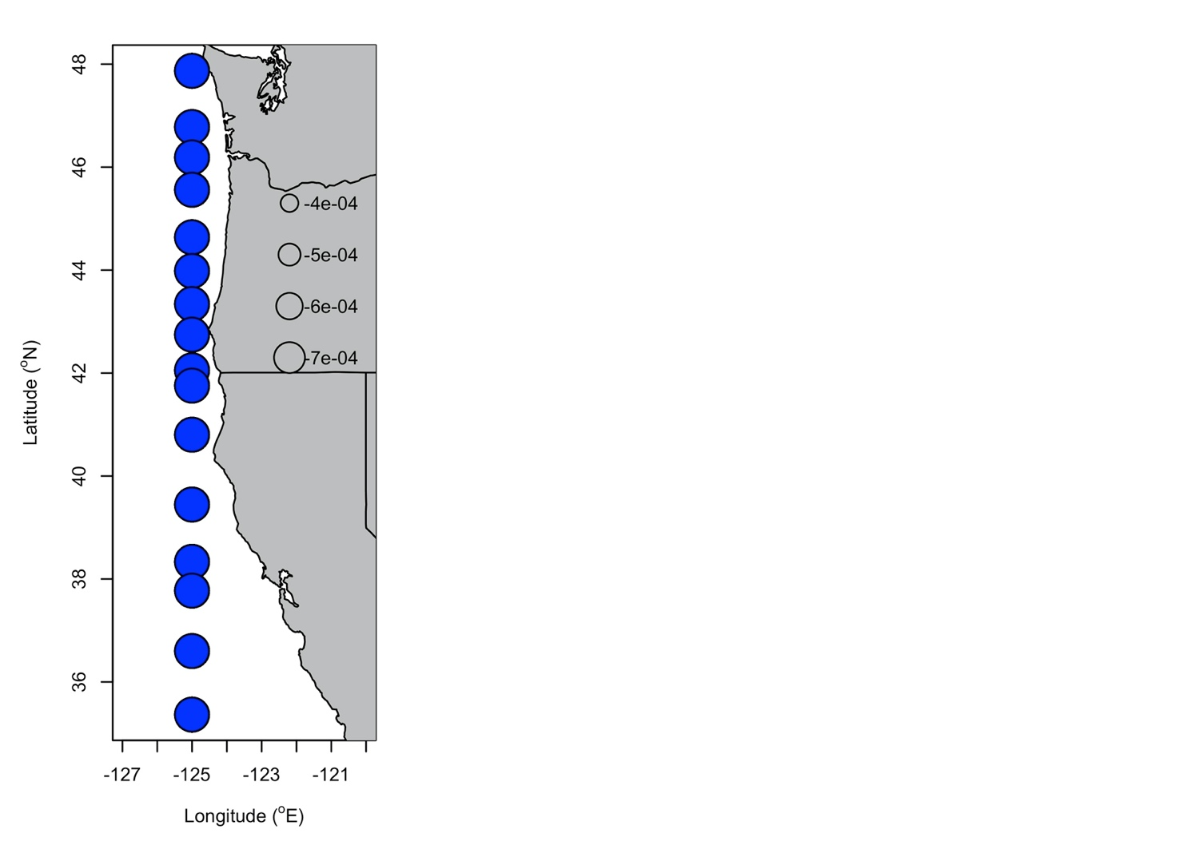
Figure S10. Coefficients of Spring Transition Index (STI) lagged by 3 years in the selected model of Dungeness crab commercial ln(CPUE) along the U.S. west coast. The latitude of ports corresponding to each of the circular symbols are listed in Table 4. Blue symbols represent negative coefficients and the size of the symbol scales with the magnitude of the coefficient.

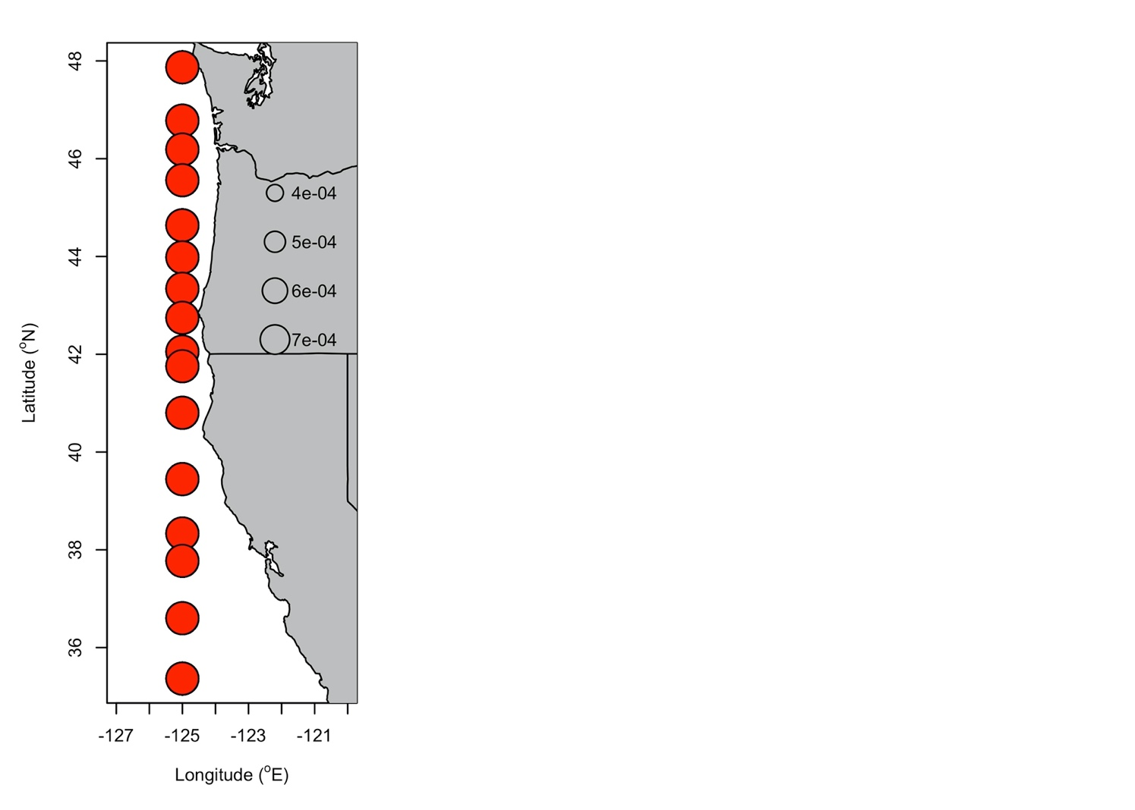
Figure S11. Coefficients of the northward component of Ekman Transport (EkTrans) lagged by 3 years in the selected model of Dungeness crab commercial ln(CPUE) along the U.S. west coast. The latitude of ports corresponding to each of the circular symbols are listed in Table 4. Red symbols represent positive coefficients and the size of the symbol scales with the magnitude of the coefficient.

