Supplementary Material

Supplementary Figure 1

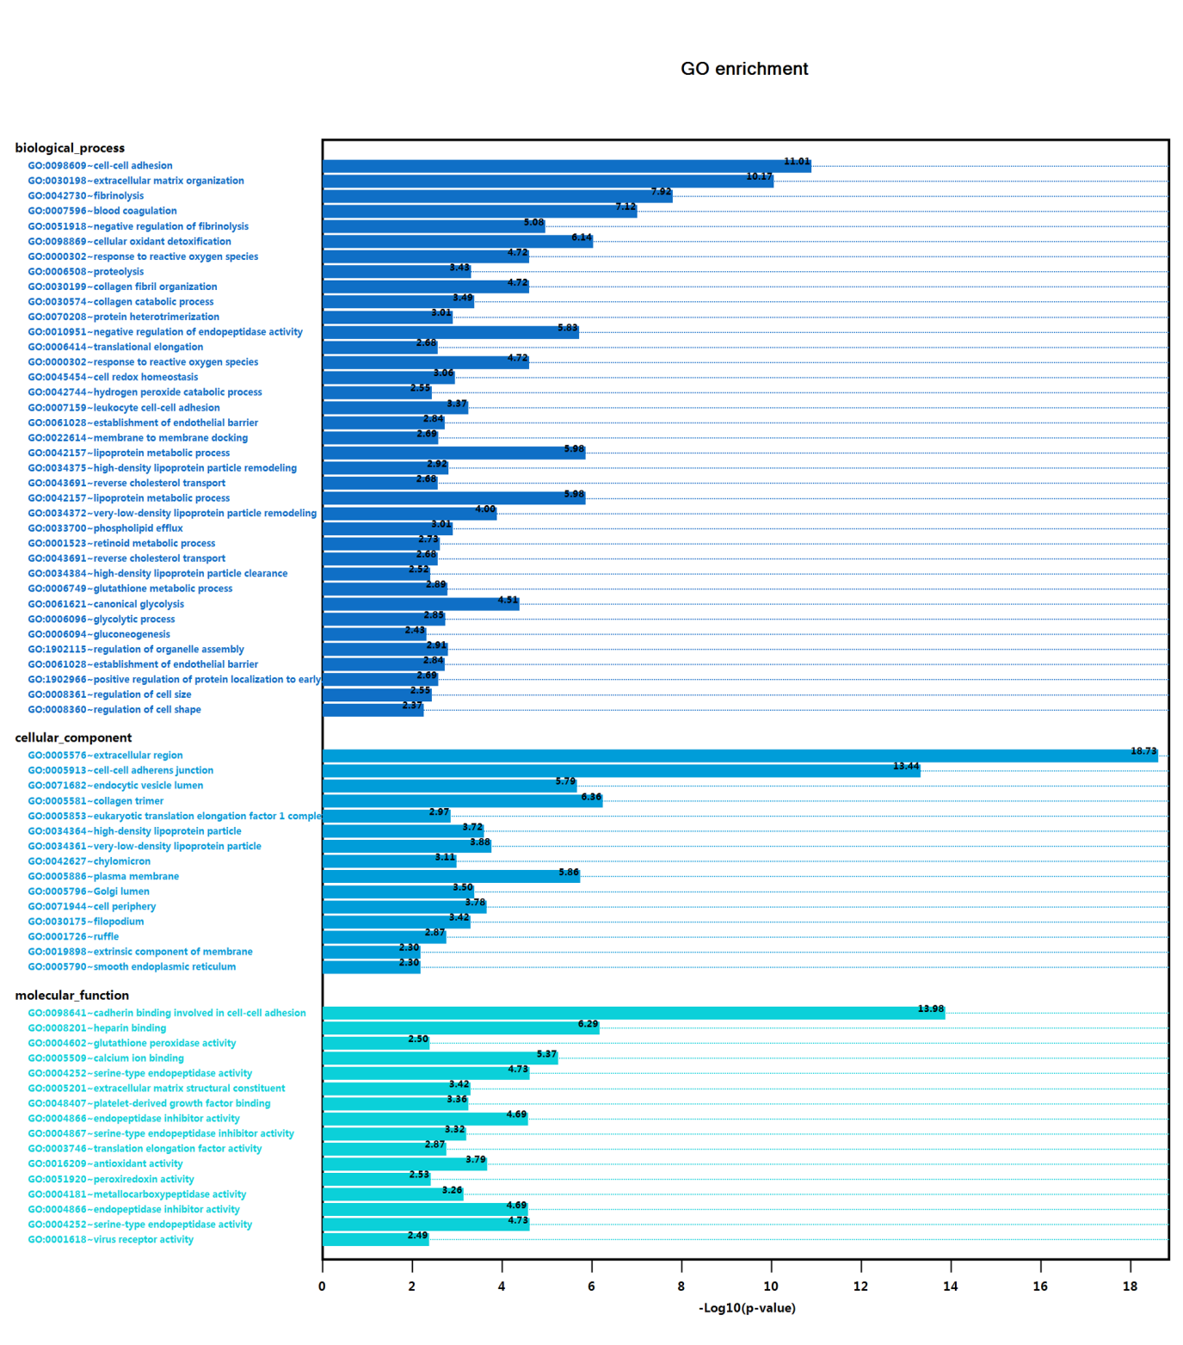
Supplementary Figure 1 GO analysis of differently expressed proteins. The differently expressed proteins mainly regulate cell-cell adhesion, cell-cell adherens junction, extracellular matrix organization, extrcellular region, and cadherin binding involved in cell-cell adhesion.

Supplementary Table 1
Table 1 Down-regulated proteins in ADR/Exo (log2FoldChange|≧1.0)
ID | geneName | log2FC | p.value | FDR
Q8N139 | ABCA6 | -2.749913623 | 1.01E-20 | 1.27E-18
Q6UXH8 | CCBE1 | -2.568773782 | 7.06E-15 | 4.20E-14
Q15113 | PCOLCE | -2.030636749 | 4.16E-20 | 3.02E-18
P42226 | STAT6 | -2.029372498 | 1.31E-17 | 1.75E-16
P28300 | LOX | -1.964732595 | 2.11E-17 | 2.59E-16
Q92616 | GCN1 | -1.90252404 | 1.52E-12 | 5.61E-12
Q96JB1 | DNAH8 | -1.74259009 | 2.20E-16 | 1.99E-15
P45877 | PPIC | -1.733721336 | 9.79E-17 | 9.92E-16
Q96JB3 | HIC2 | -1.641697244 | 4.05E-17 | 4.46E-16
Q9P2B2 | PTGFRN | -1.641418313 | 8.64E-19 | 2.11E-17
P04196 | HRG | -1.614183536 | 6.78E-19 | 1.81E-17
P09104 | ENO2 | -1.608579238 | 3.88E-17 | 4.32E-16
P02452 | COL1A1 | -1.540018335 | 2.26E-19 | 8.64E-18
Q9H444 | CHMP4B | -1.458281503 | 3.59E-17 | 4.10E-16
P69891 | HBG1 | -1.410841247 | 2.43E-19 | 8.91E-18
Q92743 | HTRA1 | -1.407445068 | 2.32E-17 | 2.80E-16
P35527 | KRT9 | -1.286180149 | 1.39E-16 | 1.32E-15
P35442 | THBS2 | -1.281549857 | 4.80E-20 | 3.02E-18
Q8WUM4 | PDCD6IP | -1.272078017 | 3.80E-21 | 6.70E-19
P04264 | KRT1 | -1.255475836 | 1.00E-17 | 1.47E-16
Q86UQ4 | ABCA13 | -1.235719556 | 4.95E-16 | 3.96E-15
P98095 | FBLN2 | -1.234047063 | 2.53E-18 | 5.02E-17
O00560 | SDCBP | -1.228518401 | 1.16E-17 | 1.65E-16
O75787 | ATP6AP2 | -1.217030018 | 4.58E-16 | 3.74E-15
Q14644 | RASA3 | -1.197061891 | 3.46E-17 | 4.02E-16
P05543 | SERPINA7 | -1.194182102 | 3.87E-15 | 2.54E-14
P27169 | PON1 | -1.183708286 | 1.42E-15 | 1.03E-14
Q96IY4 | CPB2 | -1.18209426 | 5.65E-15 | 3.52E-14
Q8IUX7 | AEBP1 | -1.177460612 | 5.67E-15 | 3.52E-14
Q13163 | MAP2K5 | -1.166608274 | 7.20E-22 | 2.11E-19
Q9NQ79 | CRTAC1 | -1.153827418 | 4.49E-12 | 1.47E-11
Q9UBX5 | FBLN5 | -1.150018759 | 2.87E-18 | 5.33E-17
P22352 | GPX3 | -1.14279763 | 1.14E-15 | 8.60E-15
P08123 | COL1A2 | -1.12703972 | 5.74E-18 | 9.21E-17
P00734 | F2 | -1.123334375 | 6.85E-20 | 3.55E-18
P35908 | KRT2 | -1.118460938 | 1.14E-17 | 1.65E-16
P13645 | KRT10 | -1.103906127 | 2.02E-15 | 1.39E-14
P12110 | COL6A2 | -1.099515524 | 1.10E-14 | 6.23E-14
Q08830 | FGL1 | -1.089668388 | 2.36E-17 | 2.81E-16
Q03181 | PPARD | -1.085861659 | 3.87E-16 | 3.22E-15
P51888 | PRELP | -1.081786073 | 4.83E-12 | 1.57E-11
Q9UKL3 | CASP8AP2 | -1.062406911 | 2.12E-14 | 1.14E-13

Supplementary Table 2
Table 2 Up-regulated proteins in ADR/Exo (log2FoldChange|≧1.0)
ID | geneName | log2FC | p.value | FDR
P21589 | NT5E | 1.009819327 | 4.74E-14 | 2.35E-13
P63313 | TMSB10 | 1.010447833 | 1.98E-13 | 8.62E-13
A0A0C4DH25 | IGKV3D-20 | 1.01148149 | 8.14E-16 | 6.29E-15
P30530 | AXL | 1.019494342 | 1.02E-10 | 2.69E-10
P36873 | PPP1CC | 1.020861041 | 2.07E-06 | 3.15E-06
Q6Y7W6 | GIGYF2 | 1.054584991 | 0.008236081 | 0.009792156
Q01469 | FABP5 | 1.082601951 | 1.33E-12 | 4.99E-12
P07355 | ANXA2 | 1.085642302 | 5.75E-18 | 9.21E-17
P05783 | KRT18 | 1.089381553 | 3.56E-19 | 1.16E-17
P15311 | EZR | 1.092422023 | 1.16E-16 | 1.16E-15
P08183 | ABCB1 | 1.100920565 | 1.80E-13 | 7.88E-13
P03956 | MMP1 | 1.107720918 | 3.41E-16 | 2.89E-15
P29279 | CTGF | 1.111400029 | 3.13E-19 | 1.10E-17
P11234 | RALB | 1.132346931 | 4.82E-10 | 1.15E-09
P05362 | ICAM1 | 1.136468428 | 5.81E-20 | 3.41E-18
O43707 | ACTN4 | 1.137934567 | 1.69E-13 | 7.44E-13
Q9NZI8 | IGF2BP1 | 1.137949597 | 1.06E-14 | 6.11E-14
P62318 | SNRPD3 | 1.154095566 | 1.78E-17 | 2.28E-16
Q9BXJ9 | NAA15 | 1.160094638 | 3.20E-10 | 7.89E-10
Q02952 | AKAP12 | 1.165918327 | 3.42E-14 | 1.73E-13
Q14166 | TTLL12 | 1.211203879 | 5.86E-17 | 6.22E-16
P13987 | CD59 | 1.222304607 | 3.22E-23 | 1.42E-20
Q9HC35 | EML4 | 1.232950225 | 5.39E-17 | 5.79E-16
P09936 | UCHL1 | 1.254060267 | 1.28E-17 | 1.75E-16
P0DP24 | CALM2 | 1.256303687 | 5.77E-15 | 3.53E-14
Q05639 | EEF1A2 | 1.257059569 | 1.04E-09 | 2.32E-09
Q96KK5 | HIST1H2AH | 1.259356299 | 2.97E-14 | 1.54E-13
P31947 | SFN | 1.284978449 | 1.24E-16 | 1.22E-15
P01705 | IGLV2-23 | 1.292466271 | 2.15E-21 | 4.75E-19
P04792 | HSPB1 | 1.329895601 | 2.52E-18 | 5.02E-17
Q15485 | FCN2 | 1.334237769 | 4.60E-19 | 1.45E-17
P80723 | BASP1 | 1.34673813 | 2.91E-13 | 1.23E-12
P00739 | HPR | 1.376022578 | 2.91E-18 | 5.33E-17
P17813 | ENG | 1.406909301 | 6.51E-20 | 3.55E-18
P16070 | CD44 | 1.507068654 | 7.13E-18 | 1.09E-16
P48509 | CD151 | 1.511050753 | 9.36E-18 | 1.40E-16
Q9GZP8 | IMUP | 1.512574238 | 8.84E-21 | 1.27E-18
O95816 | BAG2 | 1.554351074 | 2.29E-18 | 4.81E-17
P49006 | MARCKSL1 | 1.574548865 | 2.00E-16 | 1.85E-15
Q16186 | ADRM1 | 1.70465692 | 3.88E-09 | 8.03E-09
P31431 | SDC4 | 1.852031808 | 1.52E-18 | 3.51E-17
P21926 | CD9 | 1.948493353 | 7.11E-17 | 7.37E-16
P35613 | BSG | 2.103885514 | 5.82E-16 | 4.62E-15
P02795 | MT2A | 2.654815629 | 1.01E-13 | 4.68E-13

Supplementary Table 3
Table 3 KEGG analysis
KEGG pathway | Proteins
ECM-receptor interaction | THBS2, COL6A2, COL5A1, COL1A1, COL1A2, COL2A1, ITGB1, ITGB5, TNC, SDC4, VTN, HSPG2, CD44, CD47
Focal adhesion | THBS2, COL6A2, PPP1CC, ITGB1, COL5A1, COL1A1, COL1A2, PPP1CA, FLNC, ACTN1, ITGB5, TNC, COL2A1, ACTG1, VTN, ACTN4
PI3K-Akt signaling pathway | THBS2, ITGB5, TNC, GNB1, COL6A2, COL5A1, ITGB1, COL2A1, COL1A1, VTN, COL1A2
Complement and coagulation cascades | C5, CD59, SERPIND1, FGB, F13A1, F5, F10, F9, MBL2, SERPINF2, C3, F2, PLG, CPB2
Platelet activation | COL5A1, ITGB1, PPP1CC, COL2A1, FGB, COL1A1, ACTG1, PLCB3, COL1A2, PPP1CA
Amoebiasis | ACTN1, COL5A1, COL2A1, COL1A1, PLCB3, ACTN4, HSPB1, COL1A2
Protein digestion and absorption | CPA2, COL6A2, COL5A1, COL2A1, COL1A1, COL1A2, CPB2
Leukocyte transendothelial migration | ACTN1, EZR, ITGB1, ICAM1, MSN, ACTG1, ACTN4
PPAR signaling pathway | FABP5, UBC, LPL, PPARD, APOA1, PLTP, MMP1
Biosynthesis of amino acids | ALDOB, TPI1, GAPDH, PFKP, IDH1, ENO2, PGAM2
Glycolysis / Gluconeogenesis | ALDOB, TPI1, GAPDH, PFKP, ENO2, PGAM2
Carbon metabolism | ALDOB, TPI1, GAPDH, PFKP, IDH1, ENO2, PGAM2
Biosynthesis of antibiotics | ALDOB, UAP1, TPI1, GAPDH, PCYOX1, PAICS, PFKP, IDH1, ENO2, PGAM2
Fructose and mannose metabolism | ALDOB, TPI1, PFKP
Metabolic pathways | PTGES3, ALDOB, UAP1, TPI1, GAPDH, PFKP, NT5E, CKM, PLCB3, AMY1A, PRDX6, GSS, PAICS, IDH1, ENO2, PGAM2, ANPEP
Cell adhesion molecules (CAMs) | ICOSLG, ITGB1, ICAM1, SDC4, NCAM1
Protein processing in endoplasmic reticulum | HSPA8, BAG2, HSPA5, HYOU1, ERP29
Adherens junction | IQGAP1, ACTN1, ACTG1, CSNK2B, ACTN4
Protein processing in endoplasmic reticulum | HSPA8, BAG2, HSPA5, HYOU1, ACTG1
Staphylococcus aureus infection | C5, MBL2,ICAM1, C3, PLG
ABC transporters | ABCA6, ABCB1, ABCA13
Systemic lupus erythematosus | ACTN1, C5, HIST1H2BL, SNRPD3, HIST1H3A, HIST1H2AH, ACTN4, C3, HIST1H4A
Alcoholism | HIST1H2BL, GNB1, CALM2, PPP1CC, HIST1H3A, HIST1H2AH, PPP1CA, HIST1H4A
Phagosome | THBS2, ITGB5, CORO1A, MBL2, ITGB1, TUBB2B, ACTG1, C3
Arrhythmogenic right ventricular cardiomyopathy | ITGB5, ITGB1, ACTG1
Hypertrophic cardiomyopathy | ITGB5, ITGB1, ACTG1
Dilated cardiomyopathy | ITGB5, ITGB1, ACTG1
Dopaminergic synapse | GNB1, CALM2, PPP1CC, PLCB3, PPP1CA
Circadian entrainment | GNB1, CALM2, PLCB3
Oxytocin signaling pathway | CALM2, PPP1CC, MYL6, ACTG1, PLCB3, MAP2K5, PPP1CA
Vascular smooth muscle contraction | CALM2, PPP1CC, MYL6, PLCB3, PRKCE, PPP1CA
Inflammatory mediator regulation of TRP channels | CALM2, PPP1CC, PLCB3, PRKCE, PPP1CA
Long-term potentiation | CALM2, PPP1CC, PLCB3, PPP1CA
Dopaminergic synapse | GNB1, CALM2, PPP1CC, PLCB3, PPP1CA
Amphetamine addiction | CALM2, PPP1CC, PPP1CA
cGMP-PKG signaling pathway | CALM2, PPP1CC, PLCB3, PRKCE, PPP1CA
Aldosterone synthesis and secretion | CALM2, PLCB3, PRKCE
Adrenergic signaling in cardiomyocytes | CALM2, PPP1CC, PLCB3, PPP1CA
Insulin resistance | PPP1CC, Q02156, PPP1CA
Oocyte meiosis | CALM2, PPP1CC, PPP1CA
Insulin signaling pathway | CALM2, PPP1CC, PPP1CA
cAMP signaling pathway | CALM2, PPP1CC, PPP1CA

Supplementary Table 4
Table 4 Antibodies for Flow cytometry analysis
Protein | Antibody
ABCA6 | Abcam, Anti-ABCA6 antibody, CN. ab180567
CCBE1 | Invitrogen, CCBE1 Polyclonal Antibody, CN.PA5-59534
PCOLCE | Abcam, Anti-PCOLCE antibody, CN. ab220040
STAT6 | BioLegend, PE anti-STAT6 Phospho (Tyr641) Antibody, CN. 686003
LOX | BioLegend, APC anti-human LOX-1 Antibody, CN. 358605
GCN1 | Abcam, Anti-GCN1 antibody, CN. ab86139
DNAH8 | Abcam, Anti-DNAH8 antibody, CN. ab121989
PPIC | Abcam, Anti-PPIC antibody [EPR15355], CN. ab184552
HIC2 | Proteintech, HIC2 Rabbit Polyclonal antibody, CN. 22788-1-AP
PTGFRN | Abcam, Anti-PTGFRN antibody, CN. ab97567
HRG | Proteintech, HRG Rabbit Polyclonal antibody, CN. 26252-1-AP
ENO2 | BioLegend, Alexa Fluor® 488 anti-NSE Antibody, CN. 804904
COL1A1 | Abcam, Anti-Collagen I antibody [EPR22894-89], CN. ab260043
CD44 | BioLegend, APC anti-human CD44 Antibody, CN. 338806
CD151 | BioLegend, APC anti-human CD151 (PETA-3) Antibody, CN. 350405
IMUP | Abcam, Anti-IMUP antibody, CN. ab221063
BAG2 | Abcam, Anti-BAG2 antibody [EPR3568], CN. ab80596
MARCKSL1 | Abcam, Anti-MARCKS like protein antibody [EPR15353]-C-terminal, CN. ab184546
ADRM1 | Abcam, Anti-ADRM1 antibody [EPR11449(B)] (Phycoerythrin), CN. ab211702
SDC4 | RD, Human Syndecan-4 APC-conjugated Antibody, CN. FAB29181A
CD9 | BioLegend, APC anti-human CD9 Antibody, CN. 312107
BSG | BioLegend, APC anti-human CD147(BSG)Antibody, CN. 306213
MT2A | Proteintech, CoraLite488-Conjugated CES1 Antibody, CN. CL488-67079
CD63 | Thermo Fisher Scientific, PE anti-human CD63 Monoclonal Antibody (H5C6), CN. 12-0639-41

