Supplementary Figures

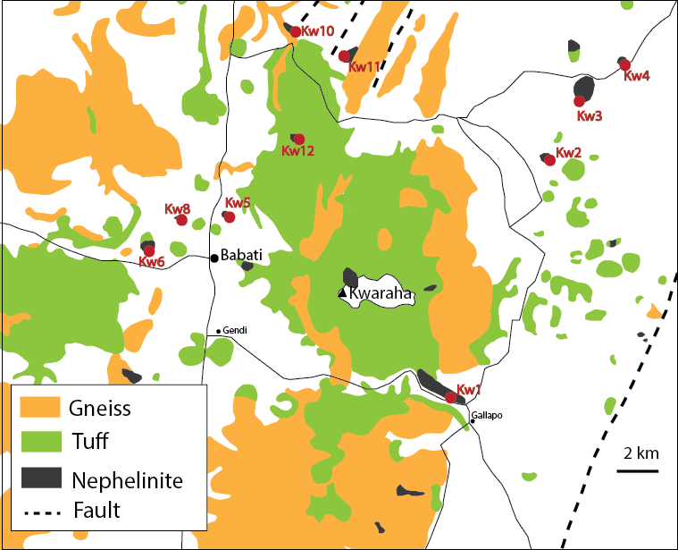

**FIGURE A1.** Geological map of Kwaraha volcano. Latitude and longitude GPS of the sample are reported in table A1.

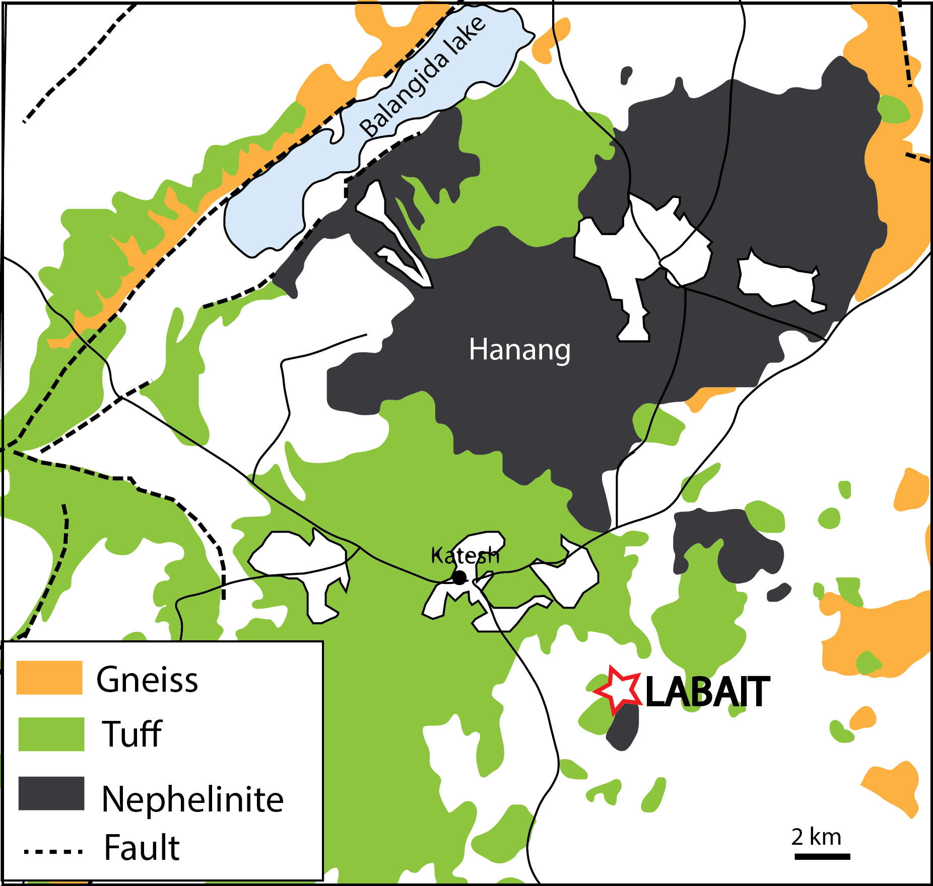

**FIGURE A2.** Geological map of Hanang and Labait volcanoes.

In this supplementary material, we add the data from Olmani nephelinitic lava (North Tanzanian Divergence), to compare the Data with the Manyara-Balangida basin.

Olmani is a small volcanic cone within the Meru volcanic field in the eastern part of the NTD (15 km southeast of Meru; Fig. 1). It erupted olivine nephelinite scoria between 0.06 and 2.5 Ma (Dawson, 2008; Wilkinson et al., 1986). Olmani magmas carried weakly hydrated dunite and harzburgite xenoliths (Baptiste et al., 2015). The presence of interstitial glasses in the mantle xenoliths strongly suggests melt-rock interactions in the lithospheric mantle and the presence of carbonate-rich silicate melt (Jones et al., 1983; Nonnotte, 2007; Rudnick et al., 1993).

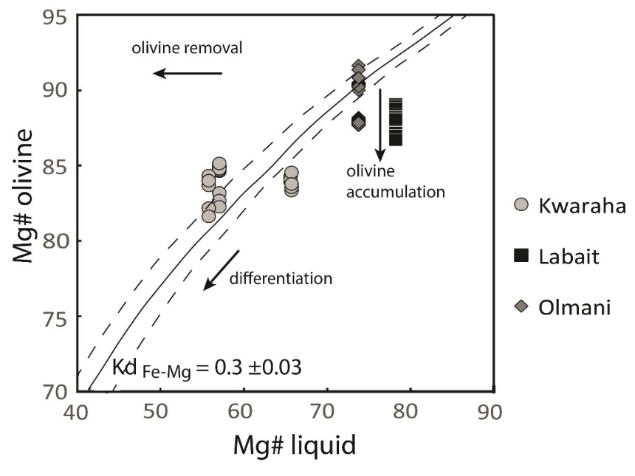

**FIGURE A3.** Mg# of olivine vs whole-rock (liquid) Mg# from Kwaraha, Labait, and Olmani lavas.

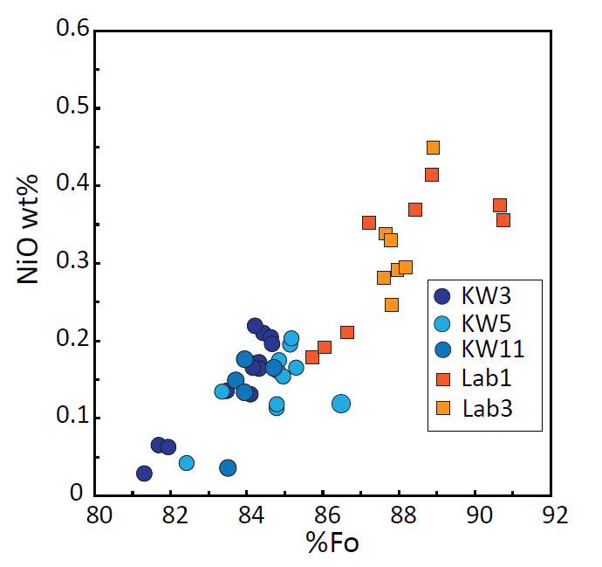

**FIGURE A4.** NiO vs. Fo content of olivines from Kwaraha (Kw3, Kw5, Kw11) and Labait (Lab1, Lab3).

KINGSTON:Figure chapitre 3:Fig8.pdf

**FIGURE A5.** Clinopyroxene (a) Cr2O3 and (b) Na2O contents vs Mg# from Kwaraha, Labait, and Olmani lavas.

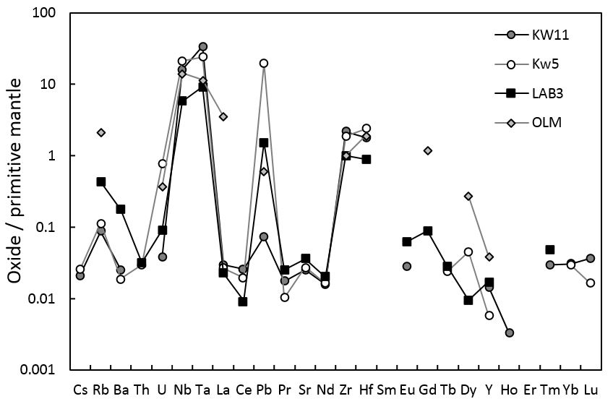

**FIGURE A6.** Primitive mantle-normalized trace element compositions of magnetites from Kwaraha, Labait, and Olmani lavas. Primitive mantle values from Sun and McDonough (1989).

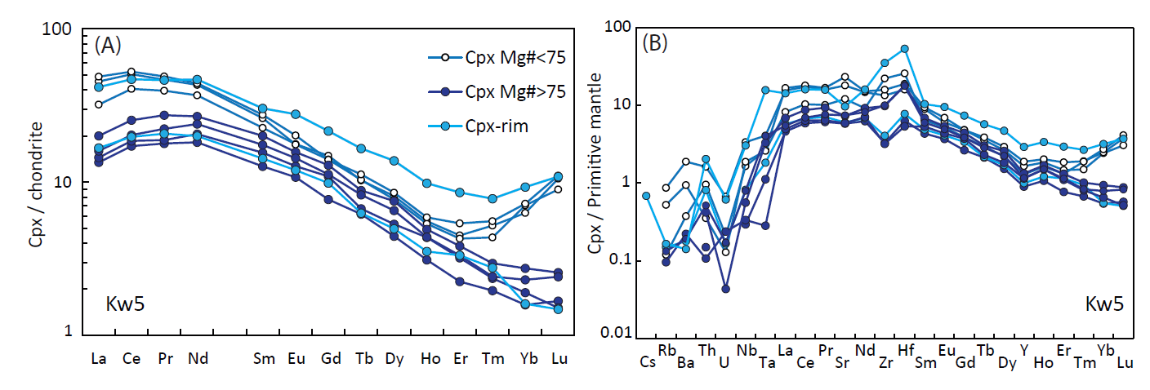

FIGURE A7. (A) Representative chondrite-normalized REE patterns and (B) primitive mantle-normalized trace element compositions of clinopyroxenes from Kwaraha. Chondrite and primitive mantle values from Sun and McDonough (1989).

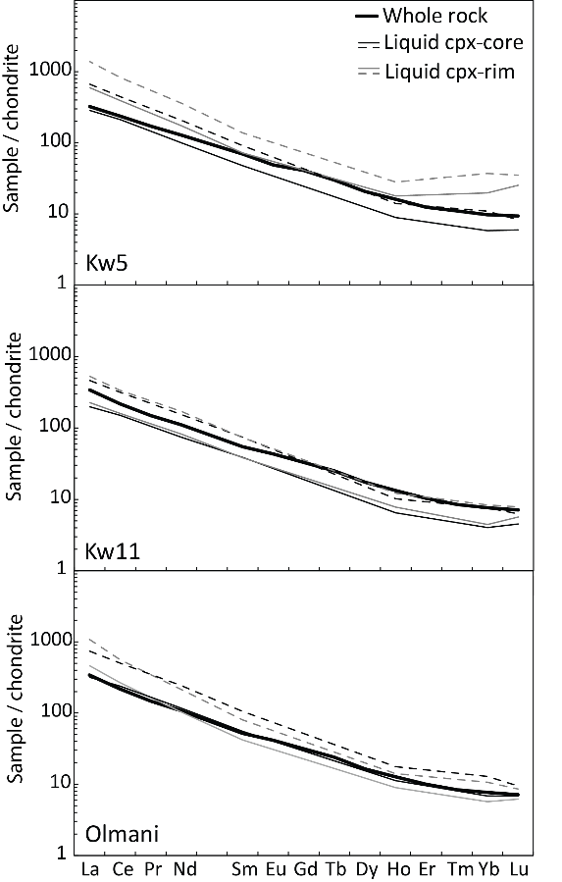

**FIGURE A8.** Chondrite-normalized whole-rock (thick black lines) and cpx core (black think lines) and rim (gray thin lines) REE patterns, and the recalculated melts (dashed lines) in equilibrium with cpx used to determine the P-T conditions of cpx crystallization (using the minimum and maximum partition coefficients from Adam and Green, 2006 for cores and rims, respectively).

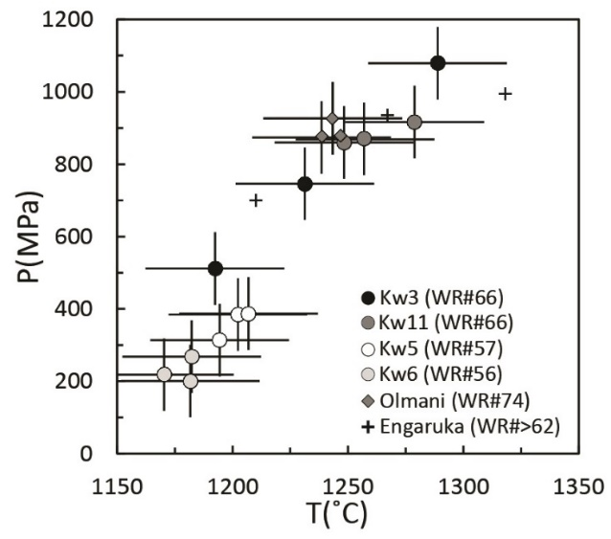

**FIGURE A9.** P-T conditions of cpx crystallization calculated using the cpx-liquid geothermobarometer (Putirka, 2008) for Kwaraha, Olmani, and Engaruka-Natron (Mattsson et al., 2013) nephelinites.

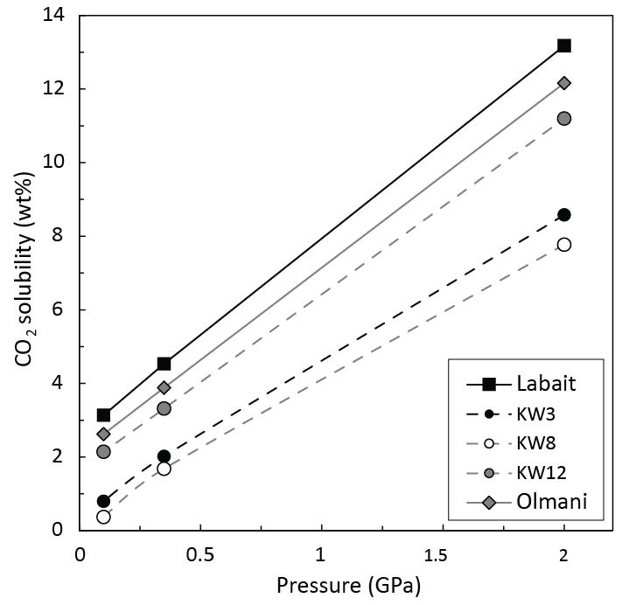

**FIGURE A10.** CO2 solubility (a function of NBO/T) vs pressure (Brooker et al., 2001; Moussallam et al., 2015). Calculated using NBO/T values of 1.4–1.67 for Labait, 1.04–1.34 for Olmani, and 0.93–1.26 for Kwaraha (Kw3, Kw8, and Kw12).

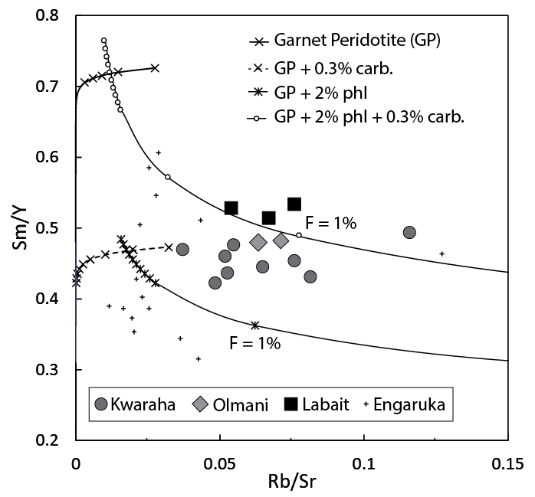

**FIGURE A11.** Modelling of primary mantle melting for Kwaraha (circles), Labait (squares), and Olmani lavas (diamonds) using Sm/Y vs. Rb/Sr. Partial melting of a garnet peridotite (63.3% olivine, 16.3% opx, 10.2% cpx, 10.2% garnet), a phlogopite-bearing garnet peridotite (62% olivine, 16% opx, 10% cpx, 10% garnet, 2% phlogopite) and both compositions with the addition of 0.3% carbonatite (Kw1 composition) was modelled with no fractional melting. The degree of melting (F) is indicated for the phlogopite-bearing assemblages. Nephelinites and melilitites (crosses) from Engaruka basin (Mattsson et al., 2013) are also reported.

**Carbonatite Kw1**

The carbonatite from Kwaraha volcano (Kw1) contains calcite (200 µm, 92 vol%), euhedral apatite (50 µm, 3 vol%), and magnetite (40–800 µm, 5 vol%). It is a calciocarbonatite with 62.1 wt% CaO, 33 wt% CO2, and low MgO (0.51 wt%), alkali (0.26 wt% Na2O, 0.15 wt% K2O), S (70 ppm), F (880 ppm), and Cl contents (47 ppm). Kw1 is enriched in Sr (3080 ppm) and LREEs (266 ppm La, La/Yb = 58.8) (Fig. 5a), very depleted in HFSEs (e.g., 26.3 ppm Zr), and shows Zr-Hf and Nb-Ta fractionations (Zr/Hf = 59.5, Nb/Ta = 87.2) (Fig. 5B, Table A1).Calcite in calciocarbonatite (Kw1) contains 50.3–55.6 wt% CaO, 0.12–0.53 wt% Na2O, 0.06–0.68 wt% MgO, and 0.03–0.13 wt% FeO, and has high trace element contents (i.e., 94–112 ppm La, 934–4225 ppm Sr). Oxides in Kw1 are magnetite with 0.08–0.82 wt% TiO2, 0.07–0.25 wt% MgO, and <0.02 wt% Cr2O3 (Table A1). Apatite is F-rich (3.5–4.5 wt%), Cl- (<0.01 wt%) and SO3-poor (0.01–0.03 wt%), and has REE concentrations up to 10,000 times chondritic values (Table A1, Fig A10).