Supplementary Material
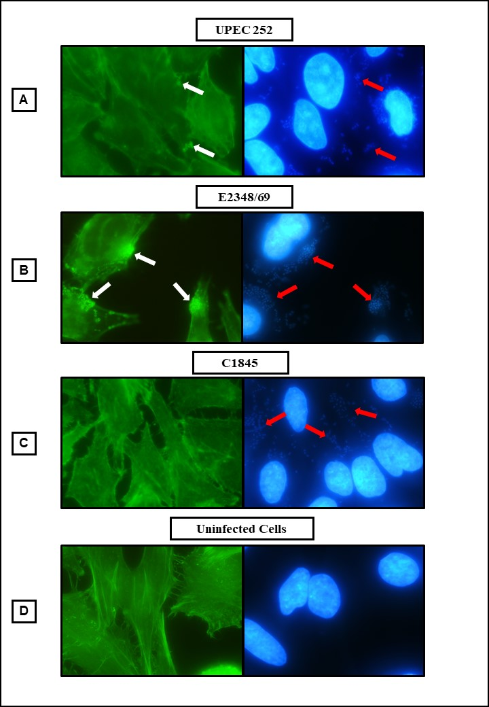
Figure S1. Actin polymerization identification test (Fluorescence Actin Staining, FAS), in HeLa cells infected for 3 hours with UPEC 252. Positive control: tEPEC E2348/69. Negative control: E. coli C1845. (Microscopic magnification of 1,000 x). Actin: phalloidin conjugated to fluorescein (Green). DNA: DAPI (Blue). The white arrows indicate the presence of actin accumulation, suggesting the formation of the A/E lesion. The red arrows indicate the site of bacterial adherence.

Figure S2. Cells with pedestals produced by the UPEC 252 and typical EPEC2348/69 strains during interaction with HeLa cells. The percentage of the number of cells with pedestals was assessed in three different fields of three different preparations. The unpaired bi-directional Student’s t-test was used to compare means of the two strains, in which P- value ≤ 0.05 was considered statistically significant. ** P ≤ 0.01.

Table S1. Escherichia coli strains used to perform phylogenetic analysis, their isolation sources and pathotypes
Strain (serotype) | Assembly or Biosample Accession Number | Phylogroup | MLST | Isolation source | Host | Isolated from infection | Pathotype ª | Sequencing reference | Observation
E2348/69 (O127:H6) | GCA_000026545.1 | B2 | 15 | Stool | Human | Yes | EPEC | 18952797
CFT073 | GCA_000007445.1 | B2 | 73 | Urine | Human | Yes | ExPEC | 12471157,2182540
536 | GCA_000013305.1 | B2 | 127 | Urine | Human | Yes | ExPEC | 16879640
S88 | GCA_000026285.1 | B2 | 95 | Meningitis | Human | Yes | ExPEC | 19165319,19307211
UMN026 | GCA_000026325.1 | D | 597 | Urine | Human | Yes | ExPEC | 19165319
Sakai (O157:H7) | GCA_000008865.1 | E | 11 | Stool | Human | Yes | EHEC | 9628576, +4
11128 (O111:H-) | GCA_000010765.1 | B1 | 16 | Stool | Human | Yes | EHEC | 19815525
upec-127 | GCA_000780965.1 | A | 10 | Urine | Human | Yes | ExPEC | 25373147
401900 | GCF_001912105.1 | A | 10 | Stool | Human | Yes | --
PNUSAE019702 | GCA_003761285.1 | A | 10 | M.D. | M.D. | M.D. | STEC | 218110
194 | SAMN05774074 | A | 10 | Urine | Human | Yes | ExPEC
Ec-03 | GCF_001893865.1 | A | 10 | Urine | Human | Yes | ExPEC |  | Inpatient with chronic diarrhea
500669 | GCA_003981165.1 | A | 10 | Stool | Human | Yes | ETEC
710469 | GCA_003981355.1 | A | 10 | Stool | Human | Yes | ETEC
710499 | GCA_003980495.1 | A | 10 | Stool | Human | Yes | ETEC
300709 | GCA_003956305.1 | A | 10 | Stool | Human | Yes | ETEC
600609 | GCA_003981745.1 | A | 10 | Stool | Human | Yes | ETEC
2726950 | GCA_000356145.1 | A | 10 | Stool | Human | Yes | ETEC
500691 | GCA_003981835.1 | A | 10 | Stool | Human | Yes | ETEC
MOD1-EC5918 | GCA_002534875.1 | A | 10 | Urine | Dog | Yes | ExPEC | 29242221
MEZEC9 | GCA_005938725.1 | A | 10 | M.D. | Sheep | M.D. | --
MOD1-EC6478 | GCA_002485665.1 | A | 10 | Heart | Chicken | M.D. | --
upec-282 | GCA_000777535.1 | A | 10 | Urine | Human | Yes | ExPEC | 25373147
HVH 164 [4-5953081] | GCA_000458495.1 | A | 10 | Blood | Human | Yes | ExPEC
FHI99 | GCA_000951935.1 | A | 10 | Stool | Human | Yes | STEC
KCJK4148 | GCA_002324495.1 | A | 10 | Stool | M.D. | M.D. | --
F345 | GCA_004767035.1 | A | 10 | Stool | Pig | No | STEC | 15574914
UMB2328 | GCA_003886545.1 | A | 10 | Urine | Human | M.D. | --
OS_09_001_-1.0 | GCA_002087785.1 | A | 10 | Urine | Human | M.D. | --
H7 | GCF_001900455.1 | A | 10 | Water river | NA | No | --
320277 | GCA_003982555.1 | A | 10 | Stool | Human | Yes | --
IH57218 | GCF_001264215.1 | A | 10 | Stool | Human | Yes | STEC/ETEC
FWSEC0149 | GCA_005044235.1 | A | 10 | M.D. | Human | M.D. | --
200144 | GCF_001911595.1 | A | 10 | Stool | Human | Yes | ETEC
710885 | GCA_003981345.1 | A | 10 | Stool | Human | Yes | --
UMEA 3889-1 | GCA_000461755.1 | A | 10 | Urine | Human | Yes | ExPEC
FHI29 | GCF_000942915.1 | A | 10 | Stool | Human | Yes | STEC/ETEC
MOD1-EC1663 | GCA_002459965.1 | A | 10 | Stool | Human | Yes | STEC | 29242221
STEC_EH250 | GCA_000225145.2 | A | 10 | M.D. | M.D. | M.D. | STEC
FWSEC0124 | GCA_005044585.1 | A | 10 | M.D. | M.D. | M.D. | STEC
PNUSAE018740 | GCA_003782245.1 | A | 10 | M.D. | M.D. | M.D. | --
381-3 | GCF_000948005.1 | A | 10 | Stool | Human | Yes | -- | 25656624
MOD1-EC667 | GCA_002466925.1 | A | 10 | Blood | Human | Yes | ExPEC
MOD1-EC720 | GCA_002456415.1 | A | 10 | Blood | Human | Yes | ExPEC
E2 | GCF_001693555.1 | A | 10 | Urine | Human | Yes | ExPEC
PNUSAE017873 | GCA_003770225.1 | A | 10 | M.D. | M.D. | M.D. | --
UMEA 3180-1 | GCA_000460635.1 | A | 10 | Urine | Human | Yes | ExPEC
PNUSAE019721 | GCA_003776245.1 | A | 10 | M.D. | M.D. | M.D. | --
721042 | GCA_003980375.1 | A | 10 | Stool | Human | Yes | --
UMB0527 | GCA_003892535.1 | A | 10 | Urine | Human | M.D. | --
MOD1-EC5862 | GCA_002548165.1 | A | 10 | Urine | Human | Yes | ExPEC
VR50 | GCF_000968515.1 | A | 10 | Urine | Human | No | --
JML138 | GCA_005387225.1 | A | 10 | Stool | Human | No | --
blood-10-1009 | GCA_000779005.1 | A | 10 | Blood | Human | Yes | ExPEC | 25373147
JML213 | GCA_005388505.1 | A | 10 | Stool | Human | No | --
148 | GCA_000511425.1 | A | 10 | Blood | Human | Yes | ExPEC
blood-09-1290 | GCA_000781915.1 | A | 10 | Blood | Human | Yes | ExPEC | 25373147
CH613_eco | SAMN05425592 | A | 10 | Urine | Human | Yes | ExPEC
DA33133 | GCA_003180975.1 | A | 10 | Stool | Human | M.D. | --
Ecol_422 | GCF_002012185.1 | A | 10 | M.D. | Human | M.D. | --
F498 | GCA_002319165.1 | A | 10 | Feces | Pig | No | STEC
CFSAN061759 | GCA_003399875.1 | A | 10 | Raw milk cheese | NA | No | --
681 | GCA_000503335.1 | A | 10 | Urine | Human | Yes | ExPEC
ED-53 | GCA_002319255.1 | A | 10 | M.D. | Pig | No | STEC
STEC 545 | GCF_001609745.1 | A | 10 | Stool | Human | Yes | STEC
upec-173 | GCA_000779955.1 | A | 10 | Urine | Human | Yes | ExPEC | 25373147
204965 | GCF_001940485.1 | A | 10 | Stool | Human | No | --
blood-90187 | GCA_000779155.1 | A | 10 | Blood | Human | Yes | ExPEC | 25373147
blood-09-0249 | GCA_000782275.1 | A | 10 | Blood | Human | Yes | ExPEC | 25373147
URMC_18 | GCA_004568035.1 | A | 10 | Urine | Human | Yes | ExPEC
M16 | SAMN04122819 | A | 10 | Blood | Human | Yes | ExPEC
M6 | SAMN04096288 | A | 10 | Blood | Human | Yes | ExPEC
103522 | GCA_003983445.1 | A | 10 | Stool | Human | Yes | --
100516 | GCA_003984305.1 | A | 10 | Stool | Human | Yes | ETEC
FWSEC0054 | GCA_005046785.1 | A | 10 | M.D. | Human | M.D. | STEC
G19 | GCF_001575305.1 | A | 10 | Mastite | Bovine | Yes | ExPEC
67-965 | GCA_002243905.1 | A | 10 | Urine | M.D. | M.D. | --
HVH 209 (4-3062651) | GCA_000459235.1 | A | 10 | Blood | Human | Yes | ExPEC
Win2013_WWKa_OUT_18 | GCA_003144805.1 | A | 10 | Wastewater outflow | NA | No | --
MOD1-EC6587 | GCA_002469285.1 | A | 10 | Liver | Chicken | M.D. | --
NCTC9087 | GCA_900636145.1 | A | 10 | M.D. | M.D. | M.D. | --
FWSEC0077 | GCA_005045415.1 | A | 10 | M.D. | Human | M.D. | STEC
MOD1-EC5691 | GCA_002226695.1 | A | 10 | Milk | Bovine | M.D. | --
39_Esco_HA-DE | GCA_002442335.1 | A | 10 | Rectal swab | Human | No | -- | 29051750
STEC 2708 | GCF_001607685.1 | A | 10 | Stool | Human | Yes | STEC
MOD1-EC5660 | GCA_002227365.1 | A | 10 | Stool | Pig | M.D. | --
2185 | GCA_002319385.1 | A | 10 | M.D. | Pig | M.D. | STEC
2.3916 | GCA_000194535.2 | A | 10 | M.D. | Pig | M.D. | STEC
VL2874 | GCF_001441335.1 | A | 10 | Milk | Bovine | Yes | ExPEC
VL2790 | GCF_001748545.1 | A | 10 | M.D. | Bovine | Yes | ExPEC
VL3009 | GCF_001748625.1 | A | 10 | M.D. | Bovine | Yes | ExPEC
MOD1-EC5813 | GCA_002474495.1 | A | 10 | Pleural cavity | Pig | Yes | ExPEC
upec-83 | GCA_000776355.1 | A | 10 | Urine | Human | Yes | ExPEC | 25373147
MOD1-EC5673 | GCA_002227115.1 | A | 10 | Stool | Bovine | M.D. | --
MOD1-EC5677 | GCA_002226905.1 | A | 10 | Stool | Bovine | M.D. | --
SC356 | GCA_003358185.1 | A | 10 | Surface water | NA | No | EPEC
SC352 | GCA_003358245.1 | A | 10 | Surface water | NA | No | EPEC
98-3133 (O157:H16) | GCA_000618005.1 | A | 10 | M.D. | M.D. | M.D. | EPEC | 25103754
TW15901 | GCA_000304075.1 | A | 10 | Beef | M.D. | No | EPEC
3.2303 | GCA_000194645.2 | A | 10 | Water | M.D. | No | EPEC
FWSEC0085 | GCA_005045345.1 | A | 10 | Stool | Human | M.D. | EPEC
EPEC 2669 | GCA_001742565.1 | A | 10 | Stool | Human | M.D. | EPEC
EPEC 631 | GCA_001742485.1 | A | 10 | Stool | Human | M.D. | EPEC
EPEC 536 | GCA_001742465.1 | A | 10 | Stool | Human | Yes | EPEC
EPEC 720 | GCA_001742475.1 | A | 10 | Stool | Human | M.D. | EPEC
VREC0305 | GCA_900479635.1 | A | 10 | Stool | Pig | No | --
FHI30 | GCF_000951895.1 | A | 10 | Stool | Human | Yes | STEC
FWSEC0089 | GCA_005045745.1 | A | 10 | M.D. | M.D. | M.D. | STEC
STEC 2953 | GCF_001607895.1 | A | 10 | Stool | Human | Yes | STEC
STEC 2236 | GCF_001607125.1 | A | 10 | Stool | Human | Yes | STEC
fhi | GCF_000752175.1 | A | 10 | Stool | Human | Yes | STEC
FWSEC0438 | GCA_005041235.1 | A | 10 | River water | NA | No | STEC
FWSEC0400 | GCA_005041485.1 | A | 10 | Intake water | NA | No | STEC
FWSEC0049 | GCA_005046385.1 | A | 10 | Manure | Bovine | No | STEC
FWSEC0625 | GCA_005037955.1 | A | 10 | M.D. | M.D. | M.D. | STEC
FWSEC0471 | GCA_005039655.1 | A | 10 | M.D. | Human | M.D. | STEC
FWSEC0050 | GCA_005046835.1 | A | 10 | Manure | Bovine | No | STEC
NCTC9100 | GCA_900636235.1 | A | 10 | M.D. | M.D. | M.D. | --
400714 aEPEC | GCF_001285265.1 | A | 10 | Stool | Human | Yes | EPEC | 30127495
C260_92 | GCA_000446325.1 | A | 10 | Stool | Human | M.D. | EPEC
C213_10 | GCA_000446225.1 | A | 10 | Stool | Human | M.D. | EPEC
MOD1-ECOR25 | GCA_003334065.1 | A | 10 | M.D. | Dog | M.D. | EPEC
ECOR25 | GCA_002190605.1 | A | 10 | M.D. | Dog | M.D. | EPEC
UMEA 3317-1 | GCA_000461215.1 | A | 10 | Urine | Human | Yes | ExPEC/ EPEC |  | Isolated in 1995, LEE+ ^{b}; patient with UTI developed urosepsis.
505393_aEPEC | GCF_001277455.1 | A | 10 | Stool | Human | No | EPEC | 30127495
700337 | GCF_001284305.1 | A | 10 | Stool | M.D. | M.D. | EPEC
102014_ aEPEC | GCF_001284445.1 | A | 10 | Stool | Human | No | EPEC
4581-2 | GCA_003651325.1 | A | 10 | Stool | Human | Yes | EPEC | 30533858, +1
401082 | GCF_001284905.1 | A | 10 | Stool | Human | No | EPEC
401174_aEPEC | GCF_001277755.1 | A | 10 | Stool | Human | No | EPEC
85B | GCA_000503415.1 | A | 10 | Retail Meat | Chicken | No | EPEC
ECO1194 (O49:H40) | ERS357855 | A | 10 | Blood | Human | Yes | ExPEC/ EPEC | 28720578 | Isolated in 2008, LEE+
VREC0450 | GCA_900479355.1 | A | 10 | Stool | Bovine | No | EPEC
A130 | GCA_003304335.1 | A | 10 | Stool | Human | No | EPEC
252 | GCA_007858995.1 | A | 10 | Urine | Human | Yes | ExPEC/ EPEC | 31649078 | Isolated in 1999, LEE+, strain classified as EPEC
200781_aEPEC | GCF_001283165.1 | A | 10 | Stool | Human | No | EPEC | 30127495
602370_aEPEC | GCF_001277415.1 | A | 10 | Stool | Human | Yes | EPEC | 30127495
202973_aEPEC | GCF_001277735.1 | A | 10 | Stool | Human | Yes | EPEC | 30127495
200439_aEPEC | GCF_001285345.1 | A | 10 | Stool | Human | Yes | EPEC | 30127495
102010_aEPEC | GCF_001283665.1 | A | 10 | Stool | Human | No | EPEC | 30127495
202317_aEPEC | GCF_001285625.1 | A | 10 | Stool | Human | No | EPEC | 30127495
302700 | GCF_001283785.1 | A | 10 | Stool | Human | No | EPEC | 30127495
300814_aEPEC | GCF_001283945.1 | A | 10 | Stool | Human | No | EPEC | 30127495
300812 aEPEC | GCF_001284565.1 | A | 10 | Stool | Human | No | EPEC | 30127495
Abbreviations: M.D., missing data; N.A., Not applicable; EPEC, enteropathogenic Escherichia coli; ExPEC, extraintestinal pathogenic E. coli; ETEC, enterotoxigenic E. coli; STEC, Shiga toxin-producing E. coli; EHEC, enterohemorrhagic E. coli.
ª Pathotypes were defined by the presence in their genome of specific virulence factors, as follows: stx for STEC; stx and LEE for EHEC; elt or est for ETEC; LEE for EPEC; ExPEC strains were defined by their isolation from confirmed infections in extraintestinal sites; --, unknown pathotype.
^{b} LEE+, strain that carries the locus of enterocyte effacement.

Table S2. Resistance related genes found in the UPEC 252 genome
Sequence | Gene | Coverage | % Coverage | % Identity | Accession No
NODE_14_length_119506_cov_15.900393 | (Bla)Penicillin_Binding_Protein  E. coli | 1-1902/1902 | 100 | 100 | CP002291:664439-666340
NODE_3_length_291521_cov_19.525749 | (Bla)ampC2_E. coli | 1-1134/1134 | 100 | 100 | CP002970:332756-333889
NODE_4_length_268620_cov_16.805358 | (Tet)tet(34) | 66-421/465 | 76.34 | 75.35 | AB061440:306-770
NODE_4_length_268620_cov_16.805358 | (Bla)ampH_E. coli | 1-1158/1158 | 100 | 100 | AP012030:395554-396711
NODE_6_length_251389_cov_16.163650 | (Bla)ampC1_E. coli | 1-1305/1305 | 100 | 100 | FN649414:2765051-2766355
NODE_11_length_151464_cov_19.824676 | cpxA | 1-1374/1374 | 100 | 98.98 | BA000007.3:4905062-4903688
NODE_12_length_148029_cov_19.346615 | crp | 1-633/633 | 100 | 99.84 | AP009048.1:4154296-4153663
NODE_13_length_141723_cov_14.239435 | mdtG | 661-1227/1227 | 46.21 | 100 | CP000800.1:1192954-1191727
NODE_13_length_141723_cov_14.239435 | mdtG | 1-670/1227 | 54.6 | 98.95 | CP000800.1:1192954-1191727
NODE_13_length_141723_cov_14.239435 | mdtH | 1-1209/1209 | 100 | 99.92 | U00096:1125326-1124117
NODE_14_length_119506_cov_15.900393 | kdpE | 1-678/678 | 100 | 100 | U00096.3:721733-721055
NODE_15_length_112375_cov_16.739746 | emrB | 1-1539/1539 | 100 | 100 | U00096:2812615-2814154
NODE_15_length_112375_cov_16.739746 | emrA | 1-1173/1173 | 100 | 100 | AP009048:2810082-2811255
NODE_15_length_112375_cov_16.739746 | emrR | 1-531/531 | 100 | 100 | U00096.3:2810769-2811300
NODE_1_length_322751_cov_13.573860 | Klebsiella_pneumoniae_kpnE | 5-363/363 | 98.62 | 75.83 | AP006725.1:2483889-2484252
NODE_1_length_322751_cov_13.573860 | Klebsiella_pneumoniae_kpnF | 6-330/330 | 98.48 | 75.39 | AP006725.1:2484238-2484568
NODE_20_length_87691_cov_14.696428 | baeR | 1-723/723 | 100 | 99.86 | AP009048.1:2166412-2167135
NODE_20_length_87691_cov_14.696428 | baeS | 1-1404/1404 | 100 | 100 | AP009048:2165012-2166416
NODE_20_length_87691_cov_14.696428 | mdtC | 1-3078/3078 | 100 | 98.44 | U00096:2158385-2161463
NODE_20_length_87691_cov_14.696428 | mdtB | 1-3123/3123 | 100 | 97.92 | U00096:2155262-2158385
NODE_20_length_87691_cov_14.696428 | mdtA | 1-1248/1248 | 100 | 100 | U00096:2154015-2155263
NODE_21_length_77445_cov_16.032670 | Escherichia_coli_emrE | 1-333/333 | 100 | 99.1 | Z11877.1:485-818
NODE_22_length_65326_cov_14.334560 | ugd | 1-1167/1167 | 100 | 98.54 | U00096:2099613-2098446
NODE_23_length_63932_cov_12.529128 | marA | 1-384/384 | 100 | 100 | AP009048.1:1621287-1621671
NODE_28_length_52876_cov_13.795863 | Escherichia_coli_emrE | 1-333/333 | 100 | 91.89 | Z11877.1:485-818
NODE_2_length_292435_cov_19.047505 | acrF | 1-3105/3105 | 100 | 99.97 | U00096:3415032-3418137
NODE_2_length_292435_cov_19.047505 | acrE | 1-1158/1158 | 100 | 100 | U00096:3413863-3415021
NODE_2_length_292435_cov_19.047505 | acrS | 1-663/663 | 100 | 100 | U00096:3413465-3412802
NODE_2_length_292435_cov_19.047505 | bacA | 1-822/822 | 100 | 100 | U00096.3:3204131-3203309
NODE_2_length_292435_cov_19.047505 | tolC | 1-1488/1488 | 100 | 100 | FJ768952:0-1488
NODE_30_length_43053_cov_15.155733 | mdtK | 1-1409/1425 | 98.74 | 75.12 | CP014358.1:2162750-2161325
NODE_33_length_39981_cov_19.428740 | gadX | 1-825/825 | 100 | 99.88 | AP009048.1:3974604-3975429
NODE_33_length_39981_cov_19.428740 | gadW | 1-729/729 | 100 | 94.65 | CP015085.1:2552440-2551711
NODE_33_length_39981_cov_19.428740 | mdtF | 1-3114/3114 | 100 | 99.97 | U00096:3660413-3663527
NODE_33_length_39981_cov_19.428740 | mdtE | 1-1158/1158 | 100 | 100 | AP009048.1:3981183-3980025
NODE_34_length_39007_cov_18.747891 | mdtM | 1-1233/1233 | 100 | 96.35 | U00096.3:4568519-4567286
NODE_3_length_291521_cov_19.525749 | Escherichia_coli_ampC | 1-1134/1134 | 100 | 100 | NC_000913.3:4378944-4377810
NODE_3_length_291521_cov_19.525749 | eptA | 1-1644/1644 | 100 | 100 | AP009048:4340268-4338624
NODE_3_length_291521_cov_19.525749 | mdtN | 1-1032/1032 | 100 | 100 | AP009048.1:4307588-4306556
NODE_3_length_291521_cov_19.525749 | mdtO | 1-2052/2052 | 100 | 100 | AP009048.1:4306557-4304505
NODE_3_length_291521_cov_19.525749 | mdtP | 1-1467/1467 | 100 | 99.93 | AP009048.1:4304509-4303042
NODE_40_length_19866_cov_20.097067 | Nocardia_rifampin_resistant_beta-subunit_of_RNA_polymerase_(rpoB2) | 2980-3332/3489 | 10.03 | 75.56 | AP006618.1:4835199-4838688
NODE_4_length_268620_cov_16.805358 | Escherichia_coli_ampH | 1-1158/1158 | 100 | 100 | AP012030.1:396711-395553
NODE_4_length_268620_cov_16.805358 | acrB | 1-3150/3150 | 100 | 99.97 | U00096.3:484403-481253
NODE_4_length_268620_cov_16.805358 | Escherichia_coli_acrA | 1-1194/1194 | 100 | 100 | U00096.3:485619-484425
NODE_59_length_3766_cov_14.707337 | Escherichia_coli_emrE | 1-133/333 | 39.94 | 99.25 | Z11877.1:485-818
NODE_5_length_264695_cov_15.010666 | Escherichia_coli_mdfA | 1-1233/1233 | 100 | 98.38 | JQ394987:0-1233
NODE_5_length_264695_cov_15.010666 | msbA | 1-1749/1749 | 100 | 100 | U00096.3:966620-968369
NODE_6_length_251389_cov_16.163650 | mphB | 1-477/477 | 100 | 98.32 | AE005174.2:3397370-3397847
NODE_6_length_251389_cov_16.163650 | acrD | 1-3114/3114 | 100 | 100 | AP009048.1:2586250-2589364
NODE_6_length_251389_cov_16.163650 | evgS | 1-3594/3594 | 100 | 100 | U00096:2484373-2487967
NODE_6_length_251389_cov_16.163650 | evgA | 1-615/615 | 100 | 100 | BA000007.3:3212025-3212640
NODE_6_length_251389_cov_16.163650 | emrK | 1-1056/1056 | 100 | 100 | D78168:536-1592
NODE_6_length_251389_cov_16.163650 | emrY | 1-1539/1539 | 100 | 99.94 | D78168:1591-3130
NODE_75_length_1167_cov_12.041346 | Escherichia_coli_emrE | 89-333/333 | 73.57 | 98.78 | Z11877.1:485-818
NODE_7_length_237541_cov_15.161296 | yojI | 1-1644/1644 | 100 | 100 | U00096.3:2308615-2306971
NODE_7_length_237541_cov_15.161296 | pmrF | 1-969/969 | 100 | 100 | U00096:2367070-2368039
NODE_8_length_221796_cov_13.359274 | hns | 1-414/414 | 100 | 99.28 | BA000007.3:1738104-1737690
NODE_5_length_264695_cov_15.010666 | mdf(A)_1 | 1-1233/1233 | 100 | 99.92 | Y08743

Table S3. Antimicrobial susceptibility profile of UPEC 252 ª
Antimicrobial | UPEC 252  halo (mm) | Report
amoxicillin-clavulanic acid (20/ 10 μg) | 25 | S
aztreonam (30 μg) | 30 | S
cefoxitin (30 μg) | 29 | S
cefepime (30 μg) | 31 | S
ceftazidime (10 μg) | 27 | S
ceftriaxone (30 μg) | 29 | S
meropenem (10 μg) | 31 | S
imipenem (10 μg) | 30 | S
ertapenem (10 μg) | 27 | S
gentamicin (10 μg) | 19 | S
amikacin (30 μg) | 20 | S
tigecycline (15 μg) | 22 | S
ciprofloxacin (5 μg) | 35 | S
ª Antimicrobial susceptibility test was performed using the disk diffusion
methodology as recommended by BrCAST guideline. The E. coli ATCC25922
was used as a quality standard in the assay.
S- Susceptible.

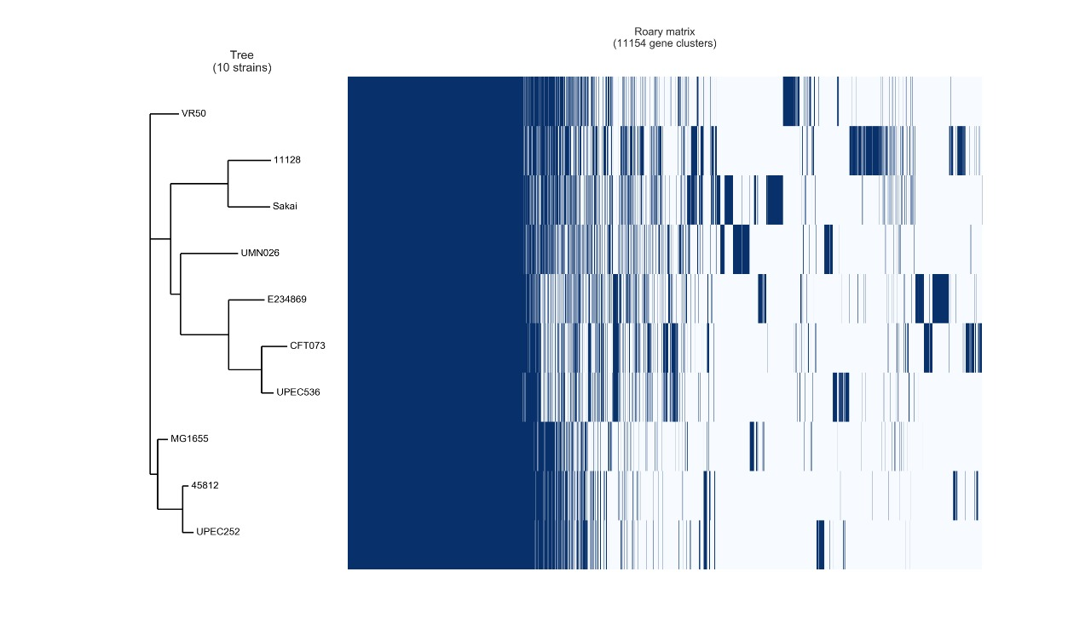
Figure S3. Roary similarity tree and genes matrix. The similarity tree was built using the pangenome of 10 E. coli strains (UPEC 252, 4581-2, 536, CFT073, UMN026, VR50, MG1655, E2348/69, 11128, and Sakai). In the Roary matrix, the blue stripes represent the presence of the gene clusters that comprise the genomes. White stripes represent the absence of the genes.
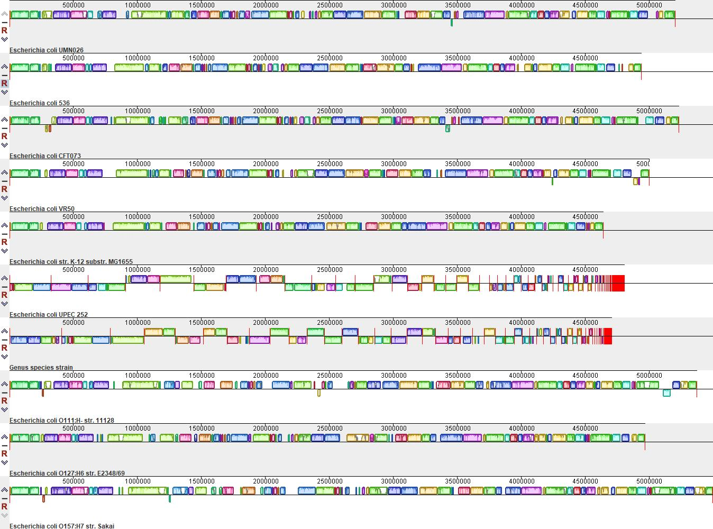
Figure S4. Alignment of UPEC 252 and other nine E. coli strains (4581-2, 536, CFT073, UMN026, VR50, MG1655,
E2348/60, 11128, and Sakai). The continuous homology blocks are represented by the same color in each genome.

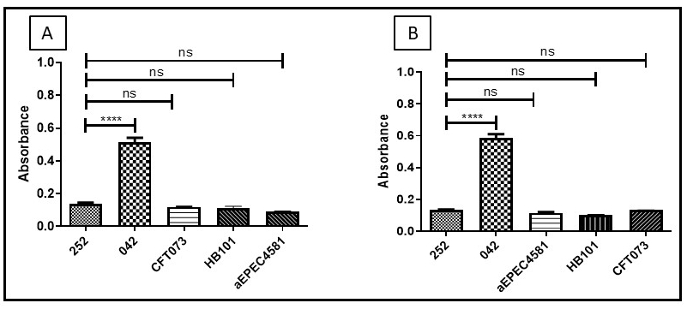
Figure S5. UPEC 252 biofilm formation with incubation periods of 24 (A) and 48 (B) hours, in DMEM + GlutaMAX medium. Positive control: EAEC prototype strain 042. Negative control: E. coli HB101.The One-way ANOVA followed by post hoc Tukey HSD test was used to compare the results. P-value, ns P > 0.05, **** P ≤ 0.0001.

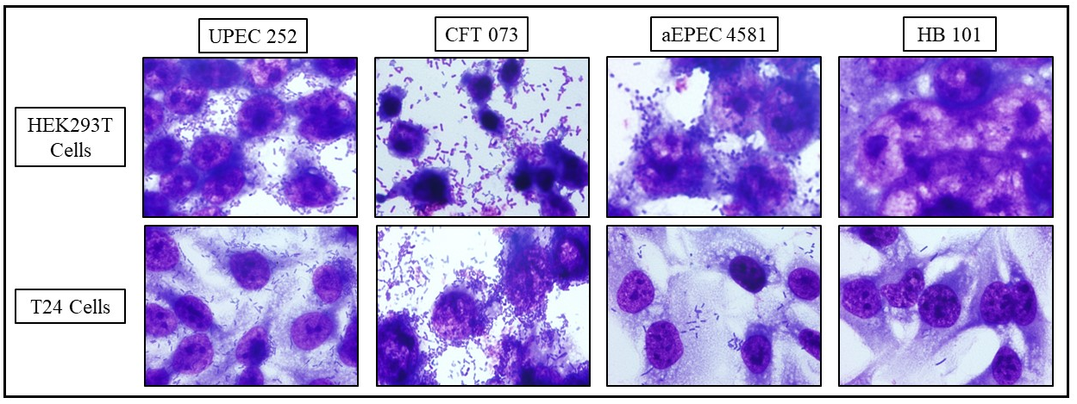
Figure S6. UPEC 252 interaction assay with urinary tract cell lineages. Qualitative interaction assay performed with a 3-hour incubation period on
the urinary cell lineages (T24 and HEK 293T), in the absence of D-mannose. Controls: UPEC CFT073; aEPEC 4581-2; non-adherent E. coli HB101.

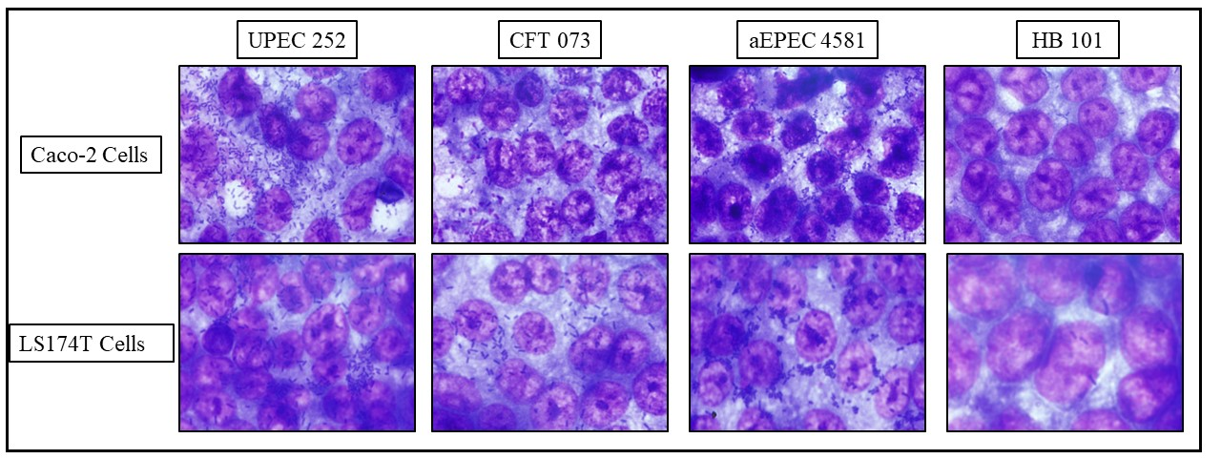
Figure S7. UPEC 252 interaction assay with intestinal tract cell lineages. Qualitative interaction assay performed with a 3- hour incubation period in the intestinal tract cells (Caco-2 and LS174T), in the absence of D-mannose. Controls: UPEC CFT073; aEPEC 4581-2; non-adherent E. coli HB101.

Figure S8. Quantitative adherence of UPEC 252 in different eukaryotic cell lineages. Quantitative assays were performed in a 3-hour incubation period, in urinary (T24 and HEK 293T), and intestinal (Caco-2 and LS174T) tract cell lineages, in the absence of D-mannose. The One-way ANOVA followed by post hoc Tukey HSD test was used to compare the results obtained in this experiment. P-value: *** P ≤ 0.001.

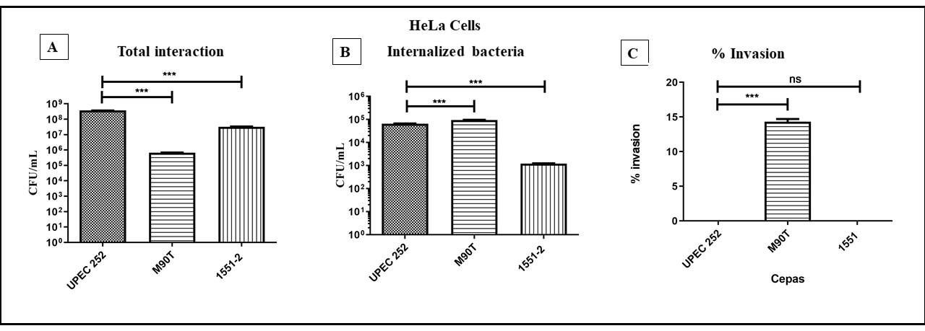
Figure S9. Interaction and invasion ability of UPEC 252 in HeLa cells. (A) Total cell-associated bacteria recovered after 3 hours of contact. The interaction of UPEC 252 was significantly more efficient than the invasive control strain M90T. (B) Quantitative invasion assay in HeLa cells performed using an infection period of 3 hours, followed by treatment with gentamicin for 1 h to kill extracellular bacteria: number of internalized bacteria after treatment. Although the number of internalized UPEC 252 bacteria was significantly lower than the positive control strain, it was significantly higher than the non-invasive control strain. (C) The invasion index is indicated as the ratio between internalized and total cell-associated bacteria expressed as a percentage. The One-way ANOVA followed by post hoc Tukey HSD test was used to compare the results obtained in this experiment. P-value: *** P <0.001; ns, statistical difference is non-significant (P >0.05). Positive control: Shigella flexneri M90T. E. albertii 1551-2Δeae was used as an adherent non-invasive control. The assays were performed in biological and experimental triplicates. The data presented consist of the mean ± Standard Deviation.

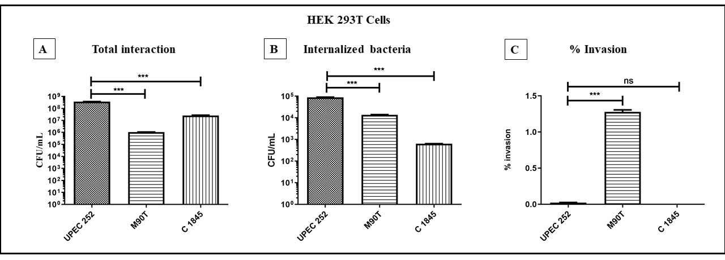

Figure S10. Interaction and invasion ability of UPEC 252 in HEK 293T cells. (A) Total cell-associated bacteria recovered after 3 hours of contact. The interaction of UPEC 252 was significantly more efficient than the invasive control strain M90T. (B) Quantitative invasion assay in HeLa cells performed using an infection period of 3 hours, followed by treatment with gentamicin for 1 h to kill extracellular bacteria: number of internalized bacteria after treatment. The number of internalized UPEC 252 bacteria was significantly higher than both the positive and non-invasive control strains. (C) The invasion index is indicated as the ratio between internalized and total cell-associated bacteria expressed as a percentage. UPEC 252 was significantly less invasive than the invasive control strain. The One-way ANOVA followed by post hoc Tukey HSD test was used to compare the results obtained in this experiment. P-value: *** P <0.001; ns, statistical difference is non-significant. Positive control: Shigella flexneri M90T. E. coli C1845 was used as an adherent non-invasive control. The assays were performed in biological and experimental triplicates. The data presented consist of the mean ± Standard Deviation.

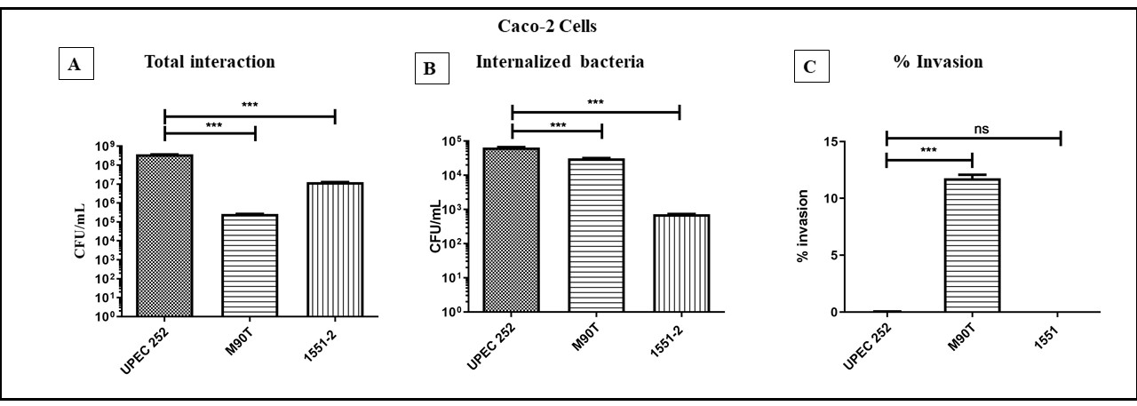
Figure S11. Interaction and invasion ability of UPEC 252 in Caco-2 cells. (A) Total cell-associated bacteria recovered after 3 hours of interaction. The interaction of UPEC 252 was significantly more efficient than the invasive control strain M90T. (B) Quantitative invasion assay in HeLa cells performed using an infection period of 3 hours, followed by treatment with gentamicin for 1 h to kill extracellular bacteria: number of internalized bacteria after treatment. The number of internalized UPEC 252 bacteria was significantly higher than both the positive and non-invasive control strains. (C) The invasion index is indicated as the ratio between internalized and total cell-associated bacteria expressed as a percentage. UPEC 252 was significantly less invasive than the invasive control strain. The One-way ANOVA followed by post hoc Tukey HSD test was used to compare the results obtained in this experiment. P-value: *** P <0.001; ns, statistical difference is non-significant. Positive control: Shigella flexneri M90T. E. albertii 1551-2Δeae was used as an adherent non-invasive control. The assays were performed in biological and experimental triplicates. The data presented consists of the mean ± Standard Deviation.

