Supplementary Material

# Supplementary Figures and Tables

**Table S1.** Classification of the assigned molecular formulas based on O:C and H:C ratio ranges (Hockaday et al., 2009; Hodgkins et al., 2016). See Fig. 6 for boundaries on van Krevelen diagram.

|  |  |  |
| --- | --- | --- |
| Classification on O:C and H:C ratios | | |
| Compound class | O:C range | H:C range |
| Lipid- & protein-like (LPD) | ≤ 0.67 | ≥ 1.5 |
| Aminosugar- and carbohydrate-like (CAR) | > 0.67 | ≥ 1.5 |
| Unsaturated hydrocarbon- & condensed aromatic-like (UHC) | 0.1< & <0.67 | 0.7-1.5 & <0.7 |
| Lignin- & tannin-like (LGN) | > 0.1 & >0.7 | 0.7-1.5 & <1.5 |

Table S2. Summary table of the obtained measurements demonstrating number of measurements (n), minimum (min), maximum (max), mean and median values.

|  |  |  |  |  |  |
| --- | --- | --- | --- | --- | --- |
|  | n | Min | Max | Mean | Median |
| Depth (m) | 5410 | 6 | 1196 | 287.5 | 193 |
| Temperature (oC) | 5410 | -1.78 | 5.43 | 2.22 | 2.74 |
| Salinity | 5410 | 33.78 | 35.03 | 34.90 | 34.95 |
| Density (σt, kg/m3) | 5410 | 27.08 | 28.13 | 27.85 | 27.85 |
| Oxygen (%) | 5410 | 78.58 | 125.54 | 92.86 | 93.24 |
| Chl Fluo. | 5410 | 0.00 | 12.38 | 0.34 | 0.06 |
| Turbidity (%) | 5410 | 0.00 | 0.65 | 0.11 | 0.09 |
| Chl *a* (μg/l) | 80 | 0.00 | 5.75 | 0.75 | 0.61 |
| PC (μM) | 80 | 0.51 | 35.64 | 5.57 | 4.22 |
| PN (μM) | 80 | 0.00 | 1.93 | 0.51 | 0.45 |
| PP (μM) | 80 | 0.01 | 0.21 | 28.04 | 11.90 |
| DIN (μM) | 80 | 0.35 | 15.64 | 8.39 | 8.91 |
| Nitrate (μM) | 80 | 0.19 | 15.34 | 7.61 | 8.14 |
| Phosphorus (μM) | 80 | 0.05 | 1.00 | 0.55 | 0.59 |
| Silicate (μM) | 80 | 0.54 | 12.96 | 4.27 | 4.35 |
| Ammonia (μM) | 80 | 0.04 | 6.21 | 0.77 | 0.64 |
| DOC (μM) | 80 | 26.90 | 104.00 | 56.90 | 56.30 |
| DON (μM) | 80 | 0.00 | 7.43 | 4.65 | 4.89 |
| DOP (μM) | 80 | 0.00 | 0.60 | 0.12 | 0.10 |
| Methane (nM) | 133 | 0.70 | 230.80 | 28.11 | 13.60 |
| MOx (nM/day) | 96 | 0.00 | 0.95 | 0.08 | 0.01 |

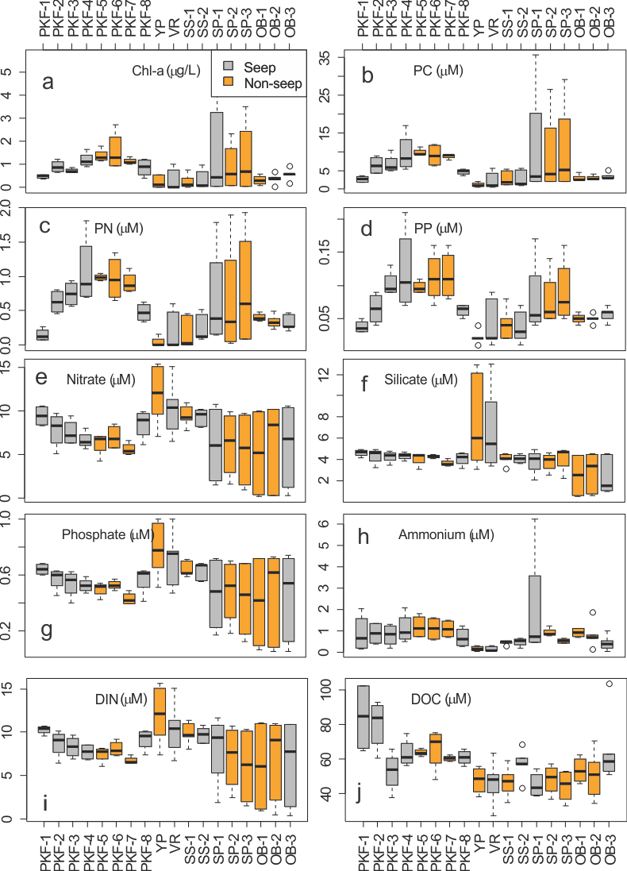

**Figure S1**: Distribution of environmental parameters organized by sampling stations shown as boxplots. Seep and non-seep stations are colored by grey and orange, respectively. Abbreviations are PC, PN, PP: particulate carbon, nitrogen and phosphorus, DIN: dissolved inorganic nitrogen, DOC: dissolved organic carbon, Chl-a.: Chlorophyll a. Stations are abbreviated as given in Table 1.

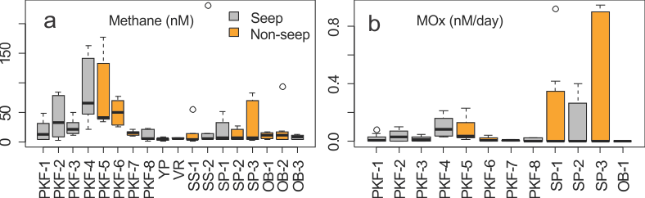

**Figure S2**: (a) Methane concentrations and (b) methane oxidation rates (MOx) at sampling stations. Seep and non-seep stations are colored by grey and orange, respectively. Stations are abbreviated as given in Table 1.

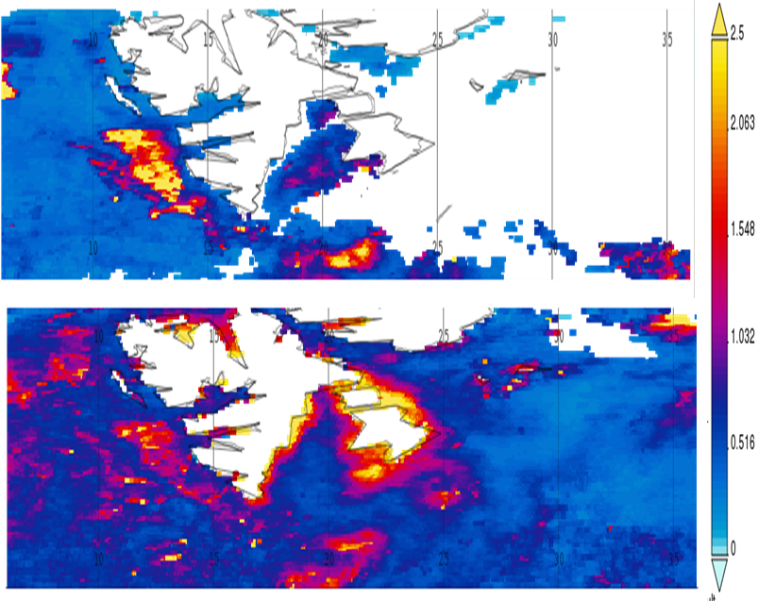

**Figure S3.** Satellite images of surface Chl*a* concentration (mg m-3) averages around Svalbard (6-36 E, 75-80 N) in 9 May -2 June (top) and 18 June – 4 July (down). Level -3 MODIS-Aqua data retrieved from <https://giovanni.gsfc.nasa.gov/giovanni/> with using Giovanni v 4.28 (Acker and Leptoukh, 2007).

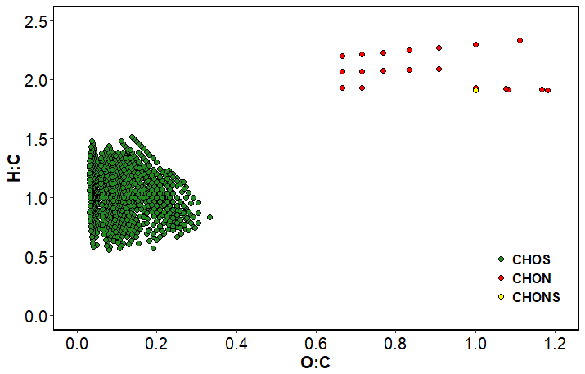

Figure S4: Unique formulas that are detected in the deepest sample at YP station indicating a link to a black sulphur presence.

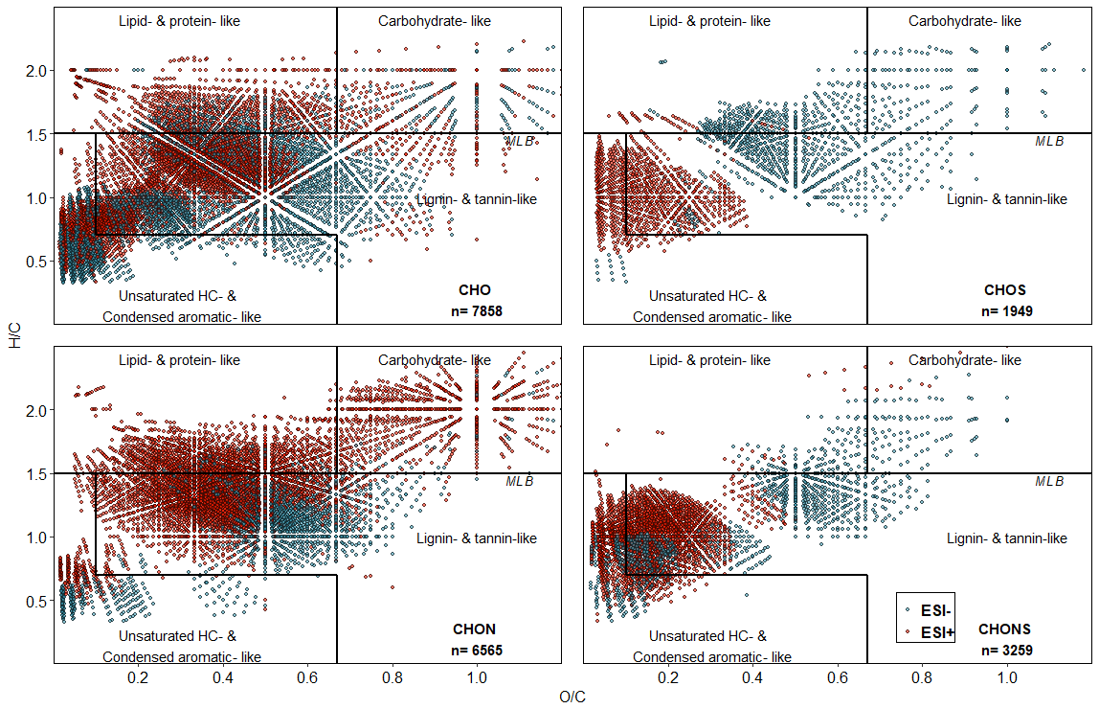

Figure S5: van Krevelen diagram for 19,641 unique formulas detected in positive (red) and negative (blue) ESI modes. Each point in the diagrams represents a single formula assigned from one resolved mass spectral peak. Each diagram represents one of the heteroatomic classes: CHO, CHON, CHOS and CHONS and the number of formulas for each heteroatomic class are given in the right corners. Dashed lines separate molecular classes and molecular lability boundary (MLB; D’Andrilli et al., 2015).

# References

Acker, J. G., and Leptoukh, G. (2007). Online analysis enhances use of NASA Earth science data. *Eos, Transactions American Geophysical Union* 88, 14–17. doi:10.1029/2007EO020003.

D’Andrilli, J., Cooper, W. T., Foreman, C. M., and Marshall, A. G. (2015). An ultrahigh-resolution mass spectrometry index to estimate natural organic matter lability: FTICRMS organic matter molecular lability index. *Rapid Communications in Mass Spectrometry* 29, 2385–2401. doi:10.1002/rcm.7400.

Hockaday, W. C., Purcell, J. M., Marshall, A. G., Baldock, J. A., and Hatcher, P. G. (2009). Electrospray and photoionization mass spectrometry for the characterization of organic matter in natural waters: a qualitative assessment. *Limnology and Oceanography: Methods* 7, 81–95.

Hodgkins, S. B., Tfaily, M. M., Podgorski, D. C., McCalley, C. K., Saleska, S. R., Crill, P. M., et al. (2016). Elemental composition and optical properties reveal changes in dissolved organic matter along a permafrost thaw chronosequence in a subarctic peatland. *Geochimica et Cosmochimica Acta* 187, 123–140. doi:10.1016/j.gca.2016.05.015.