Transcriptomics and proteomics analyses of Propionibacterium acidipropionici with high production of propionic acid through combination metabolic with evolutionary engineering
Tingting Liu^{1,2}, Qianru Zhao¹, Yang Li¹, Liying Zhu^{3,*}, Ling Jiang^{2,*}, He Huang⁴
¹College of Biotechnology and Pharmaceutical Engineering, Nanjing Tech University, Nanjing 210009, People’s Republic of China; ²College of Food Science and Light Industry, Nanjing Tech University, Nanjing 210009, People’s Republic of China; ³College of Chemical and Molecular Engineering, Nanjing Tech University, Nanjing 210009, People’s Republic of China; ⁴College of Pharmaceutical Science, Nanjing Tech University, Nanjing 210009, People’s Republic of China

*Corresponding authors.
Liying Zhu, Email: zlyhappy@njtech.edu.cn, Tel: +86-25-58139942,
College of Chemical and Molecular Engineering, Nanjing Tech University, Nanjing 210009, People’s Republic of China;
Ling Jiang, Email: jiangling@njtech.edu.cn, Tel: +86-25-58139942,
College of Food Science and Light Industry, Nanjing Tech University, Nanjing 210009, People’s Republic of China
Table S1. Descriptions and sources of strains, plasmids and primers.
Strains | Descriptions/characteristics | Reference/source
- acidipropionici | CGMCC1.2232 | CGMCC
E. coli DH5α | Host cells used in the cloning | Takara
E. coli S17–1 (λ pir) | Donor cells used in the conjugation | NTCC
Plasmids
pBluescriptII SK+ | f1(+) ori; Amp^{R}; pUC ori | Jiang et al., 2015
pJP5603 | R6K‐based suicide vector; Kan^{R} | Jiang et al., 2015
pBRESP36A | shuttle vector; Ery^{R}; Amp^{R}; | Jiang et al., 2015
pJLDH | pBluescriptII SK+ with ldh | This work
pJPOXB | pBluescriptII SK+ with poxB | This work
pBMMC | pBluescriptII SK+ with mmc over-expression | This work
Primers | Sequence(5’-3’)
ldh-for1 | ATATCTAGAGTCCGGATACACAGCCGTGCG  TATGAATTCGGGCTCCTCCTCGATGACGGGTCTTCTGC  ATAGAATTCTGACGTCAACAGTCGGGGGTGGAA  TATAAGCTTCGATCCGCAGACTGATCGTCTCGGAG
ldh-rev1
ldh-for2
ldh-rev2
poxB-for1 | ATATCTAGAGCTCACCGTCGGCATCGAAGGGT  TATGAATTCTGATTACCTCCGGATCCAGGTGATG  ATAGAATTCAGCCCACGGCACACCGGCCGGG  TATAAGCTTCGATGTGGTCCTCATGGCCATGGGTCAGC  ATATGATCAATGAGTCCGCGAAAGATTGGCGTTACCG  TATCCGCGGTCACGCAGGCTCGACGGTCACGTCG
poxB-rev1
poxB-for2
poxB-rev2
mmc-for1
mmc-rev2

Table S2. Primers for genes verified through qRT-PCR.
Genes | F-primer | R-primer
eno | GAGGTTGACCTCATCACTG | CGTCCATGCCAATTTCAATTCG
aldo | TCAGCTGATCGACGCC | ATGAACACGACTCAGTTGGA
ppdk | TCACTTGTCCCTCTCGACC | ATGACTGACCAACACCGTTA
sucA | TCATCGCTGCGCGAAGG | GTCGCTGTCTGCGGGGAT
porA | ATGGAACGCACCCGGATC | TCAGGAGCGCGTCGAAGC
aceE | ATGGCCGGAGCGGAGACT | TCAGTTGGCCTCCTCGGGG
frdA | ATGTCCATTACGTCCAAA | TCACTTGTAGCTCCTCTGC
gltA | ATGGACCAGCTCGTCGATG | TCAGCCTCGCTGGGAGCGCGGG
tal | TCACTTCGCGGCGTCCAG | ATGTCCTCATCCACCGCAGC
tkl | TCACTTGGCGAGAACCTT | ATGAGAGGAACACTGACAGTG
rbkS | TCATCGGCCCTCACCCCTC | GTGAGTCAGCGCATCGTCGT
acpP | ATGTCGACGAGTGCCACC | TCAGGCCTGCTTGCGGGTGACG
fabI | ATGGGACTTCTCGACGGT | TCAGGCGCCGGTGGAATGCAG
fabD | ATGACGCAATTTGCATTTGT | TTAAAGCTCGAGCGCCGCT
fabH | ATGCCCGAGTCAACCCGC | TCAGGGGAGGACGACGACCTGG
fabG | ATGAATTTTGAAGGAAA | TCAGACCATGTACATCCCGCCG

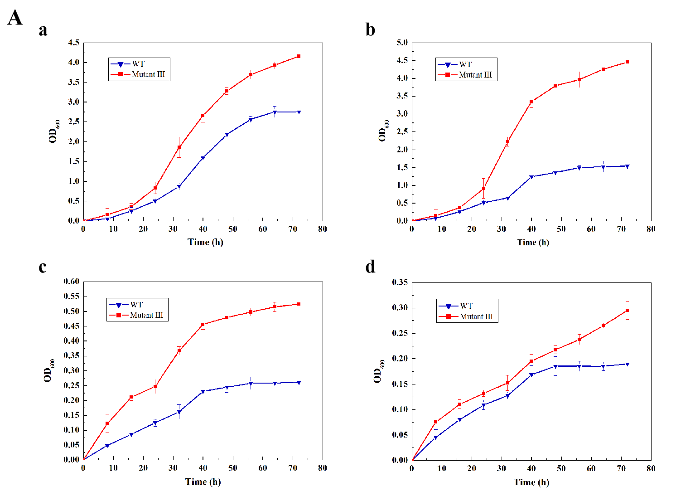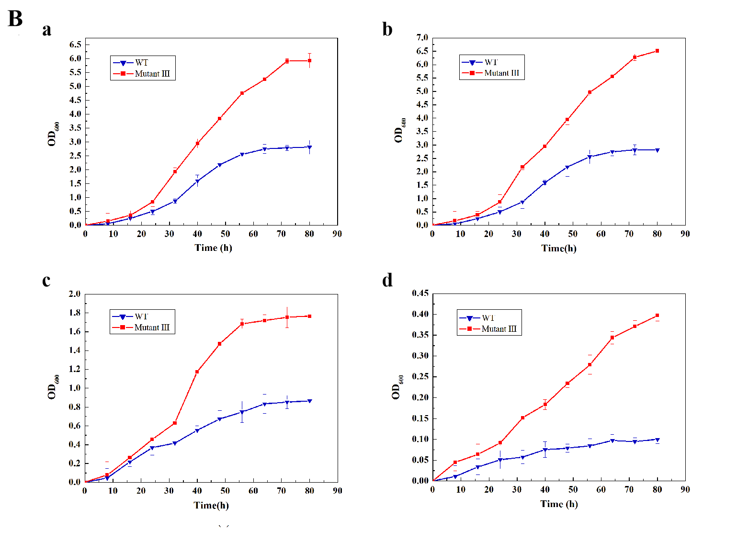

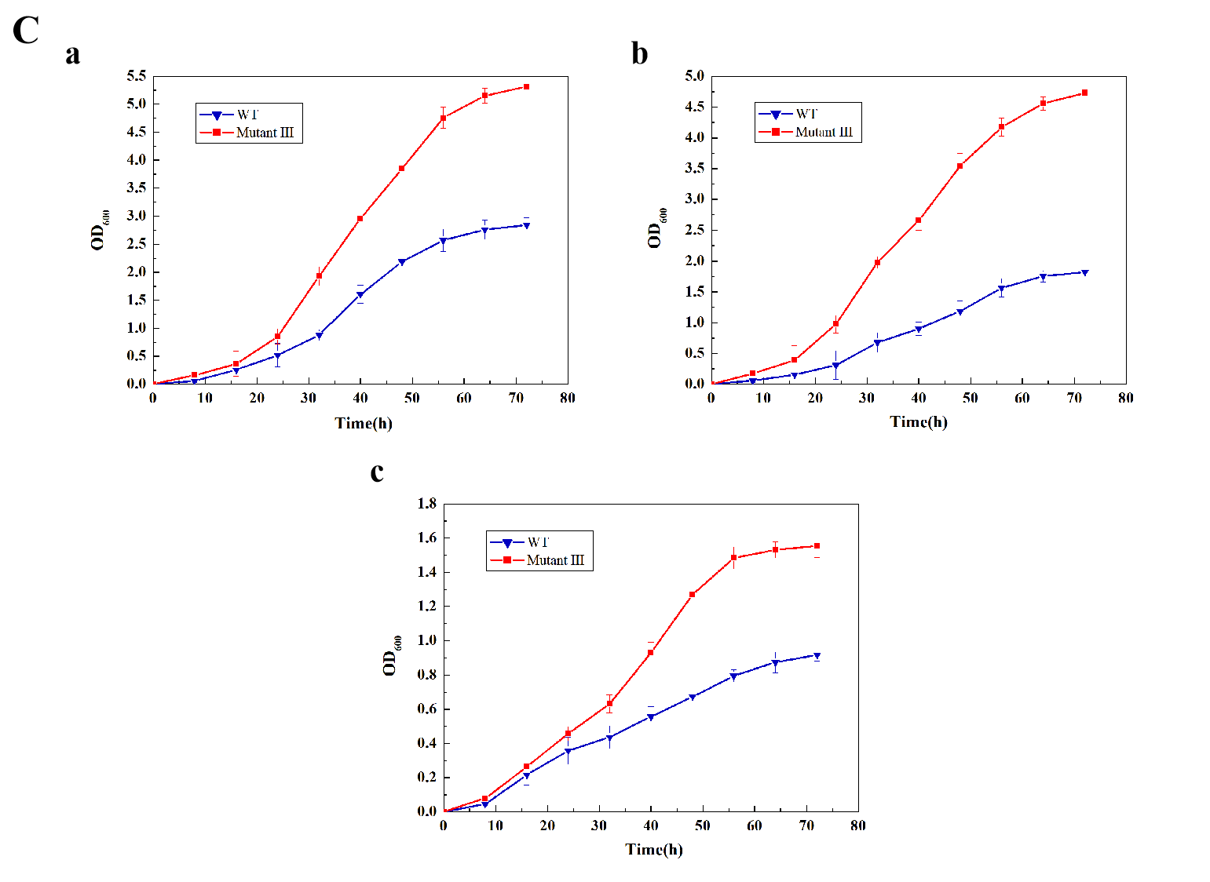
Figure S1. A Growth profiles of the wildtype and the mutant Ⅲ under different pH a pH 7, b pH 6, c pH 5, d pH 4; B Different glucose concentration a 30 g·L⁻¹, b 60 g·L⁻¹, c 90 g·L⁻¹, d 120 g·L⁻¹; C Different oxygen content a 0%, b 10%, c 21%.

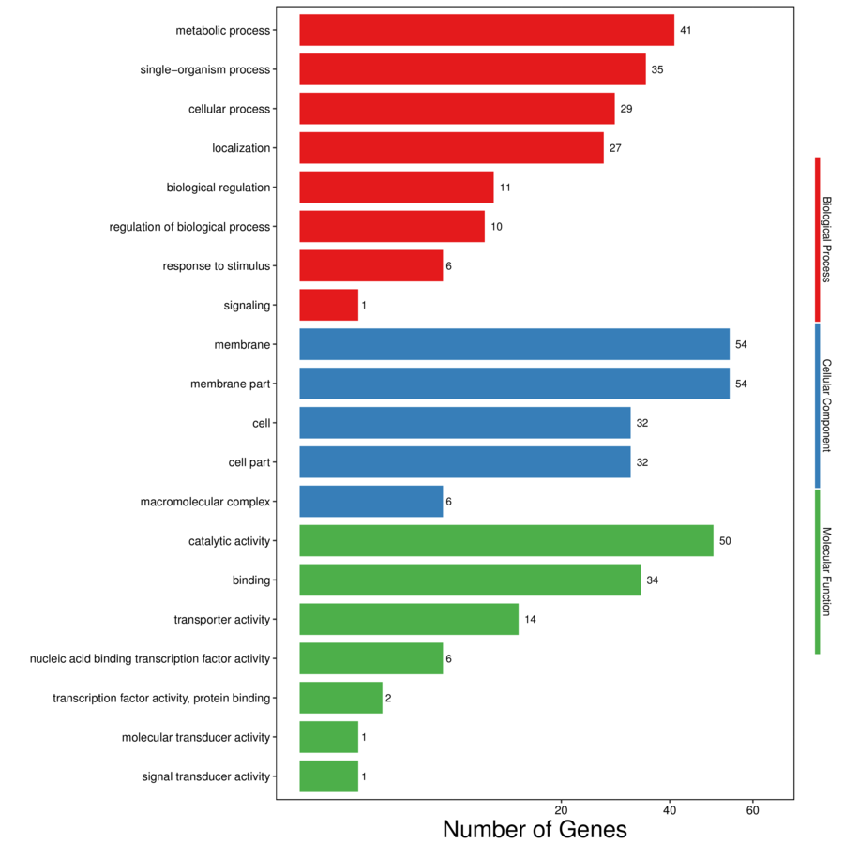
Figure S2. The GO functional analysis of the DEGs in the mutant Ⅲ compared to the wild type.

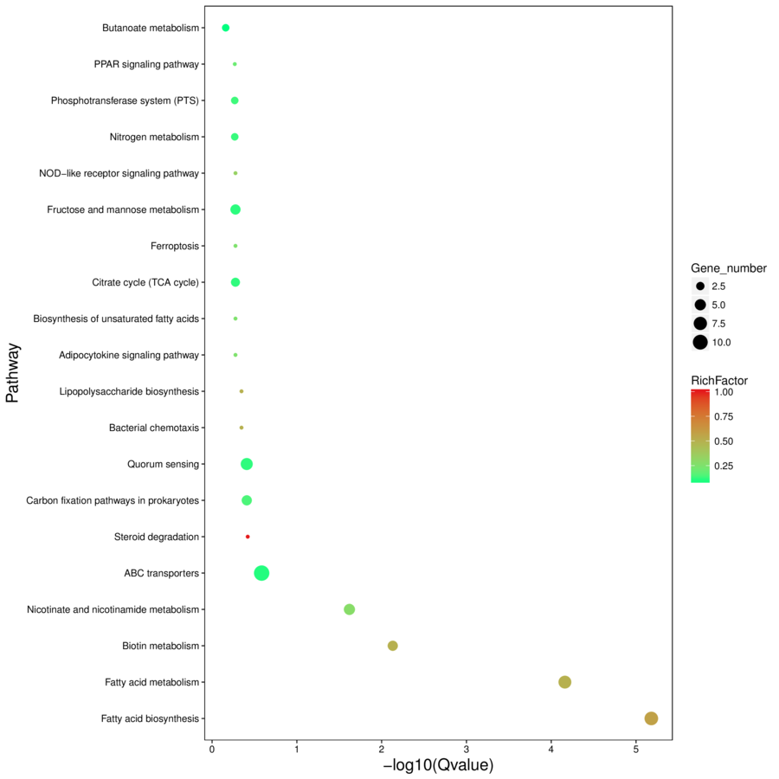
Figure S3. The KEGG pathway enrichment analysis of the DEGs in the mutant Ⅲ compared to the wild type.

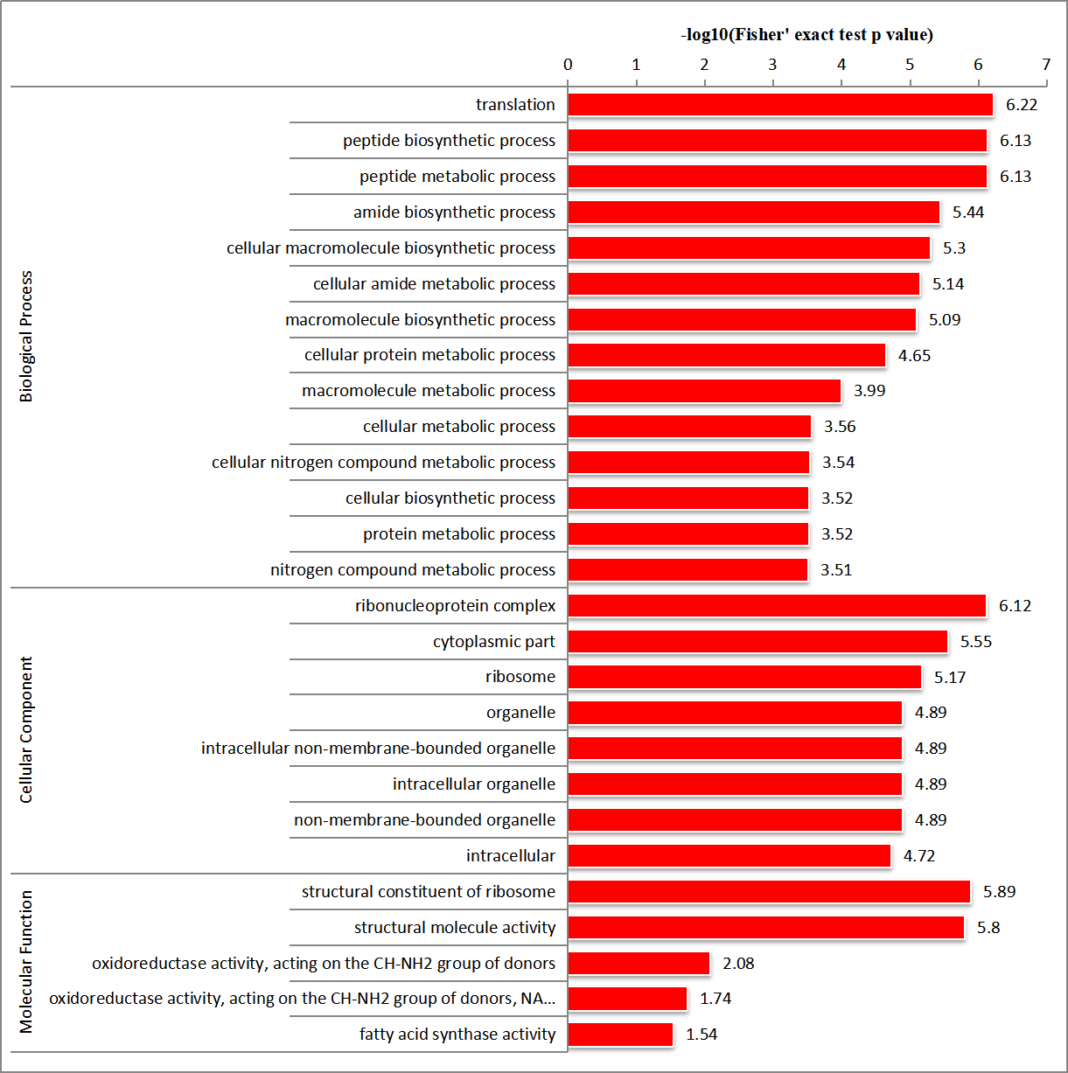
Figure S4. The GO functional analysis of the DEPs from the mutant Ⅲ compared to the wild type.

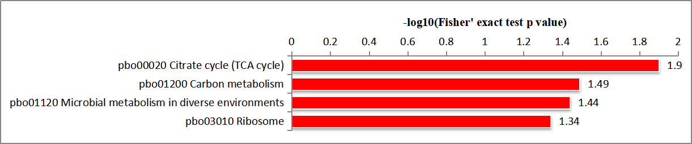
Figure S5. The KEGG pathway enrichment analysis of the DEPs from the mutant Ⅲ compared to the wild type.

