Magnetic solid phase extraction based on nanostructured magnetic porous porphyrin organic polymer for simultaneous extraction and preconcentration of neonicotinoid insecticides from surface water
Shirley K. Selahle^{1,2}, Ngwako J. Waleng^{1,2}, Anele Mpupa^{1.2}, Philiswa N. Nomngongo^{1,2,3}
¹ Department of Chemical Sciences, University of Johannesburg, Doornfontein Campus, P.O. Box 17011, Doornfontein, 2028, South Africa
²DSI/NRF SARChI Chair: Nanotechnology for Water, University of Johannesburg, Doornfontein 2028, South Africa.
³DSI/Mintek Nanotechnology Innovation Centre, University of Johannesburg, Doornfontein 2028, South Africa
Supplementary Material

Supplementary Figures and Tables

Supplementary Tables
Table S1: Independent variable and their levels used in design of experiments (DOE)
Variable | Minimum | Central | Maximum
Mass of adsorbent (mg) | 20 | 25 | 50
pH | 4 | 6.5 | 9
Extraction time (min) | 10 | 15 | 20
Eluent volume (µL) | 100 | 550 | 1000

Table S2: Factorial design matrix and the respective analytical responses
Standard Run
Standard Run | MA | EV | pH | ET | Clothi | Imida | Aceta | Thia
1 | 20 | 100 | 4 | 10 | 43,6 | 23,9 | 28,4 | 31,3
2 | 50 | 100 | 4 | 20 | 18,4 | 16,4 | 17,3 | 20,7
3 | 20 | 1000 | 4 | 20 | 88,9 | 65,4 | 74,7 | 78,1
4 | 50 | 1000 | 4 | 10 | 67,2 | 36,6 | 43,1 | 42,9
5 | 20 | 100 | 9 | 20 | 37,8 | 47,9 | 55,1 | 46,3
6 | 50 | 100 | 9 | 10 | 48,6 | 20,5 | 27,6 | 23,3
7 | 20 | 1000 | 9 | 10 | 78,8 | 45,2 | 51,0 | 53,2
8 | 50 | 1000 | 9 | 20 | 78,0 | 40,2 | 44,2 | 52,9
9 (C) | 35 | 550 | 7 | 15 | 82,0 | 72,0 | 81,7 | 83,7
10 (C) | 35 | 550 | 7 | 15 | 84,6 | 68,4 | 84,2 | 85,5
11 (C) | 35 | 550 | 7 | 15 | 82,1 | 72,4 | 83,8 | 85,3
12 (C) | 35 | 550 | 7 | 15 | 82,2 | 69,1 | 87,0 | 87,8

Table S3: Central composite design matrix and the respective analytical responses.
Expt | Mass of adsorbent | Eluent volume | Extr. time | %R
 |  |  |  | Aceta | Chlothia | Imida | Thia
1 | 20.0 | 100 | 10 | 55.5 | 26.0 | 32.7 | 35.7
2 | 20.0 | 100 | 20 | 76.6 | 69.7 | 80.3 | 92.6
3 | 20.0 | 1000 | 10 | 103.0 | 95.0 | 102.1 | 97.8
4 | 20.0 | 1000 | 20 | 87.8 | 100.3 | 89.3 | 97.3
5 | 50.0 | 100 | 10 | 66.1 | 55.1 | 63.5 | 86.1
6 | 50.0 | 100 | 20 | 98.2 | 92.5 | 106.3 | 95.8
7 | 50.0 | 1000 | 10 | 95.5 | 100.7 | 79.9 | 70.6
8 | 50.0 | 1000 | 20 | 78.3 | 84.4 | 97.6 | 80.2
9 | 15.7 | 550 | 15 | 26.4 | 24.7 | 27.6 | 32.2
10 | 54.0 | 550 | 15 | 40.2 | 58.0 | 18.2 | 31.7
11 | 35.0 | -29 | 15 | 0.0 | 0.0 | 0.0 | 0.0
12 | 35.0 | 1129 | 15 | 83.4 | 82.1 | 82.1 | 99.0
13 | 35.0 | 550 | 8.6 | 69.5 | 65.5 | 65.5 | 73.2
14 | 35.0 | 550 | 21 | 70.0 | 81.8 | 81.8 | 81.5
15 (C | 35.0 | 550 | 15 | 96.2 | 97.8 | 97.8 | 94.9
16 (C) | 35.0 | 550 | 15 | 96.1 | 101.5 | 101.5 | 97.4

Table S4 Physicochemical properties of neonicotinoid insecticides and their EF values on the MP-POP adsorbent
Compound name | Structures | Molecular mass (g/mol) | LogK_{ow}ª | EF | H bond acceptor | H bond donors
Acetamiprid | 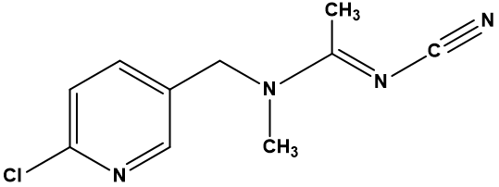 | 222.67 | 0.8 | 98 | 4 | 0
Imidacloprid | 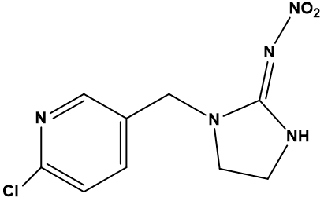 | 255.661 | 0.6 | 94 | 5 | 1
Clothianidin | 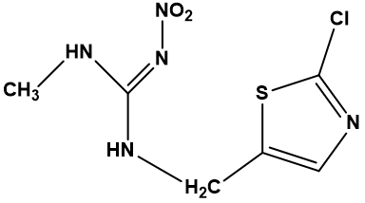 | 249.678 | 0.7 | 104 | 5 | 2
Thiacloprid | 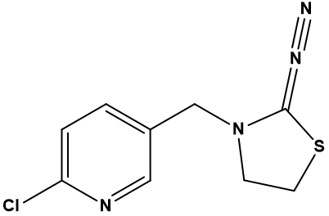 | 252.72 | 1.3 | 110 | 4 | 0
ª Data adopted from

Supplementary Figures

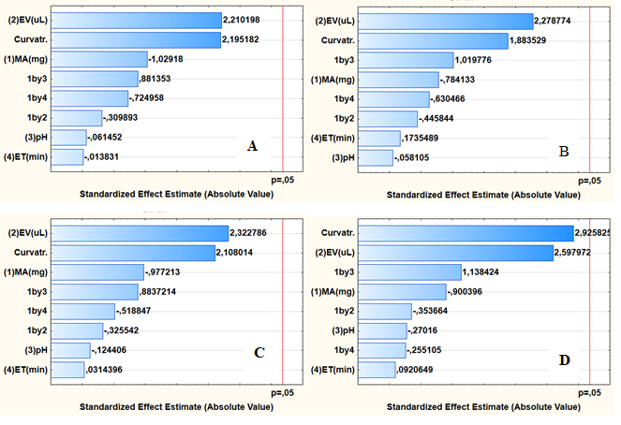
Figure S1. Pareto charts of standardised effect for preconcentration of (a) acetamiprid, (b) clothianadin, (c) imidacloprid and (d) thiacloprid. EV = Eluent volume; MA= Mass of adsorbent; ET=; Extraction time, 1 by 2= interaction of mass and the eluent volume; 1by3 = interaction of mass of adsorbent and pH; 1 by 4 = Interaction of mass of the adsorbent and extraction time;
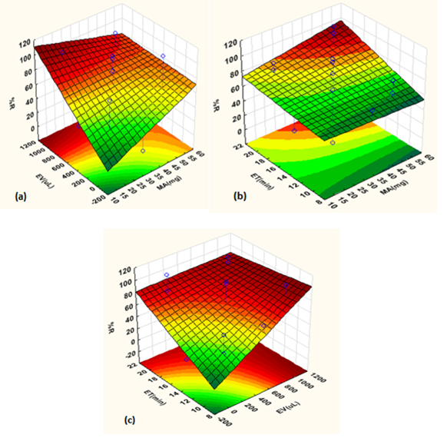
Figure S2. Response surface methodology 3D surface plots showing interaction effects.
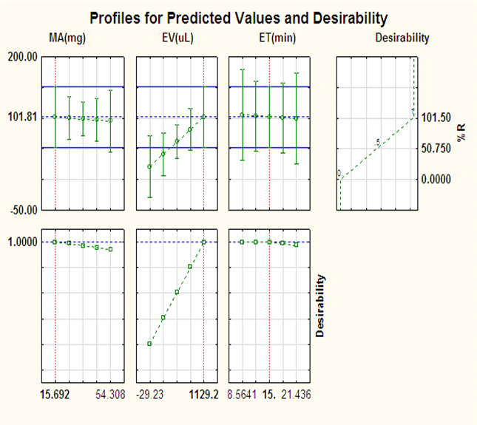
Figure S3. Profile for predicted values and desirability

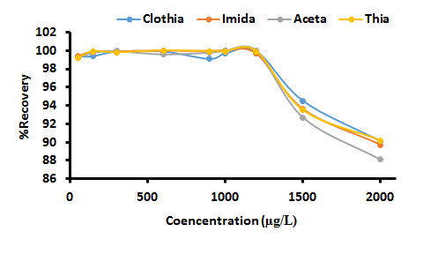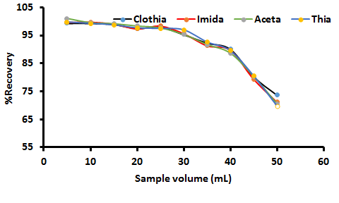
A
B
Figure S4 Effect initial concentration and sample volume

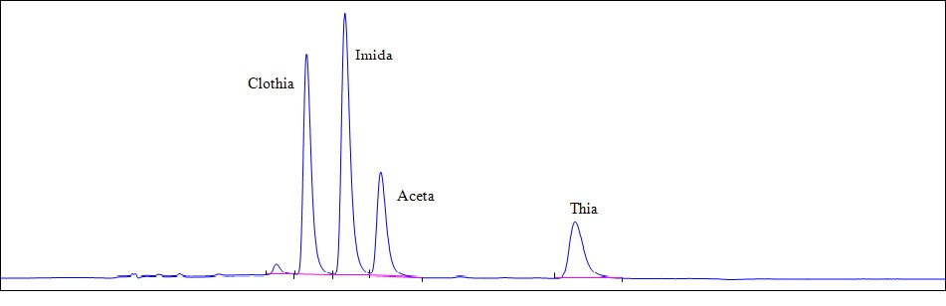
Figure S5. Chromatogram of acetamiprid (Aceta), imidacloprid (Imida), Clothiandin (Clothia) and Thiacloprid (Thia) from river water sample spiked with 100 ng L⁻¹ of each analyte.

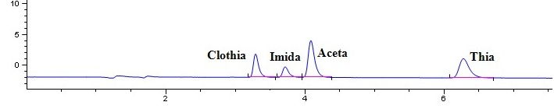
Figure S6. Typical chromatogram obtained after application of UA-DMSPE/HPLC-DAD method for analysis of river water sample 1. Acetamiprid (Aceta), imidacloprid (Imida), Clothiandin (Clothia) and Thiacloprid (Thia)

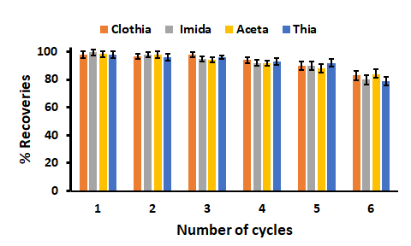
Figure S7. Regeneration and reusability of MP-POP. Acetamiprid (Aceta), imidacloprid (Imida), Clothiandin (Clothia) and Thiacloprid (Thia). Experimental conditions: sample volume, 30 mL; mass of the adsorbent, 15 mg; acetonitrile volume, 1130 µL; time of desorption, 5 min; extraction time, 15 min and pH of sample, 7.0.

Corresponding author: E-mail address:pnnomngongo@uj.ac.za, Tel: +27115596187

