Supplementary Material

**Table S1** Meteorological stations and the related records mentioned in this study from central and western Tarim Basin. The meteorological stations are plotted in **Figure 1a** (see digital numbers of 1 to 15 in **Figure 1a**).

|  |  |  |  |  |  |  |  |
| --- | --- | --- | --- | --- | --- | --- | --- |
| **Site no.** | **Meteorological station** | **Latitude(°N)** | **Longitude(°E)** | **Meteorological Records** | | | |
| **Average wind speed** | **Average temperature** | **Dust storm** | **Wind speed≥10 m/s** |
| 1 | Aksu | 41.17 | 80.23 | 1960-2012AD | 1960-2012AD | 1960-2005AD |  |
| 2 | Alar | 40.55 | 81.27 | 1960-2012AD | 1960-2012AD | 1960-2005AD |  |
| 3 | Tazhong | 39.00 | 83.67 |  |  | 1999-2005AD |  |
| 4 | Akqi | 40.93 | 78.45 | 1960-2012AD | 1960-2012AD |  |  |
| 5 | Keping | 40.50 | 79.05 | 1960-2012AD | 1960-2012AD | 1960-2005AD |  |
| 6 | Bachu | 39.80 | 78.57 | 1960-2012AD | 1960-2012AD |  |  |
| 7 | Artux | 39.72 | 76.17 |  |  |  | 1981-2010AD |
| 8 | Yopurga | 39.25 | 76.78 |  |  |  | 1981-2010AD |
| 9 | Wuqia | 39.72 | 75.25 | 1960-2012AD | 1960-2012AD | 1960-2005AD | 1981-2010AD |
| 10 | Kashgar | 39.47 | 75.98 | 1960-2012AD | 1960-2012AD | 1960-2005AD | 1981-2010AD |
| 11 | Yingjisha | 38.93 | 76.17 |  |  |  | 1981-2010AD |
| 12 | Shache | 38.43 | 77.27 | 1960-2012AD | 1960-2012AD | 1960-2005AD |  |
| 13 | Pishan | 37.62 | 78.28 | 1960-2012AD | 1960-2012AD | 1960-2005AD |  |
| 14 | Hetian | 37.13 | 79.93 | 1960-2012AD | 1960-2012AD | 1960-2005AD |  |
| 15 | Tashkurghan | 37.77 | 75.23 | 1960-2012AD | 1960-2012AD |  |  |

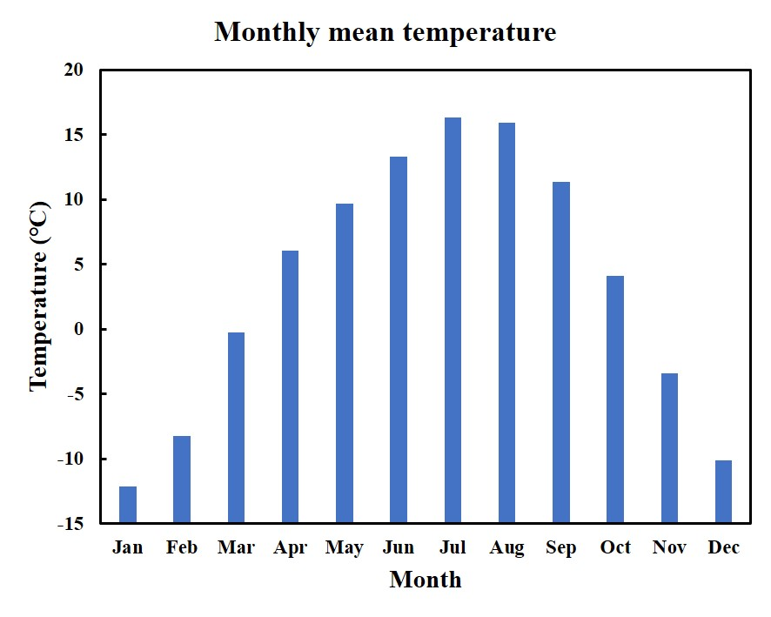

**FIGURE S1** Seasonal distribution of temperature (1957-2012 AD) recorded at Tashkurghan meteorological station. (**Table S1** and **Figure 1a**).

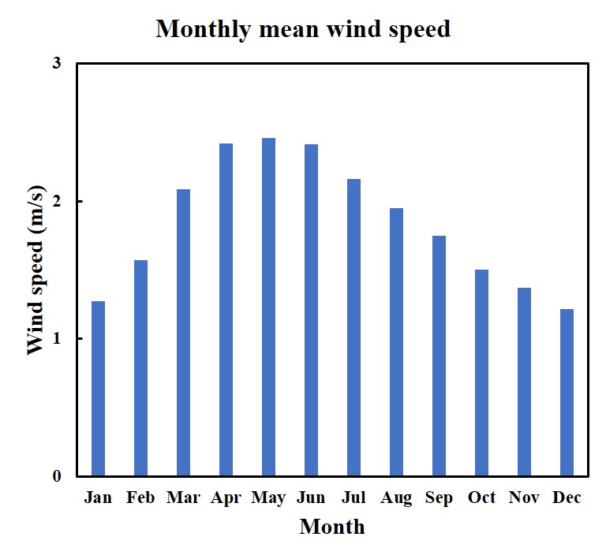

**FIGURE S2** Monthly mean wind speed (1960-2012 AD) recorded by 11 stations in the western Tarim Basin (**Table S1** and **Figure 1a**).

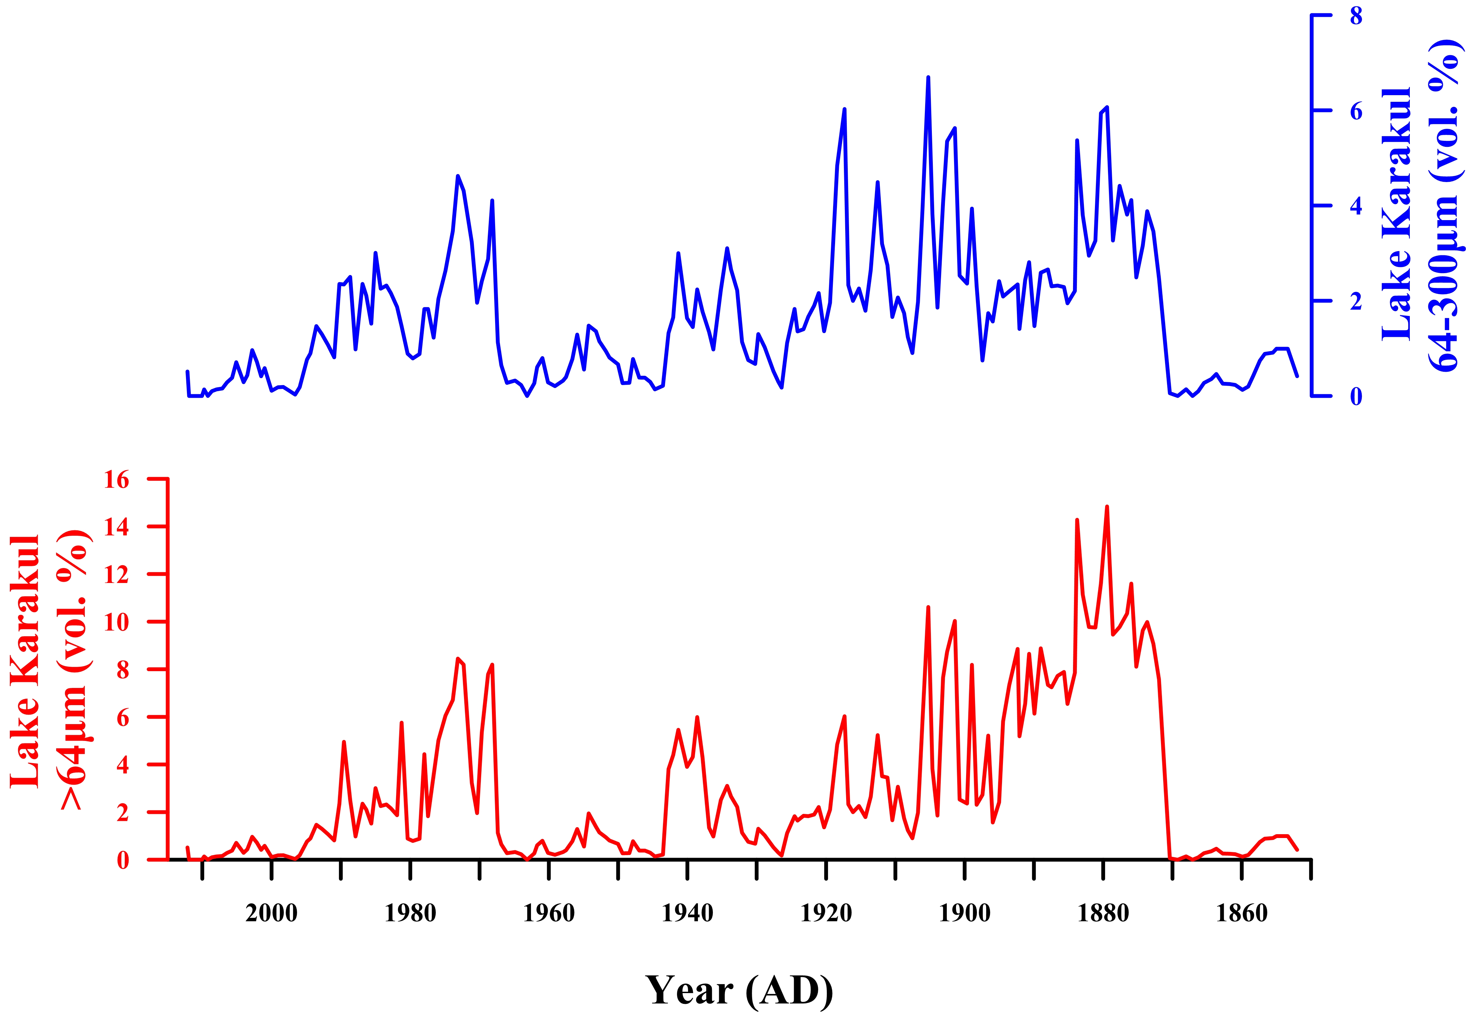

**FIGURE S3** Comparison of two grain size fractions (>64μm and 64-300μm) from Lake Karakul sediments, showing a similar variation trend over the past 160 years.

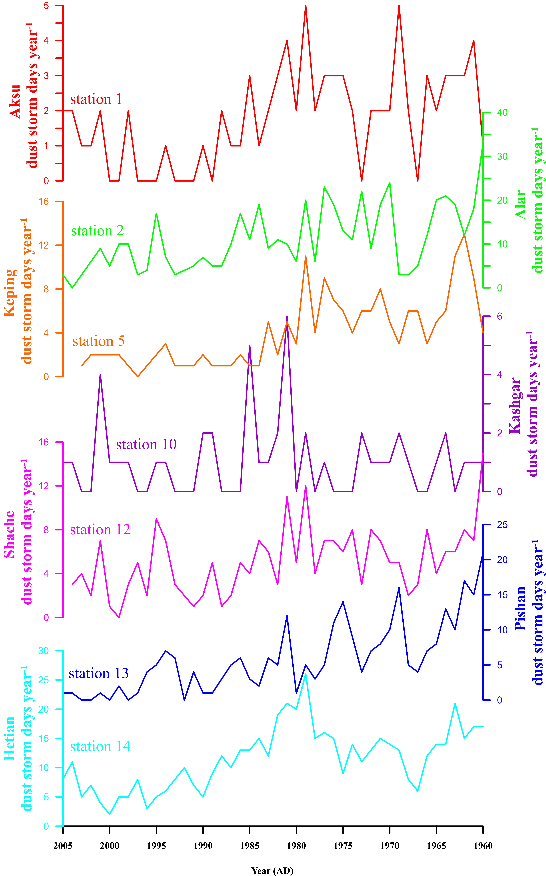

**FIGURE S4** The annual dust storm days of 7 meteorological stations in western Tarim Basin during 1960-2005AD. The meteorological stations are listed in **Table S1** and plotted in **Figure 1a** (see the corresponding digital numbers).