**Supplementary material**

**Supplementary table 1: The concentrations of the components of BG11 medium used in PHREEQC modelling.**

|  |  |  |  |  |  |
| --- | --- | --- | --- | --- | --- |
| BG11 component | Concentration / M | BG11 component | Concentration / M | BG11 component | Concentration / M |
| Na | 0.018029345 | **Citric acid** | 3.12298E-05 | **MoO4** | 1.89394E-06 |
| NO3 | 0.017648706 | **EDTA** | 2.68644E-06 | **Cu** | 5.01225E-06 |
| K | 0.000459242 | **BO3** | 4.62559E-05 | **Co** | 2.73309E-07 |
| PO4 | 0.000229621 | **Mn** | 9.14557E-06 | **Mg** | 0.000304297 |
| Ca | 0.000244881 | **Zn** | 7.65058E-07 | **CO3** | 0.000188699 |
| Cl | 0.000508054 | **SO4** | 0.000310074 | **C6H4O7** | 8.25732E-08 |
| NH4 | 0.000155311 | **Fe** | 7.76555E-06 |  |  |

Supplementary Table 2: PHREEQC thermodynamic calculations of Sr (1 mM) and Ca saturation in BG11 medium at pH 7.2 and pH 10.

|  |  |  |  |
| --- | --- | --- | --- |
| **Phase** | **Chemical formula** | **Saturation index / pH 7.2** | **Saturation index/ pH10** |
| Sr(cr) | Sr | -114.85 | -110.54 |
| Sr(HPO4)(s) | Sr(HPO4) | -0.53 | -0.51 |
| Sr(NO3)2(cr) | Sr(NO3)2 | -11.37 | -11.45 |
| Sr(NO3)2:2H2O(s) | Sr(NO3)2:2H2O | -11.07 | -11.14 |
| Sr(NO3)2:4H2O(s) | Sr(NO3)2:4H2O | -10.15 | -10.22 |
| Sr(OH)2(s) | Sr(OH)2 | -16.54 | -13.07 |
| Sr(OH)2:8H2O(s) | Sr(OH)2:8H2O | -13.13 | -9.65 |
| Sr3(PO4)2(s) | Sr3(PO4)2 | 0.03 | 3.55 |
| Sr5(PO4)3(OH)(s) | Sr5(PO4)3(OH) | 14.24 | 21.25 |
| SrCl2(s) | SrCl2 | -16.85 | -16.92 |
| SrCl2:2H2O(s) | SrCl2:2H2O | -12.11 | -12.18 |
| SrCl2:6H2O(s) | SrCl2:6H2O | -10.15 | -10.22 |
| SrCl2:H2O(s) | SrCl2:H2O | -13.58 | -13.66 |
| SrMoO4(s) | SrMoO4 | -2.65 | -2.73 |
| SrO(cr) | SrO | -31.23 | -27.76 |
| SrS(s) | SrS | -92 | -88.73 |
| Strontianite | Sr(CO3) | -1.06 | 2.42 |
| Celestite | Sr(SO4) | -0.45 | -0.52 |
| Ca(HPO4)(s) | Ca(HPO4) | -1.18 | -1.23 |
| Ca(SO3)(s) | Ca(SO3) | -30.87 | -30.17 |
| Ca3(PO4)2(alfa) | Ca3(PO4)2 | -1.46 | 1.85 |
| Ca4H(PO4)3:2.5H2O(s) | Ca4H(PO4)3:2.5H2O | -3.58 | -0.31 |
| CaCO3:H2O(s) | CaCO3:H2O | -3.36 | 0.05 |
| Calcite | CaCO3 | -2.49 | 0.91 |
| CaMg3(CO3)4(s) | CaMg3(CO3)4 | -12.96 | 0.84 |
| Brushite | Ca(HPO4):2H2O | -1.44 | -1.49 |
| Anhydrite | Ca(SO4) | -3.29 | -3.42 |
| Aragonite | CaCO3 | -2.66 | 0.74 |
| Bassanite | CaSO4:0.5H2O | -3.8 | -3.94 |
| Gaylussite | CaNa2(CO3)2:5H2O | -12.12 | -5.18 |
| Dolomite | CaMg(CO3)2 | -4.76 | 2.11 |
| Glauberite | Na2Ca(SO4)2 | -17.1 | -17.24 |
| Gypsum | CaSO4:2H2O | -3.08 | -3.21 |
| Gaylussite | CaNa2(CO3)2:5H2O | -12.12 | -5.18 |
| Hydroxyapatite | Ca5(OH)(PO4)3 | 4.17 | 10.84 |
| Pirssonite | Na2Ca(CO3)2:2H2O | -12.69 | -5.75 |
| Polyhalite | K2MgCa2(SO4)4:2H2O | -19.81 | -20.17 |
| Vaterite | CaCO3 | -3.08 | 0.32 |

**Supplementary Table 3: Fitting parameters obtained from Sr-K-edge EXAFS Spectroscopy**

|  |  |  |  |  |  |  |
| --- | --- | --- | --- | --- | --- | --- |
| Scattering path | N | R (Å) | σ2  (Å2) | E0 | R-factor | Confidence of adding shell (α)a |
| Sr-O | 9 | 2.60(1) | 0.009(1) | 3.72 | 0.017 |  |
| Sr-P | 1.8 | 3.22(3) | 0.008(4) |  |  | 95.1 b |
| Sr-Sr | 1 | 3.48(3) | 0.005(3) |  |  | 98.6 c |
| Uncertainty in interatomic distances is quoted in brackets for the last decimal place (Å), points without a value have error less than 0.005 Å. Uncertainty in Debye-Waller factors is quoted in brackets for the last decimal place, points without a value have error less than 0.0005.a F-test results; α > 0.95 statistically improves the fit with 2 σ confidence. b F-test results, shell added first. c F-test results, shell added second. S02 was fixed to 1 for all samples. | | | | | | |

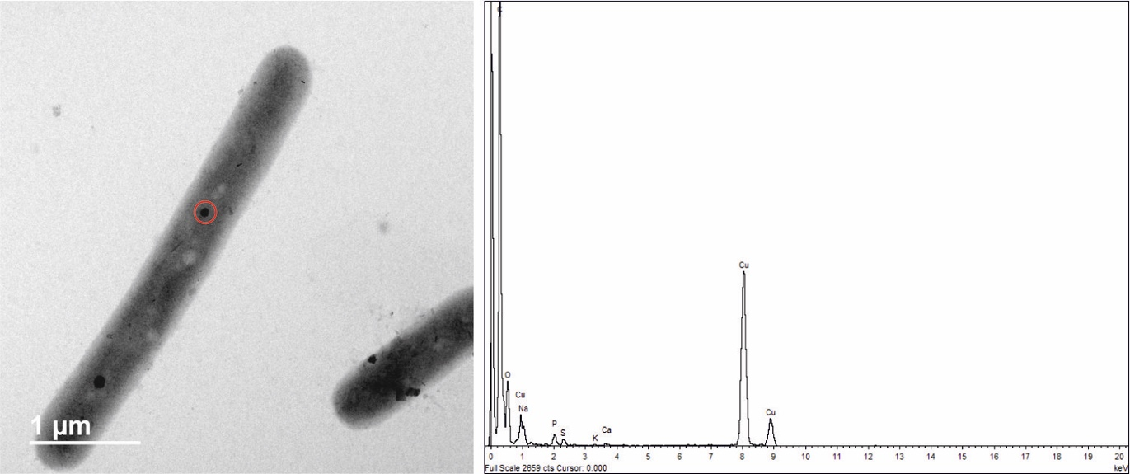

Supplementary figure 1: TEM image and EDS data taken from a sample of *P. catenata* culture day 20, washed twice. EDS data taken from the electron dense feature of highlighted with the red circle. Peaks indicate the presence of P, the Cu peaks are due to the Cu-TEM grids.

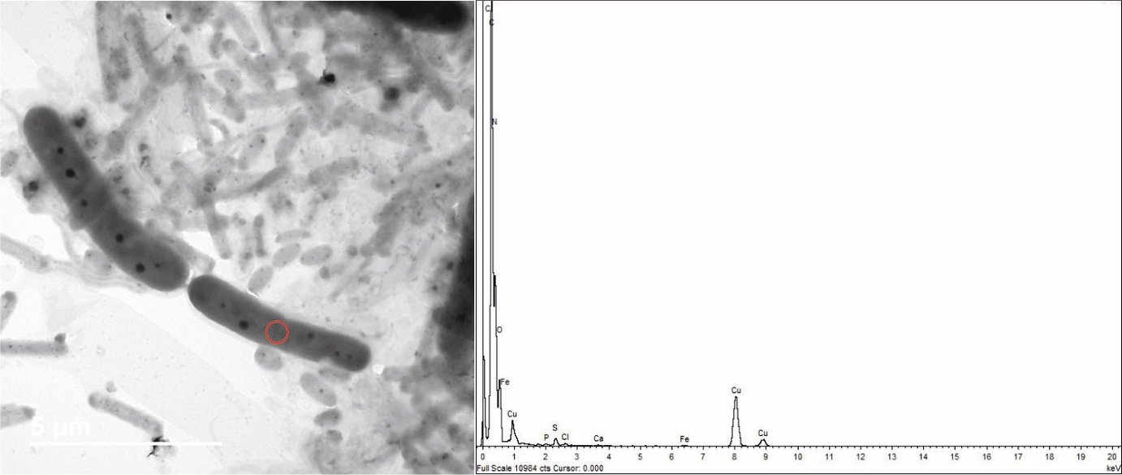

Supplementary figure 2: TEM image and EDS data taken from a sample of *P. catenata* culture incubated with SrCl2 at day 20, washed twice. EDS data collected from within the region indicated by red circle. The peaks do not show the presence of Sr associated with the cell (away from the polyphosphate features), the Cu peaks are due to the Cu-TEM grid.