Comparison

Mert Kukrer

27.04.2020

Table of Contents

### Data

getwd()

## [1] "D:/Google Drive/UNIVERSITE/Akademik/Frontiers in ecology and evolution/Latest version/Comparisons"

#install.packages(c("dunn.test","pwr", "effsize","dabestr"), type='binary', repos = "http://cran.rstudio.com/", dependencies = TRUE)  
  
library(pwr)  
library(effsize)  
library(dunn.test)  
library(dabestr)

## Loading required package: boot

## Loading required package: magrittr

source("D:/Google Drive/UNIVERSITE/Akademik/Frontiers in ecology and evolution/Latest version/Comparisons/cbind.na.R")  
  
memberships250 =read.csv2("D:/Google Drive/UNIVERSITE/Akademik/Frontiers in ecology and evolution/Latest version/Comparisons/250_membership_coefficients.csv", header = TRUE, sep = ";", quote = "", dec = ",", fill = TRUE, comment.char = "")  
head(memberships250)

## SAMPLE_ID RANK POPULATION MIGRATORY THRACIAN LEVANTINE ANATOLIAN CAUCASIAN  
## 1 TK01 1 Kirklareli 0 0.8920 0.0450 0.0473 0.0157  
## 2 TK02 2 Kirklareli 0 0.9317 0.0137 0.0397 0.0150  
## 3 TK03 3 Kirklareli 0 0.9700 0.0090 0.0093 0.0117  
## 4 TK04 4 Kirklareli 0 0.8946 0.0280 0.0297 0.0477  
## 5 TK05 5 Kirklareli 0 0.8784 0.0210 0.0710 0.0297  
## 6 TK06 6 Kirklareli 0 0.8850 0.0247 0.0307 0.0597  
## TransformedTHRACIAN TransformedLEVANTINE TransformedANATOLIAN  
## 1 1.235940 0.21375613 0.21923770  
## 2 1.306383 0.11731592 0.20059108  
## 3 1.396713 0.09501121 0.09658661  
## 4 1.240151 0.16812289 0.17320155  
## 5 1.214600 0.14542582 0.26971656  
## 6 1.224819 0.15781662 0.17612328  
## TransformedCAUCASIAN  
## 1 0.1256298  
## 2 0.1227828  
## 3 0.1083786  
## 4 0.2201780  
## 5 0.1732016  
## 6 0.2468347

memberships174 =read.csv2("D:/Google Drive/UNIVERSITE/Akademik/Frontiers in ecology and evolution/Latest version/Comparisons/174_membership_coefficients.csv", header = TRUE, sep = ";", quote = "", dec = ",", fill = TRUE, comment.char = "")  
head(memberships174)

## SAMPLE_ID RANK POPULATION ANATOLIAN THRACIAN CAUCASIAN LEVANTINE  
## 1 TK01 1 Kirklareli 0.0244 0.9415 0.0072 0.0269  
## 2 TK02 2 Kirklareli 0.0292 0.9585 0.0057 0.0067  
## 3 TK03 3 Kirklareli 0.0057 0.9835 0.0063 0.0045  
## 4 TK04 4 Kirklareli 0.0284 0.9282 0.0292 0.0142  
## 5 TK05 5 Kirklareli 0.0363 0.9404 0.0151 0.0082  
## 6 TK06 6 Kirklareli 0.0243 0.9315 0.0267 0.0176  
## TransformedANATOLIAN TransformedTHRACIAN TransformedCAUCASIAN  
## 1 0.15684730 1.326506 0.08495497  
## 2 0.17172281 1.365645 0.07557025  
## 3 0.07557025 1.441988 0.07945612  
## 4 0.16933104 1.299526 0.17172281  
## 5 0.19169752 1.324173 0.12319343  
## 6 0.15652291 1.305987 0.16413736  
## TransformedLEVANTINE  
## 1 0.16475656  
## 2 0.08194521  
## 3 0.06713245  
## 4 0.11944759  
## 5 0.09067807  
## 6 0.13305726

### Migratory beekeeping

Ankara_mig = subset(memberships250, memberships250$POPULATION=="Ankara")  
Mugla_mig = subset(memberships250, memberships250$POPULATION=="Mugla")  
Hatay_mig = subset(memberships250, memberships250$POPULATION=="Hatay")  
Kirklareli_mig = subset(memberships250, memberships250$POPULATION=="Kirklareli")  
Edirne_mig = subset(memberships250, memberships250$POPULATION=="Edirne+")  
Duzce_mig = subset(memberships250, memberships250$POPULATION=="Duzce+")  
Eskisehir_mig = subset(memberships250, memberships250$POPULATION=="Eskisehir+")  
Ardahan_mig = subset(memberships250, memberships250$POPULATION=="Ardahan")  
Artvin_mig = subset(memberships250, memberships250$POPULATION=="Artvin")  
Bitlis_mig = subset(memberships250, memberships250$POPULATION=="Bitlis+")  
  
three_provinces_mig = cbind(  
 rbind(  
 Ankara_mig,  
 Mugla_mig,  
 Hatay_mig),  
 TransformedCOEFFICIENT=c(  
 Ankara_mig$TransformedANATOLIAN,  
 Mugla_mig$TransformedANATOLIAN,  
 Hatay_mig$TransformedLEVANTINE)  
)  
  
all_provinces_mig = cbind(  
 rbind(  
 Kirklareli_mig,  
 Edirne_mig,  
 Duzce_mig,  
 Eskisehir_mig,  
 Ankara_mig,  
 Mugla_mig,  
 Ardahan_mig,  
 Artvin_mig,  
 Bitlis_mig,  
 Hatay_mig),  
 TransformedCOEFFICIENT=c(  
 Kirklareli_mig$TransformedTHRACIAN,  
 Edirne_mig$TransformedTHRACIAN,  
 Duzce_mig$TransformedANATOLIAN,  
 Eskisehir_mig$TransformedANATOLIAN,  
 Ankara_mig$TransformedANATOLIAN,  
 Mugla_mig$TransformedANATOLIAN,  
 Ardahan_mig$TransformedCAUCASIAN,  
 Artvin_mig$TransformedCAUCASIAN,  
 Bitlis_mig$TransformedLEVANTINE,  
 Hatay_mig$TransformedLEVANTINE)  
)  
  
normalities_250 = apply(memberships250[5:12], 2, function(x) {shapiro.test(x)$p.value})  
p.adjust(normalities_250, method="BH")

## THRACIAN LEVANTINE ANATOLIAN   
## 6.204134e-22 8.026862e-20 4.700821e-15   
## CAUCASIAN TransformedTHRACIAN TransformedLEVANTINE   
## 3.016805e-18 7.246785e-20 7.819709e-17   
## TransformedANATOLIAN TransformedCAUCASIAN   
## 3.925518e-12 1.824682e-15

boxplot(  
 Ankara_mig$TransformedANATOLIAN[Ankara_mig$MIGRATORY==0],  
 Ankara_mig$TransformedANATOLIAN[Ankara_mig$MIGRATORY==1],  
 Mugla_mig$TransformedANATOLIAN[Mugla_mig$MIGRATORY==0],  
 Mugla_mig$TransformedANATOLIAN[Mugla_mig$MIGRATORY==1],  
 Hatay_mig$TransformedLEVANTINE[Hatay_mig$MIGRATORY==0],  
 Hatay_mig$TransformedLEVANTINE[Hatay_mig$MIGRATORY==1],  
 three_provinces_mig$TransformedCOEFFICIENT[three_provinces_mig$MIGRATORY==0],  
 three_provinces_mig$TransformedCOEFFICIENT[three_provinces_mig$MIGRATORY==1],  
 all_provinces_mig$TransformedCOEFFICIENT[all_provinces_mig$MIGRATORY==0],  
 all_provinces_mig$TransformedCOEFFICIENT[all_provinces_mig$MIGRATORY==1],  
 col= rep(c("yellow", "yellow", "violet", "coral4", "firebrick"), each= 2),  
 names= paste0(rep(c("Sta_", "Mig_"), times= 5), rep(c("Ankara", "Mugla", "Hatay", "Combine", "All"), each= 2)),  
 las=2,  
 xlab="",  
 ylab="Arcsine square root transformed membership coefficients",  
 pars=list(par(mar=c(8,5,4,2))),  
 main="Stationary vs Migratory Colonies",  
 at =c(1,2, 4,5, 7,8, 10,11, 13,14)  
)  
  
mean_mig = apply(cbind.na(  
 Ankara_mig$TransformedANATOLIAN[Ankara_mig$MIGRATORY==0],  
 Ankara_mig$TransformedANATOLIAN[Ankara_mig$MIGRATORY==1],  
 Mugla_mig$TransformedANATOLIAN[Mugla_mig$MIGRATORY==0],  
 Mugla_mig$TransformedANATOLIAN[Mugla_mig$MIGRATORY==1],  
 Hatay_mig$TransformedLEVANTINE[Hatay_mig$MIGRATORY==0],  
 Hatay_mig$TransformedLEVANTINE[Hatay_mig$MIGRATORY==1],  
 three_provinces_mig$TransformedCOEFFICIENT[three_provinces_mig$MIGRATORY==0],  
 three_provinces_mig$TransformedCOEFFICIENT[three_provinces_mig$MIGRATORY==1],  
 all_provinces_mig$TransformedCOEFFICIENT[all_provinces_mig$MIGRATORY==0],  
 all_provinces_mig$TransformedCOEFFICIENT[all_provinces_mig$MIGRATORY==1]),  
 2, function(x) {mean(x, na.rm=TRUE)})  
mean_mig

## [1] 0.8237470 1.1147220 0.9256943 0.7033353 1.2027229 0.6633430 0.9988654  
## [8] 0.7893510 1.0590524 0.7158815

effect_sizes_mig = c(  
 cohen.d(TransformedANATOLIAN ~ MIGRATORY, data= Ankara_mig)$estimate,  
 cohen.d(TransformedANATOLIAN ~ MIGRATORY, data= Mugla_mig)$estimate,  
 cohen.d(TransformedLEVANTINE ~ MIGRATORY, data= Hatay_mig)$estimate,  
 cohen.d(TransformedCOEFFICIENT ~ MIGRATORY, data= three_provinces_mig)$estimate,  
 cohen.d(TransformedCOEFFICIENT ~ MIGRATORY, data= all_provinces_mig)$estimate  
)

## Warning in cohen.d.formula(TransformedANATOLIAN ~ MIGRATORY, data = Ankara_mig):  
## Cohercing rhs of formula to factor

## Warning in cohen.d.formula(TransformedANATOLIAN ~ MIGRATORY, data = Mugla_mig):  
## Cohercing rhs of formula to factor

## Warning in cohen.d.formula(TransformedLEVANTINE ~ MIGRATORY, data = Hatay_mig):  
## Cohercing rhs of formula to factor

## Warning in cohen.d.formula(TransformedCOEFFICIENT ~ MIGRATORY, data =  
## three_provinces_mig): Cohercing rhs of formula to factor

## Warning in cohen.d.formula(TransformedCOEFFICIENT ~ MIGRATORY, data =  
## all_provinces_mig): Cohercing rhs of formula to factor

effect_sizes_mig

## [1] -0.9987945 0.8859429 2.0124767 0.6661108 1.2218047

U_tests_mig = c(  
 wilcox.test(TransformedANATOLIAN ~ MIGRATORY, data = Ankara_mig)$p.value,  
 wilcox.test(TransformedANATOLIAN ~ MIGRATORY, data = Mugla_mig)$p.value,  
 wilcox.test(TransformedLEVANTINE ~ MIGRATORY, data = Hatay_mig)$p.value,  
 wilcox.test(TransformedCOEFFICIENT ~ MIGRATORY, data = three_provinces_mig)$p.value,  
 wilcox.test(TransformedCOEFFICIENT ~ MIGRATORY, data = all_provinces_mig)$p.value  
)  
p.adjust(U_tests_mig, method="BH")

## [1] 1.317416e-02 1.472141e-02 1.718698e-04 4.750405e-03 1.280925e-12

F_tests_mig = c(  
 var.test(TransformedANATOLIAN ~ MIGRATORY, data = Ankara_mig)$p.value,  
 var.test(TransformedANATOLIAN ~ MIGRATORY, data = Mugla_mig)$p.value,  
 var.test(TransformedLEVANTINE ~ MIGRATORY, data = Hatay_mig)$p.value,  
 var.test(TransformedCOEFFICIENT ~ MIGRATORY, data = three_provinces_mig)$p.value,  
 var.test(TransformedCOEFFICIENT ~ MIGRATORY, data = all_provinces_mig)$p.value  
)  
p.adjust(F_tests_mig, method="BH")

## [1] 0.25642361 0.54661092 0.01052260 0.29366739 0.01691253

t_tests_mig = c(  
 t.test(TransformedANATOLIAN ~ MIGRATORY, data = Ankara_mig, var.equal = FALSE)$p.value,  
 t.test(TransformedANATOLIAN ~ MIGRATORY, data = Mugla_mig, var.equal = FALSE)$p.value,  
 t.test(TransformedLEVANTINE ~ MIGRATORY, data = Hatay_mig, var.equal = FALSE)$p.value,  
 t.test(TransformedCOEFFICIENT ~ MIGRATORY, data = three_provinces_mig, var.equal = FALSE)$p.value,  
 t.test(TransformedCOEFFICIENT ~ MIGRATORY, data = all_provinces_mig, var.equal = FALSE)$p.value  
)  
p.adjust(t_tests_mig, method="BH")

## [1] 1.054398e-02 1.634470e-02 5.627352e-04 5.172127e-03 4.000278e-12

pwr_t_tests_mig = c(  
 pwr.t2n.test(  
 n1= sum(Ankara_mig$MIGRATORY),  
 n2= length(Ankara_mig$MIGRATORY) - sum(Ankara_mig$MIGRATORY),  
 d= cohen.d(TransformedANATOLIAN ~ MIGRATORY, data= Ankara_mig)$estimate,  
 sig.level= max(p.adjust(t_tests_mig, method="BH")))$power,  
 pwr.t2n.test(  
 n1= sum(Mugla_mig$MIGRATORY),  
 n2= length(Mugla_mig$MIGRATORY) - sum(Mugla_mig$MIGRATORY),  
 d= cohen.d(TransformedANATOLIAN ~ MIGRATORY, data= Mugla_mig)$estimate,  
 sig.level= max(p.adjust(t_tests_mig, method="BH")))$power,  
 pwr.t2n.test(  
 n1= sum(Hatay_mig$MIGRATORY),  
 n2= length(Hatay_mig$MIGRATORY) - sum(Hatay_mig$MIGRATORY),  
 d= cohen.d(TransformedLEVANTINE ~ MIGRATORY, data= Hatay_mig)$estimate,  
 sig.level= max(p.adjust(t_tests_mig, method="BH")))$power,  
 pwr.t2n.test(  
 n1= sum(three_provinces_mig$MIGRATORY),  
 n2= length(three_provinces_mig$MIGRATORY) - sum(three_provinces_mig$MIGRATORY),  
 d= cohen.d(TransformedCOEFFICIENT ~ MIGRATORY, data= three_provinces_mig)$estimate,  
 sig.level= max(p.adjust(t_tests_mig, method="BH")))$power,  
 pwr.t2n.test(  
 n1= sum(all_provinces_mig$MIGRATORY),  
 n2= length(all_provinces_mig$MIGRATORY) - sum(all_provinces_mig$MIGRATORY),  
 d= cohen.d(TransformedCOEFFICIENT ~ MIGRATORY, data= all_provinces_mig)$estimate,  
 sig.level= max(p.adjust(t_tests_mig, method="BH")))$power  
)

## Warning in cohen.d.formula(TransformedANATOLIAN ~ MIGRATORY, data = Ankara_mig):  
## Cohercing rhs of formula to factor

## Warning in cohen.d.formula(TransformedANATOLIAN ~ MIGRATORY, data = Mugla_mig):  
## Cohercing rhs of formula to factor

## Warning in cohen.d.formula(TransformedLEVANTINE ~ MIGRATORY, data = Hatay_mig):  
## Cohercing rhs of formula to factor

## Warning in cohen.d.formula(TransformedCOEFFICIENT ~ MIGRATORY, data =  
## three_provinces_mig): Cohercing rhs of formula to factor

## Warning in cohen.d.formula(TransformedCOEFFICIENT ~ MIGRATORY, data =  
## all_provinces_mig): Cohercing rhs of formula to factor

pwr_t_tests_mig

## [1] 0.4620189 0.5431285 0.9991666 0.7756358 1.0000000

three_provinces_mig$COEFFICIENT=c(  
 Ankara_mig$ANATOLIAN,  
 Mugla_mig$ANATOLIAN,  
 Hatay_mig$LEVANTINE)  
  
all_provinces_mig$COEFFICIENT=c(  
 Kirklareli_mig$THRACIAN,  
 Edirne_mig$THRACIAN,  
 Duzce_mig$ANATOLIAN,  
 Eskisehir_mig$ANATOLIAN,  
 Ankara_mig$ANATOLIAN,  
 Mugla_mig$ANATOLIAN,  
 Ardahan_mig$CAUCASIAN,  
 Artvin_mig$CAUCASIAN,  
 Bitlis_mig$LEVANTINE,  
 Hatay_mig$LEVANTINE)  
  
all_provinces_mig_merged = cbind(all_provinces_mig,  
 MERGED = paste("All", all_provinces_mig$MIGRATORY))  
  
all_provinces_mig$MERGED = paste(all_provinces_mig$POPULATION, all_provinces_mig$MIGRATORY)  
  
three_provinces_mig$MERGED = paste("Combine", three_provinces_mig$MIGRATORY)  
  
est_fac_mig = rbind(all_provinces_mig, three_provinces_mig, all_provinces_mig_merged)  
  
plot(dabest(est_fac_mig, MERGED, COEFFICIENT,   
 idx = list(c("Ankara 0", "Ankara 1"),   
 c("Mugla 0", "Mugla 1"),  
 c("Hatay 0", "Hatay 1"),   
 c("Combine 0", "Combine 1"),  
 c("All 0", "All 1")),  
 paired = FALSE),  
 theme = ggplot2::theme_gray(),  
 palette = rep(c("yellow", "yellow", "violet", "coral4", "firebrick"), each= 2),  
 rawplot.ylim = c(0.00, 1.10),  
 effsize.ylim = c(-0.80, 0.60),  
 rawplot.markersize = 4,  
 rawplot.groupwidth = 0.2,  
 rawplot.ylabel = "Membership Coefficient"  
)

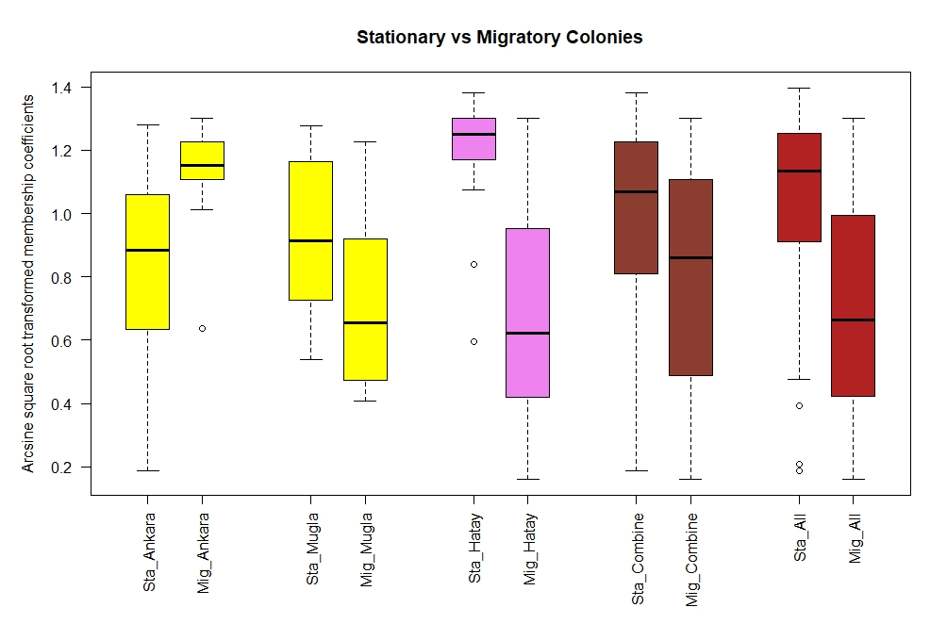 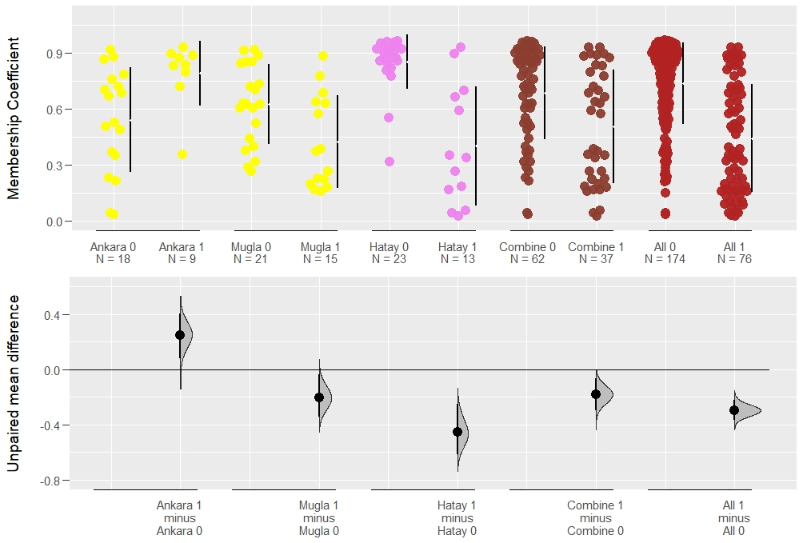

### Isolated regions

Ankara_iso = subset(memberships174, memberships174$POPULATION=="Ankara")  
Mugla_iso = subset(memberships174, memberships174$POPULATION=="Mugla")  
Hatay_iso = subset(memberships174, memberships174$POPULATION=="Hatay")  
Kirklareli_iso = subset(memberships174, memberships174$POPULATION=="Kirklareli")  
Edirne_iso = subset(memberships174, memberships174$POPULATION=="Edirne+")  
Duzce_iso = subset(memberships174, memberships174$POPULATION=="Duzce+")  
Eskisehir_iso = subset(memberships174, memberships174$POPULATION=="Eskisehir+")  
Ardahan_iso = subset(memberships174, memberships174$POPULATION=="Ardahan")  
Artvin_iso = subset(memberships174, memberships174$POPULATION=="Artvin")  
  
isolated_provinces = cbind(  
 rbind(  
 Kirklareli_iso,  
 Ardahan_iso,  
 Artvin_iso),  
 TransformedCOEFFICIENT=c(  
 Kirklareli_iso$TransformedTHRACIAN,  
 Ardahan_iso$TransformedCAUCASIAN,  
 Artvin_iso$TransformedCAUCASIAN)  
)  
  
not_isolated_provinces = cbind(  
 rbind(  
 Edirne_iso,  
 Duzce_iso,  
 Eskisehir_iso,  
 Ankara_iso,  
 Mugla_iso,  
 Hatay_iso),  
 TransformedCOEFFICIENT=c(  
 Edirne_iso$TransformedTHRACIAN,  
 Duzce_iso$TransformedANATOLIAN,  
 Eskisehir_iso$TransformedANATOLIAN,  
 Ankara_iso$TransformedANATOLIAN,  
 Mugla_iso$TransformedANATOLIAN,  
 Hatay_iso$TransformedLEVANTINE)  
)  
  
all_provinces_iso = cbind(  
 rbind(  
 Kirklareli_iso,  
 Edirne_iso,  
 Duzce_iso,  
 Eskisehir_iso,  
 Ankara_iso,  
 Mugla_iso,  
 Ardahan_iso,  
 Artvin_iso,  
 Hatay_iso),  
 TransformedCOEFFICIENT=c(  
 Kirklareli_iso$TransformedTHRACIAN,  
 Edirne_iso$TransformedTHRACIAN,  
 Duzce_iso$TransformedANATOLIAN,  
 Eskisehir_iso$TransformedANATOLIAN,  
 Ankara_iso$TransformedANATOLIAN,  
 Mugla_iso$TransformedANATOLIAN,  
 Ardahan_iso$TransformedCAUCASIAN,  
 Artvin_iso$TransformedCAUCASIAN,  
 Hatay_iso$TransformedLEVANTINE)  
)  
  
normalities_174 = apply(memberships174[4:11], 2, function(x) {shapiro.test(x)$p.value})  
p.adjust(normalities_174, method="BH")

## ANATOLIAN THRACIAN CAUCASIAN   
## 4.193447e-15 1.691329e-18 3.297198e-17   
## LEVANTINE TransformedANATOLIAN TransformedTHRACIAN   
## 3.281414e-20 3.292611e-13 3.297198e-17   
## TransformedCAUCASIAN TransformedLEVANTINE   
## 3.349581e-15 1.691329e-18

par(mfrow=c(1,2))  
boxplot(all_provinces_iso$TransformedCOEFFICIENT ~ ordered(all_provinces_iso$POPULATION, levels=rev(c("Kirklareli", "Edirne+", "Duzce+", "Eskisehir+", "Mugla", "Ankara", "Ardahan", "Artvin", "Hatay"))), data = all_provinces_iso,  
 col= rep(rev(c("orangered", "yellow", "blue", "violet")), times= rev(c(2,4,2,1))),  
 horizontal= TRUE,  
 las=1,  
 xlab="Transformed membership coefficients",  
 ylab="",  
 pars=list(par(mar=c(8,6,4,2))),  
 at =rev(c(12,11, 9,8,7,6, 4,3, 1))  
)  
boxplot(  
 not_isolated_provinces$TransformedCOEFFICIENT,  
 isolated_provinces$TransformedCOEFFICIENT,  
 col=c("forestgreen","darkorchid3"),  
 horizontal= TRUE,  
 las=1,  
 xlab="Transformed membership coefficients",  
 ylab="",  
 pars=list(par(mar=c(8,0,4,2)))  
)  
legend("left",  
 inset= 0.01,  
 c("isolated", "not_isolated"),  
 fill=c("darkorchid3", "forestgreen"),  
 cex=0.7,  
 text.font=2,  
 box.lty=0,  
 horiz=FALSE)

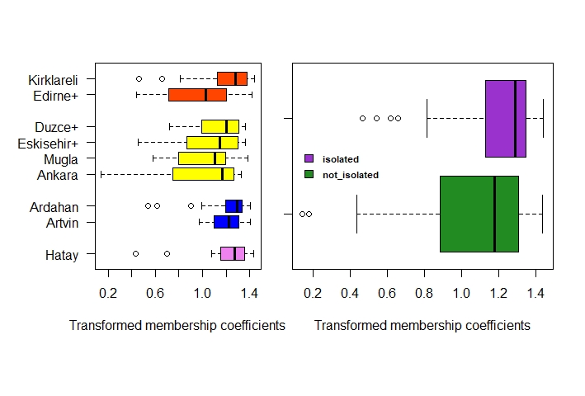

par(mfrow=c(1,1))  
  
mean_iso = apply(cbind.na(  
 isolated_provinces$TransformedCOEFFICIENT,  
 not_isolated_provinces$TransformedCOEFFICIENT),  
 2, function(x) {mean(x, na.rm=TRUE)})  
mean_iso

## [1] 1.210052 1.083340

cohen.d(isolated_provinces$TransformedCOEFFICIENT, not_isolated_provinces$TransformedCOEFFICIENT)$estimate

## [1] 0.4897751

wilcox.test(isolated_provinces$TransformedCOEFFICIENT, not_isolated_provinces$TransformedCOEFFICIENT)$p.value

## [1] 0.002100692

var.test(isolated_provinces$TransformedCOEFFICIENT, not_isolated_provinces$TransformedCOEFFICIENT)$p.value

## [1] 0.002916549

t.test(isolated_provinces$TransformedCOEFFICIENT, not_isolated_provinces$TransformedCOEFFICIENT, var.equal = FALSE)$p.value

## [1] 0.001130164

pwr.t2n.test(  
 n1= length(isolated_provinces$TransformedCOEFFICIENT),  
 n2= length(not_isolated_provinces$TransformedCOEFFICIENT),  
 d= cohen.d(isolated_provinces$TransformedCOEFFICIENT, not_isolated_provinces$TransformedCOEFFICIENT)$estimate,  
 sig.level= 0.05)$power

## [1] 0.8922584

all_provinces_iso$COEFFICIENT=c(  
 Kirklareli_iso$THRACIAN,  
 Edirne_iso$THRACIAN,  
 Duzce_iso$ANATOLIAN,  
 Eskisehir_iso$ANATOLIAN,  
 Ankara_iso$ANATOLIAN,  
 Mugla_iso$ANATOLIAN,  
 Ardahan_iso$CAUCASIAN,  
 Artvin_iso$CAUCASIAN,  
 Hatay_iso$LEVANTINE)  
  
plot(dabest(all_provinces_iso, POPULATION, COEFFICIENT,   
 idx = c("Kirklareli", "Edirne+", "Duzce+", "Eskisehir+", "Mugla", "Ankara", "Ardahan", "Artvin", "Hatay"),  
 paired = FALSE),  
 theme = ggplot2::theme_gray(),  
 palette = rep(c("orangered", "yellow", "blue", "violet"), times= c(2,4,2,1)),  
 rawplot.ylim = c(0.00, 1.10),  
 effsize.ylim = c(-0.70, 0.30),  
 rawplot.markersize = 4,  
 rawplot.groupwidth = 0.2,  
 rawplot.ylabel = "Membership Coefficient",  
 axes.title.fontsize = 12  
)

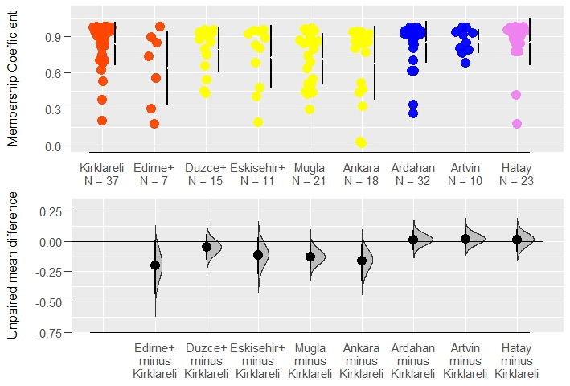

isolated_provinces$COEFFICIENT=c(  
 Kirklareli_iso$THRACIAN,  
 Ardahan_iso$CAUCASIAN,  
 Artvin_iso$CAUCASIAN)  
  
not_isolated_provinces$COEFFICIENT=c(  
 Edirne_iso$THRACIAN,  
 Duzce_iso$ANATOLIAN,  
 Eskisehir_iso$ANATOLIAN,  
 Ankara_iso$ANATOLIAN,  
 Mugla_iso$ANATOLIAN,  
 Hatay_iso$LEVANTINE)  
  
est_fac_iso = rbind(  
 cbind.data.frame(COEFFICIENT = isolated_provinces$COEFFICIENT, Isolated = "1"),  
 cbind.data.frame(COEFFICIENT = not_isolated_provinces$COEFFICIENT, Isolated = "0")  
)  
  
plot(dabest(est_fac_iso, Isolated, COEFFICIENT,   
 idx = c("0", "1"),  
 paired = FALSE),  
 theme = ggplot2::theme_gray(),  
 palette = c("forestgreen", "darkorchid3"),  
 rawplot.ylim = c(0.00, 1.10),  
 rawplot.markersize = 4,  
 rawplot.groupwidth = 0.2,  
 rawplot.ylabel = "Membership Coefficient"  
)

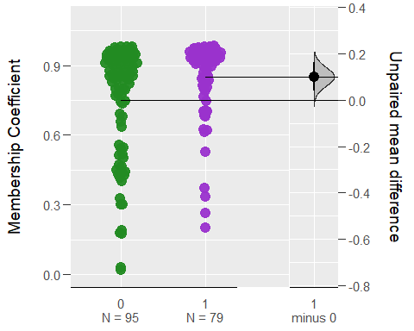

### Queen and colony trade

Thracian_mis = cbind(  
 rbind(  
 Duzce_iso,  
 Eskisehir_iso,  
 Ankara_iso,  
 Mugla_iso,  
 Ardahan_iso,  
 Artvin_iso,  
 Hatay_iso),  
 TransformedCOEFFICIENT=c(  
 Duzce_iso$TransformedTHRACIAN,  
 Eskisehir_iso$TransformedTHRACIAN,  
 Ankara_iso$TransformedTHRACIAN,  
 Mugla_iso$TransformedTHRACIAN,  
 Ardahan_iso$TransformedTHRACIAN,  
 Artvin_iso$TransformedTHRACIAN,  
 Hatay_iso$TransformedTHRACIAN)  
)  
  
Anatolian_mis = cbind(  
 rbind(  
 Kirklareli_iso,  
 Edirne_iso,  
 Ardahan_iso,  
 Artvin_iso,  
 Hatay_iso),  
 TransformedCOEFFICIENT=c(  
 Kirklareli_iso$TransformedANATOLIAN,  
 Edirne_iso$TransformedANATOLIAN,  
 Ardahan_iso$TransformedANATOLIAN,  
 Artvin_iso$TransformedANATOLIAN,  
 Hatay_iso$TransformedANATOLIAN)  
)  
  
Caucasian_mis = cbind(  
 rbind(  
 Kirklareli_iso,  
 Edirne_iso,  
 Duzce_iso,  
 Eskisehir_iso,  
 Ankara_iso,  
 Mugla_iso,  
 Hatay_iso),  
 TransformedCOEFFICIENT=c(  
 Kirklareli_iso$TransformedCAUCASIAN,  
 Edirne_iso$TransformedCAUCASIAN,  
 Duzce_iso$TransformedCAUCASIAN,  
 Eskisehir_iso$TransformedCAUCASIAN,  
 Ankara_iso$TransformedCAUCASIAN,  
 Mugla_iso$TransformedCAUCASIAN,  
 Hatay_iso$TransformedCAUCASIAN)  
)  
  
Levantine_mis = cbind(  
 rbind(  
 Kirklareli_iso,  
 Edirne_iso,  
 Duzce_iso,  
 Eskisehir_iso,  
 Ankara_iso,  
 Mugla_iso,  
 Ardahan_iso,  
 Artvin_iso),  
 TransformedCOEFFICIENT=c(  
 Kirklareli_iso$TransformedLEVANTINE,  
 Edirne_iso$TransformedLEVANTINE,  
 Duzce_iso$TransformedLEVANTINE,  
 Eskisehir_iso$TransformedLEVANTINE,  
 Ankara_iso$TransformedLEVANTINE,  
 Mugla_iso$TransformedLEVANTINE,  
 Ardahan_iso$TransformedLEVANTINE,  
 Artvin_iso$TransformedLEVANTINE)  
)  
  
boxplot(list(  
 Thracian = Thracian_mis$TransformedCOEFFICIENT,  
 Anatolian = Anatolian_mis$TransformedCOEFFICIENT,  
 Caucasian = Caucasian_mis$TransformedCOEFFICIENT,  
 Levantine = Levantine_mis$TransformedCOEFFICIENT),  
 col=c("orangered","yellow","blue","violet"),  
 las=1,  
 xlab="",  
 ylab="Arcsine square root transformed membership coefficients",  
 pars=list(par(mar=c(4,6,4,2))),  
 main="Misassignments to Clusters"  
)

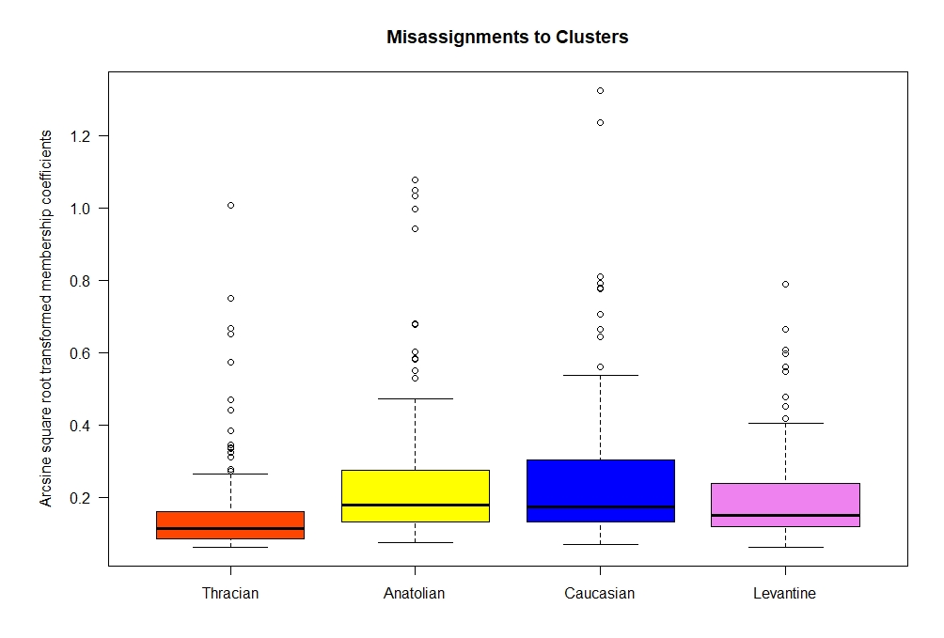

mean_mis = apply(cbind.na(  
 Thracian_mis$TransformedCOEFFICIENT,  
 Anatolian_mis$TransformedCOEFFICIENT,  
 Caucasian_mis$TransformedCOEFFICIENT,  
 Levantine_mis$TransformedCOEFFICIENT),  
 2, function(x) {mean(x, na.rm=TRUE)})  
mean_mis

## [1] 0.1599180 0.2546807 0.2576699 0.1976263

effect_sizes_mis = c(  
 cohen.d(Thracian_mis$TransformedCOEFFICIENT, Anatolian_mis$TransformedCOEFFICIENT)$estimate,  
 cohen.d(Thracian_mis$TransformedCOEFFICIENT, Caucasian_mis$TransformedCOEFFICIENT)$estimate,  
 cohen.d(Anatolian_mis$TransformedCOEFFICIENT, Caucasian_mis$TransformedCOEFFICIENT)$estimate,  
 cohen.d(Thracian_mis$TransformedCOEFFICIENT, Levantine_mis$TransformedCOEFFICIENT)$estimate,  
 cohen.d(Anatolian_mis$TransformedCOEFFICIENT, Levantine_mis$TransformedCOEFFICIENT)$estimate,  
 cohen.d(Caucasian_mis$TransformedCOEFFICIENT, Levantine_mis$TransformedCOEFFICIENT)$estimate  
)  
effect_sizes_mis

## [1] -0.53178083 -0.53846589 -0.01395682 -0.27940263 0.33515954 0.34484428

kruskal.test(list(  
 Thracian_mis$TransformedCOEFFICIENT,  
 Anatolian_mis$TransformedCOEFFICIENT,  
 Caucasian_mis$TransformedCOEFFICIENT,  
 Levantine_mis$TransformedCOEFFICIENT),  
 method="bh")$p.value

## [1] 8.161421e-12

dunn.test(list(  
 Thracian_mis$TransformedCOEFFICIENT,  
 Anatolian_mis$TransformedCOEFFICIENT,  
 Caucasian_mis$TransformedCOEFFICIENT,  
 Levantine_mis$TransformedCOEFFICIENT),  
 method="bh", table=FALSE, list=TRUE, altp=TRUE)$altP.adjust

## Kruskal-Wallis rank sum test  
##   
## data: x and group  
## Kruskal-Wallis chi-squared = 54.6482, df = 3, p-value = 0  
##   
##   
## Comparison of x by group   
## (Benjamini-Hochberg)   
##   
## List of pairwise comparisons: Z statistic (adjusted p-value)  
## ---------------------------  
## 1 - 2 : -6.185241 (0.0000)*  
## 1 - 3 : -6.517906 (0.0000)*  
## 2 - 3 : -0.016162 (0.9871)  
## 1 - 4 : -4.392869 (0.0000)*  
## 2 - 4 : 2.209515 (0.0326)*  
## 3 - 4 : 2.348135 (0.0283)*  
##   
## alpha = 0.05  
## Reject Ho if p <= alpha

## [1] 1.860224e-09 4.277724e-10 9.871048e-01 2.237283e-05 3.256659e-02  
## [6] 2.830147e-02

anova_fac_mis = rbind(  
 cbind.data.frame(TransformedCOEFFICIENT = Thracian_mis$TransformedCOEFFICIENT, Origin = gsub("_.*$", "", "Thracian_mis$TransformedCOEFFICIENT")),  
 cbind.data.frame(TransformedCOEFFICIENT = Anatolian_mis$TransformedCOEFFICIENT, Origin = gsub("_.*$", "", "Anatolian_mis$TransformedCOEFFICIENT")),  
 cbind.data.frame(TransformedCOEFFICIENT = Caucasian_mis$TransformedCOEFFICIENT, Origin = gsub("_.*$", "", "Caucasian_mis$TransformedCOEFFICIENT")),  
 cbind.data.frame(TransformedCOEFFICIENT = Levantine_mis$TransformedCOEFFICIENT, Origin = gsub("_.*$", "", "Levantine_mis$TransformedCOEFFICIENT"))  
)  
   
summary(aov(TransformedCOEFFICIENT ~ Origin, anova_fac_mis))[[1]][["Pr(>F)"]][[1]]

## [1] 6.410609e-06

TukeyHSD(aov(TransformedCOEFFICIENT ~ Origin, anova_fac_mis))$Origin[,4]

## Caucasian-Anatolian Levantine-Anatolian Thracian-Anatolian Levantine-Caucasian   
## 9.991923e-01 4.975158e-02 2.308165e-04 2.258572e-02   
## Thracian-Caucasian Thracian-Levantine   
## 5.070592e-05 2.789071e-01

plot(jitter(Thracian_mis$TransformedCOEFFICIENT,amount=0.05), pch=21, bg="orangered", cex=1.5, col="black", xlim=c(0, 151), ylim=c(0, 1.5), las=1,  
 xlab="",  
 ylab="Arcsine square root transformed membership coefficients",  
 pars=list(par(mar=c(4,6,4,2))),  
 main="Individual Misassignments")

## Warning in plot.window(...): "pars" bir grafiksel parametre değil

## Warning in plot.xy(xy, type, ...): "pars" bir grafiksel parametre değil

## Warning in axis(side = side, at = at, labels = labels, ...): "pars" bir  
## grafiksel parametre değil  
  
## Warning in axis(side = side, at = at, labels = labels, ...): "pars" bir  
## grafiksel parametre değil

## Warning in box(...): "pars" bir grafiksel parametre değil

## Warning in title(...): "pars" bir grafiksel parametre değil

points(jitter(Anatolian_mis$TransformedCOEFFICIENT,amount=0.05), pch=21, bg="yellow", cex=1.5, col="black")  
points(jitter(Caucasian_mis$TransformedCOEFFICIENT,amount=0.05), pch=21, bg="blue", cex=1.5, col="black")  
points(jitter(Levantine_mis$TransformedCOEFFICIENT,amount=0.05), pch=21, bg="violet", cex=1.5, col="black")  
abline(h=0.5, col="black",lwd=4)

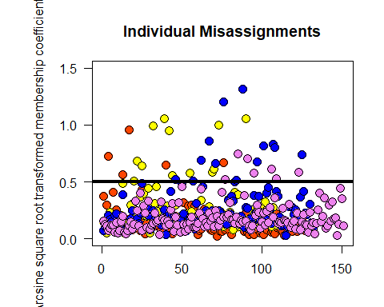

large_mis = sum(cbind.na(  
 Thracian_mis$TransformedCOEFFICIENT,  
 Anatolian_mis$TransformedCOEFFICIENT,  
 Caucasian_mis$TransformedCOEFFICIENT,  
 Levantine_mis$TransformedCOEFFICIENT)>=0.5, na.rm=TRUE)/  
 sum(cbind.na(  
 Thracian_mis$TransformedCOEFFICIENT,  
 Anatolian_mis$TransformedCOEFFICIENT,  
 Caucasian_mis$TransformedCOEFFICIENT,  
 Levantine_mis$TransformedCOEFFICIENT)>0, na.rm=TRUE)  
large_mis

## [1] 0.07471264

par(mfrow=c(2,2))  
boxplot(TransformedTHRACIAN ~ ordered(Thracian_mis$POPULATION, levels=c("Kirklareli", "Edirne+", "Duzce+", "Eskisehir+", "Mugla", "Ankara", "Ardahan", "Artvin", "Hatay")),  
 data=Thracian_mis,  
 col=c("orangered"),  
 las=1,  
 xlab="",  
 ylab="",  
 pars=list(par(mar=c(4,4,4,0))),  
 main="Misassignments to Thracian Cluster",  
 ylim=c(0, 1.4),  
 names = c("Kirklareli", "Edirne+", "Duzce+", "Eskisehir+", "Mugla", "Ankara", "Ardahan", "Artvin", "Hatay")  
)  
boxplot(TransformedANATOLIAN ~ ordered(Anatolian_mis$POPULATION, levels=c("Kirklareli", "Edirne+", "Duzce+", "Eskisehir+", "Mugla", "Ankara", "Ardahan", "Artvin", "Hatay")),  
 data=Anatolian_mis,  
 col=c("yellow"),  
 las=1,  
 xlab="",  
 ylab="",  
 pars=list(par(mar=c(4,2.5,4,1.5))),  
 main="Misassignments to Anatolian Cluster",  
 ylim=c(0, 1.4),  
 names = c("Kirklareli", "Edirne+", "Duzce+", "Eskisehir+", "Mugla", "Ankara", "Ardahan", "Artvin", "Hatay")  
)  
boxplot(TransformedCAUCASIAN ~ ordered(Caucasian_mis$POPULATION, levels=c("Kirklareli", "Edirne+", "Duzce+", "Eskisehir+", "Mugla", "Ankara", "Ardahan", "Artvin", "Hatay")),  
 data=Caucasian_mis,  
 col=c("blue"),  
 las=1,  
 xlab="",  
 ylab="",  
 pars=list(par(mar=c(4,4,4,0))),  
 main="Misassignments to Caucasian Cluster",  
 ylim=c(0, 1.4),  
 names = c("Kirklareli", "Edirne+", "Duzce+", "Eskisehir+", "Mugla", "Ankara", "Ardahan", "Artvin", "Hatay")  
)  
boxplot(TransformedLEVANTINE ~ ordered(Levantine_mis$POPULATION, levels=c("Kirklareli", "Edirne+", "Duzce+", "Eskisehir+", "Mugla", "Ankara", "Ardahan", "Artvin", "Hatay")),  
 data=Levantine_mis,  
 col=c("violet"),  
 las=1,  
 xlab="",  
 ylab="",  
 pars=list(par(mar=c(4,2.5,4,1.5))),  
 main="Misassignments to Levantine Cluster",  
 ylim=c(0, 1.4),  
 names = c("Kirklareli", "Edirne+", "Duzce+", "Eskisehir+", "Mugla", "Ankara", "Ardahan", "Artvin", "Hatay")  
)  
par(mfrow=c(1,1))  
mtext("Arcsine square root transformed membership coefficients", side = 2, line = 1.5)

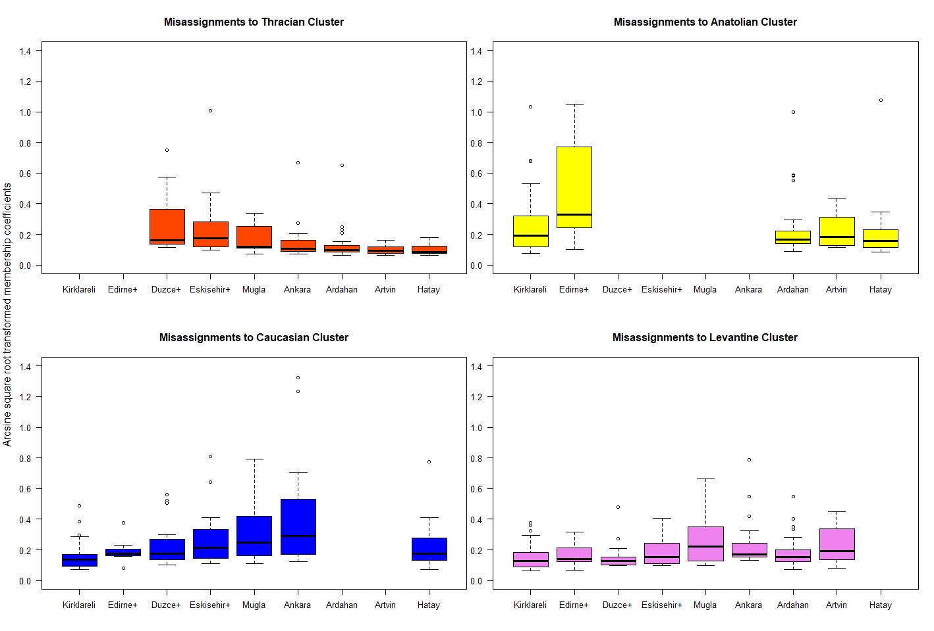

dunn.test(Thracian_mis$TransformedTHRACIAN, Thracian_mis$POPULATION, method="bh", table=FALSE, list=TRUE, altp=TRUE)$altP.adjust

## Kruskal-Wallis rank sum test  
##   
## data: x and group  
## Kruskal-Wallis chi-squared = 33.7717, df = 6, p-value = 0  
##   
##   
## Comparison of x by group   
## (Benjamini-Hochberg)   
##   
## List of pairwise comparisons: Z statistic (adjusted p-value)  
## ------------------------------------------  
## Ankara - Ardahan : 0.733480 (0.5405)  
## Ankara - Artvin : 1.187973 (0.3288)  
## Ardahan - Artvin : 0.696798 (0.5371)  
## Ankara - Duzce+ : -2.995549 (0.0096)*  
## Ardahan - Duzce+ : -4.037362 (0.0006)*  
## Artvin - Duzce+ : -3.712926 (0.0014)*  
## Ankara - Eskisehir+ : -2.180257 (0.0682)  
## Ardahan - Eskisehir+ : -3.005623 (0.0111)*  
## Artvin - Eskisehir+ : -2.982029 (0.0086)*  
## Duzce+ - Eskisehir+ : 0.536211 (0.6214)  
## Ankara - Hatay : 1.346935 (0.2875)  
## Ardahan - Hatay : 0.760054 (0.5525)  
## Artvin - Hatay : -0.117921 (0.9061)  
## Duzce+ - Hatay : 4.432701 (0.0002)*  
## Eskisehir+ - Hatay : 3.432389 (0.0031)*  
## Ankara - Mugla : -1.138340 (0.3347)  
## Ardahan - Mugla : -2.071484 (0.0731)  
## Artvin - Mugla : -2.171162 (0.0628)  
## Duzce+ - Mugla : 2.016226 (0.0766)  
## Eskisehir+ - Mugla : 1.259439 (0.3118)  
## Hatay - Mugla : -2.615835 (0.0234)*  
##   
## alpha = 0.05  
## Reject Ho if p <= alpha

## [1] 0.5404762394 0.3287816257 0.5370795810 0.0095882641 0.0005675828  
## [6] 0.0014341333 0.0682229193 0.0111315412 0.0085903221 0.6214032526  
## [11] 0.2875399886 0.5524509169 0.9061294848 0.0001954254 0.0031410113  
## [16] 0.3346588667 0.0731440909 0.0628297065 0.0766085639 0.3118073401  
## [21] 0.0233649965

dunn.test(Anatolian_mis$TransformedANATOLIAN, Anatolian_mis$POPULATION, method="bh", table=FALSE, list=TRUE, altp=TRUE)$altP.adjust

## Kruskal-Wallis rank sum test  
##   
## data: x and group  
## Kruskal-Wallis chi-squared = 6.2956, df = 4, p-value = 0.18  
##   
##   
## Comparison of x by group   
## (Benjamini-Hochberg)   
##   
## List of pairwise comparisons: Z statistic (adjusted p-value)  
## -----------------------------------------  
## Ardahan - Artvin : -0.319555 (0.8326)  
## Ardahan - Edirne+ : -2.152900 (0.1566)  
## Artvin - Edirne+ : -1.587954 (0.2807)  
## Ardahan - Hatay : 0.608762 (0.7753)  
## Artvin - Hatay : 0.744971 (0.7605)  
## Edirne+ - Hatay : 2.466576 (0.1364)  
## Ardahan - Kirklareli : -0.409257 (0.8529)  
## Artvin - Kirklareli : 0.047621 (0.9620)  
## Edirne+ - Kirklareli : 1.939794 (0.1747)  
## Hatay - Kirklareli : -0.998807 (0.6358)  
##   
## alpha = 0.05  
## Reject Ho if p <= alpha

## [1] 0.8325614 0.1566324 0.2807415 0.7752596 0.7604815 0.1364116 0.8529382  
## [8] 0.9620182 0.1746823 0.6357759

dunn.test(Caucasian_mis$TransformedCAUCASIAN, Caucasian_mis$POPULATION, method="bh", table=FALSE, list=TRUE, altp=TRUE)$altP.adjust

## Kruskal-Wallis rank sum test  
##   
## data: x and group  
## Kruskal-Wallis chi-squared = 24.4867, df = 6, p-value = 0  
##   
##   
## Comparison of x by group   
## (Benjamini-Hochberg)   
##   
## List of pairwise comparisons: Z statistic (adjusted p-value)  
## ---------------------------------------------  
## Ankara - Duzce+ : 1.503982 (0.3480)  
## Ankara - Edirne+ : 1.462703 (0.3349)  
## Duzce+ - Edirne+ : 0.274705 (0.8227)  
## Ankara - Eskisehir+ : 0.941227 (0.5599)  
## Duzce+ - Eskisehir+ : -0.417128 (0.7478)  
## Edirne+ - Eskisehir+ : -0.602542 (0.7177)  
## Ankara - Hatay : 2.156034 (0.1632)  
## Duzce+ - Hatay : 0.460103 (0.7973)  
## Edirne+ - Hatay : 0.062447 (0.9502)  
## Eskisehir+ - Hatay : 0.868226 (0.5779)  
## Ankara - Kirklareli : 4.116834 (0.0008)*  
## Duzce+ - Kirklareli : 2.147265 (0.1334)  
## Edirne+ - Kirklareli : 1.289570 (0.4141)  
## Eskisehir+ - Kirklareli : 2.396051 (0.1160)  
## Hatay - Kirklareli : 1.900234 (0.2009)  
## Ankara - Mugla : 0.417954 (0.7886)  
## Duzce+ - Mugla : -1.158209 (0.4319)  
## Edirne+ - Mugla : -1.185258 (0.4504)  
## Eskisehir+ - Mugla : -0.607113 (0.7613)  
## Hatay - Mugla : -1.803193 (0.2141)  
## Kirklareli - Mugla : -3.838787 (0.0013)*  
##   
## alpha = 0.05  
## Reject Ho if p <= alpha

## [1] 0.3480379226 0.3349468384 0.8227197142 0.5598734459 0.7478041560  
## [6] 0.7176924243 0.1631751049 0.7973106498 0.9502063240 0.5779059142  
## [11] 0.0008066361 0.1334431588 0.4141193923 0.1160093157 0.2009084083  
## [16] 0.7886436758 0.4318623501 0.4503834466 0.7612855064 0.2140734064  
## [21] 0.0012982542

dunn.test(Levantine_mis$TransformedLEVANTINE, Levantine_mis$POPULATION, method="bh", table=FALSE, list=TRUE, altp=TRUE)$altP.adjust

## Kruskal-Wallis rank sum test  
##   
## data: x and group  
## Kruskal-Wallis chi-squared = 19.2166, df = 7, p-value = 0.01  
##   
##   
## Comparison of x by group   
## (Benjamini-Hochberg)   
##   
## List of pairwise comparisons: Z statistic (adjusted p-value)  
## ---------------------------------------------  
## Ankara - Ardahan : 1.827729 (0.2704)  
## Ankara - Artvin : 0.462194 (0.8196)  
## Ardahan - Artvin : -0.983227 (0.5361)  
## Ankara - Duzce+ : 2.477045 (0.0927)  
## Ardahan - Duzce+ : 1.046549 (0.5906)  
## Artvin - Duzce+ : 1.674692 (0.3290)  
## Ankara - Edirne+ : 1.556922 (0.3346)  
## Ardahan - Edirne+ : 0.371489 (0.8287)  
## Artvin - Edirne+ : 1.037359 (0.5592)  
## Duzce+ - Edirne+ : -0.376797 (0.8599)  
## Ankara - Eskisehir+ : 1.437719 (0.3242)  
## Ardahan - Eskisehir+ : 0.033547 (0.9732)  
## Artvin - Eskisehir+ : 0.842084 (0.6218)  
## Duzce+ - Eskisehir+ : -0.795442 (0.6283)  
## Edirne+ - Eskisehir+ : -0.296349 (0.8590)  
## Ankara - Kirklareli : 3.121411 (0.0252)*  
## Ardahan - Kirklareli : 1.485072 (0.3209)  
## Artvin - Kirklareli : 2.005322 (0.2516)  
## Duzce+ - Kirklareli : 0.101352 (0.9900)  
## Edirne+ - Kirklareli : 0.493722 (0.8287)  
## Eskisehir+ - Kirklareli : 1.009791 (0.5470)  
## Ankara - Mugla : -0.040960 (1.0000)  
## Ardahan - Mugla : -1.964335 (0.2310)  
## Artvin - Mugla : -0.508700 (0.8553)  
## Duzce+ - Mugla : -2.600529 (0.0869)  
## Edirne+ - Mugla : -1.619173 (0.3279)  
## Eskisehir+ - Mugla : -1.513679 (0.3312)  
## Kirklareli - Mugla : -3.331314 (0.0242)*  
##   
## alpha = 0.05  
## Reject Ho if p <= alpha

## [1] 0.27036080 0.81956219 0.53611055 0.09273248 0.59061459 0.32898092  
## [7] 0.33456913 0.82865162 0.55919450 0.85987322 0.32418351 0.97323800  
## [13] 0.62181896 0.62831448 0.85899888 0.02519806 0.32089054 0.25160027  
## [19] 0.98998364 0.82866946 0.54704185 1.00000000 0.23095879 0.85534693  
## [25] 0.08687469 0.32794211 0.33118153 0.02420233

Thracian_mis$MISASSIGN = "Thracian"  
Anatolian_mis$MISASSIGN = "Anatolian"  
Caucasian_mis$MISASSIGN = "Caucasian"  
Levantine_mis$MISASSIGN = "Levantine"  
  
Thracian_mis$COEFFICIENT=c(  
 Duzce_iso$THRACIAN,  
 Eskisehir_iso$THRACIAN,  
 Ankara_iso$THRACIAN,  
 Mugla_iso$THRACIAN,  
 Ardahan_iso$THRACIAN,  
 Artvin_iso$THRACIAN,  
 Hatay_iso$THRACIAN)  
  
Anatolian_mis$COEFFICIENT=c(  
 Kirklareli_iso$ANATOLIAN,  
 Edirne_iso$ANATOLIAN,  
 Ardahan_iso$ANATOLIAN,  
 Artvin_iso$ANATOLIAN,  
 Hatay_iso$ANATOLIAN)  
  
Caucasian_mis$COEFFICIENT=c(  
 Kirklareli_iso$CAUCASIAN,  
 Edirne_iso$CAUCASIAN,  
 Duzce_iso$CAUCASIAN,  
 Eskisehir_iso$CAUCASIAN,  
 Ankara_iso$CAUCASIAN,  
 Mugla_iso$CAUCASIAN,  
 Hatay_iso$CAUCASIAN)  
  
Levantine_mis$COEFFICIENT=c(  
 Kirklareli_iso$LEVANTINE,  
 Edirne_iso$LEVANTINE,  
 Duzce_iso$LEVANTINE,  
 Eskisehir_iso$LEVANTINE,  
 Ankara_iso$LEVANTINE,  
 Mugla_iso$LEVANTINE,  
 Ardahan_iso$LEVANTINE,  
 Artvin_iso$LEVANTINE)  
  
est_fac_iso_mis = rbind(Thracian_mis, Anatolian_mis, Caucasian_mis, Levantine_mis)  
  
plot(dabest(est_fac_iso_mis, MISASSIGN, COEFFICIENT,   
 idx = c("Thracian", "Anatolian", "Caucasian", "Levantine"),  
 paired = FALSE),  
 theme = ggplot2::theme_gray(),  
 palette = c("orangered", "yellow", "blue", "violet"),  
 rawplot.ylim = c(0.00, 1.10),  
 effsize.ylim = c(-0.20, 0.20),  
 rawplot.markersize = 4,  
 rawplot.groupwidth = 0.2,  
 rawplot.ylabel = "Membership Coefficient"  
)

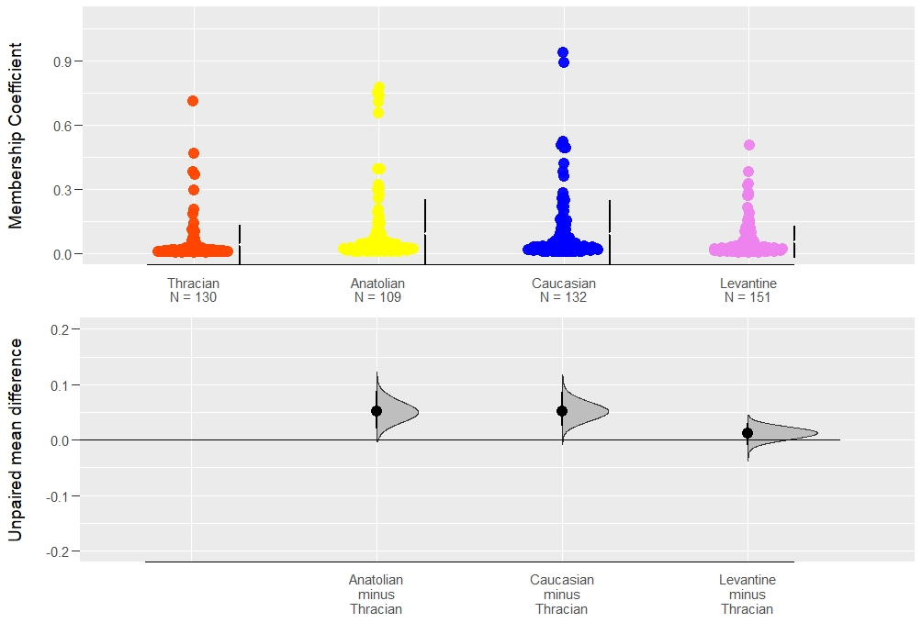

plot(dabest(all_provinces_iso, POPULATION, THRACIAN,   
 idx = c("Kirklareli", "Edirne+", "Duzce+", "Eskisehir+", "Mugla", "Ankara", "Ardahan", "Artvin", "Hatay"),  
 paired = FALSE),  
 theme = ggplot2::theme_gray(),  
 palette = rep(c("orangered"), times= 9),  
 rawplot.ylim = c(0.00, 1.10),  
 effsize.ylim = c(-1.00, 0.40),  
 rawplot.markersize = 4,  
 rawplot.groupwidth = 0.2,  
 rawplot.ylabel = "Membership Coefficient",  
 axes.title.fontsize = 12  
)

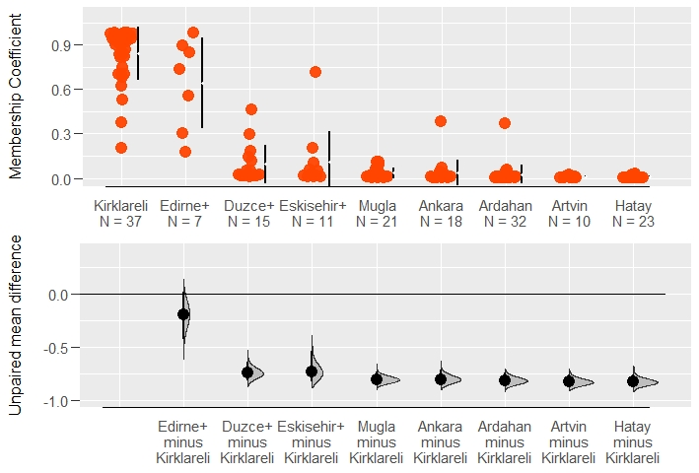

plot(dabest(all_provinces_iso, POPULATION, ANATOLIAN,   
 idx = c("Duzce+", "Eskisehir+", "Mugla", "Ankara", "Kirklareli", "Edirne+", "Ardahan", "Artvin", "Hatay"),  
 paired = FALSE),  
 theme = ggplot2::theme_gray(),  
 palette = rep(c("yellow"), times= 9),  
 rawplot.ylim = c(0.00, 1.10),  
 effsize.ylim = c(-1.00, 0.40),  
 rawplot.markersize = 4,  
 rawplot.groupwidth = 0.2,  
 rawplot.ylabel = "Membership Coefficient",  
 axes.title.fontsize = 12  
)

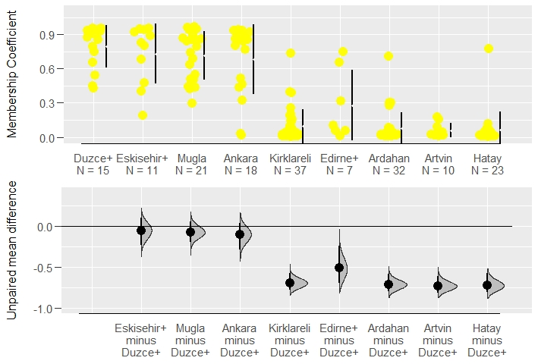

plot(dabest(all_provinces_iso, POPULATION, CAUCASIAN,   
 idx = c("Ardahan", "Artvin", "Kirklareli", "Edirne+", "Duzce+", "Eskisehir+", "Mugla", "Ankara", "Hatay"),  
 paired = FALSE),  
 theme = ggplot2::theme_gray(),  
 palette = rep(c("blue"), times= 9),  
 rawplot.ylim = c(0.00, 1.10),  
 effsize.ylim = c(-1.00, 0.40),  
 rawplot.markersize = 4,  
 rawplot.groupwidth = 0.2,  
 rawplot.ylabel = "Membership Coefficient",  
 axes.title.fontsize = 12  
)

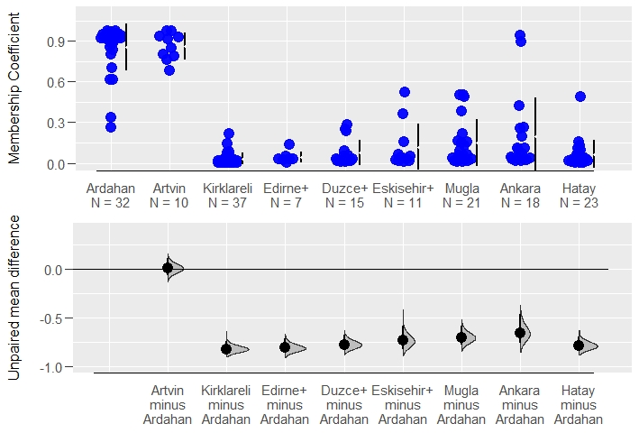

plot(dabest(all_provinces_iso, POPULATION, LEVANTINE,   
 idx = c("Hatay", "Kirklareli", "Edirne+", "Duzce+", "Eskisehir+", "Mugla", "Ankara", "Ardahan", "Artvin"),  
 paired = FALSE),  
 theme = ggplot2::theme_gray(),  
 palette = rep(c("violet"), times= 9),  
 rawplot.ylim = c(0.00, 1.10),  
 effsize.ylim = c(-1.00, 0.40),  
 rawplot.markersize = 4,  
 rawplot.groupwidth = 0.2,  
 rawplot.ylabel = "Membership Coefficient",  
 axes.title.fontsize = 12  
)

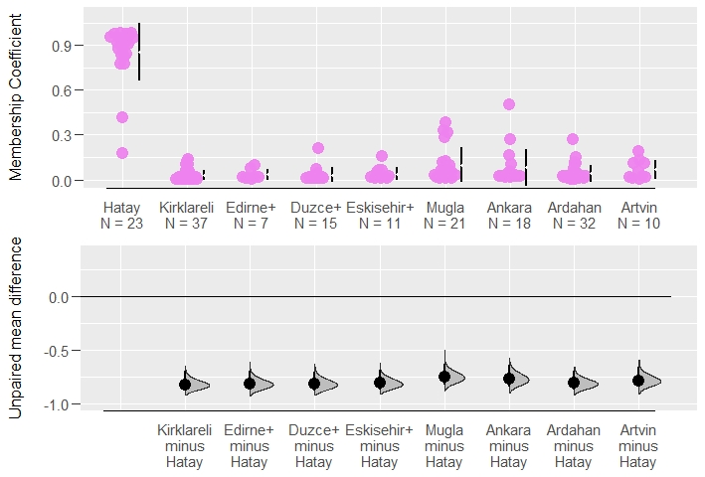

### Supplementary

plot(Bitlis_mig$ANATOLIAN, pch=21, bg="gold4", cex=1.5, col="black", las=1,  
 xlab="",  
 ylab="Membership coefficients",  
 ylim= c(0, 1.10),  
 pars=list(par(mar=c(4,6,4,2))),  
 main="Individual Assignments in Bitlis+")

## Warning in plot.window(...): "pars" bir grafiksel parametre değil

## Warning in plot.xy(xy, type, ...): "pars" bir grafiksel parametre değil

## Warning in axis(side = side, at = at, labels = labels, ...): "pars" bir  
## grafiksel parametre değil  
  
## Warning in axis(side = side, at = at, labels = labels, ...): "pars" bir  
## grafiksel parametre değil

## Warning in box(...): "pars" bir grafiksel parametre değil

## Warning in title(...): "pars" bir grafiksel parametre değil

points(Bitlis_mig$LEVANTINE, pch=21, bg="violetred", cex=1.5, col="black")  
points(Bitlis_mig$CAUCASIAN, pch=21, bg="blue", cex=1.5, col="black")  
abline(h=0.5, col="black",lwd=4)

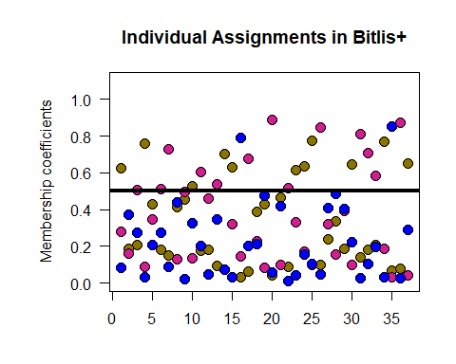

mean(Bitlis_mig$LEVANTINE)

## [1] 0.3690405

mean(Bitlis_mig$ANATOLIAN)

## [1] 0.347273

dunn.test(list(Bitlis_mig$ANATOLIAN, Bitlis_mig$LEVANTINE, Bitlis_mig$THRACIAN, Bitlis_mig$CAUCASIAN),  
method="bh", table=FALSE, list=TRUE, altp=TRUE)$altP.adjust

## Kruskal-Wallis rank sum test  
##   
## data: x and group  
## Kruskal-Wallis chi-squared = 59.0356, df = 3, p-value = 0  
##   
##   
## Comparison of x by group   
## (Benjamini-Hochberg)   
##   
## List of pairwise comparisons: Z statistic (adjusted p-value)  
## ---------------------------  
## 1 - 2 : -0.176265 (0.8601)  
## 1 - 3 : 6.562506 (0.0000)*  
## 2 - 3 : 6.738772 (0.0000)*  
## 1 - 4 : 1.987734 (0.0562)  
## 2 - 4 : 2.164000 (0.0457)*  
## 3 - 4 : -4.574772 (0.0000)*  
##   
## alpha = 0.05  
## Reject Ho if p <= alpha

## [1] 8.600852e-01 1.587321e-10 9.583830e-11 5.620928e-02 4.569651e-02  
## [6] 9.534769e-06