Supplementary Material

# Supplementary Tables

Supplementary Table 1. Microsatellite loci and multiplex primer groups.

|  |  |  |  |  |  |
| --- | --- | --- | --- | --- | --- |
|  | **Locus** | **F/R** | **Sequence** | **Length** | **Label** |
|  | Ap218 | F | AGGGATGGAATTCTTCGATT | 20 | 6-FAM |
|  |  | R | TTGTCACAATTCCGCTTGA | 19 |  |
|  | A113 | F | CTCGAATCGTGGCGTCC | 17 | 6-FAM |
|  |  | R | CCTGTATTTTGCAACCTCGC | 20 |  |
|  | A(B)024 | F | CACAAGTTCCAACAATGC | 18 | VIC |
|  |  | R | CACATTGAGGATGAGCG | 17 |  |
| **GR 1** | Ap249 | F | CGCGCGACGACGAAATGT | 18 | VIC |
|  |  | R | CAGTCCTTTGATTCGCGCTACC | 22 |  |
|  | A088 | F | CGAATTAACCGATTTGTCG | 19 | NED |
|  |  | R | GATCGCAATTATTGAAGGAG | 20 |  |
|  | AP001 | F | ACACGCGAACAATACAACA | 19 | NED |
|  |  | R | ACTAATCGGCACGATGAAG | 19 |  |
|  | Ap043 | F | GGCGTGCACAGCTTATTCC | 19 | PET |
|  |  | R | CGAAGGTGGTTTCAGGCC | 18 |  |
|  | A079 | F | CGAAGGTTGCGGAGTCCTC | 19 | 6-FAM |
|  |  | R | GTCGTCGGACCGATGCG | 17 |  |
|  | Ac306 | F | GAATATGCCGCTGCCACC | 18 | 6-FAM |
|  |  | R | TTTCGTTGCATCCGAGCG | 18 |  |
|  | Ap226 | F | AACGGTGTTCGCGAAACG | 18 | 6-FAM |
|  |  | R | AGCCAACTCGTGCGGTCA | 18 |  |
| **GR 2** | A007 | F | CCCTTCCTCTTTCATCTTCC | 20 | VIC |
|  |  | R | GTTAGTGCCCTCCTCTTGC | 19 |  |
|  | HB-C16-01 | F | AAAATGCGATTCTAATCTGG | 20 | VIC |
|  |  | R | TTGCCTAAAATGCTTGCTAT | 20 |  |
|  | Ap068 | F | TGTCTGCCCTCCTCTCTGTT | 20 | NED |
|  |  | R | CACATCGAGCGAGAAGGC | 18 |  |
|  | A014 | F | GTGTCGCAATCGACGTAACC | 20 | NED |
|  |  | R | GTCGATTACCGATCGTGACG | 20 |  |
|  | Ap223 | F | TCGTACAACGTCGCGCAA | 18 | PET |
|  |  | R | GCCGCTCGCCTGTATCTG | 18 |  |

Supplementary Table 1. Cont. Microsatellite loci and multiplex primer groups.

|  |  |  |  |  |  |
| --- | --- | --- | --- | --- | --- |
|  | **Locus** | **F/R** | **Sequence** | **Length** | **Label** |
|  | AP019 | F | CTCGTTTCTTCCATTGCG | 18 | 6-FAM |
|  |  | R | CGGTACGCGGTAGAAAGA | 18 |  |
|  | A(B)124 | F | GCAACAGGTCGGGTTAGAG | 19 | 6-FAM |
|  |  | R | CAGGATAGGGTAGGTAAGCAG | 21 |  |
|  | A043 | F | CACCGAAACAAGATGCAAG | 19 | VIC |
|  |  | R | CCGCTCATTAAGATATCCG | 19 |  |
| **GR 3** | A076 | F | GCCAATACTCTCGAACAATG | 20 | VIC |
|  |  | R | GTCCAATTCACATGTCGACATC | 22 |  |
|  | Ap273 | F | GATCTTGTGTTAAACAGCCG | 20 | NED |
|  |  | R | GATCTCTGGCAGACGAAGAG | 20 |  |
|  | Ap289 | F | AGCTAGGTCTTTCTAAGAGTGTTG | 24 | NED |
|  |  | R | TTCGACCGCAATAACATTC | 19 |  |
|  | HB-C16-05 | F | ATTTTATGCGCGTTTCGTA | 19 | PET |
|  |  | R | CATGGCTCCTCCATTAAATC | 20 |  |
|  | A028 | F | GAAGAGCGTTGGTTGCAGG | 19 | PET |
|  |  | R | GCCGTTCATGGTTACCACG | 19 |  |
|  | Ap049 | F | CCAATAGCGGCGAGTGTG | 18 | 6-FAM |
|  |  | R | GGGCTTCGTACGTCCACC | 18 |  |
|  | Ap238 | F | GTCTCGTGCGTGCGAATG | 18 | 6-FAM |
|  |  | R | TTCATCATGTTCTCAAATTTCTTTGT | 26 |  |
|  | AC006 | F | GATCGTGGAAACCGCGAC | 18 | VIC |
|  |  | R | CACGGCCTCGTAACGGTC | 18 |  |
| **GR 4** | Ap243 | F | AATGTCCGCGAGCATCTG | 18 | VIC |
|  |  | R | TGTTTACGAGAATTCGACGGG | 21 |  |
|  | Ap288 | F | GTTAGTTCGTCGTCGACCG | 19 | NED |
|  |  | R | TCTTAGCTTTATAACGAGCACG | 22 |  |
|  | HB-C16-02 | F | TAGTATCGTGCTGTTCATCG | 20 | NED |
|  |  | R | ACATACATCTCTTGGCGAGT | 20 |  |
|  | A107 | F | CCGTGGGAGGTTTATTGTCG | 20 | PET |
|  |  | R | CCTTCGTAACGGATGACACC | 20 |  |

Supplementary Table 2. PCR conditions.

|  |  |  |  |
| --- | --- | --- | --- |
|  | **STEP** | **TIME** | **TEMPERATURE** |
| Activation | | 5 minutes | 95 oC |
|  | Denaturation | 30 seconds | 95 oC |
| 30 cycles | Annealing | 150 seconds | 57 oC |
|  | Extension | 30 seconds | 72 oC |
| Final extension | | 30 minutes | 60 oC |

Supplementary Table 3. Null allele frequencies.

|  |  |  |
| --- | --- | --- |
| **LOCUS** | **POPULATION** | **FREQUENCY** |
| A(B)024 | Artvin | 0.20410 |
| Ap273 | Eskişehir+ | 0.21365 |
| Ap289 | Ardahan | 0.36818 |
| Ap289 | Artvin | 0.40463 |

Supplementary Table 4. Private alleles for populations.

|  |  |  |  |
| --- | --- | --- | --- |
| **POPULATION** | **LOCUS** | **ALLELE** | **FREQUENCY** |
| Kırklareli | AB124 | 213 | 0,053 |
| Edirne+ | A007 | 124 | 0,063 |
| Edirne+ | A007 | 149 | 0,063 |
| Edirne+ | AB124 | 244 | 0,063 |
| Edirne+ | AP001 | 252 | 0,063 |
| Edirne+ | AP223 | 182 | 0,125 |
| Düzce+ | AP238 | 262 | 0,067 |
| Muğla | AP289 | 200 | 0,056 |
| Artvin | A079 | 127 | 0,050 |
| Artvin | A107 | 185 | 0,050 |
| Artvin | A113 | 242 | 0,050 |
| Artvin | AP249 | 216 | 0,050 |
| Hatay | AP243 | 268 | 0,056 |

Supplementary Table 5. Loci based allelic diversity.

|  |  |  |  |  |  |  |
| --- | --- | --- | --- | --- | --- | --- |
| **LOCI** | **# of ALLELES** | **# of EFFECT. ALLELES** | **# of PRIVATE ALLELES** | **ALLELIC RICHNESS** | **INFORM. INDEX** | **HOMOZY. OBS.** |
| A007 | 46 | 19,0 | 11 | 11,6 | 3,3 | 0,05 |
| A014 | 9 | 2,2 | 3 | 3,2 | 1,0 | 0,45 |
| A028 | 8 | 1,3 | 4 | 2,3 | 0,5 | 0,75 |
| A043 | 13 | 2,0 | 5 | 3,8 | 1,1 | 0,50 |
| A079 | 12 | 3,9 | 4 | 4,9 | 1,6 | 0,26 |
| A088 | 13 | 2,8 | 4 | 3,9 | 1,3 | 0,36 |
| A107 | 25 | 13,6 | 2 | 10,5 | 2,9 | **0,07** |
| A113 | 23 | 9,3 | 7 | 8,3 | 2,4 | 0,11 |
| A(B)024 | 8 | 2,5 | 2 | 3,5 | 1,1 | 0,39 |
| A(B)124 | 16 | 4,8 | 4 | 6,4 | 2,0 | 0,21 |
| AC006 | 8 | 1,2 | 2 | 2,2 | 0,5 | 0,80 |
| AC306 | 11 | 3,5 | 3 | 4,3 | 1,4 | 0,29 |
| AP001 | 33 | 4,7 | 7 | 7,1 | 2,2 | 0,21 |
| AP019 | 8 | 1,6 | 2 | 2,9 | 0,8 | 0,64 |
| AP043 | 33 | 7,6 | 6 | 8,5 | 2,5 | 0,13 |
| AP049 | 13 | 1,9 | 4 | 3,9 | 1,1 | 0,52 |
| AP068 | 9 | 2,8 | 2 | 4,5 | 1,4 | 0,35 |
| AP218 | 6 | 1,1 | 3 | 1,8 | 0,3 | 0,87 |
| AP223 | 6 | 3,1 | 1 | 3,9 | 1,3 | 0,33 |
| AP226 | 7 | 1,3 | 3 | 2,4 | 0,5 | 0,79 |
| AP238 | 6 | 1,8 | 3 | 2,3 | 0,7 | 0,57 |
| AP243 | 11 | 1,2 | 6 | 2,4 | 0,5 | 0,81 |
| AP249 | 11 | 3,6 | 1 | 5,2 | 1,6 | 0,28 |
| AP273 | 4 | 1,8 | 1 | 2,1 | 0,7 | 0,56 |
| AP288 | 7 | 1,7 | 2 | 3,2 | 0,8 | 0,59 |
| AP289 | 40 | 10,7 | 5 | 9,9 | 2,9 | 0,09 |
| HB-C16-01 | 40 | 16,8 | 2 | 11,5 | 3,2 | 0,06 |
| HB-C16-02 | 35 | 3,7 | 10 | 7,2 | 2,2 | 0,27 |
| HB-C16-05 | 5 | 2,8 | 1 | 3,1 | 1,1 | 0,36 |
| MEAN | 16,1 | 4,6 | 3,8 | 5,1 | 1,5 | 0,40 |

Supplementary Table 6.. Abundances of alleles per population.

|  |  |  |  |  |  |
| --- | --- | --- | --- | --- | --- |
|  | **# of ALLELES** | **# of FREQ. ALLELES** | **# of EFFECT. ALLELES** | **# of PRIVATE ALLELES** | **# of LOCAL COMMON ALLELES** |
| **KIRKLARELİ** | 255 | 115 | 113 | 19 | 31 |
| **EDİRNE+** | 135 | 135 | 96 | 5 | 16 |
| **DÜZCE+** | 163 | 103 | 92 | 6 | 17 |
| **ESKİŞEHİR+** | 140 | 89 | 85 | 5 | 10 |
| **ANKARA** | 236 | 102 | 117 | 11 | 24 |
| **MUĞLA** | 245 | 102 | 123 | 14 | 27 |
| **ARDAHAN** | 209 | 89 | 101 | 13 | 19 |
| **ARTVİN** | 138 | 138 | 87 | 4 | 15 |
| **BİTLİS+** | 270 | 103 | 126 | 7 | 35 |
| **HATAY** | 287 | 101 | 130 | 26 | 32 |
| **MEAN** | 207,8 | 107,7 | 106,9 | 11,0 | 22,6 |

Supplementary Table 7. Allelic diversities per population.

|  |  |  |  |
| --- | --- | --- | --- |
|  | **INFO. INDEX** | **GENE DIVERSITY** | **ALLELIC RICHNESS** |
| **KIRKLARELİ** | 1,4 | 0,62 | 4,9 |
| **EDİRNE+** | 1,2 | 0,62 | 4,7 |
| **DÜZCE+** | 1,2 | 0,58 | 4,4 |
| **ESKİŞEHİR+** | 1,1 | 0,55 | 4,3 |
| **MUĞLA** | 1,3 | 0,55 | 4,6 |
| **ANKARA** | 1,3 | 0,58 | 4,8 |
| **ARDAHAN** | 1,1 | 0,50 | 4,2 |
| **ARTVİN** | 1,0 | 0,51 | 4,3 |
| **BİTLİS+** | 1,4 | 0,59 | 4,9 |
| **HATAY** | 1,4 | 0,60 | 5,1 |
| **MEAN** | 1,2 | 0,57 | 4,6 |

Supplementary Table 8. Observed and expected heterozygosities for each loci.

|  |  |  |
| --- | --- | --- |
| **Locus** | **Obs. Het.** | **Exp.Het.** |
| A007 | 0,90 | 0,95 |
| A014 | 0,46 | 0,55 |
| A028 | 0,24 | 0,25 |
| A043 | 0,39 | 0,50 |
| A079 | **0,69** | 0,74 |
| A088 | 0,58 | 0,64 |
| A107 | **0,92** | 0,93 |
| A113 | 0,82 | 0,89 |
| A(B)024 | 0,56 | 0,61 |
| A(B)124 | **0,73** | 0,79 |
| AC006 | **0,15** | 0,20 |
| AC306 | **0,64** | 0,71 |
| AP001 | 0,68 | 0,79 |
| AP019 | 0,31 | 0,36 |
| AP043 | 0,79 | 0,87 |
| AP049 | 0,43 | 0,48 |
| AP068 | 0,70 | 0,65 |
| AP218 | **0,06** | 0,13 |
| AP223 | 0,64 | 0,68 |
| AP226 | **0,17** | 0,21 |
| AP238 | 0,43 | 0,43 |
| AP243 | **0,16** | 0,19 |
| AP249 | 0,70 | 0,72 |
| AP273 | 0,38 | 0,44 |
| AP288 | 0,36 | 0,41 |
| AP289 | **0,66** | 0,91 |
| HB-C16-01 | 0,88 | 0,94 |
| HB-C16-02 | **0,59** | 0,73 |
| HB-C16-05 | 0,62 | 0,64 |

Supplementary Table 9. Loci in linkage disequilibrium.

|  |  |
| --- | --- |
| **POPULATION** | **LOCI** |
| KIRKLARELİ | 1 & 12 |
| KIRKLARELİ | 16 & 22 |
| BİTLİS+ | 27 & 29 |
| HATAY | 7 & 27 |
| HATAY | 15 & 20 |
| HATAY | 19 & 20 |

Supplementary Table 10. Estimated effective population sizes.

|  |  |
| --- | --- |
| **POPULATION** | **EFFECTIVE SIZE** |
| THRACE | 1860.3 |
| WEST ANATOLIA | 3500.0 |
| NORTH EAST | 776.6 |
| BİTLİS+ | 4655.9 |
| HATAY | 665.0 |

Supplementary Table 11. Arlequin output of Mantel test for stationary colonies

===============================================================================

== MATRIX CORRELATION ANALYSIS (MANTEL TESTS)

===============================================================================

Labels of population samples={

"Kirklareli", "Edirne+", "Duzce+", Eskisehir+", "Mugla", "Ankara", "Ardahan", "Artvin", "Hatay"

}

List of matrices:

X1 (distance)={

0.0000 43.4000 356.4000 345.8400 511.9200 515.2400 1291.3000 1216.7500 988.2700

43.4000 0.0000 373.3800 345.2600 482.6400 526.8400 1317.5400 1242.9600 988.2800

356.4000 373.3800 0.0000 147.3900 478.6700 166.4300 955.1100 880.7700 667.9700

345.8400 345.2600 147.3900 0.0000 331.2800 212.6600 1053.5800 980.4000 643.2200

511.9200 482.6400 478.6700 331.2800 0.0000 492.7500 1307.9900 1238.7400 705.3200

515.2400 526.8400 166.4300 212.6600 492.7500 0.0000 842.4600 769.7600 505.6300

1291.3000 1317.5400 955.1100 1053.5800 1307.9900 842.4600 0.0000 74.5900 786.4700

1216.7500 1242.9600 880.7700 980.4000 1238.7400 769.7600 74.5900 0.0000 739.0300

988.2700 988.2800 667.9700 643.2200 705.3200 505.6300 786.4700 739.0300 0.0000

}

Y (fst)={

0.0000 0.0108 0.0691 0.0512 0.0825 0.0879 0.1091 0.1037 0.1203

0.0108 0.0000 0.0433 0.0352 0.0441 0.0611 0.0767 0.0841 0.0941

0.0691 0.0433 0.0000 0.0086 0.0236 0.0331 0.0666 0.0701 0.0697

0.0512 0.0352 0.0086 0.0000 0.0155 0.0216 0.0464 0.0424 0.0739

0.0825 0.0441 0.0236 0.0155 0.0000 0.0153 0.0406 0.0433 0.0525

0.0879 0.0611 0.0331 0.0216 0.0153 0.0000 0.0340 0.0265 0.0534

0.1091 0.0767 0.0666 0.0464 0.0406 0.0340 0.0000 0.0018 0.0899

0.1037 0.0841 0.0701 0.0424 0.0433 0.0265 0.0018 0.0000 0.0755

0.1203 0.0941 0.0697 0.0739 0.0525 0.0534 0.0899 0.0755 0.0000

}

Mean value Y : 0.054936

Sums of squares Y : 0.032199

Mean value X1 : 681.284444

Sums of squares X1 : 4984418.420289

ZY1 : 1588.374544

Sum of products (SP(Y,X1)) : 241.001023

Regression coefficient (bY1) : 0.000048

Correlation coefficient (rY1) : 0.601571

Determination of Y by X1(%) : 0.361888

Significance testing (10000 permutations for Mantel test)

====================

P(rY1 rand >= rY1 obs) : 0.002100

No. of smaller rand rY1 : 9979

No. of equal rand rY1 : 0

No. of larger rand rY1 : 21

Supplementary Table 12. Arlequin output of Mantel test for migratory colonies

===============================================================================

== MATRIX CORRELATION ANALYSIS (MANTEL TESTS)

===============================================================================

Labels of population samples={

"Kirklareli", "Edirne+", "Mugla", "Ankara", "Bitlis+", "Hatay"

}

List of matrices:

X1 (distance)={

0.0000 43.4000 511.9200 515.2400 1276.8900 988.2700

43.4000 0.0000 482.6400 526.8400 1294.4500 988.2800

511.9200 482.6400 0.0000 492.7500 1175.8200 705.3200

515.2400 526.8400 492.7500 0.0000 774.0700 505.6300

1276.8900 1294.4500 1175.8200 774.0700 0.0000 550.4600

988.2700 988.2800 705.3200 505.6300 550.4600 0.0000

}

Y (fst)={

0.0000 -0.0294 0.0698 0.0694 0.0834 0.0895

-0.0294 0.0000 0.0286 0.0187 0.0134 0.0319

0.0698 0.0286 0.0000 0.0174 0.0054 0.0114

0.0694 0.0187 0.0174 0.0000 0.0139 0.0215

0.0834 0.0134 0.0054 0.0139 0.0000 0.0072

0.0895 0.0319 0.0114 0.0215 0.0072 0.0000

}

Mean value Y : 0.030139

Sums of squares Y : 0.015413

Mean value X1 : 722.132000

Sums of squares X1 : 1757907.914440

ZY1 : 386.232980

Sum of products (SP(Y,X1)) : 59.764796

Regression coefficient (bY1) : 0.000034

Correlation coefficient (rY1) : 0.363087

Determination of Y by X1(%) : 0.131832

Significance testing (10000 permutations for Mantel test)

====================

P(rY1 rand >= rY1 obs) : 0.101500

No. of smaller rand rY1 : 8985

No. of equal rand rY1 : 14

No. of larger rand rY1 : 1001

Supplementary Table 13. Comparison of misassignment of individuals to Thracian cluster

List of pairwise comparisons: Z statistic (Benjamini-Hochberg adjusted p-value) according to Dunn’s test

------------------------------------------

## Ankara - Ardahan : 0.733480 (0.5405)

## Ankara - Artvin : 1.187973 (0.3288)

## Ardahan - Artvin : 0.696798 (0.5371)

## Ankara - Duzce+ : -2.995549 (0.0096)*

## Ardahan - Duzce+ : -4.037362 (0.0006)*

## Artvin - Duzce+ : -3.712926 (0.0014)*

## Ankara - Eskisehir+ : -2.180257 (0.0682)

## Ardahan - Eskisehir+ : -3.005623 (0.0111)*

## Artvin - Eskisehir+ : -2.982029 (0.0086)*

## Duzce+ - Eskisehir+ : 0.536211 (0.6214)

## Ankara - Hatay : 1.346935 (0.2875)

## Ardahan - Hatay : 0.760054 (0.5525)

## Artvin - Hatay : -0.117921 (0.9061)

## Duzce+ - Hatay : 4.432701 (0.0002)*

## Eskisehir+ - Hatay : 3.432389 (0.0031)*

## Ankara - Mugla : -1.138340 (0.3347)

## Ardahan - Mugla : -2.071484 (0.0731)

## Artvin - Mugla : -2.171162 (0.0628)

## Duzce+ - Mugla : 2.016226 (0.0766)

## Eskisehir+ - Mugla : 1.259439 (0.3118)

## Hatay - Mugla : -2.615835 (0.0234)*

Supplementary Table 14. Comparison of misassignment of individuals to Anatolian cluster

List of pairwise comparisons: Z statistic (Benjamini-Hochberg adjusted p-value) according to Dunn’s test

------------------------------------------

## Ardahan - Artvin : -0.319555 (0.8326)

## Ardahan - Edirne+ : -2.152900 (0.1566)

## Artvin - Edirne+ : -1.587954 (0.2807)

## Ardahan - Hatay : 0.608762 (0.7753)

## Artvin - Hatay : 0.744971 (0.7605)

## Edirne+ - Hatay : 2.466576 (0.1364)

## Ardahan - Kirklareli : -0.409257 (0.8529)

## Artvin - Kirklareli : 0.047621 (0.9620)

## Edirne+ - Kirklareli : 1.939794 (0.1747)

## Hatay - Kirklareli : -0.998807 (0.6358)

Supplementary Table 15. Comparison of misassignment of individuals to Caucasian cluster

List of pairwise comparisons: Z statistic (Benjamini-Hochberg adjusted p-value) according to Dunn’s test

------------------------------------------

## Ankara - Duzce+ : 1.503982 (0.3480)

## Ankara - Edirne+ : 1.462703 (0.3349)

## Duzce+ - Edirne+ : 0.274705 (0.8227)

## Ankara - Eskisehir+ : 0.941227 (0.5599)

## Duzce+ - Eskisehir+ : -0.417128 (0.7478)

## Edirne+ - Eskisehir+ : -0.602542 (0.7177)

## Ankara - Hatay : 2.156034 (0.1632)

## Duzce+ - Hatay : 0.460103 (0.7973)

## Edirne+ - Hatay : 0.062447 (0.9502)

## Eskisehir+ - Hatay : 0.868226 (0.5779)

## Ankara - Kirklareli : 4.116834 (0.0008)*

## Duzce+ - Kirklareli : 2.147265 (0.1334)

## Edirne+ - Kirklareli : 1.289570 (0.4141)

## Eskisehir+ - Kirklareli : 2.396051 (0.1160)

## Hatay - Kirklareli : 1.900234 (0.2009)

## Ankara - Mugla : 0.417954 (0.7886)

## Duzce+ - Mugla : -1.158209 (0.4319)

## Edirne+ - Mugla : -1.185258 (0.4504)

## Eskisehir+ - Mugla : -0.607113 (0.7613)

## Hatay - Mugla : -1.803193 (0.2141)

## Kirklareli - Mugla : -3.838787 (0.0013)*

Supplementary Table 16. Comparison of misassignment of individuals to Levantine cluster

List of pairwise comparisons: Z statistic (Benjamini-Hochberg adjusted p-value) according to Dunn’s test

------------------------------------------

## Ankara - Ardahan : 1.827729 (0.2704)

## Ankara - Artvin : 0.462194 (0.8196)

## Ardahan - Artvin : -0.983227 (0.5361)

## Ankara - Duzce+ : 2.477045 (0.0927)

## Ardahan - Duzce+ : 1.046549 (0.5906)

## Artvin - Duzce+ : 1.674692 (0.3290)

## Ankara - Edirne+ : 1.556922 (0.3346)

## Ardahan - Edirne+ : 0.371489 (0.8287)

## Artvin - Edirne+ : 1.037359 (0.5592)

## Duzce+ - Edirne+ : -0.376797 (0.8599)

## Ankara - Eskisehir+ : 1.437719 (0.3242)

## Ardahan - Eskisehir+ : 0.033547 (0.9732)

## Artvin - Eskisehir+ : 0.842084 (0.6218)

## Duzce+ - Eskisehir+ : -0.795442 (0.6283)

## Edirne+ - Eskisehir+ : -0.296349 (0.8590)

## Ankara - Kirklareli : 3.121411 (0.0252)*

## Ardahan - Kirklareli : 1.485072 (0.3209)

## Artvin - Kirklareli : 2.005322 (0.2516)

## Duzce+ - Kirklareli : 0.101352 (0.9900)

## Edirne+ - Kirklareli : 0.493722 (0.8287)

## Eskisehir+ - Kirklareli : 1.009791 (0.5470)

## Ankara - Mugla : -0.040960 (1.0000)

## Ardahan - Mugla : -1.964335 (0.2310)

## Artvin - Mugla : -0.508700 (0.8553)

## Duzce+ - Mugla : -2.600529 (0.0869)

## Edirne+ - Mugla : -1.619173 (0.3279)

## Eskisehir+ - Mugla : -1.513679 (0.3312)

## Kirklareli - Mugla : -3.331314 (0.0242)*

# Supplementary Figures

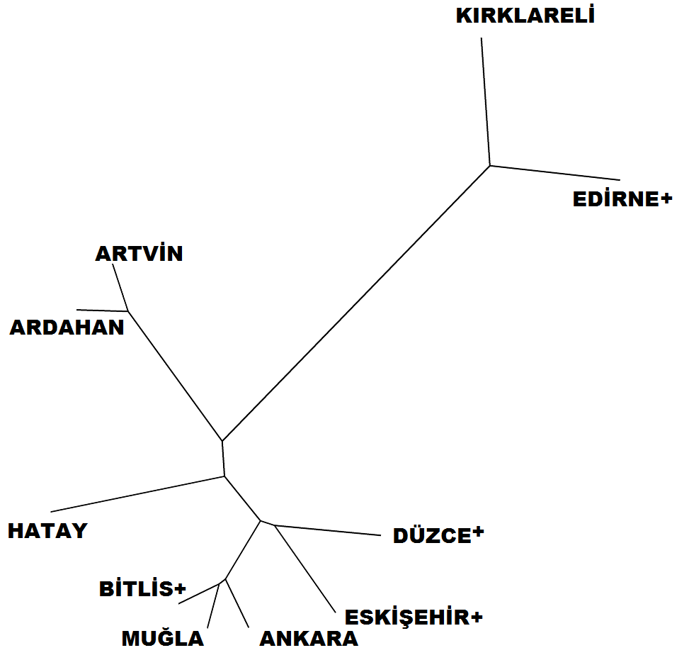

**Supplementary Figure 1.** UPGMA tree based on Nei’s genetic distance (1978).

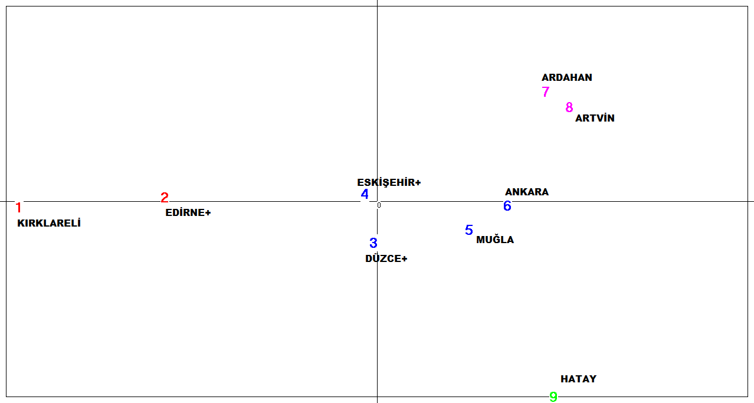

**Supplementary Figure 2.** PCA of stationary colonies. Axis 1: 43,19%. Axis 2: 21,87%.

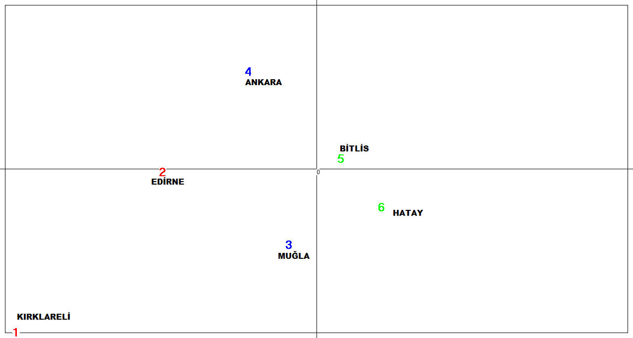

**Supplementary Figure 3.** PCA of migratory colonies. Axis 1: 28,21%. Axis 2: 20,98%.

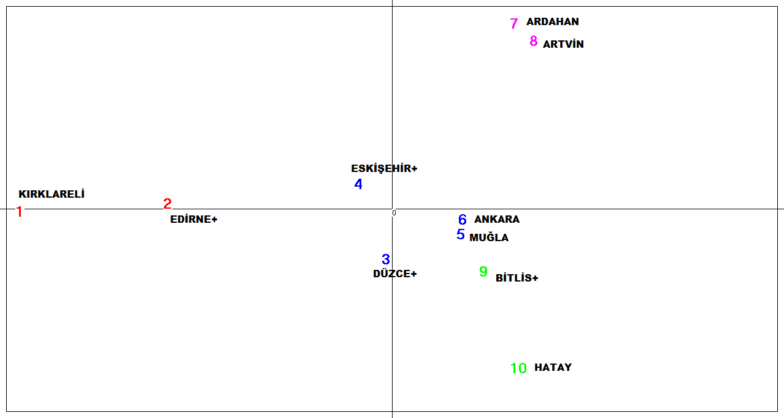

**Supplementary Figure 4.** PCA of overall data. Axis 1: 43,16%. Axis 2: 22,12%.

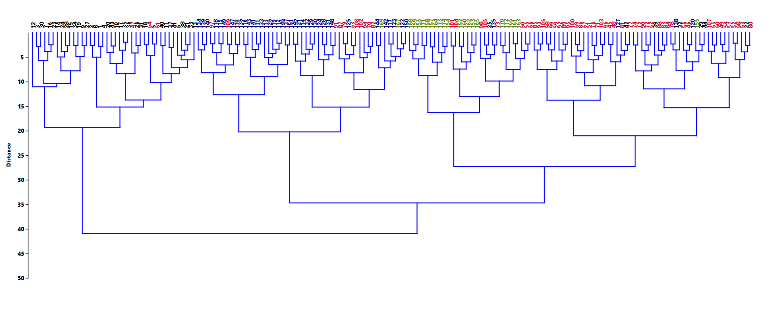

**Supplementary Figure 5.** Phylogenetic tree constructed using Ward’s method and Euclidean distances (black: Thracian, blue: Caucasian, olive: Levantine, red: Anatolian clusters )